./

Report – Stepin_SeatTemperatureApplication

Course Code: <CODE>



Version Number:

Team Members :

Team No:

Module: Model Based System Engineering

|  |  |  |  |  |  |
| --- | --- | --- | --- | --- | --- |
| **Ver. Rel. No.** | **Release Date** | **Prepared. By** | **Reviewed By** | **Approved By** | **Remarks/Revision Details** |
| 1 | 16/09/2021 | PONNOJU  NAGASHIRISHA |  |  |  |

**Document History**

# 

**Introduction:**

The system showcases a style for any sort of automotive controlled-heating part like seat heating, climate management, defrosting, glow plugs, and tank heaters. The planning consists of a main board and heating part that represents the resistive heating part found in automotive seat heaters, demonstrating the power to severally management the temperature of every seat further as offer sturdy diagnostics and protection to account for fault events.

**Components required:**

* Atmega328 microcontroller
* Heating element
* Display
* Potentiometer
* LEDs

**CASE Study:**

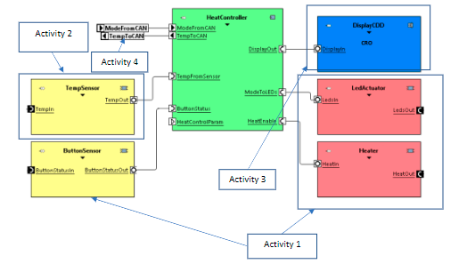

# TempRule.PNG

**ACTIVITY_1:**

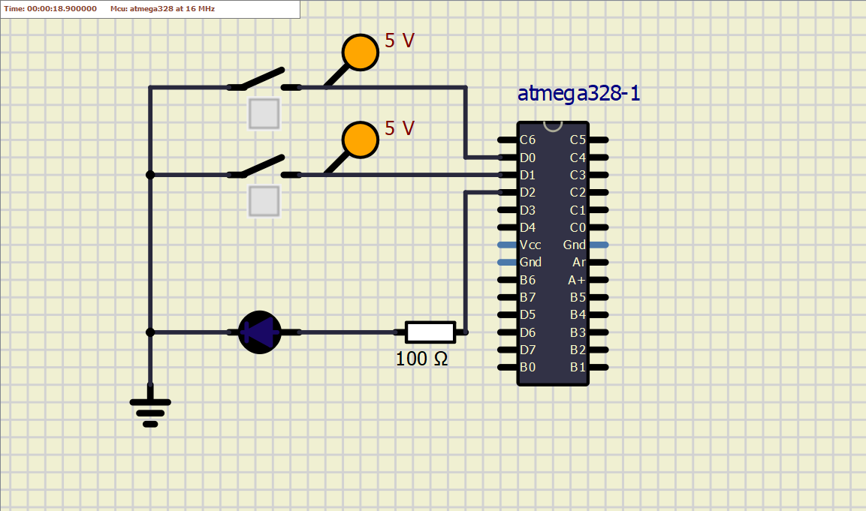

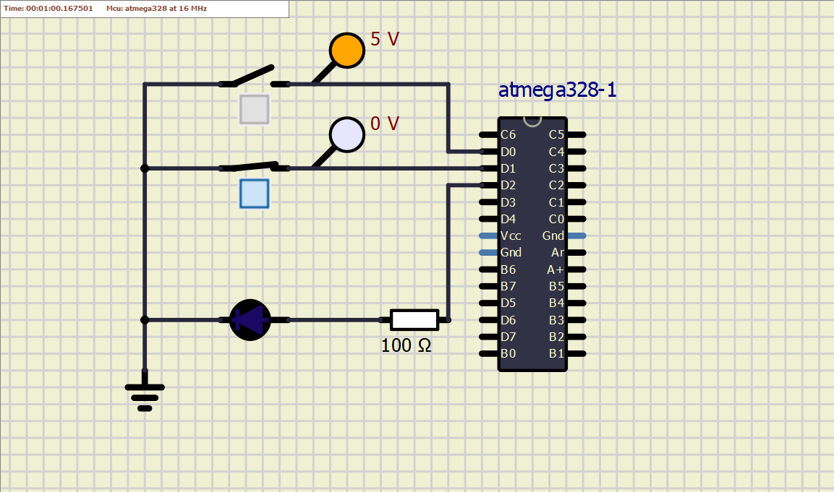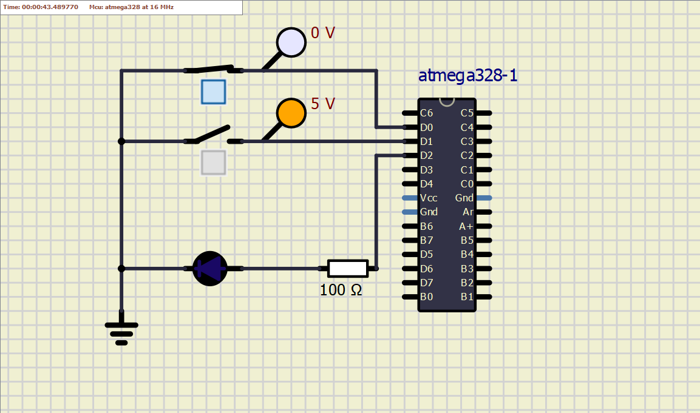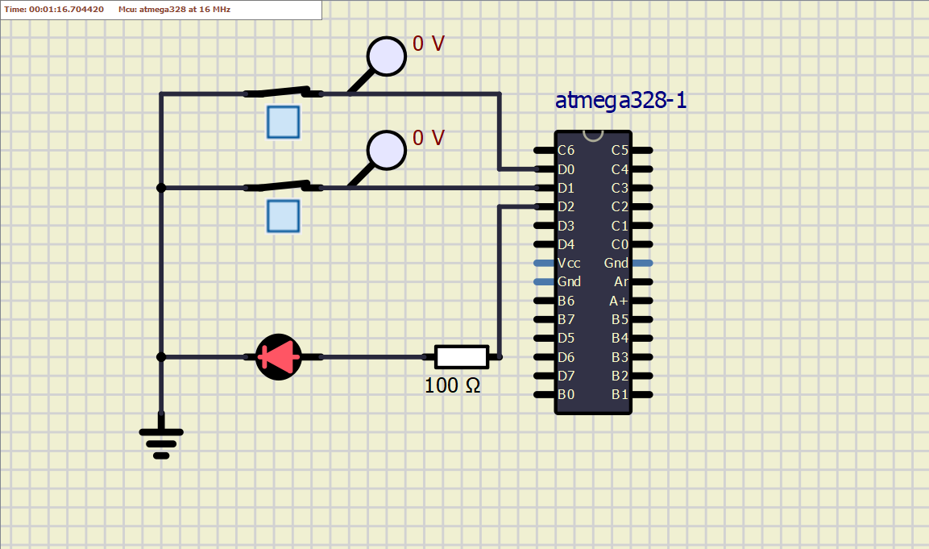

**ACTIVITY_2:**

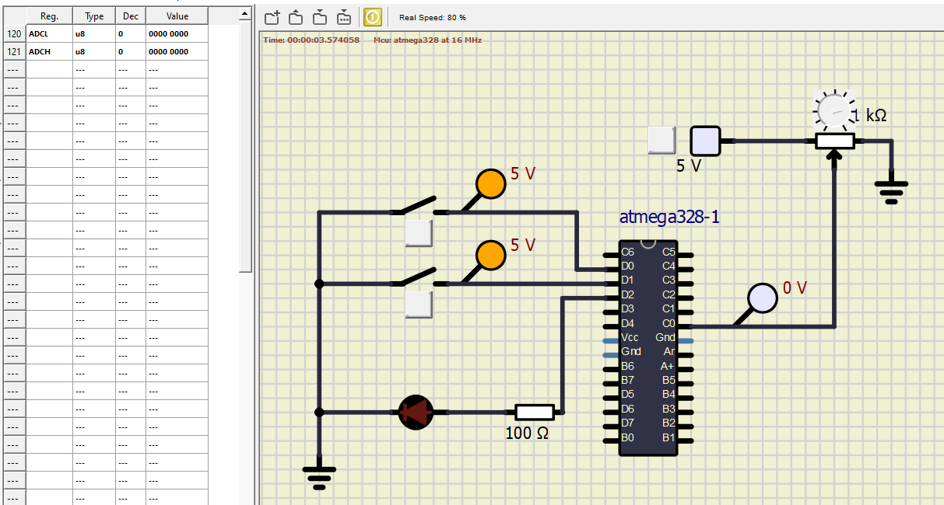

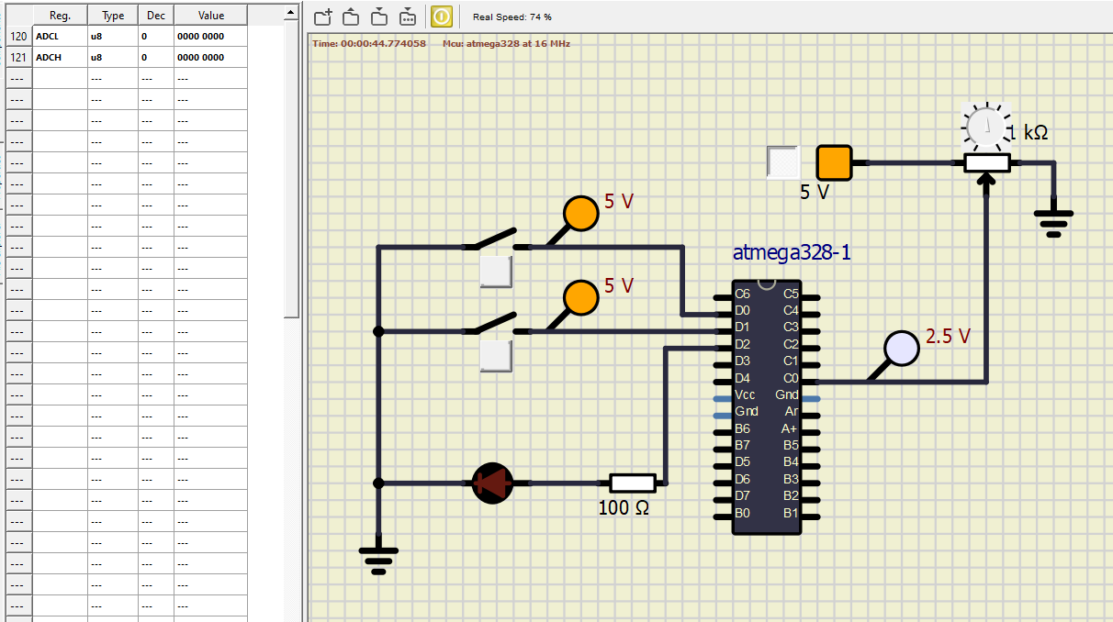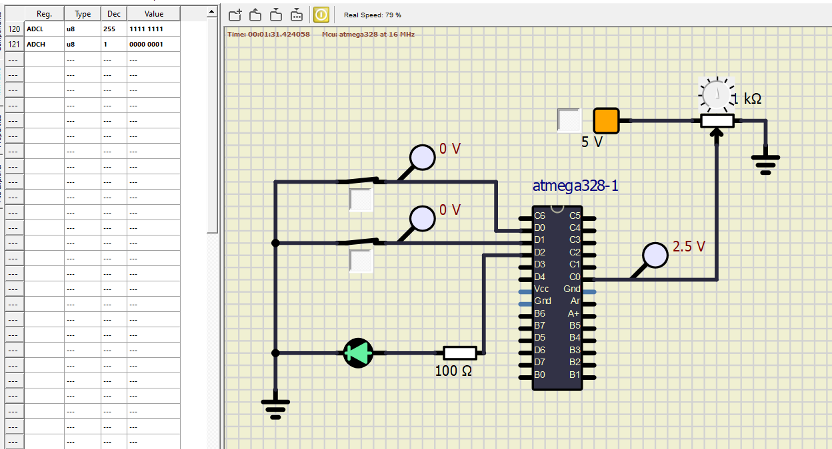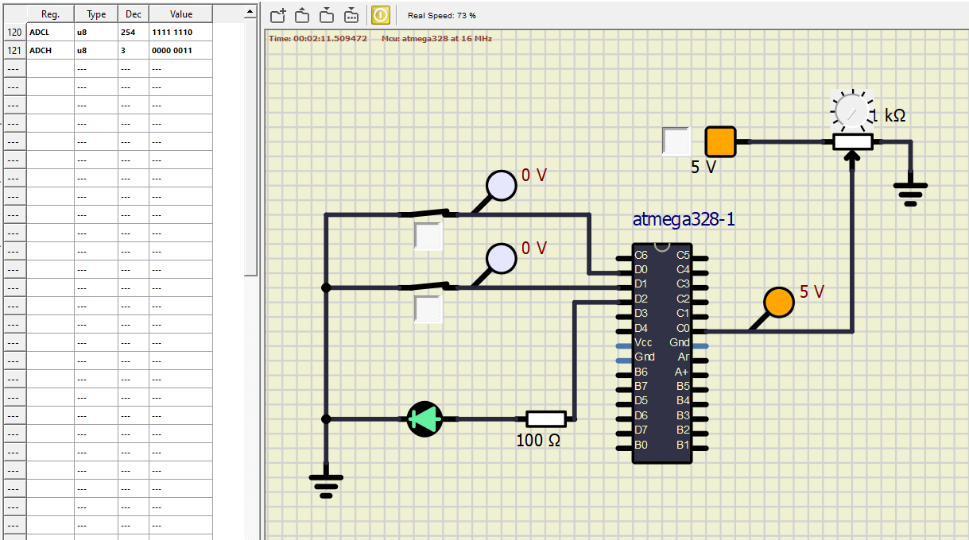

**ACTIVITY_3:**

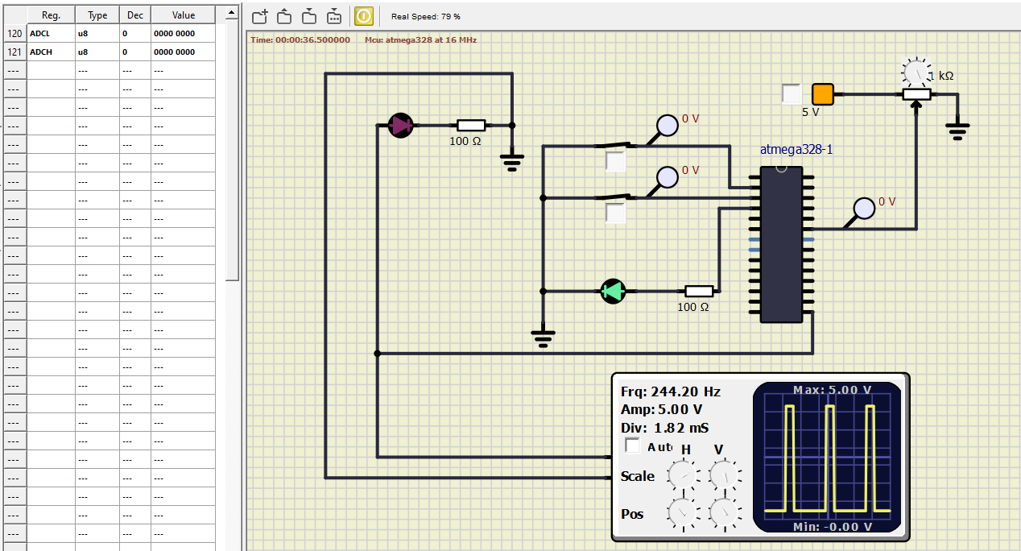

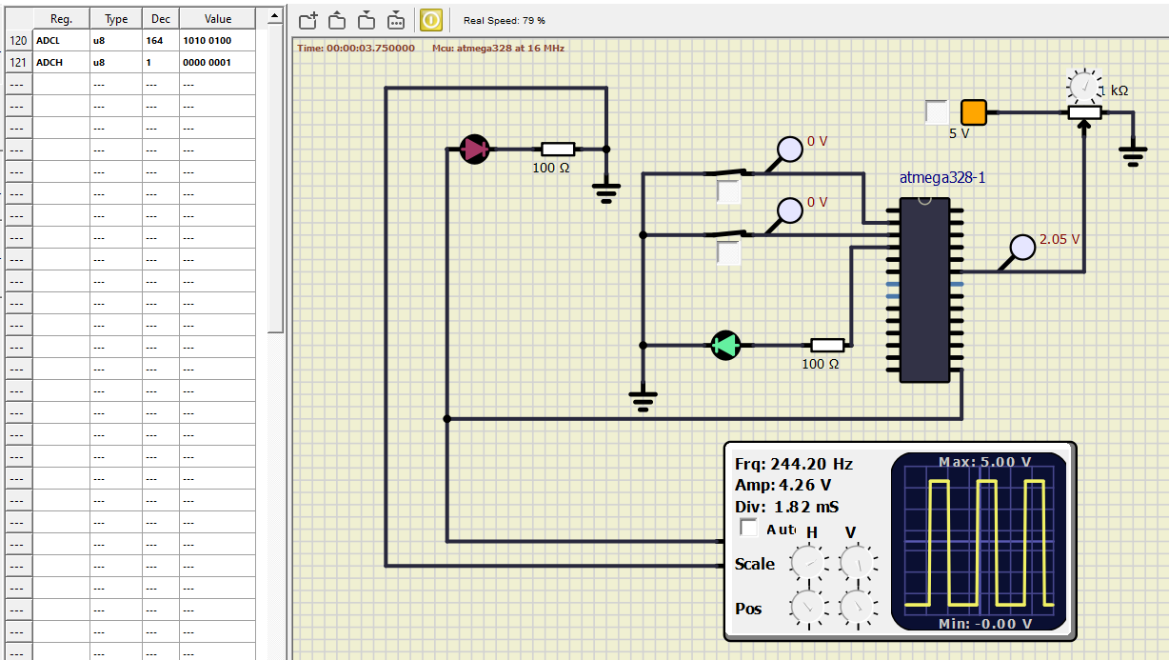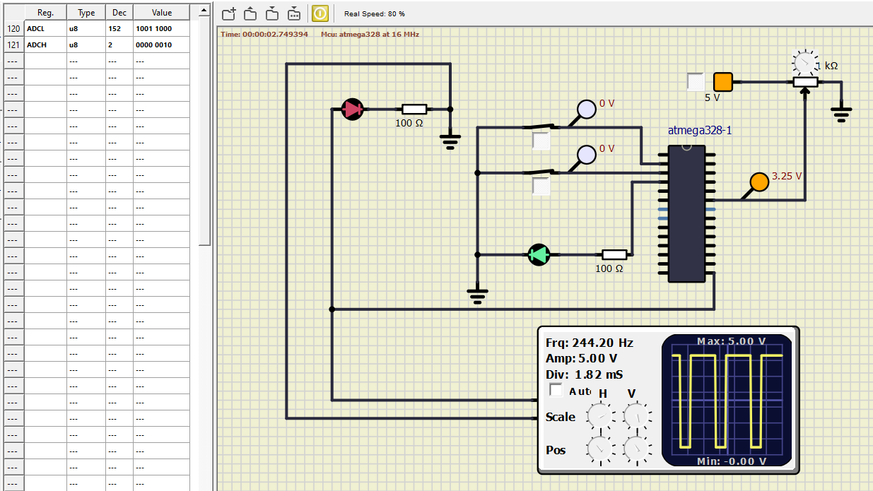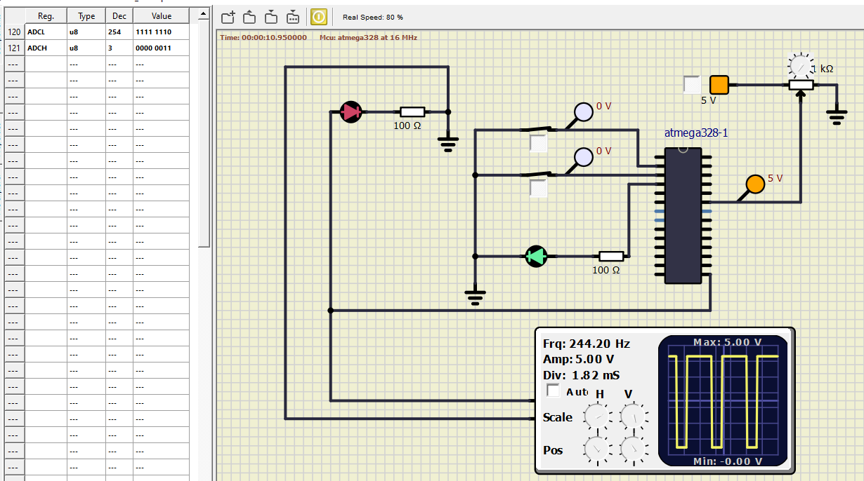

**Conclusion:**

This case study helped me to get the knowledge about Embedded system that is about programming in Embedded C, microcontroller.