# **Jenkins Pipeline to Log in to AWS, List EC2 Instances, and Create a New EC2 Instance**

# **Table of Contents**

* [Introduction](https://medium.com/@kuldeepkumawat195/using-jenkins-pipeline-to-log-in-to-aws-list-ec2-instances-and-create-a-new-ec2-instance-3d988a8e6f6d" \l "introduction)
* [Prerequisites](https://medium.com/@kuldeepkumawat195/using-jenkins-pipeline-to-log-in-to-aws-list-ec2-instances-and-create-a-new-ec2-instance-3d988a8e6f6d" \l "prerequisites)
* [Setting Up AWS Credentials in Jenkins](https://medium.com/@kuldeepkumawat195/using-jenkins-pipeline-to-log-in-to-aws-list-ec2-instances-and-create-a-new-ec2-instance-3d988a8e6f6d" \l "setting-up-aws-credentials-in-jenkins)
* [Logging in to AWS Using Jenkins Pipeline](https://medium.com/@kuldeepkumawat195/using-jenkins-pipeline-to-log-in-to-aws-list-ec2-instances-and-create-a-new-ec2-instance-3d988a8e6f6d" \l "logging-in-to-aws-using-jenkins-pipeline)
* [Listing EC2 Instances](https://medium.com/@kuldeepkumawat195/using-jenkins-pipeline-to-log-in-to-aws-list-ec2-instances-and-create-a-new-ec2-instance-3d988a8e6f6d" \l "listing-ec2-instances)
* [Creating a New EC2 Instance](https://medium.com/@kuldeepkumawat195/using-jenkins-pipeline-to-log-in-to-aws-list-ec2-instances-and-create-a-new-ec2-instance-3d988a8e6f6d" \l "creating-a-new-ec2-instance)

# **Introduction**

Jenkins, a widely-used automation server, allows developers use automate in various scenarios in software development, including deployment and integration with cloud services like AWS. In this we focus on using Jenkins to interact with AWS EC2 services through a Jenkins Pipeline. We’ll start by logging in to AWS, listing EC2 instances and creating a new EC2 instance within a pipeline.

# **Prerequisites**

Before you get started, ensure you have the following:

Create an instance in AWS account then copy SSH key to connect with linux open gitbash where **pem file**  downloaded then change it to root user **sudo su**  is command

open chrome search for jenkins.io

open first link scrolldown and click on Red Hat/Fedora/Alma/Rocky/Centos (LTS version)

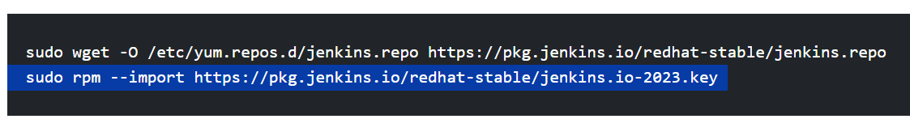

Copy past each in git then Install java in linux command line to do **use yum list java\*** then copy java version then give it

**Dnf install java -y java-17-amazon-corretto.x86_64** wait to finish installation check it.

**java --version** we can see version if it is installed.

we use above command for repository acess then Install jenkins now

1. **yum install jenkins**
2. **Sysyemctl start jenkins**
3. **Sysyemctl enable jenkins**
4. **Sysyemctl stauts jenkins**
5. **Jenkins --version**

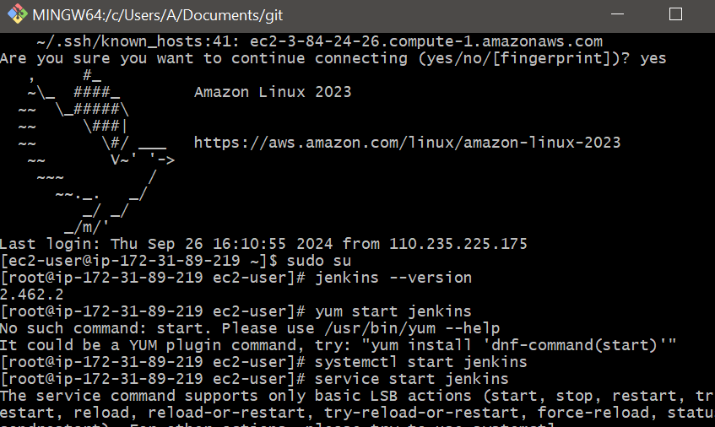

Then copy public id of instance :8080 for jenkins then will go to console if error occurred go to AWS **edit security inbounds add alltraffic then port change to 8080 then next ip4 select all 0.0.00** save changes**.** in order to do so have to sginup but it will ask **for unlock jenkis copy the path**  give in git bash **cat /var/lib/jenkins/secrets/initialAdminpassword** will get code past it in password then jenkins will unlock see in below screen shots.



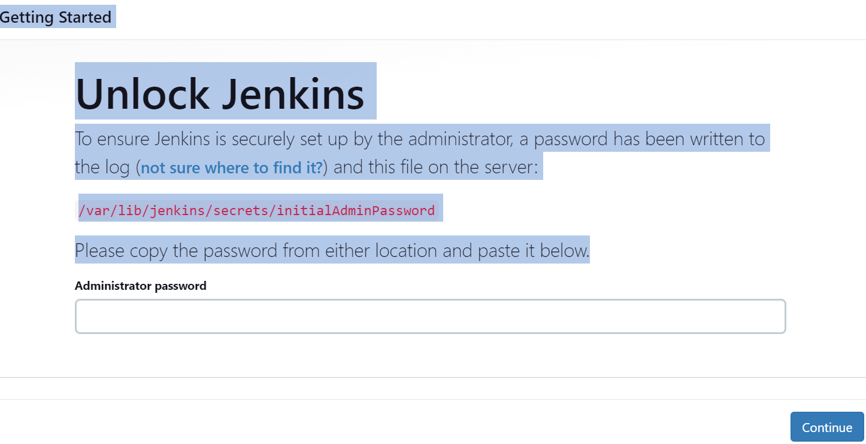

Sginup for jenkins credentials like name, password,mail then sginin with same name & password.

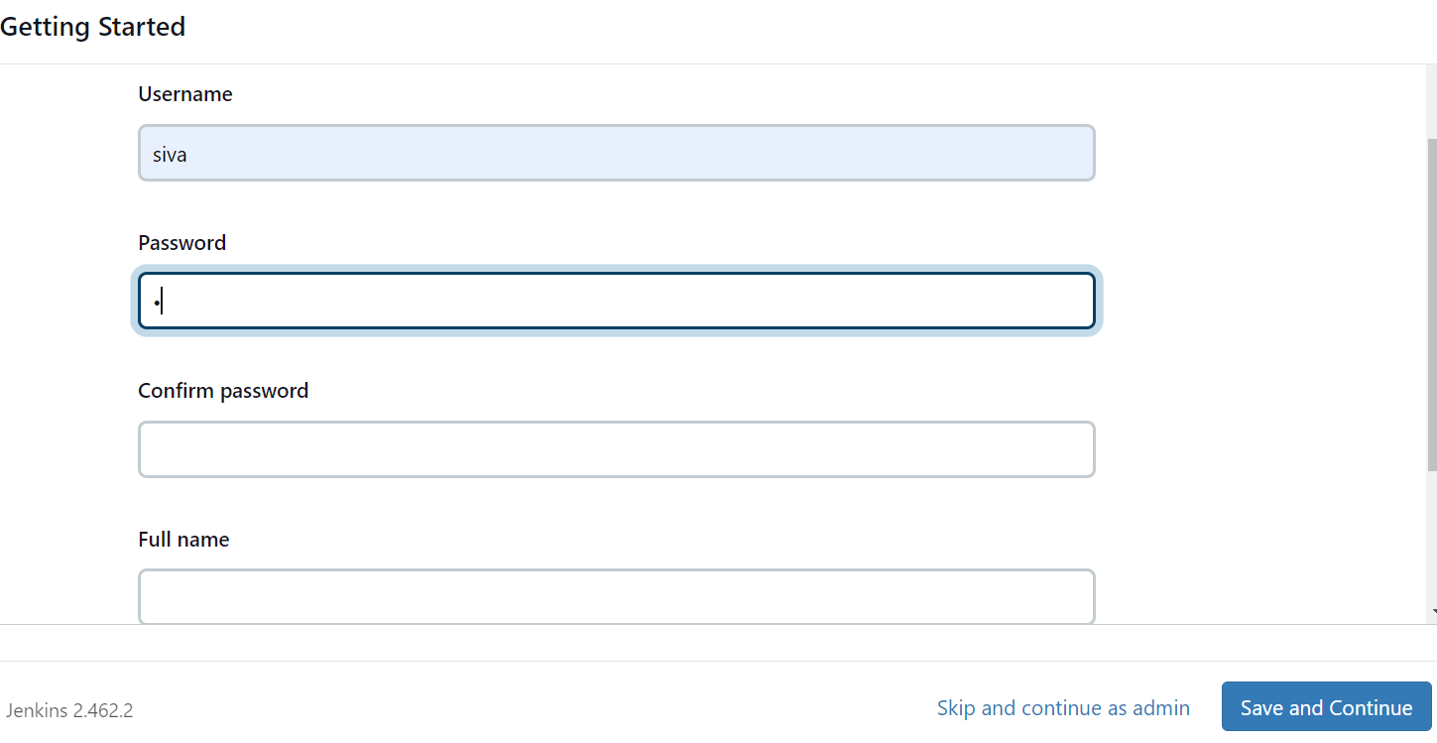**Create an AWS Access Key and Secret Key**

To interact with AWS services programmatically or through tools like Jenkins we need AWS Access Key ID and Secret Access Key. Here’s how you can create them.

Go to AWS account in search bar type IAM click on IAM then go to users click on create user.

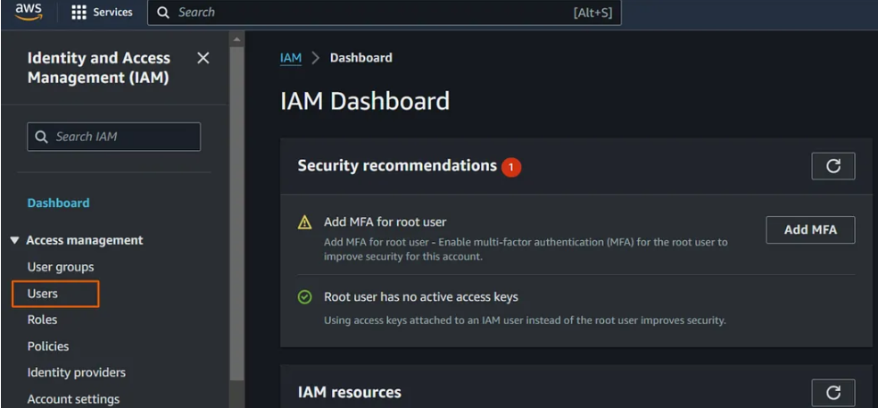

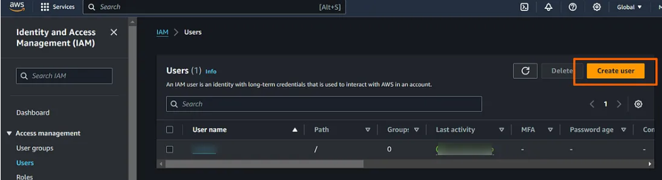

Give name for IAM user then tick in check box click on next then in permission attach policy EC2 full acess click on create user.

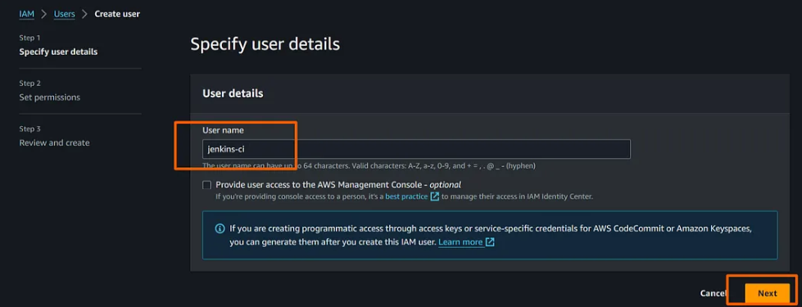

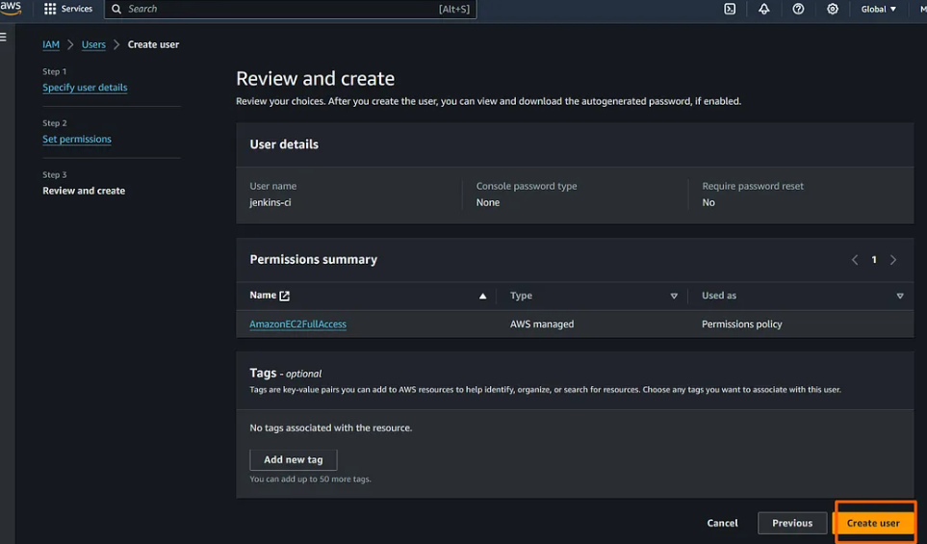

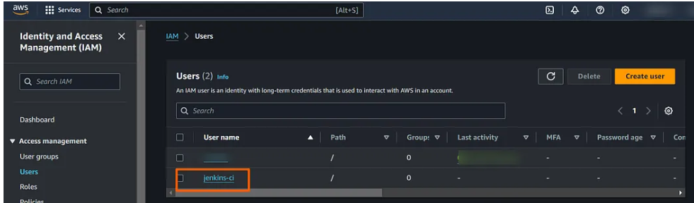

For creating **Acess key id** and **password** go to **security credentials** click on **create acesss key**

Select on **CLI** tick in checkbox then **next**.

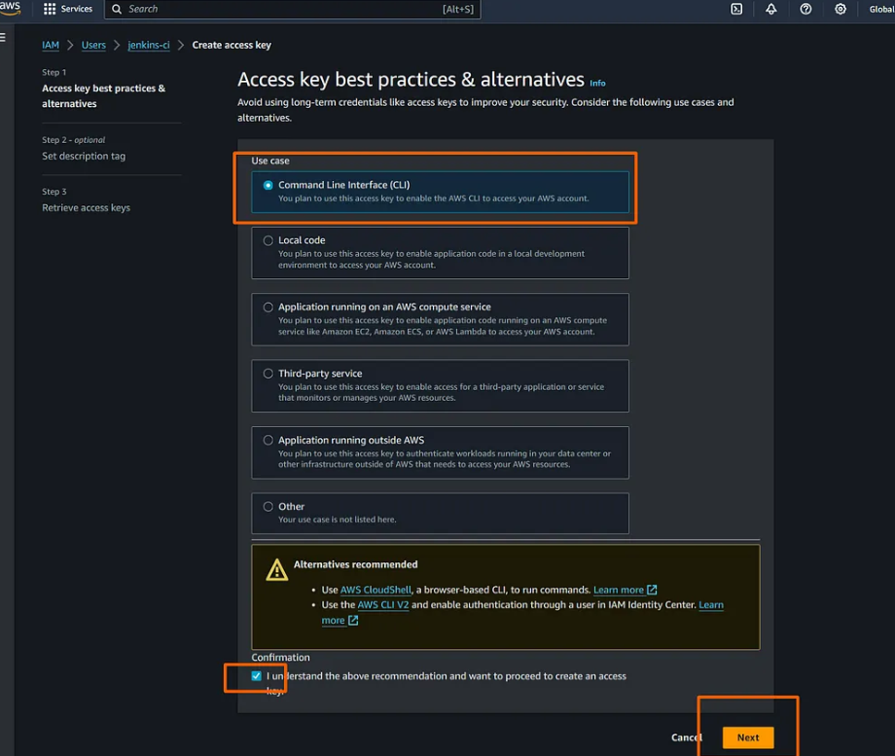



take a note in note pad of Acess key id and password for later use .

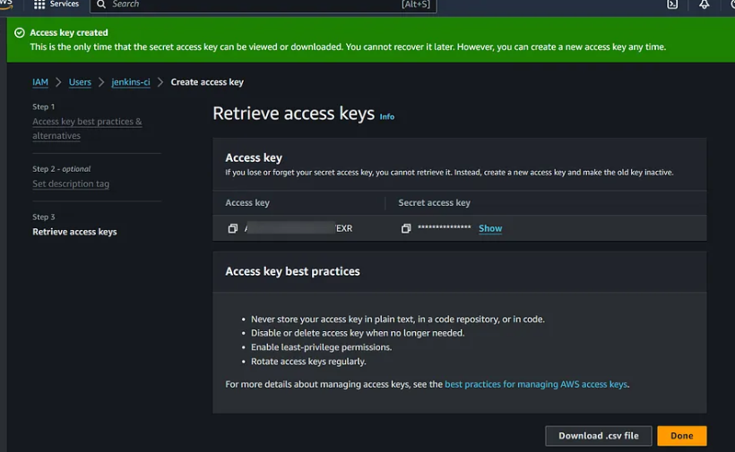

**[Setting Up AWS Credentials in Jenkins](https://medium.com/@kuldeepkumawat195/using-jenkins-pipeline-to-log-in-to-aws-list-ec2-instances-and-create-a-new-ec2-instance-3d988a8e6f6d" \l "setting-up-aws-credentials-in-jenkins):**

****AWS Credentials****: We need AWS credentials with the necessary permissions to interact with EC2 services.

Go to dash board click on manage jenkins then on credentials click on key symbol as shown in below add AWS credentials acesskey id & password click on create.

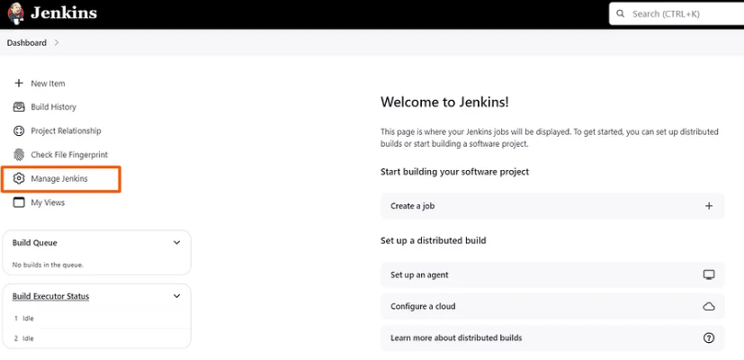

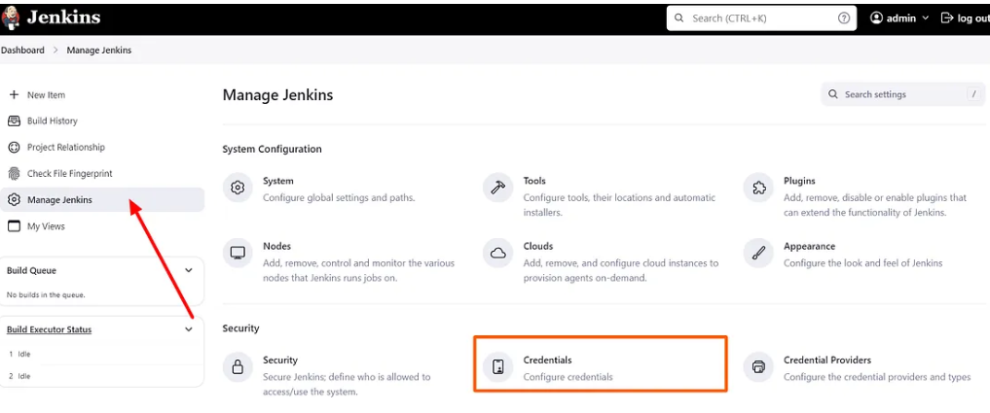

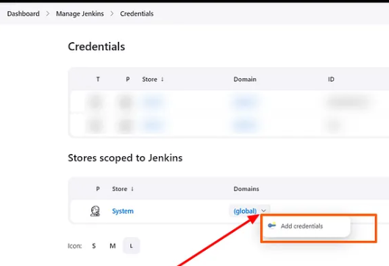

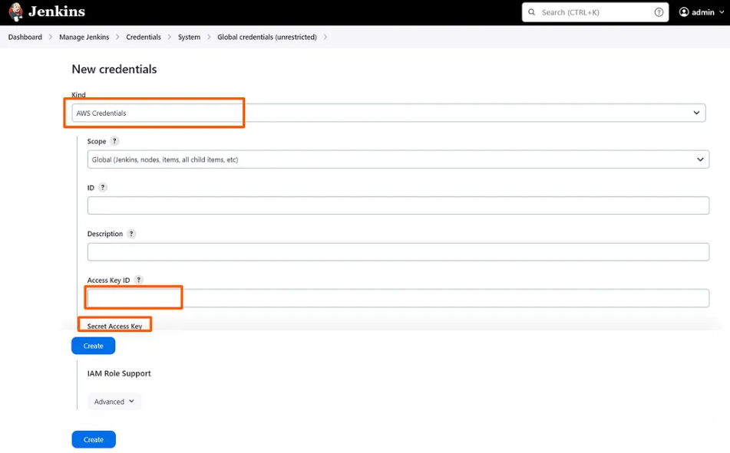

Go back to linux in git bash give command.



****AWS CLI****: The AWS Command Line Interface (CLI) should be installed on the Jenkins agent.

**Plugins to add:**

Go to dashboard click on **manage jenkins** …..>**Available plugins** search in search bar for **AWS credentials,pipeline for API,stage veiw then click on install wait to complete all then do newjob.**

****Jenkins Credentials Plugin****: Plugin helps securely to store AWS credentials within Jenkins.

**[Logging in to AWS Using Jenkins Pipeline](https://medium.com/@kuldeepkumawat195/using-jenkins-pipeline-to-log-in-to-aws-list-ec2-instances-and-create-a-new-ec2-instance-3d988a8e6f6d" \l "logging-in-to-aws-using-jenkins-pipeline):**

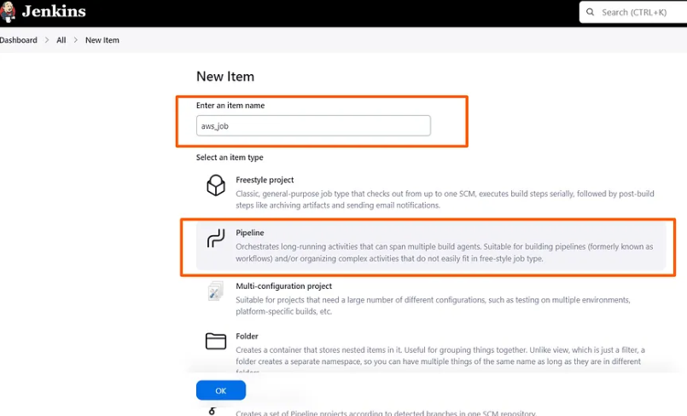

Click on new job give name select pipeline click ok in configure go to pipeline scroll down has to be in pipeline script.

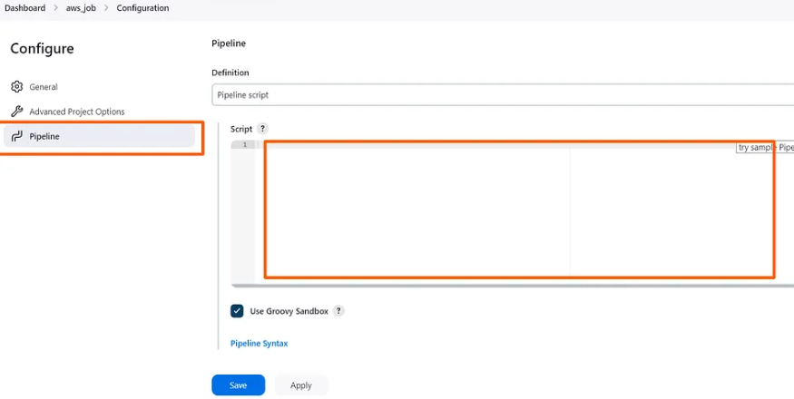

For login to AWS give sample code give data in code like AWS acesskey id,AWS-secret-acess key

Then give region click on **apply and save.**

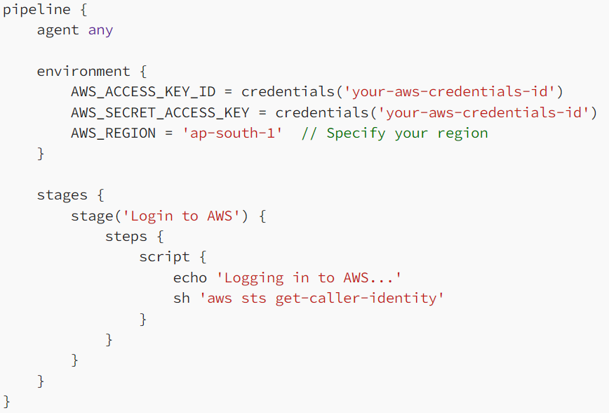

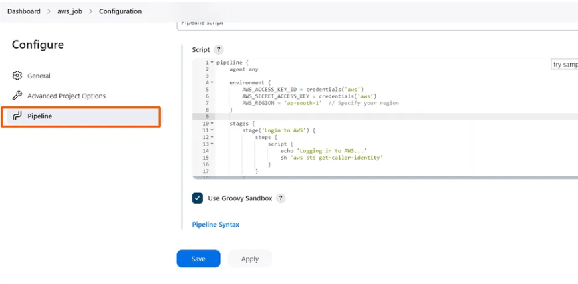

Click on **Buils Now** after redirection then build history popup will come .

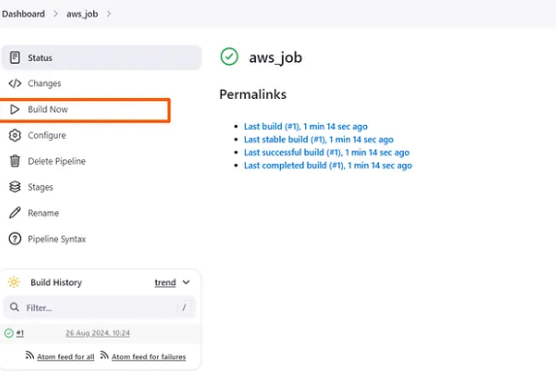

Click on it then click on console output to see code success if it shows message like waiting for executer then come to dashboard click on build node then click on back to online .

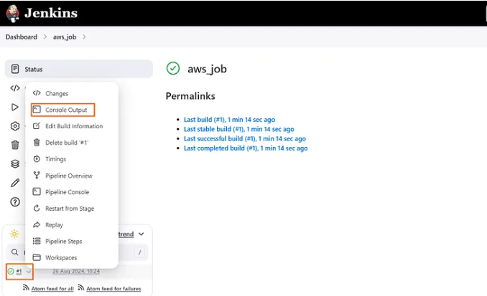

Code success

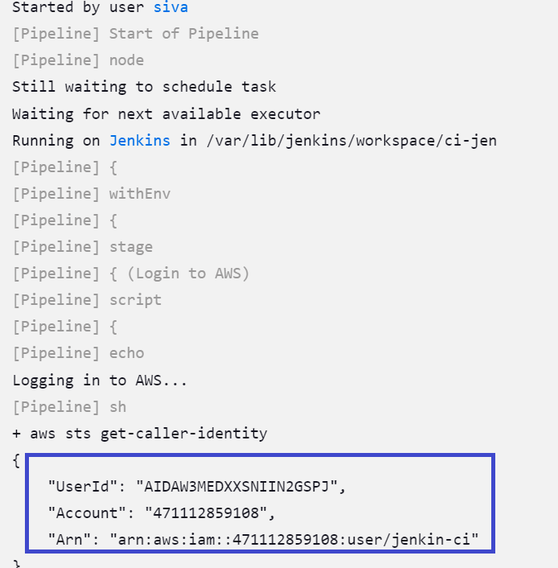

**[Listing EC2 Instances](https://medium.com/@kuldeepkumawat195/using-jenkins-pipeline-to-log-in-to-aws-list-ec2-instances-and-create-a-new-ec2-instance-3d988a8e6f6d" \l "listing-ec2-instances):**

After logging in, you can list all EC2 instances in your AWS account This script retrieves and lists all EC2 instance IDs in the specified AWS region. The output will show the instance IDs of all running instances.

same process of code execution

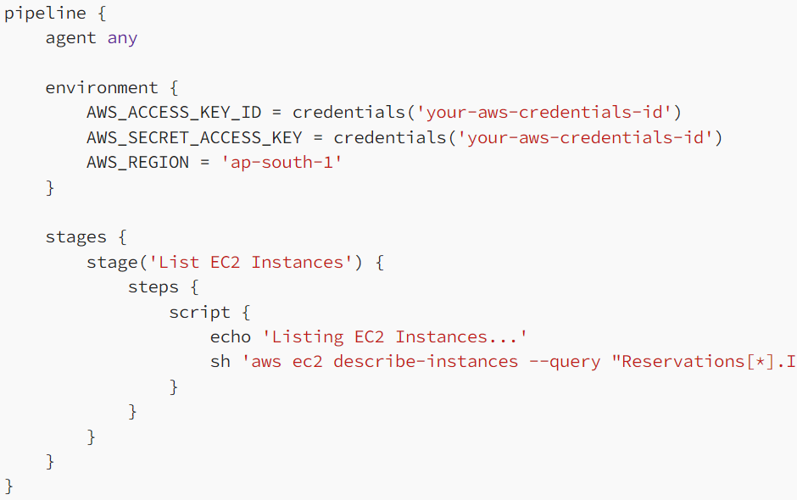

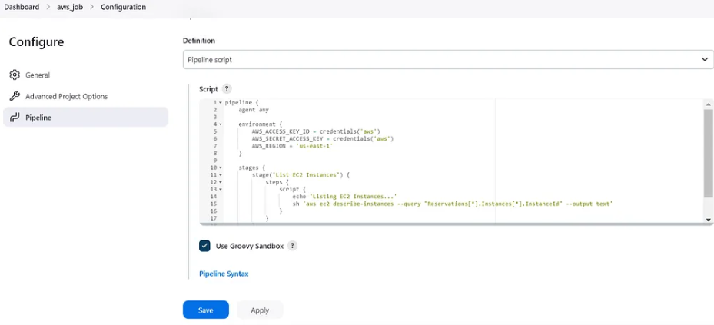





Click on it then click on console output to see code success if it shows message like waiting for executer then come to dashboard click on build node then click on back to online .

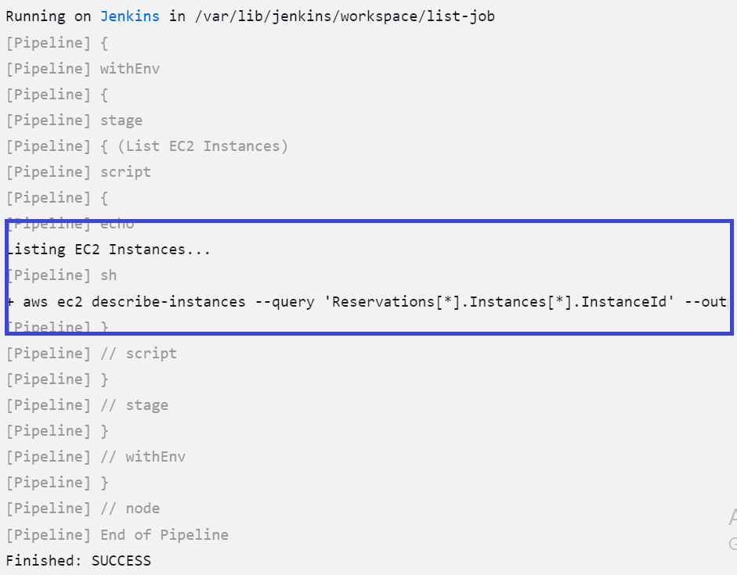**[Creating a New EC2 Instance](https://medium.com/@kuldeepkumawat195/using-jenkins-pipeline-to-log-in-to-aws-list-ec2-instances-and-create-a-new-ec2-instance-3d988a8e6f6d" \l "creating-a-new-ec2-instance):**

This creation of instance is bit more than above 2 login and list in this we give **region,pem file name,AMID number,**tierand acess key id,password remaing all same.

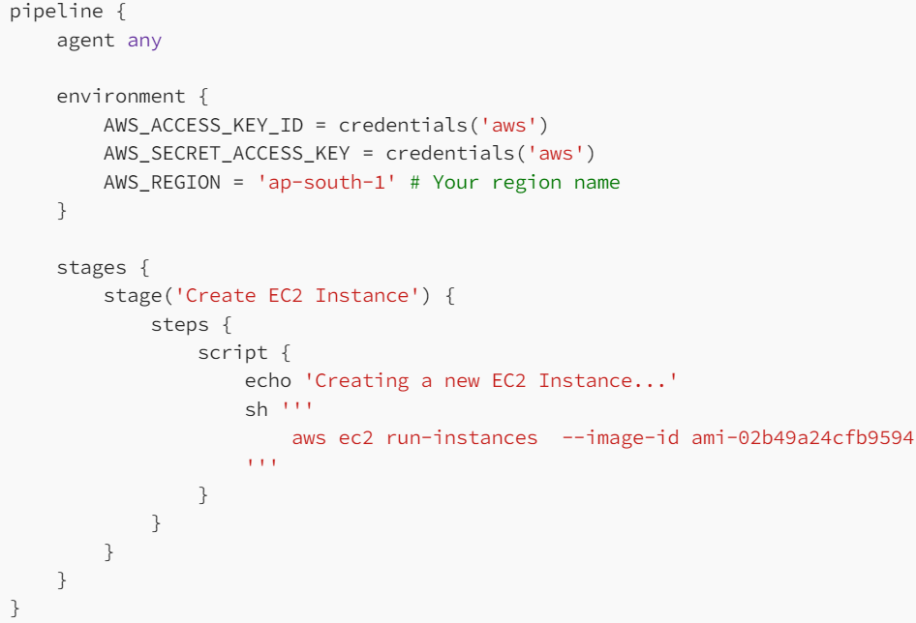

For getting AMID while creating instance we can take note of all above mentioned **region,pem file name,AMID number,**tier etc….





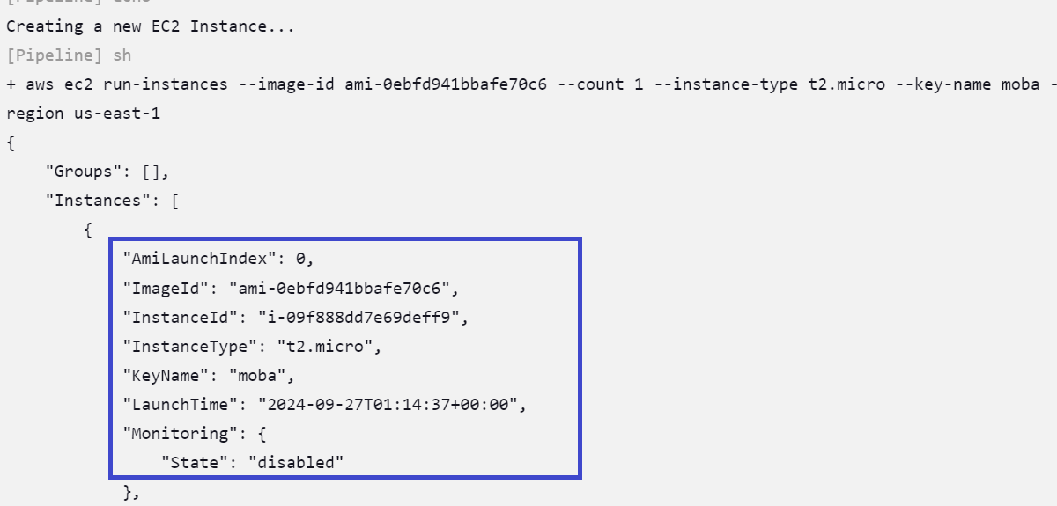

After code got success check in AWS account to see instances created how many times you build those many instance will created with same mode of features what we given its automated once we give and run its same for all times we run .

So no error,more efficient , time save,less man power

