URBAN ASSET INTELLIGENCE
Complete Implementation Document
Makeathon 2026 | AI-Powered City Infrastructure Detection
Version 1.0 | March 2026 | Scope: Indian Cities

Executive Summary
Urban Asset Intelligence is an AI-powered web platform that enables municipal officers to detect, classify, and track urban infrastructure assets from satellite and aerial imagery. Using computer vision models (YOLOv8 + SAM), the system automatically identifies buildings, roads, water bodies, vegetation, parks, and drainage systems — producing precise boundary masks, area calculations, GPS-referenced maps, and exportable reports.

Key Capabilities:
- Upload satellite/drone images or fetch tiles by city name / coordinates
- AI-powered detection of 6+ urban asset categories with mask overlays
- Interactive map view with GeoJSON polygon layers (Leaflet.js)
- Change detection: compare two time periods to spot new construction or encroachment
- Detection history with full session storage in PostgreSQL
- Export to GeoJSON (QGIS/DIGIT compatible), CSV (Excel), and PDF reports
- Designed for non-technical municipal officers — no AI jargon

Technology Stack:
- Frontend: React + Tailwind CSS + Leaflet.js
- Backend API: Express.js (Node.js)
- AI Service: FastAPI (Python) + YOLOv8 + SAM (Segment Anything Model)
- Database: PostgreSQL with Drizzle ORM
- File Storage: Object Storage (S3-compatible)
- All models are free/open-source. No paid API keys required.

Part 1: Problem Statement & Context

1.1 The Challenge
Indian municipalities manage vast urban infrastructure across rapidly growing cities. Current asset tracking methods rely on manual surveys, outdated records, and inconsistent reporting. Municipal officers lack tools to:
- Quickly quantify buildings, roads, water bodies, and green cover in any area
- Detect unauthorized construction or encroachment on water bodies
- Track infrastructure changes over time
- Generate standardized reports for government registries (like DIGIT)

1.2 Our Solution
An AI-powered web application that processes satellite imagery to automatically:
- 1. Detect urban assets using YOLOv8 object detection
- 2. Segment precise boundaries using SAM (Segment Anything Model)
- 3. Classify into 6 must-have categories: Buildings, Roads, Water Bodies, Vegetation, Parks, Drains
- 4. Measure area in square meters for each detected asset
- 5. Map results on interactive GIS layers with GPS coordinates
- 6. Compare imagery from different dates to detect changes
- 7. Export results in formats compatible with QGIS, DIGIT, Excel, and PDF

1.3 Target Users
- Municipal Officers — Primary users; non-technical, need simple interface
- Urban Planners — Review reports for city planning decisions
- Revenue Officers — Identify unauthorized construction, encroachments
- Environmental Teams — Track green cover changes, water body health

Part 2: AI Approach — Technical Architecture

2.1 Recommended Approach: YOLOv8 + SAM Hybrid
We evaluated three approaches and recommend Approach A for production:
Criteria | A: YOLOv8+SAM | B: U-Net | C: GPT-4V+YOLO
Detection | YOLOv8 bounding boxes | Pixel-level segmentation | GPT-4V scene understanding
Segmentation | SAM precise masks | Built-in (encoder-decoder) | YOLOv8 post-detection
Speed | Fast (~5-15s) | Medium (~10-30s) | Slow (~30-60s)
Cost | Free (open-source) | Free | Paid API ($0.01-0.03/image)
Accuracy | High (mAP ~0.75) | High on trained classes | Variable
Verdict | RECOMMENDED ★ | Good alternative | Not for production

2.2 Why YOLOv8 + SAM?
YOLOv8 (You Only Look Once v8 by Ultralytics):
- State-of-the-art real-time object detection, pre-trained on COCO dataset
- Can be fine-tuned on satellite imagery datasets
- Outputs bounding boxes with class labels and confidence scores
- MIT License — completely free and open-source

SAM (Segment Anything Model by Meta AI):
- Foundation model for image segmentation
- Given a bounding box prompt, produces pixel-perfect masks
- Works zero-shot — no fine-tuning needed
- Apache 2.0 License — completely free and open-source

2.3 Detection Pipeline
Step 1: Tile — Split input image into 640×640 tiles with 10% overlap
Step 2: YOLOv8 — Run detection on each tile (~200ms per tile). Filter confidence >= 0.40
Step 3: De-duplicate — Remove overlapping detections from tile boundaries using NMS (IoU > 0.50)
Step 4: SAM — For each bounding box, get pixel-perfect mask polygon (~50ms per detection)
Step 5: Post-process — Calculate area in m², map to GPS coordinates, generate overlay image

2.4 Asset Classes & Colour Coding
# | Asset Class | Mask Colour | Hex Code | Threshold
1 | Buildings | Red | #E53935 | 0.40
2 | Roads | Teal | #00897B | 0.40
3 | Water Bodies | Blue | #1E88E5 | 0.40
4 | Vegetation | Green | #43A047 | 0.40
5 | Parks | Light Green | #66BB6A | 0.40
6 | Drains | Purple | #8E24AA | 0.40
7 | Vehicles (bonus) | Orange | #FB8C00 | 0.50
8 | Waste Dumps (bonus) | Brown | #795548 | 0.50
9 | Solar Panels (bonus) | Yellow | #FDD835 | 0.50

2.5 Free Data Sources
Source | Resolution | Coverage | Cost
Copernicus Sentinel-2 | 10m/pixel | Global | Free
Bhuvan (ISRO) | 5.8m-23m | India | Free
Google Maps Static | ~0.5m (zoom 18) | Global | Free tier
OpenStreetMap | Vector + raster | Global | Free
USGS Landsat | 30m/pixel | Global | Free

2.6 Model Training & Fine-Tuning
For the Makeathon prototype, we use YOLOv8-nano (yolov8n) with pre-trained weights. Recommended free training datasets:
- xView Dataset — 60 classes of overhead imagery, 1M+ objects (DIUx, free)
- SpaceNet — Building footprint segmentation from satellite imagery (AWS, free)
- DOTA — Detection in Aerial Images, 15 categories (free)
- INRIA Aerial Image Labeling — Building segmentation from aerial photos (free)

Part 3: Data Architecture — Storage Design

3.1 Database Schema (PostgreSQL)
Table: detection_sessions
Column | Type | Description
id | UUID (PK) | Unique session identifier
session_name | VARCHAR(255) | Auto-generated name
original_image_url | TEXT | Path in object storage
result_overlay_url | TEXT | Overlay image path
thumbnail_url | TEXT | 200×200 preview path
source_type | ENUM | 'upload', 'location_fetch', 'change_detection'
location_name | VARCHAR(255) | City/area name (nullable)
latitude / longitude | DECIMAL | GPS coordinates (nullable)
image_width / height | INTEGER | Original dimensions in pixels
resolution_mpp | DECIMAL | Meters per pixel (nullable)
status | ENUM | 'processing', 'completed', 'failed'
total_assets_detected | INTEGER | Total count across categories
processing_time_ms | INTEGER | Inference duration
summary_json | JSONB | Quick counts per category
created_at / updated_at | TIMESTAMP | Timestamps

Table: detected_assets
Column | Type | Description
id | UUID (PK) | Detection identifier
session_id | UUID (FK) | Links to detection_sessions
category | ENUM | Asset class
confidence | DECIMAL(4,3) | 0.000 to 1.000
area_sqm | DECIMAL | Area in square meters
bbox_x1/y1/x2/y2 | INTEGER | Bounding box corners
mask_polygon | JSONB | Polygon points [[x,y], ...]
geo_polygon | JSONB | GPS polygon (nullable)
geo_center_lat/lng | DECIMAL | Center coordinates (nullable)

Table: change_detection_sessions
Column | Type | Description
id | UUID (PK) | Change session identifier
session_before_id | UUID (FK) | First analysis session
session_after_id | UUID (FK) | Second analysis session
diff_overlay_url | TEXT | Change heat-map image path
changes_json | JSONB | Structured change summary

3.2 File Storage Layout
What | Format | Path Pattern
Uploaded images | JPG/PNG/GeoTIFF | /uploads/{session_id}/original.jpg
Thumbnails | JPG (200×200) | /uploads/{session_id}/thumbnail.jpg
Overlay images | PNG (transparent) | /results/{session_id}/overlay.png
Asset crops | PNG | /results/{session_id}/crops/det_{id}.png
GeoJSON/CSV/PDF | Generated on demand | Not stored permanently

3.3 Data Flow
1. API receives uploaded file → saves to Object Storage → creates detection_session (status: 'processing')
2. Image sent to Python AI service → tiled into 640×640 chunks
3. YOLOv8 runs on each tile → SAM refines each detection → returns JSON
4. API saves each detection to detected_assets table
5. Overlay image generated (masks on original) → saved to Object Storage
6. Thumbnail generated (200×200) → saved to Object Storage
7. Session summary_json updated → status set to 'completed'
8. Frontend polls for completion → shows results

Part 4: API Endpoints
Method | Endpoint | Description
POST | /api/detect | Upload image, trigger AI pipeline, return session ID
GET | /api/sessions | List all sessions (paginated)
GET | /api/sessions/:id | Full session details with detections
GET | /api/export/geojson/:id | Download GeoJSON file
GET | /api/export/csv/:id | Download CSV file
GET | /api/export/pdf/:id | Download PDF report
POST | /api/change-detect | Upload two images, compare results
DELETE | /api/sessions/:id | Delete session and files

4.1 Request/Response Example
POST /api/detect — Request (multipart/form-data):
{ "image": <file>, "location_name": "Chennai T Nagar", "latitude": 13.0827, "longitude": 80.2707 }
Response:
{ "session_id": "abc-123", "status": "processing", "message": "Analysis started." }

Part 5: UX Design — All 8 Screens
The following screens are designed for non-technical municipal officers. The interface uses clear language, colour-coded categories, and simple navigation. No AI jargon is exposed to the user. All screens shown below are pixel-accurate mockups rendered from React components.

Screen 1: Dashboard (Home Page)
The landing page showing overview statistics and recent analysis sessions. Four stat cards provide cumulative data. Recent analyses show thumbnail, location, date, and asset count breakdown.
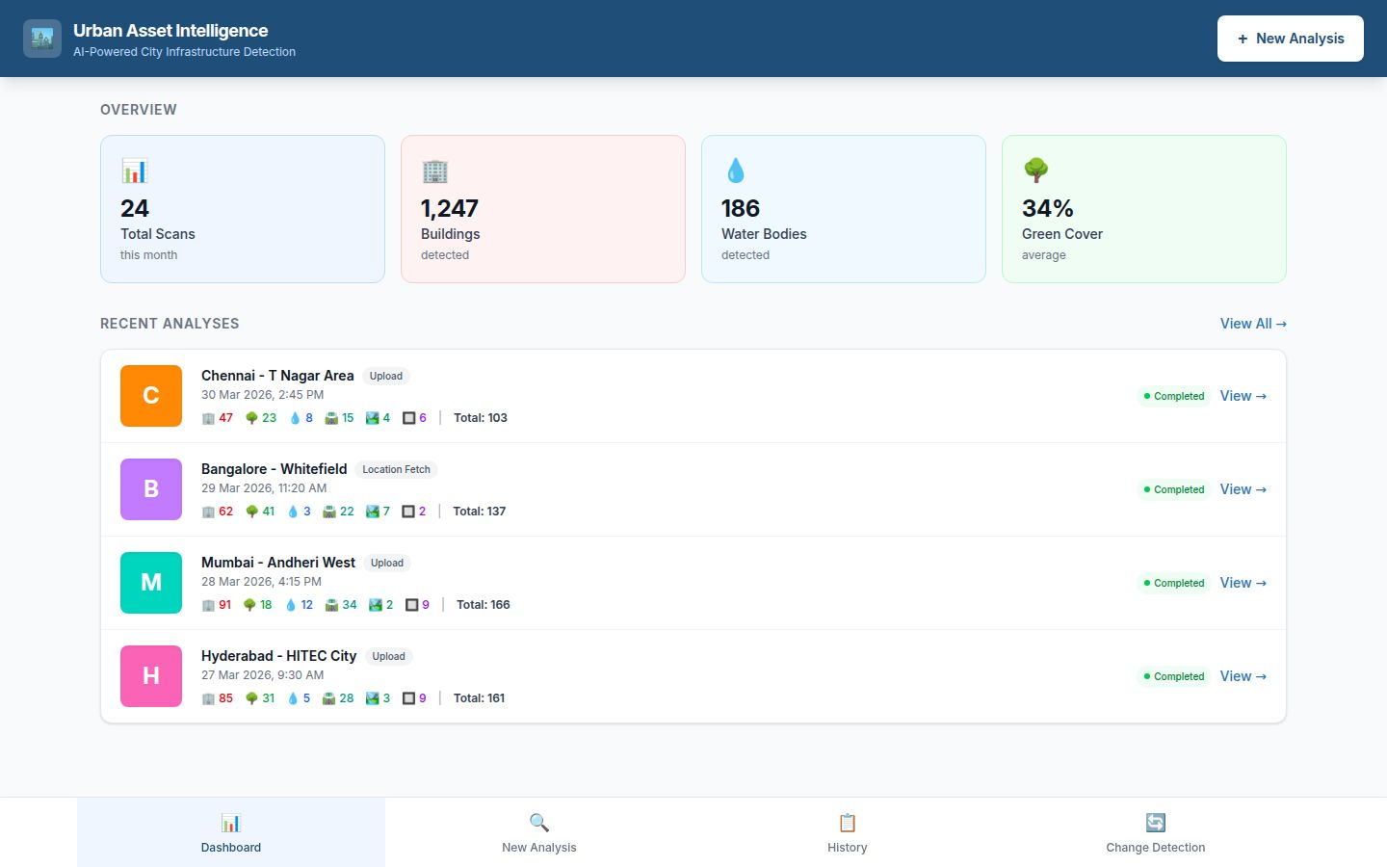

Screen 2: Upload / New Analysis
Two input methods: drag-and-drop file upload (JPG, PNG, GeoTIFF up to 50 MB), or fetch satellite tiles by entering a city name or GPS coordinates. Supports Google Maps, Bhuvan ISRO, and Copernicus Sentinel sources.
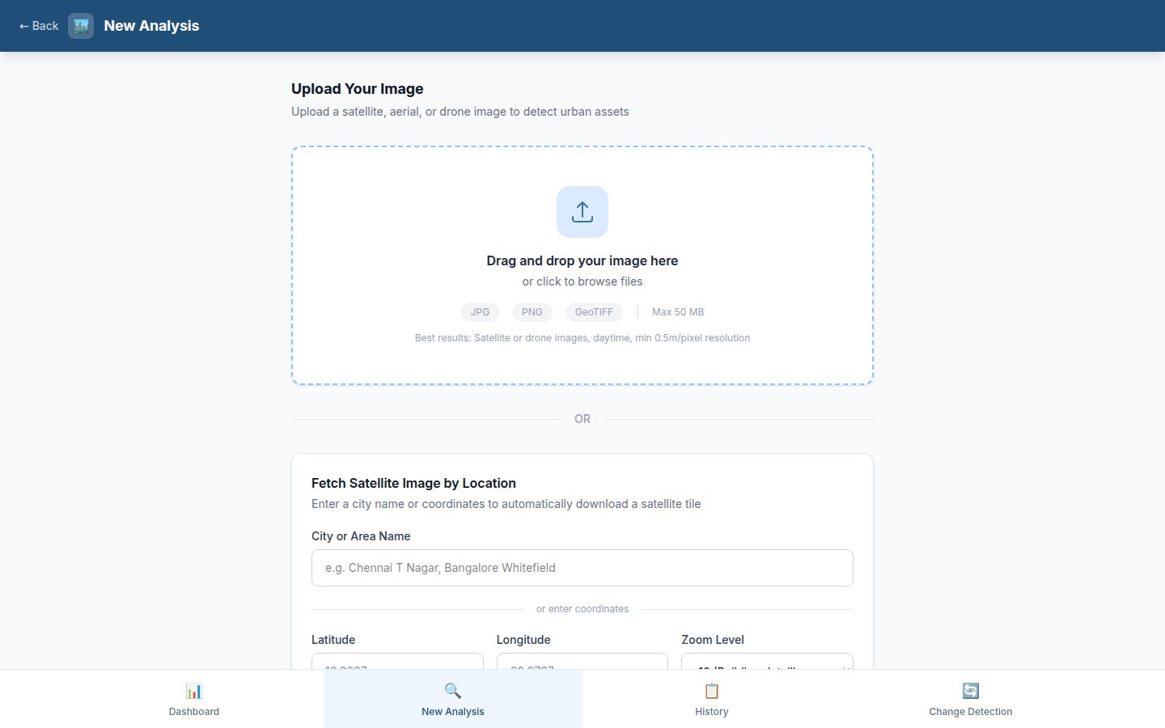

Screen 3: Processing / Analysis in Progress
Real-time 4-step progress display: Image Prepared → Detecting Assets → Refining Boundaries → Generating Results. Shows tile-level progress (e.g., 9/16 tiles complete). Cancel button available.
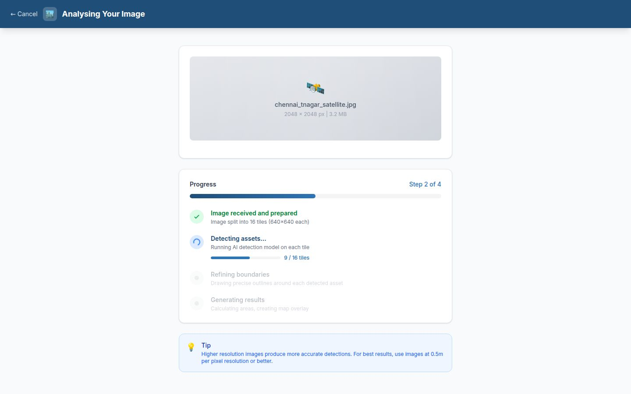

Screen 4: Detection Results — Image Overlay View
Main results screen with 60/40 split layout. Left: satellite image with semi-transparent coloured masks for each asset class, opacity slider, and colour legend. Right: summary panel with count, area (m²), and confidence bar per category. Click any mask to see details.
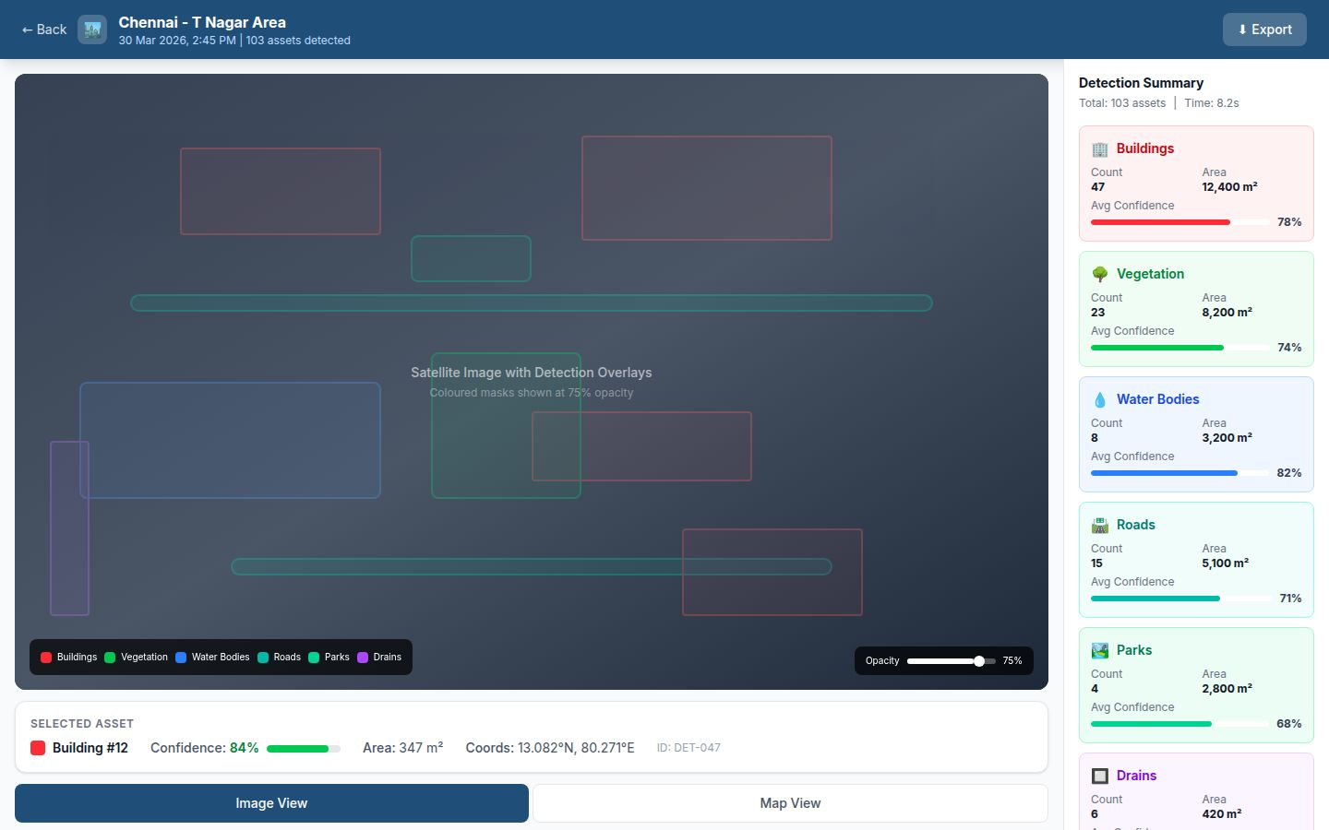

Screen 5: Map View (GIS)
Interactive Leaflet.js map with GeoJSON polygon overlays. Layer control panel toggles each asset category. Base map selector: Satellite, Street Map, OpenStreetMap. Click any polygon for popup with confidence, area, ID, and coordinates.
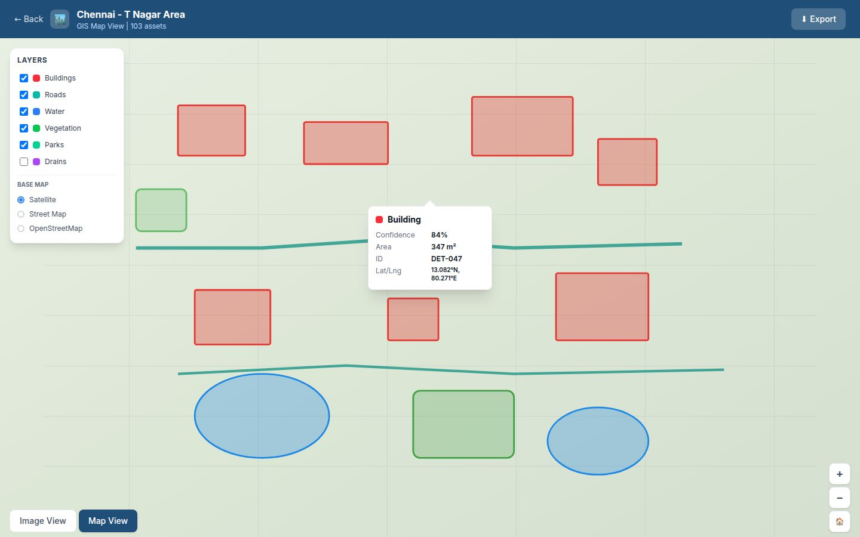

Screen 6: Change Detection
Upload two images of the same area from different dates. Before/After slider comparison for visual analysis. Results categorized: New Construction (red), Removed/Demolished (yellow), Area Changed with encroachment warnings (orange), Unchanged (green).
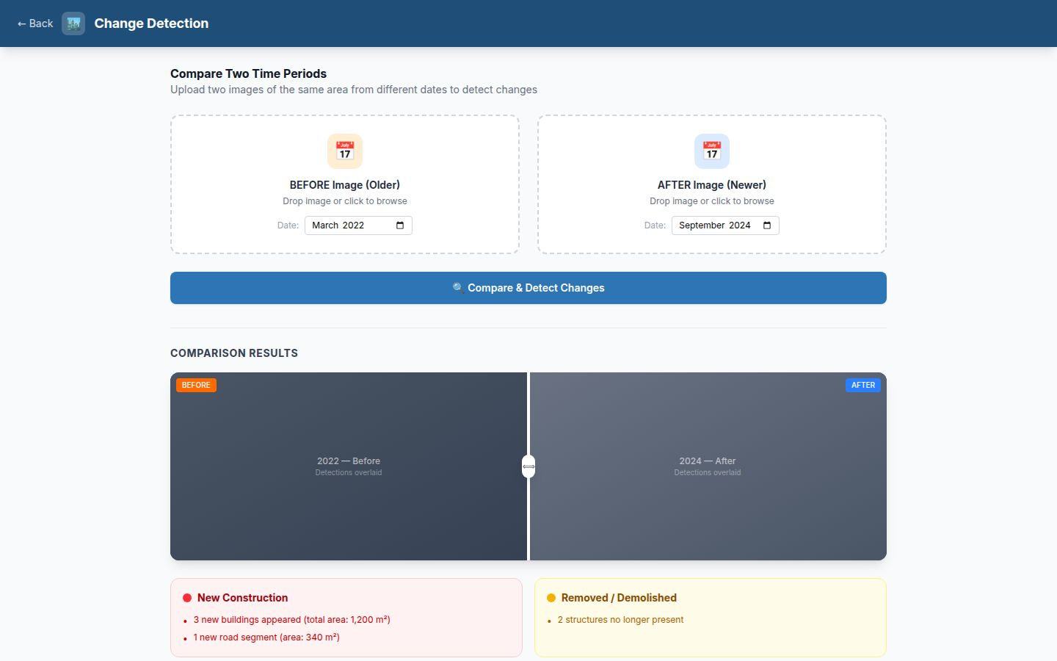

Screen 7: Analysis History
Complete searchable list of all past detection sessions. Filter by type, sort by date/assets/location. Each row shows thumbnail, location, date, asset counts, source type, and action buttons (View, Export, Delete). Pagination with 10 items per page.
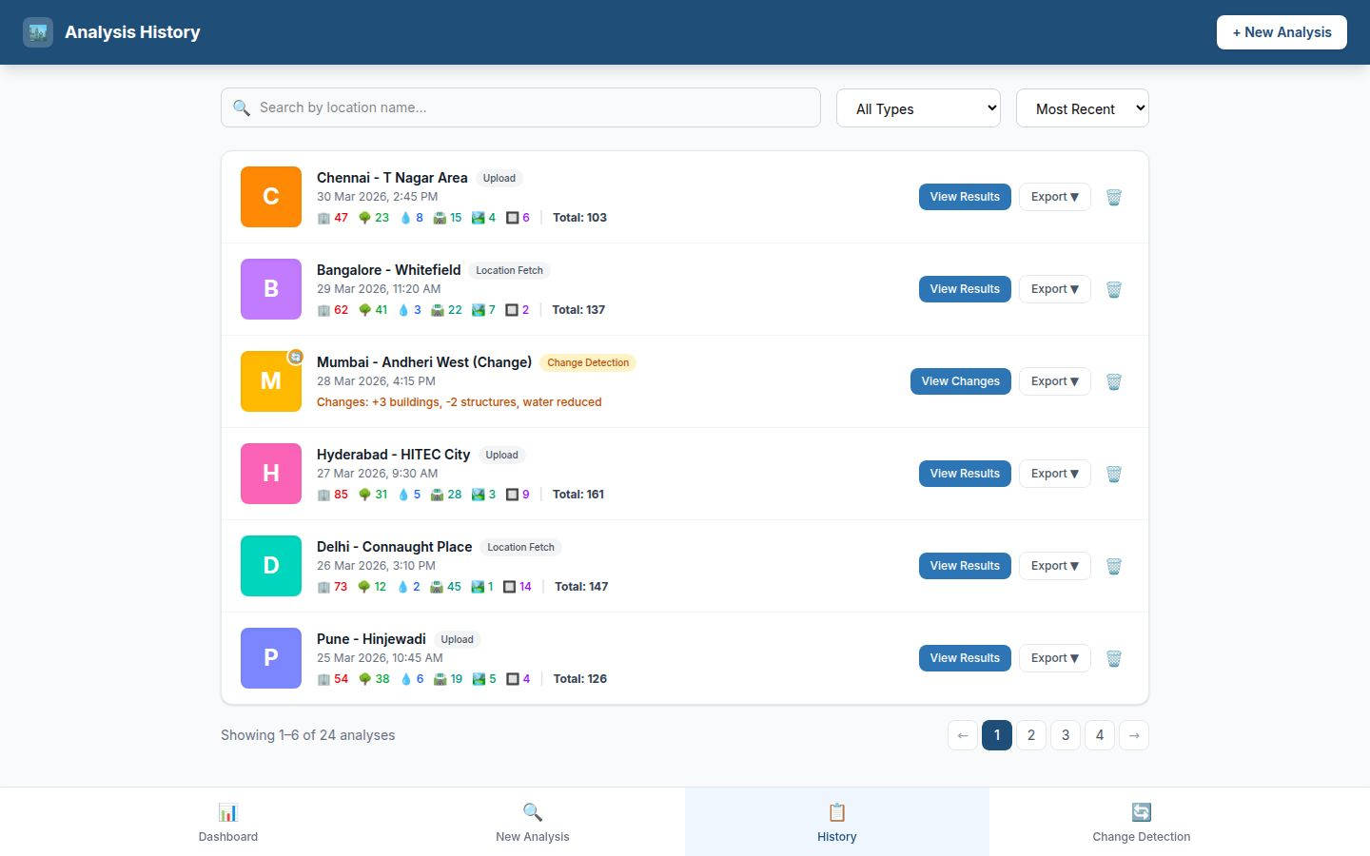

Screen 8: Export Panel
Four export options: GeoJSON (QGIS/DIGIT/ArcGIS compatible, filterable by asset class), CSV (Excel/Google Sheets), PDF Report (professional format for supervisors), and optional DIGIT push with API endpoint configuration.
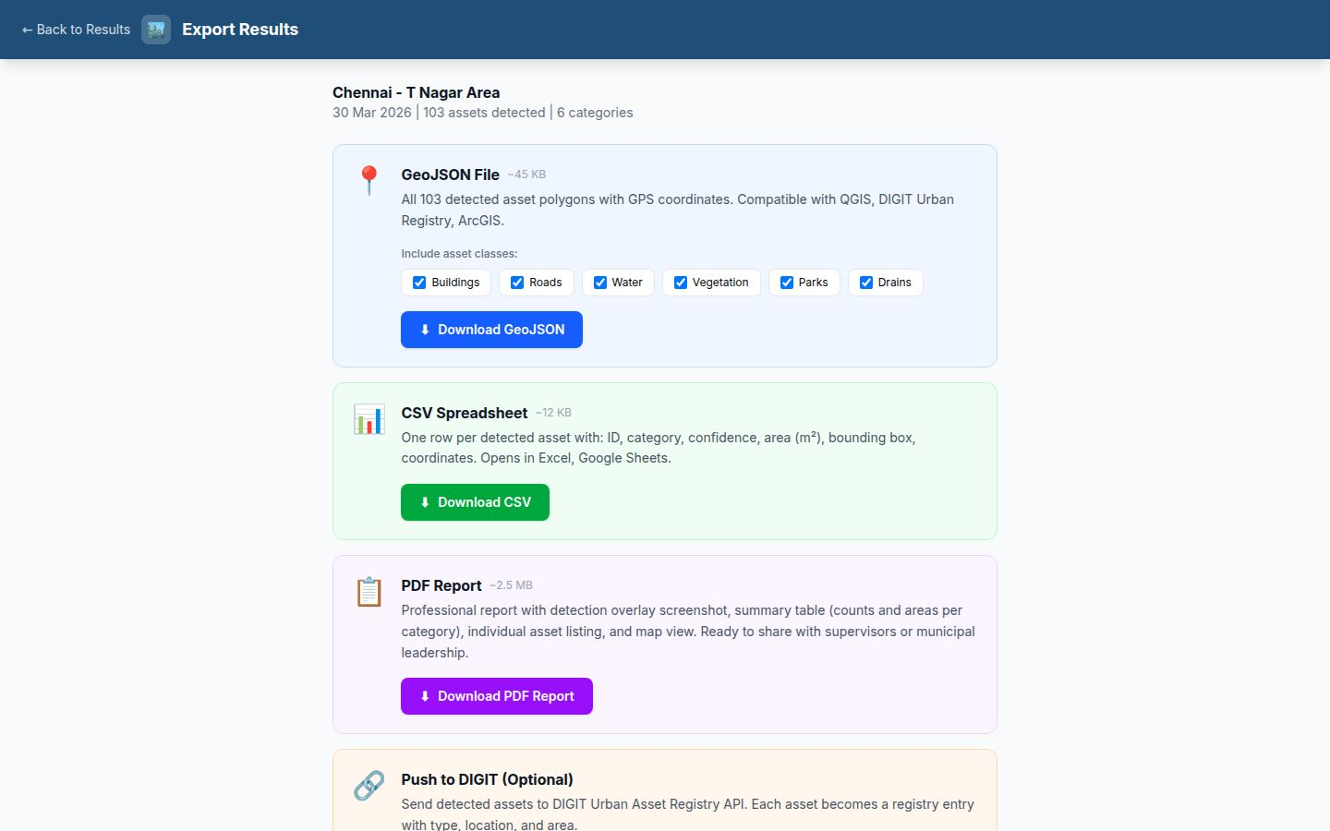

Part 6: UI Design System

6.1 Colour Palette
Element | Hex Code | Usage
Primary | #1F4E79 | Header, active nav, primary buttons
Secondary | #2E75B6 | Links, secondary buttons
Background | #FAFBFC | Page background
Card BG | #FFFFFF | Content cards
Text Primary | #1A1A2E | Headings, body
Text Secondary | #666666 | Timestamps, secondary info
Success | #43A047 | Completed badges
Warning | #FB8C00 | Attention items
Error | #E53935 | Errors, delete

6.2 Typography & Components
- Font: Inter (or system font stack)
- Headings: Bold, 18-24px
- Body: Regular, 14px
- Border Radius: 8px (cards), 12px (large cards)
- Shadows: Subtle (0 1px 3px rgba(0,0,0,0.1))
- Bottom Navigation: Fixed, 4 items with icons + labels

Part 7: Navigation Flow
Dashboard → New Analysis → Processing → Results (Image View / Map View) → Export
Dashboard → History → (any past session) → Results
Dashboard → Change Detection → Comparison Results

Navigation Rules:
- Bottom nav bar always visible: Dashboard, New Analysis, History, Change Detection
- Back button in top-left on all sub-pages
- Export accessible from any results view
- History items link directly to saved results

Part 8: System Architecture

8.1 Components
Component | Technology | Purpose
Frontend | React + Tailwind + Leaflet.js | 8-screen web application
Backend API | Express.js (Node.js) | REST API, file handling, exports
AI Service | FastAPI (Python) | YOLOv8 + SAM inference
Database | PostgreSQL + Drizzle ORM | Sessions, detections, history
File Storage | Object Storage (S3) | Images, overlays, thumbnails

8.2 Technology Versions
Technology | Version | License
React | 18.x | MIT
Vite | 5.x | MIT
Tailwind CSS | 3.x | MIT
Leaflet.js | 1.9.x | BSD-2
Express.js | 4.x | MIT
Drizzle ORM | 0.30.x | Apache 2.0
PostgreSQL | 16 | PostgreSQL License
Python | 3.11+ | PSF
FastAPI | 0.110.x | MIT
YOLOv8 (Ultralytics) | 8.1.x | AGPL-3.0
SAM | 1.0 | Apache 2.0
OpenCV | 4.9.x | Apache 2.0

Part 9: Change Detection — How It Works
1. User uploads two images of the same area from different dates
2. Both images processed through full detection pipeline independently
3. Results compared by spatial overlap using Intersection over Union (IoU):
- Assets in Image B not in Image A → New Construction
- Assets in Image A not in Image B → Demolished / Removed
- Assets in both but different areas (>20% change) → Area Changed
- Assets in both with similar areas → Unchanged

Encroachment Detection: When water body area decreases significantly, the system flags it with actionable language: 'Water body #3: area reduced by 340 m² — possible encroachment. Municipal inspection recommended.'

Part 10: Export Formats

10.1 GeoJSON
Standard GeoJSON FeatureCollection. One Feature per detected asset with polygon geometry and properties (id, category, confidence, area_sqm). Compatible with: QGIS, ArcGIS, DIGIT Urban Registry, Google Earth, Mapbox.

10.2 CSV
Flat table with one row per detection: id, session_id, category, confidence, area_sqm, bbox coordinates, GPS center. Compatible with: Excel, Google Sheets, LibreOffice.

10.3 PDF Report
Professional report containing: cover page, detection overlay image, summary table, detailed asset listing, map view screenshot, methodology note. Designed for sharing with supervisors and municipal leadership.

Part 11: DIGIT Integration (Optional)
DIGIT (Digital Infrastructure for Governance, Impact & Transformation) is India's open-source platform for e-governance. Our system can push detections to DIGIT's Urban Asset Registry as standardized entries with asset type, location, area, and source metadata. Requires DIGIT tenant access (varies by city). Implemented as UI-ready with mock API calls for Makeathon.

Part 12: Performance & Scalability
Image Size | Tiles | Total Time | Typical Assets
640×640 | 1 | ~3s | 5-15
1280×1280 | 4 | ~6s | 20-40
2048×2048 | 16 | ~12s | 50-150
4096×4096 | 64 | ~40s | 200-500

Scalability:
- Horizontal scaling: Multiple Python AI service instances behind load balancer
- Queue-based processing: Long-running detections via BullMQ job queue
- GPU acceleration: YOLOv8 and SAM support CUDA — ~10x speedup
- Database indexing: Indexes on session_id, category, created_at

Part 13: Security & Privacy
- All uploaded images stored in private object storage
- Session data isolated per analysis
- API endpoints rate-limited
- No data sent to external services — all AI runs locally
- User authentication can be added with OAuth/SSO

Part 14: Future Enhancements
- 1. User Authentication — Government SSO (eSign/DigiLocker)
- 2. Multi-tenant — Support multiple cities with isolated data
- 3. Real-time Monitoring — Automated satellite monitoring with alerts
- 4. Mobile App — React Native for field officers
- 5. 3D Building Models — Height estimation from shadow analysis
- 6. Tax Assessment — Property tax integration using detected building areas
- 7. Flood Risk Mapping — Water body and drain detection for flood prediction
- 8. Carbon Footprint — Green cover contribution to carbon sequestration
- 9. Road Condition — Pothole and damage detection from high-res imagery
- 10. Automated Reports — Scheduled weekly/monthly analysis with email delivery

Appendix A: Glossary
Term | Definition
YOLOv8 | You Only Look Once v8 — real-time object detection model
SAM | Segment Anything Model — precise segmentation by Meta AI
GeoJSON | Standard format for encoding geographic data
IoU | Intersection over Union — overlap measure
NMS | Non-Maximum Suppression — removes duplicate detections
mAP | Mean Average Precision — accuracy metric
DIGIT | Digital Infrastructure for Governance — India's e-governance platform
Bhuvan | ISRO's geoportal for Indian satellite imagery
Copernicus | EU Earth observation programme with free satellite data
Sentinel-2 | Copernicus satellite with 10m resolution
Drizzle ORM | TypeScript ORM for PostgreSQL
Leaflet.js | Open-source JavaScript library for interactive maps

— Document prepared for Makeathon 2026 — Urban Asset Intelligence Team —

