FSAD SKILL EXAM

ID: 2400030128
Name: M.Naga Subrahmanyam

Question: Develop an Maven Hibernate Insert and Update operation on the fsadexam database.
Database: fsadexam
Classes: CustomerAccount, ClientDemo.

Answer:
Code:
CustomerAccount.java:
package com.klef.fsad.exam;

import jakarta.persistence.Entity;
import jakarta.persistence.GeneratedValue;
import jakarta.persistence.GenerationType;
import jakarta.persistence.Id;
import jakarta.persistence.Table;

@Entity
@Table(name="CustomerAccount")
public class CustomerAccount {
@Id
@GeneratedValue(strategy = GenerationType.IDENTITY)
private int id;
private String name;
private String description;
private String date;
private String status;
private String location;

public CustomerAccount(int id, String name, String description, String date, String status, String location) {
super();
this.id = id;
this.name = name;
this.description = description;
this.date = date;
this.status = status;
this.location = location;
}
public CustomerAccount() {
// TODO Auto-generated constructor stub
}
public int getId() {
return id;
}
public void setId(int id) {
this.id = id;
}
public String getName() {
return name;
}
public void setName(String name) {
this.name = name;
}
public String getDescription() {
return description;
}
public void setDescription(String description) {
this.description = description;
}
public String getDate() {
return date;
}
public void setDate(String date) {
this.date = date;
}
public String getStatus() {
return status;
}
public void setStatus(String status) {
this.status = status;
}
public String getLocation() {
return location;
}
public void setLocation(String location) {
this.location = location;
}
@Override
public String toString() {
return "CustomerAccount [id=" + id + ", name=" + name + ", description=" + description + ", date=" + date
+ ", status=" + status + ", location=" + location + ", getId()=" + getId() + ", getName()=" + getName()
+ ", getDescription()=" + getDescription() + ", getDate()=" + getDate() + ", getStatus()=" + getStatus()
+ ", getLocation()=" + getLocation() + ", getClass()=" + getClass() + ", hashCode()=" + hashCode()
+ ", toString()=" + super.toString() + "]";
}

}

ClientDemo.java:
package com.klef.fsad.exam;

import org.hibernate.Session;

public class ClientDemo {
public static void main(String[] args) {

org.hibernate.cfg.Configuration conf =
new org.hibernate.cfg.Configuration().configure("hibernate.cfg.xml");

org.hibernate.SessionFactory sf = conf.buildSessionFactory();

CustomerAccount c = new CustomerAccount();
Session s = sf.openSession();

org.hibernate.Transaction tx = s.beginTransaction();

c.setName("Subbu");
c.setDate("10/03/26");
c.setDescription("A Student");
c.setLocation("Vijayawada");
c.setStatus("Selected");

s.persist(c);

tx.commit();
s.close();

// Second session
Session s1 = sf.openSession();
org.hibernate.Transaction tx1 = s1.beginTransaction();

CustomerAccount c1 = s1.find(CustomerAccount.class, 1);
c1.setName("Subrahmanyam");

tx1.commit();
s1.close();

sf.close();
}
}

Hibernate.cfg.xml:
<hibernate-configuration>
<session-factory>
<!-- DB properties -->
<property name="hibernate.connection.driver_class"> com.mysql.cj.jdbc.Driver </property>
<property name="hibernate.connection.url"> jdbc:mysql://localhost:3306/fsadexam </property>
<property name="hibernate.connection.username"> root </property>
<property name="hibernate.connection.password"> #Sudheer@2007 </property>
<!-- Hibernate properties -->
<property name="hibernate.dialect"> org.hibernate.dialect.MySQL8Dialect </property>
<property name="hibernate.hbm2ddl.auto"> update </property>
<property name="hibernate.show_sql"> true </property>
<!-- mapping class information -->
<mapping class="com.klef.fsad.exam.CustomerAccount"/>
</session-factory>
</hibernate-configuration>

OUTPUT:
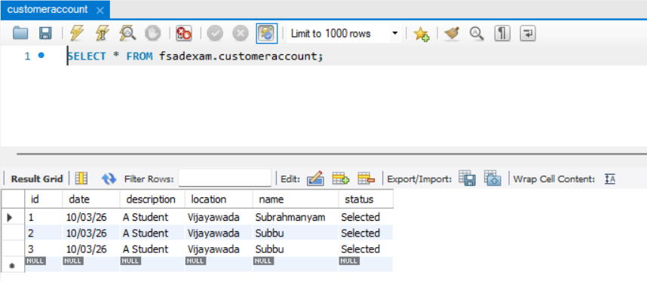

GitHub Repository Link:
https://github.com/nagasubrahmanyammeka/2400030128-FSAD-SKILL-EXAM

