Skill 11: React API Integration - Fetching Data Using Fetch API, Axios & Local JSON
Name: M. Naga Subrahmanyam
ID: 2400030128
Section: 2
Scenario:
A news portal wants to fetch and display user and article information dynamically using React. Developers must learn how useState, useEffect, fetch(), axios, and local JSON work. This Skill demonstrates how frontend applications interact with local data, public APIs, and fake APIs, and how different components are navigated using hyperlinks.

Structure:
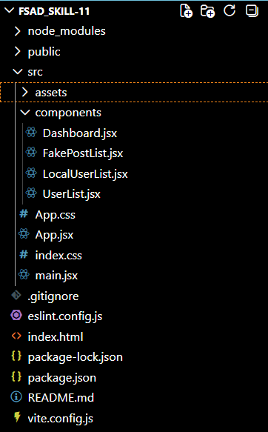

Codes:
Dashboard.jsx:
import React, { useState } from "react";
import LocalUserList from "./LocalUserList";
import UserList from "./UserList";
import FakePostList from "./FakePostList";

function Dashboard() {
const [page, setPage] = useState("");

return (
<div>
<h1>News Portal Dashboard</h1>

<button onClick={() => setPage("local")}>Local Users</button>
<button onClick={() => setPage("api")}>Users API</button>
<button onClick={() => setPage("posts")}>Fake API Posts</button>

<hr />

{page === "local" && <LocalUserList />}
{page === "api" && <UserList />}
{page === "posts" && <FakePostList />}
</div>
);
}

export default Dashboard;

FakePostList.jsx:
import React, { useEffect, useState } from "react";
import axios from "axios";

function FakePostList() {
const [posts, setPosts] = useState([]);
const [filtered, setFiltered] = useState([]);
const [userId, setUserId] = useState("");

const fetchData = () => {
axios.get("https://dummyjson.com/posts")
.then((res) => {
setPosts(res.data.posts);
setFiltered(res.data.posts);
})
.catch(() => {
alert("Error fetching posts");
});
};

useEffect(() => {
fetchData();
}, []);

const handleFilter = (id) => {
setUserId(id);
if (id === "") {
setFiltered(posts);
} else {
setFiltered(posts.filter(post => post.userId === parseInt(id)));
}
};

return (
<div>
<h2>Fake API Posts</h2>

<button onClick={fetchData}>Refresh</button>

<select value={userId} onChange={(e) => handleFilter(e.target.value)}>
<option value="">All Users</option>
<option value="1">User 1</option>
<option value="2">User 2</option>
<option value="3">User 3</option>
</select>

{filtered.map(post => (
<div key={post.id} className="card">
<h4>{post.title}</h4>
<p>{post.body}</p>
</div>
))}
</div>
);
}

export default FakePostList;

LocalUserList.jsx:
import React, { useEffect, useState } from "react";

function LocalUserList() {
const [users, setUsers] = useState([]);
const [loading, setLoading] = useState(true);
const [error, setError] = useState("");

useEffect(() => {
fetch("/users.json")
.then((res) => {
if (!res.ok) throw new Error("Failed to fetch local data");
return res.json();
})
.then((data) => {
setUsers(data);
setLoading(false);
})
.catch((err) => {
setError(err.message);
setLoading(false);
});
}, []);

if (loading) return <p>Loading local users...</p>;
if (error) return <p>{error}</p>;

return (
<div>
<h2>Local Users</h2>
{users.map((user) => (
<div key={user.id} className="card">
<p><b>{user.name}</b></p>
<p>{user.email}</p>
<p>{user.phone}</p>
</div>
))}
</div>
);
}

export default LocalUserList;

UserList.jsx:
import React, { useEffect, useState } from "react";

function UserList() {
const [users, setUsers] = useState([]);
const [loading, setLoading] = useState(true);
const [error, setError] = useState("");

useEffect(() => {
fetch("https://jsonplaceholder.typicode.com/users")
.then((res) => {
if (!res.ok) throw new Error("API Error");
return res.json();
})
.then((data) => {
setUsers(data);
setLoading(false);
})
.catch((err) => {
setError(err.message);
setLoading(false);
});
}, []);

if (loading) return <p>Loading API users...</p>;
if (error) return <p>{error}</p>;

return (
<div>
<h2>Users from API</h2>
{users.map((user) => (
<div key={user.id} className="card">
<p><b>{user.name}</b></p>
<p>{user.email}</p>
<p>{user.phone}</p>
</div>
))}
</div>
);
}

export default UserList;

App.css:
body {
font-family: Arial;
background-color: #f5f5f5;
}

.app {
text-align: center;
}

button {
margin: 10px;
padding: 10px 15px;
cursor: pointer;
}

.card {
background: white;
padding: 10px;
margin: 10px auto;
width: 300px;
border-radius: 8px;
box-shadow: 0 0 5px gray;
}

App.jsx:
<!doctype html>
<html lang="en">
<head>
<meta charset="UTF-8" />
<link rel="icon" type="image/svg+xml" href="/favicon.svg" />
<meta name="viewport" content="width=device-width, initial-scale=1.0" />
<title>fsad_skill-11</title>
</head>
<body>
<div id="root"></div>
<script type="module" src="/src/main.jsx"></script>
</body>
</html>

Index.html:
<!doctype html>
<html lang="en">
<head>
<meta charset="UTF-8" />
<link rel="icon" type="image/svg+xml" href="/favicon.svg" />
<meta name="viewport" content="width=device-width, initial-scale=1.0" />
<title>fsad_skill-11</title>
</head>
<body>
<div id="root"></div>
<script type="module" src="/src/main.jsx"></script>
</body>
</html>

OUTPUTS:
