SKILL – 12: Full-Stack CRUD Application using React & Spring Boot
Name: M. Naga Subrahmanyam
ID: 2400030128
Section: 2
Scenario:
A student management system needs full CRUD operations where the React frontend communicates with a Spring Boot backend through REST APIs. Users should be able to add, view, update, and delete student records through a simple UI, and all operations must update the data immediately without page reloads. Your task is to build both the backend (Spring Boot) and frontend (React) parts and integrate them into a working full-stack application.
Project Structure:
Frontend:
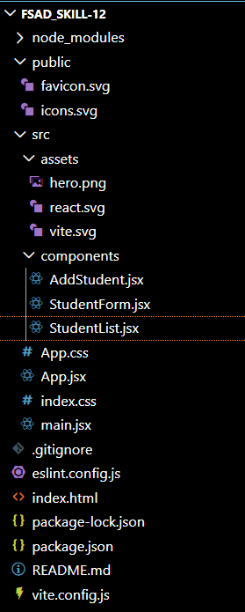
Backend:
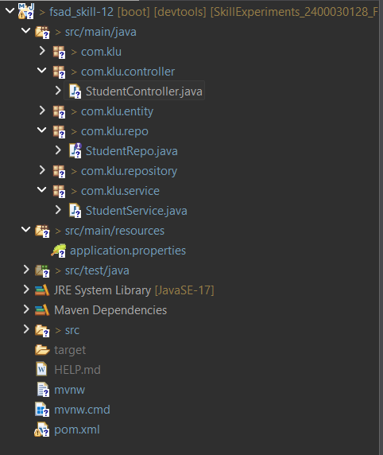
Codes:
Frontend:
App.jsx:
import React, { useState } from "react";
import AddStudent from "./components/AddStudent";
import StudentList from "./components/StudentList";
import "./App.css";

function App() {
const [selectedStudent, setSelectedStudent] = useState(null);
const [refresh, setRefresh] = useState(false);

const refreshData = () => {
setRefresh(!refresh);
setSelectedStudent(null);
};

return (
<div className="app">
<h1>Student Management System</h1>

<AddStudent
selected={selectedStudent}
refresh={refreshData}
/>

<StudentList
editStudent={setSelectedStudent}
refresh={refresh}
/>
</div>
);
}

export default App;

index.html:
<!doctype html>
<html lang="en">
<head>
<meta charset="UTF-8" />
<link rel="icon" type="image/svg+xml" href="/favicon.svg" />
<meta name="viewport" content="width=device-width, initial-scale=1.0" />
<title>fsad_skill-12</title>
</head>
<body>
<div id="root"></div>
<script type="module" src="/src/main.jsx"></script>
</body>
</html>

AddStudent.jsx:
import React, { useState, useEffect } from "react";
import axios from "axios";

function AddStudent({ selected, refresh }) {
const [student, setStudent] = useState({
name: "",
email: "",
course: ""
});

useEffect(() => {
if (selected) {
setStudent(selected);
}
}, [selected]);

const handleChange = (e) => {
setStudent({
...student,
[e.target.name]: e.target.value
});
};

const handleSubmit = () => {
if (student.id) {
axios.put(`http://localhost:2026/students/${student.id}`, student)
.then(() => refresh());
} else {
axios.post("http://localhost:2026/students", student)
.then(() => refresh());
}

setStudent({ name: "", email: "", course: "" });
};

return (
<div className="card">
<h2>{student.id ? "Update Student" : "Add Student"}</h2>

<div className="form-group">
<label>Name</label>
<input
type="text"
name="name"
value={student.name}
onChange={handleChange}
placeholder="Enter name"
/>
</div>

<div className="form-group">
<label>Email</label>
<input
type="email"
name="email"
value={student.email}
onChange={handleChange}
placeholder="Enter email"
/>
</div>

<div className="form-group">
<label>Course</label>
<input
type="text"
name="course"
value={student.course}
onChange={handleChange}
placeholder="Enter course"
/>
</div>

<button onClick={handleSubmit}>
{student.id ? "Update" : "Add"}
</button>
</div>
);
}

export default AddStudent;

StudentList.jsx:
import React, { useEffect, useState } from "react";
import axios from "axios";

function StudentList({ editStudent, refresh }) {
const [students, setStudents] = useState([]);

const fetchData = () => {
axios.get("http://localhost:2026/students")
.then(res => setStudents(res.data));
};

useEffect(() => {
fetchData();
}, [refresh]); // 🔥 THIS LINE IS IMPORTANT

const deleteStudent = (id) => {
if (window.confirm("Are you sure?")) {
axios.delete(`http://localhost:2026/students/${id}`)
.then(() => fetchData());
}
};

return (
<div className="card">
<h2>Student List</h2>

{students.map(s => (
<div className="student-item" key={s.id}>

<div className="student-info">
<strong>{s.name}</strong><br />
{s.email}<br />
{s.course}
</div>

<div className="actions">
<button className="edit-btn" onClick={() => editStudent(s)}>
Edit
</button>

<button className="delete-btn" onClick={() => deleteStudent(s.id)}>
Delete
</button>
</div>

</div>
))}
</div>
);
}

export default StudentList;
StudentForm.jsx:
import React, { useState, useEffect } from "react";
import axios from "axios";

function StudentForm({ selected, clearSelection }) {
const [form, setForm] = useState({
name: "",
email: "",
course: ""
});

useEffect(() => {
if (selected) {
setForm(selected);
}
}, [selected]);

const handleChange = (e) => {
setForm({ ...form, [e.target.name]: e.target.value });
};

const handleSubmit = () => {
if (form.id) {
axios.put(`http://localhost:2026/students/${form.id}`, form)
.then(() => {
alert("Student Updated");
clearSelection();
window.location.reload();
});
} else {
axios.post("http://localhost:2026/students", form)
.then(() => {
alert("Student Added");
window.location.reload();
});
}
};

return (
<div className="card">
<h2>{form.id ? "Update Student" : "Add Student"}</h2>

<div className="form-group">
<label>Name</label>
<input
name="name"
value={form.name}
onChange={handleChange}
placeholder="Enter name"
/>
</div>

<div className="form-group">
<label>Email</label>
<input
name="email"
value={form.email}
onChange={handleChange}
placeholder="Enter email"
/>
</div>

<div className="form-group">
<label>Course</label>
<input
name="course"
value={form.course}
onChange={handleChange}
placeholder="Enter course"
/>
</div>

<button onClick={handleSubmit}>
{form.id ? "Update" : "Add"}
</button>
</div>
);
}

export default StudentForm;
App.css:
@import url('https://fonts.googleapis.com/css2?family=Poppins:wght@300;400;500;600&display=swap');

body {
font-family: 'Poppins', sans-serif;
background: #0f172a;
margin: 0;
padding: 0;
color: #e2e8f0;
}

/* Main Container */
.app {
max-width: 700px;
margin: 40px auto;
padding: 20px;
}

/* Heading */
h1 {
text-align: center;
margin-bottom: 30px;
font-weight: 600;
}

/* Card */
.card {
background: #1e293b;
padding: 25px;
border-radius: 12px;
margin-bottom: 25px;
box-shadow: 0 5px 20px rgba(0,0,0,0.3);
}

/* Form */
.form-group {
display: flex;
flex-direction: column;
margin-bottom: 15px;
text-align: left;
}

label {
margin-bottom: 5px;
font-size: 14px;
color: #cbd5f5;
}

input {
padding: 10px;
border-radius: 8px;
border: 1px solid #334155;
background: #0f172a;
color: white;
}

input:focus {
outline: none;
border-color: #6366f1;
}

/* Button */
button {
margin-top: 10px;
padding: 10px;
border: none;
border-radius: 8px;
background: #6366f1;
color: white;
cursor: pointer;
font-weight: 500;
}

button:hover {
background: #4f46e5;
}

/* Student List */
.student-item {
background: #0f172a;
padding: 12px;
border-radius: 8px;
margin-bottom: 10px;
display: flex;
justify-content: space-between;
align-items: center;
}

/* Text */
.student-info {
text-align: left;
}

/* Buttons */
.actions button {
margin-left: 5px;
padding: 6px 10px;
font-size: 12px;
}

.edit-btn {
background: #22c55e;
}

.edit-btn:hover {
background: #16a34a;
}

.delete-btn {
background: #ef4444;
}

.delete-btn:hover {
background: #dc2626;
}

Backend:
Student.java:
package com.klu.entity;

import jakarta.persistence.*;

@Entity
@Table(name = "stud_skill12")
public class Student {

@Id
@GeneratedValue(strategy = GenerationType.IDENTITY)
private Long id;

private String name;
private String email;
private String course;

// Getters & Setters
public Long getId() { return id; }
public void setId(Long id) { this.id = id; }

public String getName() { return name; }
public void setName(String name) { this.name = name; }

public String getEmail() { return email; }
public void setEmail(String email) { this.email = email; }

public String getCourse() { return course; }
public void setCourse(String course) { this.course = course; }
}

StudentRepo.java:
package com.klu.repo;

import org.springframework.data.jpa.repository.JpaRepository;
import com.klu.entity.Student;

public interface StudentRepo extends JpaRepository<Student, Long> {

}

StudentController.java:
package com.klu.controller;

import java.util.List;
import org.springframework.beans.factory.annotation.Autowired;
import org.springframework.http.ResponseEntity;
import org.springframework.web.bind.annotation.*;

import com.klu.entity.Student;
import com.klu.service.StudentService;

@RestController
@CrossOrigin(origins = "*")
@RequestMapping("/students")
public class StudentController {

@Autowired
private StudentService service;

@PostMapping
public ResponseEntity<Student> addStudent(@RequestBody Student s) {
return ResponseEntity.ok(service.addStudent(s));
}

@GetMapping
public ResponseEntity<List<Student>> getAll() {
return ResponseEntity.ok(service.getAllStudents());
}

@PutMapping("/{id}")
public ResponseEntity<Student> update(@PathVariable Long id, @RequestBody Student s) {
return ResponseEntity.ok(service.updateStudent(id, s));
}

@DeleteMapping("/{id}")
public ResponseEntity<String> delete(@PathVariable Long id) {
service.deleteStudent(id);
return ResponseEntity.ok("Deleted Successfully");
}
}

StudentService.java:
package com.klu.service;

import java.util.List;
import org.springframework.beans.factory.annotation.Autowired;
import org.springframework.stereotype.Service;

import com.klu.entity.Student;
import com.klu.repository.StudentRepository;

@Service
public class StudentService {

@Autowired
private StudentRepository repository;

public Student addStudent(Student s) {
return repository.save(s);
}

public List<Student> getAllStudents() {
return repository.findAll();
}

public Student updateStudent(Long id, Student s) {
Student existing = repository.findById(id).orElseThrow();
existing.setName(s.getName());
existing.setEmail(s.getEmail());
existing.setCourse(s.getCourse());
return repository.save(existing);
}

public void deleteStudent(Long id) {
repository.deleteById(id);
}
}

applications.properties:
spring.application.name=fsad_skill-12
#configure of the server port number with the different number
server.port = 2026
#configure the db properties
spring.datasource.url=jdbc:mysql://localhost:3306/sec2
spring.datasource.username=root
spring.datasource.password=#Sudheer@2007

#configure the hiberante and the jpa properties
spring.jpa.properties.hibernate.dialect = org.hibernate.dialect.MySQLDialect
spring.jpa.show-sql = true
spring.jpa.hibernate.ddl-auto = update

OUTPUTS:
