SKILL – 13: Deployment of Full-Stack Application (Spring Boot + React)
ID: 2400030128
Name: M. Naga Subrahmanyam
Section: 2
Scenario:
A company wants to deploy a production-ready full-stack application. Developers must prepare the React frontend and Spring Boot backend for deployment, configure environment variables, host the application, and verify functionality after deployment.

OUTPUTS: 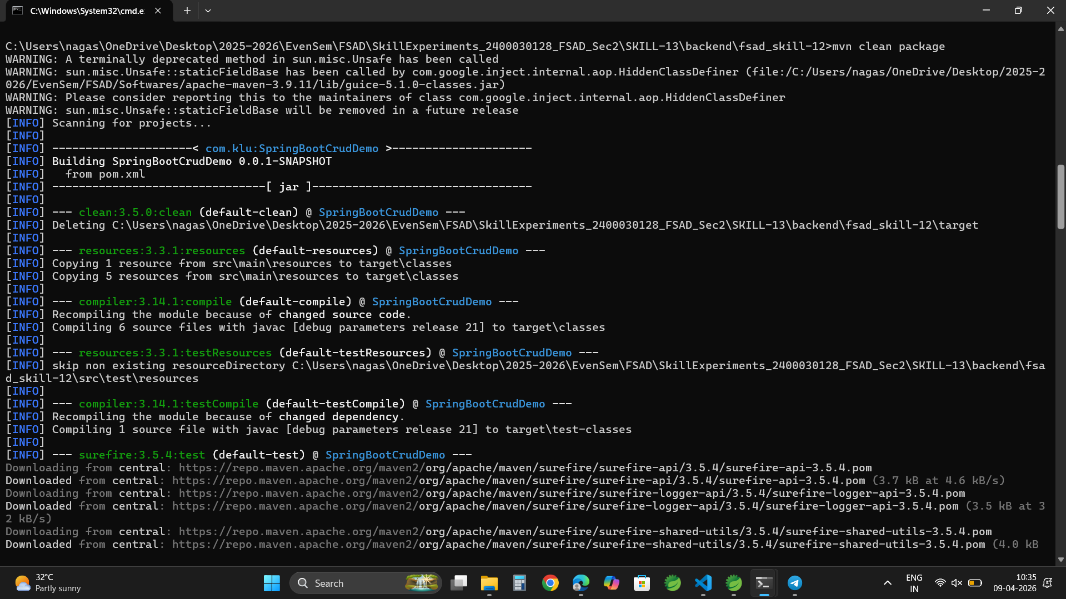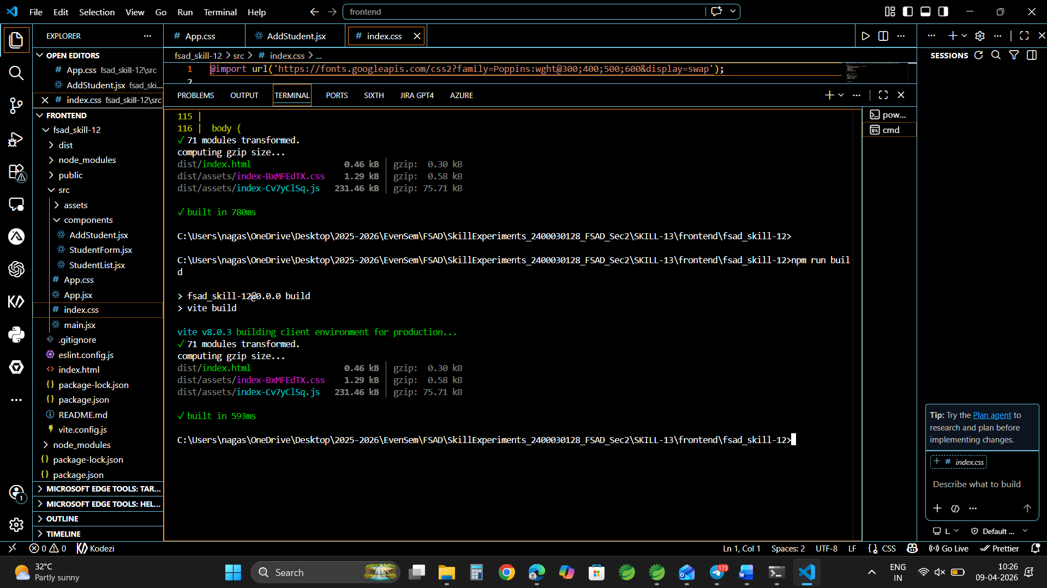
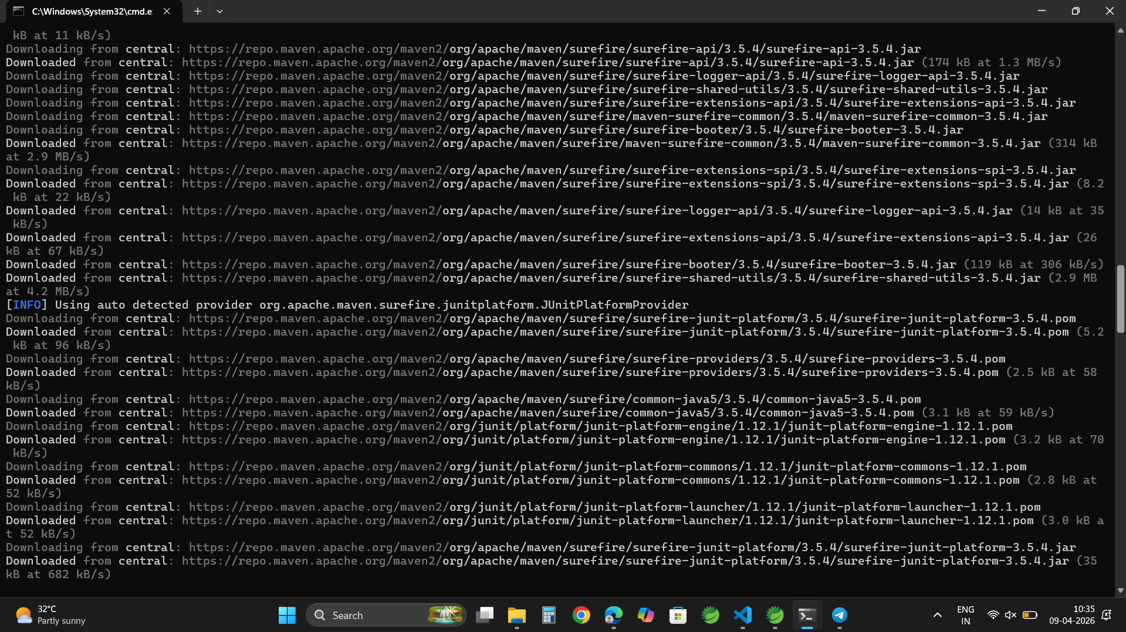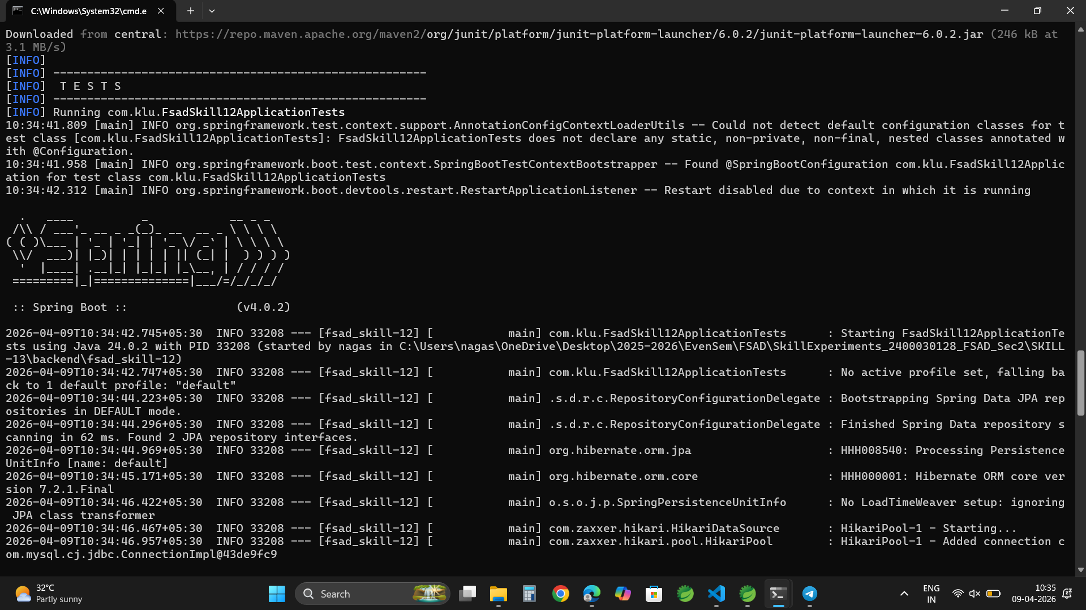

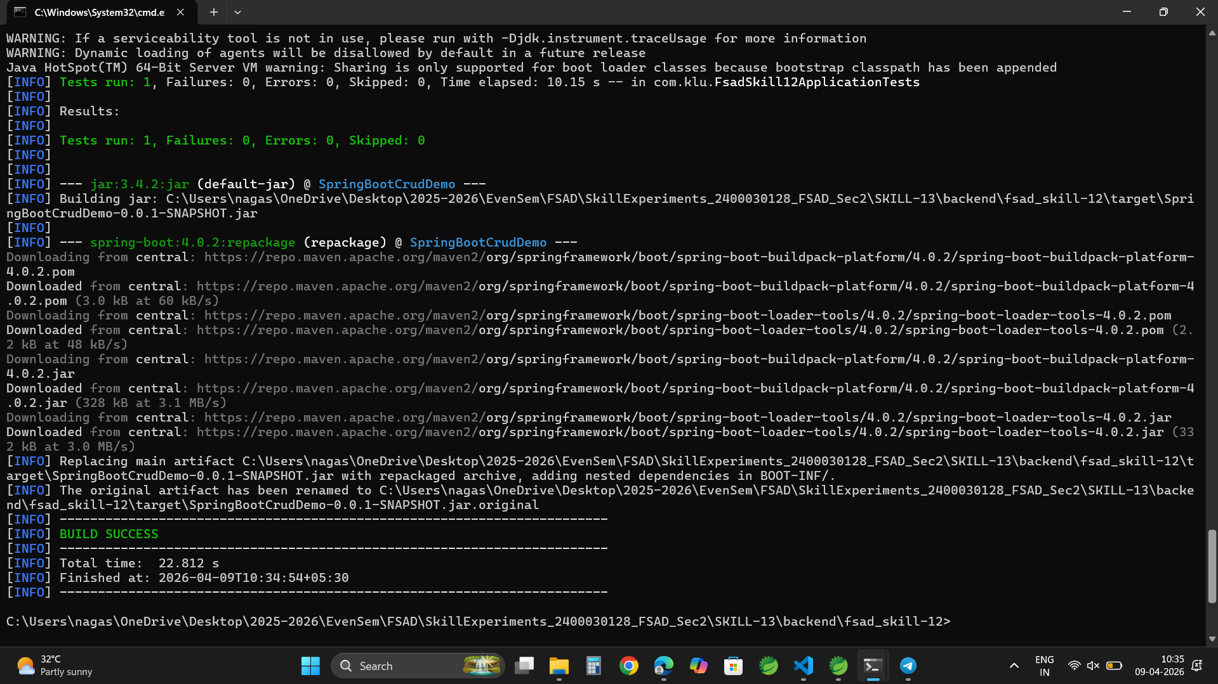

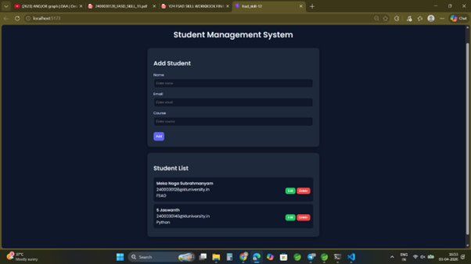


GITHUB LINK:
https://github.com/nagasubrahmanyammeka/SkillExperiments_2400030128_FSAD_Sec2/tree/main/SKILL-13

