SKILL-10: React State Management using useState Object

ID: 2400030128
Name: M. Naga Subrahmanyam
Section:2
An online academic portal wants to maintain a list of students where the user can add new students, display the list, and delete a student instantly without refreshing the page. The application should use React Hooks to manage data at the component level so that the UI updates automatically whenever the state changes. Your task is to implement a React component using useState to store an object array, add new items, display them, and delete them dynamically.
Codes:
StudentManager.jsx:
import React, { useState } from "react";
import "./StudentManager.css";

const StudentManager = () => {
// Initial students list
const [students, setStudents] = useState([
{ id: 1, name: "Sudheer", course: "Python",department:"CSE-1" },
{ id: 2, name: "Ravi", course: "Java" ,department:"ECE"},
{ id: 3, name: "Anjali", course: "C" , department:"IT"},
{ id: 4, name: "Kiran", course: "C#" ,department:"EEE"},
{ id: 5, name: "Meena", course: "React" ,department:"CIVIL"}
]);

// New student state
const [newStudent, setNewStudent] = useState({
id: "",
name: "",
course: "",
department:""
});

// Handle input changes
const handleChange = (e) => {
const { name, value } = e.target;
setNewStudent({
...newStudent,
[name]: value
});
};

// Add student
const addStudent = () => {
if (!newStudent.id || !newStudent.name || !newStudent.course) {
alert("Please fill all fields");
return;
}

// Add new student
setStudents([...students, newStudent]);

// Clear inputs
setNewStudent({
id: "",
name: "",
course: "",
department: ""
});
};

// Delete student
const deleteStudent = (id) => {
const updatedStudents = students.filter(
(student) => student.id !== id
);
setStudents(updatedStudents);
};

return (
<div className="container">
<h2>Student Manager</h2>

{/* Input Fields */}
<div className="form">
<input
type="number"
name="id"
placeholder="Enter ID"
value={newStudent.id}
onChange={handleChange}
/>

<input
type="text"
name="name"
placeholder="Enter Name"
value={newStudent.name}
onChange={handleChange}
/>

<input
type="text"
name="course"
placeholder="Enter Course"
value={newStudent.course}
onChange={handleChange}
/>
<input
type="text"
name="department"
placeholder="Enter Department"
value={newStudent.department}
onChange={handleChange}
/>

<button onClick={addStudent}>Add Student</button>
</div>

{/* Display Students */}
{students.length === 0 ? (
<p className="empty">No students available</p>
) : (
<table>
<thead>
<tr>
<th>ID</th>
<th>Name</th>
<th>Course</th>
<th>Department</th>
<th>Action</th>
</tr>
</thead>

<tbody>
{students.map((student) => (
<tr key={student.id}>
<td>{student.id}</td>
<td>{student.name}</td>
<td>{student.course}</td>
<td>{student.department}</td>
<td>
<button
className="delete-btn"
onClick={() => deleteStudent(student.id)}
>
Delete
</button>
</td>
</tr>
))}
</tbody>
</table>
)}
</div>
);
};

export default StudentManager;

StudentManager.css:
.container {
width: 60%;
margin: 30px auto;
text-align: center;
font-family: Arial, sans-serif;
}

h2 {
margin-bottom: 20px;
}

.form {
margin-bottom: 20px;
}

.form input {
margin: 5px;
padding: 8px;
width: 150px;
}

.form button {
padding: 8px 15px;
background-color: green;
color: white;
border: none;
cursor: pointer;
}

.form button:hover {
background-color: darkgreen;
}

table {
width: 100%;
border-collapse: collapse;
}

th {
background-color: #333;
color: white;
padding: 10px;
}

td {
padding: 10px;
border: 1px solid #ccc;
}

.delete-btn {
padding: 5px 10px;
background-color: red;
color: white;
border: none;
cursor: pointer;
}

.delete-btn:hover {
background-color: darkred;
}

.empty {
color: red;
font-weight: bold;
}

App.jsx:
import StudentManager from "./StudentManager";

function App() {
return (
<div>
<StudentManager />
</div>
);
}

export default App;

OUTPUT:
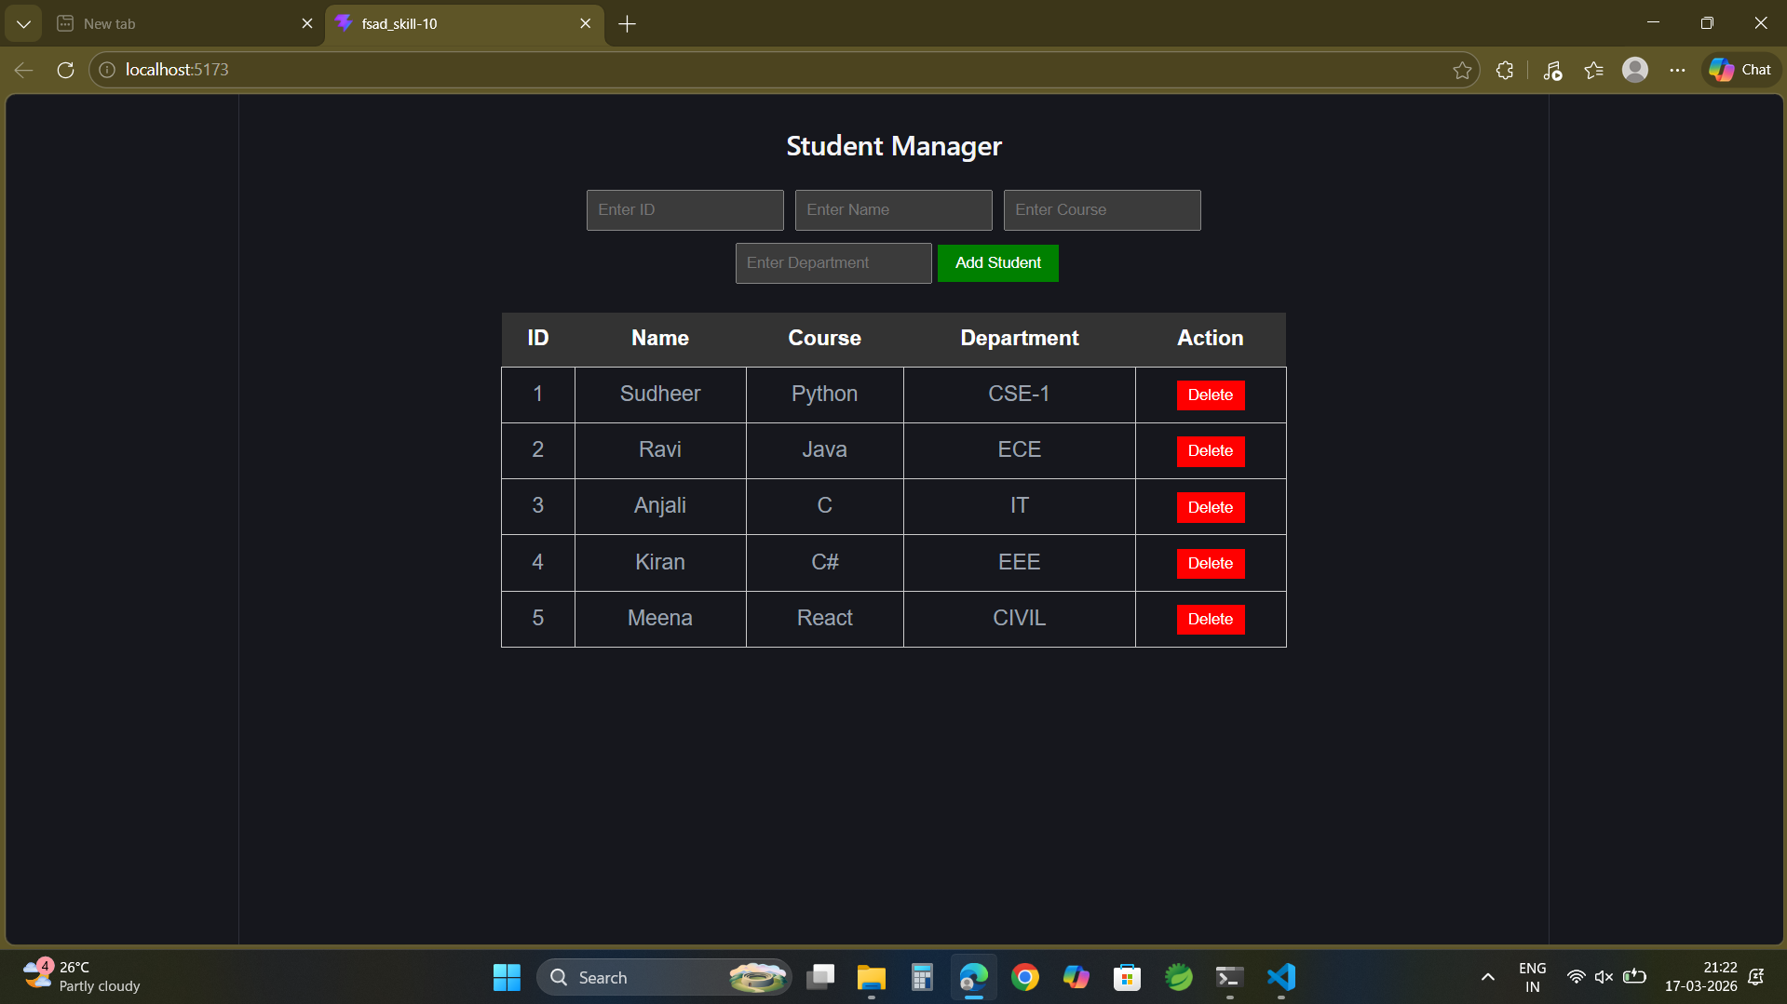

GITHUB LINK:

