SKILL-4 : Spring Dependency Injection – Constructor & Setter Injection
ID: 2400030128
Name: M.Naga Subrahmanyam
Section: 2
----------------------------------------------------------------------------------------------
A training institute wants to automate the management of student information in a Spring application. The system should inject details such as studentId, name, course, and academic year into objects without manually assigning values. This Skill demonstrates Constructor Injection and Setter Injection using both XML and Annotation configurations.
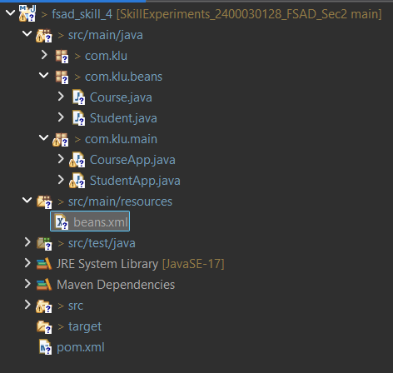

Codes:
Student.java:
package com.klu.beans;
public class Student {
private int studentId;
private String name;
private int year;
private Course course;
private String email;
private String phoneNumber;

// Constructor Injection
public Student(int studentId, String name, int year) {
this.studentId = studentId;
this.name = name;
this.year = year;
}

// Setter Injection
public void setCourse(Course course) {
this.course = course;
}

public void setEmail(String email) {
this.email = email;
}

public void setPhoneNumber(String phoneNumber) {
this.phoneNumber = phoneNumber;
}

public void display() {

System.out.println("Student ID : " + studentId);
System.out.println("Student Name : " + name);
System.out.println("Academic Year : " + year);
System.out.println("Email : " + email);
System.out.println("Phone Number : " + phoneNumber);
System.out.println("Course : " + course);

}

public void getStudentDetails() {
// TODO Auto-generated method stub

}
}

Course.java:
package com.klu.beans;
public class Course {

private String courseName;
private int duration;

// Constructor Injection
public Course(String courseName, int duration) {
this.courseName = courseName;
this.duration = duration;
}

public String getCourseName() {
return courseName;
}

public int getDuration() {
return duration;
}

@Override
public String toString() {
return courseName + " (" + duration + " months)";
}
}

StudentApp.java:
package com.klu.main;

import org.springframework.context.ApplicationContext;
import org.springframework.context.support.ClassPathXmlApplicationContext;

import com.klu.beans.Course;
import com.klu.beans.Student;

public class StudentApp {
public static void main(String[] args) {
ApplicationContext context = new ClassPathXmlApplicationContext("beans.xml");
Student st = context.getBean("stud", Student.class);
System.out.println("Student Details: ");
st.display();
}
}

CourseApp.java:
package com.klu.main;

import org.springframework.context.ApplicationContext;
import org.springframework.context.support.ClassPathXmlApplicationContext;

import com.klu.beans.Course;

public class CourseApp {

public static void main(String[] args) {

ApplicationContext context = new ClassPathXmlApplicationContext("beans.xml");

Course course = context.getBean("course", Course.class);

System.out.println("Course Details:");
System.out.println(course);

}
}

Beans.xml:
<beans xmlns="http://www.springframework.org/schema/beans"
xmlns:xsi="http://www.w3.org/2001/XMLSchema-instance"
xsi:schemaLocation="
http://www.springframework.org/schema/beans
http://www.springframework.org/schema/beans/spring-beans.xsd">

<!-- Course Bean -->
<bean id="course" class="com.klu.beans.Course">
<constructor-arg value="Spring Framework"/>
<constructor-arg value="6"/>
</bean>

<!-- Student Bean -->
<bean id="stud" class="com.klu.beans.Student">

<!-- Constructor Injection -->
<constructor-arg value="101"/>
<constructor-arg value="ram"/>
<constructor-arg value="2026"/>

<!-- Setter Injection -->
<property name="course" ref="course"/>
<property name="email" value="ram@klu.edu"/>
<property name="phoneNumber" value="9876543210"/>

</bean>

</beans>

OUTPUT:
