SKILL-5 : Spring Autowiring Demo using @Autowired
ID: 2400030128
Name: M. Naga Subrahmanyam
Section:2
-------------------------------------------------------------------------------------------------------------------

A college application maintains student information along with their certification details. The Student object contains a Certification object, and instead of creating this Certification object manually, Spring should automatically provide it using the @Autowired annotation. When the required classes are marked with @Component, Spring creates their objects and manages them inside the IoC container. Using @Autowired, the Certification object is supplied to the Student object by Spring without using the new keyword, allowing both objects to be linked through annotation-based configuration.
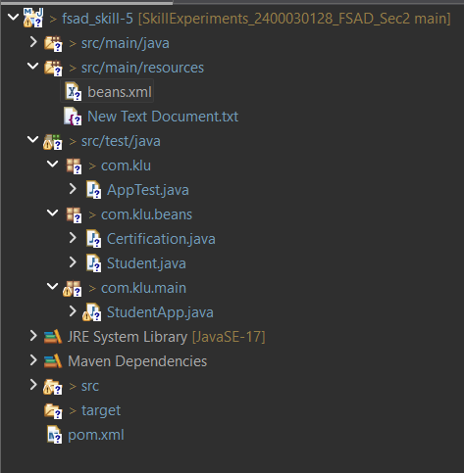

Codes:
Student.java:
package com.klu.beans;

import org.springframework.beans.factory.annotation.Autowired;
import org.springframework.stereotype.Component;

@Component
public class Student {

private int id = 101;
private String name = "Ram";
private String gender = "Male";

@Autowired
private Certification certification;

public void display() {

System.out.println("Student ID : " + id);
System.out.println("Name : " + name);
System.out.println("Gender : " + gender);
System.out.println(certification);

}
}

Certification.java:
package com.klu.beans;

import org.springframework.stereotype.Component;

@Component
public class Certification {

private int id;
private String name;
private String dateOfCompletion;

public Certification() {
this.id = 1;
this.name = "Spring Boot Certification";
this.dateOfCompletion = "2026";
}

@Override
public String toString() {
return "Certification ID: " + id +
", Name: " + name +
", Date: " + dateOfCompletion;
}
}

StudentApp.java:
package com.klu.main;

import org.springframework.context.ApplicationContext;
import org.springframework.context.support.ClassPathXmlApplicationContext;

import com.klu.beans.Student;

public class StudentApp {

public static void main(String[] args) {

ApplicationContext context =
new ClassPathXmlApplicationContext("beans.xml");

Student student = context.getBean(Student.class);

System.out.println("Student Details:");
student.display();

}
}

beans.xml:
<?xml version="1.0" encoding="UTF-8"?>

<beans xmlns="http://www.springframework.org/schema/beans"
xmlns:xsi="http://www.w3.org/2001/XMLSchema-instance"
xmlns:context="http://www.springframework.org/schema/context"

xsi:schemaLocation="
http://www.springframework.org/schema/beans
http://www.springframework.org/schema/beans/spring-beans.xsd
http://www.springframework.org/schema/context
http://www.springframework.org/schema/context/spring-context.xsd">

<!-- Enable annotation based configuration -->
<context:annotation-config/>

<!-- Enable component scanning -->
<context:component-scan base-package="com.klu.beans"/>

</beans>

OUTPUT:
