SKILL-6 : Spring MVC Web Request Handling Demo
ID: 2400030128
Name: M. Naga Subrahmanyam
Section: 2
------------------------------------------------------------------------------------------------------------------------
An online library system wants to allow users to explore books, view specific book details, submit feedback, and interact with the system through various types of requests. To support these features, the backend team needs to implement multiple Spring MVC endpoints demonstrating request mappings, path variables, request parameters, and JSON data handling. Your task is to create a Spring Boot MVC controller that exposes different demo operations using @RestController, @GetMapping, @PostMapping, and @PathVariable.
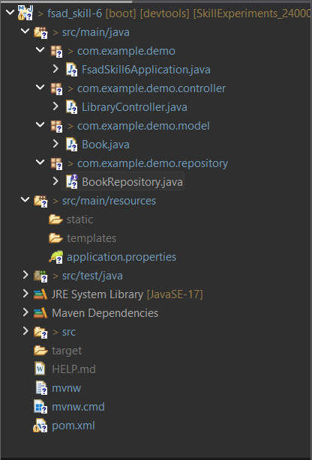

Codes:
Book.java:
package com.example.demo.model;

import jakarta.persistence.Entity;
import jakarta.persistence.GeneratedValue;
import jakarta.persistence.GenerationType;
import jakarta.persistence.Id;
import jakarta.persistence.Table;

@Entity
@Table(name = "book_skill6")
public class Book
{
@Id
@GeneratedValue(strategy = GenerationType.IDENTITY)
private Integer id;

private String title;
private String author;
private double price;

public Book() {}

public Book(Integer id, String title, String author, double price)
{
this.id = id;
this.title = title;
this.author = author;
this.price = price;
}

public Integer getId()
{
return id;
}

public void setId(Integer id)
{
this.id = id;
}

public String getTitle()
{
return title;
}

public void setTitle(String title)
{
this.title = title;
}

public String getAuthor()
{
return author;
}

public void setAuthor(String author)
{
this.author = author;
}

public double getPrice()
{
return price;
}

public void setPrice(double price)
{
this.price = price;
}
}

LibraryController.java:
package com.example.demo.controller;

import java.util.Arrays;
import java.util.List;

import org.springframework.beans.factory.annotation.Autowired;
import org.springframework.web.bind.annotation.*;

import com.example.demo.model.Book;
import com.example.demo.repository.BookRepository;

@RestController
public class LibraryController
{

@Autowired
BookRepository repo;

@GetMapping("/welcome")
public String welcome()
{
return "Welcome to Online Library System";
}

@GetMapping("/count")
public long getBookCount()
{
return repo.count();
}

@GetMapping("/price")
public double getPrice()
{
return 499.99;
}

@GetMapping("/books")
public List<String> getBooks()
{
return Arrays.asList("Java Programming", "Spring Boot Guide", "Data Structures", "Python Basics");
}

@GetMapping("/books/{id}")
public Book getBookById(@PathVariable int id)
{
return repo.findById(id).orElse(null);
}

@GetMapping("/search")
public String searchBook(@RequestParam String title)
{
return "Searching for book titled : " + title;
}

@GetMapping("/author/{name}")
public String getAuthor(@PathVariable String name)
{
return "Books written by Author : " + name;
}

@PostMapping("/addbook")
public Book addBook(@RequestBody Book book)
{
return repo.save(book);
}

@GetMapping("/viewbooks")
public List<Book> viewBooks()
{
return repo.findAll();
}

}

BookRepository.java:
package com.example.demo.repository;

import org.springframework.data.jpa.repository.JpaRepository;
import com.example.demo.model.Book;

public interface BookRepository extends JpaRepository<Book, Integer>
{

}

OUTPUTS:
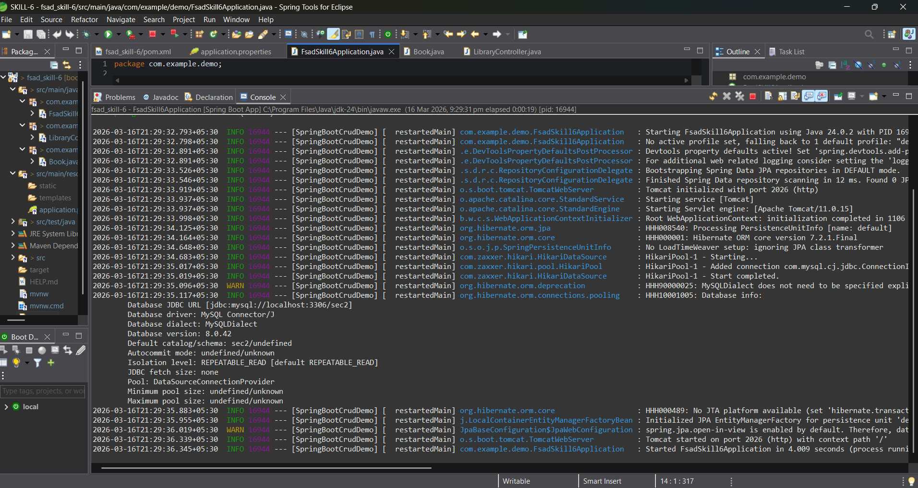
http://localhost:2026/welcome
