SKILL-7: REST API - CRUD Operations using ResponseEntity
ID: 2400030128
Name: M. Naga Subrahmanyam
Section:2
--------------------------------------------------------------------------------------------------------------------
A university application needs backend services to manage course details such as courseId, title, duration, and fee. The admin should be able to add, update, delete, and view course information. The system must return proper HTTP status codes and structured responses for reliable communication between client and server. Your task is to implement REST endpoints using ResponseEntity to perform complete CRUD operations on course data.
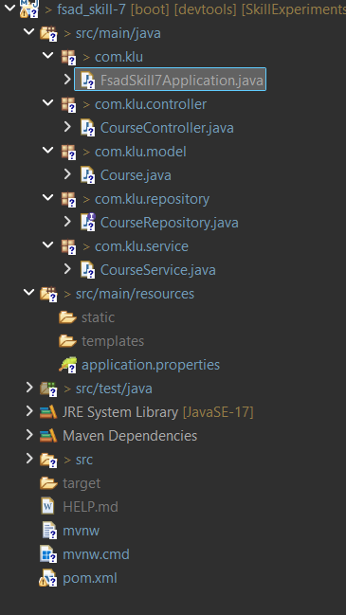

Codes:
Course.java:
package com.klu.model;

import jakarta.persistence.Entity;
import jakarta.persistence.Id;
import jakarta.persistence.Table;

@Entity
@Table(name="course_skill7")
public class Course {

@Id
private Integer courseId;

private String title;
private String duration;
private Double fee;

public Course() {}

public Integer getCourseId() {
return courseId;
}

public void setCourseId(Integer courseId) {
this.courseId = courseId;
}

public String getTitle() {
return title;
}

public void setTitle(String title) {
this.title = title;
}

public String getDuration() {
return duration;
}

public void setDuration(String duration) {
this.duration = duration;
}

public Double getFee() {
return fee;
}

public void setFee(Double fee) {
this.fee = fee;
}
}

CourseController.java:
package com.klu.controller;

import java.util.List;

import org.springframework.beans.factory.annotation.Autowired;
import org.springframework.http.HttpStatus;
import org.springframework.http.ResponseEntity;
import org.springframework.web.bind.annotation.*;

import com.klu.model.Course;
import com.klu.service.CourseService;

@RestController
@RequestMapping("/courses")
public class CourseController {

@Autowired
CourseService service;

// Add Course
@PostMapping
public ResponseEntity<?> addCourse(@RequestBody Course course) {

Course saved = service.addCourse(course);

return new ResponseEntity<>(saved, HttpStatus.CREATED);
}

// Get All Courses
@GetMapping
public ResponseEntity<List<Course>> getAllCourses() {

return new ResponseEntity<>(service.getAllCourses(), HttpStatus.OK);
}

// Get Course By ID
@GetMapping("/{id}")
public ResponseEntity<?> getCourse(@PathVariable Integer id) {

Course course = service.getCourseById(id);

if(course == null)
return new ResponseEntity<>("Course Not Found", HttpStatus.NOT_FOUND);

return new ResponseEntity<>(course, HttpStatus.OK);
}

// Update Course
@PutMapping("/{id}")
public ResponseEntity<?> updateCourse(@PathVariable Integer id, @RequestBody Course course) {

Course updated = service.updateCourse(id, course);

if(updated == null)
return new ResponseEntity<>("Course Not Found", HttpStatus.NOT_FOUND);

return new ResponseEntity<>(updated, HttpStatus.OK);
}

// Delete Course
@DeleteMapping("/{id}")
public ResponseEntity<?> deleteCourse(@PathVariable Integer id) {

boolean deleted = service.deleteCourse(id);

if(!deleted)
return new ResponseEntity<>("Course Not Found", HttpStatus.NOT_FOUND);

return new ResponseEntity<>("Course Deleted Successfully", HttpStatus.OK);
}

// Search by Title
@GetMapping("/search/{title}")
public ResponseEntity<List<Course>> searchCourse(@PathVariable String title) {

List<Course> courses = service.searchByTitle(title);

return new ResponseEntity<>(courses, HttpStatus.OK);
}
}

CourseRepository.java:
package com.klu.repository;

import java.util.List;

import org.springframework.data.jpa.repository.JpaRepository;

import com.klu.model.Course;

public interface CourseRepository extends JpaRepository<Course, Integer>
{
List<Course> findByTitle(String title);
}

CourseService.java:
package com.klu.service;

import java.util.List;

import org.springframework.beans.factory.annotation.Autowired;
import org.springframework.stereotype.Service;

import com.klu.model.Course;
import com.klu.repository.CourseRepository;

@Service
public class CourseService {

@Autowired
CourseRepository repo;

public Course addCourse(Course course) {
return repo.save(course);
}

public List<Course> getAllCourses() {
return repo.findAll();
}

public Course getCourseById(Integer id) {
return repo.findById(id).orElse(null);
}

public Course updateCourse(Integer id, Course course) {

Course existing = repo.findById(id).orElse(null);

if(existing != null) {
existing.setTitle(course.getTitle());
existing.setDuration(course.getDuration());
existing.setFee(course.getFee());
return repo.save(existing);
}

return null;
}

public boolean deleteCourse(Integer id) {

Course course = repo.findById(id).orElse(null);

if(course != null) {
repo.delete(course);
return true;
}

return false;
}

public List<Course> searchByTitle(String title) {
return repo.findByTitle(title);
}
}

OUTPUTS:
