SKILL – 8: Spring Boot – JPQL & Query Methods Module
ID : 2400030128
Name: M. Naga Subrahmanyam
Section: 2
----------------------------------------------------------------------------------------------
An e-commerce application needs a product search feature where users can view products by category, filter items within a price range, and sort products by price. The backend team must implement these operations using Spring Data JPA, including derived query methods and JPQL queries, to fetch data efficiently without writing long SQL statements. Your task is to build a product search module that supports category-based search, price filtering, and sorting using Spring Data JPA.
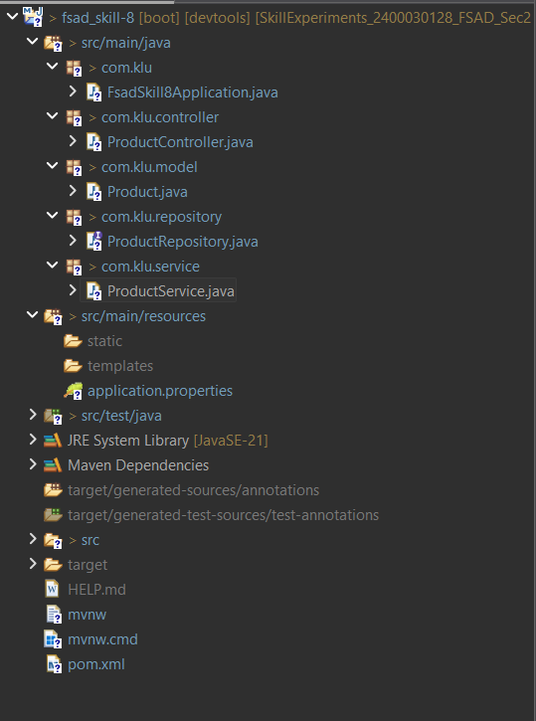

Codes:
Product.java:
package com.klu.model;

import jakarta.persistence.*;

@Entity
@Table(name = "product_skill8")
public class Product {

@Id
@GeneratedValue(strategy = GenerationType.IDENTITY)
private Integer id;

private String name;
private String category;
private Double price;

public Product() {}

public Integer getId() {
return id;
}

public void setId(Integer id) {
this.id = id;
}

public String getName() {
return name;
}

public void setName(String name) {
this.name = name;
}

public String getCategory() {
return category;
}

public void setCategory(String category) {
this.category = category;
}

public Double getPrice() {
return price;
}

public void setPrice(Double price) {
this.price = price;
}
}

ProductController.java:
package com.klu.controller;

import java.util.List;

import org.springframework.beans.factory.annotation.Autowired;
import org.springframework.web.bind.annotation.*;

import com.klu.model.Product;
import com.klu.service.ProductService;

@RestController
@RequestMapping("/products")
public class ProductController {

@Autowired
ProductService service;

// Add product (for testing)
@PostMapping
public Product addProduct(@RequestBody Product product) {
return service.addProduct(product);
}

// Get all products
@GetMapping
public List<Product> getAll() {
return service.getAllProducts();
}

// a. Category search
@GetMapping("/category/{category}")
public List<Product> getByCategory(@PathVariable String category) {
return service.getByCategory(category);
}

// b. Price filter
@GetMapping("/filter")
public List<Product> filterByPrice(@RequestParam Double min,
@RequestParam Double max) {
return service.getByPriceRange(min, max);
}

// c. Sorted products
@GetMapping("/sorted")
public List<Product> getSorted() {
return service.getSortedProducts();
}

// d. Expensive products
@GetMapping("/expensive/{price}")
public List<Product> getExpensive(@PathVariable Double price) {
return service.getExpensiveProducts(price);
}
}

ProductRepository.java:
package com.klu.repository;

import java.util.List;

import org.springframework.data.jpa.repository.JpaRepository;
import org.springframework.data.jpa.repository.Query;

import com.klu.model.Product;

public interface ProductRepository extends JpaRepository<Product, Integer> {

// 🔹 Derived Query Methods
List<Product> findByCategory(String category);

List<Product> findByPriceBetween(Double min, Double max);

// 🔹 JPQL Queries

// a. Sort by price (ascending)
@Query("SELECT p FROM Product p ORDER BY p.price ASC")
List<Product> getProductsSortedByPrice();

// b. Products above price
@Query("SELECT p FROM Product p WHERE p.price > :price")
List<Product> getExpensiveProducts(Double price);

// c. Products by category (JPQL)
@Query("SELECT p FROM Product p WHERE p.category = :category")
List<Product> getProductsByCategoryJPQL(String category);
}

ProductService.java:
package com.klu.service;

import java.util.List;

import org.springframework.beans.factory.annotation.Autowired;
import org.springframework.stereotype.Service;

import com.klu.model.Product;
import com.klu.repository.ProductRepository;

@Service
public class ProductService {

@Autowired
ProductRepository repo;

public List<Product> getByCategory(String category) {
return repo.findByCategory(category);
}

public List<Product> getByPriceRange(Double min, Double max) {
return repo.findByPriceBetween(min, max);
}

public List<Product> getSortedProducts() {
return repo.getProductsSortedByPrice();
}

public List<Product> getExpensiveProducts(Double price) {
return repo.getExpensiveProducts(price);
}

public Product addProduct(Product product) {
return repo.save(product);
}

public List<Product> getAllProducts() {
return repo.findAll();
}
}

OUTPUT:
