SKILL-10: Global Exception Handling using @ControllerAdvice
ID: 2400030128
Name: M. Naga Subrahmanyam
Section: 2
A university application provides student details through REST APIs. When users enter an invalid student ID, the system shows technical error messages that are difficult for users to understand. To improve usability, the application should return clear, readable, and user-friendly error responses through centralized exception handling. Your task is to implement Global Exception Handling using @ControllerAdvice and create custom exceptions for invalid student inputs.
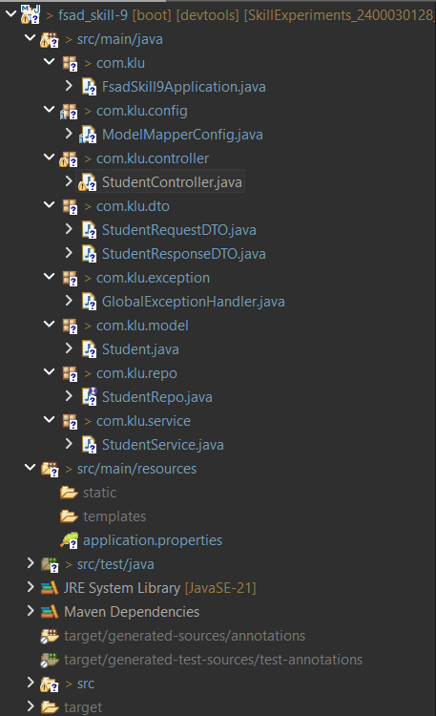

Codes:
Student.java:
package com.klu.model;

import jakarta.persistence.Entity;
import jakarta.persistence.GeneratedValue;
import jakarta.persistence.GenerationType;
import jakarta.persistence.Id;
import jakarta.persistence.Table;
import lombok.AllArgsConstructor;
import lombok.Data;
import lombok.NoArgsConstructor;

@Data
@AllArgsConstructor
@NoArgsConstructor
@Entity
@Table(name="student_skill10")
public class Student {
@Id
@GeneratedValue(strategy = GenerationType.IDENTITY)
private Long id; // lowercase 'id'
private String name;
private String email;
private String branch;
private String course;
private Double fees; // wrapper type for null safety

private String password;
}
StudentRepo.java:
package com.klu.repo;

import org.springframework.data.jpa.repository.JpaRepository;
import org.springframework.stereotype.Repository;

import com.klu.model.Student;

@Repository
public interface StudentRepo extends JpaRepository<Student, Long>{

}
StudentService.java:
package com.klu.service;

import java.util.List;
import java.util.stream.Collectors;

import org.modelmapper.ModelMapper;
import org.springframework.beans.factory.annotation.Autowired;
import org.springframework.stereotype.Service;

import com.klu.dto.StudentRequestDTO;
import com.klu.dto.StudentResponseDTO;
import com.klu.model.Student;
import com.klu.repo.StudentRepo;

@Service
public class StudentService {
@Autowired
public StudentRepo studentRepo;
@Autowired
public ModelMapper modelMapper;

//create student
public StudentResponseDTO addStudent(StudentRequestDTO reqdto) {
//step-1: convert dto to entity
Student entity = modelMapper.map(reqdto, Student.class);
//step-2: assign default password in the entity
entity.setPassword("klu123");

return modelMapper.map(studentRepo.save(entity),StudentResponseDTO.class);
}

//Read all student details
public List<StudentResponseDTO> getAllStudents() {
List<Student> list = studentRepo.findAll();
return list.stream()
.map(student -> modelMapper.map(student, StudentResponseDTO.class))
.collect(Collectors.toList());
}

//Read Specific student
public StudentResponseDTO getStudentById(long id) {
Student s = studentRepo.findById(id).orElseThrow();
return modelMapper.map(s, StudentResponseDTO.class);
}

//delete specific student
public String deleteStudent(Long id) {
studentRepo.findById(id).orElseThrow();
studentRepo.deleteById(id);
return "Student Deleted Successfully";
}

//update Student
public StudentResponseDTO updateStudent(Long id, StudentRequestDTO s) {
Student existedStudent = studentRepo.findById(id).orElseThrow();
existedStudent.setName(s.getName());
existedStudent.setEmail(s.getEmail());
existedStudent.setCourse(s.getCourse());
existedStudent.setBranch(s.getBranch());
existedStudent.setFees(s.getFees());
Student updated = studentRepo.save(existedStudent);
return modelMapper.map(updated, StudentResponseDTO.class);

}
}
StudentController.java:
package com.klu.controller;

import java.util.List;

import org.springframework.beans.factory.annotation.Autowired;
import org.springframework.http.HttpStatus;
import org.springframework.http.ResponseEntity;
import org.springframework.web.bind.annotation.CrossOrigin;
import org.springframework.web.bind.annotation.DeleteMapping;
import org.springframework.web.bind.annotation.GetMapping;
import org.springframework.web.bind.annotation.PathVariable;
import org.springframework.web.bind.annotation.PostMapping;
import org.springframework.web.bind.annotation.RequestBody;
import org.springframework.web.bind.annotation.RequestMapping;
import org.springframework.web.bind.annotation.RestController;
import org.springframework.web.service.annotation.PutExchange;

import com.klu.dto.StudentRequestDTO;
import com.klu.dto.StudentResponseDTO;
import com.klu.service.StudentService;

import jakarta.validation.Valid;
import org.springframework.web.bind.annotation.PutMapping;

@RestController
@RequestMapping("/stud")
@CrossOrigin("*")
public class StudentController {
@Autowired
private StudentService studentService;

@PostMapping("/addStudent")
public ResponseEntity<StudentResponseDTO> addStudent(@Valid @RequestBody StudentRequestDTO dto){
return new ResponseEntity<>(studentService.addStudent(dto),HttpStatus.CREATED);
}

@GetMapping("/getAllStudents")
public ResponseEntity<List<StudentResponseDTO>> getAllStudents(){
return ResponseEntity.ok(studentService.getAllStudents());
}
@GetMapping("/getStudentById/{id}")
public ResponseEntity<StudentResponseDTO> getStudentById(@PathVariable Long id){
return ResponseEntity.ok(studentService.getStudentById(id));
}
@DeleteMapping("/deleteStudent/{id}")
public ResponseEntity<String> deleteStudent(@PathVariable Long id){
return ResponseEntity.ok(studentService.deleteStudent(id));
}

@PutMapping("/updateStudent/{id}")
public ResponseEntity<StudentResponseDTO> updateStudent(@PathVariable Long id,
@Valid @RequestBody StudentRequestDTO dto) {
StudentResponseDTO updatedStudent = studentService.updateStudent(id, dto);
return ResponseEntity.ok(updatedStudent);
}
}
ModelMapperConfig.java:
package com.klu.config;

import org.modelmapper.ModelMapper;
import org.springframework.context.annotation.Bean;
import org.springframework.context.annotation.Configuration;

@Configuration
public class ModelMapperConfig {
@Bean
public ModelMapper getModelMapper() {
return new ModelMapper();
}
}
GlobalExceptionHandler.java:
package com.klu.exception;

import java.util.HashMap;
import java.util.Map;

import org.springframework.web.bind.MethodArgumentNotValidException;
import org.springframework.web.bind.annotation.ExceptionHandler;
import org.springframework.web.bind.annotation.RestControllerAdvice;

@RestControllerAdvice
public class GlobalExceptionHandler {
@ExceptionHandler(MethodArgumentNotValidException.class)
public Map<String, String> handleMethodArgumentNotFoundException(MethodArgumentNotValidException e){
Map<String,String> errors = new HashMap<>();
e.getBindingResult().getFieldErrors()
.forEach(student -> errors.put(student.getField(), student.getDefaultMessage()));

return errors;

}

@ExceptionHandler(Exception.class)
public String handleInternalServerException(Exception e) {
return e.getMessage();
}
}
StudentResponseDTO.java:
package com.klu.dto;

import lombok.AllArgsConstructor;
import lombok.Data;
import lombok.NoArgsConstructor;

@Data
@NoArgsConstructor
@AllArgsConstructor
public class StudentResponseDTO {
private Long id;
private String name;
private String email;
private String branch;
private String course;
private double fees;
}
StudentRequestDTO.java:
package com.klu.dto;

import jakarta.validation.constraints.Email;
import jakarta.validation.constraints.NotBlank;
import jakarta.validation.constraints.NotEmpty;
import jakarta.validation.constraints.Positive;
import lombok.AllArgsConstructor;
import lombok.Data;
import lombok.NoArgsConstructor;

@Data
@AllArgsConstructor
@NoArgsConstructor
public class StudentRequestDTO {
@NotEmpty(message = "Student name is required")
private String name;
@Email(message = "Email must have proper format")
private String email;
@NotBlank(message = "Branch must not be null")
private String branch;
@NotBlank(message = "Course must not be null")
private String course;
@Positive(message = "Fees must be positive number")
private double fees;
}

OUTPUTS:
