SKILL-10: Working with HQL - Sorting, Pagination & Aggregates
ID: 2400030128
Name: M. Naga Subrahmanyam
Section: 2
In this lab, you will extend the Hibernate module created in Skill 2 and perform advanced data retrieval using HQL, including sorting, pagination, filtering, and aggregate functions. These operations help in retrieving structured and meaningful data from the database using Hibernate.

Structure:
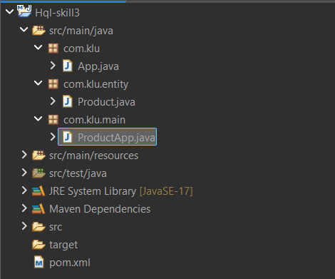

Codes:
Product.java:
package com.klu.entity;

import jakarta.persistence.Entity;
import jakarta.persistence.Id;
import jakarta.persistence.Table;

@Entity
@Table(name="product_skill3")
public class Product
{
@Id
private int id;
private String name;
private String description;
private double price;
private int quantity;

// Getters and Setters

public int getId() {
return id;
}

public void setId(int id) {
this.id = id;
}

public String getName() {
return name;
}

public void setName(String name) {
this.name = name;
}

public String getDescription() {
return description;
}

public void setDescription(String description) {
this.description = description;
}

public double getPrice() {
return price;
}

public void setPrice(double price) {
this.price = price;
}

public int getQuantity() {
return quantity;
}

public void setQuantity(int quantity) {
this.quantity = quantity;
}
}
ProductApp.java:
package com.klu.main;

import java.util.List;

import org.hibernate.Session;
import org.hibernate.SessionFactory;
import org.hibernate.cfg.Configuration;
import org.hibernate.query.Query;

import com.klu.entity.Product;

public class ProductApp
{
public static void main(String[] args)
{
Configuration cfg = new Configuration().configure("hibernate.cfg.xml");
SessionFactory sf = cfg.buildSessionFactory();
Session session = sf.openSession();

// 1. Sorting by price ASC
Query<Product> q1 = session.createQuery("from Product p order by p.price asc", Product.class);
List<Product> list1 = q1.list();
System.out.println("Products sorted by price ASC:");
list1.forEach(p -> System.out.println(p.getName()+" "+p.getPrice()));

// 2. Sorting by price DESC
Query<Product> q2 = session.createQuery("from Product p order by p.price desc", Product.class);
List<Product> list2 = q2.list();
System.out.println("Products sorted by price DESC:");
list2.forEach(p -> System.out.println(p.getName()+" "+p.getPrice()));

// 3. Sort by quantity highest first
Query<Product> q3 = session.createQuery("from Product p order by p.quantity desc", Product.class);
List<Product> list3 = q3.list();
System.out.println("Products sorted by quantity:");
list3.forEach(p -> System.out.println(p.getName()+" "+p.getQuantity()));

// 4. Pagination - First 3
Query<Product> q4 = session.createQuery("from Product", Product.class);
q4.setFirstResult(0);
q4.setMaxResults(3);
List<Product> page1 = q4.list();

System.out.println("First 3 Products:");
page1.forEach(p -> System.out.println(p.getName()));

// 5. Pagination - Next 3
Query<Product> q5 = session.createQuery("from Product", Product.class);
q5.setFirstResult(3);
q5.setMaxResults(3);
List<Product> page2 = q5.list();

System.out.println("Next 3 Products:");
page2.forEach(p -> System.out.println(p.getName()));

// 6. Aggregate Functions

// Count total products
Query<Long> q6 = session.createQuery("select count(p.id) from Product p", Long.class);
System.out.println("Total Products: "+q6.uniqueResult());

// Count products where quantity > 0
Query<Long> q7 = session.createQuery("select count(p.id) from Product p where p.quantity > 0", Long.class);
System.out.println("Products with quantity >0: "+q7.uniqueResult());

// Minimum price
Query<Double> q8 = session.createQuery("select min(p.price) from Product p", Double.class);
System.out.println("Minimum Price: "+q8.uniqueResult());

// Maximum price
Query<Double> q9 = session.createQuery("select max(p.price) from Product p", Double.class);
System.out.println("Maximum Price: "+q9.uniqueResult());

// 7. GROUP BY description
Query<Object[]> q10 = session.createQuery(
"select p.description, count(p.id) from Product p group by p.description",
Object[].class);

List<Object[]> groupList = q10.list();

for(Object[] row : groupList)
{
System.out.println("Description: "+row[0]+" Count: "+row[1]);
}

// 8. WHERE clause price range
Query<Product> q11 = session.createQuery(
"from Product p where p.price between 100 and 500", Product.class);

List<Product> priceRange = q11.list();

System.out.println("Products between price 100 and 500:");
priceRange.forEach(p -> System.out.println(p.getName()+" "+p.getPrice()));

// 9. LIKE queries

// Names starting with 'A'
Query<Product> q12 = session.createQuery(
"from Product p where p.name like 'A%'", Product.class);

q12.list().forEach(p -> System.out.println("Starts with A: "+p.getName()));

// Names ending with 'e'
Query<Product> q13 = session.createQuery(
"from Product p where p.name like '%e'", Product.class);

q13.list().forEach(p -> System.out.println("Ends with e: "+p.getName()));

// Names containing 'oo'
Query<Product> q14 = session.createQuery(
"from Product p where p.name like '%oo%'", Product.class);

q14.list().forEach(p -> System.out.println("Contains oo: "+p.getName()));

// Exact length (example 5 characters)
Query<Product> q15 = session.createQuery(
"from Product p where length(p.name)=5", Product.class);

q15.list().forEach(p -> System.out.println("Name length 5: "+p.getName()));

session.close();
sf.close();
}
}

OUTPUT:
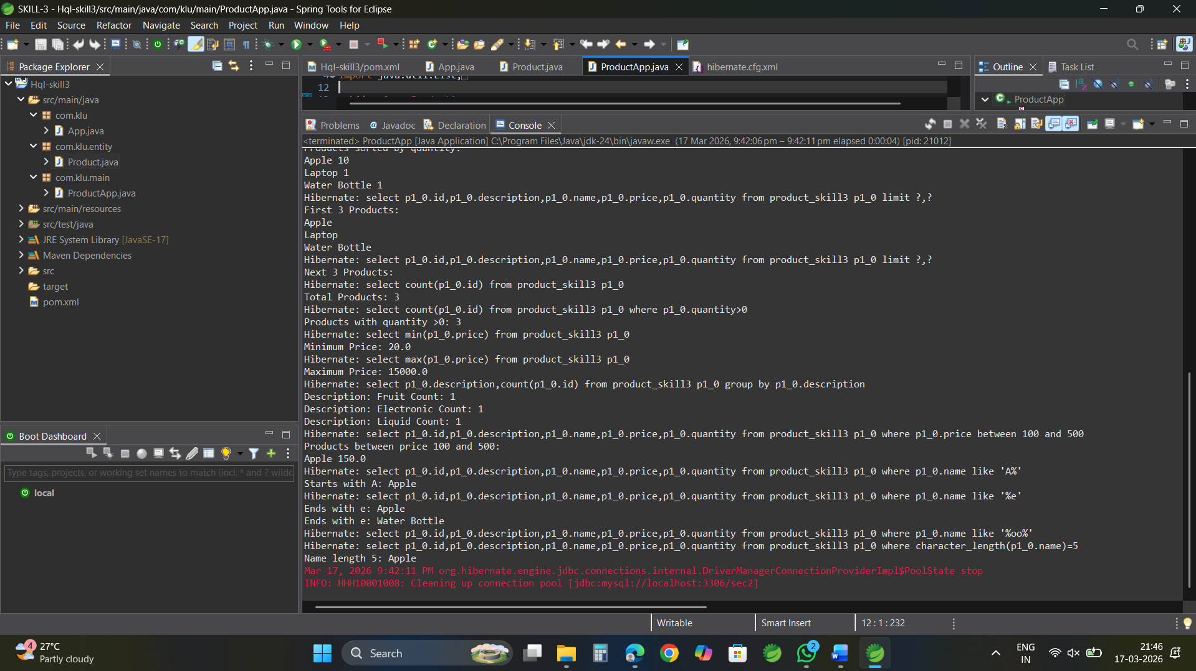

GITHUB LINK:
https://github.com/nagasubrahmanyammeka/SkillExperiments_2400030128_FSAD_Sec2/tree/main/SKILL-3

