SKILL – 15: Implementing JWT-Based Authentication & Role Authorization
ID: 2400030128
Name: M. Naga Subrahmanyam
Section:2
Scenario:
A corporate portal requires authentication using JWT tokens with role-based access. Only ADMIN users should manage employee records, while EMPLOYEE users can access profile-related data. Your task is to implement JWT-based secure login and restrict access to specific endpoints.
Structure:
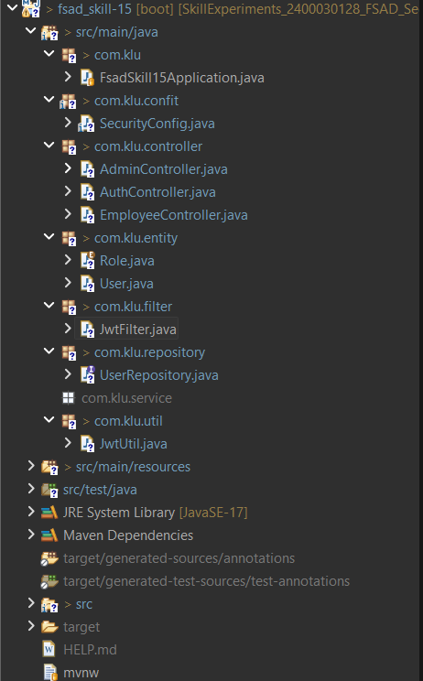

Codes:
User.java:
package com.klu.entity;

import jakarta.persistence.*;

@Entity
@Table(name = "user_skill15")
public class User {

@Id
@GeneratedValue(strategy = GenerationType.IDENTITY)
private Long id;

private String username;
private String password;

@Enumerated(EnumType.STRING)
private Role role;

public Long getId() {
return id;
}

public void setId(Long id) {
this.id = id;
}

public String getUsername() {
return username;
}

public void setUsername(String username) {
this.username = username;
}

public String getPassword() {
return password;
}

public void setPassword(String password) {
this.password = password;
}

public Role getRole() {
return role;
}

public void setRole(Role role) {
this.role = role;
}

// getters & setters
}

Role.java:
package com.klu.entity;

public enum Role {
ADMIN,
EMPLOYEE
}

SecurityConfig.java:
package com.klu.confit;

import com.klu.filter.JwtFilter;
import org.springframework.beans.factory.annotation.Autowired;
import org.springframework.context.annotation.*;
import org.springframework.security.config.annotation.web.builders.HttpSecurity;
import org.springframework.security.web.SecurityFilterChain;
import org.springframework.security.web.authentication.UsernamePasswordAuthenticationFilter;

@Configuration
public class SecurityConfig {

@Autowired
private JwtFilter jwtFilter;

@Bean
public SecurityFilterChain filterChain(HttpSecurity http) throws Exception {

http.csrf(csrf -> csrf.disable())
.authorizeHttpRequests(auth -> auth
.requestMatchers("/login").permitAll()
.requestMatchers("/admin/**").hasRole("ADMIN")
.requestMatchers("/employee/**").hasAnyRole("EMPLOYEE", "ADMIN")
.anyRequest().authenticated()
);

http.addFilterBefore(jwtFilter, UsernamePasswordAuthenticationFilter.class);

return http.build();
}
}

AdminContoller.java:
package com.klu.controller;

import org.springframework.web.bind.annotation.*;

@RestController
@RequestMapping("/admin")
public class AdminController {

@PostMapping("/add")
public String addEmployee() {
return "Employee added by ADMIN";
}

@DeleteMapping("/delete")
public String deleteEmployee() {
return "Employee deleted by ADMIN";
}
}

EmployeeController.java:
package com.klu.controller;

import org.springframework.web.bind.annotation.*;

@RestController
@RequestMapping("/employee")
public class EmployeeController {

@GetMapping("/profile")
public String profile() {
return "Employee profile data";
}
}

AuthController.java:
package com.klu.controller;

import com.klu.entity.User;
import com.klu.repository.UserRepository;
import com.klu.util.JwtUtil;
import org.springframework.beans.factory.annotation.Autowired;
import org.springframework.web.bind.annotation.*;

import java.util.Optional;

@RestController
public class AuthController {

@Autowired
private UserRepository repo;

@Autowired
private JwtUtil jwtUtil;

@PostMapping("/login")
public String login(@RequestBody User user) {

Optional<User> dbUser = repo.findByUsername(user.getUsername());

if (dbUser.isPresent() &&
dbUser.get().getPassword().equals(user.getPassword())) {

return jwtUtil.generateToken(
dbUser.get().getUsername(),
dbUser.get().getRole().name()
);
}

return "Invalid credentials";
}
}

JwtFilter.java:
package com.klu.filter;

import com.klu.util.JwtUtil;
import io.jsonwebtoken.ExpiredJwtException;
import jakarta.servlet.*;
import jakarta.servlet.http.HttpServletRequest;
import jakarta.servlet.http.HttpServletResponse;
import org.springframework.beans.factory.annotation.Autowired;
import org.springframework.security.authentication.UsernamePasswordAuthenticationToken;
import org.springframework.security.core.context.SecurityContextHolder;
import org.springframework.stereotype.Component;
import org.springframework.web.filter.OncePerRequestFilter;

import java.io.IOException;
import java.util.Collections;

@Component
public class JwtFilter extends OncePerRequestFilter {

@Autowired
private JwtUtil jwtUtil;

@Override
protected void doFilterInternal(HttpServletRequest request,
HttpServletResponse response,
FilterChain filterChain)
throws ServletException, IOException {

String path = request.getRequestURI();

// ✅ SKIP LOGIN REQUEST
if (path.equals("/login")) {
filterChain.doFilter(request, response);
return;
}

String header = request.getHeader("Authorization");

String token = null;
String username = null;

try {
if (header != null && header.startsWith("Bearer ")) {
token = header.substring(7);
username = jwtUtil.extractUsername(token);
}
} catch (ExpiredJwtException e) {
System.out.println("❌ Token expired");
} catch (Exception e) {
System.out.println("❌ Invalid token");
}

if (username != null &&
SecurityContextHolder.getContext().getAuthentication() == null) {

UsernamePasswordAuthenticationToken auth =
new UsernamePasswordAuthenticationToken(username, null, Collections.emptyList());

SecurityContextHolder.getContext().setAuthentication(auth);
}

filterChain.doFilter(request, response);
}
}

UserRepository.java:
package com.klu.repository;

import com.klu.entity.User;
import org.springframework.data.jpa.repository.JpaRepository;

import java.util.Optional;

public interface UserRepository extends JpaRepository<User, Long> {
Optional<User> findByUsername(String username);
}

JwtUtil.java:
package com.klu.util;

import io.jsonwebtoken.*;
import io.jsonwebtoken.security.Keys;
import org.springframework.stereotype.Component;

import java.security.Key;
import java.util.Date;

@Component
public class JwtUtil {

private final String SECRET = "mysecretkeymysecretkeymysecretkey";

private Key getSignKey() {
return Keys.hmacShaKeyFor(SECRET.getBytes());
}

public String generateToken(String username, String role) {
return Jwts.builder()
.setSubject(username)
.claim("role", role)
.setIssuedAt(new Date())
.setExpiration(new Date(System.currentTimeMillis() + 1000 * 60 * 60))
.signWith(getSignKey(), SignatureAlgorithm.HS256)
.compact();
}

public Claims extractClaims(String token) {
return Jwts.parserBuilder()
.setSigningKey(getSignKey())
.build()
.parseClaimsJws(token)
.getBody();
}

public String extractUsername(String token) {
return extractClaims(token).getSubject();
}

public String extractRole(String token) {
return (String) extractClaims(token).get("role");
}
}
OUTPUTS:
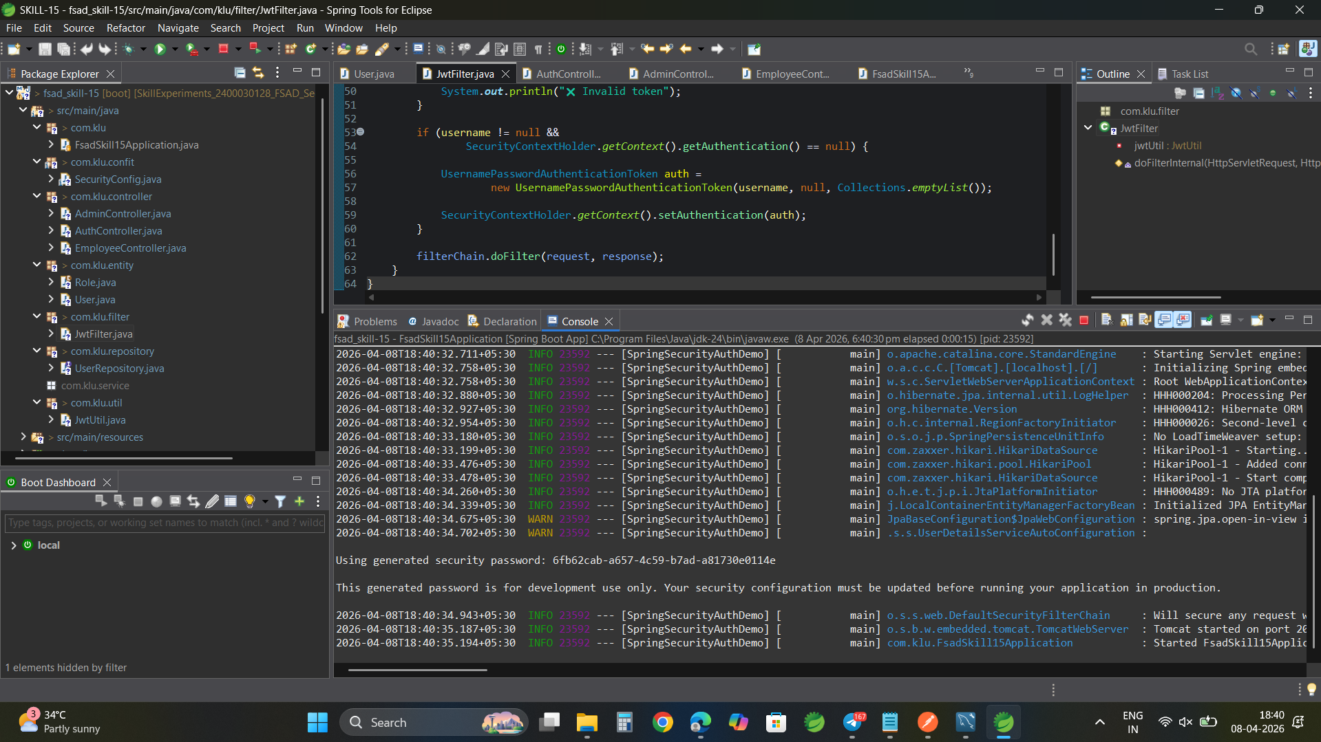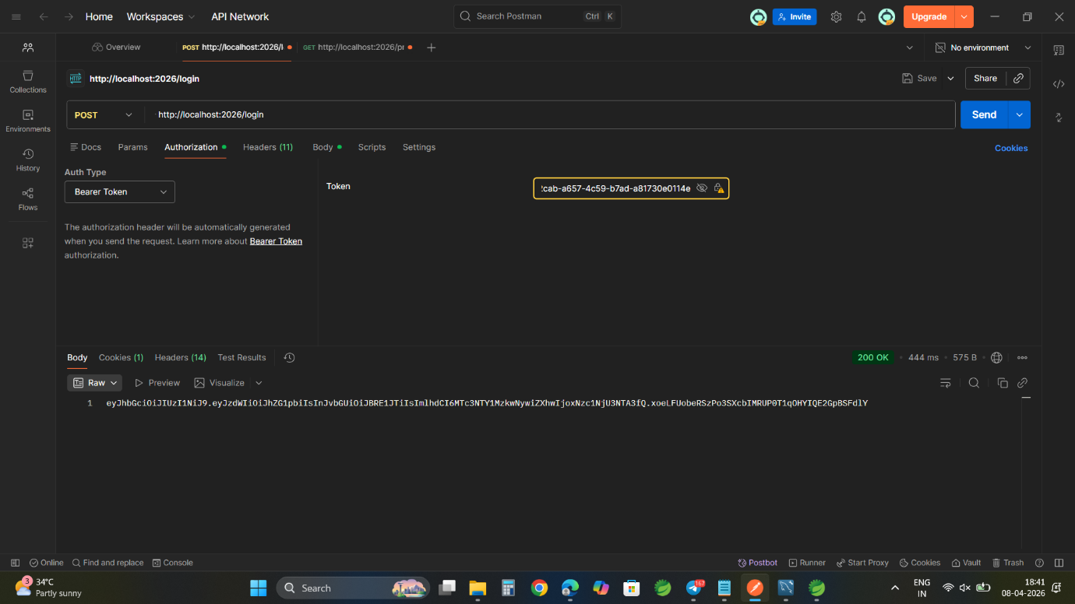

GITHUB LINK:
https://github.com/nagasubrahmanyammeka/SkillExperiments_2400030128_FSAD_Sec2/tree/main/SKILL-15

