SKILL-16: API Documentation for Full-Stack Student CRUD Application using Swagger
ID: 2400030128
Name: M. Naga Subrahmanyam
Section: 2
Scenario:
The student management system developed in SKILL – 12 includes full CRUD operations using Spring Boot REST APIs. To help testers, developers, and frontend teams understand each endpoint clearly, the backend must include Swagger/OpenAPI documentation. Swagger UI must display all Student CRUD endpoints, response structures, validation messages, and example requests.

Structure:
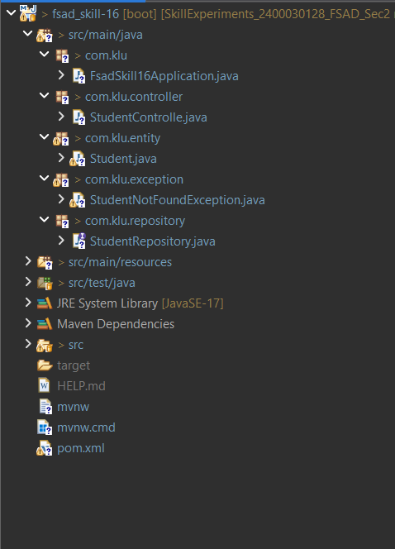

Codes:
Student.java:
package com.klu.entity;

import org.hibernate.annotations.*;

import jakarta.persistence.*;
import jakarta.persistence.Table;

@Entity
@Table(name = "student_skill16")
public class Student
{

@Id
@GeneratedValue(strategy = GenerationType.IDENTITY)
private Long id;

private String name;
private String email;
private String course;

public Long getId() {
return id;
}

public void setId(Long id) {
this.id = id;
}

public String getName() {
return name;
}

public void setName(String name) {
this.name = name;
}

public String getEmail() {
return email;
}

public void setEmail(String email) {
this.email = email;
}

public String getCourse() {
return course;
}

public void setCourse(String course) {
this.course = course;
}
}

StudentController.java:
package com.klu.controller;

import com.klu.entity.Student;
import com.klu.repository.StudentRepository;
import com.klu.exception.StudentNotFoundException;

import io.swagger.v3.oas.annotations.Operation;
import io.swagger.v3.oas.annotations.responses.ApiResponse;

import org.springframework.beans.factory.annotation.Autowired;
import org.springframework.web.bind.annotation.*;

import java.util.List;

@RestController
@RequestMapping("/students")
public class StudentControlle {

@Autowired
private StudentRepository repo;

@Operation(summary = "Add new student")
@ApiResponse(responseCode = "200", description = "Student created")
@PostMapping
public Student addStudent(@RequestBody Student student) {
return repo.save(student);
}

@Operation(summary = "Get all students")
@GetMapping
public List<Student> getAllStudents() {
return repo.findAll();
}

@Operation(summary = "Get student by ID")
@GetMapping("/{id}")
public Student getStudent(@PathVariable Long id) {
return repo.findById(id)
.orElseThrow(() -> new StudentNotFoundException("Student not found"));
}

@Operation(summary = "Update student")
@PutMapping("/{id}")
public Student updateStudent(@PathVariable Long id, @RequestBody Student student) {

Student existing = repo.findById(id)
.orElseThrow(() -> new StudentNotFoundException("Student not found"));

existing.setName(student.getName());
existing.setEmail(student.getEmail());
existing.setCourse(student.getCourse());

return repo.save(existing);
}

@Operation(summary = "Delete student")
@DeleteMapping("/{id}")
public String deleteStudent(@PathVariable Long id) {
repo.deleteById(id);
return "Student deleted successfully";
}
}
StudentNotFoundException.java:
package com.klu.exception;

public class StudentNotFoundException extends RuntimeException {
public StudentNotFoundException(String message) {
super(message);
}
}

StudentRepository.java:
package com.klu.repository;

import com.klu.entity.Student;
import org.springframework.data.jpa.repository.JpaRepository;

public interface StudentRepository extends JpaRepository<Student, Long> {
}

OUTPUTS:
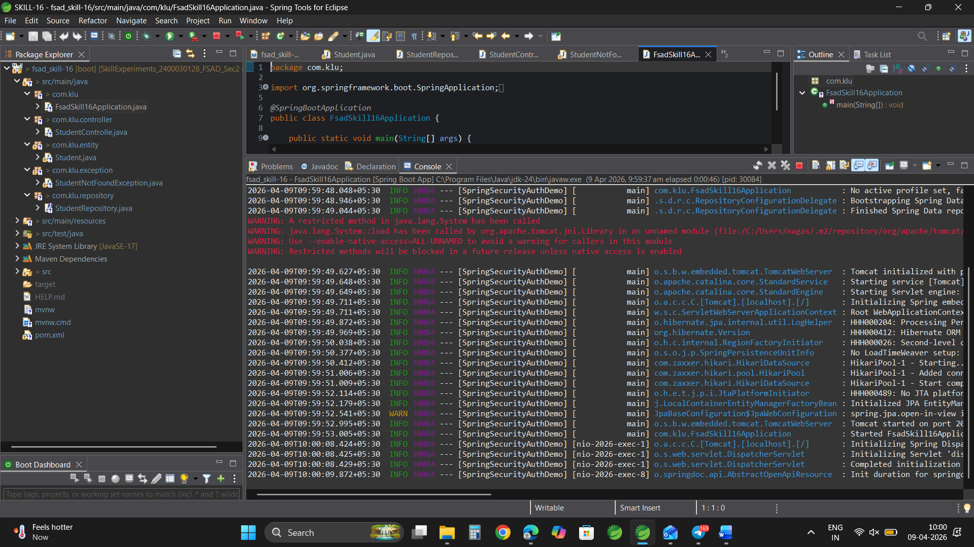
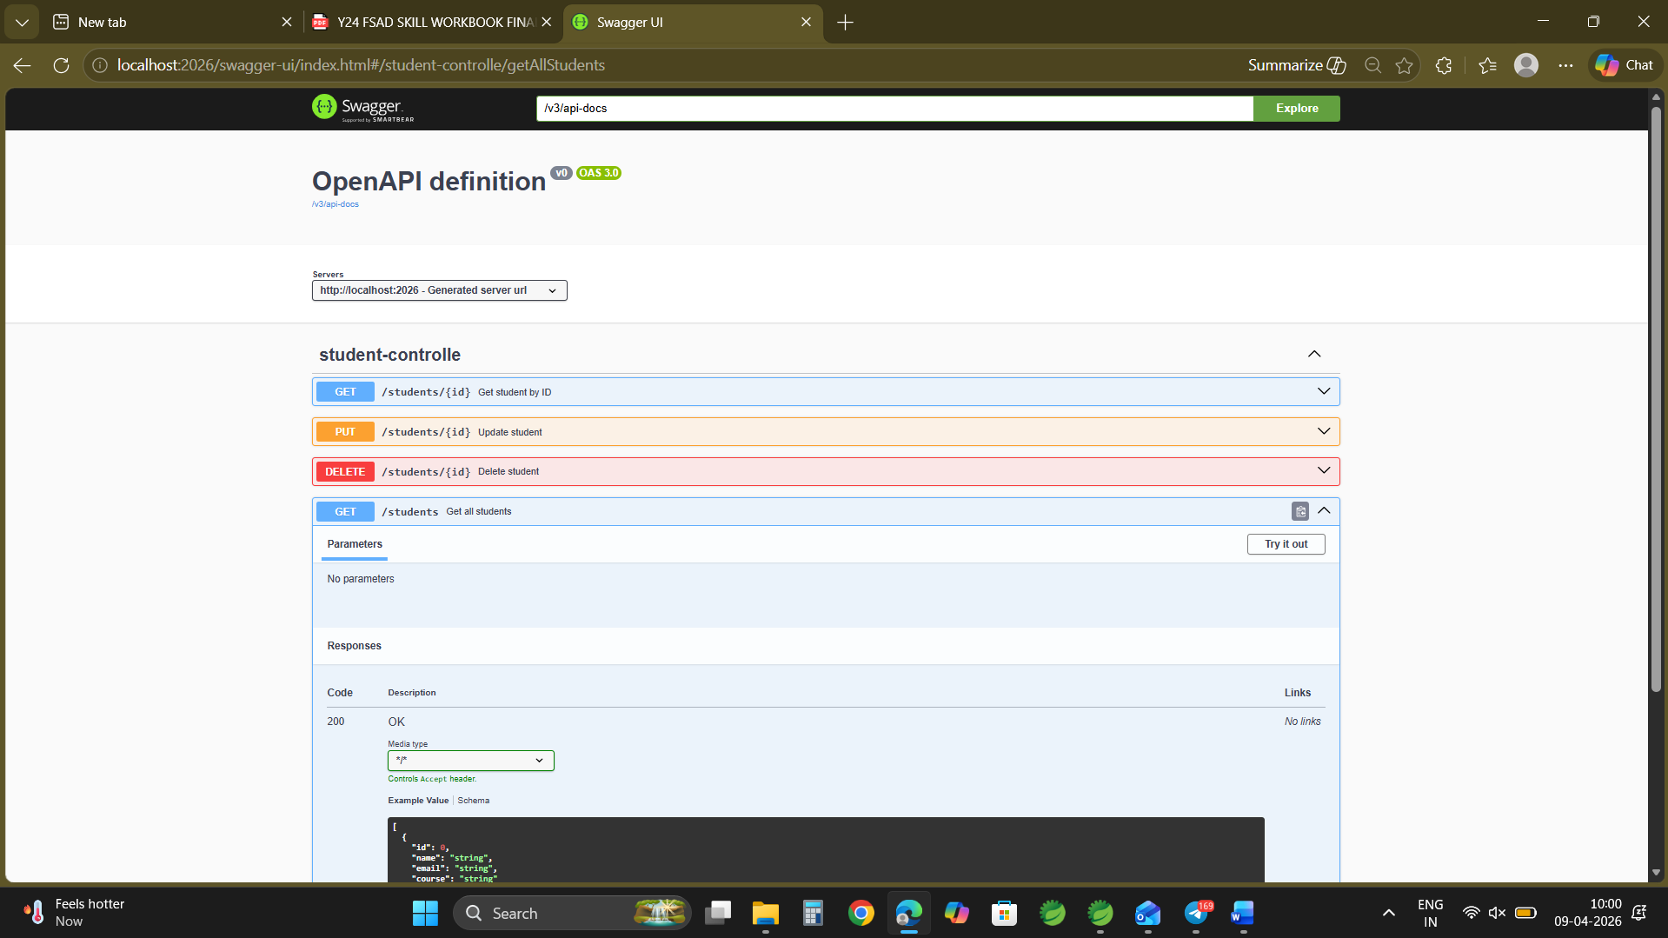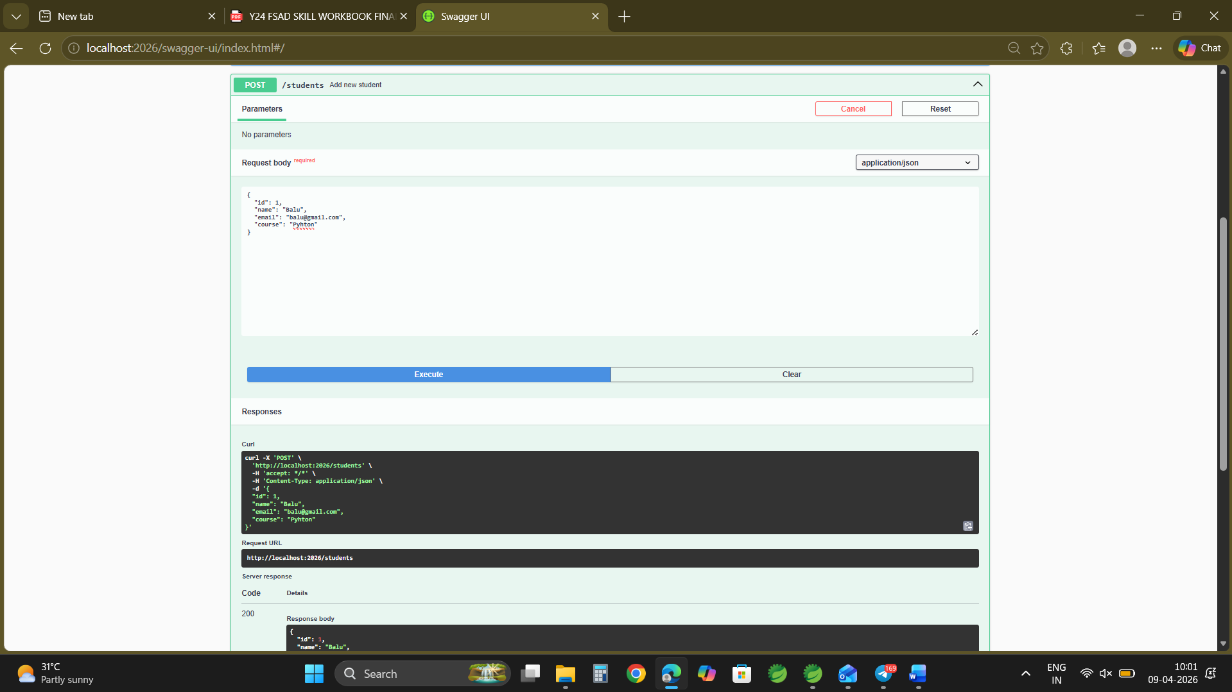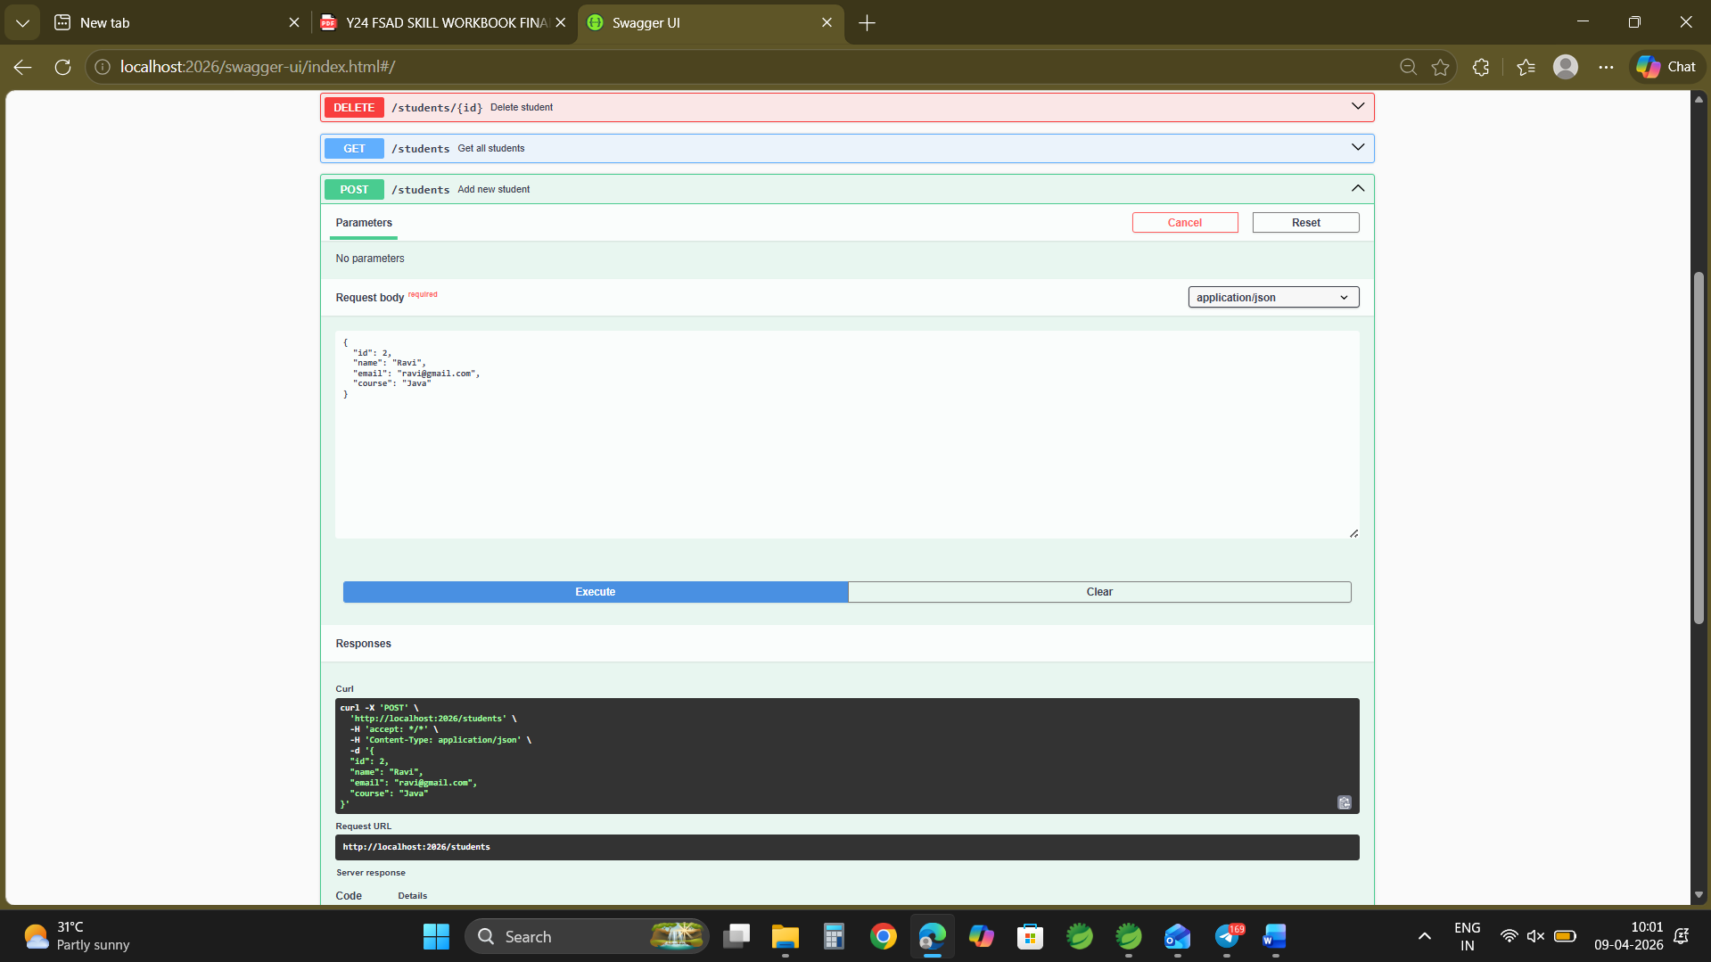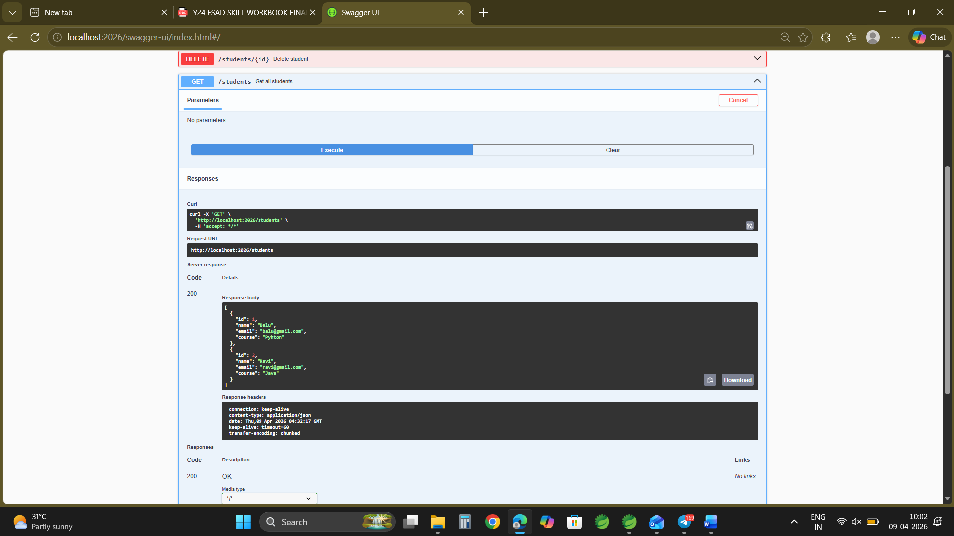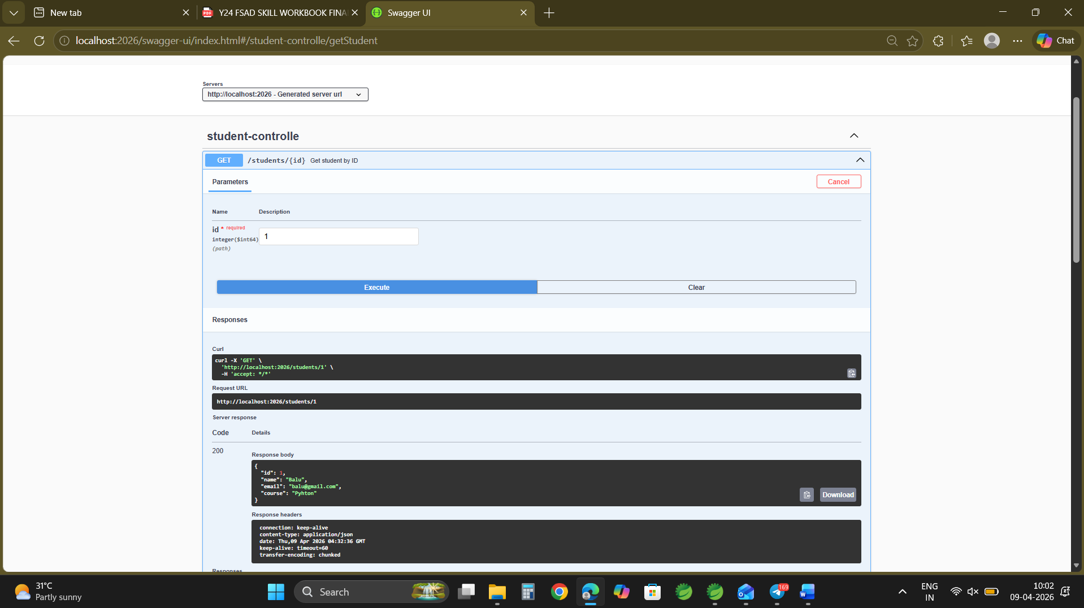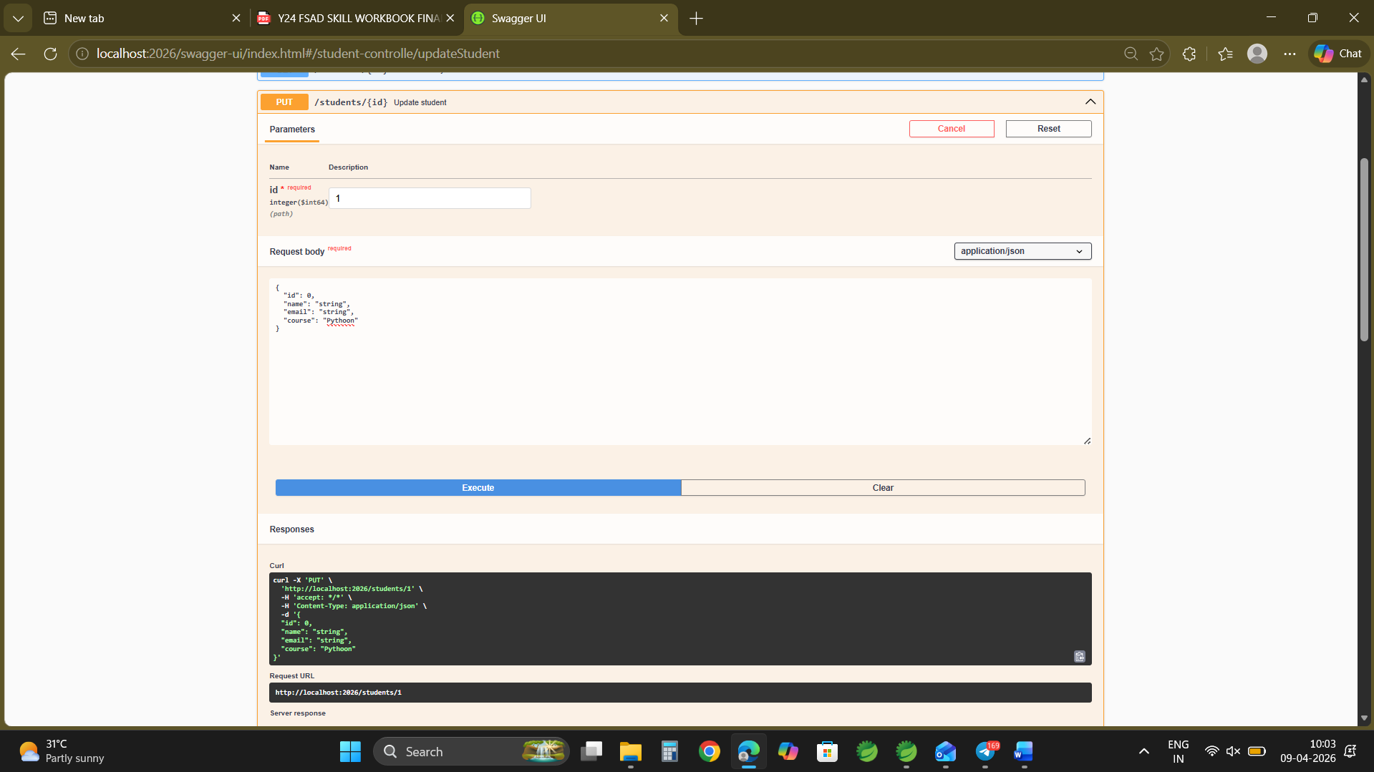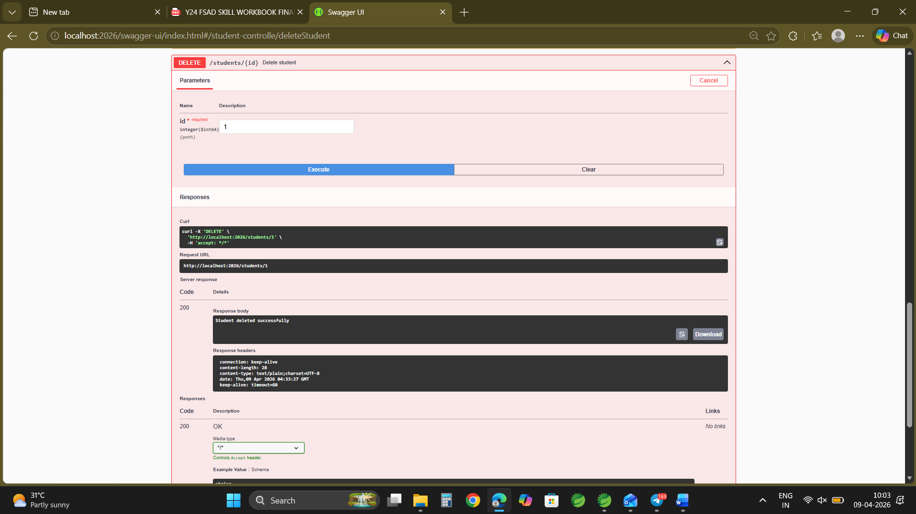

GITHUB LINK:
https://github.com/nagasubrahmanyammeka/SkillExperiments_2400030128_FSAD_Sec2/tree/main/SKILL-16

