SKILL -1 : GIT VERSION CONTROL
ID : 2400030128
Name : M.Naga Subrahmanyam

Tasks:
- Create a new project folder, initialize Git using git init, and configure Git with your username and email.
a. Create a new Project Folder
b. Initialize Git
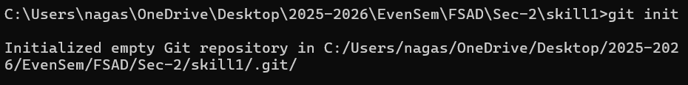
c. Configure git with username and email
d. Verify Configuration
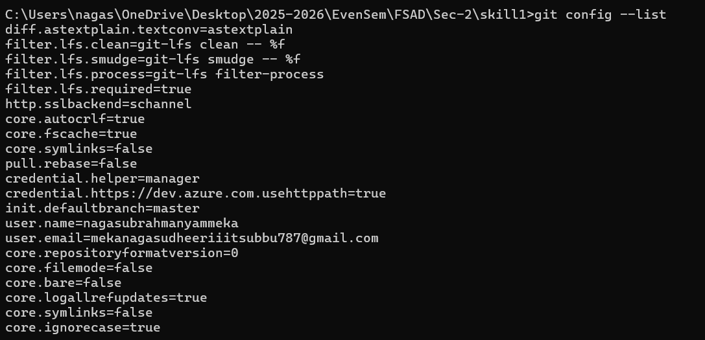

- Create two files (example: main.java, notes.txt) with sample content, check the repository status, and add them to staging.
- Creating Two files

- Adding Sample Content
- Check Repository Status
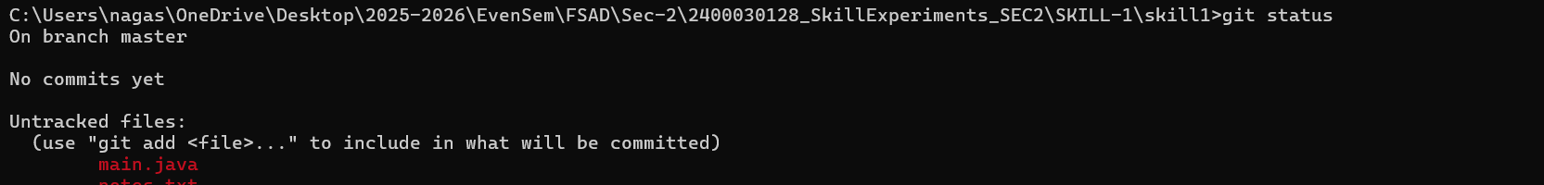
- Add files to Staging
- Checking status
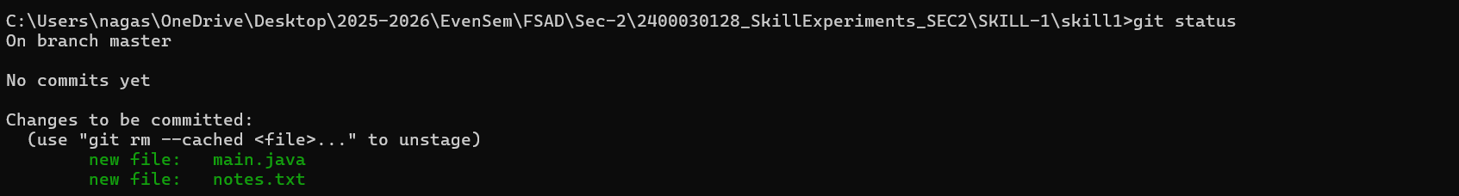

- Commit the staged files with a meaningful commit message

- Created a new repository on GitHub, connect your local repo using the remote URL and push the committed changes.
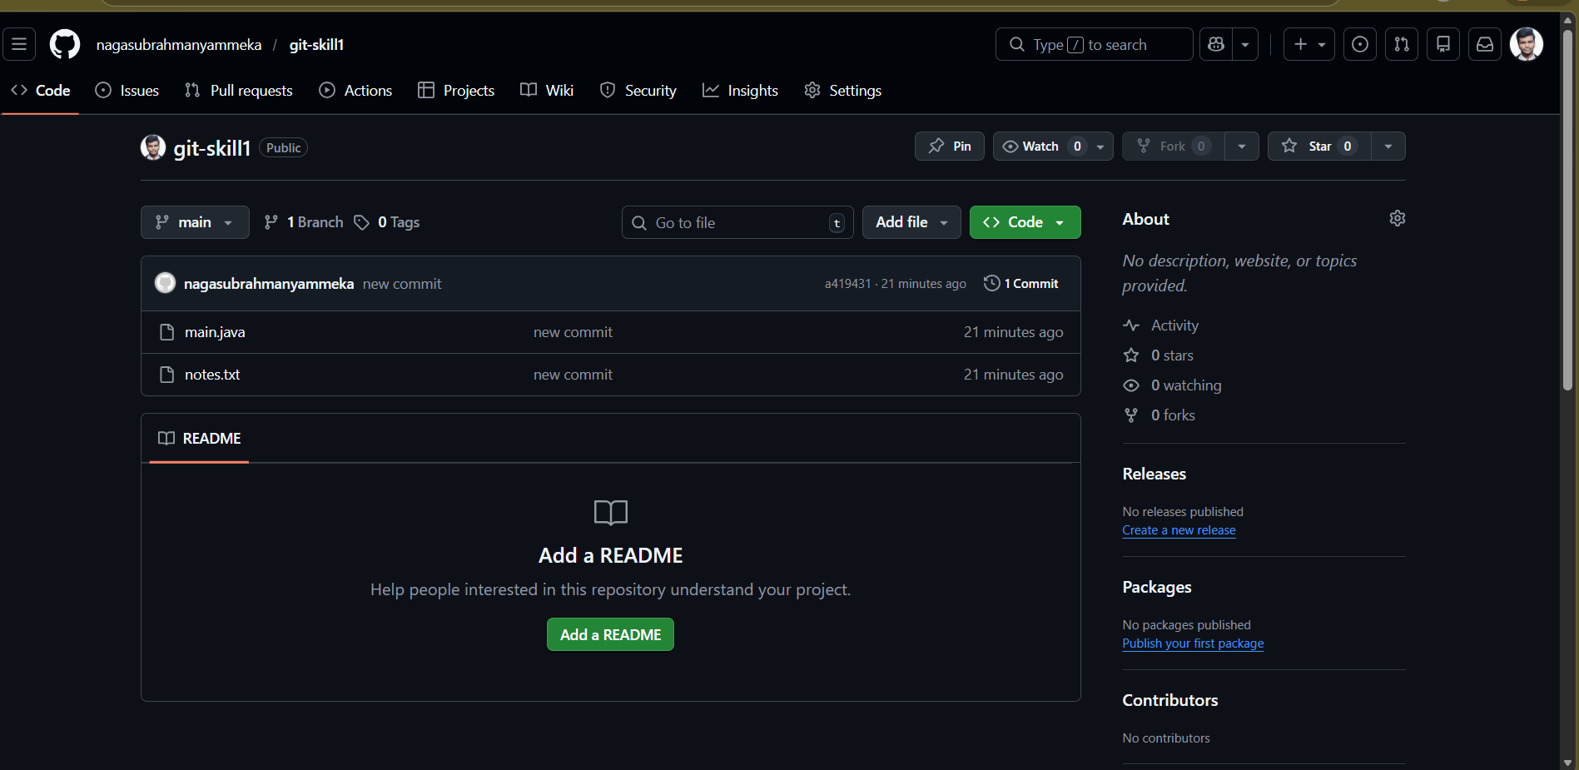

- Created the first branch (example: feature-update), make modifications, and add + commit the changes.
- Created and Switched to the branch
- Modified the file

- Add and commit

- Created a second branch (example: bug-fix), apply changes, and add + commit them.
- Switched to main
- Created new branch
- Modified the file
- Add and commit

- Switch back to the main branch and merge both branches one after the other
- Switched to main branch
- Merge feature branch
- Merge bug-fix branch

- If any merge conflict occurs, resolve it manually, commit the fix, and complete the merge
- Manually edited the conflicted file
- Added Resolved file

Final Log History:
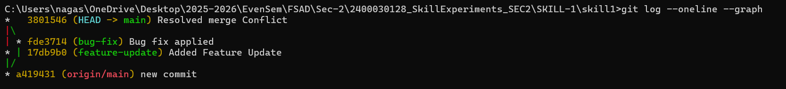

Viva Questions:
- Why is Git used in development?
- Git is a distributed version control system used to:
- Track changes in source code.
- Allow multiple developers to work on the same project simultaneously.
- Maintain version history (who changed what and when).
- Create and manage branches for features or bug fixes.

- What information is stored in Git configuration?
- Git configuration stores settings that control Git’s behavior.

- What is Maven and why is it used?
- Apache Maven is a build automation and project management tool mainly used for Java projects.
Uses:
- Manages project dependencies automatically.
- Standardizes project structure.
- Automates build process.

- What is the role of the POM.xml file?
- POM Stands for Project Object Model
It contains:
- Project metadata (name, version, groupId, artifactId)
- Dependencies (external libraries required)
- Build plugins
- Packaging type (jar, war, etc.)
- Build configurations

- Explain Maven Build Life Cycle

- Validate
- Compile
- Test
- Package
- Verify
- Install
- Deploy

