WEEK 8 PROJECT REPORT
RobustDeep: Real-Data FaceForensics++ Training and Evaluation
Vertical: A - Group I
Prepared by: Anvitha GR [R23EF028]
Bhoomika S [R23EF048]
D Nagasumukh [R23EF059]
Guide: Prof. Amarjit Khan | Center for Artificial Intelligence & Machine Learning
Project repository: RobustDeep local workspace

Executive Summary
RobustDeep is a real-data deepfake detection pipeline for FaceForensics++, Celeb-DF v2, and DFDC. This report records the first verified real-data execution: an approved FaceForensics++ c23 subset was downloaded, preprocessed with video-level splits, and evaluated with EfficientNet-B0. The best saved checkpoint produced validation AUROC 0.7000 and held-out test AUROC 0.5000. The test set contains only 8 videos, so these values are preliminary and must not be generalized to the full benchmark.
No Celeb-DF or DFDC videos were present in this run. Their metrics are therefore pending. Synthetic data remains restricted to the Stage-1 smoke test and is not included in the results below.

Assignment Requirements and Completion Status
Requirement | Evidence | Status
Prepare the three official datasets | Folder structure and official acquisition instructions are implemented. | Ready; data-dependent
Preprocess FaceForensics++ | 50 approved c23 videos imported; 35 train, 7 validation, 8 test videos yielded face crops. | Completed for subset
Train a real CNN baseline | EfficientNet-B0 checkpoint and real evaluation artifacts saved under artifacts/models. | Completed; interrupted 5-epoch run
Train an initial ViT/hybrid model | ViT-Small trained for one epoch on the same real FF++ split with saved evaluation artifacts. | Completed for subset
Train Celeb-DF and DFDC | No local videos or face crops were available for these datasets. | Pending data
Synthetic isolation | train.py rejects synthetic; smoke_test.py remains the synthetic entry point. | Verified

Preprocessing Pipeline
The official FaceForensics++ downloader was used with c23 compression and a 10-video request per source group. The downloaded original, Deepfakes, Face2Face, FaceSwap, and NeuralTextures videos were copied into the project’s expected raw folders. OpenCV Haar detection was selected because RetinaFace and MTCNN were not available in the active environment.
Observed preprocessing output:
- Dataset: FaceForensics++ c23 subset
- Raw videos imported: 50 across five project-supported groups
- Face crops: 35 train videos, 7 validation videos, 8 test videos
- Frames per video: 16; face crop size: 224 x 224 pixels
- Manifests: data/processed/faceforensics/{train,val,test}_manifest.json

Model and Training Setup
The evaluated model is EfficientNet-B0 with pretrained ImageNet weights, mean temporal aggregation, AdamW optimization, random seed 42, and real-data-only loading. The checkpoint is stored separately from synthetic smoke-test checkpoints at:
C:\Users\Lenovo\Downloads\robustdeep\robustdeep\artifacts\models\ff_c23_subset10\best.pt
Initial ViT-Small checkpoint:
C:\Users\Lenovo\Downloads\robustdeep\robustdeep\artifacts\models\ff_c23_vit_small_milestone\best.pt
The five-epoch CPU run completed through epoch 3 before termination. The best checkpoint was selected using validation AUROC; the final test set was evaluated once without target threshold tuning. The saved report marks the run as incomplete.

Saved Preliminary Evaluation Results
All values below are read from the saved real-data JSON artifacts and are labelled REAL DATA.
Dataset | Model | Split | Samples | Accuracy | AUROC | F1 / EER
FaceForensics++ c23 | EfficientNet-B0 | Validation | 7 | 0.8571 | 0.7000 | 0.9091 / 0.5500
FaceForensics++ c23 | EfficientNet-B0 | Test | 8 | 0.6250 | 0.5000 | 0.7692 / 0.2500
FaceForensics++ c23 | ViT-Small | Validation | 7 | 0.7143 | 0.9000 | 0.8333 / 0.1000
FaceForensics++ c23 | ViT-Small | Test | 8 | 0.7500 | 0.0000 | 0.8571 / 1.0000
Celeb-DF v2 | EfficientNet-B0 | Test | Pending | Pending | Pending | Pending
DFDC | EfficientNet-B0 | Test | Pending | Pending | Pending | Pending
The FF++ test confusion matrix is TN=0, FP=2, FN=1, TP=5 at the fixed 0.5 decision threshold. Because the test sample is small and imbalanced, the metrics are evidence of this subset only, not a full-dataset benchmark claim.

Training Log Evidence
The best validation checkpoint was saved after the second completed epoch with validation AUROC 0.7000 and validation accuracy 0.8571. A later completed epoch had lower validation AUROC, so the earlier checkpoint was retained. The final export was interrupted, but the saved checkpoint was independently evaluated and its test artifacts were preserved.
The initial ViT-Small run completed one epoch with validation AUROC 0.9000 and test AUROC 0.0000. The validation/test gap is recorded as a failure-analysis result, not hidden by reporting validation performance as the final benchmark.

Results Figures
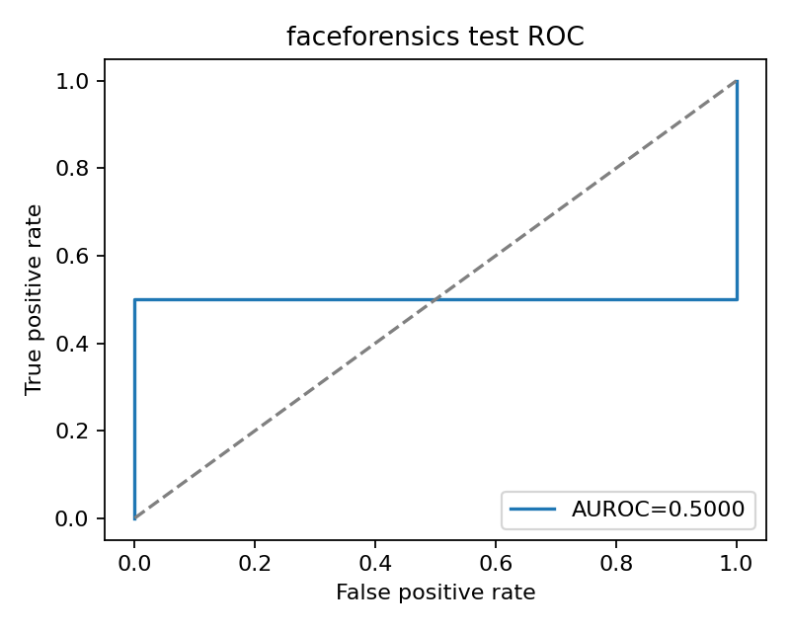
Figure 1. REAL DATA FaceForensics++ test ROC curve.
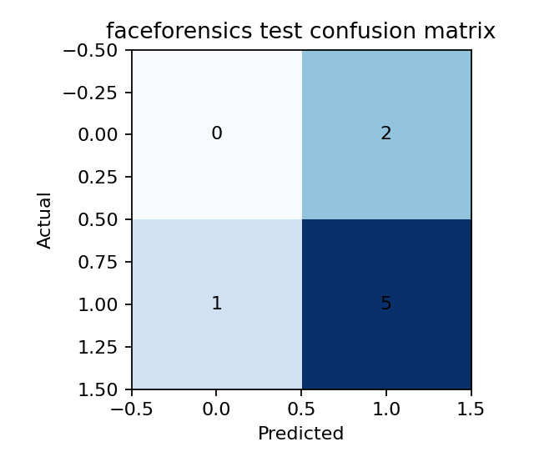
Figure 2. REAL DATA FaceForensics++ test confusion matrix at threshold 0.5.
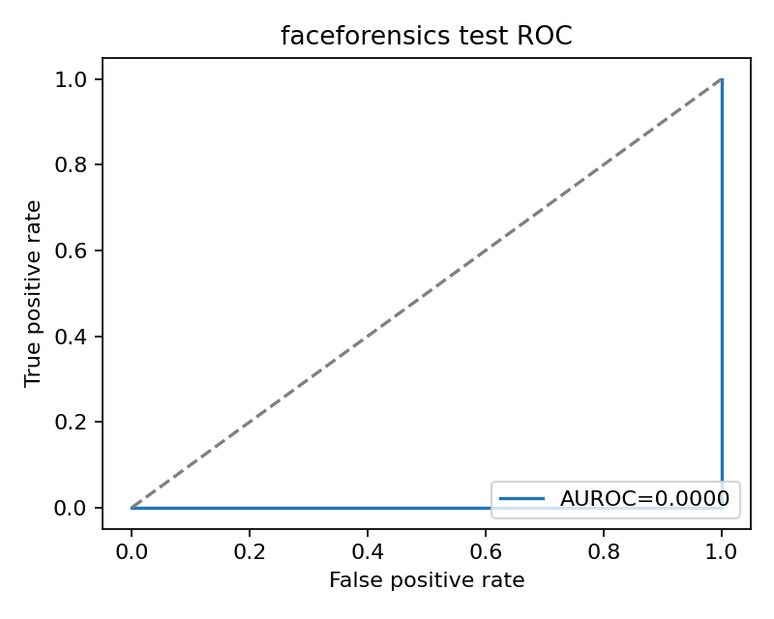
Figure 3. REAL DATA FaceForensics++ ViT-Small test ROC curve.
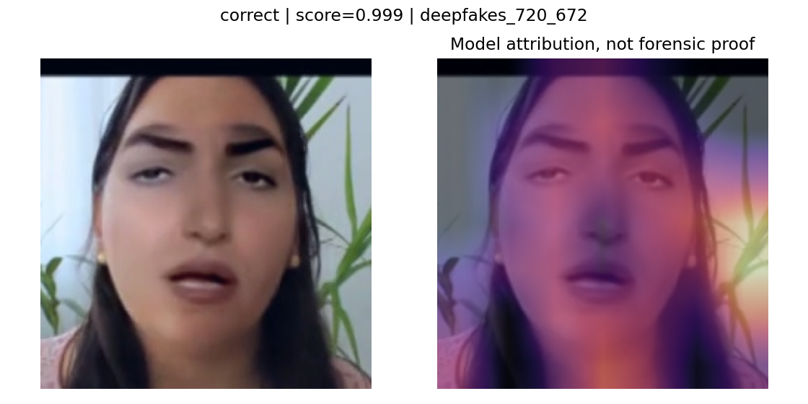
Figure 4. Model attribution visualization; attribution is not forensic proof.

Limitations and Next Steps
- Complete a stable multi-epoch run on a GPU or a smaller controlled subset, then compare only using the untouched test split.
- The ViT-Small validation/test gap is a failure-analysis result; do not report the validation AUROC as its final test score.
- Acquire and preprocess licensed Celeb-DF v2 and DFDC subsets before reporting cross-dataset or three-dataset results.
- Increase the number and identity diversity of videos; the current FF++ test set has only 8 videos.
- Run the six-pair matrix only after source and target face crops exist for all three official datasets.
- Do not treat the validation AUROC as the final benchmark result; the held-out test AUROC is the relevant reported value.
- Keep synthetic smoke-test metrics in the explicitly labelled non-research dashboard section.

Reproducibility and Repository
Primary commands used for this report:
python scripts/preprocess_faces.py --dataset faceforensics --max-videos 50 --frames-per-video 16
python scripts/train.py --dataset faceforensics --model efficientnet_b0 --epochs 5 --max-videos 50 --experiment-id ff_c23_subset10
python scripts/train.py --dataset faceforensics --model vit_small --epochs 1 --max-videos 50 --num-workers 0 --experiment-id ff_c23_vit_small_milestone
python scripts/evaluate.py --dataset faceforensics --split test --model efficientnet_b0 --checkpoint artifacts/models/ff_c23_subset10/best.pt
python scripts/run_explainability.py --checkpoint artifacts/models/ff_c23_subset10/best.pt --dataset faceforensics --split test --model efficientnet_b0 --max-videos 8
The dashboard reads saved real outputs from artifacts/models and is available at http://localhost:8501 when Streamlit is running.

References
- FaceForensics++ official repository and access instructions: https://github.com/ondyari/FaceForensics
- FaceForensics++ access form: https://docs.google.com/forms/d/e/1FAIpQLSdRRR3L5zAv6tQ_CKxmK4W96tAab_pfBu2EKAgQbeDVhmXagg/viewform
- Rössler et al., FaceForensics++: Learning to Detect Manipulated Facial Images, ICCV 2019: https://arxiv.org/abs/1901.08971
- RobustDeep dataset protocol: docs/dataset_protocol.md
- RobustDeep experiment protocol: docs/experiment_protocol.md

Conclusion
The project now demonstrates a reproducible real-data FaceForensics++ path from approved download through face preprocessing, checkpoint storage, held-out evaluation, visual artifacts, and explainability outputs. The saved results are useful preliminary evidence, but they are limited by the small subset and interrupted training run. Celeb-DF v2, DFDC, and the complete six-pair research matrix remain pending until their licensed data are supplied and processed.

