WEEK 8 PROJECT REPORT
Deepfake Detection: Preprocessing Pipeline and Baseline Models
Vertical: A - Group I
Prepared by: Anvitha GR [R23EF028]
Bhoomika S [R23EF048]
D Nagasumukh [R23EF059]
Guide: Prof. Amarjit Khan | Center for Artificial Intelligence & Machine Learning

Project repository: https://github.com/nagasumukh01/RIIO-1

Executive Summary
This project implements a reusable video-to-face preprocessing pipeline and a deepfake classification framework with EfficientNet CNN and Vision Transformer (ViT) model options. The repository contains configuration and code for preprocessing FaceForensics++, Celeb-DF v2, and DFDC, as well as saved model-evaluation artifacts and experiment figures. The available workspace does not contain the three real datasets or evidence that preprocessing and training were completed on each one. Therefore, the metrics below are reported as preliminary saved runs, not as confirmed benchmark results for those named datasets.

Assignment Requirements and Completion Status
Requirement | Evidence in repository | Status
Preprocess all three datasets | Shared preprocessing implementation and dataset-specific extraction scripts/configuration are present. Real dataset files are not in the workspace. | Implemented; real-dataset execution not verified
Train a baseline CNN | EfficientNet-B0 and EfficientNet-B4 evaluation artifacts are present; training history is available for a small synthetic run. | Model and pipeline present; full real-data run not verified
Train an initial ViT or hybrid model | ViT-Small and ViT-Base evaluation artifacts are present; model options are configured. | Model and pipeline present; full real-data run not verified
Report within-dataset accuracy and AUROC | Saved 50-sample evaluation files report accuracy/AUROC. Their `bb_*` dataset tags do not establish which licensed benchmark dataset was used. | Preliminary figures reported with provenance caveat
Provide evidence and repository link | Existing figures are embedded in this report; the repository link is provided above. | Partially met; add fresh training screenshots for final submission

Preprocessing Pipeline
The core VideoPreprocessor flow validates and opens a video, samples frames, detects the largest face, expands the crop with a configurable margin, resizes the face to 224 Ã— 224 pixels, and writes frame crops plus video/frame identifiers. MTCNN is preferred when installed; OpenCV Haar detection and a center-crop fallback are available. The project configuration specifies uniform sampling, 16 frames per video, a 0.30 face margin, a video-level 70/15/15 train/validation/test split, and seed 42. The separate face-extraction script defaults to 20 frames per video, so use one documented setting consistently when running the final experiments.

Dataset coverage
â€¢ FaceForensics++: extraction paths are defined for original videos and four manipulation methods. Access requires the dataset academic agreement.
â€¢ Celeb-DF v2: extraction paths cover real and synthesized video folders. Use is subject to the research terms.
â€¢ DFDC: the extractor reads metadata.json and supports a configurable video subset; Kaggle competition terms apply.
The processing code is shared across datasets to keep image size and face-cropping behavior consistent. Splits should be made by video before frames are extracted; frames from one source video must never appear in multiple splits.

Model and Training Setup
The baseline CNN options are EfficientNet-B0 and EfficientNet-B4. The transformer options are ViT-Small/16 and ViT-Base/16; a hybrid option is also represented in the model configuration. The recorded training configuration uses AdamW with learning rate 0.0001, weight decay 0.01, cosine learning-rate scheduling, batch size 16, up to 30 epochs, cross-entropy loss, and early stopping based on validation AUROC. The configured random seed is 42.

Saved Preliminary Evaluation Results
The following values are read from saved test-metric JSON files. Each evaluation contains 50 samples (27 positive and 23 negative). The file tags use `bb_*`; the workspace does not document these as FaceForensics++, Celeb-DF, or DFDC. Do not cite them as results on a named real benchmark without confirming data provenance and rerunning the evaluation on the corresponding held-out split.
Model | Evaluation tag | Samples | Accuracy | AUROC | F1
EfficientNet-B0 | bb_efficientnet_b0_test | 50 | 0.720 | 1.000 | 0.794
EfficientNet-B4 | bb_efficientnet_b4_test | 50 | 1.000 | 1.000 | 1.000
ViT-Small | bb_vit_small_test | 50 | 1.000 | 1.000 | 1.000
ViT-Base | bb_vit_base_test | 50 | 1.000 | 1.000 | 1.000
Interpretation: the recorded AUROC of 1.000 alongside 0.720 accuracy for EfficientNet-B0 indicates the ranking metric and the fixed 0.5 decision threshold tell different stories. The perfect scores for the other 50-sample runs are preliminary and should be treated cautiously until data provenance, split independence, and the evaluation protocol are confirmed. A separate synthetic smoke test also reports 1.000 accuracy/AUROC for 30 samples per model; it is a software check and is not a real-dataset result.

Training Log Evidence
A saved three-epoch training history associated with the synthetic experiment shows training accuracy rising from 0.854 to 1.000 and validation accuracy rising from 0.367 to 1.000. Validation AUROC is recorded as 0.917, 1.000, and 1.000 across the three epochs. Because this run is short and synthetic, it demonstrates the training loop and logging path only; it is not evidence of full benchmark training.

Results Figures
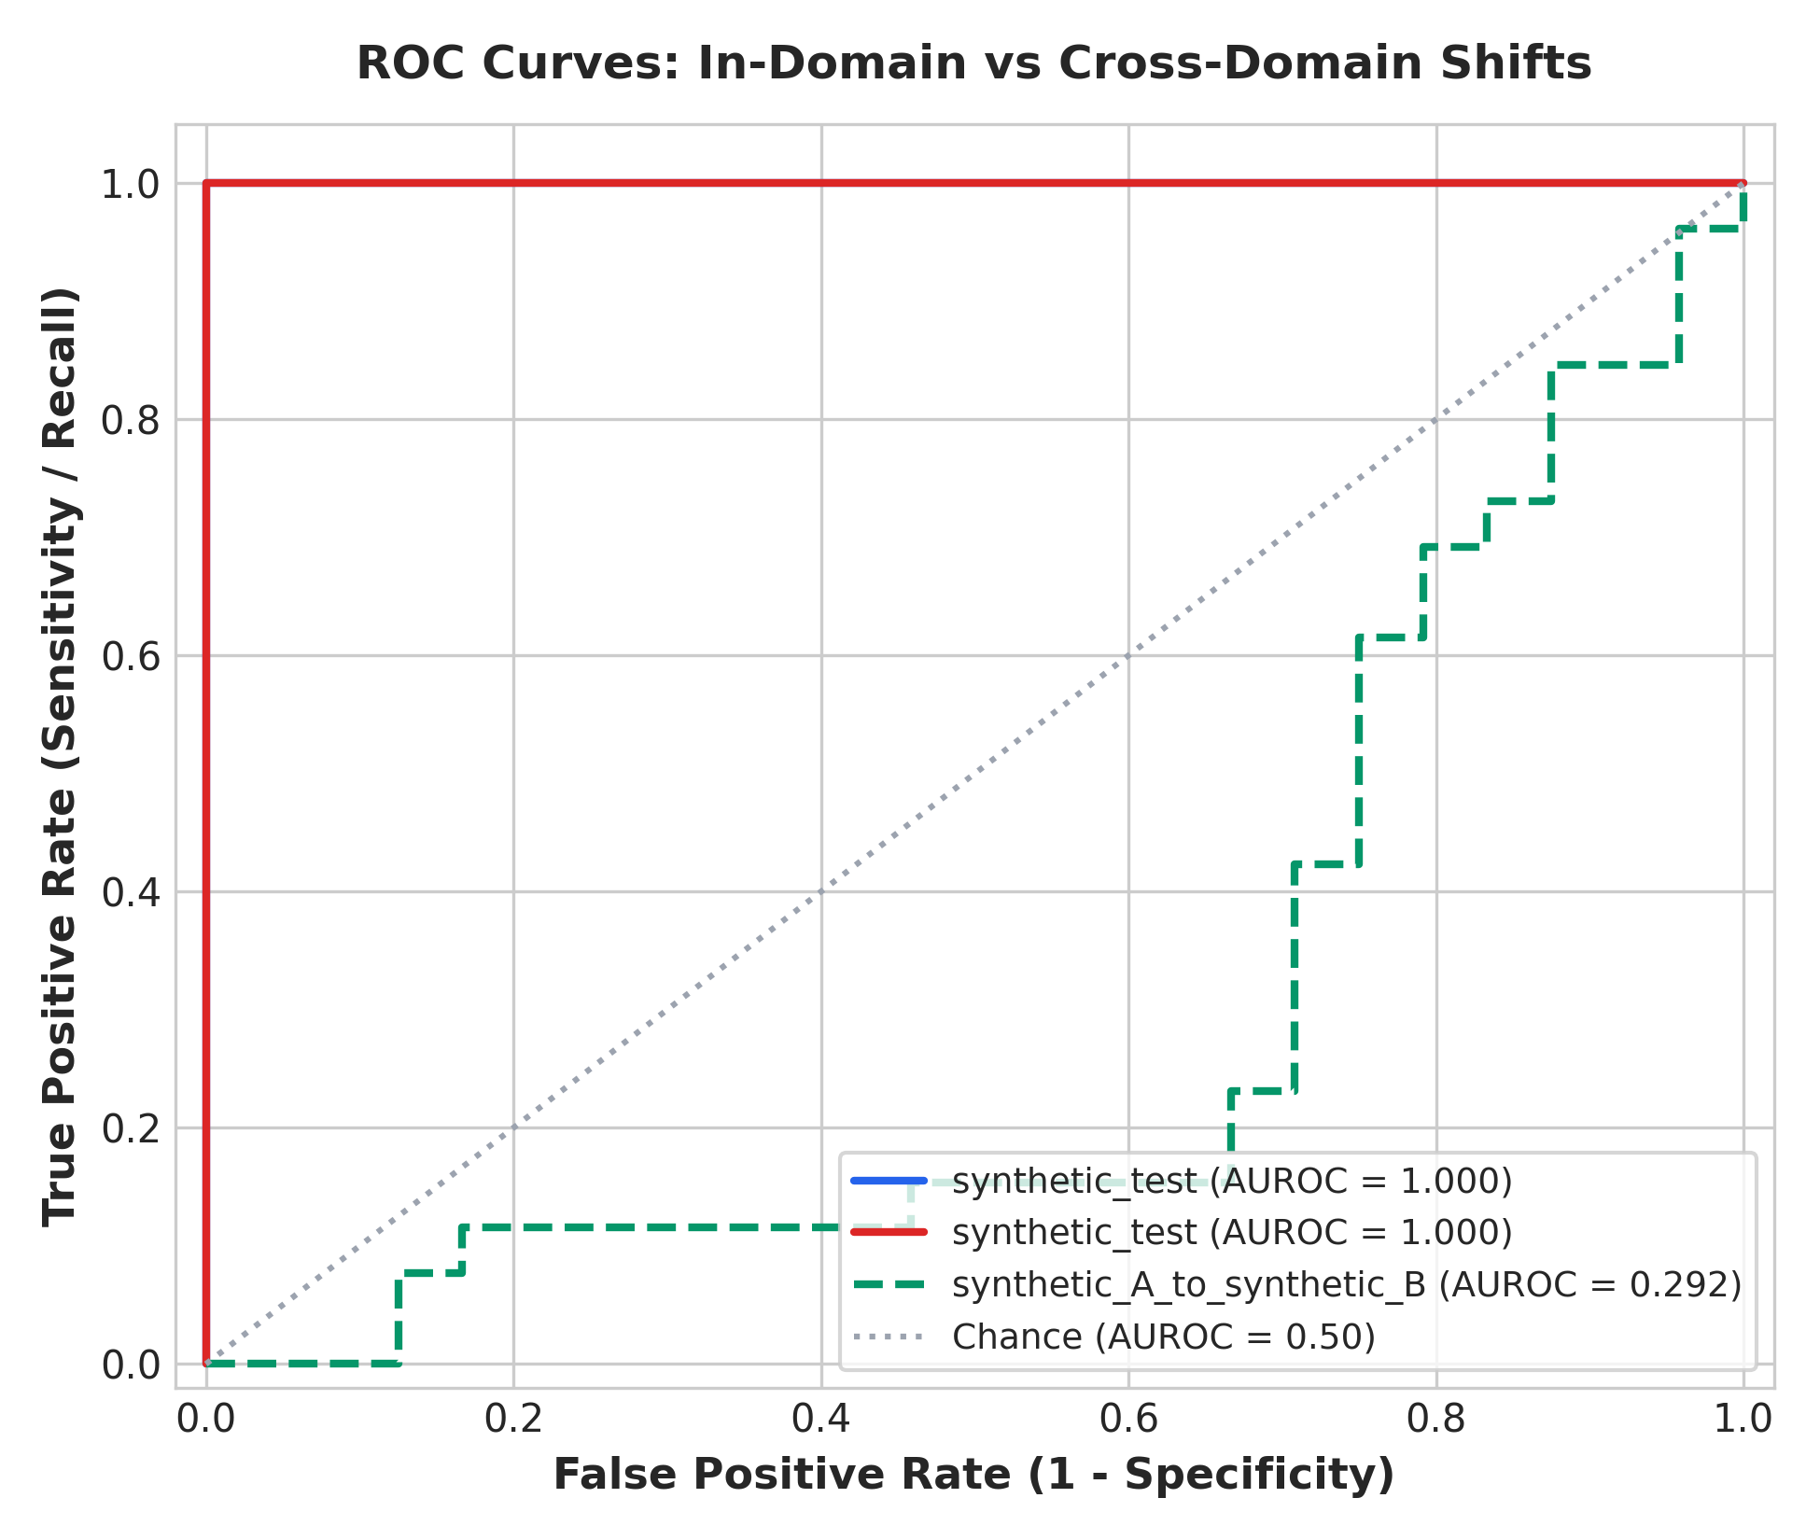
Figure 1. Stored ROC visualization. The labeled synthetic cross-domain curve has AUROC 0.292; synthetic smoke-test curves are not real-benchmark evidence.
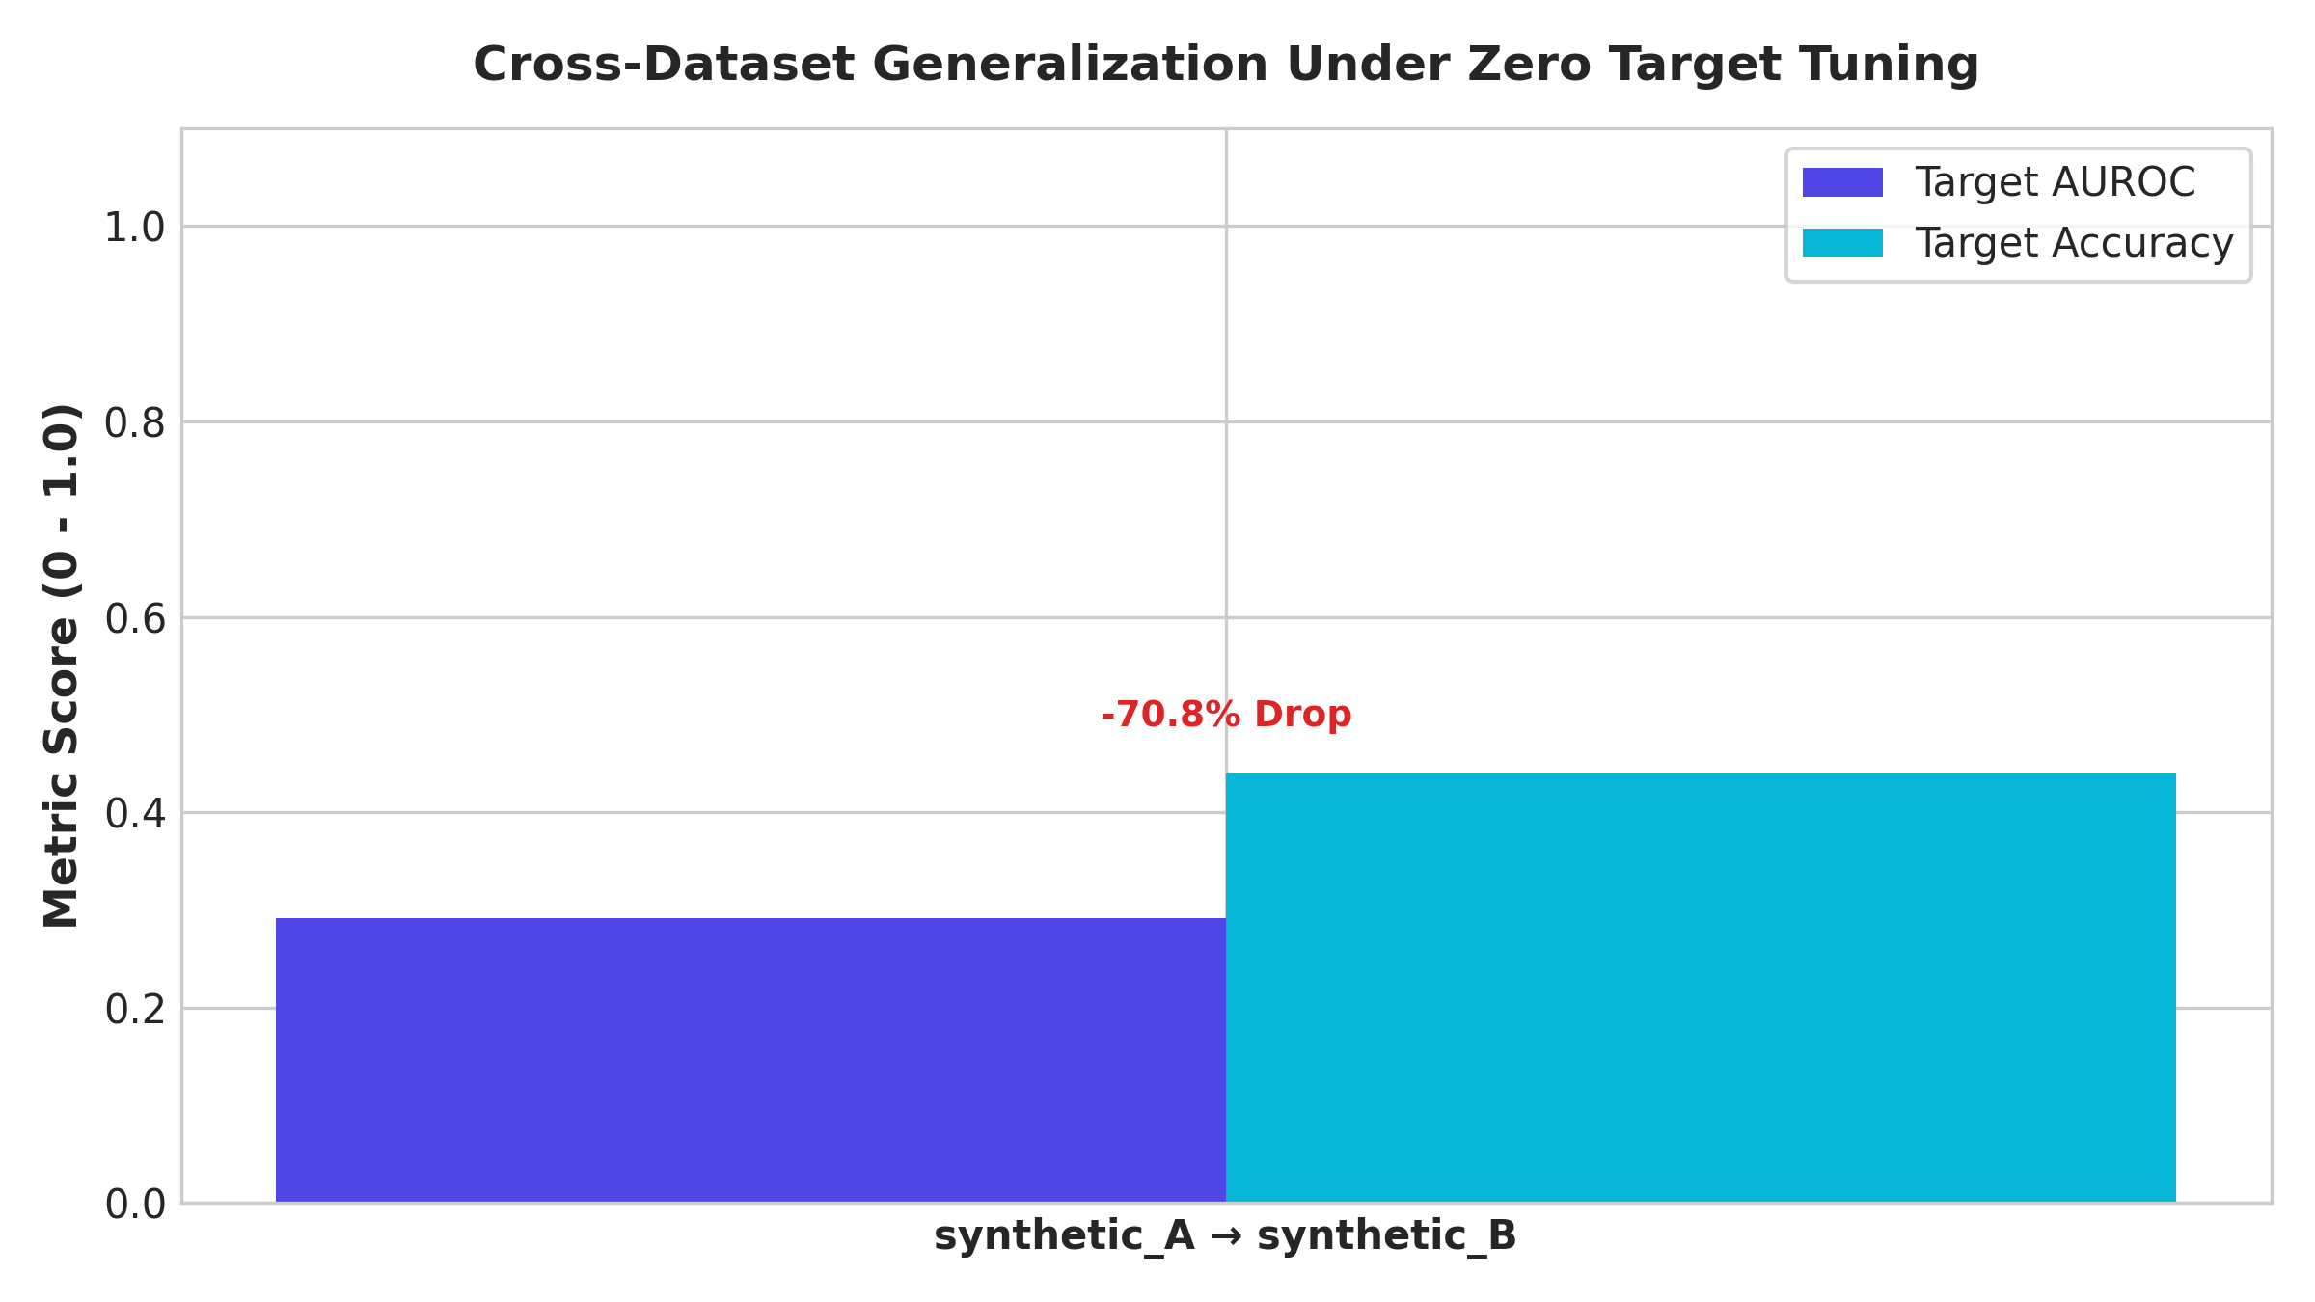
Figure 2. Stored cross-dataset visualization. Its displayed synthetic A to synthetic B result is a demo result, not one of the three licensed benchmarks.
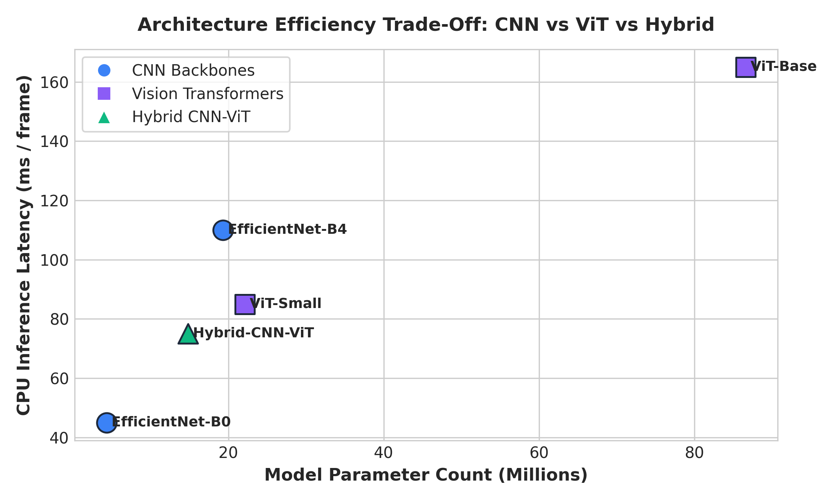
Figure 3. Stored model architecture efficiency comparison.

Limitations and Next Steps
â€¢ Acquire the licensed FF++, Celeb-DF v2, and DFDC data and record dataset versions, sample counts, and class balance.
â€¢ Run preprocessing on all three datasets and record successfully processed videos, extracted face frames, and failures.
â€¢ Create deterministic video-level splits before frame extraction; check identity leakage where metadata permits.
â€¢ Train at least one CNN and one ViT/hybrid model on a named dataset, then evaluate on that datasetâ€™s held-out test split.
â€¢ Report accuracy and AUROC alongside sample counts, precision, recall, F1, confusion matrix, threshold, and the exact dataset/split.
â€¢ Capture screenshots of preprocessing output, training logs, and the final accuracy/AUROC results for the submission package.

Reproducibility and Repository
Repository: https://github.com/nagasumukh01/RIIO-1
The training entry point is scripts/train.py. The current training script explicitly supports the synthetic dataset path; its non-synthetic training datasets must be connected before claiming end-to-end real-benchmark training. Face extraction is available through scripts/preprocess_faces.py, and dataset access/setup guidance is in scripts/prepare_data.py and docs/dataset_protocol.md.

Conclusion
The project has the main Week 8 software components in place: a configurable face preprocessing pipeline, EfficientNet CNN and ViT model choices, training/evaluation code, experiment artifacts, and an accessible repository. The remaining evidence gap is execution on the actual three licensed datasets. The saved metrics and figures are useful preliminary progress, but the final submission should add verified named-dataset preprocessing counts and held-out accuracy/AUROC results before marking the empirical requirements complete.

