**SELENIUM WEBHANDLERS**

1)CODE:

package com.selenium.day3.ex1;

import org.openqa.selenium.By;

import org.openqa.selenium.JavascriptExecutor;

import org.openqa.selenium.WebDriver;

import org.openqa.selenium.WebElement;

import org.openqa.selenium.chrome.ChromeDriver;

import org.openqa.selenium.chrome.ChromeOptions;

import org.openqa.selenium.interactions.Actions;

import io.github.bonigarcia.wdm.WebDriverManager;

public class d5c1 {

public static void main(String[] args) throws InterruptedException {

WebDriverManager.*chromedriver*().setup();

ChromeOptions co=new ChromeOptions();

co.addArguments("--remote-allow-origins=*");

WebDriver driver=new ChromeDriver(co);

//open an url

driver.get("https://demoqa.com/droppable/");

//maximise

driver.manage().window().maximize();

Thread.*sleep*(3000);

JavascriptExecutor js = (JavascriptExecutor) driver;

js.executeScript("window.scrollBy(0,1000)","");

//class and obj

Actions a=new Actions(driver);

WebElement drag=driver.findElement(By.*id*("draggable"));

WebElement drop=driver.findElement(By.*id*("droppable"));

a.clickAndHold(drag).release(drop).build().perform();

}

}

OUTPUT:

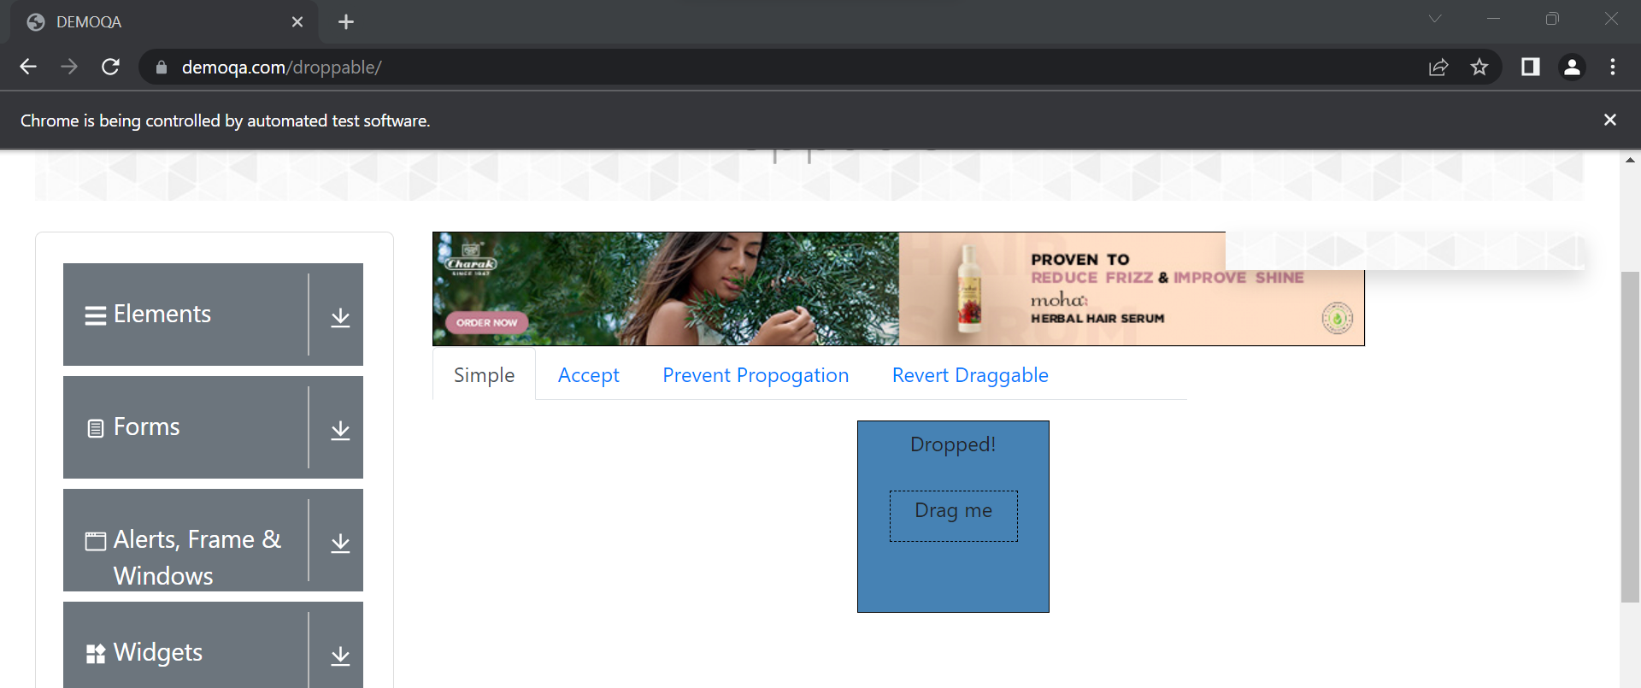

2)CODE:

package com.selenium.day3.ex1;

import org.openqa.selenium.By;

import org.openqa.selenium.JavascriptExecutor;

import org.openqa.selenium.WebDriver;

import org.openqa.selenium.WebElement;

import org.openqa.selenium.chrome.ChromeDriver;

import org.openqa.selenium.chrome.ChromeOptions;

import org.openqa.selenium.interactions.Actions;

import io.github.bonigarcia.wdm.WebDriverManager;

public class d5c2 {

public static void main(String[] args) throws InterruptedException {

WebDriverManager.chromedriver().setup();

ChromeOptions co=new ChromeOptions();

co.addArguments("--remote-allow-origins=*");

WebDriver driver=new ChromeDriver(co);

//open an url

driver.get("https://jqueryui.com/droppable/");

//maximise

driver.manage().window().maximize();

Thread.sleep(3000);

JavascriptExecutor js = (JavascriptExecutor) driver;

js.executeScript("window.scrollBy(0,1000)","");

//switch to frame

driver.switchTo().frame(0);

//class and obj

Actions a=new Actions(driver);

WebElement drag=driver.findElement(By.id("draggable"));

WebElement drop=driver.findElement(By.id("droppable"));

a.clickAndHold(drag).release(drop).build().perform();

}

}

OUTPUT:

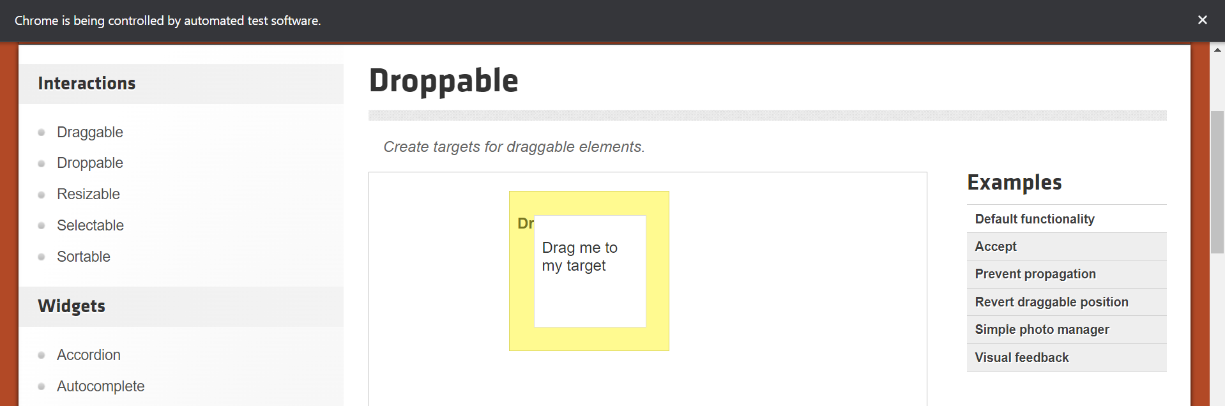

3)CODE:

package com.selenium.day3.ex1;

import org.openqa.selenium.Alert;

import org.openqa.selenium.By;

import org.openqa.selenium.JavascriptExecutor;

import org.openqa.selenium.WebDriver;

import org.openqa.selenium.WebElement;

import org.openqa.selenium.chrome.ChromeDriver;

import org.openqa.selenium.chrome.ChromeOptions;

import io.github.bonigarcia.wdm.WebDriverManager;

public class d5c3 {

public static void main(String[] args) throws InterruptedException {

WebDriverManager.chromedriver().setup();

ChromeOptions co=new ChromeOptions();

co.addArguments("--remote-allow-origins=*");

WebDriver driver=new ChromeDriver(co);

//open an url

driver.get("https://demo.guru99.com/test/delete_customer.php");

//maximise

driver.manage().window().maximize();

WebElement fn=driver.findElement(By.name("cusid"));

fn.sendKeys("401");

WebElement sub=driver.findElement(By.name("submit"));

sub.click();

//dynamic data

Alert alert1=driver.switchTo().alert();

alert1.dismiss();

//to clear text box

fn.clear();

fn.sendKeys("402");

sub.click();

Alert alert2=driver.switchTo().alert();

alert2.accept();

Alert alert3=driver.switchTo().alert();

String message=alert3.getText();

alert3.accept();

System.out.println(message);

}

}

OUTPUT:

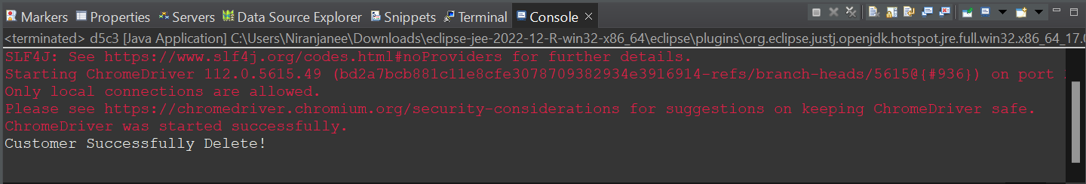

4)CODE:

package com.selenium.day3.ex1;

import org.openqa.selenium.By;

import org.openqa.selenium.JavascriptExecutor;

import org.openqa.selenium.WebDriver;

import org.openqa.selenium.WebElement;

import org.openqa.selenium.chrome.ChromeDriver;

import org.openqa.selenium.chrome.ChromeOptions;

import io.github.bonigarcia.wdm.WebDriverManager;

public class d5c4 {

public static void main(String[] args) throws InterruptedException {

WebDriverManager.chromedriver().setup();

ChromeOptions co=new ChromeOptions();

co.addArguments("--remote-allow-origins=*");

WebDriver driver=new ChromeDriver(co);

//open an url

driver.get("https://www.abhibus.com/bus-ticket-booking/");

//maximise

driver.manage().window().maximize();

Thread.sleep(3000);

JavascriptExecutor js = (JavascriptExecutor) driver;

js.executeScript("window.scrollBy(0,1000)","");

WebElement from=driver.findElement(By.id("source"));

from.sendKeys("coimbatore");

WebElement to=driver.findElement(By.id("destination"));

to.sendKeys("chennai");

//date

WebElement date=driver.findElement(By.xpath("//*[@id=\"datepicker1\"]"));

js.executeScript("arguments[0].setAttribute('value','10/07/2023')",date);

}

}

OUTPUT:

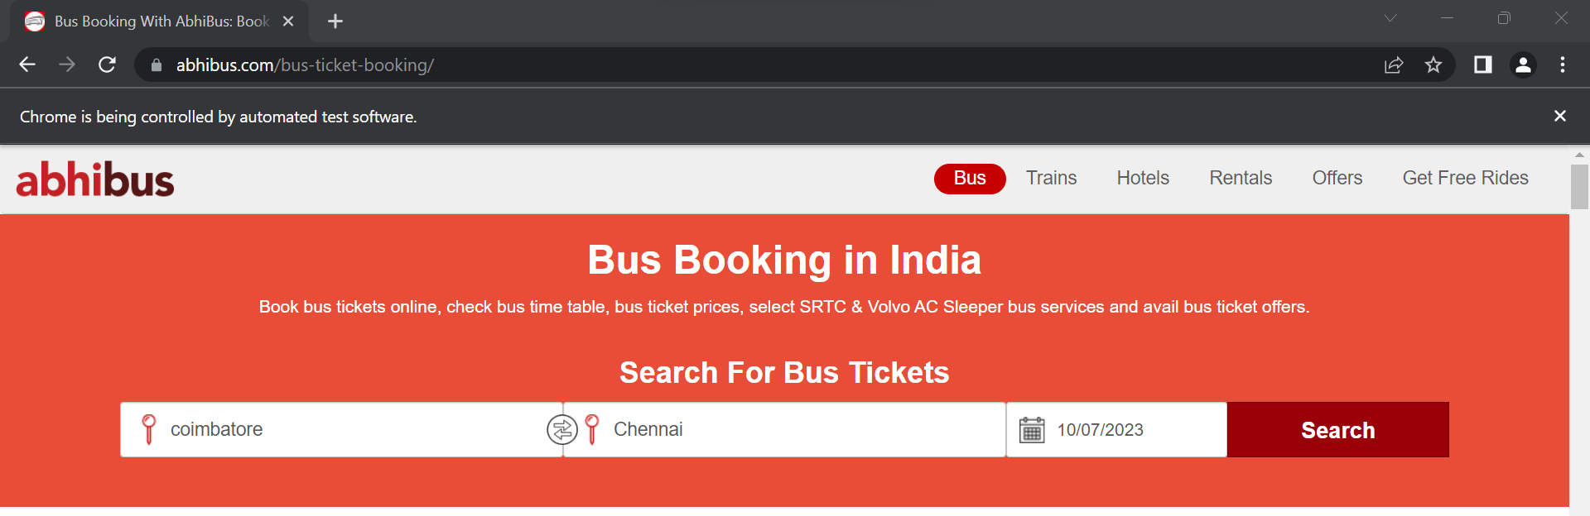

5)CODE:

package com.selenium.day3.ex1;

import java.util.Set;

import org.openqa.selenium.By;

import org.openqa.selenium.JavascriptExecutor;

import org.openqa.selenium.Keys;

import org.openqa.selenium.WebDriver;

import org.openqa.selenium.WindowType;

import org.openqa.selenium.chrome.ChromeDriver;

import org.openqa.selenium.chrome.ChromeOptions;

import io.github.bonigarcia.wdm.WebDriverManager;

public class d5c5 {

public static void main(String[] args) throws InterruptedException {

// TODO Auto-generated method stub

WebDriverManager.chromedriver().setup();

ChromeOptions co=new ChromeOptions();

co.addArguments("--remote-allow-origins=*");

WebDriver driver=new ChromeDriver(co);

//open an url

driver.get("https://www.google.com");

//maximise

driver.manage().window().maximize();

driver.findElement(By.name("q")).sendKeys("Apple");

driver.findElement(By.name("q")).sendKeys(Keys.ENTER);

Thread.sleep(3000);

String t1=driver.getTitle();

String id1=driver.getWindowHandle();

System.out.println(id1);

System.out.println(t1);

//for next tab

driver.switchTo().newWindow(WindowType.TAB);

driver.get("https://www.google.com");

driver.findElement(By.name("q")).sendKeys("selenium");

driver.findElement(By.name("q")).sendKeys(Keys.ENTER);

Thread.sleep(3000);

String t2=driver.getTitle();

String id2=driver.getWindowHandle();

System.out.println(id2);

System.out.println(t2);

//next tab

driver.switchTo().newWindow(WindowType.TAB);

driver.get("https://www.google.com");

driver.findElement(By.name("q")).sendKeys("cucumber");

driver.findElement(By.name("q")).sendKeys(Keys.ENTER);

Thread.sleep(3000);

String t3=driver.getTitle();

String id3=driver.getWindowHandle();

System.out.println(id3);

System.out.println(t3);

Set<String>s=driver.getWindowHandles();

System.out.println("number of tabs opened:"+s.size());

}

}

OUTPUT:

