**SELENIUM-TESTNG**

1)CODE:

package com.selenium.day3.ex1;

import org.testng.annotations.Test;

import io.github.bonigarcia.wdm.WebDriverManager;

//import junit.framework.Assert;

import org.testng.annotations.BeforeTest;

import org.junit.Assert;

import org.openqa.selenium.By;

import org.openqa.selenium.Keys;

import org.openqa.selenium.WebDriver;

import org.openqa.selenium.chrome.ChromeDriver;

import org.openqa.selenium.chrome.ChromeOptions;

import org.testng.annotations.AfterTest;

public class d7q1 {

WebDriver driver;

*@Test*

public void f() {

String str1=driver.getTitle();

System.***out***.println(str1);

String str2="Guest Registration Form – User Registration";

Assert.*assertEquals*(str1,str2);

}

*@BeforeTest*

public void beforeTest() {

WebDriverManager.*chromedriver*().setup();

ChromeOptions co=new ChromeOptions();

co.addArguments("--remote-allow-origins=*");

driver=new ChromeDriver(co);

driver.get("https://demo.wpeverest.com/user-registration/guest-registration-form/");

}

*@AfterTest*

public void afterTest() {

driver.quit();

}

}

OUTPUT:

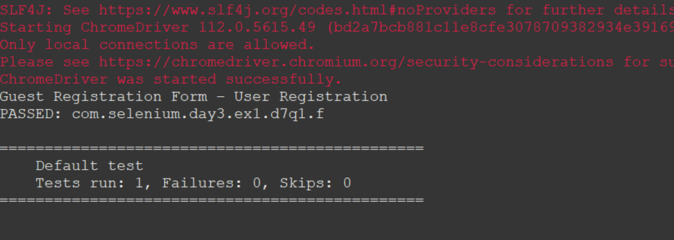

2)CODE:

package com.selenium.day3.ex1;

import org.testng.annotations.Test;

import org.testng.annotations.BeforeTest;

import org.junit.Assert;

import org.testng.annotations.AfterTest;

public class d7q2 {

int a=10,b=5,c;

@Test(priority=4)

public void add() {

c=a+b;

System.out.println(c);

Assert.assertEquals(c,15);

}

@Test(priority=3)

public void sub() {

c=a-b;

System.out.println(c);

Assert.assertEquals(c,5);

}

@Test(priority=2)

public void mul() {

c=a*b;

System.out.println(c);

Assert.assertEquals(c,50);

}

@Test(priority=1)

public void div() {

c=a/b;

System.out.println(c);

Assert.assertEquals(c,2);

}

@BeforeTest

public void beforeTest() {

}

@AfterTest

public void afterTest() {

}

}

OUTPUT:

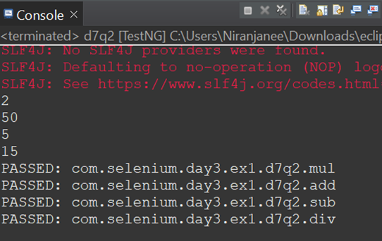

3)CODE:

package com.selenium.day3.ex1;

import org.testng.annotations.Test;

import io.github.bonigarcia.wdm.WebDriverManager;

import org.testng.annotations.BeforeTest;

import org.junit.Assert;

import org.openqa.selenium.By;

import org.openqa.selenium.WebDriver;

import org.openqa.selenium.WebElement;

import org.openqa.selenium.chrome.ChromeDriver;

import org.openqa.selenium.chrome.ChromeOptions;

import org.testng.annotations.AfterTest;

public class d7q3 {

WebDriver driver;

*@Test*

public void f() {

driver.findElement(By.*name*("username")).sendKeys("admin");

driver.findElement(By.*name*("password")).sendKeys("admin123");

driver.findElement(By.*xpath*("//*[@id=\"app\"]/div[1]/div/div[1]/div/div[2]/div[2]/form/div[3]/button")).submit();

String url=driver.getCurrentUrl();

System.***out***.println(url);

String hurl="https://opensource-demo.orangehrmlive.com/web/index.php/dashboard/index";

Assert.*assertEquals*(url,hurl);

}

*@BeforeTest*

public void beforeTest() throws InterruptedException {

WebDriverManager.*chromedriver*().setup();

ChromeOptions co=new ChromeOptions();

co.addArguments("--remote-allow-origins=*");

driver=new ChromeDriver(co);

driver.get("https://opensource-demo.orangehrmlive.com/web/index.php/auth/login");

Thread.*sleep*(3000);

driver.manage().window().maximize();

Thread.*sleep*(2000);

}

*@AfterTest*

public void afterTest() {

driver.close();

}

}

OUTPUT:

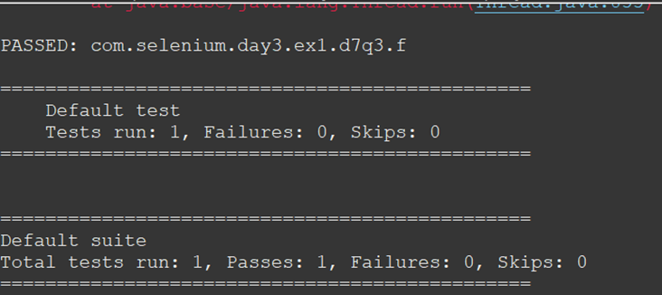

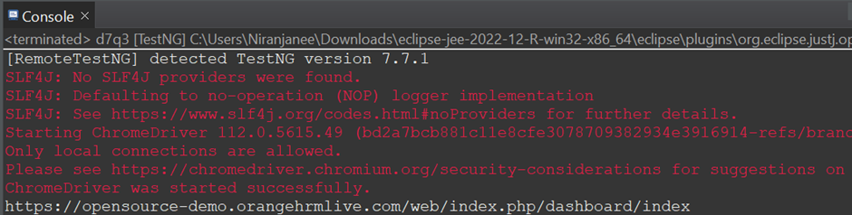

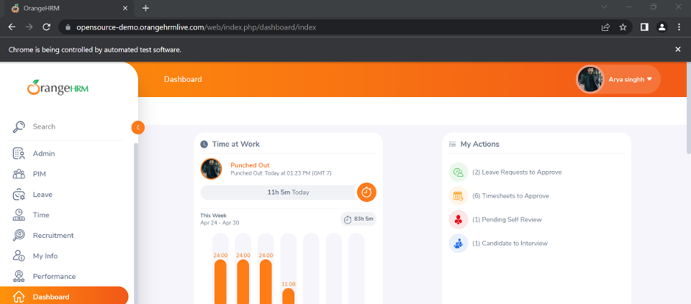

4)CODE:

package com.selenium.day3.ex1;

import org.testng.annotations.Test;

import io.github.bonigarcia.wdm.WebDriverManager;

import org.testng.annotations.BeforeTest;

import org.junit.Assert;

import org.openqa.selenium.By;

import org.openqa.selenium.WebDriver;

import org.openqa.selenium.WebElement;

import org.openqa.selenium.chrome.ChromeDriver;

import org.openqa.selenium.chrome.ChromeOptions;

import org.testng.annotations.AfterTest;

public class d7q4 {

WebDriver driver;

*@Test*

public void login() {

driver.findElement(By.*name*("username")).sendKeys("admin");

driver.findElement(By.*name*("password")).sendKeys("admin123");

driver.findElement(By.*xpath*("//*[@id=\"app\"]/div[1]/div/div[1]/div/div[2]/div[2]/form/div[3]/button")).submit();

String url=driver.getCurrentUrl();

System.***out***.println(url);

String hurl="https://opensource-demo.orangehrmlive.com/web/index.php/dashboard/index";

Assert.*assertEquals*(url,hurl);

}

*@Test*(dependsOnMethods="login")

public void logout() throws Exception

{

Thread.*sleep*(3000);

driver.findElement(By.*xpath*("//*[@id=\"app\"]/div[1]/div[1]/header/div[1]/div[2]/ul/li/span")).click();

driver.findElement(By.*xpath*("//*[@id=\"app\"]/div[1]/div[1]/header/div[1]/div[2]/ul/li/ul/li[4]/a")).click();

String lurl = driver.getCurrentUrl();

System.***out***.println(lurl);

Assert.*assertEquals*(lurl, "https://opensource-demo.orangehrmlive.com/web/index.php/auth/login");

}

*@BeforeTest*

public void beforeTest() throws InterruptedException {

WebDriverManager.*chromedriver*().setup();

ChromeOptions co=new ChromeOptions();

co.addArguments("--remote-allow-origins=*");

driver=new ChromeDriver(co);

driver.get("https://opensource-demo.orangehrmlive.com/web/index.php/auth/login");

Thread.*sleep*(3000);

driver.manage().window().maximize();

Thread.*sleep*(2000);

}

*@AfterTest*

public void afterTest() {

}

}

OUTPUT:

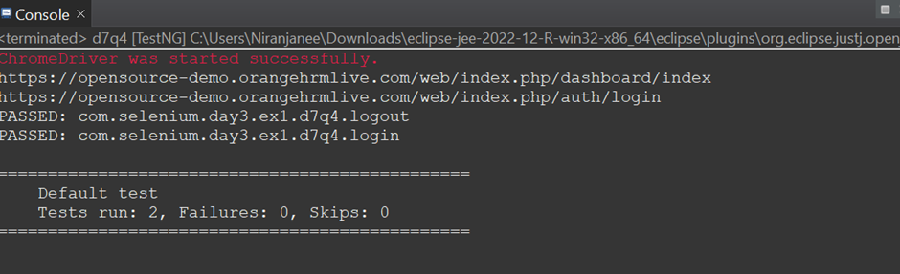

5)CODE:

package com.selenium.day3.ex1;

import org.testng.annotations.Test;

import io.github.bonigarcia.wdm.WebDriverManager;

import org.testng.annotations.BeforeTest;

import java.util.concurrent.TimeUnit;

import org.junit.Assert;

import org.openqa.selenium.By;

import org.openqa.selenium.WebDriver;

import org.openqa.selenium.WindowType;

import org.openqa.selenium.chrome.ChromeDriver;

import org.openqa.selenium.chrome.ChromeOptions;

import org.openqa.selenium.edge.EdgeDriver;

import org.testng.annotations.AfterTest;

public class d7q5 {

WebDriver driver;

@Test(groups= {"SmokeTest"})

public void Test1() throws Exception {

WebDriverManager.chromedriver().setup();

WebDriver driver;

ChromeOptions co = new ChromeOptions();

co.addArguments("--remote-allow-origins=*");

driver=new ChromeDriver(co);

driver.get("https://www.godaddy.com/en-in");

driver.manage().window().maximize();

Thread.sleep(3000);

String t1=driver.getTitle();

System.out.println(t1);

Assert.assertEquals(t1, "Domain Names, Websites, Hosting & Online Marketing Tools - GoDaddy IN");

String u1=driver.getCurrentUrl();

Assert.assertEquals(u1,"https://www.godaddy.com/en-in");

driver.quit();

}

@Test(groups= {"RegressionTest"})

public void Test2() throws Exception {

WebDriverManager.chromedriver().setup();

WebDriver driver;

ChromeOptions co = new ChromeOptions();

co.addArguments("--remote-allow-origins=*");

driver=new ChromeDriver(co);

driver.get("https://www.godaddy.com/en-in");

driver.manage().window().maximize();

Thread.sleep(3000);

driver.findElement(By.xpath("//*[@id=\"id-631b049a-e9c0-4d24-8710-c504745206dd\"]/button/span")).click();

driver.findElement(By.xpath("//*[@id=\"id-631b049a-e9c0-4d24-8710-c504745206dd\"]/div[2]/div[1]/ul/li[1]")).click();

driver.findElement(By.xpath("//*[@id=\"id-631b049a-e9c0-4d24-8710-c504745206dd\"]/div[2]/div[1]/ul/li[1]/div/div[2]/div[1]/ul/li[2]/a")).click();

}

@Test(groups= {"SmokeTest"})

public void Test3() throws Exception {

System.out.println("in smoke test");

}

@Test(groups= {"RegressionTest"})

public void Test4() throws Exception {

System.out.println("in RegressionTest");

}

@Test(groups = "Regression TestCase")

public void test3() throws Exception

{

// WebDriverManager.edgedriver().setup();

// driver=new EdgeDriver();

driver.switchTo().newWindow(WindowType.TAB);

driver.get("https://www.godaddy.com");

driver.manage().window().maximize();

// Thread.sleep(3000);

driver.manage().timeouts().implicitlyWait(3, TimeUnit.SECONDS);

driver.findElement(By.xpath("//*[@id=\"id-631b049a-e9c0-4d24-8710-c504745206dd\"]/div[2]/div[1]/ul/li[1]/button")).click();

driver.findElement(By.xpath("//*[@id=\"id-631b049a-e9c0-4d24-8710-c504745206dd\"]/div[2]/div[1]/ul/li[1]/div/div[2]/div[1]/ul/li[2]/a")).click();

driver.manage().timeouts().implicitlyWait(3, TimeUnit.SECONDS);

Thread.sleep(3000);

String t1 = driver.getTitle();

Assert.assertEquals(t1, "GoDaddy Domain Search - Buy and Register Available Domain Names");

driver.findElement(By.xpath("//*[@id=\"8469f0c3-e08f-4343-9756-ce0390b0d581\"]")).isDisplayed();

driver.findElement(By.xpath("//*[@id=\"8469f0c3-e08f-4343-9756-ce0390b0d581\"]")).isEnabled();

driver.findElement(By.xpath("//*[@id=\"id-1467954b-c5e3-4b0c-9046-9fc94d8ca892\"]/section/div/div/section/div/div[1]/div/div/div[2]/button")).isDisplayed();

driver.findElement(By.xpath("//*[@id=\"8469f0c3-e08f-4343-9756-ce0390b0d581\"]")).sendKeys("mydomain");

driver.findElement(By.xpath("//*[@id=\"id-1467954b-c5e3-4b0c-9046-9fc94d8ca892\"]/section/div/div/section/div/div[1]/div/div/div[2]/button")).click();

}

@BeforeTest

public void beforeTest() {

}

@AfterTest

public void afterTest() {

}

}

OUTPUT:

