Bharathbrands Consolidated SRS

Business Process ID—

## service nomenclature:

**Screen Number**: 1

**Screen Name**:<Newsfeed>

**Business Process Name:** <Common Social Media Activity>

## Screen Definition:

**Front end Screen Screenshot/Design:**

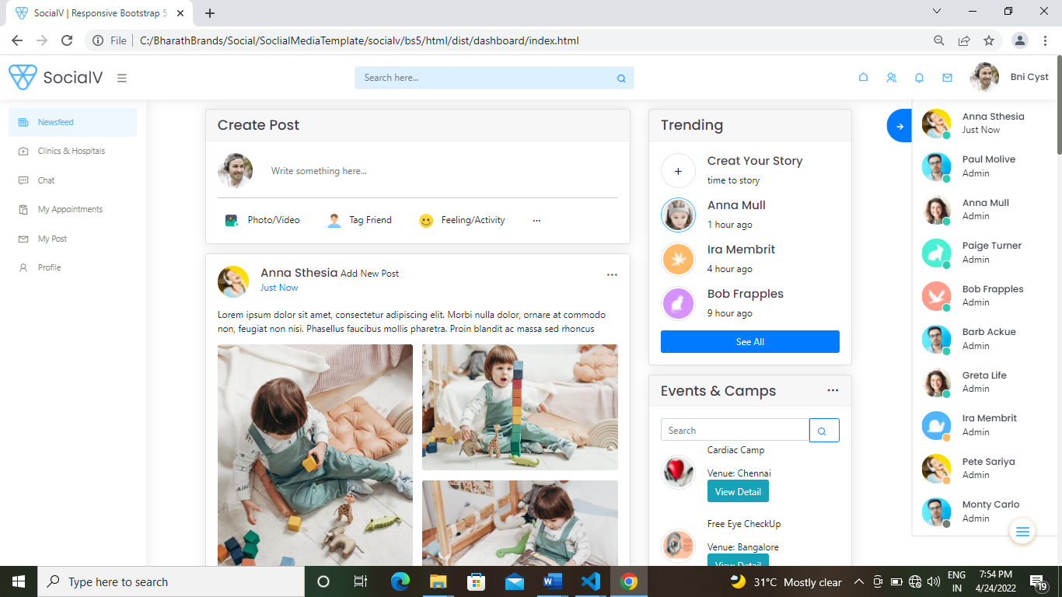

Note :Screen Continues

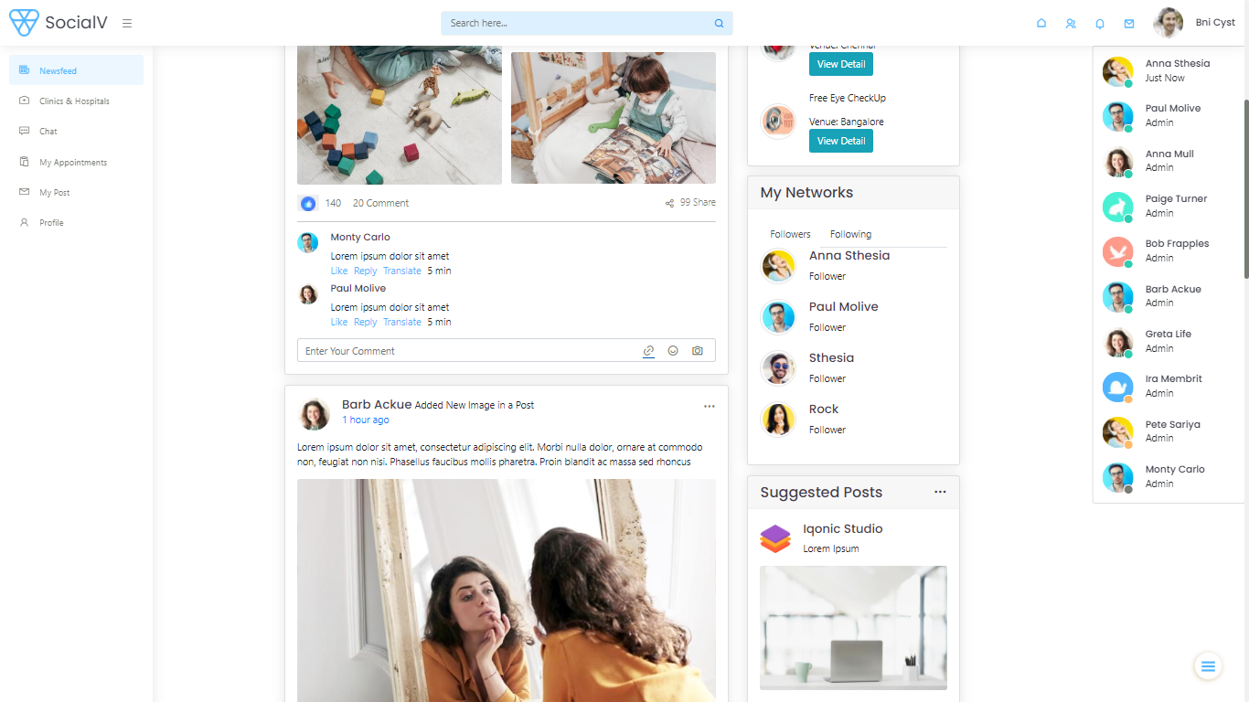

**Front End Screen Attributes:**

|  |  |  |  |  |
| --- | --- | --- | --- | --- |
| Field/widget number | Field/widget Name | Field/widget Characteristics | Functionality | Editable or Not |
| 1. | Create Post(write something here) | Text Field | Should create a post | editable |
| 2. | Events&Camps  (search) | Search | Display the result based on search |  |
| 3. | Like (Button) present below every post | Button |  |  |
| 4. | Comment Section  present below every post | comment | comment works for every individual |  |

Overall Functionality of the screen:

* This Screen is most similar to other social media sites where we can create post and posted it,in which other users can view on their news feed.
* The trending stories will be displayed which gonna be disappear automatically within 24 hours of their uploading Time.
* Then the uploaded post will be display which can be like,comment and share by other users.
  + - Post is of two types active post & archive post (only the active post will be displayed to other users
    - Active post is the post which is active that got frequent like comments etc.
    - Archive post is something like post which is not active for a time period(i.e If a post which doesn’t get any like,comment for a period of time like 2 months then that post is said to be archive post.That particular post will not be visible to other users)
* In Events and camps section you can view the events like(ie: free Eye camps,and other health related camps)can be posted by the clinic /hospital here,where if you need more details about it you can view by clicking view detail (you can view full details like venue,contact number,registration ph number,notices/brochure and even you can register if they provided any other links)
* In My Networks Section you can view your networks like people you are following(Following),and people who follows you(Followers).
* Suggested post blogs will display the trending posts which may be useful for users.This can be of anytimes based on their intreset or by their frequent searches.