Bharathbrands Consolidated SRS

Business Process ID—

## service nomenclature:

**Screen Number**: 2

**Screen Name**:<Main User Profile >

**Business Process Name:** <Profile>

## Screen Definition:

**Front end Screen Screenshot/Design:**

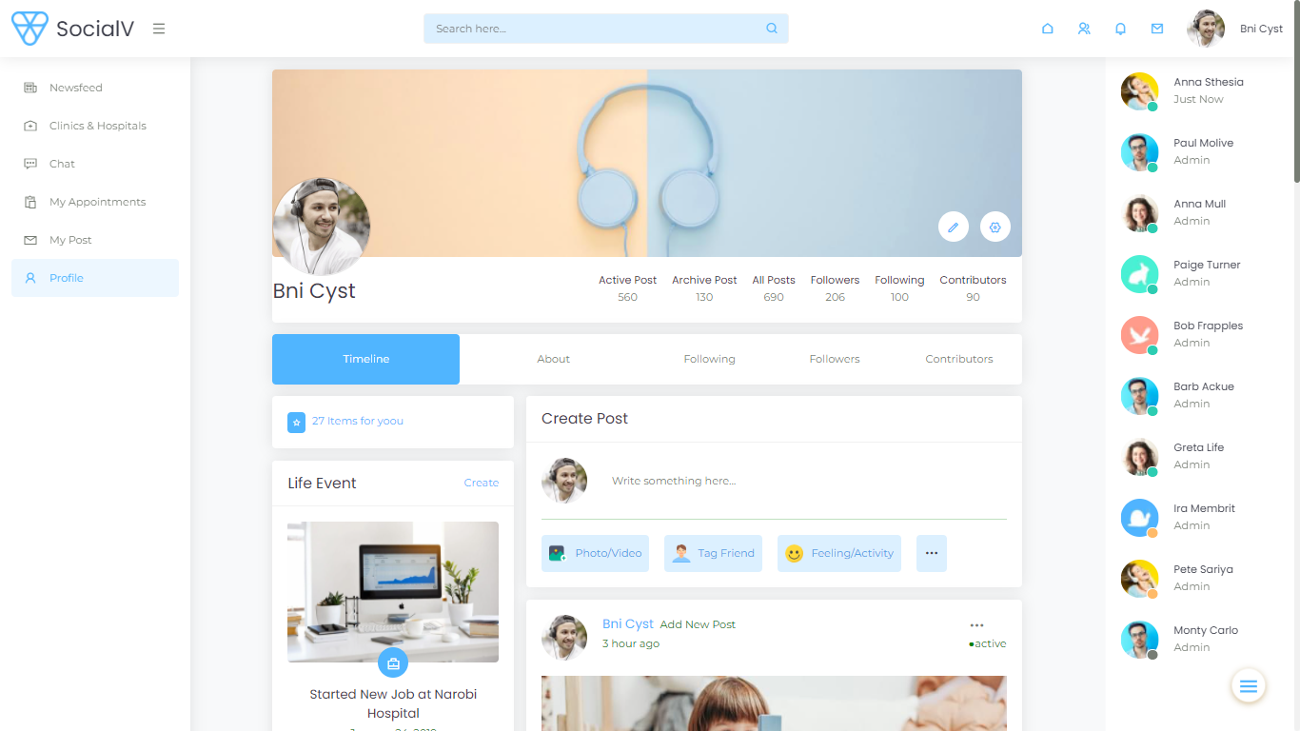

**Front End Screen Attributes:**

|  |  |  |  |  |
| --- | --- | --- | --- | --- |
| Field/widget number | Field/widget Name | Field/widget Characteristics | Functionality | Editable or Not |
| 1. | Create Post(write something here) | Text Field | Should create a post | editable |

Overall Functionality of the screen:

* This Screen is Profile page for a particular single user where some common details like (name,and their activities where seen here)
* Counters Field
  + 1. Active Post-Display the total number of Active Post for the Individual Under.(the post which gets frequent like and comment is called active post)
    2. Archive Post- Display the total number of Archive Post for the Individual Under.(the post which dosen’t gets frequent like and comment for a period of time is called archive post)
    3. Total Post- Display the total number of post (i.e active post+archive post)
    4. Followers-Those who follows your post then they will be called as Followers.
    5. Following-If you follows someother persons post then they are the persons you are following.

Contributors- Contributors are those you like, comments for your post then they are your Contributors.

* Timeline**-** Here you can find all your post (active & archive post)
* Active post will be indicated by greendot (.)
* Archive Post will be indicated by red dot(.)
* About-Display details like (basic detail,residential detail,qualification detail,medical &family history,area of intrest etc..)
* Following,Followers,Contributore- As Already Listed above. (Here it will display their images with name by clicking that it will be redirect to their profile)