Methodology

Here we analyse the impact of COVID-19 vaccine distribution in US (once it’s ready). We start with a standard facility location problem. We consider in this case the every US city as a demand point, since people will have to be vaccinated and main decision is where to locate distribution points (let’s call it hubs) to attend all the demand.

The problem can be formalized as following: given $n$ cities and $m$ possible distribution points we define continuous variables $x_{ij}≥0$ as the amount of vaccines serviced from hub $j$ to city $i$, and binary variables $y_{j}=1$ if a hub is established at location $j$, 0 otherwise. An integer-optimization model for the capacitated facility location problem can now be specified as follows:

$$Minimize \sum_{j}{f_{j}y_{j}}+\sum_{i}{\sum_{j}{c_{ij}x_{ij}}}$$

Subject to

$$\sum_{j}{x_{ij}=d_{i} ∀i in N}$$

$$\sum_{i}{x_{ij}≤ M_{j}y_{j} ∀j in M}$$

$$x_{ij}≤d_{i}y_{j} ∀i in N ∀j in M$$

$$x_{ij}≥0 ∀i in N ∀j in M$$

$$y_{j}∈\{0,1\} ∀j in M$$

Where $d_{i}$ is the population of city, $M_{j}$ the capacity of each hub, $c_{ij} and f_{j}$ as variable and fixed cost respectively. We’ll consider variable cost as distance and fixed cost as 1000, for now. Every city can serve as a hub.

The first task is to collect all the population data from census (<https://www.census.gov/>)for each of the 32637 cities in the US. With this data we can plot a heat map with population for each city

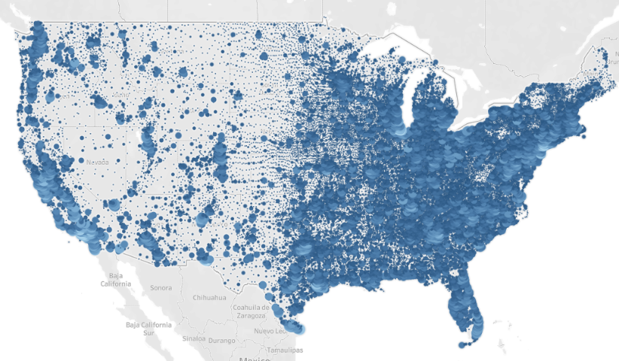

It can be seen that east coast has a higher population density and will require more vaccines. To avoid model explosion we’ll consider only the top 250 cities population wise.

The first analysis will be how to split these hubs minimizing only distance to final demand point (city) if we want to build 3, 8 or 15 hubs. So we’ll add the constraint:

$$\sum_{j}{y_{j}}=k$$

Where k will be 3, 8 or 15.

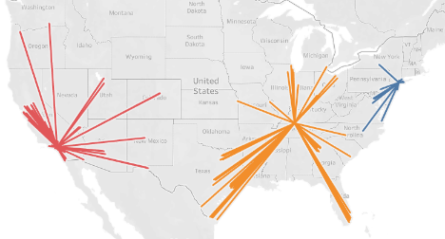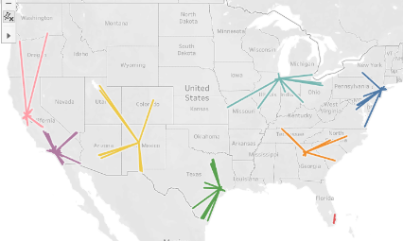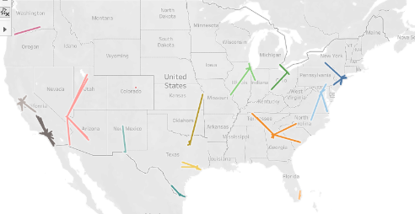

We’ll now add a different constraint and change the objective function: a city is served by a hib within 500km distance and we want to minimize the number of hub points used. The model will be modified as following:

$$Minimize \sum_{j}{y_{j}}$$

$$\sum_{i}{x_{ij}=0 ∀j in M:dist_{ij}}≥500$$

The optimal number of hubs are 8

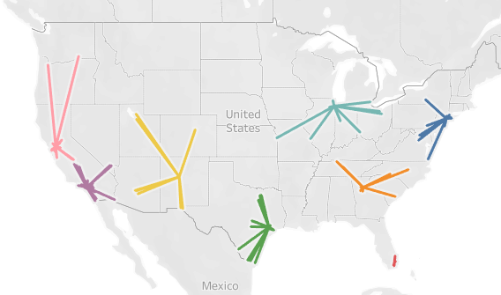

Introducing the COVID context we’ll collect data on number of covid cases habitants for each state in the US (source: <https://usafacts.org/visualizations/coronavirus-covid-19-spread-map/>)

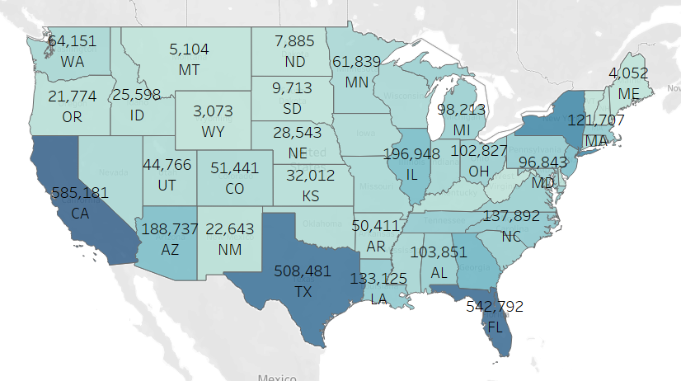

We’ll add a constraint that a hub needs to be built in a state where we have more than 500.000 cases

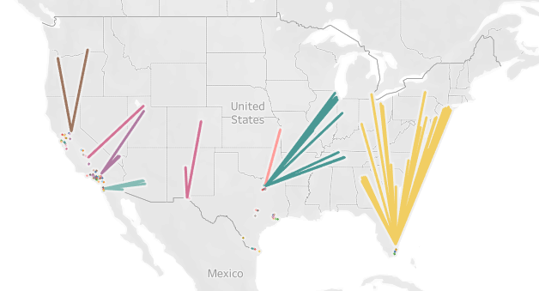

Analysis 1: fac_loc.py -> minimizing distance + fixed cost with open number of hubs

Analysis 2: fac_loc2.py -> minimizing distance + fixed cost with open number of hubs (3 hubs fixed)

Analysis 3: fac_loc3.py -> minimizing distance + fixed cost with open number of hubs (8 hubs fixed)

Analysis 4: fac_loc4.py -> minimizing distance + fixed cost with open number of hubs (15 hubs fixed)

Analysis 5: fac_loc5.py -> minimizing distance + fixed cost with extra constraint that state with more than 500k cases needs a hub built in it

Analysis 6: fac_loc6.py -> minimizing distance + fixed cost with maximum distance between hub and city as 500km