Deploying Wazuh SIEM to Detect Event Log Clearing Audits across Cross-Platform Environments

1. Objective
The objective of this lab was to deploy and configure a Wazuh SIEM environment capable of monitoring Linux and Windows systems for suspicious activities and security events. The project focused on generating attack simulations, collecting telemetry data, and analyzing security alerts generated through the Wazuh platform.

2. Environment Setup
The lab environment consisted of an Ubuntu Linux Virtual Machine configured as the Wazuh SIEM server and a Windows host system integrated using the Wazuh Agent named “Naina.” Oracle VirtualBox with bridged networking was used for communication between systems. SSH monitoring and Windows telemetry collection were enabled to support real-time threat detection and analysis.

3. Attack Simulations
Two security attack simulations were performed during the lab. The first simulation involved multiple failed SSH and sudo authentication attempts on the Ubuntu Linux system to generate suspicious login activity. The second simulation involved clearing Windows Security Event Logs using PowerShell commands to simulate defense evasion techniques commonly used by attackers.

4. Alert Triage Analysis
Wazuh successfully detected and generated alerts for both Linux and Windows attack simulations. The Linux failed authentication attempts triggered Rule ID 5404 with Severity Level 10, indicating suspicious login behavior. The Windows Event Log clearing simulation triggered Rule ID 63103 with Severity Level 5 and generated the alert “Audit log was cleared.” These detections demonstrated the effectiveness of Wazuh SIEM in monitoring and identifying suspicious activities across cross-platform environments.

5. Conclusion
This lab provided hands-on experience with SIEM deployment, threat hunting, telemetry analysis, and security monitoring workflows. The project improved understanding of how SOC analysts investigate alerts and monitor suspicious activities using Wazuh SIEM across Linux and Windows environments.

6. Screenshots & Evidence
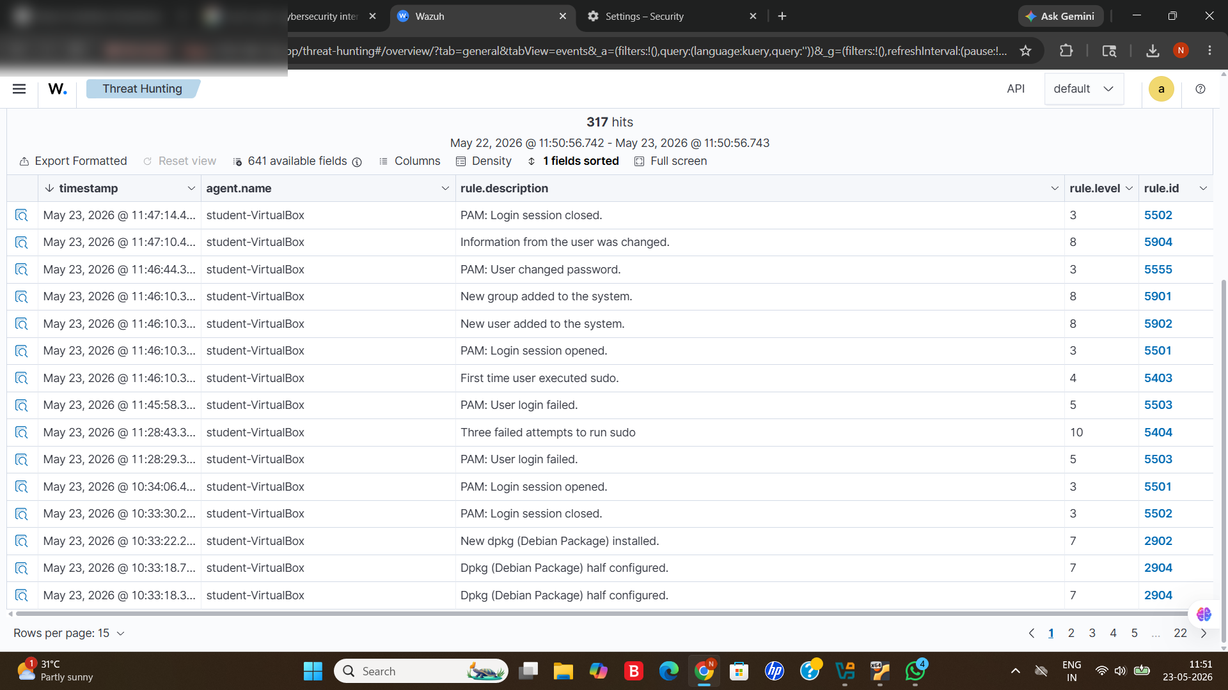

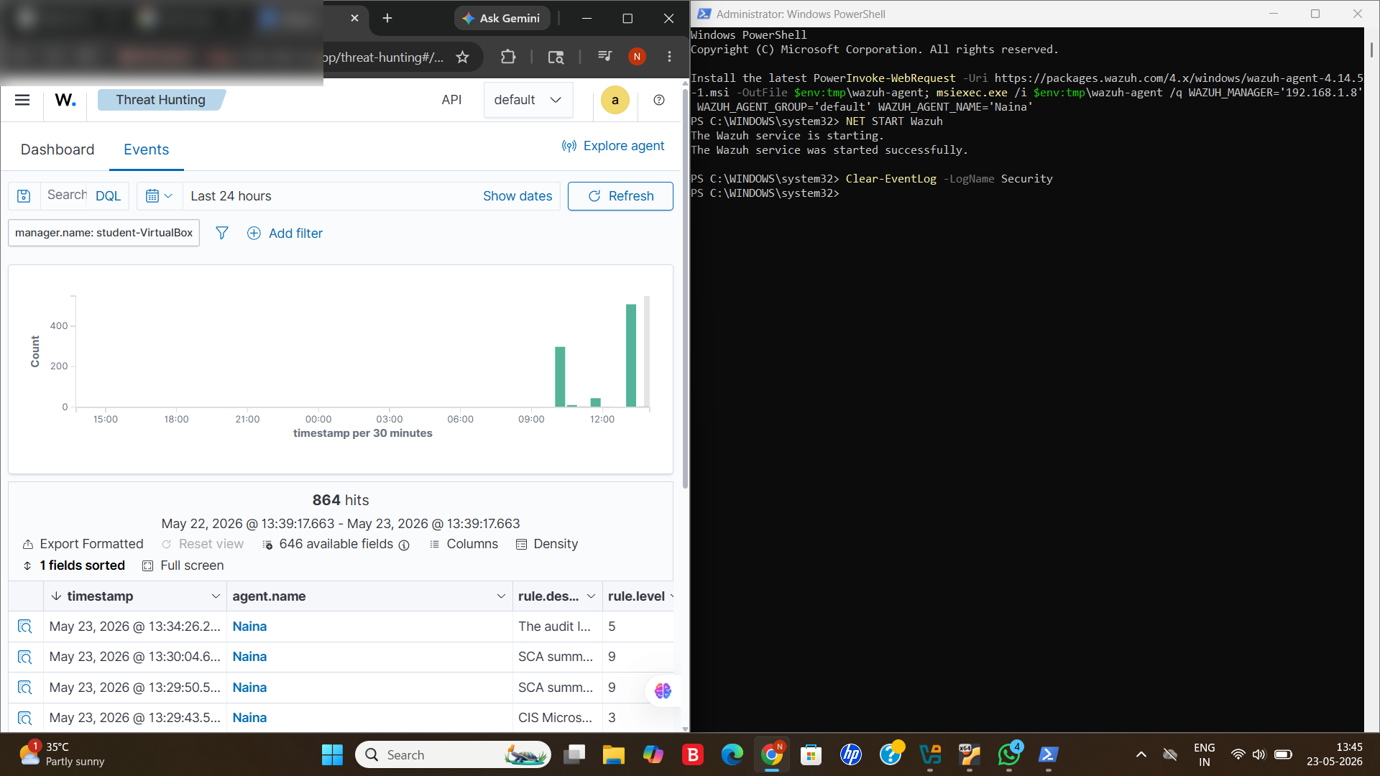
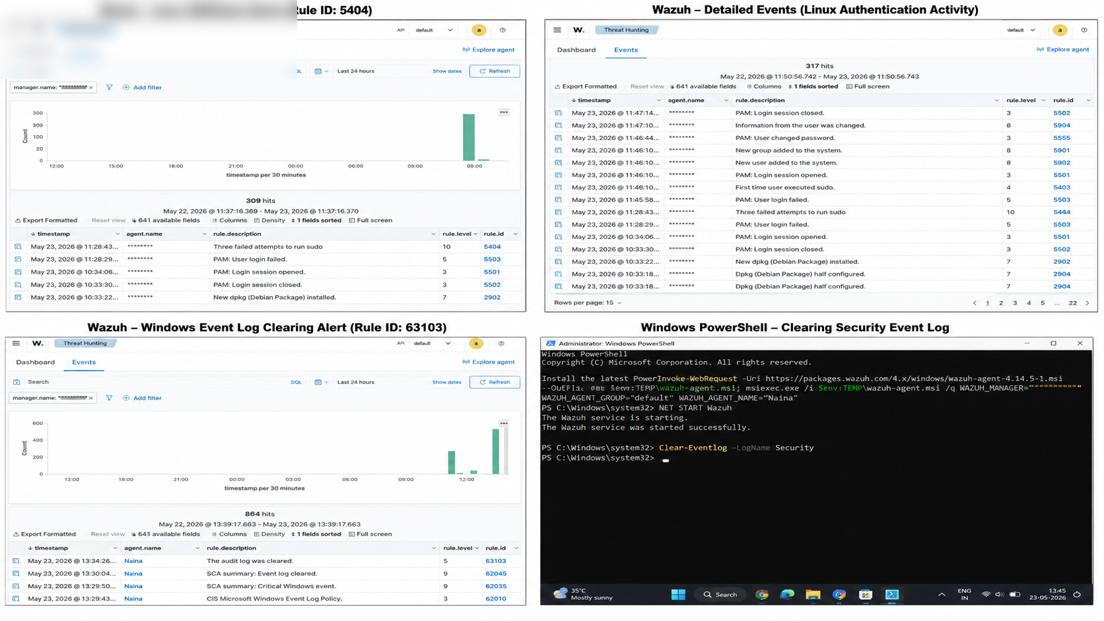

7. Skills Practiced
- SIEM Deployment & Configuration
- Threat Hunting
- Security Monitoring
- Alert Triage Analysis
- Windows Telemetry Monitoring
- Linux Authentication Monitoring
- Cross-Platform Log Analysis
- SOC Analyst Workflow

