EXPERIMENT-10

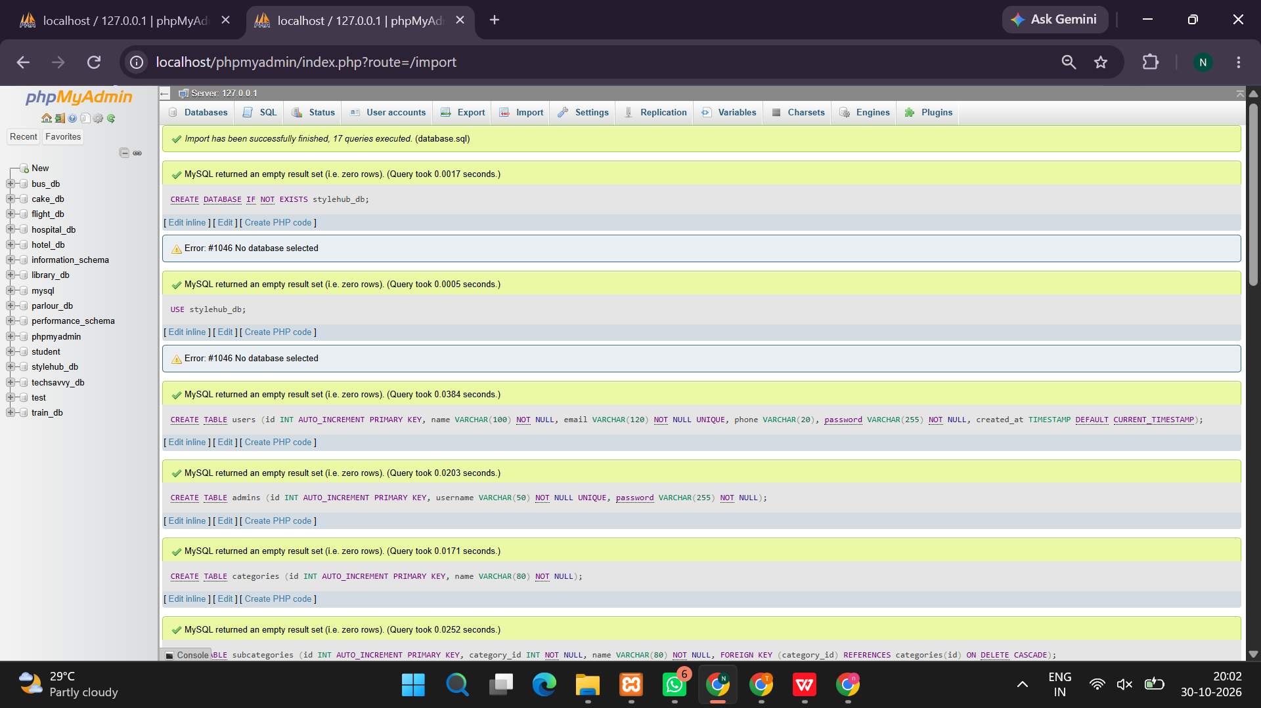
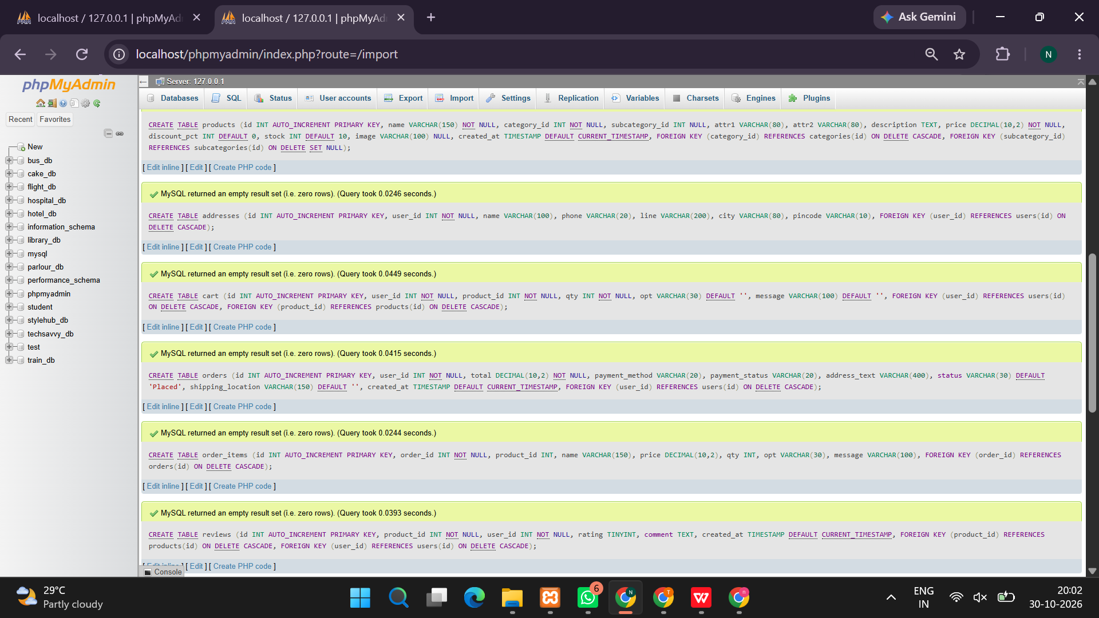
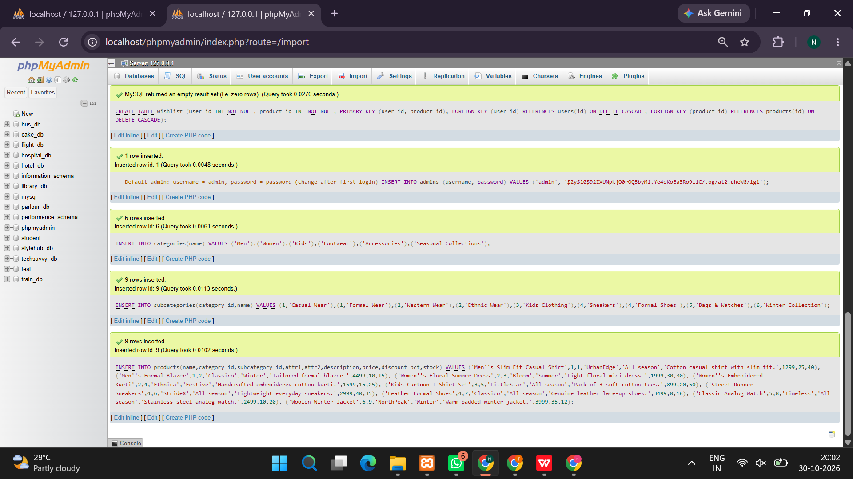
<?php
session_start();

/* DATABASE SETUP */
try {
$pdo = new PDO("mysql:host=localhost;charset=utf8mb4", "root", "", [
PDO::ATTR_ERRMODE => PDO::ERRMODE_EXCEPTION,
PDO::ATTR_DEFAULT_FETCH_MODE => PDO::FETCH_ASSOC
]);

$pdo->exec("CREATE DATABASE IF NOT EXISTS stylehub");
$pdo->exec("USE stylehub");

$pdo->exec("CREATE TABLE IF NOT EXISTS users (
id INT AUTO_INCREMENT PRIMARY KEY,
name VARCHAR(100) NOT NULL,
email VARCHAR(150) UNIQUE NOT NULL,
password VARCHAR(255) NOT NULL,
role VARCHAR(20) DEFAULT 'customer'
)");

$pdo->exec("CREATE TABLE IF NOT EXISTS products (
id INT AUTO_INCREMENT PRIMARY KEY,
name VARCHAR(150) NOT NULL,
category VARCHAR(80) NOT NULL,
subcategory VARCHAR(80) NOT NULL,
audience VARCHAR(30) NOT NULL,
size VARCHAR(100) NOT NULL,
price DECIMAL(10,2) NOT NULL,
description TEXT,
image VARCHAR(500),
stock INT NOT NULL DEFAULT 10
)");

$pdo->exec("CREATE TABLE IF NOT EXISTS orders (
id INT AUTO_INCREMENT PRIMARY KEY,
user_id INT NOT NULL,
total DECIMAL(10,2) NOT NULL,
status VARCHAR(30) DEFAULT 'Order Placed',
created_at TIMESTAMP DEFAULT CURRENT_TIMESTAMP,
FOREIGN KEY (user_id) REFERENCES users(id)
)");

$pdo->exec("CREATE TABLE IF NOT EXISTS order_items (
id INT AUTO_INCREMENT PRIMARY KEY,
order_id INT NOT NULL,
product_id INT NOT NULL,
product_name VARCHAR(150) NOT NULL,
size VARCHAR(20) NOT NULL,
quantity INT NOT NULL,
price DECIMAL(10,2) NOT NULL,
FOREIGN KEY (order_id) REFERENCES orders(id) ON DELETE CASCADE
)");

$pdo->exec("CREATE TABLE IF NOT EXISTS reviews (
id INT AUTO_INCREMENT PRIMARY KEY,
user_id INT NOT NULL,
product_id INT NOT NULL,
rating INT NOT NULL,
review TEXT,
UNIQUE KEY user_product (user_id, product_id),
FOREIGN KEY (user_id) REFERENCES users(id) ON DELETE CASCADE,
FOREIGN KEY (product_id) REFERENCES products(id) ON DELETE CASCADE
)");

$pdo->exec("CREATE TABLE IF NOT EXISTS wishlist (
user_id INT NOT NULL,
product_id INT NOT NULL,
PRIMARY KEY (user_id, product_id),
FOREIGN KEY (user_id) REFERENCES users(id) ON DELETE CASCADE,
FOREIGN KEY (product_id) REFERENCES products(id) ON DELETE CASCADE
)");

if ($pdo->query("SELECT COUNT(*) FROM products")->fetchColumn() == 0) {
$pdo->exec("INSERT INTO products
(name,category,subcategory,audience,size,price,description,image,stock) VALUES
('Classic Cotton T-Shirt','Clothing','Casual Wear','Men','S,M,L,XL',699,'Comfortable everyday cotton T-shirt.','https://images.unsplash.com/photo-1521572163474-6864f9cf17ab?w=500',20),
('Formal Office Shirt','Clothing','Formal Wear','Men','S,M,L,XL',1299,'Smart formal shirt for work and occasions.','https://images.unsplash.com/photo-1598033129183-c4f50c736f10?w=500',15),
('Floral Summer Dress','Clothing','Seasonal Collection','Women','S,M,L,XL',1799,'Lightweight floral dress for summer.','https://images.unsplash.com/photo-1595777457583-95e059d581b8?w=500',12),
('Denim Jeans','Clothing','Casual Wear','Women','28,30,32,34',1499,'Classic denim jeans for everyday styling.','https://images.unsplash.com/photo-1541099649105-f69ad21f3246?w=500',18),
('Kids Hoodie','Clothing','Kids Wear','Children','2Y,4Y,6Y,8Y',999,'Soft and warm hoodie for children.','https://images.unsplash.com/photo-1519238263530-99bdd11df2ea?w=500',10),
('Running Sneakers','Footwear','Sports Shoes','Men','7,8,9,10,11',2199,'Lightweight sneakers for daily activities.','https://images.unsplash.com/photo-1542291026-7eec264c27ff?w=500',14),
('Women Handbag','Accessories','Bags','Women','Free Size',1599,'Stylish handbag for daily use.','https://images.unsplash.com/photo-1584917865442-de89df76afd3?w=500',9),
('Classic Sunglasses','Accessories','Fashion Accessories','Unisex','Free Size',799,'Modern sunglasses to complete your look.','https://images.unsplash.com/photo-1511499767150-a48a237f0083?w=500',25)");
}

} catch (PDOException $ex) {
die("Database error. Start MySQL in XAMPP and check your credentials.");
}

function e($v) {
return htmlspecialchars((string)$v, ENT_QUOTES, 'UTF-8');
}

function loggedIn() {
return isset($_SESSION['user_id']);
}

function isAdmin() {
return ($_SESSION['role'] ?? '') === 'admin';
}

if (!isset($_SESSION['cart'])) {
$_SESSION['cart'] = [];
}

$message = '';
$error = '';

/* FORM ACTIONS */
if ($_SERVER['REQUEST_METHOD'] === 'POST') {
$action = $_POST['action'] ?? '';

// REGISTER
if ($action === 'register') {
$name = trim($_POST['name'] ?? '');
$email = strtolower(trim($_POST['email'] ?? ''));
$password = $_POST['password'] ?? '';

if ($name === '' || !filter_var($email, FILTER_VALIDATE_EMAIL)
|| strlen($password) < 6) {
$error = "Enter valid details and a password of at least 6 characters.";
} else {
try {
$stmt = $pdo->prepare(
"INSERT INTO users(name,email,password) VALUES(?,?,?)"
);
$stmt->execute([
$name, $email,
password_hash($password, PASSWORD_DEFAULT)
]);
$message = "Registration successful. Please log in.";
} catch (PDOException $ex) {
$error = "This email is already registered.";
}
}
}

// LOGIN
if ($action === 'login') {
$email = strtolower(trim($_POST['email'] ?? ''));
$password = $_POST['password'] ?? '';

$stmt = $pdo->prepare("SELECT * FROM users WHERE email=?");
$stmt->execute([$email]);
$user = $stmt->fetch();

if ($user && password_verify($password, $user['password'])) {
session_regenerate_id(true);
$_SESSION['user_id'] = $user['id'];
$_SESSION['user_name'] = $user['name'];
$_SESSION['role'] = $user['role'];
header("Location: index.php");
exit;
} else {
$error = "Incorrect email or password.";
}
}

// ADD TO CART
if ($action === 'add_cart') {
$id = (int)($_POST['product_id'] ?? 0);
$qty = max(1, min(20, (int)($_POST['quantity'] ?? 1)));
$size = trim($_POST['size'] ?? '');

$stmt = $pdo->prepare("SELECT * FROM products WHERE id=?");
$stmt->execute([$id]);
$p = $stmt->fetch();

if (!$p || $p['stock'] < 1) {
$error = "Product is unavailable.";
} elseif (!in_array($size, explode(',', $p['size']), true)) {
$error = "Please select a valid size.";
} else {
$key = $id . '_' . $size;
$current = $_SESSION['cart'][$key]['quantity'] ?? 0;
$_SESSION['cart'][$key] = [
'product_id' => $id,
'size' => $size,
'quantity' => min((int)$p['stock'], $current + $qty)
];
$message = "Item added to your shopping bag.";
}
}

// UPDATE CART
if ($action === 'update_cart') {
foreach ($_POST['qty'] ?? [] as $key => $qty) {
$qty = (int)$qty;

if ($qty <= 0) {
unset($_SESSION['cart'][$key]);
continue;
}

if (isset($_SESSION['cart'][$key])) {
$id = $_SESSION['cart'][$key]['product_id'];
$stmt = $pdo->prepare("SELECT stock FROM products WHERE id=?");
$stmt->execute([$id]);
$stock = $stmt->fetchColumn();

if ($stock !== false) {
$_SESSION['cart'][$key]['quantity'] =
min($qty, (int)$stock);
} else {
unset($_SESSION['cart'][$key]);
}
}
}
$message = "Shopping bag updated.";
}

// REMOVE CART ITEM
if ($action === 'remove_cart') {
unset($_SESSION['cart'][$_POST['cart_key'] ?? '']);
$message = "Item removed from your shopping bag.";
}

// CHECKOUT
if ($action === 'checkout') {
if (!loggedIn()) {
$error = "Please log in before checkout.";
} elseif (empty($_SESSION['cart'])) {
$error = "Your shopping bag is empty.";
} else {
try {
$pdo->beginTransaction();
$items = [];
$total = 0;

foreach ($_SESSION['cart'] as $item) {
$stmt = $pdo->prepare(
"SELECT * FROM products WHERE id=? FOR UPDATE"
);
$stmt->execute([$item['product_id']]);
$p = $stmt->fetch();

if (!$p || $item['quantity'] > $p['stock']
|| !in_array($item['size'], explode(',', $p['size']), true)) {
throw new Exception(
"A product or size is unavailable. Update your bag."
);
}

$items[] = ['product' => $p, 'item' => $item];
$total += $p['price'] * $item['quantity'];
}

$stmt = $pdo->prepare(
"INSERT INTO orders(user_id,total) VALUES(?,?)"
);
$stmt->execute([$_SESSION['user_id'], $total]);
$orderId = $pdo->lastInsertId();

foreach ($items as $row) {
$p = $row['product'];
$item = $row['item'];

$stmt = $pdo->prepare(
"INSERT INTO order_items
(order_id,product_id,product_name,size,quantity,price)
VALUES(?,?,?,?,?,?)"
);
$stmt->execute([
$orderId, $p['id'], $p['name'], $item['size'],
$item['quantity'], $p['price']
]);

$stmt = $pdo->prepare(
"UPDATE products SET stock=stock-? WHERE id=?"
);
$stmt->execute([$item['quantity'], $p['id']]);
}

$pdo->commit();
$_SESSION['cart'] = [];
$message = "Order placed successfully! Order ID: #" . $orderId;
} catch (Throwable $ex) {
if ($pdo->inTransaction()) {
$pdo->rollBack();
}
$error = $ex instanceof PDOException
? "Unable to place the order. Please try again."
: $ex->getMessage();
}
}
}

// WISHLIST
if ($action === 'wishlist') {
if (!loggedIn()) {
$error = "Please log in to manage your wishlist.";
} else {
$id = (int)($_POST['product_id'] ?? 0);
$stmt = $pdo->prepare(
"SELECT 1 FROM wishlist WHERE user_id=? AND product_id=?"
);
$stmt->execute([$_SESSION['user_id'], $id]);

if ($stmt->fetchColumn()) {
$stmt = $pdo->prepare(
"DELETE FROM wishlist WHERE user_id=? AND product_id=?"
);
$stmt->execute([$_SESSION['user_id'], $id]);
$message = "Removed from wishlist.";
} else {
$stmt = $pdo->prepare(
"INSERT IGNORE INTO wishlist(user_id,product_id) VALUES(?,?)"
);
$stmt->execute([$_SESSION['user_id'], $id]);
$message = "Added to wishlist.";
}
}
}

// PRODUCT REVIEW
if ($action === 'review') {
if (!loggedIn()) {
$error = "Please log in to submit a review.";
} else {
$id = (int)($_POST['product_id'] ?? 0);
$rating = (int)($_POST['rating'] ?? 0);
$review = trim($_POST['review'] ?? '');

if ($rating < 1 || $rating > 5 || $review === '') {
$error = "Choose a rating and enter a review.";
} else {
$stmt = $pdo->prepare(
"INSERT INTO reviews(user_id,product_id,rating,review)
VALUES(?,?,?,?)
ON DUPLICATE KEY UPDATE rating=VALUES(rating),review=VALUES(review)"
);
$stmt->execute([
$_SESSION['user_id'], $id, $rating, $review
]);
$message = "Review saved.";
}
}
}

// ADMIN ADD PRODUCT
if ($action === 'add_product' && isAdmin()) {
$name = trim($_POST['name'] ?? '');
$category = trim($_POST['category'] ?? '');
$subcategory = trim($_POST['subcategory'] ?? '');
$audience = trim($_POST['audience'] ?? 'Unisex');
$size = trim($_POST['size'] ?? 'Free Size');
$price = (float)($_POST['price'] ?? 0);
$description = trim($_POST['description'] ?? '');
$image = trim($_POST['image'] ?? '');
$stock = max(0, (int)($_POST['stock'] ?? 0));

if ($name === '' || $category === '' || $subcategory === '' || $price <= 0) {
$error = "Enter valid product information.";
} else {
$stmt = $pdo->prepare(
"INSERT INTO products
(name,category,subcategory,audience,size,price,description,image,stock)
VALUES(?,?,?,?,?,?,?,?,?)"
);
$stmt->execute([
$name, $category, $subcategory, $audience, $size,
$price, $description, $image, $stock
]);
$message = "Product added.";
}
}

// ADMIN UPDATE PRODUCT
if ($action === 'update_product' && isAdmin()) {
$stmt = $pdo->prepare(
"UPDATE products SET name=?,category=?,subcategory=?,audience=?,
size=?,price=?,description=?,image=?,stock=? WHERE id=?"
);
$stmt->execute([
trim($_POST['name'] ?? ''),
trim($_POST['category'] ?? ''),
trim($_POST['subcategory'] ?? ''),
trim($_POST['audience'] ?? 'Unisex'),
trim($_POST['size'] ?? 'Free Size'),
max(0.01, (float)($_POST['price'] ?? 0)),
trim($_POST['description'] ?? ''),
trim($_POST['image'] ?? ''),
max(0, (int)($_POST['stock'] ?? 0)),
(int)($_POST['product_id'] ?? 0)
]);
$message = "Product updated.";
}

// ADMIN DELETE PRODUCT
if ($action === 'delete_product' && isAdmin()) {
$id = (int)($_POST['product_id'] ?? 0);
$stmt = $pdo->prepare("DELETE FROM products WHERE id=?");
$stmt->execute([$id]);

foreach ($_SESSION['cart'] as $key => $item) {
if ($item['product_id'] === $id) {
unset($_SESSION['cart'][$key]);
}
}
$message = "Product deleted.";
}

// ADMIN ORDER STATUS
if ($action === 'order_status' && isAdmin()) {
$status = $_POST['status'] ?? '';
$allowed = ['Order Placed', 'Processing', 'Shipped', 'Delivered', 'Cancelled'];

if (in_array($status, $allowed, true)) {
$stmt = $pdo->prepare("UPDATE orders SET status=? WHERE id=?");
$stmt->execute([$status, (int)($_POST['order_id'] ?? 0)]);
$message = "Order status updated.";
}
}
}

// LOGOUT
if (isset($_GET['logout'])) {
$_SESSION = [];
session_destroy();
header("Location: index.php");
exit;
}

// SEARCH AND FILTER
$search = trim($_GET['search'] ?? '');
$categoryFilter = trim($_GET['category'] ?? '');
$audienceFilter = trim($_GET['audience'] ?? '');

$sql = "SELECT p.*,
(SELECT ROUND(AVG(rating),1) FROM reviews r WHERE r.product_id=p.id) AS avg_rating
FROM products p WHERE 1=1";
$params = [];

if ($search !== '') {
$sql .= " AND (p.name LIKE ? OR p.description LIKE ? OR p.subcategory LIKE ?)";
$like = "%$search%";
array_push($params, $like, $like, $like);
}
if ($categoryFilter !== '') {
$sql .= " AND p.category=?";
$params[] = $categoryFilter;
}
if ($audienceFilter !== '') {
$sql .= " AND p.audience=?";
$params[] = $audienceFilter;
}

$sql .= " ORDER BY p.id DESC";
$stmt = $pdo->prepare($sql);
$stmt->execute($params);
$products = $stmt->fetchAll();

$categories = $pdo->query(
"SELECT category,COUNT(*) total FROM products
GROUP BY category ORDER BY total DESC"
)->fetchAll();

$cartItems = [];
$cartTotal = 0;
$cartCount = 0;

foreach ($_SESSION['cart'] as $key => $item) {
$stmt = $pdo->prepare("SELECT * FROM products WHERE id=?");
$stmt->execute([$item['product_id']]);
$p = $stmt->fetch();

if ($p) {
$p['cart_key'] = $key;
$p['selected_size'] = $item['size'];
$p['quantity'] = $item['quantity'];
$p['subtotal'] = $p['price'] * $item['quantity'];
$cartTotal += $p['subtotal'];
$cartCount += $item['quantity'];
$cartItems[] = $p;
}
}

$orders = [];
$wishlistProducts = [];

if (loggedIn()) {
$stmt = $pdo->prepare("SELECT * FROM orders WHERE user_id=? ORDER BY id DESC");
$stmt->execute([$_SESSION['user_id']]);
$orders = $stmt->fetchAll();

$stmt = $pdo->prepare(
"SELECT p.* FROM wishlist w JOIN products p ON w.product_id=p.id
WHERE w.user_id=?"
);
$stmt->execute([$_SESSION['user_id']]);
$wishlistProducts = $stmt->fetchAll();
}

$adminProducts = [];
$adminOrders = [];
$customers = [];

if (isAdmin()) {
$adminProducts = $pdo->query("SELECT * FROM products ORDER BY id DESC")->fetchAll();
$adminOrders = $pdo->query(
"SELECT o.*,u.name customer_name,u.email
FROM orders o JOIN users u ON o.user_id=u.id ORDER BY o.id DESC"
)->fetchAll();
$customers = $pdo->query(
"SELECT id,name,email FROM users WHERE role='customer' ORDER BY id DESC"
)->fetchAll();
}
?>

<!DOCTYPE html>
<html lang="en">
<head>
<meta charset="UTF-8">
<meta name="viewport" content="width=device-width, initial-scale=1">
<title>StyleHub | Fashion Store</title>
<style>
*{box-sizing:border-box}
body{margin:0;font-family:Arial,sans-serif;background:#fffaf8;color:#302b2b}
header{background:#31202b;color:white;padding:20px 6%;display:flex;justify-content:space-between;align-items:center;flex-wrap:wrap;gap:12px}
header h1{margin:0;letter-spacing:2px}
nav a{color:white;text-decoration:none;margin:7px;font-size:14px}
.hero{padding:55px 7%;background:linear-gradient(120deg,#f9e1df,#f4e9f0)}
.hero h2{font-size:36px;color:#512b3a;margin-bottom:10px}
.hero p{line-height:1.7}
main{max-width:1200px;margin:25px auto;padding:0 18px}
.grid{display:grid;grid-template-columns:repeat(auto-fit,minmax(245px,1fr));gap:18px}
.card{background:white;padding:18px;border-radius:12px;box-shadow:0 4px 15px #34202b12;margin-bottom:18px}
h2,h3{color:#743d54}
input,select,textarea{width:100%;padding:10px;margin:7px 0 12px;border:1px solid #dfd2d7;border-radius:7px}
button,.btn{background:#783f57;color:white;padding:10px 14px;border:0;border-radius:7px;cursor:pointer;text-decoration:none;display:inline-block}
button:hover,.btn:hover{background:#512b3a}
.danger{background:#bd3d45}
.notice{padding:13px;border-radius:7px;background:#dcfce7;color:#166534;margin-bottom:15px}
.error{background:#fee2e2;color:#991b1b}
.category{display:inline-block;background:white;border:1px solid #e8d5dd;color:#743d54;padding:10px 14px;border-radius:22px;margin:5px;text-decoration:none}
.product-image{width:100%;height:220px;object-fit:cover;border-radius:9px;background:#f2e9ed}
.price{font-size:20px;font-weight:bold;color:#783f57}
.muted{color:#786c71;font-size:14px}
table{width:100%;border-collapse:collapse;background:white}
th,td{text-align:left;padding:10px;border-bottom:1px solid #eadfe3}
footer{background:#31202b;color:white;text-align:center;padding:22px;margin-top:30px}
@media(max-width:600px){header{padding:18px}.hero h2{font-size:27px}nav a{display:inline-block}}
</style>
</head>
<body>

<header>
<h1>StyleHub</h1>
<nav>
<a href="#home">Home</a>
<a href="#products">Shop</a>
<a href="#cart">Bag (<?= (int)$cartCount ?>)</a>
<?php if (loggedIn()): ?>
<a href="#wishlist">Wishlist</a>
<a href="#orders">My Orders</a>
<?php endif; ?>
<?php if (isAdmin()): ?><a href="#admin">Admin</a><?php endif; ?>
<?php if (loggedIn()): ?>
<a href="?logout=1">Logout</a>
<?php else: ?>
<a href="#account">Login / Register</a>
<?php endif; ?>
</nav>
</header>

<section class="hero" id="home">
<h2>Wear Your Style.</h2>
<p>Discover clothing, footwear, and accessories for every occasion.</p>
<a href="#products" class="btn">Explore Collection</a>
</section>

<main>
<?php if ($message): ?><div class="notice"><?= e($message) ?></div><?php endif; ?>
<?php if ($error): ?><div class="notice error"><?= e($error) ?></div><?php endif; ?>

<h2>Shop by Category</h2>
<div>
<a class="category" href="index.php">All Products</a>
<?php foreach ($categories as $c): ?>
<a class="category" href="?category=<?= urlencode($c['category']) ?>">
<?= e($c['category']) ?> (<?= (int)$c['total'] ?>)
</a>
<?php endforeach; ?>
</div>

<h3>Shop by Collection</h3>
<div>
<?php foreach (['Men','Women','Children','Unisex'] as $a): ?>
<a class="category" href="?audience=<?= urlencode($a) ?>"><?= e($a) ?></a>
<?php endforeach; ?>
</div>

<?php if (!loggedIn()): ?>
<section class="grid" id="account">
<div class="card">
<h2>Login</h2>
<form method="post">
<input type="hidden" name="action" value="login">
<label>Email</label><input type="email" name="email" required>
<label>Password</label><input type="password" name="password" required>
<button type="submit">Login</button>
</form>
</div>
<div class="card">
<h2>Create Account</h2>
<form method="post">
<input type="hidden" name="action" value="register">
<label>Name</label><input name="name" required>
<label>Email</label><input type="email" name="email" required>
<label>Password (minimum 6 characters)</label>
<input type="password" name="password" minlength="6" required>
<button type="submit">Register</button>
</form>
</div>
</section>
<?php else: ?>
<div class="card">Welcome, <strong><?= e($_SESSION['user_name']) ?></strong>!</div>
<?php endif; ?>

<section id="products">
<h2>Latest Fashion Collection</h2>
<div class="card">
<form method="get">
<label>Search products</label>
<input name="search" value="<?= e($search) ?>" placeholder="Search shirts, dresses, shoes...">
<label>Category</label>
<select name="category">
<option value="">All categories</option>
<?php foreach ($categories as $c): ?>
<option value="<?= e($c['category']) ?>" <?= $categoryFilter===$c['category']?'selected':'' ?>>
<?= e($c['category']) ?>
</option>
<?php endforeach; ?>
</select>
<label>Collection</label>
<select name="audience">
<option value="">All collections</option>
<?php foreach (['Men','Women','Children','Unisex'] as $a): ?>
<option value="<?= e($a) ?>" <?= $audienceFilter===$a?'selected':'' ?>><?= e($a) ?></option>
<?php endforeach; ?>
</select>
<button type="submit">Search & Filter</button>
<a class="btn" href="index.php">Clear</a>
</form>
</div>

<div class="grid">
<?php foreach ($products as $p): ?>
<div class="card">
<img class="product-image"
src="<?= e($p['image']) ?>"
alt="<?= e($p['name']) ?>"
onerror="this.style.display='none'">
<h3><?= e($p['name']) ?></h3>
<p class="muted"><?= e($p['category']) ?> · <?= e($p['subcategory']) ?></p>
<p class="muted">Collection: <?= e($p['audience']) ?></p>
<p><?= e($p['description']) ?></p>
<p class="price">₹<?= number_format((float)$p['price'],2) ?></p>
<p>Availability: <?= $p['stock']>0 ? (int)$p['stock'].' in stock' : 'Out of stock' ?></p>
<p>Rating: <?= $p['avg_rating'] !== null ? e($p['avg_rating']).' / 5' : 'No reviews yet' ?></p>

<?php if ($p['stock']>0): ?>
<form method="post">
<input type="hidden" name="action" value="add_cart">
<input type="hidden" name="product_id" value="<?= (int)$p['id'] ?>">
<label>Size</label>
<select name="size" required>
<?php foreach (explode(',', $p['size']) as $size): ?>
<option value="<?= e($size) ?>"><?= e($size) ?></option>
<?php endforeach; ?>
</select>
<label>Quantity</label>
<input type="number" name="quantity" value="1" min="1" max="<?= min(20,(int)$p['stock']) ?>">
<button type="submit">Add to Bag</button>
</form>
<?php endif; ?>

<form method="post" style="margin-top:10px">
<input type="hidden" name="action" value="wishlist">
<input type="hidden" name="product_id" value="<?= (int)$p['id'] ?>">
<button type="submit">♡ Wishlist</button>
</form>

<h4>Customer Review</h4>
<form method="post">
<input type="hidden" name="action" value="review">
<input type="hidden" name="product_id" value="<?= (int)$p['id'] ?>">
<label>Rating</label>
<select name="rating" required>
<option value="5">5 - Excellent</option>
<option value="4">4 - Very Good</option>
<option value="3">3 - Good</option>
<option value="2">2 - Fair</option>
<option value="1">1 - Poor</option>
</select>
<textarea name="review" placeholder="Write your review" required></textarea>
<button type="submit">Submit Review</button>
</form>

<?php
$rv = $pdo->prepare(
"SELECT r.rating,r.review,u.name FROM reviews r
JOIN users u ON r.user_id=u.id WHERE r.product_id=? ORDER BY r.id DESC LIMIT 3"
);
$rv->execute([$p['id']]);
foreach ($rv->fetchAll() as $r):
?>
<p class="muted"><?= e($r['name']) ?> · <?= (int)$r['rating'] ?>/5:
<?= e($r['review']) ?></p>
<?php endforeach; ?>
</div>
<?php endforeach; ?>

<?php if (!$products): ?><div class="card">No matching products found.</div><?php endif; ?>
</div>
</section>

<section id="cart">
<h2>Shopping Bag</h2>
<div class="card">
<?php if (!$cartItems): ?>
<p>Your shopping bag is empty.</p>
<?php else: ?>
<form method="post">
<input type="hidden" name="action" value="update_cart">
<table>
<tr><th>Product</th><th>Size</th><th>Price</th><th>Quantity</th><th>Subtotal</th></tr>
<?php foreach ($cartItems as $item): ?>
<tr>
<td><?= e($item['name']) ?></td>
<td><?= e($item['selected_size']) ?></td>
<td>₹<?= number_format((float)$item['price'],2) ?></td>
<td><input type="number" name="qty[<?= e($item['cart_key']) ?>]"
value="<?= (int)$item['quantity'] ?>" min="0" max="<?= (int)$item['stock'] ?>"></td>
<td>₹<?= number_format((float)$item['subtotal'],2) ?></td>
</tr>
<?php endforeach; ?>
</table>
<p><strong>Total: ₹<?= number_format((float)$cartTotal,2) ?></strong></p>
<p class="muted">Set quantity to zero to remove an item.</p>
<button type="submit">Update Bag</button>
</form>
<form method="post" style="margin-top:12px">
<input type="hidden" name="action" value="checkout">
<button type="submit">Checkout / Place Order</button>
</form>
<?php endif; ?>
</div>
</section>

<?php if (loggedIn()): ?>
<section id="wishlist">
<h2>My Wishlist</h2>
<div class="grid">
<?php foreach ($wishlistProducts as $wp): ?>
<div class="card">
<h3><?= e($wp['name']) ?></h3>
<p>₹<?= number_format((float)$wp['price'],2) ?></p>
<p><?= e($wp['category']) ?> · <?= e($wp['subcategory']) ?></p>
</div>
<?php endforeach; ?>
<?php if (!$wishlistProducts): ?><div class="card">Your wishlist is empty.</div><?php endif; ?>
</div>
</section>

<section id="orders">
<h2>Order History and Tracking</h2>
<div class="grid">
<?php foreach ($orders as $o): ?>
<div class="card">
<h3>Order #<?= (int)$o['id'] ?></h3>
<p>Total: ₹<?= number_format((float)$o['total'],2) ?></p>
<p>Status: <strong><?= e($o['status']) ?></strong></p>
<p class="muted"><?= e($o['created_at']) ?></p>
<?php
$oi = $pdo->prepare("SELECT * FROM order_items WHERE order_id=?");
$oi->execute([$o['id']]);
foreach ($oi->fetchAll() as $line):
?>
<p><?= e($line['product_name']) ?> (<?= e($line['size']) ?>)
× <?= (int)$line['quantity'] ?></p>
<?php endforeach; ?>
</div>
<?php endforeach; ?>
<?php if (!$orders): ?><div class="card">No orders yet.</div><?php endif; ?>
</div>
</section>
<?php endif; ?>

<?php if (isAdmin()): ?>
<section id="admin">
<h2>Admin Dashboard</h2>

<div class="card">
<h3>Add Product</h3>
<form method="post">
<input type="hidden" name="action" value="add_product">
<label>Product Name</label><input name="name" required>
<label>Category</label>
<select name="category">
<option>Clothing</option><option>Footwear</option><option>Accessories</option>
</select>
<label>Subcategory</label><input name="subcategory" required>
<label>Collection</label>
<select name="audience">
<option>Men</option><option>Women</option><option>Children</option><option>Unisex</option>
</select>
<label>Available Sizes (comma-separated)</label><input name="size" value="S,M,L,XL" required>
<label>Price</label><input type="number" name="price" min="0.01" step="0.01" required>
<label>Description</label><textarea name="description" required></textarea>
<label>Image URL</label><input name="image">
<label>Stock</label><input type="number" name="stock" min="0" value="10">
<button type="submit">Add Product</button>
</form>
</div>

<h3>Manage Products</h3>
<div class="grid">
<?php foreach ($adminProducts as $p): ?>
<div class="card">
<form method="post">
<input type="hidden" name="action" value="update_product">
<input type="hidden" name="product_id" value="<?= (int)$p['id'] ?>">
<label>Name</label><input name="name" value="<?= e($p['name']) ?>" required>
<label>Category</label><input name="category" value="<?= e($p['category']) ?>" required>
<label>Subcategory</label><input name="subcategory" value="<?= e($p['subcategory']) ?>" required>
<label>Collection</label><input name="audience" value="<?= e($p['audience']) ?>" required>
<label>Sizes</label><input name="size" value="<?= e($p['size']) ?>" required>
<label>Price</label><input type="number" name="price" step="0.01" min="0.01" value="<?= e($p['price']) ?>" required>
<label>Description</label><textarea name="description"><?= e($p['description']) ?></textarea>
<label>Image URL</label><input name="image" value="<?= e($p['image']) ?>">
<label>Stock</label><input type="number" name="stock" min="0" value="<?= (int)$p['stock'] ?>">
<button type="submit">Update Product</button>
</form>
<form method="post" onsubmit="return confirm('Delete this product?')">
<input type="hidden" name="action" value="delete_product">
<input type="hidden" name="product_id" value="<?= (int)$p['id'] ?>">
<button class="danger" type="submit">Delete Product</button>
</form>
</div>
<?php endforeach; ?>
</div>

<h3>Customer Checkout Information and Order Status</h3>
<div class="card">
<table>
<tr><th>Order</th><th>Customer</th><th>Email</th><th>Total</th><th>Status</th><th>Update</th></tr>
<?php foreach ($adminOrders as $o): ?>
<tr>
<td>#<?= (int)$o['id'] ?></td>
<td><?= e($o['customer_name']) ?></td>
<td><?= e($o['email']) ?></td>
<td>₹<?= number_format((float)$o['total'],2) ?></td>
<td><?= e($o['status']) ?></td>
<td>
<form method="post">
<input type="hidden" name="action" value="order_status">
<input type="hidden" name="order_id" value="<?= (int)$o['id'] ?>">
<select name="status">
<?php foreach (['Order Placed','Processing','Shipped','Delivered','Cancelled'] as $s): ?>
<option value="<?= e($s) ?>" <?= $o['status']===$s?'selected':'' ?>><?= e($s) ?></option>
<?php endforeach; ?>
</select>
<button type="submit">Save</button>
</form>
</td>
</tr>
<?php endforeach; ?>
</table>
</div>

<h3>Registered Customers</h3>
<div class="card">
<?php foreach ($customers as $c): ?>
<p><?= e($c['name']) ?> — <?= e($c['email']) ?></p>
<?php endforeach; ?>
</div>
</section>
<?php endif; ?>

</main>

<footer>
<p>StyleHub Online Fashion Shopping System</p>
<p>Internet Programming Lab Experiment 10</p>
</footer>
</body>
</html>

OUTPUT:


