EXPERIMENT-11

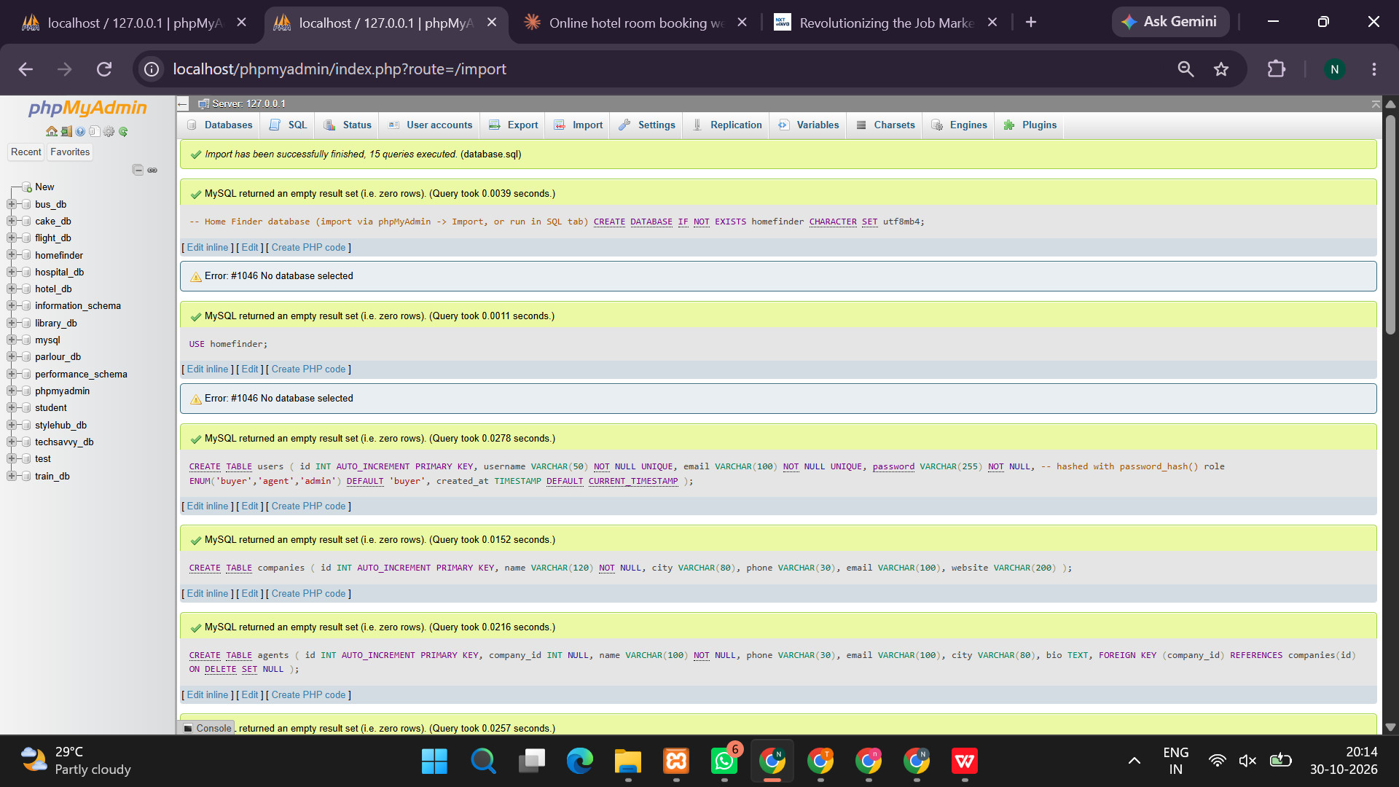
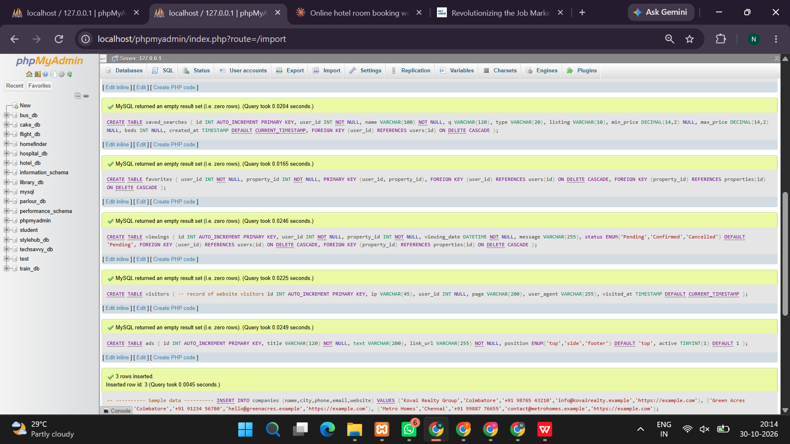
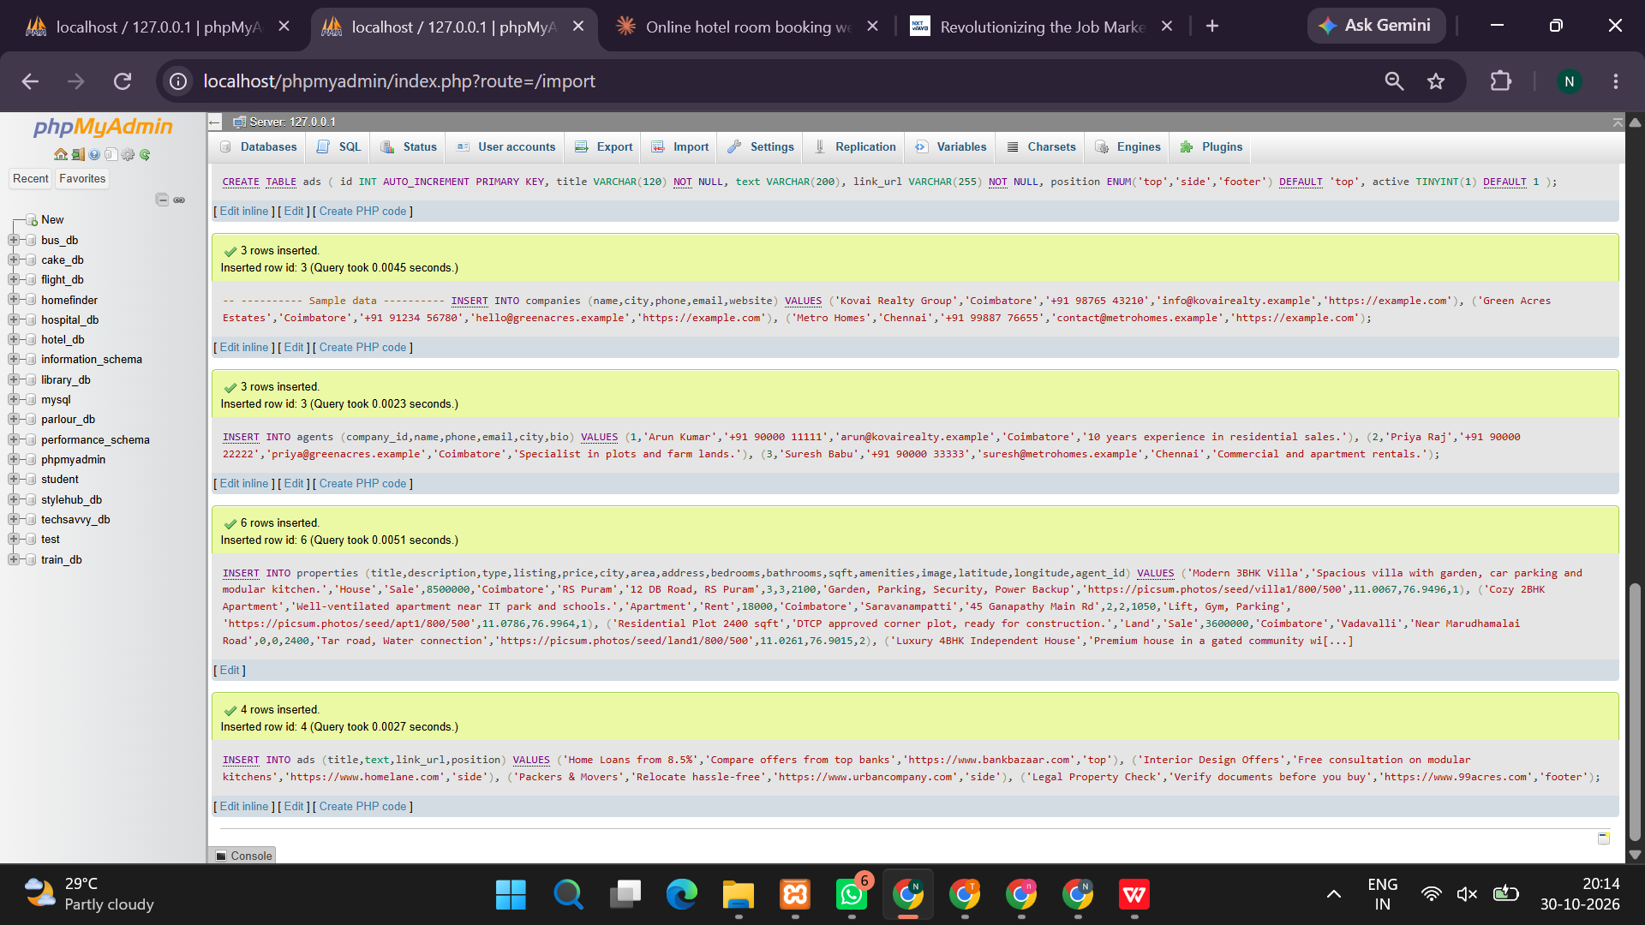
<?php
session_start();

/* DATABASE SETUP */
$db = new mysqli("localhost", "root", "");
if ($db->connect_error) die("Start MySQL in XAMPP first.");
$db->query("CREATE DATABASE IF NOT EXISTS homefinder");
$db->select_db("homefinder");
$db->set_charset("utf8mb4");

$db->query("CREATE TABLE IF NOT EXISTS users(
id INT AUTO_INCREMENT PRIMARY KEY,
name VARCHAR(100) NOT NULL,
email VARCHAR(150) UNIQUE NOT NULL,
password VARCHAR(255) NOT NULL
)");

$db->query("CREATE TABLE IF NOT EXISTS properties(
id INT AUTO_INCREMENT PRIMARY KEY,
title VARCHAR(150) NOT NULL,
location VARCHAR(150) NOT NULL,
price DECIMAL(12,2) NOT NULL,
type VARCHAR(50) NOT NULL,
bedrooms INT DEFAULT 0,
description TEXT,
agent VARCHAR(100) DEFAULT 'Home Finder Agent'
)");

$db->query("CREATE TABLE IF NOT EXISTS saved_searches(
id INT AUTO_INCREMENT PRIMARY KEY,
user_id INT NOT NULL,
location VARCHAR(150),
max_price DECIMAL(12,2),
type VARCHAR(50)
)");

$db->query("CREATE TABLE IF NOT EXISTS favorites(
id INT AUTO_INCREMENT PRIMARY KEY,
user_id INT NOT NULL,
property_id INT NOT NULL,
UNIQUE KEY unique_fav(user_id,property_id)
)");

$db->query("CREATE TABLE IF NOT EXISTS viewings(
id INT AUTO_INCREMENT PRIMARY KEY,
user_id INT NOT NULL,
property_id INT NOT NULL,
viewing_date DATE NOT NULL
)");

$db->query("CREATE TABLE IF NOT EXISTS visits(
id INT AUTO_INCREMENT PRIMARY KEY,
page VARCHAR(100),
visited_at TIMESTAMP DEFAULT CURRENT_TIMESTAMP
)");

$count = $db->query("SELECT COUNT(*) AS n FROM properties")->fetch_assoc()['n'];
if (!$count) {
$db->query("INSERT INTO properties(title,location,price,type,bedrooms,description,agent) VALUES
('Modern Family House','Chennai',6500000,'House',3,'Spacious family house near schools and transport.','Ravi Kumar'),
('Residential Plot','Sriperumbudur',1800000,'Land',0,'Residential plot in a developing neighborhood.','Priya Sharma'),
('Luxury Apartment','Bengaluru',8500000,'Apartment',2,'Modern apartment with parking and security.','Arun Kumar'),
('Commercial Property','Hyderabad',12000000,'Commercial',0,'Commercial space suitable for offices.','Meena Rao')");
}

function h($v){return htmlspecialchars((string)$v,ENT_QUOTES,'UTF-8');}
function go(){header("Location: index.php");exit;}
$msg="";
$uid=(int)($_SESSION['uid']??0);

/* REGISTER / LOGIN / LOGOUT */
if(isset($_GET['logout'])){
session_destroy();go();
}

if($_SERVER['REQUEST_METHOD']==='POST'){
$action=$_POST['action']??'';

if($action==='register'){
$name=trim($_POST['name']??'');
$email=trim($_POST['email']??'');
$pass=$_POST['password']??'';

if($name===''||!filter_var($email,FILTER_VALIDATE_EMAIL)||strlen($pass)<6){
$msg="Enter valid details. Password must contain at least 6 characters.";
}else{
$hash=password_hash($pass,PASSWORD_DEFAULT);
$st=$db->prepare("INSERT INTO users(name,email,password) VALUES(?,?,?)");
$st->bind_param("sss",$name,$email,$hash);
if($st->execute()){
session_regenerate_id(true);
$_SESSION['uid']=$st->insert_id;
$_SESSION['name']=$name;
go();
}else $msg="Email already registered.";
}
}

if($action==='login'){
$email=trim($_POST['email']??'');
$pass=$_POST['password']??'';
$st=$db->prepare("SELECT id,name,password FROM users WHERE email=?");
$st->bind_param("s",$email);$st->execute();
$u=$st->get_result()->fetch_assoc();
if($u&&password_verify($pass,$u['password'])){
session_regenerate_id(true);
$_SESSION['uid']=$u['id'];$_SESSION['name']=$u['name'];go();
}else $msg="Incorrect email or password.";
}

$uid=(int)($_SESSION['uid']??0);

if($action==='save'&&$uid){
$loc=trim($_POST['location']??'');
$price=(float)($_POST['max_price']??0);
$type=trim($_POST['type']??'');
$st=$db->prepare("INSERT INTO saved_searches(user_id,location,max_price,type) VALUES(?,?,?,?)");
$st->bind_param("isds",$uid,$loc,$price,$type);
$st->execute();$msg="Search saved successfully.";
}

if($action==='favorite'&&$uid){
$pid=(int)$_POST['pid'];
$st=$db->prepare("SELECT id FROM favorites WHERE user_id=? AND property_id=?");
$st->bind_param("ii",$uid,$pid);$st->execute();
$old=$st->get_result()->fetch_assoc();
if($old){
$st=$db->prepare("DELETE FROM favorites WHERE id=? AND user_id=?");
$st->bind_param("ii",$old['id'],$uid);$st->execute();
$msg="Removed from favorites.";
}else{
$st=$db->prepare("INSERT IGNORE INTO favorites(user_id,property_id) VALUES(?,?)");
$st->bind_param("ii",$uid,$pid);$st->execute();
$msg="Added to favorites.";
}
}

if($action==='view'&&$uid){
$pid=(int)($_POST['pid']??0);
$date=$_POST['date']??'';
$dt=DateTime::createFromFormat('Y-m-d',$date);
if(!$dt||$dt->format('Y-m-d')!==$date||$date<date('Y-m-d')){
$msg="Please select a valid date.";
}else{
$st=$db->prepare("SELECT id FROM properties WHERE id=?");
$st->bind_param("i",$pid);$st->execute();
if(!$st->get_result()->fetch_assoc())$msg="Property not found.";
else{
$st=$db->prepare("INSERT INTO viewings(user_id,property_id,viewing_date) VALUES(?,?,?)");
$st->bind_param("iis",$uid,$pid,$date);$st->execute();
$msg="Viewing request submitted.";
}
}
}

if($action==='delete'&&$uid){
$sid=(int)$_POST['sid'];
$st=$db->prepare("DELETE FROM saved_searches WHERE id=? AND user_id=?");
$st->bind_param("ii",$sid,$uid);$st->execute();$msg="Saved search deleted.";
}
}

/* SEARCH FILTERS */
$loc=trim($_GET['location']??'');
$type=trim($_GET['type']??'');
$price=(float)($_GET['max_price']??0);
$fav=isset($_GET['favorites'])&&$uid;
$searches=[];

if(isset($_GET['use'])&&$uid){
$sid=(int)$_GET['use'];
$st=$db->prepare("SELECT location,max_price,type FROM saved_searches WHERE id=? AND user_id=?");
$st->bind_param("ii",$sid,$uid);$st->execute();
if($s=$st->get_result()->fetch_assoc()){
$loc=$s['location'];$price=(float)$s['max_price'];$type=$s['type'];
}
}

if($uid){
$st=$db->prepare("SELECT property_id FROM favorites WHERE user_id=?");
$st->bind_param("i",$uid);$st->execute();
$favs=array_column($st->get_result()->fetch_all(MYSQLI_ASSOC),'property_id');

$st=$db->prepare("SELECT * FROM saved_searches WHERE user_id=? ORDER BY id DESC");
$st->bind_param("i",$uid);$st->execute();
$searches=$st->get_result()->fetch_all(MYSQLI_ASSOC);
}else $favs=[];

$sql="SELECT p.* FROM properties p WHERE 1=1";
$params=[];$sig="";
if($loc!==""){$sql.=" AND p.location LIKE ?";$params[]="%$loc%";$sig.="s";}
if($price>0){$sql.=" AND p.price<=?";$params[]=$price;$sig.="d";}
if(in_array($type,['House','Land','Apartment','Commercial'],true)){
$sql.=" AND p.type=?";$params[]=$type;$sig.="s";
}
if($fav){$sql.=" AND EXISTS(SELECT 1 FROM favorites f WHERE f.property_id=p.id AND f.user_id=?)";$params[]=$uid;$sig.="i";}
$sql.=" ORDER BY p.id DESC";
$st=$db->prepare($sql);
if($params)$st->bind_param($sig,...$params);
$st->execute();$properties=$st->get_result()->fetch_all(MYSQLI_ASSOC);

$detail=null;
if(isset($_GET['property'])){
$pid=(int)$_GET['property'];
$st=$db->prepare("SELECT * FROM properties WHERE id=?");
$st->bind_param("i",$pid);$st->execute();
$detail=$st->get_result()->fetch_assoc();
}

$pg=$db->prepare("INSERT INTO visits(page) VALUES('Home Finder')");
$pg->execute();
$login=isset($_GET['login']);$register=isset($_GET['register']);
?>
<!DOCTYPE html>
<html lang="en">
<head>
<meta charset="UTF-8">
<meta name="viewport" content="width=device-width,initial-scale=1">
<title>Home Finder - Real Estate</title>
<style>
*{box-sizing:border-box}
body{margin:0;font-family:Arial,sans-serif;background:#f4f7fc;color:#25334b}
header{display:flex;justify-content:space-between;align-items:center;gap:15px;flex-wrap:wrap;padding:20px 6%;background:white}
.logo{font-size:26px;color:#2563eb;font-weight:bold}
nav a{margin:7px;color:#34425a;text-decoration:none;font-weight:bold}
.hero{padding:65px 20px;text-align:center;color:white;background:linear-gradient(120deg,#1749a8,#6295ff)}
.hero h1{font-size:clamp(30px,5vw,48px);margin:0 0 12px}
.hero p{font-size:18px}
.container{max-width:1150px;margin:30px auto;padding:0 18px}
.panel{background:white;padding:23px;border-radius:15px;margin-bottom:24px;box-shadow:0 4px 20px #1725540b}
.filters{display:grid;grid-template-columns:2fr 1fr 1fr auto;gap:10px}
input,select,button{padding:12px;border:1px solid #d3dceb;border-radius:8px;font-size:15px}
input,select{width:100%;margin:4px 0}
button,.btn{background:#2563eb;color:white;border:0;padding:12px 15px;border-radius:8px;cursor:pointer;text-decoration:none;display:inline-block}
button:hover,.btn:hover{background:#1749a8}
.grid{display:grid;grid-template-columns:repeat(auto-fit,minmax(250px,1fr));gap:20px}
.card{background:white;border-radius:15px;overflow:hidden;box-shadow:0 4px 20px #17255412}
.art{height:130px;display:grid;place-items:center;font-size:58px;background:linear-gradient(135deg,#dbeafe,#a5c5ff)}
.info{padding:18px}
.price{color:#2563eb;font-weight:bold;font-size:23px}
.tag{background:#e7efff;color:#1d4ed8;padding:6px 10px;border-radius:20px;font-size:12px}
.muted{color:#68758a;line-height:1.6}
.actions{display:flex;gap:8px;flex-wrap:wrap;margin-top:12px}
.actions form{margin:0}
.notice{background:#e3f8e9;color:#176c37;padding:13px;border-radius:8px;margin:15px 0}
.auth{max-width:430px;margin:30px auto}
.auth form{display:grid;gap:10px}
footer{text-align:center;background:#172846;color:white;padding:28px;margin-top:45px}
@media(max-width:700px){.filters{grid-template-columns:1fr}header{justify-content:center}nav{text-align:center}}
</style>
</head>
<body>
<header>
<div class="logo">⌂ Home Finder</div>
<nav>
<a href="index.php">Home</a>
<a href="index.php#properties">Properties</a>
<?php if($uid): ?>
<a href="index.php?favorites=1">Favorites</a>
<a href="index.php#saved">Saved Searches</a>
<a href="index.php?logout=1">Logout (<?=h($_SESSION['name']??'Buyer')?>)</a>
<?php else: ?>
<a href="index.php?login=1">Login</a>
<a href="index.php?register=1">Register</a>
<?php endif; ?>
</nav>
</header>
<section class="hero">
<h1>Find a Place You'll Love</h1>
<p>Discover houses, apartments and land within your budget.</p>
<a class="btn" href="#properties">Explore Properties</a>
</section>
<div class="container">
<?php if($msg): ?><div class="notice"><?=h($msg)?></div><?php endif; ?>

<?php if($login||$register): ?>
<div class="panel auth">
<h2><?=$login?'Buyer Login':'Create Account'?></h2>
<form method="post">
<input type="hidden" name="action" value="<?=$login?'login':'register'?>">
<?php if($register): ?><input name="name" placeholder="Full name" required><?php endif; ?>
<input type="email" name="email" placeholder="Email address" required>
<input type="password" name="password" placeholder="Password (minimum 6 characters)" minlength="6" required>
<button><?=$login?'Login':'Register'?></button>
</form>
<p><?=$login?'New user? <a href="index.php?register=1">Register</a>':'Already registered? <a href="index.php?login=1">Login</a>'?></p>
</div>
<?php endif; ?>

<section class="panel" id="properties">
<h2>Search Properties</h2>
<form method="get" class="filters">
<input name="location" placeholder="City or area" value="<?=h($loc)?>">
<input type="number" name="max_price" min="0" placeholder="Max budget (₹)" value="<?=$price>0?h($price):''?>">
<select name="type">
<option value="">All types</option>
<?php foreach(['House','Land','Apartment','Commercial'] as $t): ?>
<option value="<?=h($t)?>" <?=$type===$t?'selected':''?>><?=h($t)?></option>
<?php endforeach; ?>
</select>
<button>Search</button>
</form>
<?php if($uid): ?>
<form method="post" class="actions">
<input type="hidden" name="action" value="save">
<input type="hidden" name="location" value="<?=h($loc)?>">
<input type="hidden" name="max_price" value="<?=h($price)?>">
<input type="hidden" name="type" value="<?=h($type)?>">
<button>Save Search Criteria</button>
</form>
<?php else: ?>
<p class="muted">Login to save your searches and favorite properties.</p>
<?php endif; ?>
</section>

<?php if($uid): ?>
<section class="panel" id="saved">
<h2>My Saved Searches</h2>
<?php if(!$searches): ?><p>No saved searches yet.</p><?php endif; ?>
<?php foreach($searches as $s): ?>
<div class="panel">
<?=h($s['location']?:'Any location')?> · Budget ₹<?=number_format((float)$s['max_price'])?> · <?=h($s['type']?:'All types')?>
<div class="actions">
<a class="btn" href="index.php?use=<?=$s['id']?>#properties">Use Search</a>
<form method="post"><input type="hidden" name="action" value="delete"><input type="hidden" name="sid" value="<?=$s['id']?>"><button>Delete</button></form>
</div>
</div>
<?php endforeach; ?>
</section>
<?php endif; ?>

<h2><?=$fav?'My Favorite Properties':'Available Properties'?> (<?=count($properties)?>)</h2>
<div class="grid">
<?php foreach($properties as $p): ?>
<article class="card">
<div class="art"><?=$p['type']==='Land'?'🌳':($p['type']==='Commercial'?'🏢':($p['type']==='Apartment'?'🏙️':'🏡'))?></div>
<div class="info">
<span class="tag"><?=h($p['type'])?></span>
<h3><?=h($p['title'])?></h3>
<div class="price">₹<?=number_format((float)$p['price'])?></div>
<p class="muted">📍 <?=h($p['location'])?></p>
<?php if($p['bedrooms']): ?><p>🛏 <?=h($p['bedrooms'])?> bedrooms</p><?php endif; ?>
<p><?=h($p['description'])?></p>
<p class="muted">Agent: <?=h($p['agent'])?></p>
<div class="actions">
<a class="btn" href="index.php?property=<?=$p['id']?>">View / Book</a>
<?php if($uid): ?>
<form method="post"><input type="hidden" name="action" value="favorite"><input type="hidden" name="pid" value="<?=$p['id']?>"><button><?=in_array($p['id'],$favs)?'♥ Saved':'♡ Favorite'?></button></form>
<?php endif; ?>
</div>
</div>
</article>
<?php endforeach; ?>
</div>

<?php if($detail): ?>
<section class="panel" style="margin-top:25px">
<h2><?=h($detail['title'])?></h2>
<p class="price">₹<?=number_format((float)$detail['price'])?></p>
<p><?=h($detail['description'])?></p>
<p>Location: <?=h($detail['location'])?></p>
<p>Type: <?=h($detail['type'])?></p>
<p>Agent: <?=h($detail['agent'])?></p>
<?php if($uid): ?>
<h3>Schedule Property Viewing</h3>
<form method="post">
<input type="hidden" name="action" value="view">
<input type="hidden" name="pid" value="<?=$detail['id']?>">
<input type="date" name="date" min="<?=date('Y-m-d')?>" required>
<button>Request Viewing</button>
</form>
<?php else: ?><a class="btn" href="index.php?login=1">Login to book a viewing</a><?php endif; ?>
</section>
<?php endif; ?>

<section class="panel">
<h2>Explore the Area</h2>
<p class="muted">Explore the selected location and nearby facilities using Google Maps.</p>
<a class="btn" target="_blank" rel="noopener" href="https://www.google.com/maps/search/?api=1&query=<?=rawurlencode($loc?:($detail['location']??'properties near me'))?>">Open Google Maps</a>
</section>
</div>
<footer><h3>Home Finder</h3><p>Find your dream home within your budget.</p><p>© <?=date('Y')?> Home Finder</p></footer>
</body>
</html>
OUTPUT:


