EXPERIMENT-12

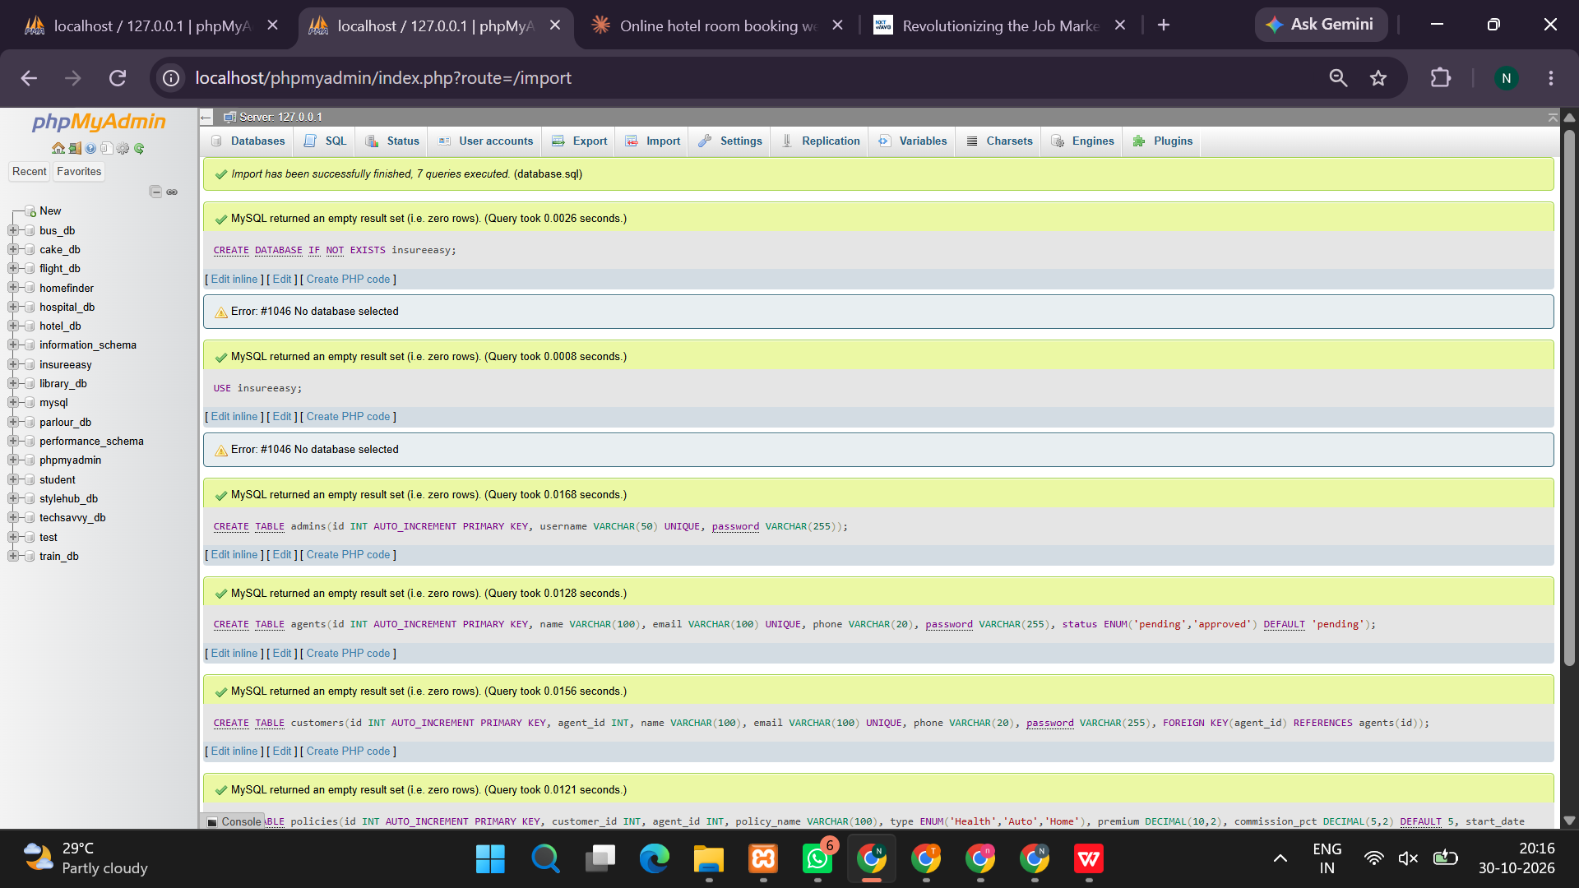
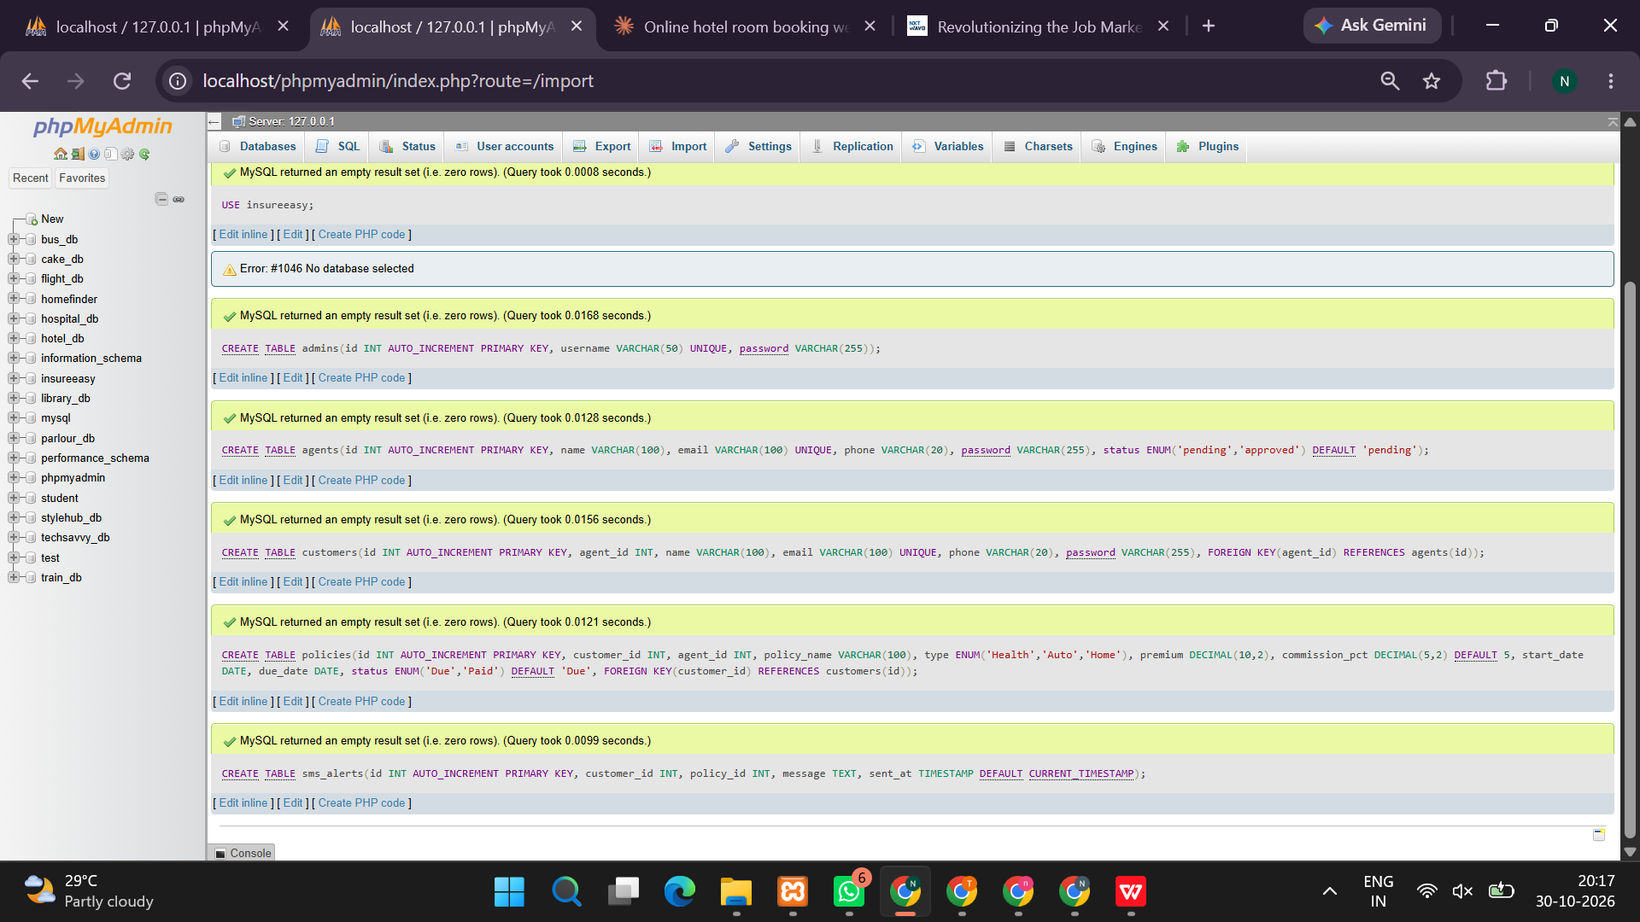
<?php
session_start();

$host = "localhost";
$dbuser = "root";
$dbpass = "";
$dbname = "insure_easy";

$conn = new mysqli($host, $dbuser, $dbpass);
if ($conn->connect_error) {
die("MySQL connection failed: " . $conn->connect_error);
}

$conn->query("CREATE DATABASE IF NOT EXISTS `$dbname`");
$conn->select_db($dbname);
$conn->set_charset("utf8mb4");

$conn->query("CREATE TABLE IF NOT EXISTS users (
id INT AUTO_INCREMENT PRIMARY KEY,
name VARCHAR(100) NOT NULL,
email VARCHAR(150) UNIQUE NOT NULL,
password VARCHAR(255) NOT NULL,
role ENUM('admin','agent','customer') DEFAULT 'customer'
)");

$conn->query("CREATE TABLE IF NOT EXISTS policies (
id INT AUTO_INCREMENT PRIMARY KEY,
policy_name VARCHAR(150) NOT NULL,
policy_type VARCHAR(60) NOT NULL,
premium DECIMAL(10,2) NOT NULL,
coverage DECIMAL(12,2) NOT NULL,
agent_id INT DEFAULT NULL
)");

$conn->query("CREATE TABLE IF NOT EXISTS customers (
id INT AUTO_INCREMENT PRIMARY KEY,
name VARCHAR(100) NOT NULL,
email VARCHAR(150) NOT NULL,
phone VARCHAR(20),
policy_id INT DEFAULT NULL,
premium DECIMAL(10,2) DEFAULT 0,
commission DECIMAL(10,2) DEFAULT 0,
status VARCHAR(30) DEFAULT 'Active'
)");

$conn->query("CREATE TABLE IF NOT EXISTS alerts (
id INT AUTO_INCREMENT PRIMARY KEY,
user_id INT NOT NULL,
message VARCHAR(255) NOT NULL,
created_at TIMESTAMP DEFAULT CURRENT_TIMESTAMP
)");

$count = $conn->query("SELECT COUNT(*) AS total FROM policies")->fetch_assoc();
if ((int)$count['total'] === 0) {
$conn->query("INSERT INTO policies
(policy_name,policy_type,premium,coverage) VALUES
('Family Health Shield','Health',8000,500000),
('Secure Life Plan','Life',12000,1000000),
('Safe Drive Insurance','Vehicle',6000,300000)");
}

$notice = "";

function h($value) {
return htmlspecialchars((string)$value, ENT_QUOTES, 'UTF-8');
}

if (isset($_POST['register'])) {
$name = trim($_POST['name']);
$email = trim($_POST['email']);
$password = password_hash($_POST['password'], PASSWORD_DEFAULT);
$role = $_POST['role'] ?? 'customer';

// Public registration is restricted to customers.
$role = 'customer';

$stmt = $conn->prepare(
"INSERT INTO users(name,email,password,role) VALUES(?,?,?,?)"
);
$stmt->bind_param("ssss", $name, $email, $password, $role);

if ($stmt->execute()) {
$notice = "Registration successful. Please log in.";
} else {
$notice = "Registration failed. This email may already be registered.";
}
}

if (isset($_POST['login'])) {
$email = trim($_POST['email']);
$password = $_POST['password'];

$stmt = $conn->prepare("SELECT * FROM users WHERE email=?");
$stmt->bind_param("s", $email);
$stmt->execute();
$user = $stmt->get_result()->fetch_assoc();

if ($user && password_verify($password, $user['password'])) {
session_regenerate_id(true);
$_SESSION['uid'] = $user['id'];
$_SESSION['name'] = $user['name'];
$_SESSION['role'] = $user['role'];
header("Location: index.php");
exit;
} else {
$notice = "Invalid email or password.";
}
}

if (isset($_POST['logout'])) {
$_SESSION = [];
session_destroy();
header("Location: index.php");
exit;
}

$loggedIn = isset($_SESSION['uid']);
$role = $_SESSION['role'] ?? '';

if ($loggedIn && $role === 'admin' && isset($_POST['add_policy'])) {
$name = trim($_POST['policy_name']);
$type = trim($_POST['policy_type']);
$premium = (float)$_POST['premium'];
$coverage = (float)$_POST['coverage'];

if ($name !== '' && $type !== '' && $premium > 0 && $coverage > 0) {
$stmt = $conn->prepare(
"INSERT INTO policies(policy_name,policy_type,premium,coverage)
VALUES(?,?,?,?)"
);
$stmt->bind_param("ssdd", $name, $type, $premium, $coverage);
$stmt->execute();
$notice = "Insurance policy added successfully.";
} else {
$notice = "Enter valid policy details.";
}
}

if ($loggedIn && $role === 'agent' && isset($_POST['add_customer'])) {
$name = trim($_POST['customer_name']);
$email = trim($_POST['customer_email']);
$phone = trim($_POST['phone']);
$policyId = (int)$_POST['policy_id'];

$stmt = $conn->prepare("SELECT premium FROM policies WHERE id=?");
$stmt->bind_param("i", $policyId);
$stmt->execute();
$policy = $stmt->get_result()->fetch_assoc();

if ($name !== '' && filter_var($email, FILTER_VALIDATE_EMAIL) && $policy) {
$premium = (float)$policy['premium'];
$commission = round($premium * 0.10, 2);

$stmt = $conn->prepare(
"INSERT INTO customers(name,email,phone,policy_id,premium,commission)
VALUES(?,?,?,?,?,?)"
);
$stmt->bind_param(
"sssidd", $name, $email, $phone, $policyId, $premium, $commission
);

if ($stmt->execute()) {
$notice = "Customer added. Demo alert generated.";
$alertMessage = "Hello $name, your insurance enquiry has been recorded.";
$alertStmt = $conn->prepare(
"INSERT INTO alerts(user_id,message) VALUES(?,?)"
);
$alertStmt->bind_param("is", $_SESSION['uid'], $alertMessage);
$alertStmt->execute();
} else {
$notice = "Could not add customer.";
}
} else {
$notice = "Enter valid customer details and select a policy.";
}
}

if ($loggedIn && $role === 'admin' && isset($_POST['delete_policy'])) {
$id = (int)$_POST['policy_id'];
$stmt = $conn->prepare("DELETE FROM policies WHERE id=?");
$stmt->bind_param("i", $id);
$stmt->execute();
$notice = "Policy deletion processed.";
}

$policies = $conn->query("SELECT * FROM policies ORDER BY id DESC");

$customers = null;
if ($loggedIn && in_array($role, ['admin','agent'], true)) {
$customers = $conn->query(
"SELECT c.*, p.policy_name FROM customers c
LEFT JOIN policies p ON c.policy_id=p.id ORDER BY c.id DESC"
);
}

$alerts = null;
if ($loggedIn) {
$stmt = $conn->prepare(
"SELECT message,created_at FROM alerts WHERE user_id=? ORDER BY id DESC"
);
$stmt->bind_param("i", $_SESSION['uid']);
$stmt->execute();
$alerts = $stmt->get_result();
}
?>
<!DOCTYPE html>
<html lang="en">
<head>
<meta charset="UTF-8">
<meta name="viewport" content="width=device-width, initial-scale=1">
<title>InsureEasy | Insurance Management</title>
<style>
*{box-sizing:border-box}
body{margin:0;font-family:Arial,sans-serif;background:#f3f6fb;color:#25324a}
header{background:linear-gradient(120deg,#123d72,#167d9a);color:white;padding:25px 7%}
header h1{margin:0 0 8px}
nav{display:flex;gap:18px;flex-wrap:wrap;margin-top:18px}
nav a{color:white;text-decoration:none;font-weight:bold}
main{max-width:1150px;margin:28px auto;padding:0 18px}
.hero{background:#e0f2fe;padding:28px;border-radius:18px;margin-bottom:22px}
.grid{display:grid;grid-template-columns:repeat(auto-fit,minmax(250px,1fr));gap:18px}
.card{background:white;padding:22px;border-radius:14px;box-shadow:0 5px 20px #182d4910;margin-bottom:20px}
h2{color:#174b7a}
input,select{width:100%;padding:12px;margin:7px 0 14px;border:1px solid #ccd5e0;border-radius:8px}
button,.btn{background:#087e8b;color:white;padding:11px 16px;border:0;border-radius:8px;cursor:pointer;text-decoration:none}
button:hover,.btn:hover{background:#075e68}
.notice{background:#dcfce7;padding:13px;border-radius:8px;margin-bottom:18px}
.muted{color:#667085}
.price{font-size:25px;font-weight:bold;color:#087e8b}
table{width:100%;border-collapse:collapse;background:white}
th,td{text-align:left;padding:12px;border-bottom:1px solid #e6ebf2}
th{background:#e8f2fb}
.table-wrap{overflow-x:auto}
footer{text-align:center;padding:24px;color:#667085}
</style>
</head>
<body>
<header>
<h1>InsureEasy</h1>
<div>Simple and smart insurance management</div>
<nav>
<a href="index.php">Home</a>
<a href="#policies">Insurance Policies</a>
<?php if ($loggedIn): ?>
<a href="#dashboard">Dashboard</a>
<a href="#alerts">Alerts</a>
<?php else: ?>
<a href="#login">Login</a>
<a href="#register">Register</a>
<?php endif; ?>
</nav>
</header>

<main>
<?php if ($notice !== ''): ?>
<div class="notice"><?=h($notice)?></div>
<?php endif; ?>

<section class="hero">
<h2>Protect what matters most</h2>
<p>Explore life, health and vehicle insurance policies in one place.</p>
<a class="btn" href="#policies">Explore Policies</a>
</section>

<?php if (!$loggedIn): ?>
<div class="grid">
<section class="card" id="login">
<h2>Login</h2>
<form method="post">
<label>Email</label>
<input type="email" name="email" required>
<label>Password</label>
<input type="password" name="password" required>
<button name="login">Login</button>
</form>
</section>

<section class="card" id="register">
<h2>Create Customer Account</h2>
<form method="post">
<label>Full Name</label>
<input name="name" required maxlength="100">
<label>Email</label>
<input type="email" name="email" required>
<label>Password</label>
<input type="password" name="password" required minlength="8">
<button name="register">Register</button>
</form>
<p class="muted">New registrations create customer accounts only.</p>
</section>
</div>
<?php else: ?>
<section class="card" id="dashboard">
<h2>Welcome, <?=h($_SESSION['name'])?></h2>
<p>Your role: <strong><?=h(ucfirst($role))?></strong></p>
<form method="post">
<button name="logout">Logout</button>
</form>
</section>

<?php if ($role === 'admin'): ?>
<section class="card">
<h2>Admin: Add Insurance Policy</h2>
<form method="post">
<label>Policy Name</label>
<input name="policy_name" required>
<label>Policy Type</label>
<select name="policy_type" required>
<option value="Health">Health</option>
<option value="Life">Life</option>
<option value="Vehicle">Vehicle</option>
<option value="Travel">Travel</option>
<option value="Property">Property</option>
</select>
<label>Annual Premium (₹)</label>
<input type="number" name="premium" min="1" step="0.01" required>
<label>Coverage Amount (₹)</label>
<input type="number" name="coverage" min="1" step="0.01" required>
<button name="add_policy">Add Policy</button>
</form>
</section>
<?php endif; ?>

<?php if ($role === 'agent'): ?>
<section class="card">
<h2>Agent: Add Customer</h2>
<form method="post">
<label>Customer Name</label>
<input name="customer_name" required>
<label>Customer Email</label>
<input type="email" name="customer_email" required>
<label>Phone Number</label>
<input name="phone" maxlength="20">
<label>Select Policy</label>
<select name="policy_id" required>
<?php
$policyOptions = $conn->query("SELECT id,policy_name FROM policies");
while ($p = $policyOptions->fetch_assoc()):
?>
<option value="<?=h($p['id'])?>"><?=h($p['policy_name'])?></option>
<?php endwhile; ?>
</select>
<button name="add_customer">Add Customer</button>
</form>
</section>
<?php endif; ?>
<?php endif; ?>

<section id="policies">
<h2>Available Insurance Policies</h2>
<div class="grid">
<?php while ($p = $policies->fetch_assoc()): ?>
<article class="card">
<h3><?=h($p['policy_name'])?></h3>
<p class="muted"><?=h($p['policy_type'])?> Insurance</p>
<p>Annual Premium</p>
<div class="price">₹<?=number_format((float)$p['premium'],2)?></div>
<p>Coverage: ₹<?=number_format((float)$p['coverage'],2)?></p>
<?php if ($loggedIn && $role === 'admin'): ?>
<form method="post" onsubmit="return confirm('Delete this policy?')">
<input type="hidden" name="policy_id" value="<?=h($p['id'])?>">
<button name="delete_policy">Delete Policy</button>
</form>
<?php endif; ?>
</article>
<?php endwhile; ?>
</div>
</section>

<?php if ($loggedIn && $customers): ?>
<section class="card">
<h2><?= $role === 'admin' ? 'All Customer Records' : 'Managed Customers' ?></h2>
<div class="table-wrap">
<table>
<tr>
<th>Name</th><th>Email</th><th>Phone</th><th>Policy</th>
<th>Premium</th><th>Commission</th><th>Status</th>
</tr>
<?php while ($c = $customers->fetch_assoc()): ?>
<tr>
<td><?=h($c['name'])?></td>
<td><?=h($c['email'])?></td>
<td><?=h($c['phone'])?></td>
<td><?=h($c['policy_name'] ?? 'N/A')?></td>
<td>₹<?=number_format((float)$c['premium'],2)?></td>
<td>₹<?=number_format((float)$c['commission'],2)?></td>
<td><?=h($c['status'])?></td>
</tr>
<?php endwhile; ?>
</table>
</div>
<p class="muted">Demo commission is calculated as 10% of the selected premium.</p>
</section>
<?php endif; ?>

<?php if ($loggedIn && $alerts): ?>
<section class="card" id="alerts">
<h2>Notifications</h2>
<?php if ($alerts->num_rows === 0): ?>
<p>No notifications yet.</p>
<?php else: ?>
<?php while ($a = $alerts->fetch_assoc()): ?>
<p>🔔 <?=h($a['message'])?>
<span class="muted"> — <?=h($a['created_at'])?></span></p>
<?php endwhile; ?>
<?php endif; ?>
<p class="muted">These are in-app demo alerts, not real SMS messages.</p>
</section>
<?php endif; ?>

</main>
<footer>InsureEasy Insurance Management System | Academic Project Demo</footer>
</body>
</html>
OUTPUT:


