EXPERIMENT-13

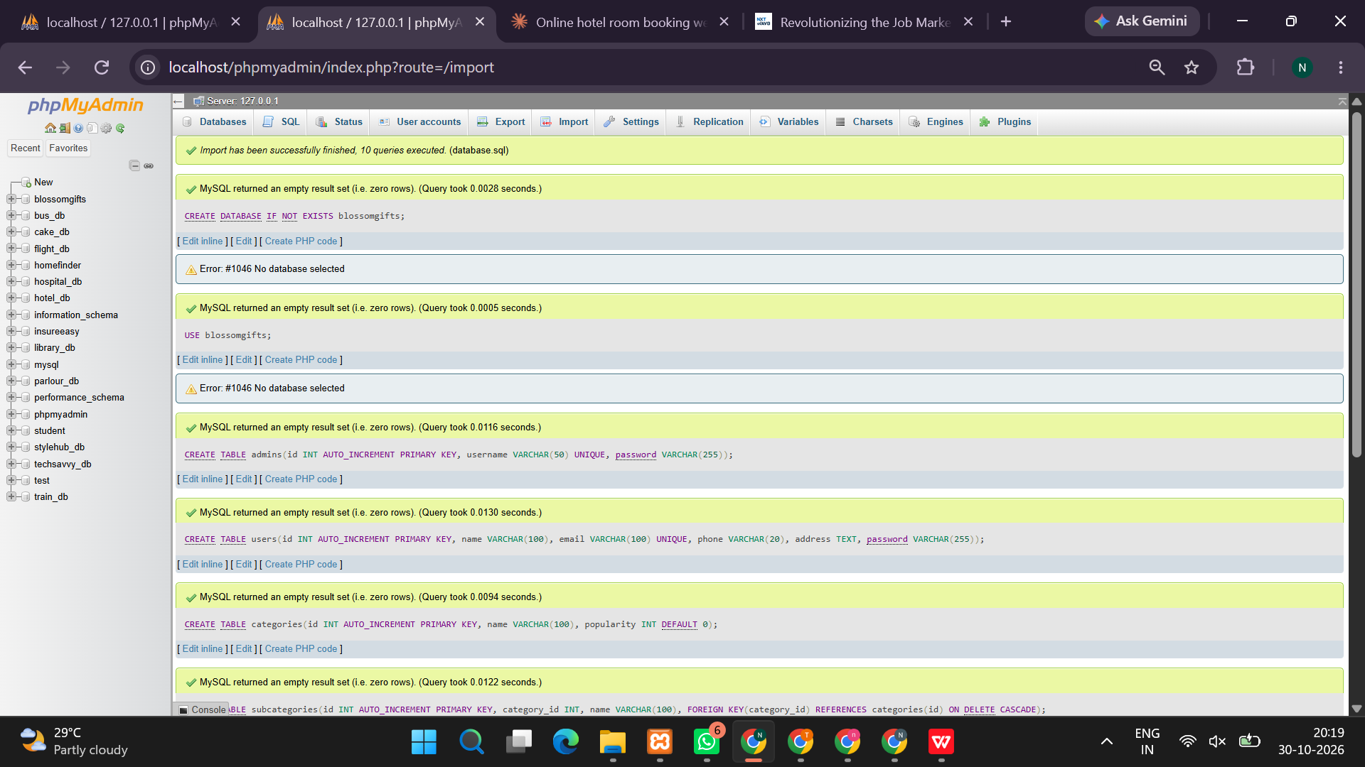
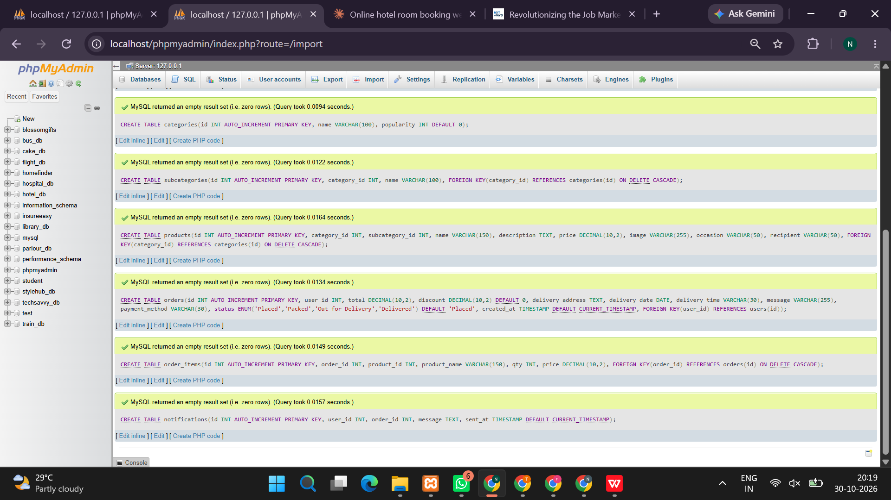
<?php
session_start();

$conn = new mysqli("localhost", "root", "");
if ($conn->connect_error) {
die("Database connection failed. Start MySQL in XAMPP.");
}

$conn->query("CREATE DATABASE IF NOT EXISTS blossom_gifts");
$conn->select_db("blossom_gifts");
$conn->set_charset("utf8mb4");

$conn->query("CREATE TABLE IF NOT EXISTS users (
id INT AUTO_INCREMENT PRIMARY KEY,
name VARCHAR(100) NOT NULL,
email VARCHAR(150) UNIQUE NOT NULL,
password VARCHAR(255) NOT NULL,
role ENUM('customer','admin') DEFAULT 'customer'
)");

$conn->query("CREATE TABLE IF NOT EXISTS products (
id INT AUTO_INCREMENT PRIMARY KEY,
name VARCHAR(150) NOT NULL,
category VARCHAR(60) NOT NULL,
price DECIMAL(10,2) NOT NULL,
description TEXT
)");

$conn->query("CREATE TABLE IF NOT EXISTS orders (
id INT AUTO_INCREMENT PRIMARY KEY,
user_id INT NOT NULL,
product_id INT NOT NULL,
quantity INT NOT NULL,
delivery_date DATE NOT NULL,
address VARCHAR(255) NOT NULL,
status VARCHAR(30) DEFAULT 'Placed',
created_at TIMESTAMP DEFAULT CURRENT_TIMESTAMP
)");

$conn->query("CREATE TABLE IF NOT EXISTS notifications (
id INT AUTO_INCREMENT PRIMARY KEY,
user_id INT NOT NULL,
message VARCHAR(255) NOT NULL,
created_at TIMESTAMP DEFAULT CURRENT_TIMESTAMP
)");

$total = $conn->query("SELECT COUNT(*) AS total FROM products")->fetch_assoc();

if ((int)$total['total'] === 0) {
$conn->query("INSERT INTO products(name,category,price,description) VALUES
('Red Rose Bouquet','Flowers',799,'Fresh red roses for special occasions.'),
('Birthday Gift Box','Gifts',999,'A gift box for birthday celebrations.'),
('Orchid Arrangement','Flowers',1299,'Elegant orchids beautifully arranged.'),
('Chocolate Hamper','Chocolates',649,'A hamper of assorted chocolates.'),
('Teddy Bear','Gifts',499,'A soft teddy bear for your loved ones.'),
('Anniversary Combo','Combos',1499,'Flowers and gifts for anniversaries.')");
}

function h($value) {
return htmlspecialchars((string)$value, ENT_QUOTES, 'UTF-8');
}

$msg = "";

if (isset($_POST['register'])) {
$name = trim($_POST['name']);
$email = trim($_POST['email']);
$password = $_POST['password'];

if ($name === '' || !filter_var($email, FILTER_VALIDATE_EMAIL)
|| strlen($password) < 8) {
$msg = "Enter a valid name, email and password of at least 8 characters.";
} else {
$hash = password_hash($password, PASSWORD_DEFAULT);
$stmt = $conn->prepare(
"INSERT INTO users(name,email,password) VALUES(?,?,?)"
);
$stmt->bind_param("sss", $name, $email, $hash);

if ($stmt->execute()) {
$msg = "Registration successful. Please log in.";
} else {
$msg = "Registration failed. This email may already exist.";
}
}
}

if (isset($_POST['login'])) {
$email = trim($_POST['email']);
$password = $_POST['password'];

$stmt = $conn->prepare("SELECT * FROM users WHERE email=?");
$stmt->bind_param("s", $email);
$stmt->execute();
$user = $stmt->get_result()->fetch_assoc();

if ($user && password_verify($password, $user['password'])) {
session_regenerate_id(true);
$_SESSION['uid'] = $user['id'];
$_SESSION['name'] = $user['name'];
$_SESSION['role'] = $user['role'];

header("Location: index.php");
exit;
} else {
$msg = "Invalid email or password.";
}
}

if (isset($_POST['logout'])) {
$_SESSION = [];
session_destroy();
header("Location: index.php");
exit;
}

$loggedIn = isset($_SESSION['uid']);
$role = $_SESSION['role'] ?? '';

// Place an order
if ($loggedIn && isset($_POST['place_order'])) {
$productId = (int)$_POST['product_id'];
$quantity = (int)$_POST['quantity'];
$deliveryDate = $_POST['delivery_date'];
$address = trim($_POST['address']);

$stmt = $conn->prepare("SELECT id FROM products WHERE id=?");
$stmt->bind_param("i", $productId);
$stmt->execute();
$product = $stmt->get_result()->fetch_assoc();

if (!$product || $quantity < 1 || $quantity > 20 ||
$deliveryDate < date('Y-m-d') || $address === '') {
$msg = "Please enter valid order details.";
} else {
$uid = (int)$_SESSION['uid'];

$stmt = $conn->prepare(
"INSERT INTO orders(user_id,product_id,quantity,delivery_date,address)
VALUES(?,?,?,?,?)"
);
$stmt->bind_param(
"iiiss", $uid, $productId, $quantity, $deliveryDate, $address
);

if ($stmt->execute()) {
$message = "Your BlossomGifts order has been placed successfully.";
$notify = $conn->prepare(
"INSERT INTO notifications(user_id,message) VALUES(?,?)"
);
$notify->bind_param("is", $uid, $message);
$notify->execute();
$msg = "Order placed successfully! Check My Orders.";
} else {
$msg = "Unable to place the order.";
}
}
}

// Admin adds a product
if ($loggedIn && $role === 'admin' && isset($_POST['add_product'])) {
$name = trim($_POST['product_name']);
$category = trim($_POST['category']);
$price = (float)$_POST['price'];
$description = trim($_POST['description']);

if ($name !== '' && $category !== '' && $price > 0) {
$stmt = $conn->prepare(
"INSERT INTO products(name,category,price,description)
VALUES(?,?,?,?)"
);
$stmt->bind_param("ssds", $name, $category, $price, $description);

if ($stmt->execute()) {
$msg = "Product added successfully.";
}
} else {
$msg = "Enter valid product details.";
}
}

// Admin deletes a product
if ($loggedIn && $role === 'admin' && isset($_POST['delete_product'])) {
$id = (int)$_POST['product_id'];

$stmt = $conn->prepare("DELETE FROM products WHERE id=?");
$stmt->bind_param("i", $id);
$stmt->execute();

$msg = "Product deletion processed.";
}

$category = $_GET['category'] ?? '';

if ($category !== '') {
$stmt = $conn->prepare("SELECT * FROM products WHERE category=? ORDER BY id DESC");
$stmt->bind_param("s", $category);
$stmt->execute();
$products = $stmt->get_result();
} else {
$products = $conn->query("SELECT * FROM products ORDER BY id DESC");
}
?>
<!DOCTYPE html>
<html lang="en">
<head>
<meta charset="UTF-8">
<meta name="viewport" content="width=device-width, initial-scale=1">
<title>BlossomGifts - Online Gift Shop</title>
<style>
*{box-sizing:border-box}
body{margin:0;font-family:Arial,sans-serif;background:#fff6f9;color:#402b36}
header{background:linear-gradient(120deg,#8e2455,#d94b80);color:white;padding:25px 7%}
header h1{margin:0 0 8px;font-size:32px}
nav{display:flex;gap:20px;flex-wrap:wrap;margin-top:18px}
nav a{color:white;text-decoration:none;font-weight:bold}
main{max-width:1150px;margin:28px auto;padding:0 18px}
.hero{background:#ffe0ec;padding:30px;border-radius:18px;margin-bottom:24px}
.hero h2{font-size:30px;margin-top:0}
h2{color:#9b2859}
.grid{display:grid;grid-template-columns:repeat(auto-fit,minmax(250px,1fr));gap:18px}
.card{background:white;padding:22px;border-radius:15px;box-shadow:0 5px 20px #63204410;margin-bottom:20px}
input,select,textarea{width:100%;padding:12px;margin:7px 0 14px;border:1px solid #e3c7d3;border-radius:8px;font-size:15px}
button,.btn{display:inline-block;background:#a72c61;color:white;padding:11px 16px;border:0;border-radius:8px;cursor:pointer;text-decoration:none}
button:hover,.btn:hover{background:#7f1e49}
.price{font-size:25px;font-weight:bold;color:#a72c61}
.notice{background:#dcfce7;padding:13px;border-radius:8px;margin-bottom:18px}
.muted{color:#756570}
footer{text-align:center;padding:25px;color:#756570}
</style>
</head>
<body>

<header>
<h1>🌸 BlossomGifts</h1>
<p>Beautiful flowers and gifts for every occasion</p>
<nav>
<a href="index.php">Home</a>
<a href="#shop">Shop</a>
<a href="#account">Account</a>
<a href="#orders">My Orders</a>
<?php if ($loggedIn && $role === 'admin'): ?>
<a href="#admin">Admin Panel</a>
<?php endif; ?>
</nav>
</header>

<main>
<?php if ($msg !== ''): ?>
<div class="notice"><?=h($msg)?></div>
<?php endif; ?>

<section class="hero">
<h2>Make Every Moment Special</h2>
<p>Discover flower bouquets, chocolates, gift boxes and more.</p>
<a class="btn" href="#shop">Explore Products</a>
</section>

<?php if (!$loggedIn): ?>
<div class="grid">
<section class="card" id="account">
<h2>Customer Login</h2>
<form method="post">
<label>Email</label>
<input type="email" name="email" required>
<label>Password</label>
<input type="password" name="password" required>
<button name="login">Login</button>
</form>
</section>

<section class="card">
<h2>Create Account</h2>
<form method="post">
<label>Full Name</label>
<input name="name" required maxlength="100">
<label>Email</label>
<input type="email" name="email" required>
<label>Password</label>
<input type="password" name="password" minlength="8" required>
<button name="register">Register</button>
</form>
</section>
</div>
<?php else: ?>
<section class="card">
<h2>Welcome, <?=h($_SESSION['name'])?>!</h2>
<p>Account type: <?=h(ucfirst($role))?></p>
<form method="post"><button name="logout">Logout</button></form>
</section>
<?php endif; ?>

<?php if ($loggedIn && $role === 'admin'): ?>
<section class="card" id="admin">
<h2>Admin - Add New Product</h2>
<form method="post">
<label>Product Name</label>
<input name="product_name" required>
<label>Category</label>
<select name="category" required>
<option value="Flowers">Flowers</option>
<option value="Gifts">Gifts</option>
<option value="Chocolates">Chocolates</option>
<option value="Combos">Combos</option>
</select>
<label>Price (₹)</label>
<input type="number" name="price" min="1" step="0.01" required>
<label>Description</label>
<textarea name="description" rows="3"></textarea>
<button name="add_product">Add Product</button>
</form>
</section>
<?php endif; ?>

<section class="card">
<h2>Shop by Category</h2>
<a class="btn" href="index.php#shop">All Products</a>
<?php foreach (['Flowers','Gifts','Chocolates','Combos'] as $cat): ?>
<a class="btn" href="?category=<?=urlencode($cat)?>#shop"><?=h($cat)?></a>
<?php endforeach; ?>
</section>

<section id="shop">
<h2>Our Products</h2>
<div class="grid">
<?php while ($p = $products->fetch_assoc()): ?>
<article class="card">
<h3><?=h($p['name'])?></h3>
<p class="muted"><?=h($p['category'])?></p>
<p><?=h($p['description'])?></p>
<div class="price">₹<?=number_format((float)$p['price'],2)?></div>

<?php if ($loggedIn && $role === 'admin'): ?>
<form method="post" onsubmit="return confirm('Delete this product?')">
<input type="hidden" name="product_id" value="<?=h($p['id'])?>">
<button name="delete_product">Delete Product</button>
</form>
<?php elseif ($loggedIn): ?>
<form method="post">
<input type="hidden" name="product_id" value="<?=h($p['id'])?>">
<label>Quantity</label>
<input type="number" name="quantity" min="1" max="20" value="1" required>
<label>Delivery Date</label>
<input type="date" name="delivery_date" min="<?=date('Y-m-d')?>" required>
<label>Delivery Address</label>
<textarea name="address" rows="2" maxlength="255" required></textarea>
<button name="place_order">Place Order</button>
</form>
<?php else: ?>
<p>Login to order this product.</p>
<a class="btn" href="#account">Login / Register</a>
<?php endif; ?>
</article>
<?php endwhile; ?>
</div>
</section>

<?php if ($loggedIn): ?>
<?php
$stmt = $conn->prepare(
"SELECT o.*,p.name,p.price FROM orders o
JOIN products p ON p.id=o.product_id
WHERE o.user_id=? ORDER BY o.id DESC"
);
$stmt->bind_param("i", $_SESSION['uid']);
$stmt->execute();
$orders = $stmt->get_result();
?>
<section class="card" id="orders">
<h2>My Orders</h2>
<?php if ($orders->num_rows === 0): ?>
<p>You have not placed any orders yet.</p>
<?php else: ?>
<div style="overflow-x:auto">
<table width="100%" cellpadding="10">
<tr><th>Product</th><th>Quantity</th><th>Total</th><th>Delivery</th><th>Status</th></tr>
<?php while ($o = $orders->fetch_assoc()): ?>
<tr>
<td><?=h($o['name'])?></td>
<td><?=h($o['quantity'])?></td>
<td>₹<?=number_format((float)$o['price']*(int)$o['quantity'],2)?></td>
<td><?=h($o['delivery_date'])?></td>
<td><?=h($o['status'])?></td>
</tr>
<?php endwhile; ?>
</table>
</div>
<?php endif; ?>
</section>

<section class="card">
<h2>Notifications</h2>
<?php
$stmt = $conn->prepare(
"SELECT message,created_at FROM notifications WHERE user_id=? ORDER BY id DESC"
);
$stmt->bind_param("i", $_SESSION['uid']);
$stmt->execute();
$notifications = $stmt->get_result();
?>
<?php if (!$notifications->num_rows): ?>
<p>No notifications yet.</p>
<?php else: ?>
<?php while ($n = $notifications->fetch_assoc()): ?>
<p>🔔 <?=h($n['message'])?> <span class="muted"><?=h($n['created_at'])?></span></p>
<?php endwhile; ?>
<?php endif; ?>
<p class="muted">Notifications are shown inside the website. Real SMS/email requires a configured service.</p>
</section>
<?php endif; ?>

<footer>
<p>BlossomGifts — Online Flower and Gift Shopping Platform</p>
<p>Academic project demonstration</p>
</footer>
</main>
</body>
</html>

OUTPUT:


