EXPERIMENT-14

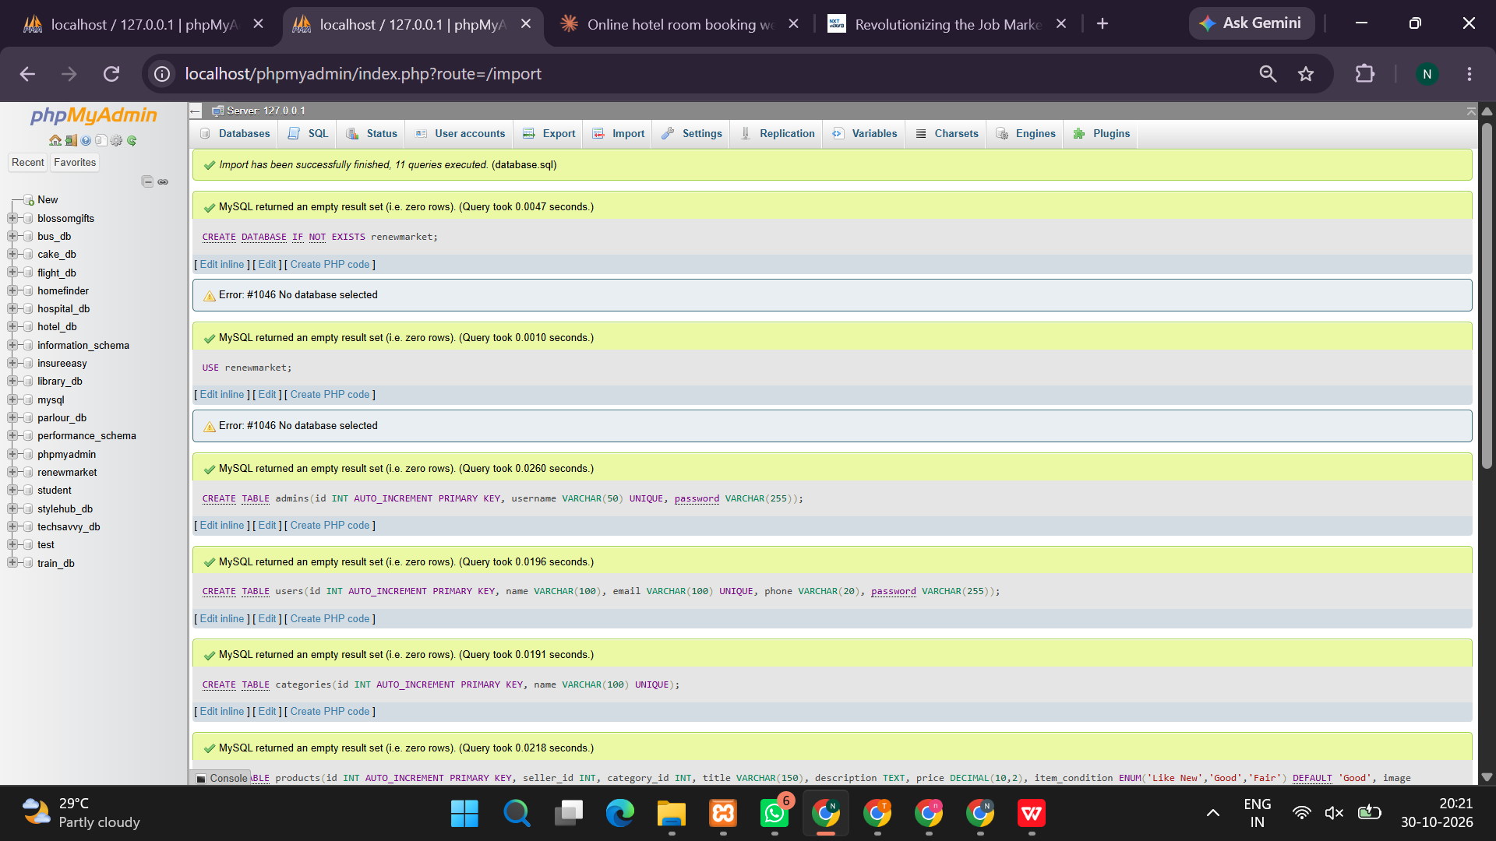
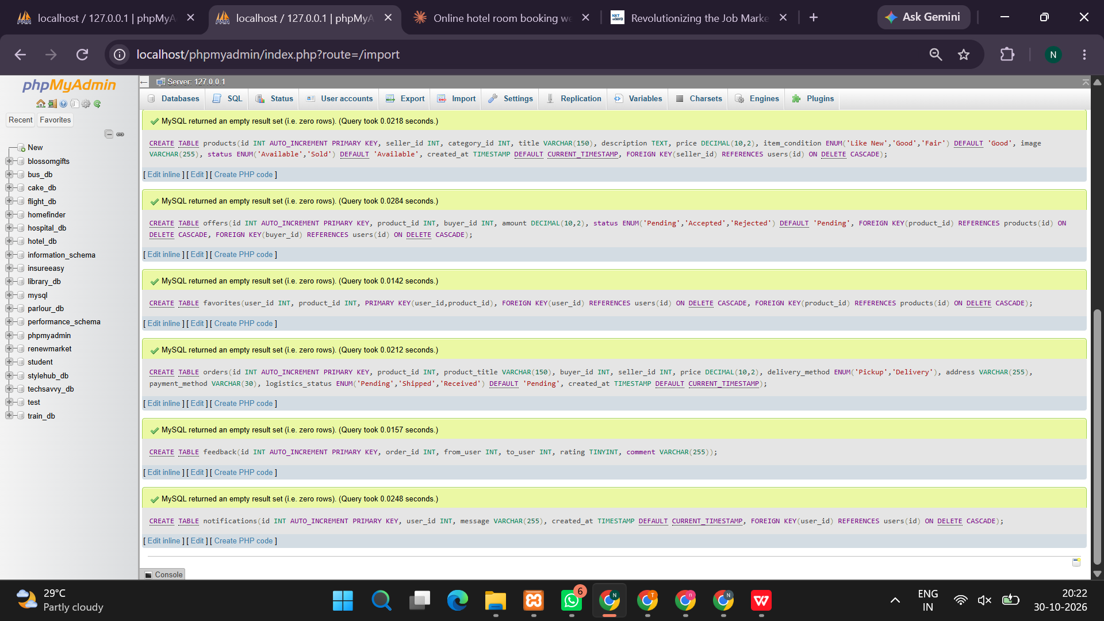
<?php
session_start();

$conn = new mysqli("localhost", "root", "", "");
if ($conn->connect_error) {
die("Database connection failed: " . $conn->connect_error);
}

$conn->query("CREATE DATABASE IF NOT EXISTS renew_market");
$conn->select_db("renew_market");
$conn->set_charset("utf8mb4");

$conn->query("CREATE TABLE IF NOT EXISTS users (
id INT AUTO_INCREMENT PRIMARY KEY,
name VARCHAR(100) NOT NULL,
email VARCHAR(150) UNIQUE NOT NULL,
password VARCHAR(255) NOT NULL,
role VARCHAR(20) DEFAULT 'user'
)");

$conn->query("CREATE TABLE IF NOT EXISTS products (
id INT AUTO_INCREMENT PRIMARY KEY,
seller_id INT NOT NULL,
title VARCHAR(150) NOT NULL,
category VARCHAR(60) NOT NULL,
price DECIMAL(10,2) NOT NULL,
item_condition VARCHAR(40) NOT NULL,
description TEXT,
status VARCHAR(30) DEFAULT 'Available',
created_at TIMESTAMP DEFAULT CURRENT_TIMESTAMP
)");

$conn->query("CREATE TABLE IF NOT EXISTS orders (
id INT AUTO_INCREMENT PRIMARY KEY,
buyer_id INT NOT NULL,
product_id INT NOT NULL,
status VARCHAR(40) DEFAULT 'Order Placed',
created_at TIMESTAMP DEFAULT CURRENT_TIMESTAMP
)");

$count = $conn->query("SELECT COUNT(*) AS total FROM products")->fetch_assoc()['total'];
if ($count == 0) {
$conn->query("INSERT INTO products
(seller_id,title,category,price,item_condition,description)
VALUES
(1,'Used Laptop','Electronics',18000,'Good','Working laptop suitable for students.'),
(1,'Study Table','Furniture',1500,'Good','Wooden study table in good condition.'),
(1,'Mountain Bicycle','Sports',3500,'Very Good','Second-hand bicycle for daily use.'),
(1,'College Backpack','Accessories',400,'Like New','Clean backpack with multiple compartments')");
}

function e($value) {
return htmlspecialchars((string)$value, ENT_QUOTES, 'UTF-8');
}

$message = "";

if (isset($_POST['register'])) {
$name = trim($_POST['name']);
$email = trim($_POST['email']);
$password = password_hash($_POST['password'], PASSWORD_DEFAULT);

$stmt = $conn->prepare("INSERT INTO users (name,email,password) VALUES (?,?,?)");
$stmt->bind_param("sss", $name, $email, $password);

if ($stmt->execute()) {
$message = "Registration successful. Please log in.";
} else {
$message = "Registration failed. This email may already be registered.";
}
}

if (isset($_POST['login'])) {
$email = trim($_POST['email']);
$password = $_POST['password'];

$stmt = $conn->prepare("SELECT id,name,password,role FROM users WHERE email=?");
$stmt->bind_param("s", $email);
$stmt->execute();
$user = $stmt->get_result()->fetch_assoc();

if ($user && password_verify($password, $user['password'])) {
session_regenerate_id(true);
$_SESSION['user_id'] = $user['id'];
$_SESSION['name'] = $user['name'];
$_SESSION['role'] = $user['role'];
header("Location: index.php");
exit;
} else {
$message = "Invalid email or password.";
}
}

if (isset($_GET['logout'])) {
$_SESSION = [];
session_destroy();
header("Location: index.php");
exit;
}

$loggedIn = isset($_SESSION['user_id']);
$isAdmin = $loggedIn && $_SESSION['role'] === 'admin';

if ($loggedIn && isset($_POST['add_product'])) {
$title = trim($_POST['title']);
$category = $_POST['category'];
$price = (float)$_POST['price'];
$condition = $_POST['item_condition'];
$description = trim($_POST['description']);

if ($title !== "" && $price > 0) {
$stmt = $conn->prepare("INSERT INTO products
(seller_id,title,category,price,item_condition,description)
VALUES (?,?,?,?,?,?)");
$stmt->bind_param(
"isdsss",
$_SESSION['user_id'],
$title,
$category,
$price,
$condition,
$description
);

if ($stmt->execute()) {
$message = "Product listed successfully.";
} else {
$message = "Unable to list the product.";
}
} else {
$message = "Enter a product name and a price greater than zero.";
}
}

if ($loggedIn && isset($_POST['buy_product'])) {
$productId = (int)$_POST['product_id'];

$conn->begin_transaction();

try {
$stmt = $conn->prepare(
"SELECT seller_id,status FROM products WHERE id=? FOR UPDATE"
);
$stmt->bind_param("i", $productId);
$stmt->execute();
$product = $stmt->get_result()->fetch_assoc();

if (!$product || $product['status'] !== 'Available') {
throw new Exception("This product is no longer available.");
}

if ((int)$product['seller_id'] === (int)$_SESSION['user_id']) {
throw new Exception("You cannot buy your own listing.");
}

$stmt = $conn->prepare(
"INSERT INTO orders (buyer_id,product_id) VALUES (?,?)"
);
$stmt->bind_param("ii", $_SESSION['user_id'], $productId);
$stmt->execute();

$stmt = $conn->prepare(
"UPDATE products SET status='Sold' WHERE id=?"
);
$stmt->bind_param("i", $productId);
$stmt->execute();

$conn->commit();
$message = "Demo order placed successfully.";
} catch (Exception $ex) {
$conn->rollback();
$message = $ex->getMessage();
}
}

if ($isAdmin && isset($_POST['update_order'])) {
$orderId = (int)$_POST['order_id'];
$status = $_POST['status'];
$allowed = ['Order Placed', 'Processing', 'Shipped', 'Delivered', 'Cancelled'];

if (in_array($status, $allowed, true)) {
$stmt = $conn->prepare("UPDATE orders SET status=? WHERE id=?");
$stmt->bind_param("si", $status, $orderId);
$stmt->execute();

if ($status === 'Cancelled') {
$stmt = $conn->prepare(
"UPDATE products p JOIN orders o ON p.id=o.product_id
SET p.status='Available'
WHERE o.id=? AND o.status='Cancelled'"
);
$stmt->bind_param("i", $orderId);
$stmt->execute();
}

$message = "Order status updated.";
}
}

if ($isAdmin && isset($_POST['delete_product'])) {
$productId = (int)$_POST['product_id'];

$stmt = $conn->prepare(
"SELECT COUNT(*) AS total FROM orders WHERE product_id=?"
);
$stmt->bind_param("i", $productId);
$stmt->execute();
$hasOrders = (int)$stmt->get_result()->fetch_assoc()['total'] > 0;

if (!$hasOrders) {
$stmt = $conn->prepare("DELETE FROM products WHERE id=?");
$stmt->bind_param("i", $productId);
$stmt->execute();
$message = "Product deleted.";
} else {
$message = "This product has order history and cannot be deleted.";
}
}

$search = trim($_GET['search'] ?? '');
$categoryFilter = trim($_GET['category'] ?? '');

$sql = "SELECT p.*, u.name AS seller_name FROM products p
LEFT JOIN users u ON p.seller_id=u.id
WHERE p.status='Available'";
$params = [];
$types = "";

if ($search !== "") {
$sql .= " AND (p.title LIKE ? OR p.description LIKE ?)";
$term = "%".$search."%";
$params[] = $term;
$params[] = $term;
$types .= "ss";
}
if ($categoryFilter !== "") {
$sql .= " AND p.category=?";
$params[] = $categoryFilter;
$types .= "s";
}
$sql .= " ORDER BY p.created_at DESC";

$stmt = $conn->prepare($sql);
if ($params) {
$stmt->bind_param($types, ...$params);
}
$stmt->execute();
$products = $stmt->get_result();

$myProducts = null;
$myOrders = null;
$allOrders = null;

if ($loggedIn) {
$stmt = $conn->prepare(
"SELECT * FROM products WHERE seller_id=? ORDER BY id DESC"
);
$stmt->bind_param("i", $_SESSION['user_id']);
$stmt->execute();
$myProducts = $stmt->get_result();

$stmt = $conn->prepare(
"SELECT o.id,o.status,o.created_at,p.title,p.price
FROM orders o JOIN products p ON p.id=o.product_id
WHERE o.buyer_id=? ORDER BY o.id DESC"
);
$stmt->bind_param("i", $_SESSION['user_id']);
$stmt->execute();
$myOrders = $stmt->get_result();
}

if ($isAdmin) {
$allOrders = $conn->query(
"SELECT o.id,o.status,o.created_at,p.title,u.name AS buyer_name
FROM orders o
JOIN products p ON p.id=o.product_id
JOIN users u ON u.id=o.buyer_id
ORDER BY o.id DESC"
);
}
?>
<!DOCTYPE html>
<html lang="en">
<head>
<meta charset="UTF-8">
<meta name="viewport" content="width=device-width, initial-scale=1">
<title>ReNewMarket - Second-Hand Marketplace</title>
<style>
*{box-sizing:border-box}
body{margin:0;font-family:Arial,sans-serif;background:#f4f7f5;color:#25332b}
header{background:#176b4d;color:white;padding:22px 7%;display:flex;justify-content:space-between;align-items:center;gap:15px;flex-wrap:wrap}
header h1{margin:0;font-size:27px}
header a{color:white;text-decoration:none;margin-left:14px}
.hero{padding:35px 7%;background:#dff3e8}
.hero h2{font-size:30px;margin:0 0 10px}
main{padding:25px 7%}
.panel{background:white;padding:20px;border-radius:12px;margin-bottom:22px;box-shadow:0 2px 10px #0000000c}
input,select,textarea,button{font:inherit;padding:10px;border:1px solid #cbd5cf;border-radius:6px;margin:5px 0;max-width:100%}
input,select,textarea{width:100%}
button,.btn{background:#176b4d;color:white;border:0;padding:10px 15px;cursor:pointer;border-radius:6px;text-decoration:none;display:inline-block}
button:hover,.btn:hover{background:#0e5038}
.grid{display:grid;grid-template-columns:repeat(auto-fit,minmax(220px,1fr));gap:18px}
.product{background:white;padding:18px;border-radius:12px;border:1px solid #e1e8e3}
.price{font-size:22px;font-weight:bold;color:#176b4d}
small,.muted{color:#68766e}
.notice{background:#e1f5e8;padding:13px;border-radius:7px;margin-bottom:18px}
table{width:100%;border-collapse:collapse;background:white}
th,td{padding:10px;border:1px solid #dce4de;text-align:left}
.tablewrap{overflow-x:auto}
.inline{display:flex;gap:8px;align-items:center;flex-wrap:wrap}
.inline input,.inline select{flex:1;min-width:120px}
footer{text-align:center;padding:20px;background:#e3ece6}
@media(max-width:600px){header{padding:20px}main{padding:18px}.hero{padding:25px 18px}header a{margin-left:5px}}
</style>
</head>
<body>
<header>
<h1>♻ ReNewMarket</h1>
<nav>
<a href="index.php">Home</a>
<?php if ($loggedIn): ?>
<a href="#sell">Sell Product</a>
<a href="#orders">My Orders</a>
<?php if ($isAdmin): ?><a href="#admin">Admin</a><?php endif; ?>
<a href="?logout=1">Logout</a>
<?php else: ?>
<a href="#account">Login / Register</a>
<?php endif; ?>
</nav>
</header>

<section class="hero">
<h2>Give Pre-Loved Products a New Life!</h2>
<p>Buy and sell second-hand products at affordable prices.</p>
<a class="btn" href="#products">Explore Products</a>
</section>

<main>
<?php if ($message !== ""): ?>
<div class="notice"><?= e($message) ?></div>
<?php endif; ?>

<?php if (!$loggedIn): ?>
<div class="grid" id="account">
<section class="panel">
<h2>Login</h2>
<form method="post">
<label>Email</label>
<input type="email" name="email" required>
<label>Password</label>
<input type="password" name="password" required>
<button name="login">Login</button>
</form>
</section>
<section class="panel">
<h2>Create Account</h2>
<form method="post">
<label>Full Name</label>
<input name="name" required maxlength="100">
<label>Email</label>
<input type="email" name="email" required>
<label>Password</label>
<input type="password" name="password" minlength="6" required>
<button name="register">Register</button>
</form>
</section>
</div>
<?php else: ?>
<section class="panel">
<h2>Welcome, <?= e($_SESSION['name']) ?>!</h2>
<p>Account type: <?= e($_SESSION['role']) ?></p>
</section>

<section class="panel" id="sell">
<h2>List a Second-Hand Product</h2>
<form method="post">
<label>Product Name</label>
<input name="title" required maxlength="150">
<label>Category</label>
<select name="category" required>
<option>Electronics</option>
<option>Furniture</option>
<option>Books</option>
<option>Clothing</option>
<option>Sports</option>
<option>Accessories</option>
<option>Other</option>
</select>
<label>Price (₹)</label>
<input type="number" name="price" min="1" step="0.01" required>
<label>Product Condition</label>
<select name="item_condition" required>
<option>Like New</option>
<option>Very Good</option>
<option>Good</option>
<option>Fair</option>
</select>
<label>Description</label>
<textarea name="description" rows="3" maxlength="2000"></textarea>
<button name="add_product">List Product</button>
</form>
</section>
<?php endif; ?>

<section id="products">
<h2>Available Products</h2>
<form method="get" class="panel inline">
<input name="search" placeholder="Search products..." value="<?= e($search) ?>">
<select name="category">
<option value="">All Categories</option>
<?php foreach (['Electronics','Furniture','Books','Clothing','Sports','Accessories','Other'] as $cat): ?>
<option value="<?= e($cat) ?>" <?= $categoryFilter===$cat?'selected':'' ?>>
<?= e($cat) ?>
</option>
<?php endforeach; ?>
</select>
<button type="submit">Search</button>
<a class="btn" href="index.php">Reset</a>
</form>

<div class="grid">
<?php if ($products->num_rows === 0): ?>
<p>No available products found.</p>
<?php endif; ?>

<?php while ($p = $products->fetch_assoc()): ?>
<article class="product">
<h3><?= e($p['title']) ?></h3>
<p class="price">₹<?= number_format((float)$p['price'], 2) ?></p>
<p><b>Category:</b> <?= e($p['category']) ?></p>
<p><b>Condition:</b> <?= e($p['item_condition']) ?></p>
<p><?= e($p['description']) ?></p>
<p><small>Seller: <?= e($p['seller_name'] ?? 'Marketplace seller') ?></small></p>
<?php if ($loggedIn && (int)$p['seller_id'] !== (int)$_SESSION['user_id']): ?>
<form method="post" onsubmit="return confirm('Place this demo order?');">
<input type="hidden" name="product_id" value="<?= (int)$p['id'] ?>">
<button name="buy_product">Buy Now</button>
</form>
<?php elseif (!$loggedIn): ?>
<a class="btn" href="#account">Login to Buy</a>
<?php else: ?>
<p><small>This is your listing.</small></p>
<?php endif; ?>
</article>
<?php endwhile; ?>
</div>
</section>

<?php if ($loggedIn): ?>
<section class="panel">
<h2>My Listings</h2>
<div class="tablewrap">
<table>
<tr><th>Product</th><th>Price</th><th>Condition</th><th>Status</th></tr>
<?php while ($p = $myProducts->fetch_assoc()): ?>
<tr>
<td><?= e($p['title']) ?></td>
<td>₹<?= number_format((float)$p['price'],2) ?></td>
<td><?= e($p['item_condition']) ?></td>
<td><?= e($p['status']) ?></td>
</tr>
<?php endwhile; ?>
</table>
</div>
</section>

<section class="panel" id="orders">
<h2>My Purchase History</h2>
<div class="tablewrap">
<table>
<tr><th>Order ID</th><th>Product</th><th>Price</th><th>Status</th><th>Date</th></tr>
<?php while ($o = $myOrders->fetch_assoc()): ?>
<tr>
<td><?= (int)$o['id'] ?></td>
<td><?= e($o['title']) ?></td>
<td>₹<?= number_format((float)$o['price'],2) ?></td>
<td><?= e($o['status']) ?></td>
<td><?= e($o['created_at']) ?></td>
</tr>
<?php endwhile; ?>
</table>
</div>
</section>
<?php endif; ?>

<?php if ($isAdmin): ?>
<section class="panel" id="admin">
<h2>Admin: Manage Orders</h2>
<div class="tablewrap">
<table>
<tr><th>Order</th><th>Buyer</th><th>Product</th><th>Status</th><th>Update</th></tr>
<?php while ($o = $allOrders->fetch_assoc()): ?>
<tr>
<td><?= (int)$o['id'] ?></td>
<td><?= e($o['buyer_name']) ?></td>
<td><?= e($o['title']) ?></td>
<td><?= e($o['status']) ?></td>
<td>
<form method="post" class="inline">
<input type="hidden" name="order_id" value="<?= (int)$o['id'] ?>">
<select name="status">
<?php foreach (['Order Placed','Processing','Shipped','Delivered','Cancelled'] as $s): ?>
<option <?= $o['status']===$s?'selected':'' ?>><?= e($s) ?></option>
<?php endforeach; ?>
</select>
<button name="update_order">Save</button>
</form>
</td>
</tr>
<?php endwhile; ?>
</table>
</div>

<h2>Manage Listings</h2>
<div class="tablewrap">
<table>
<tr><th>ID</th><th>Product</th><th>Seller ID</th><th>Status</th><th>Action</th></tr>
<?php
$adminProducts = $conn->query("SELECT * FROM products ORDER BY id DESC");
while ($p = $adminProducts->fetch_assoc()):
?>
<tr>
<td><?= (int)$p['id'] ?></td>
<td><?= e($p['title']) ?></td>
<td><?= (int)$p['seller_id'] ?></td>
<td><?= e($p['status']) ?></td>
<td>
<form method="post" onsubmit="return confirm('Delete this product?');">
<input type="hidden" name="product_id" value="<?= (int)$p['id'] ?>">
<button name="delete_product">Delete</button>
</form>
</td>
</tr>
<?php endwhile; ?>
</table>
</div>
</section>
<?php endif; ?>
</main>

<footer>
ReNewMarket — Second-Hand Marketplace | Academic Demonstration Project
</footer>
</body>
</html>
OUTPUT:


