EXPERIMENT-15

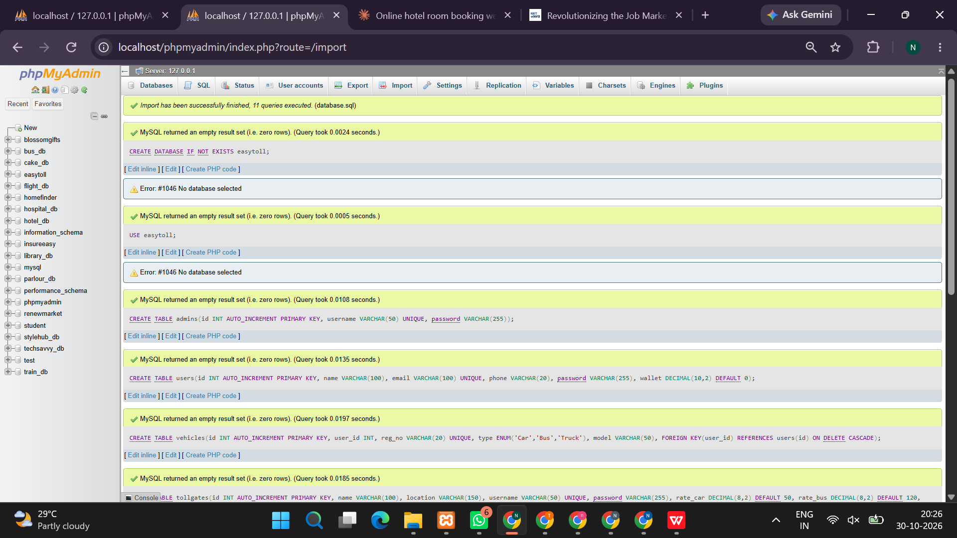
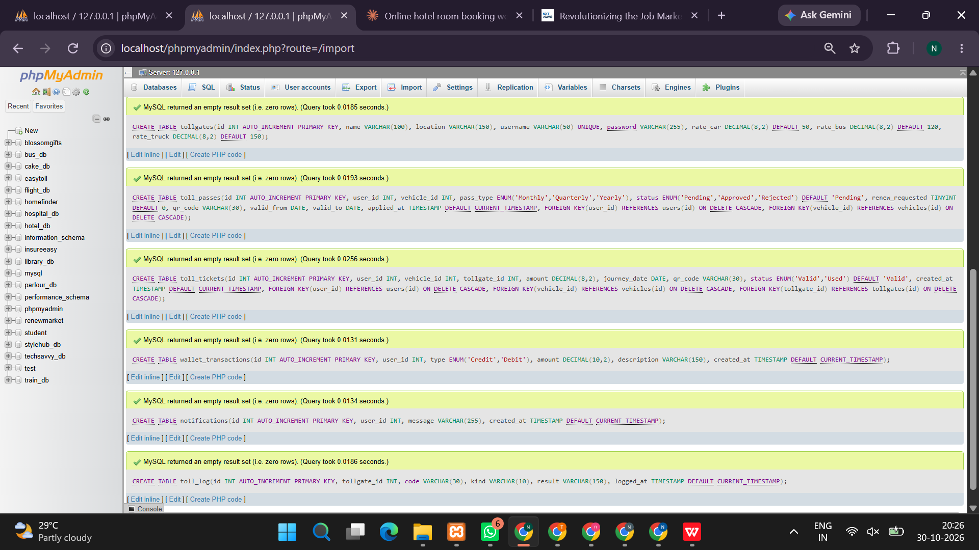
<?php
session_start();

$conn = new mysqli("localhost", "root", "", "");
if ($conn->connect_error) {
die("Database connection failed: " . $conn->connect_error);
}

$conn->query("CREATE DATABASE IF NOT EXISTS easy_toll");
$conn->select_db("easy_toll");
$conn->set_charset("utf8mb4");

$conn->query("CREATE TABLE IF NOT EXISTS users (
id INT AUTO_INCREMENT PRIMARY KEY,
name VARCHAR(100) NOT NULL,
email VARCHAR(150) UNIQUE NOT NULL,
password VARCHAR(255) NOT NULL,
role VARCHAR(20) NOT NULL DEFAULT 'user',
wallet DECIMAL(10,2) NOT NULL DEFAULT 0
)");

$conn->query("CREATE TABLE IF NOT EXISTS wallet_transactions (
id INT AUTO_INCREMENT PRIMARY KEY,
user_id INT NOT NULL,
transaction_type VARCHAR(30) NOT NULL,
amount DECIMAL(10,2) NOT NULL,
note VARCHAR(255),
created_at TIMESTAMP DEFAULT CURRENT_TIMESTAMP
)");

$conn->query("CREATE TABLE IF NOT EXISTS passes (
id INT AUTO_INCREMENT PRIMARY KEY,
pass_code VARCHAR(40) UNIQUE NOT NULL,
user_id INT NOT NULL,
vehicle_no VARCHAR(20) NOT NULL,
route VARCHAR(150) NOT NULL,
amount DECIMAL(10,2) NOT NULL,
status VARCHAR(20) NOT NULL DEFAULT 'Active',
created_at TIMESTAMP DEFAULT CURRENT_TIMESTAMP
)");

function e($value) {
return htmlspecialchars((string)$value, ENT_QUOTES, 'UTF-8');
}

$message = "";

if (isset($_POST['register'])) {
$name = trim($_POST['name']);
$email = trim($_POST['email']);
$password = password_hash($_POST['password'], PASSWORD_DEFAULT);

$stmt = $conn->prepare(
"INSERT INTO users (name,email,password) VALUES (?,?,?)"
);
$stmt->bind_param("sss", $name, $email, $password);

if ($stmt->execute()) {
$message = "Registration successful. Please log in.";
} else {
$message = "Registration failed. This email may already be registered.";
}
}

if (isset($_POST['login'])) {
$email = trim($_POST['email']);
$password = $_POST['password'];

$stmt = $conn->prepare(
"SELECT id,name,password,role FROM users WHERE email=?"
);
$stmt->bind_param("s", $email);
$stmt->execute();
$user = $stmt->get_result()->fetch_assoc();

if ($user && password_verify($password, $user['password'])) {
session_regenerate_id(true);
$_SESSION['user_id'] = $user['id'];
$_SESSION['name'] = $user['name'];
$_SESSION['role'] = $user['role'];

header("Location: index.php");
exit;
} else {
$message = "Invalid email or password.";
}
}

if (isset($_GET['logout'])) {
$_SESSION = [];
session_destroy();
header("Location: index.php");
exit;
}

$loggedIn = isset($_SESSION['user_id']);
$isAdmin = $loggedIn && $_SESSION['role'] === 'admin';

if ($loggedIn && isset($_POST['topup'])) {
$amount = (float)($_POST['amount'] ?? 0);

if ($amount < 1 || $amount > 10000) {
$message = "Enter a demo top-up amount between ₹1 and ₹10,000.";
} else {
$conn->begin_transaction();

try {
$stmt = $conn->prepare("UPDATE users SET wallet=wallet+? WHERE id=?");
$stmt->bind_param("di", $amount, $_SESSION['user_id']);
$stmt->execute();

$stmt = $conn->prepare(
"INSERT INTO wallet_transactions
(user_id,transaction_type,amount,note)
VALUES (?,'Top-up',?,'Demo wallet top-up')"
);
$stmt->bind_param("id", $_SESSION['user_id'], $amount);
$stmt->execute();

$conn->commit();
$message = "Demo wallet topped up successfully.";
} catch (Throwable $ex) {
$conn->rollback();
$message = "Unable to update the demo wallet.";
}
}
}

$routes = [
'Chennai - Sriperumbudur' => 80,
'Chennai - Chengalpattu' => 100,
'Chennai - Vellore' => 150,
'Chennai - Bengaluru' => 250
];

if ($loggedIn && isset($_POST['buy_pass'])) {
$vehicle = strtoupper(trim($_POST['vehicle_no'] ?? ''));
$route = $_POST['route'] ?? '';

if (!preg_match('/^[A-Z0-9 -]{4,20}$/', $vehicle)) {
$message = "Enter a valid vehicle number.";
} elseif (!isset($routes[$route])) {
$message = "Please select a valid route.";
} else {
$amount = (float)$routes[$route];
$conn->begin_transaction();

try {
$stmt = $conn->prepare(
"UPDATE users SET wallet=wallet-?
WHERE id=? AND wallet>=?"
);
$stmt->bind_param("did", $amount, $_SESSION['user_id'], $amount);
$stmt->execute();

if ($stmt->affected_rows !== 1) {
throw new Exception("Insufficient wallet balance. Please top up first.");
}

$passCode = "ET" . strtoupper(bin2hex(random_bytes(6)));

$stmt = $conn->prepare(
"INSERT INTO passes
(pass_code,user_id,vehicle_no,route,amount)
VALUES (?,?,?,?,?)"
);
$stmt->bind_param(
"sissd",
$passCode,
$_SESSION['user_id'],
$vehicle,
$route,
$amount
);
$stmt->execute();

$stmt = $conn->prepare(
"INSERT INTO wallet_transactions
(user_id,transaction_type,amount,note)
VALUES (?,'Toll Pass',?,'Demo toll pass purchase')"
);
$stmt->bind_param("id", $_SESSION['user_id'], $amount);
$stmt->execute();

$conn->commit();
$message = "Toll pass created. Your pass ID is " . $passCode;
} catch (Throwable $ex) {
$conn->rollback();
$message = $ex->getMessage();
}
}
}

if ($isAdmin && isset($_POST['verify_pass'])) {
$passCode = strtoupper(trim($_POST['pass_code'] ?? ''));

$stmt = $conn->prepare("SELECT id,status FROM passes WHERE pass_code=?");
$stmt->bind_param("s", $passCode);
$stmt->execute();
$pass = $stmt->get_result()->fetch_assoc();

if (!$pass) {
$message = "Pass not found. Check the pass ID.";
} elseif ($pass['status'] !== 'Active') {
$message = "This pass has already been used or is inactive.";
} else {
$stmt = $conn->prepare(
"UPDATE passes SET status='Used' WHERE id=? AND status='Active'"
);
$stmt->bind_param("i", $pass['id']);
$stmt->execute();

$message = $stmt->affected_rows === 1
? "Pass verified successfully and marked as Used."
: "Pass could not be verified.";
}
}

$wallet = 0;
$myPasses = null;
$transactions = null;
$allPasses = null;

if ($loggedIn) {
$stmt = $conn->prepare("SELECT wallet FROM users WHERE id=?");
$stmt->bind_param("i", $_SESSION['user_id']);
$stmt->execute();
$walletRow = $stmt->get_result()->fetch_assoc();
$wallet = (float)($walletRow['wallet'] ?? 0);

$stmt = $conn->prepare(
"SELECT * FROM passes WHERE user_id=? ORDER BY id DESC"
);
$stmt->bind_param("i", $_SESSION['user_id']);
$stmt->execute();
$myPasses = $stmt->get_result();

$stmt = $conn->prepare(
"SELECT * FROM wallet_transactions
WHERE user_id=? ORDER BY id DESC"
);
$stmt->bind_param("i", $_SESSION['user_id']);
$stmt->execute();
$transactions = $stmt->get_result();
}

if ($isAdmin) {
$allPasses = $conn->query(
"SELECT p.*,u.name AS customer_name
FROM passes p JOIN users u ON p.user_id=u.id
ORDER BY p.id DESC"
);
}
?>
<!DOCTYPE html>
<html lang="en">
<head>
<meta charset="UTF-8">
<meta name="viewport" content="width=device-width, initial-scale=1">
<title>EasyToll - Online Toll Payment</title>
<style>
*{box-sizing:border-box}
body{margin:0;font-family:Arial,sans-serif;background:#f3f6fa;color:#233247}
header{background:#143e73;color:white;padding:22px 7%;display:flex;justify-content:space-between;align-items:center;gap:12px;flex-wrap:wrap}
header h1{margin:0}
header a{color:white;text-decoration:none;margin-left:14px}
.hero{background:#dceaff;padding:35px 7%}
.hero h2{font-size:30px;margin:0 0 10px}
main{padding:25px 7%}
.grid{display:grid;grid-template-columns:repeat(auto-fit,minmax(230px,1fr));gap:18px}
.panel,.ticket{background:white;border-radius:12px;padding:20px;margin-bottom:20px;box-shadow:0 3px 12px #0000000b}
input,select,button{width:100%;padding:11px;margin:6px 0;border:1px solid #ccd5e0;border-radius:6px;font:inherit}
button,.btn{background:#1769aa;color:white;border:0;padding:11px 15px;border-radius:6px;cursor:pointer;text-decoration:none;display:inline-block}
button:hover,.btn:hover{background:#0e4d82}
.balance{font-size:29px;font-weight:bold;color:#1769aa}
.notice{padding:13px;background:#e0f5e8;border-radius:7px;margin-bottom:18px;overflow-wrap:anywhere}
table{width:100%;border-collapse:collapse;background:white}
th,td{border:1px solid #d9e0e8;padding:10px;text-align:left}
.tablewrap{overflow-x:auto}
.passid{font-size:19px;font-weight:bold;overflow-wrap:anywhere;color:#143e73}
small{color:#657487}
footer{text-align:center;padding:20px;background:#e2e9f2}
@media(max-width:600px){header,main,.hero{padding:20px}header a{margin-left:5px}}
</style>
</head>
<body>
<header>
<h1>🚗 EasyToll</h1>
<nav>
<a href="index.php">Home</a>
<?php if ($loggedIn): ?>
<a href="#wallet">Wallet</a>
<a href="#passes">My Passes</a>
<?php if ($isAdmin): ?><a href="#admin">Admin</a><?php endif; ?>
<a href="?logout=1">Logout</a>
<?php else: ?>
<a href="#account">Login / Register</a>
<?php endif; ?>
</nav>
</header>

<section class="hero">
<h2>Travel Smarter with EasyToll</h2>
<p>Manage your demo wallet, purchase toll passes and check pass status in one place.</p>
<a class="btn" href="#buy">Get a Toll Pass</a>
</section>

<main>
<?php if ($message !== ""): ?>
<div class="notice"><?= e($message) ?></div>
<?php endif; ?>

<?php if (!$loggedIn): ?>
<div class="grid" id="account">
<section class="panel">
<h2>Login</h2>
<form method="post">
<label>Email</label>
<input type="email" name="email" required>
<label>Password</label>
<input type="password" name="password" required>
<button name="login">Login</button>
</form>
</section>

<section class="panel">
<h2>Create Account</h2>
<form method="post">
<label>Full Name</label>
<input name="name" maxlength="100" required>
<label>Email</label>
<input type="email" name="email" required>
<label>Password</label>
<input type="password" name="password" minlength="6" required>
<button name="register">Register</button>
</form>
</section>
</div>
<?php else: ?>
<section class="panel">
<h2>Welcome, <?= e($_SESSION['name']) ?>!</h2>
<p>Account type: <?= e($_SESSION['role']) ?></p>
<p class="balance">Wallet Balance: ₹<?= number_format($wallet,2) ?></p>
<small>Demo balance only; no real money is transferred.</small>
</section>

<div class="grid">
<section class="panel" id="wallet">
<h2>Demo Wallet Top-up</h2>
<form method="post">
<label>Amount (₹1–₹10,000)</label>
<input type="number" name="amount" min="1" max="10000" step="1" required>
<button name="topup">Add Demo Balance</button>
</form>
</section>

<section class="panel" id="buy">
<h2>Purchase Toll Pass</h2>
<form method="post">
<label>Vehicle Registration Number</label>
<input name="vehicle_no" placeholder="e.g. TN 00 AB 1234" maxlength="20" required>
<label>Select Route</label>
<select name="route" required>
<option value="">-- Select Route --</option>
<?php foreach ($routes as $routeName => $fare): ?>
<option value="<?= e($routeName) ?>">
<?= e($routeName) ?> — ₹<?= number_format($fare,2) ?>
</option>
<?php endforeach; ?>
</select>
<button name="buy_pass">Purchase Demo Pass</button>
</form>
</section>
</div>

<section class="panel" id="passes">
<h2>My Toll Passes</h2>
<div class="grid">
<?php if ($myPasses->num_rows === 0): ?>
<p>No passes purchased yet.</p>
<?php endif; ?>

<?php while ($p = $myPasses->fetch_assoc()): ?>
<article class="ticket">
<h3>EasyToll Pass</h3>
<p class="passid"><?= e($p['pass_code']) ?></p>
<p><b>Vehicle:</b> <?= e($p['vehicle_no']) ?></p>
<p><b>Route:</b> <?= e($p['route']) ?></p>
<p><b>Fare:</b> ₹<?= number_format((float)$p['amount'],2) ?></p>
<p><b>Status:</b> <?= e($p['status']) ?></p>
<p><small>Created: <?= e($p['created_at']) ?></small></p>
<small>Keep this pass ID for demo verification. This is not a real QR ticket.</small>
</article>
<?php endwhile; ?>
</div>
</section>

<section class="panel">
<h2>Wallet Transaction History</h2>
<div class="tablewrap">
<table>
<tr><th>Transaction ID</th><th>Type</th><th>Amount</th><th>Note</th><th>Date</th></tr>
<?php while ($t = $transactions->fetch_assoc()): ?>
<tr>
<td><?= (int)$t['id'] ?></td>
<td><?= e($t['transaction_type']) ?></td>
<td>₹<?= number_format((float)$t['amount'],2) ?></td>
<td><?= e($t['note']) ?></td>
<td><?= e($t['created_at']) ?></td>
</tr>
<?php endwhile; ?>
</table>
</div>
</section>
<?php endif; ?>

<?php if ($isAdmin): ?>
<section class="panel" id="admin">
<h2>Admin / Toll Gate Pass Verification</h2>
<p>Enter the pass ID to check it and mark an active pass as used.</p>
<form method="post">
<label>Pass ID</label>
<input name="pass_code" placeholder="e.g. ET123456ABCDEF" required>
<button name="verify_pass">Verify Pass</button>
</form>

<h2>All Toll Passes</h2>
<div class="tablewrap">
<table>
<tr><th>Pass ID</th><th>Customer</th><th>Vehicle</th><th>Route</th><th>Fare</th><th>Status</th></tr>
<?php while ($p = $allPasses->fetch_assoc()): ?>
<tr>
<td><?= e($p['pass_code']) ?></td>
<td><?= e($p['customer_name']) ?></td>
<td><?= e($p['vehicle_no']) ?></td>
<td><?= e($p['route']) ?></td>
<td>₹<?= number_format((float)$p['amount'],2) ?></td>
<td><?= e($p['status']) ?></td>
</tr>
<?php endwhile; ?>
</table>
</div>
</section>
<?php endif; ?>
</main>

<footer>
EasyToll — Online Toll Payment System | Academic Demonstration Project
</footer>
</body>
</html>
OUTPUT:


