- COMPLAIN EASE:
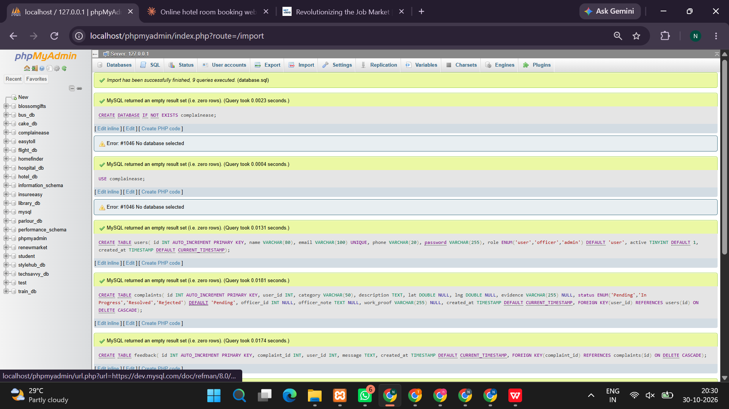
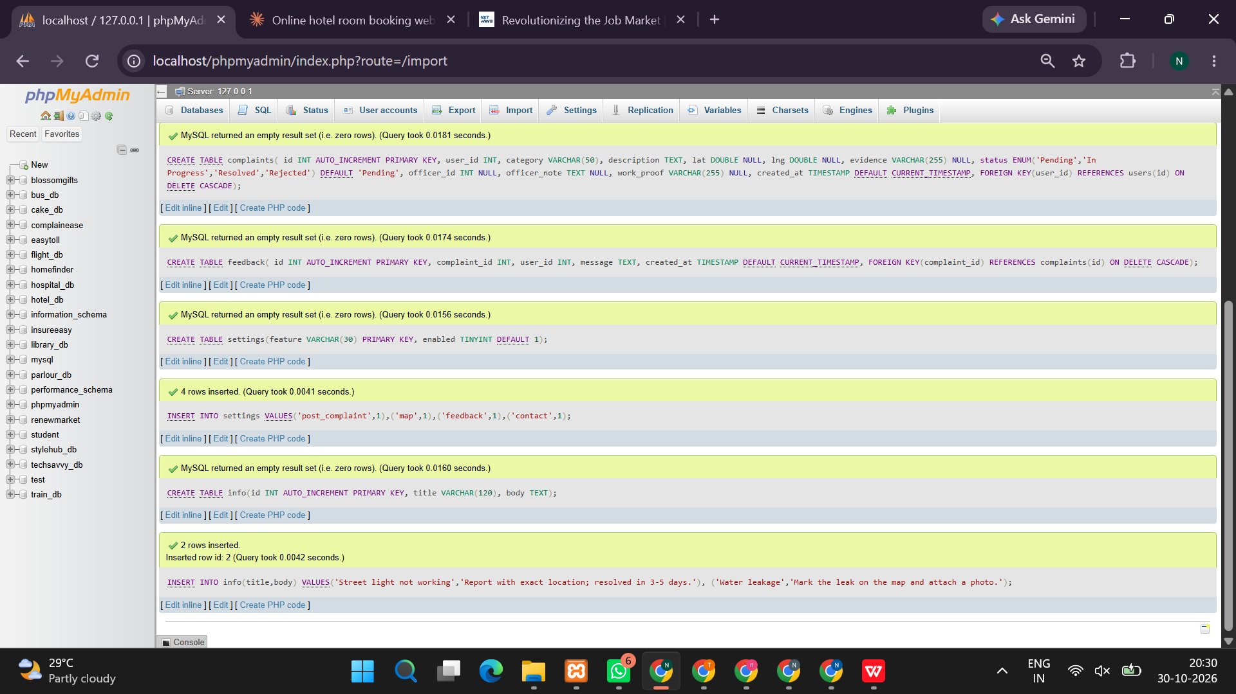

<!DOCTYPE html>
<html lang="en">
<head>
<meta charset="UTF-8">
<meta name="viewport" content="width=device-width, initial-scale=1.0">
<title>ComplainEase | Complaint Management System</title>

<style>
* {
box-sizing: border-box;
margin: 0;
padding: 0;
font-family: Arial, sans-serif;
}

body {
background: #f1f5f9;
color: #1e293b;
}

header {
background: #123c69;
color: white;
padding: 22px 7%;
display: flex;
justify-content: space-between;
align-items: center;
flex-wrap: wrap;
gap: 12px;
}

header h1 { font-size: 27px; }
header p { margin-top: 5px; color: #dbeafe; }

nav {
background: #ffffff;
padding: 12px 7%;
display: flex;
gap: 10px;
flex-wrap: wrap;
box-shadow: 0 2px 8px #00000010;
}

button, .btn {
background: #1769aa;
color: white;
border: none;
padding: 10px 15px;
border-radius: 6px;
cursor: pointer;
margin: 3px;
font-size: 14px;
}

button:hover { background: #0d4f86; }
.secondary { background: #64748b; }
.danger { background: #dc2626; }
.success { background: #15803d; }

main {
width: 90%;
max-width: 1150px;
margin: 28px auto;
min-height: 65vh;
}

.hero {
background: linear-gradient(120deg, #123c69, #2185c5);
color: white;
padding: 45px 30px;
border-radius: 12px;
margin-bottom: 25px;
}

.hero h2 { font-size: 30px; margin-bottom: 12px; }
.hero p { line-height: 1.7; max-width: 700px; }

.grid {
display: grid;
grid-template-columns: repeat(auto-fit, minmax(230px, 1fr));
gap: 18px;
margin: 20px 0;
}

.card {
background: white;
padding: 22px;
border-radius: 10px;
box-shadow: 0 3px 12px #0000000d;
margin-bottom: 18px;
}

.card h3 { color: #123c69; margin-bottom: 14px; }
.card p { line-height: 1.6; }

form { margin-top: 12px; }

label {
display: block;
margin: 13px 0 6px;
font-weight: bold;
font-size: 14px;
}

input, select, textarea {
width: 100%;
padding: 11px;
border: 1px solid #cbd5e1;
border-radius: 6px;
font-size: 14px;
background: white;
}

textarea { resize: vertical; min-height: 90px; }

input:focus, select:focus, textarea:focus {
outline: 2px solid #93c5fd;
border-color: #1769aa;
}

.notice {
background: #e0f2fe;
padding: 12px;
border-radius: 6px;
margin: 12px 0;
line-height: 1.5;
}

.stats {
font-size: 28px;
color: #1769aa;
font-weight: bold;
margin-top: 8px;
}

.table-wrap { overflow-x: auto; }

table {
width: 100%;
border-collapse: collapse;
margin-top: 15px;
background: white;
min-width: 650px;
}

th, td {
border: 1px solid #e2e8f0;
padding: 12px;
text-align: left;
vertical-align: top;
}

th { background: #eaf2fb; color: #123c69; }

.status {
display: inline-block;
padding: 5px 8px;
border-radius: 5px;
background: #fef3c7;
font-size: 12px;
font-weight: bold;
}

footer {
background: #123c69;
color: white;
text-align: center;
padding: 20px;
margin-top: 30px;
}

.small { color: #64748b; font-size: 13px; }
.hidden { display: none !important; }

@media(max-width: 600px) {
header { padding: 20px; }
main { width: 94%; }
.hero h2 { font-size: 24px; }
}
</style>
</head>

<body>

<header>
<div>
<h1>ComplainEase</h1>
<p>Complaint Registration and Resolution Portal</p>
</div>
<div id="sessionInfo">Guest User</div>
</header>

<nav id="navigation">
<button onclick="home()">Home</button>
<button onclick="showLogin()">Login</button>
<button onclick="showRegister()">User Registration</button>
<button onclick="showLogin('officer')">Officer Login</button>
<button onclick="showLogin('admin')">Admin Login</button>
</nav>

<main id="app"></main>

<footer>
<p>ComplainEase | Internet Programming Lab Experiment</p>
<p class="small">A demonstration complaint management application</p>
</footer>

<script>
// DEMONSTRATION APPLICATION
// Data is stored in this browser using localStorage.
// Do not use demo passwords or localStorage authentication
// for a real production system.

const $ = id => document.getElementById(id);

function load(key, fallback) {
try {
const value = JSON.parse(localStorage.getItem(key));
return value === null ? fallback : value;
} catch {
return fallback;
}
}

function save(key, value) {
localStorage.setItem(key, JSON.stringify(value));
}

let users = load("ce_users", []);
let officers = load("ce_officers", [
{
username: "officer",
password: "officer123",
name: "Demo Officer",
email: "officer@example.com"
}
]);
let complaints = load("ce_complaints", []);
let feedbacks = load("ce_feedback", []);
let settings = load("ce_settings", {
showRegistration: true,
showComplaintForm: true,
contact: "admin@example.com",
information: "Welcome to ComplainEase. Submit a complaint and track its status."
});

let current = null;

function persist() {
save("ce_users", users);
save("ce_officers", officers);
save("ce_complaints", complaints);
save("ce_feedback", feedbacks);
save("ce_settings", settings);
}

function safe(value) {
return String(value ?? "").replace(/[&<>"']/g, ch => ({
"&": "&amp;",
"<": "&lt;",
">": "&gt;",
'"': "&quot;",
"'": "&#39;"
})[ch]);
}

function id() {
return "CE" + Date.now().toString().slice(-8) +
Math.floor(Math.random() * 90 + 10);
}

function home() {
$("sessionInfo").textContent = current
? current.name + " (" + current.role + ")"
: "Guest User";

$("app").innerHTML = `
<section class="hero">
<h2>Welcome to ComplainEase</h2>
<p>Register complaints, track progress, communicate with
resolution officers, and help improve service transparency
through a simple online platform.</p>
<br>
<button onclick="showRegister()">Register as User</button>
<button onclick="showLogin()">Login to Portal</button>
</section>

<div class="grid">
<div class="card">
<h3>📝 Register Complaints</h3>
<p>Submit complaints with categories, descriptions,
supporting documents and location details.</p>
</div>
<div class="card">
<h3>🔎 Track Status</h3>
<p>Check whether a complaint is submitted, in progress,
resolved or rejected.</p>
</div>
<div class="card">
<h3>📍 Location Support</h3>
<p>Record a location and open it on Google Maps.</p>
</div>
<div class="card">
<h3>👨‍💼 Administration</h3>
<p>Manage officer accounts, complaints and portal settings.</p>
</div>
</div>

<div class="card">
<h3>Portal Information</h3>
<p>${safe(settings.information)}</p>
</div>

<div class="notice">
<b>Demo accounts</b><br>
Admin: username <b>admin</b>, password <b>admin123</b><br>
Officer: username <b>officer</b>, password <b>officer123</b>
</div>
`;
}

function showRegister() {
if (!settings.showRegistration) {
$("app").innerHTML = `<div class="card">
<h2>Registration Unavailable</h2>
<p>User registration is currently disabled by the administrator.</p>
</div>`;
return;
}

$("app").innerHTML = `
<div class="card">
<h2>User Registration</h2>
<p>Create an account to submit and track complaints.</p>

<form onsubmit="registerUser(event)">
<label>Full Name</label>
<input name="name" required maxlength="80">

<label>Email Address</label>
<input name="email" type="email" required>

<label>Phone Number</label>
<input name="phone" type="tel" required>

<label>Username</label>
<input name="username" required minlength="3">

<label>Password</label>
<input name="password" type="password"
required minlength="6">

<button type="submit">Create Account</button>
<button type="button" class="secondary"
onclick="showLogin()">Already Registered? Login</button>
</form>
</div>
`;
}

function registerUser(event) {
event.preventDefault();
const f = new FormData(event.target);

const username = String(f.get("username")).trim();
const email = String(f.get("email")).trim().toLowerCase();

if ([...users, ...officers].some(
u => u.username.toLowerCase() === username.toLowerCase()
) || username.toLowerCase() === "admin") {
alert("Username already exists. Choose another username.");
return;
}

if (users.some(u => u.email.toLowerCase() === email)) {
alert("An account with this email already exists.");
return;
}

users.push({
name: String(f.get("name")).trim(),
email,
phone: String(f.get("phone")).trim(),
username,
// Demo only: production passwords must be hashed on the server.
password: String(f.get("password"))
});

persist();
alert("Registration successful! Please log in.");
showLogin();
}

function showLogin(role = "user") {
$("app").innerHTML = `
<div class="card">
<h2>${role.charAt(0).toUpperCase() + role.slice(1)} Login</h2>

<form onsubmit="login(event, '${role}')">
<label>Username</label>
<input name="username" required autocomplete="username">

<label>Password</label>
<input name="password" type="password" required
autocomplete="current-password">

<button type="submit">Login</button>
<button type="button" class="secondary" onclick="home()">
Back to Home
</button>
</form>

<p class="small">
User: register first. Officer and admin: use the demo
credentials displayed on the home page.
</p>
</div>
`;
}

function login(event, role) {
event.preventDefault();
const f = new FormData(event.target);
const username = String(f.get("username")).trim();
const password = String(f.get("password"));

let account = null;

if (role === "admin") {
if (username === "admin" && password === "admin123") {
account = {
name: "Administrator",
username: "admin",
role: "admin"
};
}
} else if (role === "officer") {
const found = officers.find(o =>
o.username === username && o.password === password
);
if (found) account = { ...found, role: "officer" };
} else {
const found = users.find(u =>
u.username === username && u.password === password
);
if (found) account = { ...found, role: "user" };
}

if (!account) {
alert("Invalid username or password.");
return;
}

current = account;
$("sessionInfo").textContent = current.name + " (" + current.role + ")";
renderDashboard();
}

function logout() {
current = null;
$("sessionInfo").textContent = "Guest User";
home();
}

function renderDashboard() {
if (!current) return showLogin();

if (current.role === "user") userDashboard();
if (current.role === "officer") officerDashboard();
if (current.role === "admin") adminDashboard();
}

function userDashboard() {
const mine = complaints.filter(c => c.username === current.username);

$("app").innerHTML = `
<div class="card">
<h2>User Dashboard</h2>
<p>Welcome, ${safe(current.name)}!</p>
<div class="grid">
<div class="card">
<h3>Total Complaints</h3>
<div class="stats">${mine.length}</div>
</div>
<div class="card">
<h3>Resolved</h3>
<div class="stats">
${mine.filter(c => c.status === "Resolved").length}
</div>
</div>
<div class="card">
<h3>Pending</h3>
<div class="stats">
${mine.filter(c => c.status === "Submitted" ||
c.status === "In Progress").length}
</div>
</div>
</div>
<button onclick="showComplaintForm()">Post Complaint</button>
<button onclick="viewMyComplaints()">View Complaint Status</button>
<button onclick="feedbackForm()">Feedback</button>
<button onclick="showContact()">Admin Contact</button>
<button class="secondary" onclick="logout()">Logout</button>
</div>
`;
}

function showComplaintForm() {
if (!current || current.role !== "user") return showLogin();

if (!settings.showComplaintForm) {
alert("The administrator has temporarily disabled complaints.");
return userDashboard();
}

$("app").innerHTML = `
<div class="card">
<h2>Post a Complaint</h2>
<form onsubmit="submitComplaint(event)">
<label>Complaint Category</label>
<select name="category" required>
<option value="">Select Category</option>
<option>Water Supply</option>
<option>Electricity</option>
<option>Road and Transport</option>
<option>Sanitation</option>
<option>Public Safety</option>
<option>Education</option>
<option>Healthcare</option>
<option>Other</option>
</select>

<label>Complaint Title</label>
<input name="title" required maxlength="120">

<label>Detailed Description</label>
<textarea name="description" required maxlength="3000"></textarea>

<label>Location / Address</label>
<input name="location" id="locationInput"
placeholder="Enter address or place">

<button type="button" onclick="getLocation()">
Use My Current Location
</button>

<p id="locationMessage" class="small"></p>

<label>Supporting Document or Image</label>
<input type="file" id="proofFile"
accept=".pdf,.jpg,.jpeg,.png"
onchange="checkFile(this)">

<p class="small">Demo limit: 1 MB. PDF, JPG or PNG only.</p>

<button type="submit">Submit Complaint</button>
<button type="button" class="secondary"
onclick="userDashboard()">Cancel</button>
</form>
</div>
`;
}

function checkFile(input) {
const file = input.files[0];
if (!file) return;

const allowed = ["application/pdf", "image/jpeg", "image/png"];
if (!allowed.includes(file.type) || file.size > 1024 * 1024) {
alert("Choose a PDF, JPG or PNG file smaller than 1 MB.");
input.value = "";
}
}

let coordinates = "";

function getLocation() {
if (!navigator.geolocation) {
alert("Geolocation is not supported by this browser.");
return;
}

$("locationMessage").textContent = "Requesting location permission...";

navigator.geolocation.getCurrentPosition(
position => {
const lat = position.coords.latitude;
const lng = position.coords.longitude;
coordinates = lat + "," + lng;
$("locationInput").value = coordinates;
$("locationMessage").textContent =
"Location recorded: " + coordinates;
},
() => {
$("locationMessage").textContent =
"Unable to get location. Enter the address manually.";
}
);
}

function submitComplaint(event) {
event.preventDefault();

const f = new FormData(event.target);
const fileInput = $("proofFile");
const file = fileInput.files[0];

const complaint = {
id: id(),
username: current.username,
name: current.name,
category: String(f.get("category")),
title: String(f.get("title")).trim(),
description: String(f.get("description")).trim(),
location: String(f.get("location")).trim(),
attachmentName: file ? file.name : "",
status: "Submitted",
officerNote: "",
officerProof: "",
createdAt: new Date().toLocaleString(),
updatedAt: new Date().toLocaleString()
};

complaints.unshift(complaint);
persist();

alert("Complaint submitted successfully! Your ID is " + complaint.id);
viewMyComplaints();
}

function viewMyComplaints() {
if (!current || current.role !== "user") return showLogin();

const mine = complaints.filter(c => c.username === current.username);

$("app").innerHTML = `
<div class="card">
<h2>My Complaint History</h2>
${mine.length ? `
<div class="table-wrap">
<table>
<tr>
<th>Complaint ID</th>
<th>Title / Category</th>
<th>Location</th>
<th>Status</th>
<th>Officer Update</th>
<th>Action</th>
</tr>
${mine.map(c => `
<tr>
<td>${safe(c.id)}<br>
<span class="small">${safe(c.createdAt)}</span>
</td>
<td>${safe(c.title)}<br>${safe(c.category)}
<p class="small">${safe(c.description)}</p>
${c.attachmentName ?
"Attachment: " + safe(c.attachmentName) : ""}
</td>
<td>${safe(c.location || "Not provided")}
${c.location ? `<br>
<a target="_blank" rel="noopener"
href="https://www.google.com/maps/search/?api=1&query=${encodeURIComponent(c.location)}">
Open Map</a>` : ""}
</td>
<td><span class="status">${safe(c.status)}</span>
<p class="small">Updated: ${safe(c.updatedAt)}</p>
</td>
<td>${safe(c.officerNote || "No update yet")}
${c.officerProof ? `<p>Proof: ${safe(c.officerProof)}</p>` : ""}
</td>
<td>
<button onclick="feedbackFor('${safe(c.id)}')">
Give Feedback
</button>
${c.status !== "Resolved" &&
c.status !== "Rejected" ? `
<button class="secondary"
onclick="addEvidence('${safe(c.id)}')">
Add Information
</button>` : ""}
</td>
</tr>
`).join("")}
</table>
</div>
` : `<p>You have not submitted any complaints yet.</p>`}
<button onclick="showComplaintForm()">Post Complaint</button>
<button class="secondary" onclick="userDashboard()">Back</button>
</div>
`;
}

function addEvidence(complaintId) {
const c = complaints.find(c => c.id === complaintId &&
c.username === current.username);
if (!c) return;

const extra = prompt("Enter additional information for this complaint:");
if (extra && extra.trim()) {
c.description += "\nAdditional information: " + extra.trim();
c.updatedAt = new Date().toLocaleString();
persist();
viewMyComplaints();
}
}

function feedbackFor(complaintId) {
if (!current || current.role !== "user") return;

const c = complaints.find(c => c.id === complaintId &&
c.username === current.username);
if (!c) return;

$("app").innerHTML = `
<div class="card">
<h2>Feedback</h2>
<p>Complaint: ${safe(c.id)} — ${safe(c.title)}</p>

<form onsubmit="submitFeedback(event, '${safe(c.id)}')">
<label>Rating</label>
<select name="rating" required>
<option value="">Select Rating</option>
<option value="5">5 - Excellent</option>
<option value="4">4 - Good</option>
<option value="3">3 - Average</option>
<option value="2">2 - Poor</option>
<option value="1">1 - Very Poor</option>
</select>

<label>Comments</label>
<textarea name="comments" required></textarea>

<button type="submit">Submit Feedback</button>
<button type="button" class="secondary"
onclick="viewMyComplaints()">Cancel</button>
</form>
</div>
`;
}

function feedbackForm() {
if (!current || current.role !== "user") return showLogin();
viewMyComplaints();
}

function submitFeedback(event, complaintId) {
event.preventDefault();
const f = new FormData(event.target);

feedbacks.push({
id: complaintId,
username: current.username,
rating: String(f.get("rating")),
comments: String(f.get("comments")).trim(),
date: new Date().toLocaleString()
});

persist();
alert("Thank you! Your feedback has been recorded.");
userDashboard();
}

function showContact() {
$("app").innerHTML = `
<div class="card">
<h2>Administrator Contact Details</h2>
<p>Email: ${safe(settings.contact)}</p>
<p>For urgent matters, contact your relevant local authority.</p>
<button onclick="userDashboard()">Back to Dashboard</button>
</div>
`;
}

function officerDashboard() {
const all = complaints;

$("app").innerHTML = `
<div class="card">
<h2>Officer Dashboard</h2>
<p>Welcome, ${safe(current.name)}!</p>
<div class="grid">
<div class="card">
<h3>Total Complaints</h3>
<div class="stats">${all.length}</div>
</div>
<div class="card">
<h3>Pending</h3>
<div class="stats">
${all.filter(c => c.status === "Submitted").length}
</div>
</div>
<div class="card">
<h3>Resolved</h3>
<div class="stats">
${all.filter(c => c.status === "Resolved").length}
</div>
</div>
</div>
<button onclick="officerViewComplaints()">View Complaints</button>
<button class="secondary" onclick="logout()">Logout</button>
</div>
`;
}

function officerViewComplaints() {
if (!current || current.role !== "officer") return showLogin("officer");

$("app").innerHTML = `
<div class="card">
<h2>Manage Complaints</h2>
<label>Search by ID, title, category or user</label>
<input id="officerSearch" oninput="filterOfficerComplaints()"
placeholder="Search complaints...">
<div id="officerComplaintTable"></div>
<button class="secondary" onclick="officerDashboard()">Back</button>
</div>
`;

filterOfficerComplaints();
}

function filterOfficerComplaints() {
const search = ($("officerSearch")?.value || "").toLowerCase();

const filtered = complaints.filter(c =>
[c.id, c.title, c.category, c.name, c.username]
.some(v => String(v).toLowerCase().includes(search))
);

$("officerComplaintTable").innerHTML = filtered.length ? `
<div class="table-wrap">
<table>
<tr>
<th>ID / User</th>
<th>Complaint</th>
<th>Location</th>
<th>Status</th>
<th>Update</th>
</tr>
${filtered.map(c => `
<tr>
<td>${safe(c.id)}<br>${safe(c.name)}
<br><span class="small">${safe(c.username)}</span>
</td>
<td><b>${safe(c.title)}</b><br>${safe(c.category)}
<p>${safe(c.description)}</p>
${c.attachmentName ?
"Attachment name: " + safe(c.attachmentName) : ""}
</td>
<td>${safe(c.location || "Not provided")}
${c.location ? `<br>
<a target="_blank" rel="noopener"
href="https://www.google.com/maps/search/?api=1&query=${encodeURIComponent(c.location)}">
Open Map</a>` : ""}
</td>
<td>${safe(c.status)}</td>
<td>
<button onclick="updateComplaint('${safe(c.id)}')">
Update
</button>
</td>
</tr>
`).join("")}
</table>
</div>
` : "<p>No complaints found.</p>";
}

function updateComplaint(complaintId) {
const c = complaints.find(c => c.id === complaintId);
if (!c) return;

$("app").innerHTML = `
<div class="card">
<h2>Update Complaint</h2>
<p><b>ID:</b> ${safe(c.id)}</p>
<p><b>Title:</b> ${safe(c.title)}</p>
<p><b>User:</b> ${safe(c.name)}</p>
<p><b>Description:</b> ${safe(c.description)}</p>

<form onsubmit="saveComplaintUpdate(event, '${safe(c.id)}')">
<label>Complaint Status</label>
<select name="status" required>
${["Submitted", "In Progress", "Resolved", "Rejected"]
.map(s => `<option ${s === c.status ? "selected" : ""}>
${s}</option>`).join("")}
</select>

<label>Officer Remarks / Feedback</label>
<textarea name="note">${safe(c.officerNote)}</textarea>

<label>Proof of Work (file name or reference)</label>
<input name="proof" value="${safe(c.officerProof)}"
placeholder="e.g. repair_report.pdf">

<button type="submit">Save Update</button>
<button type="button" class="secondary"
onclick="officerViewComplaints()">Cancel</button>
</form>
</div>
`;
}

function saveComplaintUpdate(event, complaintId) {
event.preventDefault();
const f = new FormData(event.target);
const c = complaints.find(c => c.id === complaintId);
if (!c) return;

c.status = String(f.get("status"));
c.officerNote = String(f.get("note")).trim();
c.officerProof = String(f.get("proof")).trim();
c.updatedAt = new Date().toLocaleString();

persist();
alert("Complaint status updated successfully.");
officerViewComplaints();
}

function adminDashboard() {
if (!current || current.role !== "admin") return showLogin("admin");

$("app").innerHTML = `
<div class="card">
<h2>Administrator Dashboard</h2>
<p>The administrator can manage officers, inspect complaints,
view registered accounts, and configure portal features.</p>

<div class="grid">
<div class="card">
<h3>Total Users</h3>
<div class="stats">${users.length}</div>
</div>
<div class="card">
<h3>Total Officers</h3>
<div class="stats">${officers.length}</div>
</div>
<div class="card">
<h3>Total Complaints</h3>
<div class="stats">${complaints.length}</div>
</div>
<div class="card">
<h3>Feedback Entries</h3>
<div class="stats">${feedbacks.length}</div>
</div>
</div>

<button onclick="adminOfficerForm()">Create Officer</button>
<button onclick="adminViewOfficers()">View / Delete Officers</button>
<button onclick="adminViewUsers()">View / Delete Users</button>
<button onclick="adminViewComplaints()">View All Complaints</button>
<button onclick="adminViewFeedback()">View Feedback</button>
<button onclick="adminSettings()">Portal Settings</button>
<button onclick="adminChangePassword()">Change Admin Password</button>
<button class="secondary" onclick="logout()">Logout</button>

<p class="notice">
Demo admin login is hardcoded in this example. A real system
must store admin accounts securely on the server.
</p>
</div>
`;
}

function adminOfficerForm() {
$("app").innerHTML = `
<div class="card">
<h2>Create Officer Account</h2>
<p>The administrator generates the officer username and password.</p>

<form onsubmit="createOfficer(event)">
<label>Officer Name</label>
<input name="name" required>

<label>Officer Email</label>
<input name="email" type="email" required>

<label>Username</label>
<input name="username" required minlength="3">

<label>Temporary Password</label>
<input name="password" required minlength="6">

<button type="submit">Create Account</button>
<button type="button" class="secondary"
onclick="adminDashboard()">Back</button>
</form>
</div>
`;
}

function createOfficer(event) {
event.preventDefault();
const f = new FormData(event.target);
const username = String(f.get("username")).trim();

if (username.toLowerCase() === "admin" ||
[...users, ...officers].some(
u => u.username.toLowerCase() === username.toLowerCase()
)) {
alert("That username already exists.");
return;
}

const officer = {
name: String(f.get("name")).trim(),
email: String(f.get("email")).trim(),
username,
password: String(f.get("password"))
};

officers.push(officer);
persist();

alert("Officer account created successfully.");
adminViewOfficers();
}

function adminViewOfficers() {
$("app").innerHTML = `
<div class="card">
<h2>Officer Accounts</h2>
${officers.length ? `
<div class="table-wrap"><table>
<tr><th>Name</th><th>Email</th><th>Username</th><th>Action</th></tr>
${officers.map(o => `
<tr>
<td>${safe(o.name)}</td>
<td>${safe(o.email)}</td>
<td>${safe(o.username)}</td>
<td><button class="danger"
onclick="deleteOfficer('${safe(o.username)}')">
Delete</button></td>
</tr>
`).join("")}
</table></div>` : "<p>No officer accounts.</p>"}
<button onclick="adminOfficerForm()">Create Officer</button>
<button class="secondary" onclick="adminDashboard()">Back</button>
</div>
`;
}

function deleteOfficer(username) {
if (!confirm("Delete this officer account?")) return;
officers = officers.filter(o => o.username !== username);
persist();
adminViewOfficers();
}

function adminViewUsers() {
$("app").innerHTML = `
<div class="card">
<h2>Registered User Accounts</h2>
${users.length ? `
<div class="table-wrap"><table>
<tr><th>Name</th><th>Email</th><th>Phone</th>
<th>Username</th><th>Action</th></tr>
${users.map(u => `
<tr>
<td>${safe(u.name)}</td>
<td>${safe(u.email)}</td>
<td>${safe(u.phone)}</td>
<td>${safe(u.username)}</td>
<td><button class="danger"
onclick="deleteUser('${safe(u.username)}')">
Delete</button></td>
</tr>
`).join("")}
</table></div>` : "<p>No registered users.</p>"}
<button class="secondary" onclick="adminDashboard()">Back</button>
</div>
`;
}

function deleteUser(username) {
if (!confirm("Delete this user and their complaint history?")) return;
users = users.filter(u => u.username !== username);
complaints = complaints.filter(c => c.username !== username);
feedbacks = feedbacks.filter(f => f.username !== username);
persist();
adminViewUsers();
}

function adminViewComplaints() {
$("app").innerHTML = `
<div class="card">
<h2>All Complaints</h2>
${complaints.length ? `
<div class="table-wrap"><table>
<tr><th>ID</th><th>User</th><th>Complaint</th>
<th>Location</th><th>Status</th><th>Action</th></tr>
${complaints.map(c => `
<tr>
<td>${safe(c.id)}</td>
<td>${safe(c.name)}<br>${safe(c.username)}</td>
<td>${safe(c.title)}<br>${safe(c.category)}
<p>${safe(c.description)}</p></td>
<td>${safe(c.location || "Not provided")}</td>
<td>${safe(c.status)}</td>
<td><button class="danger"
onclick="deleteComplaint('${safe(c.id)}')">
Delete</button></td>
</tr>
`).join("")}
</table></div>` : "<p>No complaints have been submitted.</p>"}
<button class="secondary" onclick="adminDashboard()">Back</button>
</div>
`;
}

function deleteComplaint(complaintId) {
if (!confirm("Permanently delete this complaint?")) return;
complaints = complaints.filter(c => c.id !== complaintId);
feedbacks = feedbacks.filter(f => f.id !== complaintId);
persist();
adminViewComplaints();
}

function adminViewFeedback() {
$("app").innerHTML = `
<div class="card">
<h2>User Feedback</h2>
${feedbacks.length ? `
<div class="table-wrap"><table>
<tr><th>Complaint ID</th><th>User</th>
<th>Rating</th><th>Comments</th><th>Date</th></tr>
${feedbacks.map(f => `
<tr>
<td>${safe(f.id)}</td>
<td>${safe(f.username)}</td>
<td>${safe(f.rating)} / 5</td>
<td>${safe(f.comments)}</td>
<td>${safe(f.date)}</td>
</tr>
`).join("")}
</table></div>` : "<p>No feedback received yet.</p>"}
<button class="secondary" onclick="adminDashboard()">Back</button>
</div>
`;
}

function adminSettings() {
$("app").innerHTML = `
<div class="card">
<h2>Portal Settings</h2>
<form onsubmit="saveSettings(event)">
<label>Administrator Contact Email</label>
<input name="contact" type="email" required
value="${safe(settings.contact)}">

<label>Home Page Information</label>
<textarea name="information" required>${safe(settings.information)}</textarea>

<label>
<input style="width:auto" type="checkbox"
name="showRegistration"
${settings.showRegistration ? "checked" : ""}>
Enable User Registration
</label>

<label>
<input style="width:auto" type="checkbox"
name="showComplaintForm"
${settings.showComplaintForm ? "checked" : ""}>
Enable Complaint Submission
</label>

<button type="submit">Save Settings</button>
<button type="button" class="secondary"
onclick="adminDashboard()">Back</button>
</form>
</div>
`;
}

function saveSettings(event) {
event.preventDefault();
const f = new FormData(event.target);

settings = {
contact: String(f.get("contact")).trim(),
information: String(f.get("information")).trim(),
showRegistration: f.has("showRegistration"),
showComplaintForm: f.has("showComplaintForm")
};

persist();
alert("Portal settings saved.");
adminDashboard();
}

function adminChangePassword() {
$("app").innerHTML = `
<div class="card">
<h2>Change Admin Password</h2>
<p class="notice">
In this standalone demo, the administrator password is
hardcoded. A secure password-change function requires
server-side authentication and a database.
</p>
<button class="secondary" onclick="adminDashboard()">Back</button>
</div>
`;
}

// Start application
home();
</script>

</body>
</html>



