EXPERIMENT-17

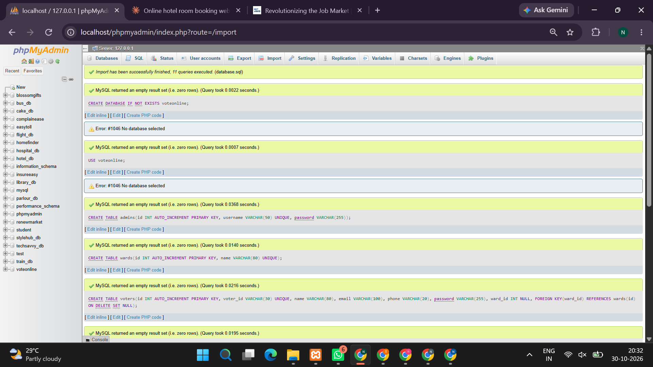
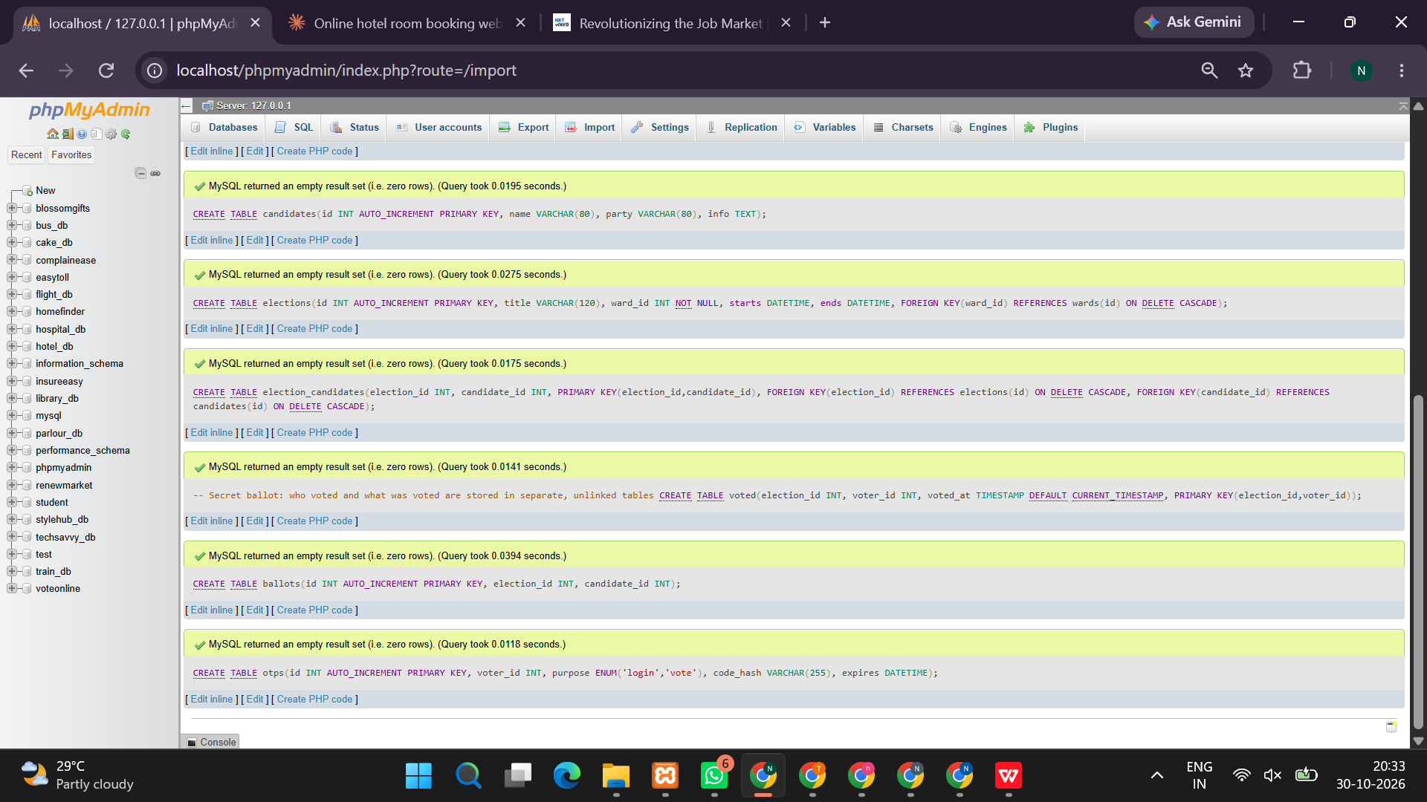
<!DOCTYPE html>
<html lang="en">
<head>
<meta charset="UTF-8">
<meta name="viewport" content="width=device-width, initial-scale=1.0">
<title>VoteOnline - E-Voting System</title>

<style>
*{box-sizing:border-box}
body{margin:0;font-family:Arial,sans-serif;background:#f0f4f8;color:#24364b}
header{background:#173f68;color:white;padding:20px 7%;display:flex;justify-content:space-between;align-items:center}
header h1{margin:0}
header p{margin:5px 0 0}
nav{background:white;padding:14px 7%;box-shadow:0 2px 5px #ddd;display:flex;gap:8px;flex-wrap:wrap}
button{background:#2176b9;color:white;border:0;padding:10px 15px;border-radius:5px;cursor:pointer;margin:3px}
button:hover{background:#15588f}
.container{width:86%;max-width:1200px;margin:25px auto;min-height:65vh}
.hero{padding:35px 25px;border-radius:10px;background:linear-gradient(110deg,#174675,#2589c7);color:white;margin-bottom:20px}
.hero h2{font-size:28px}
.cards{display:grid;grid-template-columns:repeat(auto-fit,minmax(220px,1fr));gap:16px}
.card,.panel{background:white;border-radius:8px;padding:22px;margin-bottom:18px;box-shadow:0 2px 8px #0000000c}
.card h3,.panel h2{color:#173f68}
input,select,textarea{width:100%;padding:11px;margin:8px 0 15px;border:1px solid #ccd5df;border-radius:5px}
label{font-weight:bold}
table{width:100%;border-collapse:collapse;margin:15px 0}
th,td{padding:10px;border:1px solid #ddd;text-align:left}
th{background:#e4eef8}
.notice{background:#d9f5e4;padding:12px;border-radius:5px;margin-bottom:15px}
.hidden{display:none}
.muted{font-size:12px;color:#68788b}
.candidate{display:block;padding:15px;border:1px solid #ddd;border-radius:7px;margin:10px 0}
.candidate input{width:auto}
footer{text-align:center;padding:20px;background:white;color:#66788a}
@media(max-width:600px){.container{width:94%}header{padding:15px}}
</style>
</head>

<body>
<header>
<div>
<h1>VoteOnline</h1>
<p>Online Election and Voting Management System</p>
</div>
<div id="who">Guest User</div>
</header>

<nav>
<button onclick="home()">Home</button>
<button onclick="voterLogin()">Voter Login</button>
<button onclick="adminLogin()">Admin Login</button>
<button onclick="results()">Election Results</button>
<button onclick="logout()">Logout</button>
</nav>

<main class="container">
<div id="notice" class="notice hidden"></div>
<div id="app"></div>
</main>

<footer>VoteOnline | Secure E-Voting Portal</footer>

<script>
const KEY="voteonline_complete_demo";

function defaults(){
return {
adminPassword:"Admin@123",
elections:[{name:"College Election 2026",date:"2026-12-01",status:"Open"}],
candidates:[
{id:1,name:"Arun Kumar",party:"Student Unity",election:"College Election 2026",ward:"Ward 1"},
{id:2,name:"Priya Sharma",party:"Progress Team",election:"College Election 2026",ward:"Ward 1"},
{id:3,name:"Rahul Kumar",party:"Student Voice",election:"College Election 2026",ward:"Ward 2"}
],
voters:[
{id:"VOTER001",name:"Student One",ward:"Ward 1",election:"College Election 2026",active:true},
{id:"VOTER002",name:"Student Two",ward:"Ward 1",election:"College Election 2026",active:true},
{id:"VOTER003",name:"Student Three",ward:"Ward 2",election:"College Election 2026",active:true}
],
votes:[],nextCandidate:4,nextVote:1
};
}

let db;
try{
db=JSON.parse(localStorage.getItem(KEY));
if(!db||!Array.isArray(db.voters)||!Array.isArray(db.votes))db=defaults();
}catch(e){db=defaults()}

let voterId="",admin=false,otp="",otpType="",selectedCandidate=null;

function save(){localStorage.setItem(KEY,JSON.stringify(db))}
function esc(s){return String(s??"").replace(/[&<>"']/g,c=>({"&":"&amp;","<":"&lt;",">":"&gt;",'"':"&quot;","'":"&#39;"}[c]))}
function page(html){document.getElementById("app").innerHTML=html;document.getElementById("notice").classList.add("hidden")}
function message(s){let n=document.getElementById("notice");n.textContent=s;n.classList.remove("hidden")}
function activeElection(){return db.elections.find(e=>e.status==="Open")}
function voted(v){return db.votes.some(x=>x.voterId===v.id&&x.election===v.election)}

function home(){
document.getElementById("who").textContent=admin?"Administrator":voterId||"Guest User";
page(`
<section class="hero">
<h2>Welcome to VoteOnline</h2>
<p>VoteOnline makes election management simple. Voters can verify their identity, select a candidate, submit a vote and view election results.</p>
<button onclick="voterLogin()">Login as Voter</button>
<button onclick="adminLogin()">Admin Dashboard</button>
</section>
<section class="cards">
<div class="card"><h3>🗳️ Cast Your Vote</h3><p>Login using your voter ID and select your preferred candidate.</p></div>
<div class="card"><h3>🔐 OTP Verification</h3><p>Verify your identity using a demo OTP.</p></div>
<div class="card"><h3>👥 Candidate Management</h3><p>Administrators can create and manage candidates.</p></div>
<div class="card"><h3>📋 Voter List</h3><p>View, import and update voter information.</p></div>
<div class="card"><h3>📅 Election Management</h3><p>Create elections and manage their status.</p></div>
<div class="card"><h3>📊 Election Results</h3><p>Display candidate vote counts.</p></div>
</section>
<section class="panel">
<h2>Available Elections</h2>
${db.elections.map(e=>`<p><b>${esc(e.name)}</b> | ${esc(e.date)} | ${esc(e.status)}</p>`).join("")}
</section>`);
}

function voterLogin(){
page(`<section class="panel">
<h2>Voter Login</h2>
<form id="loginForm">
<label>Voter ID</label>
<input name="id" placeholder="Enter voter ID" required>
<button>Login</button>
</form>
<p class="muted">Demo IDs: VOTER001, VOTER002, VOTER003</p>
</section>`);
document.getElementById("loginForm").onsubmit=e=>{
e.preventDefault();
let id=new FormData(e.target).get("id").trim().toUpperCase();
let v=db.voters.find(x=>x.id.toUpperCase()===id&&x.active);
if(!v){alert("Invalid voter ID or inactive account.");return}
voterId=v.id;
otpType="login";
generateOTP();
};
}

function generateOTP(){
otp=String(Math.floor(100000+Math.random()*900000));
page(`<section class="panel">
<h2>OTP Verification</h2>
<div class="notice">Demo OTP: <b>${otp}</b></div>
<p>Enter the generated OTP to continue.</p>
<form id="otpForm">
<label>Enter OTP</label>
<input name="code" maxlength="6" inputmode="numeric" required>
<button>Verify OTP</button>
</form>
</section>`);
document.getElementById("otpForm").onsubmit=e=>{
e.preventDefault();
if(new FormData(e.target).get("code")!==otp){alert("Incorrect OTP.");return}
otp="";
if(otpType==="login")dashboard();
if(otpType==="vote")submitVote();
};
}

function dashboard(){
let v=db.voters.find(x=>x.id===voterId);
if(!v||!v.active){logout();return}
document.getElementById("who").textContent=v.name;
let election=activeElection();
page(`<section class="hero">
<h2>Welcome, ${esc(v.name)}</h2>
<p>Voter ID: ${esc(v.id)} | Ward: ${esc(v.ward)}</p>
<p>Election: ${esc(v.election)}</p>
</section>
<section class="panel">
<h2>Voter Dashboard</h2>
${!election?"<p>No election is currently open.</p>":voted(v)?"<p>You have already voted in this election.</p>":'<button onclick="chooseCandidate()">Vote Now</button>'}
<button onclick="history()">Voting History</button>
<button onclick="home()">Home</button>
</section>`);
}

function chooseCandidate(){
let v=db.voters.find(x=>x.id===voterId);
let e=activeElection();
if(!v||!e||v.election!==e.name){alert("No matching open election.");return}
if(voted(v)){alert("You have already voted.");return}
let list=db.candidates.filter(c=>c.election===e.name&&(c.ward==="All Wards"||c.ward===v.ward));
if(!list.length){alert("No candidates available for your ward.");return}
page(`<section class="panel">
<h2>Select Candidate</h2>
<p>Election: ${esc(e.name)} | ${esc(v.ward)}</p>
<form id="candidateForm">
${list.map(c=>`<label class="candidate">
<input type="radio" name="candidate" value="${c.id}" required>
<b>${esc(c.name)}</b><br>Party: ${esc(c.party)}
</label>`).join("")}
<button>Get OTP and Submit Vote</button>
</form>
</section>`);
document.getElementById("candidateForm").onsubmit=e=>{
e.preventDefault();
selectedCandidate=Number(new FormData(e.target).get("candidate"));
otpType="vote";
generateOTP();
};
}

function submitVote(){
let v=db.voters.find(x=>x.id===voterId);
let e=activeElection();
let c=db.candidates.find(x=>x.id===selectedCandidate);
if(!v||!e||!c||c.election!==e.name||
!(c.ward==="All Wards"||c.ward===v.ward)||voted(v)){
alert("Vote could not be recorded. Please check the election and voter status.");
return;
}
let confirmation="VO-"+String(db.nextVote++).padStart(5,"0");
db.votes.push({id:confirmation,voterId:v.id,election:e.name,time:new Date().toLocaleString()});
save();
selectedCandidate=null;
page(`<section class="panel">
<h2>Vote Submitted Successfully!</h2>
<p>Your vote has been recorded.</p>
<p>Confirmation ID: <b>${confirmation}</b></p>
<button onclick="dashboard()">Return to Dashboard</button>
</section>`);
}

function history(){
let list=db.votes.filter(x=>x.voterId===voterId);
page(`<section class="panel">
<h2>Voting History</h2>
${list.length?`<table><tr><th>Confirmation ID</th><th>Election</th><th>Date</th></tr>
${list.map(v=>`<tr><td>${esc(v.id)}</td><td>${esc(v.election)}</td><td>${esc(v.time)}</td></tr>`).join("")}</table>`:"No voting history available."}
<button onclick="dashboard()">Back</button>
</section>`);
}

function adminLogin(){
page(`<section class="panel">
<h2>Admin Login</h2>
<form id="adminForm">
<label>Username</label><input name="username" required>
<label>Password</label><input type="password" name="password" required>
<button>Login</button>
</form>
<p class="muted">Demo username: admin | Password: Admin@123</p>
</section>`);
document.getElementById("adminForm").onsubmit=e=>{
e.preventDefault();
let f=new FormData(e.target);
if(f.get("username")==="admin"&&f.get("password")===db.adminPassword){
admin=true;
document.getElementById("who").textContent="Administrator";
adminDashboard();
}else alert("Invalid admin username or password.");
};
}

function checkAdmin(){if(!admin){alert("Please log in as administrator.");adminLogin();return false}return true}

function adminDashboard(){
if(!checkAdmin())return;
page(`<section class="hero"><h2>Admin Dashboard</h2><p>Manage elections, candidates, voters and results.</p></section>
<section class="cards">
<div class="card"><h3>Election Management</h3><p>${db.elections.length} elections</p><button onclick="manageElections()">Manage Elections</button></div>
<div class="card"><h3>Candidate Management</h3><p>${db.candidates.length} candidates</p><button onclick="manageCandidates()">Manage Candidates</button></div>
<div class="card"><h3>Voter Management</h3><p>${db.voters.length} voters</p><button onclick="manageVoters()">Manage Voters</button></div>
<div class="card"><h3>Election Results</h3><button onclick="results()">View Results</button></div>
</section>`);
}

function manageElections(){
if(!checkAdmin())return;
page(`<section class="panel">
<h2>Create Election</h2>
<form id="electionForm">
<label>Election Name</label><input name="name" required>
<label>Election Date</label><input type="date" name="date" required>
<label>Status</label><select name="status"><option>Open</option><option>Closed</option></select>
<button>Create Election</button>
</form>
<h2>Existing Elections</h2>
<table><tr><th>Name</th><th>Date</th><th>Status</th><th>Action</th></tr>
${db.elections.map((e,i)=>`<tr><td>${esc(e.name)}</td><td>${esc(e.date)}</td><td>${esc(e.status)}</td><td><button onclick="toggleElection(${i})">Open/Close</button><button onclick="deleteElection(${i})">Delete</button></td></tr>`).join("")}
</table><button onclick="adminDashboard()">Back</button>
</section>`);
document.getElementById("electionForm").onsubmit=e=>{
e.preventDefault();let f=new FormData(e.target),name=f.get("name").trim();
if(db.elections.some(x=>x.name.toLowerCase()===name.toLowerCase())){alert("Election already exists.");return}
db.elections.push({name,date:f.get("date"),status:f.get("status")});
save();manageElections();message("Election created.");
};
}
function toggleElection(i){if(!checkAdmin())return;db.elections[i].status=db.elections[i].status==="Open"?"Closed":"Open";save();manageElections()}
function deleteElection(i){
if(!checkAdmin()||!confirm("Delete this election?"))return;
let name=db.elections[i].name;
if(db.votes.some(v=>v.election===name)){alert("Cannot delete an election with recorded votes.");return}
db.elections.splice(i,1);
db.candidates=db.candidates.filter(c=>c.election!==name);
db.voters=db.voters.filter(v=>v.election!==name);
save();manageElections();
}

function manageCandidates(){
if(!checkAdmin())return;
page(`<section class="panel">
<h2>Create Candidate</h2>
<form id="candidateAdminForm">
<label>Candidate Name</label><input name="name" required>
<label>Party Name</label><input name="party" required>
<label>Election</label><select name="election" required>${db.elections.map(e=>`<option>${esc(e.name)}</option>`).join("")}</select>
<label>Ward</label><input name="ward" value="All Wards" required>
<button>Create Candidate</button>
</form>
<h2>Candidate List</h2>
<table><tr><th>Name</th><th>Party</th><th>Election</th><th>Ward</th><th>Action</th></tr>
${db.candidates.map(c=>`<tr><td>${esc(c.name)}</td><td>${esc(c.party)}</td><td>${esc(c.election)}</td><td>${esc(c.ward)}</td><td><button onclick="deleteCandidate(${c.id})">Delete</button></td></tr>`).join("")}
</table><button onclick="adminDashboard()">Back</button>
</section>`);
document.getElementById("candidateAdminForm").onsubmit=e=>{
e.preventDefault();let f=new FormData(e.target);
db.candidates.push({id:db.nextCandidate++,name:f.get("name").trim(),party:f.get("party").trim(),election:f.get("election"),ward:f.get("ward").trim()});
save();manageCandidates();message("Candidate created.");
};
}
function deleteCandidate(id){
if(!checkAdmin()||!confirm("Delete candidate?"))return;
if(db.votes.some(v=>v.candidateId===id)){alert("Candidate has already received votes.");return}
db.candidates=db.candidates.filter(c=>c.id!==id);save();manageCandidates();
}

function manageVoters(){
if(!checkAdmin())return;
page(`<section class="panel">
<h2>Add Voter</h2>
<form id="voterForm">
<label>Voter ID</label><input name="id" required>
<label>Full Name</label><input name="name" required>
<label>Ward</label><input name="ward" required>
<label>Election</label><select name="election" required>${db.elections.map(e=>`<option>${esc(e.name)}</option>`).join("")}</select>
<button>Add Voter</button>
</form>
<h2>Import Voter List</h2>
<p class="muted">CSV format: id,name,ward,election</p>
<input type="file" id="csvFile" accept=".csv">
<button onclick="importCSV()">Import CSV</button>
<h2>Voter List</h2>
<table><tr><th>ID</th><th>Name</th><th>Ward</th><th>Election</th><th>Status</th><th>Action</th></tr>
${db.voters.map((v,i)=>`<tr><td>${esc(v.id)}</td><td>${esc(v.name)}</td><td>${esc(v.ward)}</td><td>${esc(v.election)}</td><td>${v.active?"Active":"Inactive"}</td><td><button onclick="toggleVoter(${i})">Activate/Deactivate</button></td></tr>`).join("")}
</table><button onclick="adminDashboard()">Back</button>
</section>`);
document.getElementById("voterForm").onsubmit=e=>{
e.preventDefault();let f=new FormData(e.target),id=f.get("id").trim().toUpperCase();
if(db.voters.some(v=>v.id.toUpperCase()===id)){alert("Voter ID already exists.");return}
db.voters.push({id,name:f.get("name").trim(),ward:f.get("ward").trim(),election:f.get("election"),active:true});
save();manageVoters();message("Voter added.");
};
}
function toggleVoter(i){if(!checkAdmin())return;db.voters[i].active=!db.voters[i].active;save();manageVoters()}

function importCSV(){
if(!checkAdmin())return;
let file=document.getElementById("csvFile").files[0];
if(!file){alert("Select a CSV file.");return}
let reader=new FileReader();
reader.onload=()=>{
let added=0;
String(reader.result).split(/\r?\n/).slice(1).forEach(line=>{
let c=line.split(",").map(x=>x.trim().replace(/^"|"$/g,""));
if(c.length<4)return;
let [id,name,ward,election]=c;
if(!id||!name||!ward||!db.elections.some(e=>e.name===election)||db.voters.some(v=>v.id.toUpperCase()===id.toUpperCase()))return;
db.voters.push({id:id.toUpperCase(),name,ward,election,active:true});added++;
});
save();manageVoters();message(added+" voters imported.");
};
reader.readAsText(file);
}

function results(){
let names=[...new Set(db.elections.map(e=>e.name))];
page(`<section class="panel">
<h2>Election Results</h2>
<label>Select Election</label>
<select id="resultElection">${names.map(n=>`<option>${esc(n)}</option>`).join("")}</select>
<div id="resultData"></div>
<button onclick="${admin?"adminDashboard()":"home()"}">Back</button>
</section>`);
let select=document.getElementById("resultElection");
function draw(){
let name=select.value;
let votes=db.votes.filter(v=>v.election===name);
let candidates=db.candidates.filter(c=>c.election===name);
document.getElementById("resultData").innerHTML=`
<p>Total votes cast: <b>${votes.length}</b></p>
<table><tr><th>Candidate</th><th>Party</th><th>Votes</th></tr>
${candidates.map(c=>`<tr><td>${esc(c.name)}</td><td>${esc(c.party)}</td><td>${votes.filter(v=>v.voterId&&v.election===name&&v.candidateId===c.id).length}</td></tr>`).join("")}
</table>`;
}
select.onchange=draw;draw();
}

function logout(){
voterId="";admin=false;otp="";otpType="";selectedCandidate=null;
document.getElementById("who").textContent="Guest User";
home();
}
save();
home();
</script>
</body>
</html>

OUTPUT:


