EXPERIMENT-9

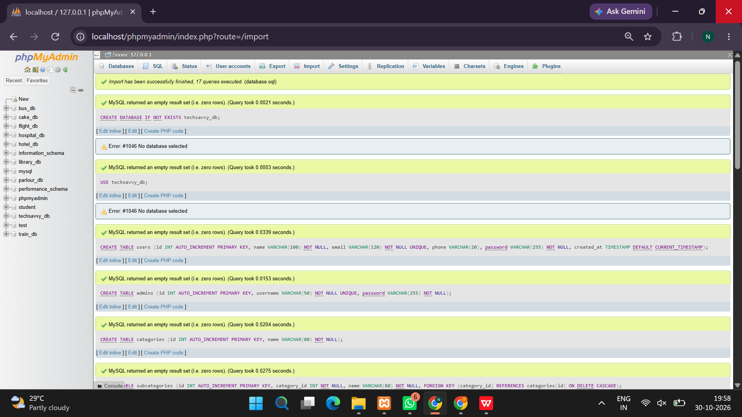
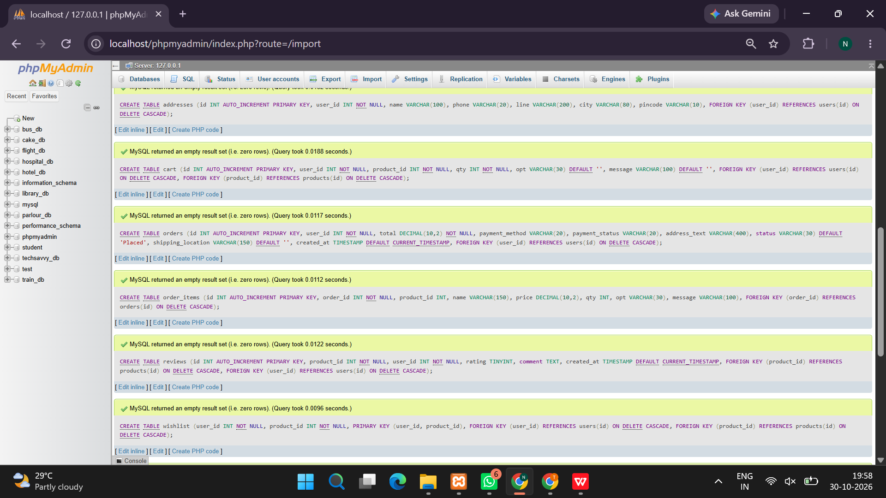
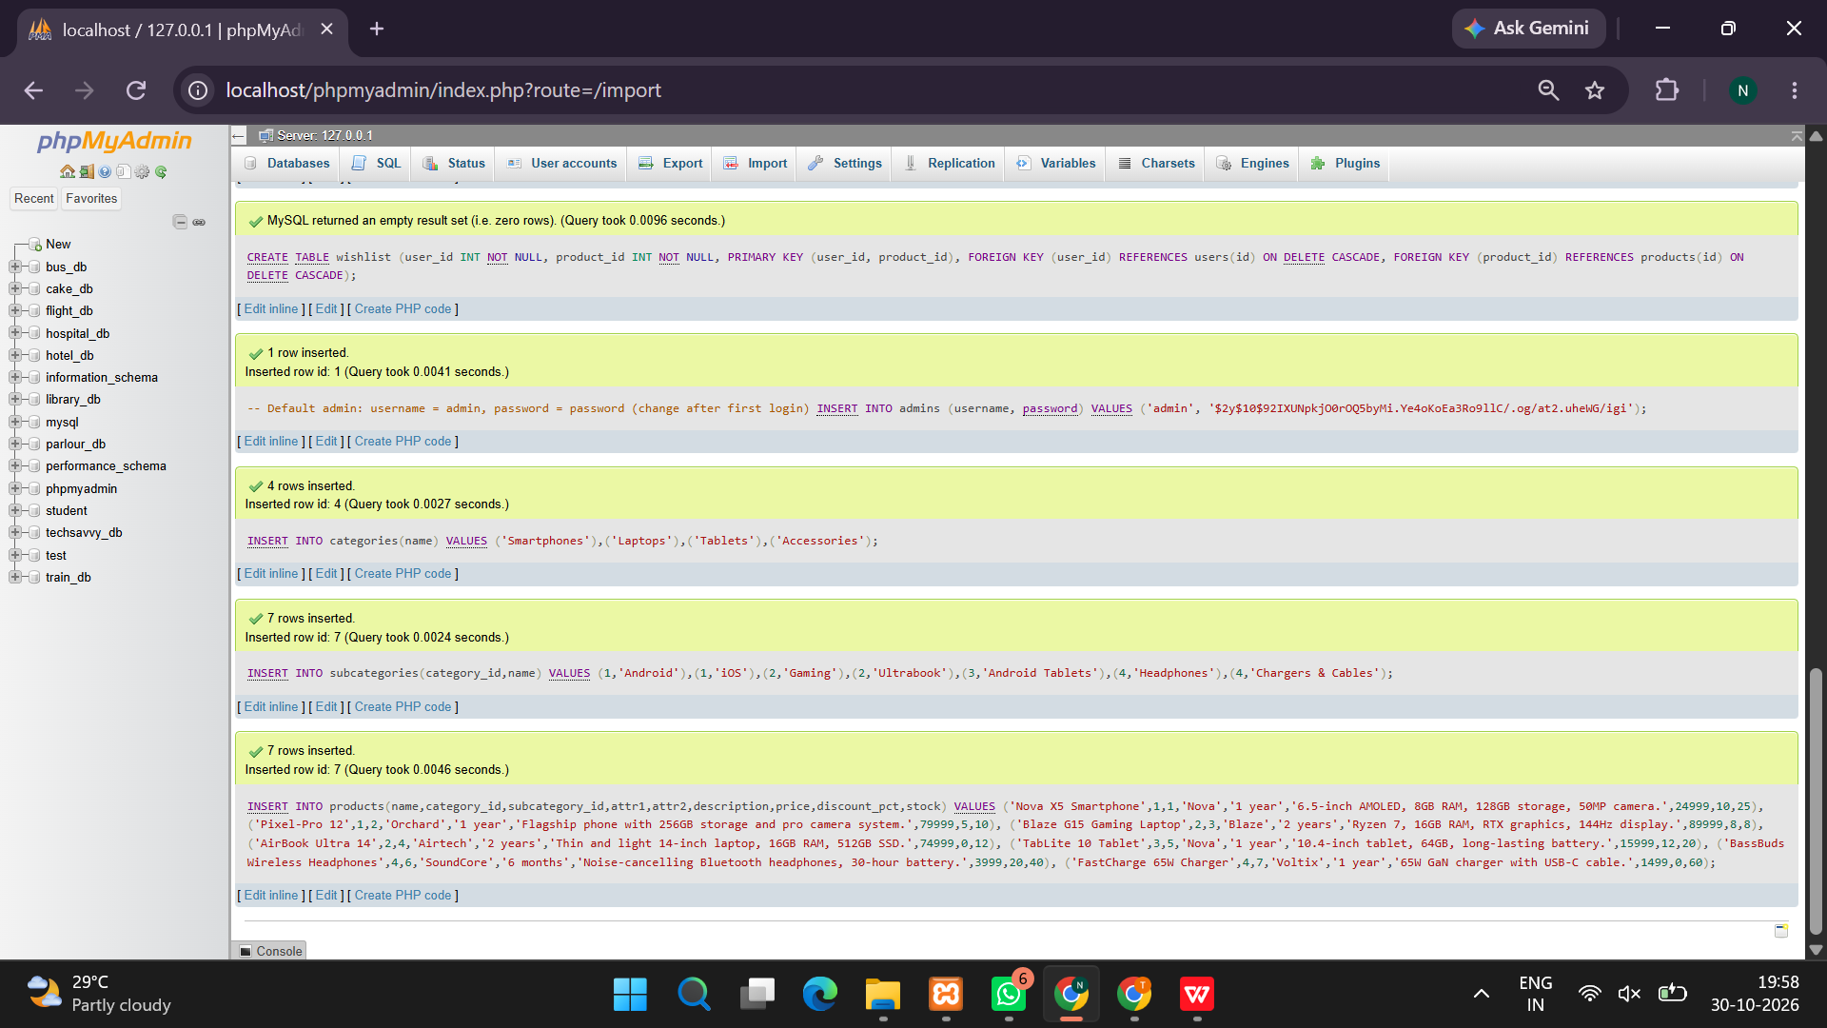
<?php
session_start();

/* DATABASE SETUP */
try {
$pdo = new PDO("mysql:host=localhost;charset=utf8mb4", "root", "", [
PDO::ATTR_ERRMODE => PDO::ERRMODE_EXCEPTION,
PDO::ATTR_DEFAULT_FETCH_MODE => PDO::FETCH_ASSOC
]);

$pdo->exec("CREATE DATABASE IF NOT EXISTS techsavvy");
$pdo->exec("USE techsavvy");

$pdo->exec("CREATE TABLE IF NOT EXISTS users (
id INT AUTO_INCREMENT PRIMARY KEY,
name VARCHAR(100) NOT NULL,
email VARCHAR(150) UNIQUE NOT NULL,
password VARCHAR(255) NOT NULL,
role VARCHAR(20) DEFAULT 'customer'
)");

$pdo->exec("CREATE TABLE IF NOT EXISTS products (
id INT AUTO_INCREMENT PRIMARY KEY,
name VARCHAR(150) NOT NULL,
category VARCHAR(80) NOT NULL,
subcategory VARCHAR(80) NOT NULL,
price DECIMAL(10,2) NOT NULL,
description TEXT,
stock INT NOT NULL DEFAULT 10
)");

$pdo->exec("CREATE TABLE IF NOT EXISTS orders (
id INT AUTO_INCREMENT PRIMARY KEY,
user_id INT NOT NULL,
total DECIMAL(10,2) NOT NULL,
status VARCHAR(30) DEFAULT 'Order Placed',
created_at TIMESTAMP DEFAULT CURRENT_TIMESTAMP,
FOREIGN KEY (user_id) REFERENCES users(id)
)");

$pdo->exec("CREATE TABLE IF NOT EXISTS order_items (
id INT AUTO_INCREMENT PRIMARY KEY,
order_id INT NOT NULL,
product_id INT NOT NULL,
product_name VARCHAR(150) NOT NULL,
quantity INT NOT NULL,
price DECIMAL(10,2) NOT NULL,
FOREIGN KEY (order_id) REFERENCES orders(id) ON DELETE CASCADE
)");

if ($pdo->query("SELECT COUNT(*) FROM products")->fetchColumn() == 0) {
$pdo->exec("INSERT INTO products
(name,category,subcategory,price,description,stock) VALUES
('Smartphone X','Smartphones','Android Phones',24999,'High-performance smartphone with a bright display.',15),
('iPhone 16','Smartphones','Apple Phones',69999,'Premium smartphone with advanced camera features.',10),
('TechBook Pro','Laptops','Student Laptops',54999,'Laptop for students, programming, and office work.',8),
('Gaming Laptop','Laptops','Gaming Laptops',89999,'Powerful laptop designed for gaming.',5),
('Tablet Air','Tablets','Android Tablets',19999,'Lightweight tablet for entertainment and study.',12),
('Wireless Headphones','Accessories','Audio Accessories',1999,'Wireless headphones with clear sound.',25),
('Fast Charger','Accessories','Mobile Accessories',799,'Fast charging adapter for compatible devices.',30),
('Smart Watch','Accessories','Wearables',2999,'Smart watch with activity tracking features.',18)");
}

} catch (PDOException $e) {
die("Database connection failed. Start MySQL in XAMPP and check your settings.");
}

function e($value) {
return htmlspecialchars((string)$value, ENT_QUOTES, 'UTF-8');
}

function loggedIn() {
return isset($_SESSION['user_id']);
}

function isAdmin() {
return ($_SESSION['role'] ?? '') === 'admin';
}

if (!isset($_SESSION['cart'])) {
$_SESSION['cart'] = [];
}

$message = '';
$error = '';

/* HANDLE ACTIONS */
if ($_SERVER['REQUEST_METHOD'] === 'POST') {
$action = $_POST['action'] ?? '';

// REGISTER
if ($action === 'register') {
$name = trim($_POST['name'] ?? '');
$email = strtolower(trim($_POST['email'] ?? ''));
$password = $_POST['password'] ?? '';

if ($name === '' || !filter_var($email, FILTER_VALIDATE_EMAIL)
|| strlen($password) < 6) {
$error = "Enter a valid name, email and password of at least 6 characters.";
} else {
try {
$stmt = $pdo->prepare(
"INSERT INTO users(name,email,password) VALUES(?,?,?)"
);
$stmt->execute([
$name, $email,
password_hash($password, PASSWORD_DEFAULT)
]);
$message = "Registration successful. Please log in.";
} catch (PDOException $ex) {
$error = "This email is already registered.";
}
}
}

// LOGIN
if ($action === 'login') {
$email = strtolower(trim($_POST['email'] ?? ''));
$password = $_POST['password'] ?? '';

$stmt = $pdo->prepare("SELECT * FROM users WHERE email=?");
$stmt->execute([$email]);
$user = $stmt->fetch();

if ($user && password_verify($password, $user['password'])) {
session_regenerate_id(true);
$_SESSION['user_id'] = $user['id'];
$_SESSION['user_name'] = $user['name'];
$_SESSION['role'] = $user['role'];
header("Location: index.php");
exit;
} else {
$error = "Incorrect email or password.";
}
}

// ADD PRODUCT TO CART
if ($action === 'add_cart') {
$id = (int)($_POST['product_id'] ?? 0);
$qty = max(1, min(20, (int)($_POST['quantity'] ?? 1)));

$stmt = $pdo->prepare("SELECT * FROM products WHERE id=?");
$stmt->execute([$id]);
$product = $stmt->fetch();

if (!$product || $product['stock'] < 1) {
$error = "Product is unavailable.";
} else {
$current = $_SESSION['cart'][$id] ?? 0;
$_SESSION['cart'][$id] = min(
(int)$product['stock'],
$current + $qty
);
$message = "Product added to cart.";
}
}

// UPDATE CART QUANTITY
if ($action === 'update_cart') {
foreach ($_POST['qty'] ?? [] as $id => $qty) {
$id = (int)$id;
$qty = (int)$qty;

$stmt = $pdo->prepare("SELECT stock FROM products WHERE id=?");
$stmt->execute([$id]);
$stock = $stmt->fetchColumn();

if (!$stock || $qty <= 0) {
unset($_SESSION['cart'][$id]);
} else {
$_SESSION['cart'][$id] = min($qty, (int)$stock);
}
}
$message = "Shopping cart updated.";
}

// REMOVE CART ITEM
if ($action === 'remove_cart') {
unset($_SESSION['cart'][(int)($_POST['product_id'] ?? 0)]);
$message = "Item removed from cart.";
}

// CHECKOUT
if ($action === 'checkout') {
if (!loggedIn()) {
$error = "Please log in before checkout.";
} elseif (empty($_SESSION['cart'])) {
$error = "Your shopping cart is empty.";
} else {
try {
$pdo->beginTransaction();
$items = [];
$total = 0;

foreach ($_SESSION['cart'] as $id => $qty) {
$stmt = $pdo->prepare(
"SELECT * FROM products WHERE id=? FOR UPDATE"
);
$stmt->execute([(int)$id]);
$product = $stmt->fetch();

if (!$product || $qty > $product['stock'] || $qty < 1) {
throw new Exception("Insufficient stock for an item. Update your cart.");
}

$items[] = [
'product' => $product,
'qty' => $qty
];
$total += $product['price'] * $qty;
}

$stmt = $pdo->prepare(
"INSERT INTO orders(user_id,total) VALUES(?,?)"
);
$stmt->execute([$_SESSION['user_id'], $total]);
$orderId = $pdo->lastInsertId();

foreach ($items as $item) {
$p = $item['product'];
$qty = $item['qty'];

$stmt = $pdo->prepare(
"INSERT INTO order_items
(order_id,product_id,product_name,quantity,price)
VALUES(?,?,?,?,?)"
);
$stmt->execute([
$orderId, $p['id'], $p['name'], $qty, $p['price']
]);

$stmt = $pdo->prepare(
"UPDATE products SET stock=stock-? WHERE id=?"
);
$stmt->execute([$qty, $p['id']]);
}

$pdo->commit();
$_SESSION['cart'] = [];
$message = "Order placed successfully! Order number: #" . $orderId;
} catch (Throwable $ex) {
if ($pdo->inTransaction()) {
$pdo->rollBack();
}
$error = $ex instanceof PDOException
? "Unable to place the order. Please try again."
: $ex->getMessage();
}
}
}

// ADMIN ADD PRODUCT
if ($action === 'add_product' && isAdmin()) {
$name = trim($_POST['name'] ?? '');
$category = trim($_POST['category'] ?? '');
$subcategory = trim($_POST['subcategory'] ?? '');
$price = (float)($_POST['price'] ?? 0);
$description = trim($_POST['description'] ?? '');
$stock = max(0, (int)($_POST['stock'] ?? 0));

if ($name === '' || $category === '' || $subcategory === ''
|| $price <= 0) {
$error = "Enter valid product details and price.";
} else {
$stmt = $pdo->prepare(
"INSERT INTO products(name,category,subcategory,price,description,stock)
VALUES(?,?,?,?,?,?)"
);
$stmt->execute([
$name, $category, $subcategory, $price, $description, $stock
]);
$message = "Product added successfully.";
}
}

// ADMIN UPDATE PRODUCT
if ($action === 'update_product' && isAdmin()) {
$id = (int)($_POST['product_id'] ?? 0);
$name = trim($_POST['name'] ?? '');
$category = trim($_POST['category'] ?? '');
$subcategory = trim($_POST['subcategory'] ?? '');
$price = (float)($_POST['price'] ?? 0);
$description = trim($_POST['description'] ?? '');
$stock = max(0, (int)($_POST['stock'] ?? 0));

if ($name !== '' && $category !== '' && $subcategory !== '' && $price > 0) {
$stmt = $pdo->prepare(
"UPDATE products SET name=?,category=?,subcategory=?,
price=?,description=?,stock=? WHERE id=?"
);
$stmt->execute([
$name, $category, $subcategory, $price,
$description, $stock, $id
]);
$message = "Product updated.";
} else {
$error = "Please enter valid product details.";
}
}

// ADMIN DELETE PRODUCT
if ($action === 'delete_product' && isAdmin()) {
$id = (int)($_POST['product_id'] ?? 0);
$stmt = $pdo->prepare("DELETE FROM products WHERE id=?");
$stmt->execute([$id]);
unset($_SESSION['cart'][$id]);
$message = "Product deleted.";
}

// ADMIN UPDATE ORDER STATUS
if ($action === 'order_status' && isAdmin()) {
$id = (int)($_POST['order_id'] ?? 0);
$status = $_POST['status'] ?? '';
$allowed = ['Order Placed', 'Processing', 'Shipped', 'Delivered', 'Cancelled'];

if (in_array($status, $allowed, true)) {
$stmt = $pdo->prepare("UPDATE orders SET status=? WHERE id=?");
$stmt->execute([$status, $id]);
$message = "Order status updated.";
}
}
}

// LOGOUT
if (isset($_GET['logout'])) {
$_SESSION = [];
session_destroy();
header("Location: index.php");
exit;
}

// SEARCH AND FILTER PRODUCTS
$search = trim($_GET['search'] ?? '');
$categoryFilter = trim($_GET['category'] ?? '');

$sql = "SELECT * FROM products WHERE 1=1";
$params = [];

if ($search !== '') {
$sql .= " AND (name LIKE ? OR description LIKE ? OR subcategory LIKE ?)";
$like = "%$search%";
array_push($params, $like, $like, $like);
}
if ($categoryFilter !== '') {
$sql .= " AND category=?";
$params[] = $categoryFilter;
}
$sql .= " ORDER BY category, name";

$stmt = $pdo->prepare($sql);
$stmt->execute($params);
$products = $stmt->fetchAll();

// CATEGORIES
$categories = $pdo->query(
"SELECT category, COUNT(*) AS total FROM products
GROUP BY category ORDER BY total DESC, category"
)->fetchAll();

// CART DETAILS
$cartItems = [];
$cartTotal = 0;

foreach ($_SESSION['cart'] as $id => $qty) {
$stmt = $pdo->prepare("SELECT * FROM products WHERE id=?");
$stmt->execute([(int)$id]);
$p = $stmt->fetch();

if ($p) {
$p['quantity'] = $qty;
$p['subtotal'] = $p['price'] * $qty;
$cartTotal += $p['subtotal'];
$cartItems[] = $p;
}
}

// CUSTOMER ORDER HISTORY
$orders = [];
if (loggedIn()) {
$stmt = $pdo->prepare("SELECT * FROM orders WHERE user_id=? ORDER BY id DESC");
$stmt->execute([$_SESSION['user_id']]);
$orders = $stmt->fetchAll();
}

// ADMIN DATA
$adminProducts = [];
$adminOrders = [];
$customers = [];

if (isAdmin()) {
$adminProducts = $pdo->query("SELECT * FROM products ORDER BY id DESC")->fetchAll();
$adminOrders = $pdo->query(
"SELECT o.*, u.name AS customer_name, u.email
FROM orders o JOIN users u ON o.user_id=u.id ORDER BY o.id DESC"
)->fetchAll();
$customers = $pdo->query(
"SELECT id,name,email FROM users WHERE role='customer' ORDER BY id DESC"
)->fetchAll();
}
?>

<!DOCTYPE html>
<html lang="en">
<head>
<meta charset="UTF-8">
<meta name="viewport" content="width=device-width, initial-scale=1.0">
<title>TechSavvy Online Shopping</title>
<style>
*{box-sizing:border-box}
body{margin:0;font-family:Arial,sans-serif;background:#f5f7fb;color:#263445}
header{background:#172554;color:white;padding:20px 6%;display:flex;justify-content:space-between;align-items:center;flex-wrap:wrap;gap:12px}
header h1{margin:0}
nav a{color:white;text-decoration:none;margin:8px;font-weight:bold}
.hero{background:linear-gradient(120deg,#dbeafe,#ede9fe);padding:40px 7%}
.hero h2{font-size:32px;color:#172554}
main{max-width:1200px;margin:25px auto;padding:0 18px}
.grid{display:grid;grid-template-columns:repeat(auto-fit,minmax(245px,1fr));gap:18px}
.card{background:white;padding:20px;border-radius:13px;box-shadow:0 4px 15px #152a4614;margin-bottom:18px}
h2,h3{color:#1d4ed8}
input,select,textarea{width:100%;padding:10px;margin:7px 0 12px;border:1px solid #ccd5e1;border-radius:7px}
button,.btn{background:#2563eb;color:white;padding:10px 15px;border:0;border-radius:7px;cursor:pointer;text-decoration:none;display:inline-block}
button:hover,.btn:hover{background:#1d4ed8}
.danger{background:#c0392b}
.notice{padding:13px;border-radius:7px;background:#dcfce7;color:#166534;margin-bottom:15px}
.error{background:#fee2e2;color:#991b1b}
.category{display:inline-block;padding:10px 15px;background:white;border-radius:20px;margin:5px;text-decoration:none;color:#1d4ed8;border:1px solid #dbeafe}
.price{font-size:20px;font-weight:bold;color:#047857}
.muted{color:#64748b}
table{width:100%;border-collapse:collapse;background:white}
th,td{text-align:left;padding:10px;border-bottom:1px solid #e2e8f0}
footer{text-align:center;background:#172554;color:white;padding:20px;margin-top:30px}
@media(max-width:600px){header{padding:18px}.hero h2{font-size:25px}nav a{display:inline-block}}
</style>
</head>
<body>

<header>
<h1>TechSavvy</h1>
<nav>
<a href="#home">Home</a>
<a href="#products">Products</a>
<a href="#cart">Cart (<?= array_sum($_SESSION['cart']) ?>)</a>
<?php if (loggedIn()): ?>
<a href="#orders">My Orders</a>
<?php endif; ?>
<?php if (isAdmin()): ?>
<a href="#admin">Admin</a>
<?php endif; ?>
<?php if (loggedIn()): ?>
<a href="?logout=1">Logout</a>
<?php else: ?>
<a href="#account">Login / Register</a>
<?php endif; ?>
</nav>
</header>

<section class="hero" id="home">
<h2>Discover the Latest Gadgets</h2>
<p>Shop smartphones, laptops, tablets, and accessories at TechSavvy.</p>
<a class="btn" href="#products">Shop Now</a>
</section>

<main>

<?php if ($message): ?><div class="notice"><?= e($message) ?></div><?php endif; ?>
<?php if ($error): ?><div class="notice error"><?= e($error) ?></div><?php endif; ?>

<h2>Shop by Category</h2>
<div>
<a class="category" href="index.php">All Products</a>
<?php foreach ($categories as $c): ?>
<a class="category" href="?category=<?= urlencode($c['category']) ?>">
<?= e($c['category']) ?> (<?= e($c['total']) ?>)
</a>
<?php endforeach; ?>
</div>

<?php if (!loggedIn()): ?>
<section class="grid" id="account">
<div class="card">
<h2>Customer Login</h2>
<form method="post">
<input type="hidden" name="action" value="login">
<label>Email</label>
<input type="email" name="email" required>
<label>Password</label>
<input type="password" name="password" required>
<button type="submit">Login</button>
</form>
</div>

<div class="card">
<h2>Create Account</h2>
<form method="post">
<input type="hidden" name="action" value="register">
<label>Full Name</label>
<input name="name" required>
<label>Email</label>
<input type="email" name="email" required>
<label>Password (minimum 6 characters)</label>
<input type="password" name="password" minlength="6" required>
<button type="submit">Register</button>
</form>
</div>
</section>
<?php else: ?>
<div class="card">
Welcome, <strong><?= e($_SESSION['user_name']) ?></strong>!
</div>
<?php endif; ?>

<section id="products">
<h2>Available Products</h2>
<div class="card">
<form method="get">
<label>Search products</label>
<input name="search" value="<?= e($search) ?>" placeholder="Search smartphones, laptops, accessories...">
<button type="submit">Search</button>
<a class="btn" href="index.php">Clear</a>
</form>
</div>

<div class="grid">
<?php foreach ($products as $p): ?>
<div class="card">
<h3><?= e($p['name']) ?></h3>
<p class="muted"><?= e($p['category']) ?> / <?= e($p['subcategory']) ?></p>
<p><?= e($p['description']) ?></p>
<p class="price">₹<?= number_format((float)$p['price'], 2) ?></p>
<p>Availability: <?= $p['stock'] > 0 ? e($p['stock']).' in stock' : 'Out of stock' ?></p>

<?php if ($p['stock'] > 0): ?>
<form method="post">
<input type="hidden" name="action" value="add_cart">
<input type="hidden" name="product_id" value="<?= e($p['id']) ?>">
<label>Quantity</label>
<input type="number" name="quantity" value="1" min="1" max="<?= e(min(20,$p['stock'])) ?>">
<button type="submit">Add to Cart</button>
</form>
<?php endif; ?>
</div>
<?php endforeach; ?>

<?php if (!$products): ?>
<div class="card">No products found.</div>
<?php endif; ?>
</div>
</section>

<section id="cart">
<h2>Shopping Cart</h2>
<div class="card">
<?php if (!$cartItems): ?>
<p>Your cart is empty.</p>
<?php else: ?>
<form method="post">
<input type="hidden" name="action" value="update_cart">
<table>
<tr><th>Product</th><th>Price</th><th>Quantity</th><th>Subtotal</th></tr>
<?php foreach ($cartItems as $item): ?>
<tr>
<td><?= e($item['name']) ?></td>
<td>₹<?= number_format((float)$item['price'],2) ?></td>
<td>
<input type="number" name="qty[<?= e($item['id']) ?>]"
value="<?= e($item['quantity']) ?>" min="0" max="<?= e($item['stock']) ?>">
</td>
<td>₹<?= number_format((float)$item['subtotal'],2) ?></td>
</tr>
<?php endforeach; ?>
</table>
<p><strong>Total: ₹<?= number_format((float)$cartTotal,2) ?></strong></p>
<p class="muted">Set quantity to 0 to remove an item.</p>
<button type="submit">Update Cart</button>
</form>

<form method="post" style="margin-top:15px">
<input type="hidden" name="action" value="checkout">
<button type="submit">Checkout / Place Order</button>
</form>
<?php endif; ?>
</div>
</section>

<?php if (loggedIn()): ?>
<section id="orders">
<h2>My Order History and Status</h2>
<div class="grid">
<?php foreach ($orders as $o): ?>
<div class="card">
<h3>Order #<?= e($o['id']) ?></h3>
<p>Total: ₹<?= number_format((float)$o['total'],2) ?></p>
<p>Status: <strong><?= e($o['status']) ?></strong></p>
<p class="muted"><?= e($o['created_at']) ?></p>
<h4>Items</h4>
<?php
$oi = $pdo->prepare("SELECT * FROM order_items WHERE order_id=?");
$oi->execute([$o['id']]);
foreach ($oi->fetchAll() as $line):
?>
<p><?= e($line['product_name']) ?> × <?= e($line['quantity']) ?></p>
<?php endforeach; ?>
</div>
<?php endforeach; ?>
<?php if (!$orders): ?><div class="card">No orders yet.</div><?php endif; ?>
</div>
</section>
<?php endif; ?>

<?php if (isAdmin()): ?>
<section id="admin">
<h2>Admin Dashboard</h2>

<div class="card">
<h3>Add New Product</h3>
<form method="post">
<input type="hidden" name="action" value="add_product">
<label>Product Name</label><input name="name" required>
<label>Category</label>
<select name="category" required>
<option>Smartphones</option><option>Laptops</option>
<option>Tablets</option><option>Accessories</option>
</select>
<label>Subcategory</label><input name="subcategory" required>
<label>Price (₹)</label><input type="number" name="price" min="0.01" step="0.01" required>
<label>Description</label><textarea name="description" required></textarea>
<label>Stock</label><input type="number" name="stock" min="0" value="10" required>
<button type="submit">Add Product</button>
</form>
</div>

<h3>Manage Products</h3>
<div class="grid">
<?php foreach ($adminProducts as $p): ?>
<div class="card">
<form method="post">
<input type="hidden" name="action" value="update_product">
<input type="hidden" name="product_id" value="<?= e($p['id']) ?>">
<label>Product Name</label><input name="name" value="<?= e($p['name']) ?>" required>
<label>Category</label><input name="category" value="<?= e($p['category']) ?>" required>
<label>Subcategory</label><input name="subcategory" value="<?= e($p['subcategory']) ?>" required>
<label>Price</label><input type="number" name="price" step="0.01" min="0.01" value="<?= e($p['price']) ?>" required>
<label>Description</label><textarea name="description"><?= e($p['description']) ?></textarea>
<label>Stock</label><input type="number" name="stock" min="0" value="<?= e($p['stock']) ?>" required>
<button type="submit">Update Product</button>
</form>
<form method="post" onsubmit="return confirm('Delete this product?')">
<input type="hidden" name="action" value="delete_product">
<input type="hidden" name="product_id" value="<?= e($p['id']) ?>">
<button class="danger" type="submit">Delete Product</button>
</form>
</div>
<?php endforeach; ?>
</div>

<h3>Customer Checkout Information</h3>
<div class="card">
<table>
<tr><th>Order</th><th>Customer</th><th>Email</th><th>Total</th><th>Status</th><th>Update Status</th></tr>
<?php foreach ($adminOrders as $o): ?>
<tr>
<td>#<?= e($o['id']) ?></td>
<td><?= e($o['customer_name']) ?></td>
<td><?= e($o['email']) ?></td>
<td>₹<?= number_format((float)$o['total'],2) ?></td>
<td><?= e($o['status']) ?></td>
<td>
<form method="post">
<input type="hidden" name="action" value="order_status">
<input type="hidden" name="order_id" value="<?= e($o['id']) ?>">
<select name="status">
<?php foreach (['Order Placed','Processing','Shipped','Delivered','Cancelled'] as $s): ?>
<option value="<?= e($s) ?>" <?= $o['status']===$s?'selected':'' ?>><?= e($s) ?></option>
<?php endforeach; ?>
</select>
<button type="submit">Save</button>
</form>
</td>
</tr>
<?php endforeach; ?>
</table>
</div>

<h3>Registered Customers</h3>
<div class="card">
<?php foreach ($customers as $c): ?>
<p><?= e($c['name']) ?> — <?= e($c['email']) ?></p>
<?php endforeach; ?>
</div>
</section>
<?php endif; ?>

</main>

<footer>
<p>TechSavvy Online Shopping Platform</p>
<p>Internet Programming Lab Experiment 9</p>
</footer>
</body>
</html>
OUTPUT:


