
DEPI
Under the supervision of:
Eng Ahmed Ali

Smart City Energy Optimization & Prediction Platform



Team 4 Names:
- Merna Sameh Mahmoud
- Nagat Osama
- Ebrahim Ateff
- Abdullah Mohamed
Table of Contents
Executive Summary: 2
1. Introduction 3
1.1 Problem Statement 3
1.2Solution Overview 3
1.3 Project Goals 4
System Architecture 5
2.1 Architecture Diagram 5
2.2 Components Used 6
2.3 Medallion Architecture 6
Data Engineering Pipelines 9
Pipeline 1 — Ingest Energy (CSV → ADLS Raw → Bronze) 9
Pipeline 2 — Ingest Weather API (REST → Raw → Bronze) 13
Pipeline 3 — Ingest Traffic API 16
ADF Monitoring & Alerts 19
Monitoring 19
Alerts (Azure Monitor Integration) 20

Executive Summary:
Azure Data Engineering and Machine Learning services. The system integrates batch energy data, real-time weather API, and traffic API to build a unified city-level intelligence model. After processing and enriching the data through the Medallion Architecture (Raw → Bronze → Silver → Gold), the platform predicts hourly and daily energy consumption, identifies peak load zones, and analyzes how weather and traffic variables influence consumption patterns.
The final solution includes an automated data ingestion pipeline (Azure Data Factory), a full cleaning and transformation layer (Databricks), a forecasting model built using Azure Machine Learning Designer, analytical views hosted in Synapse Serverless, and an interactive Power BI dashboard. The system delivers accurate forecasts, risk detection, and optimization recommendations to support stable and efficient energy distribution across the smart city.

1. Introduction

1.1 Problem Statement
Modern smart cities are experiencing rapid growth in population, infrastructure, and mobility. As a result, energy consumption is increasing at an unpredictable rate, causing pressure on the electric grid, especially during peak hours. Weather conditions such as temperature, humidity, and cloud cover directly influence household and industrial energy usage. Traffic congestion also plays a significant role, as longer travel times and rush-hour patterns increase the overall power demand across different regions.
Without an automated system capable of analyzing these variables and predicting future energy needs, cities face challenges such as:
- Sudden peak loads that can cause electrical instability
- Inefficient energy distribution across districts
- Difficulty planning for power shortages or high-demand periods
- Lack of insights to support decision-making for city planners
These issues highlight the need for an intelligent solution that can forecast consumption and identify risk zones before problems occur.

1.2Solution Overview
This project provides a complete Smart City Energy Optimization and Forecasting Platform that integrates three essential data streams:
- Energy consumption data (batch CSV)
- Weather data (external API)
- Traffic congestion data (external API)
The system processes these datasets through a modern Medallion Architecture (Raw → Bronze → Silver → Gold) using Azure cloud services.
The platform delivers:
- Clean, unified, and enriched data using Azure Databricks
- Accurate energy forecasting using Azure Machine Learning Designer
- Risk zone identification for regions with expected high loads
- Optimization recommendations that help balance the grid
- An interactive end-to-end dashboard built in Power BI
The solution aims to support smart city decision-makers with reliable analytics and real-time insights to improve energy stability and operational efficiency.

1.3 Project Goals
The main goals of this project are:
- Predict hourly and daily energy consumption for different city regions
- Create risk zones based on forecasted peak load levels
- Develop an optimization engine to recommend load shifting and resource balancing
- Build a fully interactive Power BI dashboard for data visualization and decision support
- Implement an automated Azure pipeline from ingestion to ML to reporting
- Provide a scalable and reusable architecture suitable for smart city applications

System Architecture

2.1 Architecture Diagram
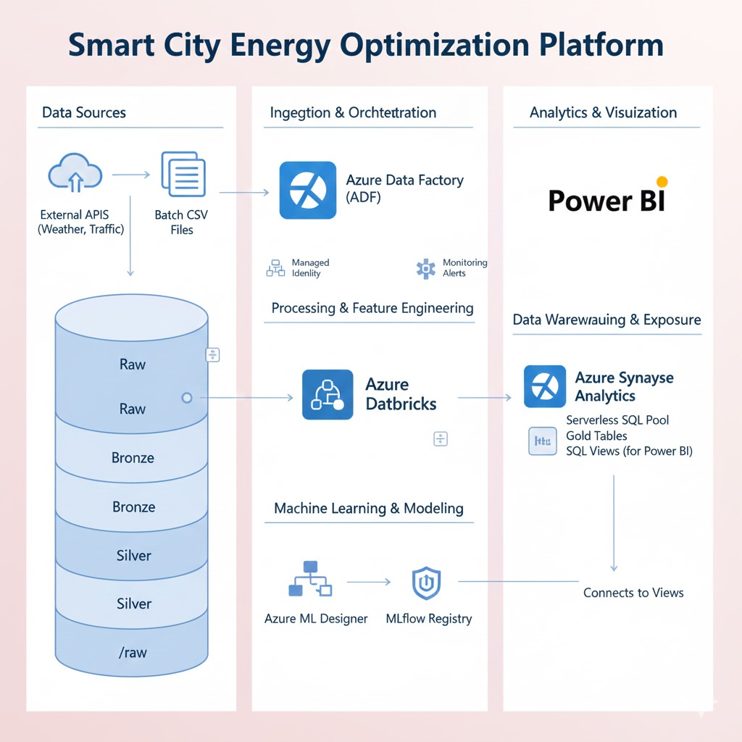

2.2 Components Used
– Azure Data Lake
– Azure Data Factory
– Azure Databricks
– Azure ML Designer
– Synapse Serverless
– Power BI

2.3 Medallion Architecture
The solution follows the Medallion Architecture, which is a modern data engineering framework designed to organize data into multiple incremental layers. Each layer adds more structure, quality, and business value to the data as it flows through the system. This architecture ensures scalability, reliability, and clarity for large data pipelines used in smart city environments.
Raw Layer — Landing Zone
This layer stores all incoming data exactly as received, without any processing or modification.
It serves as the single source of truth and provides full traceability.
In our project, Raw contains:
- Energy CSV files
- Weather API responses
- Traffic API responses
Characteristics:
- No transformations
- No cleaning
- Used for auditing and backup

Bronze Layer — Ingestion Layer
This layer contains data after ingestion using Azure Data Factory.
The Bronze layer adds essential metadata and stores the data in a consistent, queryable format.
Transformations applied:
- Adding metadata columns (load_date, source_file_name, status)
- Normalizing API responses
- Converting CSV/API files into Delta-friendly structures
This layer ensures:
- Unified structure
- Reliable ingestion
- Separation between raw data and cleaned data

Silver Layer — Cleaning & Enrichment
The Silver Layer is where the real data processing happens.
Using Databricks, data is cleaned, validated, enriched, and joined.
Transformations include:
- Removing duplicates
- Fixing timestamps and formats
- Handling missing values
- Feature engineering (weather_index, congestion_index, peak_hour_flag)
- Joining energy + weather + traffic into one unified master table
Output:
A high-quality analytics-ready table → silver.smartcity_master

Gold Layer — Business & ML Layer
The Gold Layer contains the final analytical and machine learning outputs.
This layer powers dashboards, reports, and optimization recommendations.
Gold layer contains:
- gold.energy_forecast
→ Forecasted energy consumption using Azure ML Designer (ARIMA/Prophet)
- gold.risk_zones
→ Classification of city regions into Low / Medium / High risk
- gold.optimization_recommendations
→ Smart suggestions like load shifting and peak management
- Synapse SQL views
→ Exposed directly to Power BI for business reporting
3.Data Engineering Pipelines →Bronze Layer
in this layer we created
1. Create ADLS folders: Raw / Bronze / Silver / Gold in storage account
2. Create Linked Services:
Linked Service for ADLS
Linked Service for APIs (Weather/Traffic)

3. Pipeline 1 — Ingest Energy (CSV → ADLS Raw → Bronze)
Objective
Ingest daily CSV files containing energy consumption data, enrich them with metadata, and store the cleaned output in the Bronze zone for downstream processing.
Pipeline Structure
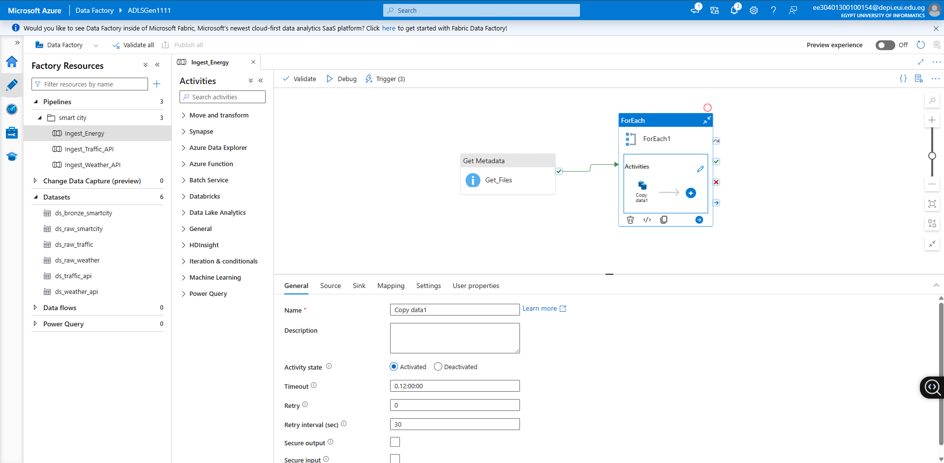

Copy Data source/sink configuration
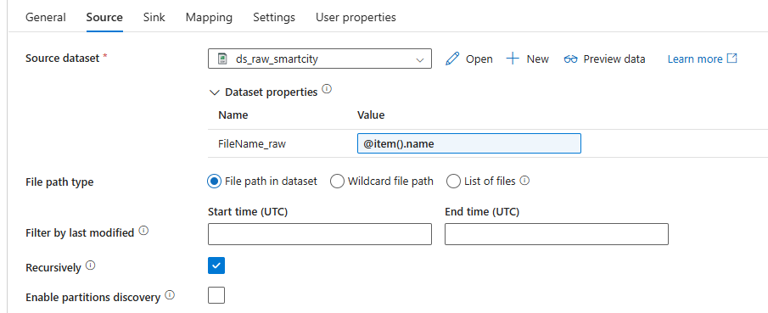
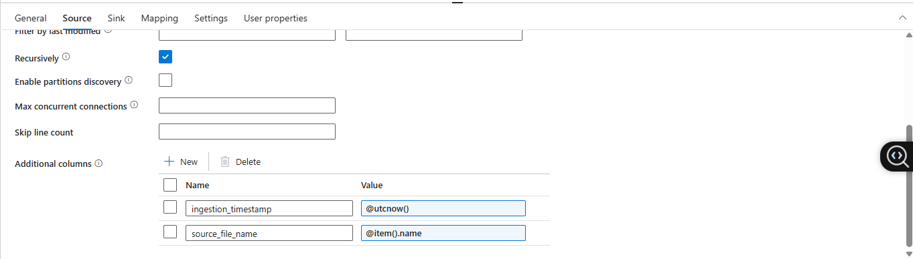
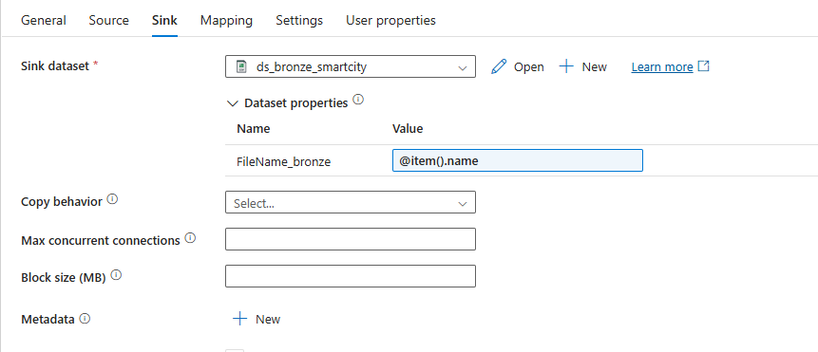

Metadata settings
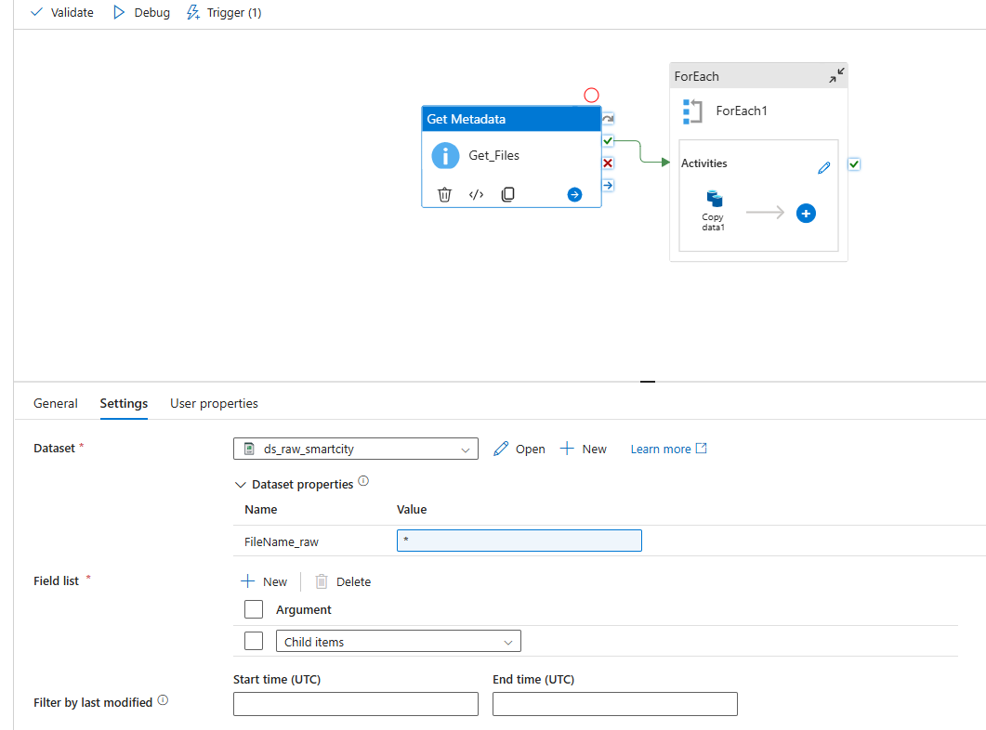
ForEach settings
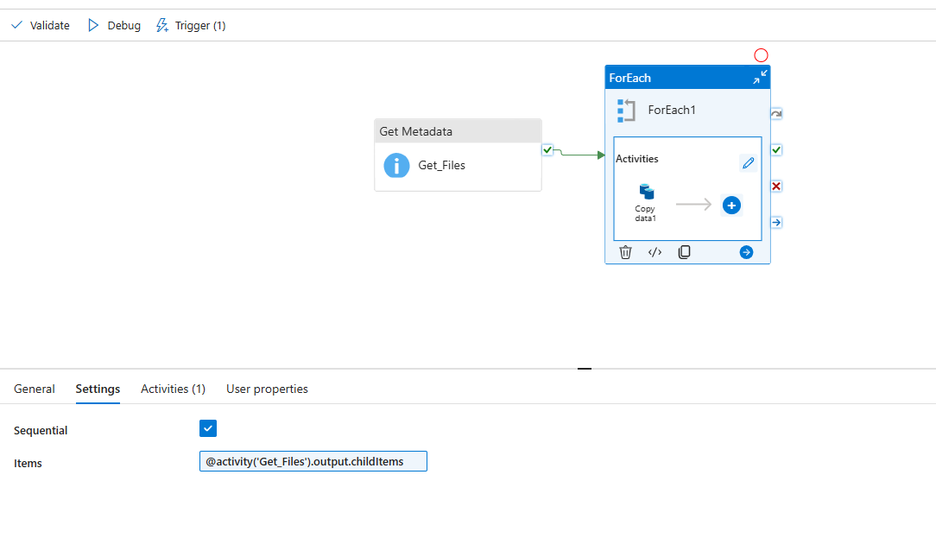
Trigger details
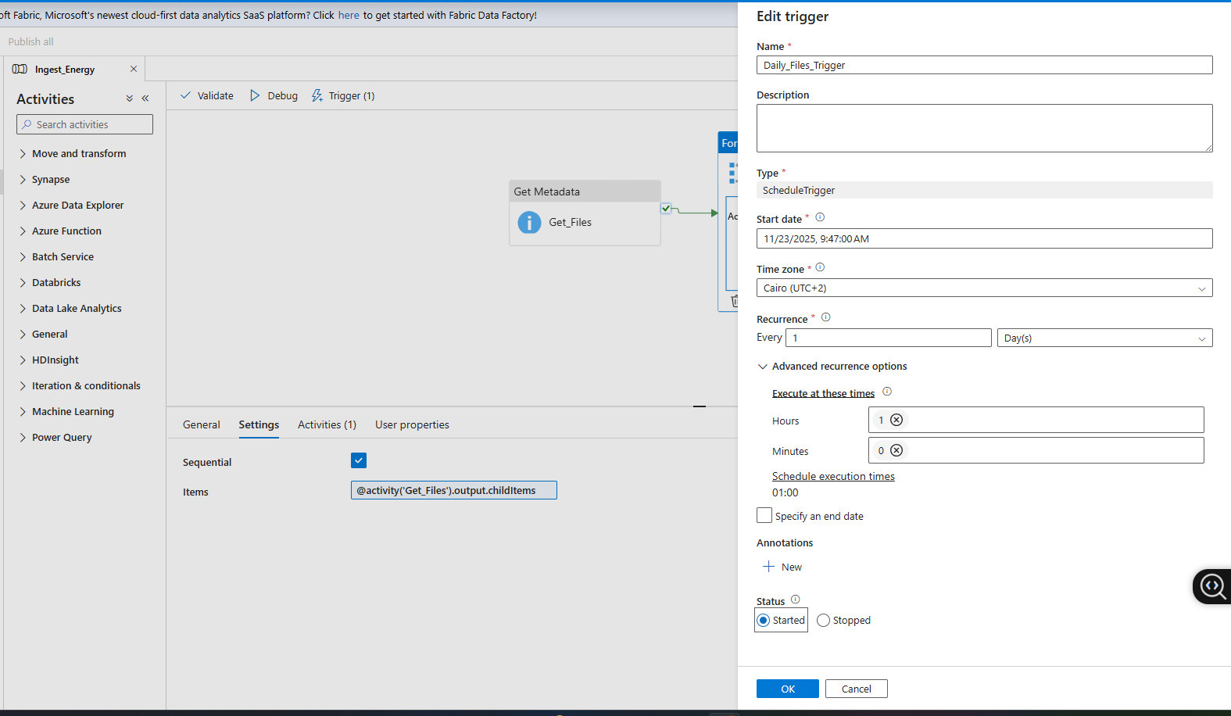
Successful pipeline run
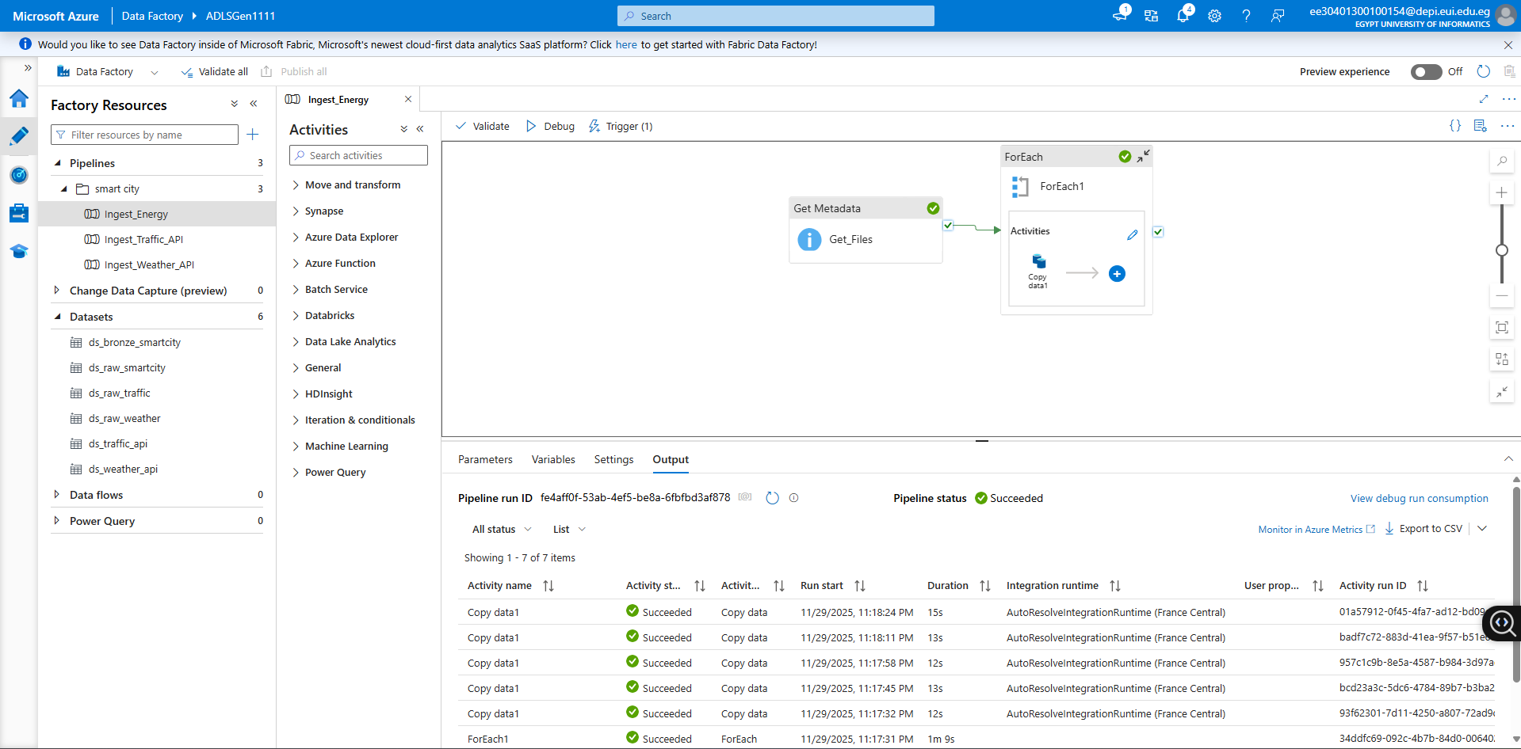

Pipeline 2 — Ingest Weather API (REST → Raw → Bronze)
Objective
Fetch real-time or daily weather data from a public API and store the JSON output into ADLS raw for further transformation in Silver.
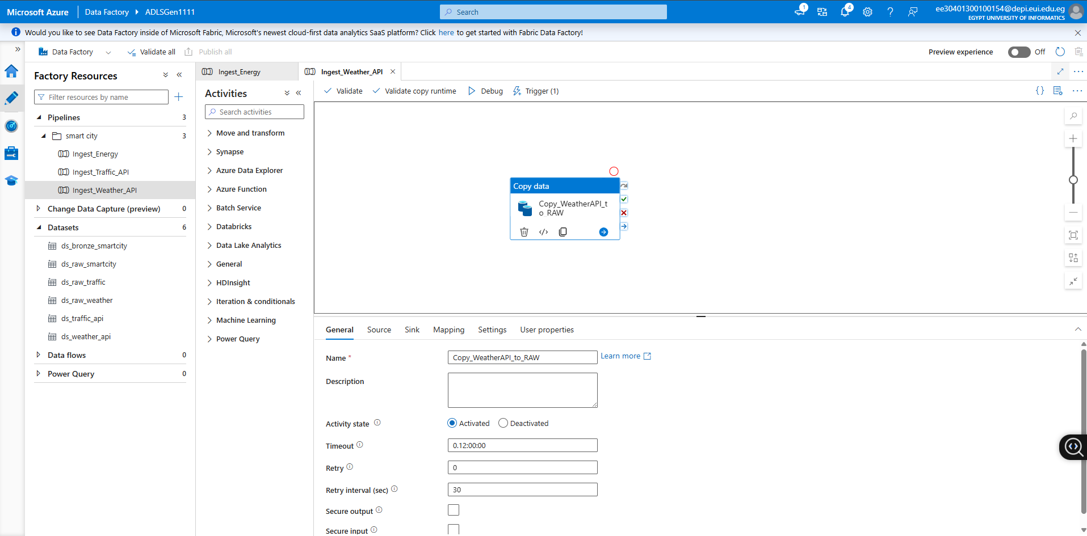
Copy Data source/sink configuration
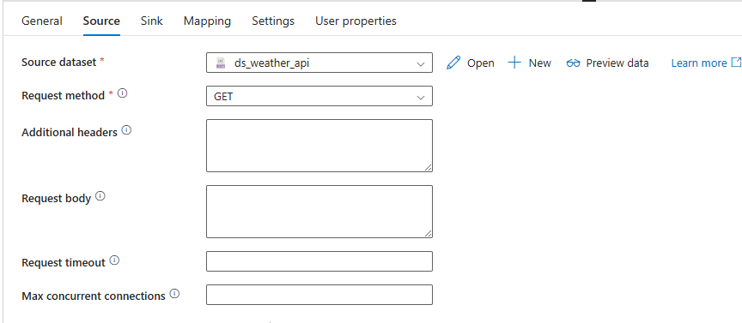
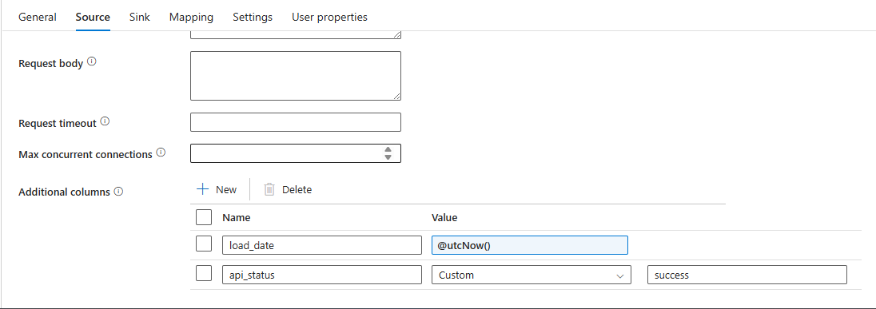
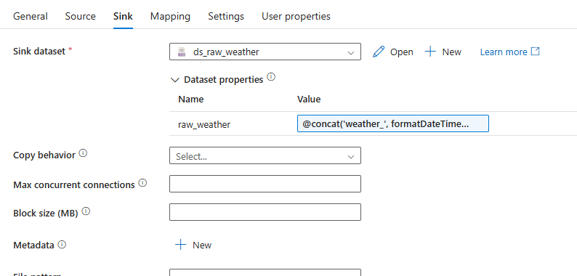
REST dataset settings : URL( https://api.open-meteo.com/v1/forecast)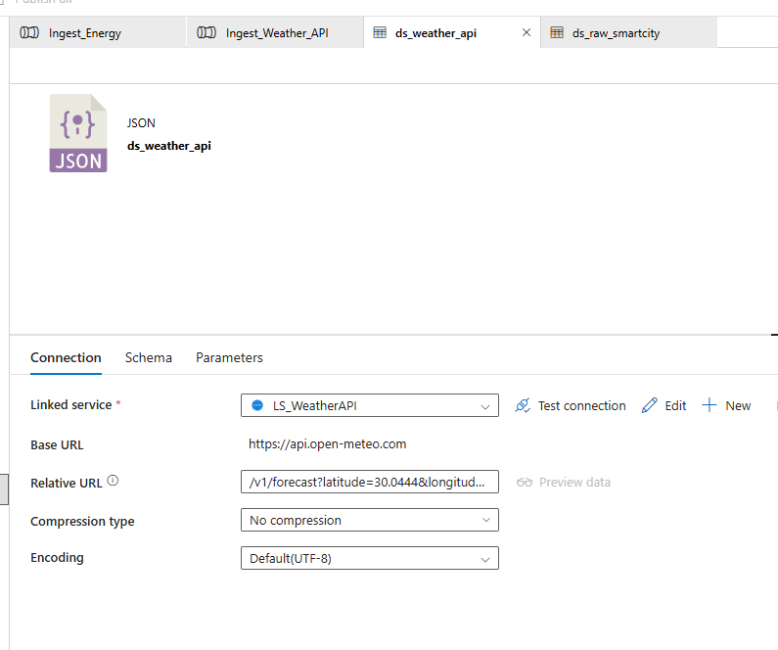
Trigger details
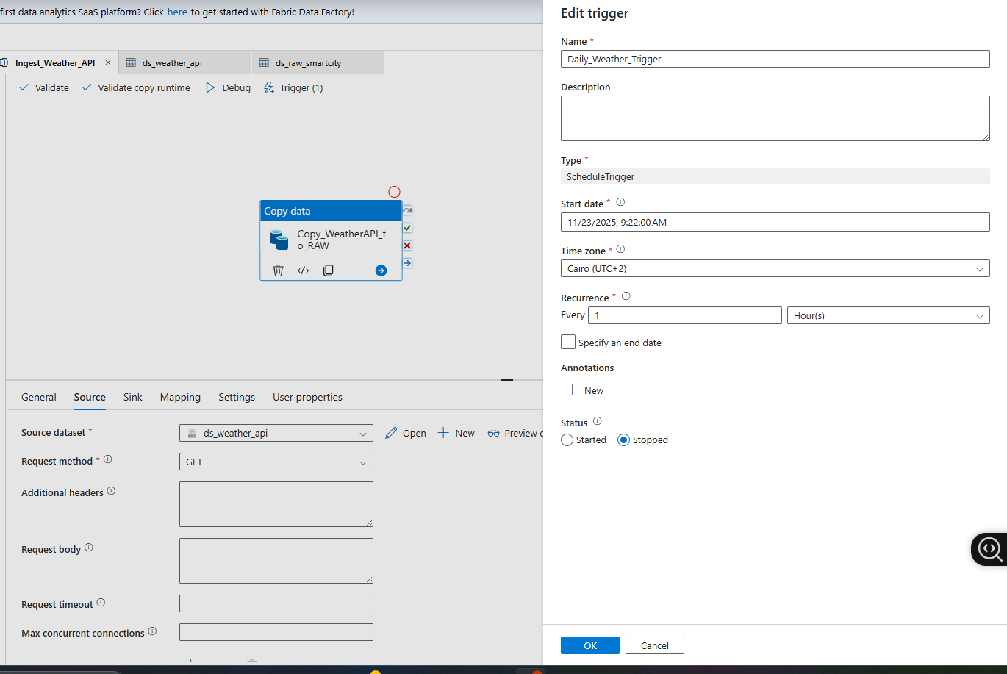
Successful pipeline run
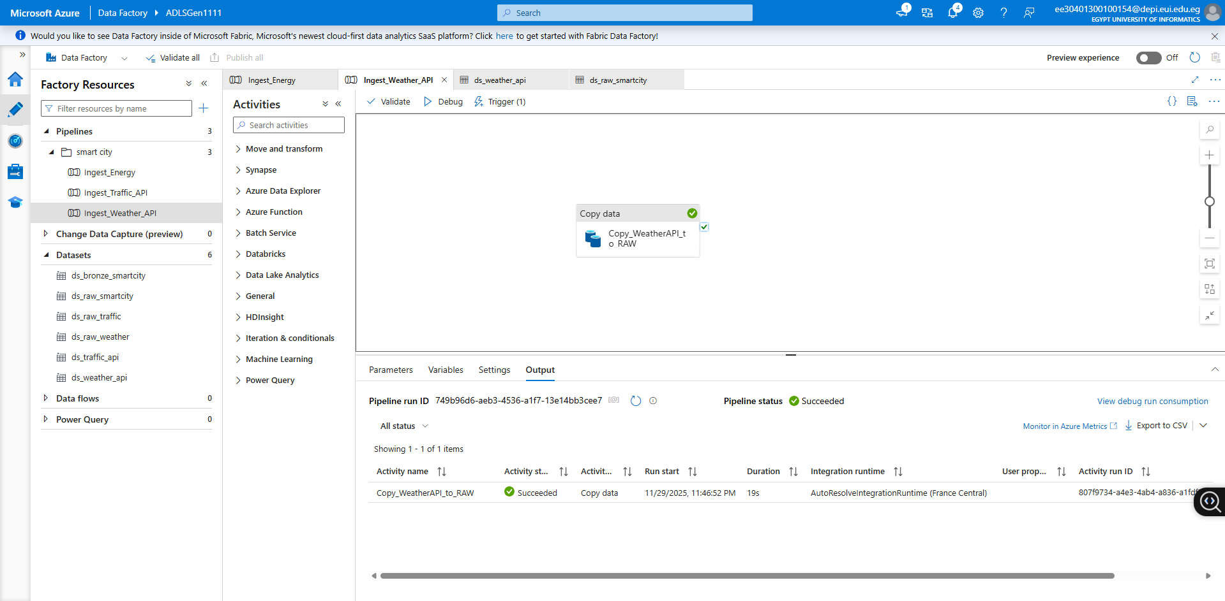

Pipeline 3 — Ingest Traffic API
Objective
Extract live traffic congestion information (speed, congestion index, city zone, etc.) and save it into ADLS raw for use in feature engineering and forecasting.
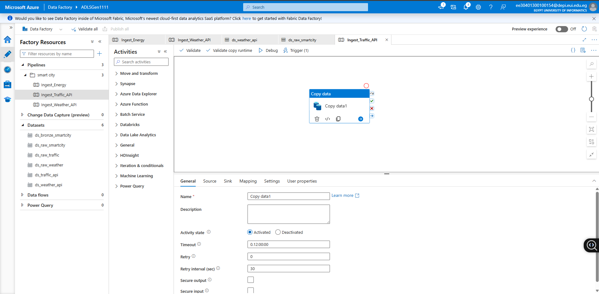
Copy Data source/sink configuration
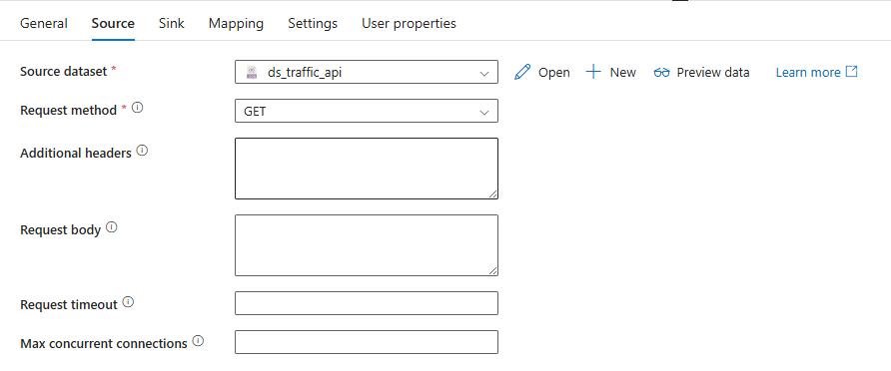
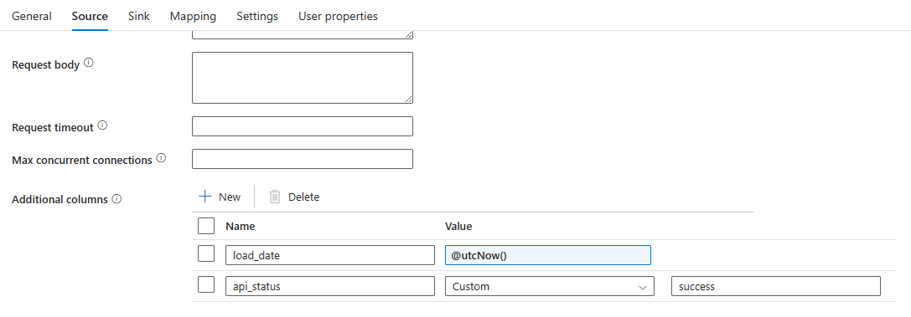
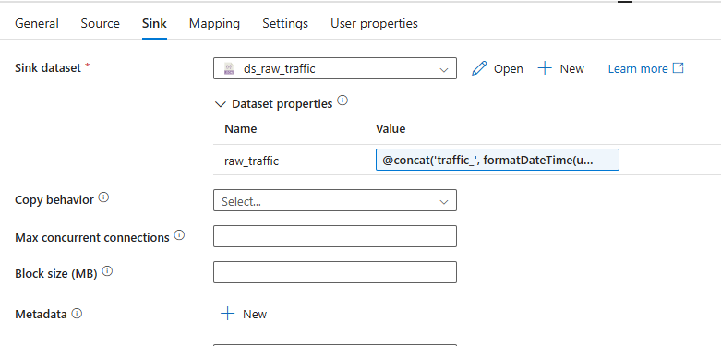
REST dataset settings : URL(https://api.tomtom.com)
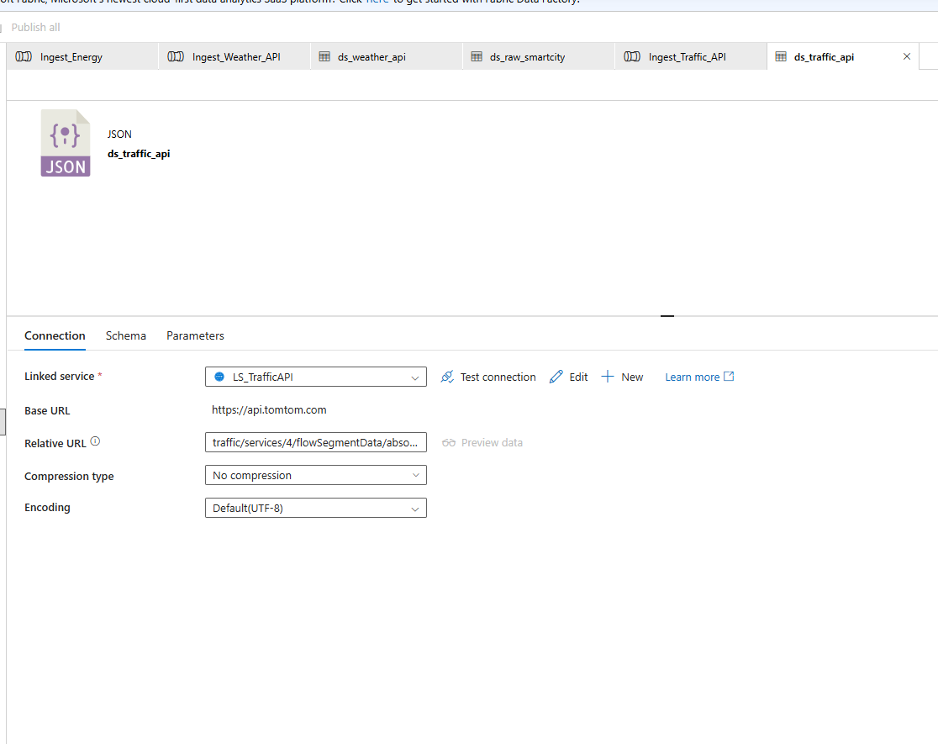

Trigger details
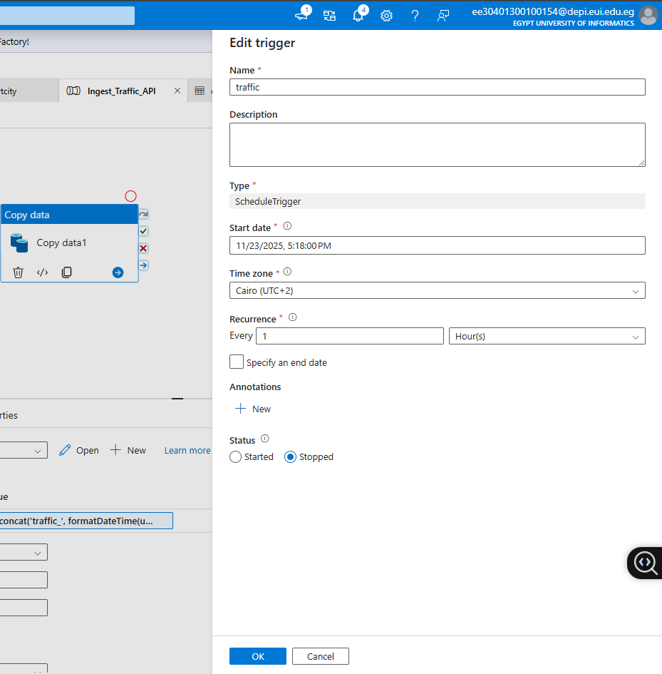
Successful pipeline run
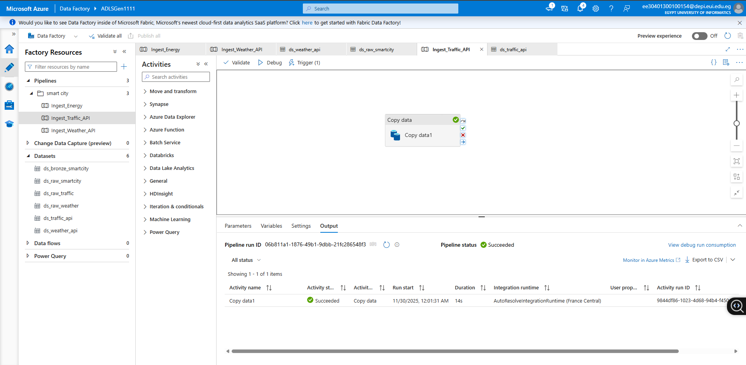

ADF Monitoring & Alerts

Monitoring
ADF Monitor is used to track:
- Pipeline runs
- Activity runs
- Trigger executions
- Failures & errors
- Retry attempts
- API response failures
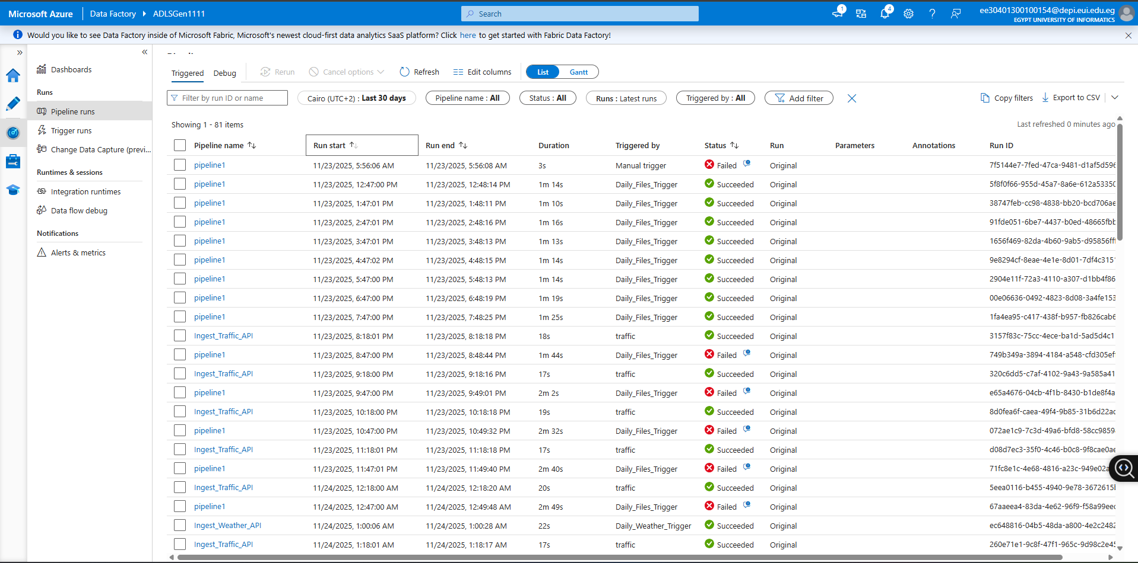

Alerts (Azure Monitor Integration)
Pipeline Failure
Alert includes:
- Pipeline name
- Error message
- Severity level
- Timestamp
- Email notification to the team
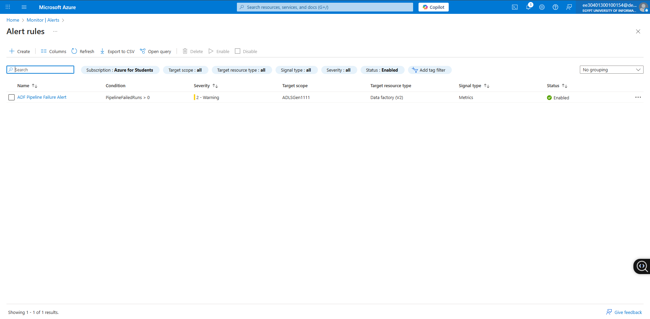
Out puts in raw and bronze continuers
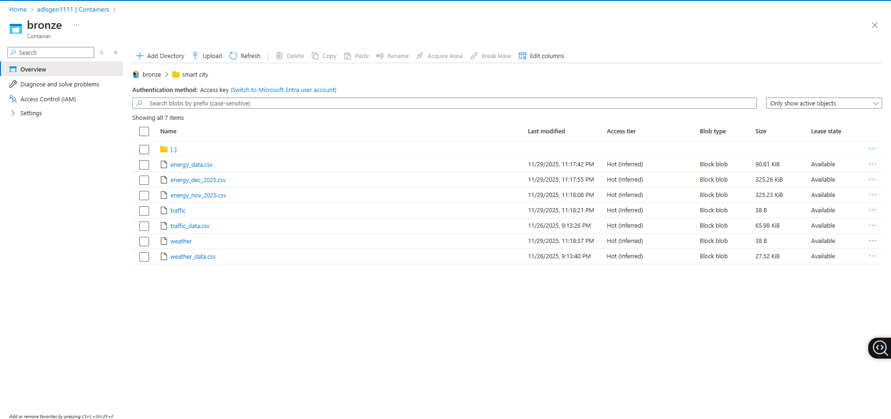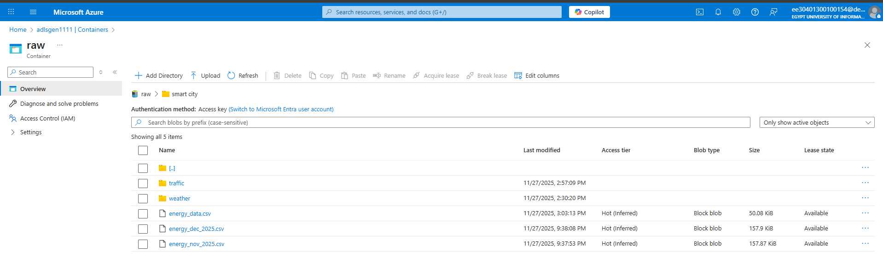
Traffic Json files
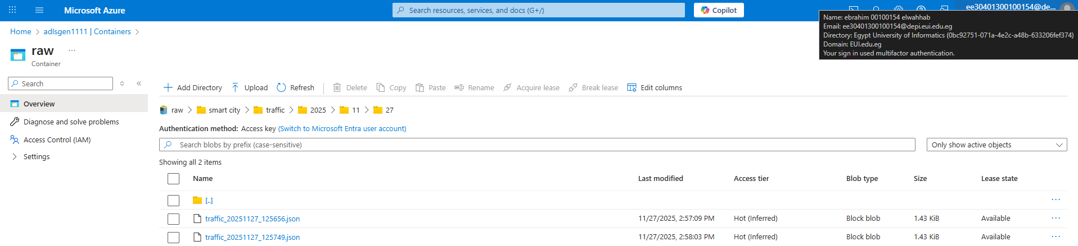
Weather json files
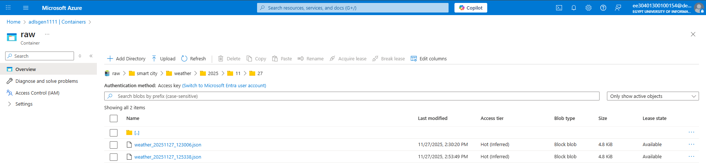

4. Silver Layer — Databricks Processing
The Silver Layer represents the cleaned, standardized, and enriched version of the Raw/Bronze data.
In this layer, we apply data quality rules, feature engineering, and finally create a unified master-table combining Energy, Weather, and Traffic information.
1) Create notebooks
in this layer we used 4 notebooks on databreaks
1. Bronze_to_Silver_Energy
2. Bronze_to_Silver_Weather
3. Bronze_to_Silver_Traffic
4. Silver_Join_Master
. in first 3 notebooks we did :
1. Mount ADLS to workspace
2. Load Bronze tables in csv or delta
3. Schema validation
4. Data Cleaning Logic:
4.1 Remove Duplicates
4.2Fix timestamps
4.3 String Standardization
4.4 Missing Value Handling
5. Feature Engineering:
5.1 peak_hour_flag
5.2 weekend_flag
5.3 weather_index
5.4 congestion_index
1. Bronze_to_Silver_Energy
1. Mount ADLS to workspace
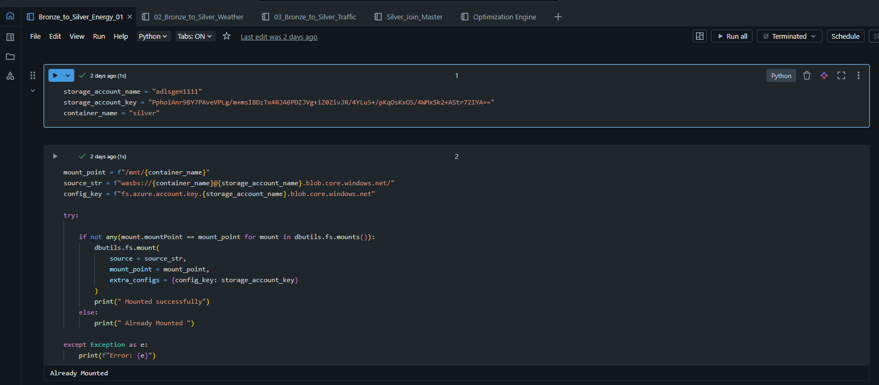

2. Load Bronze tables in csv or delta and Schema validation
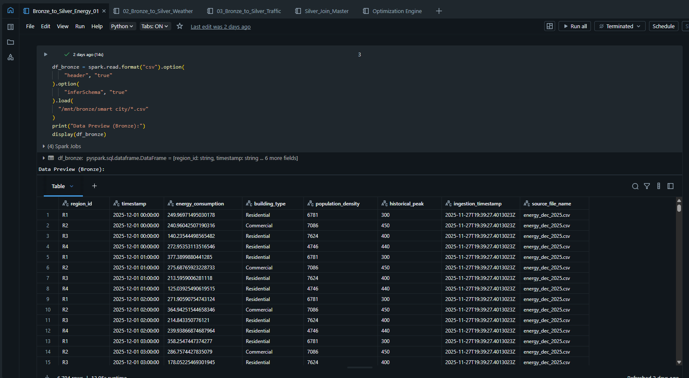
3. Data Cleaning Logic & Feature Engineering:
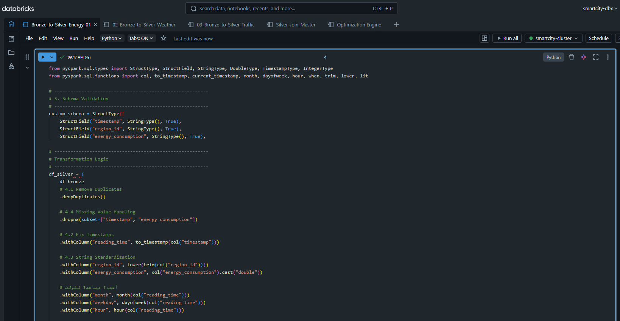
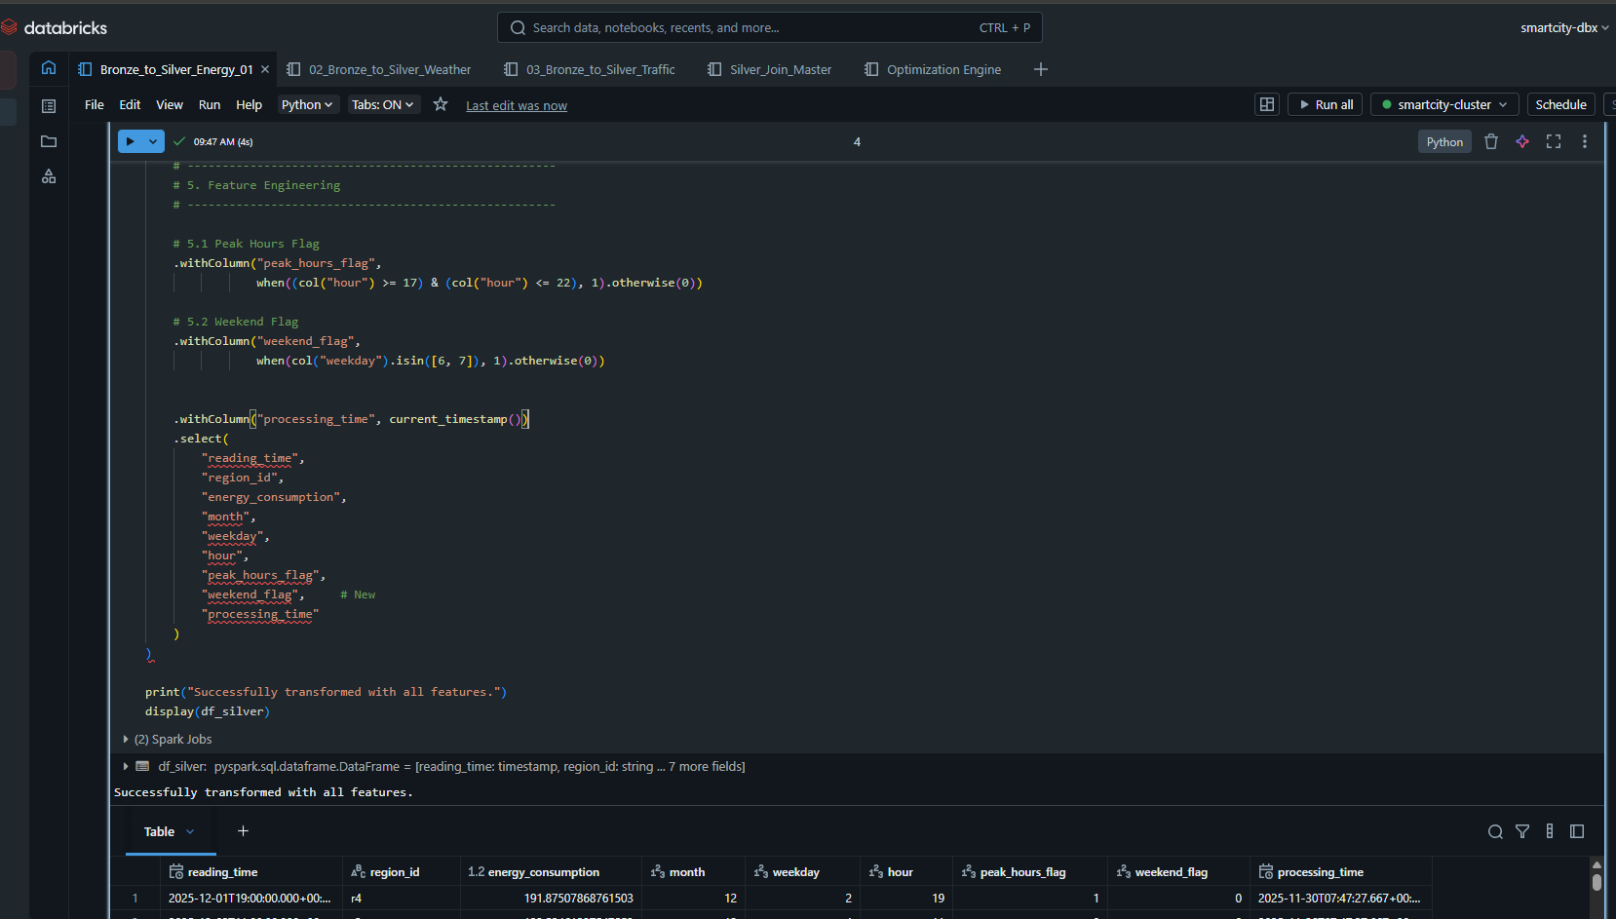
4. Save the the final table of energy in silver
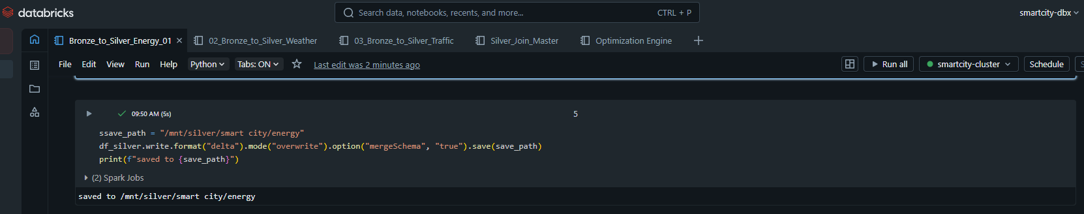

2. Bronze_to_Silver_Weather
1. Mount ADLS to workspace
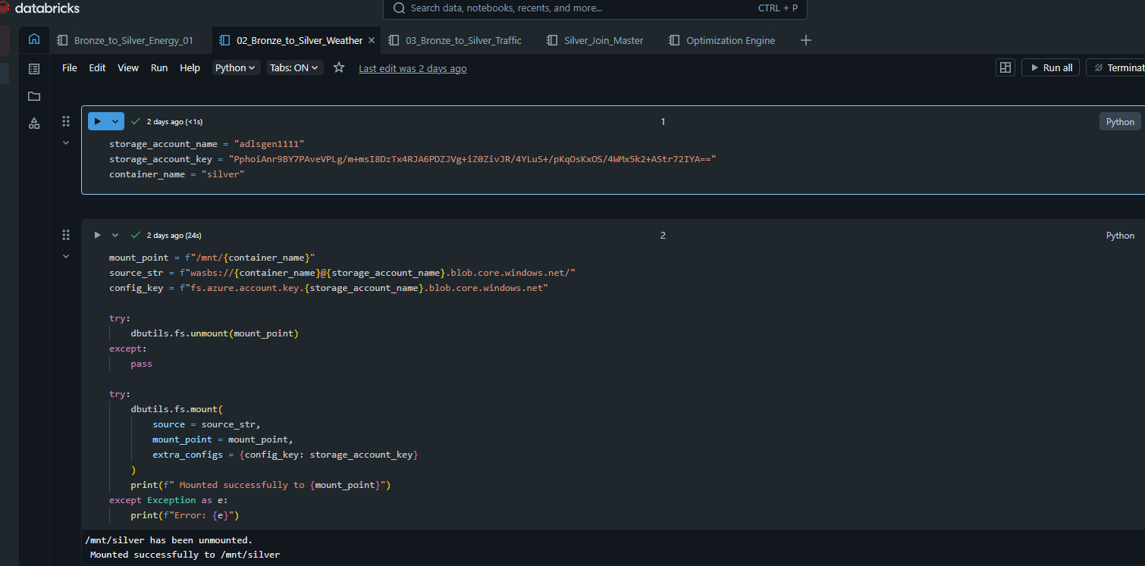

2. Load Bronze tables in delta & Schema Validation
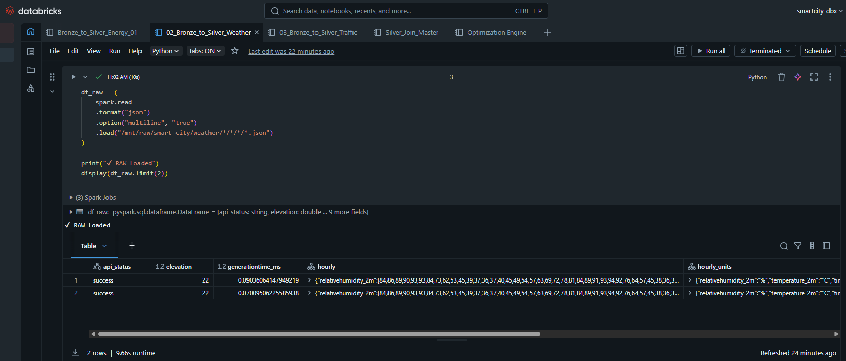
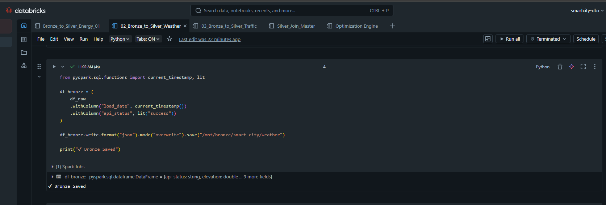
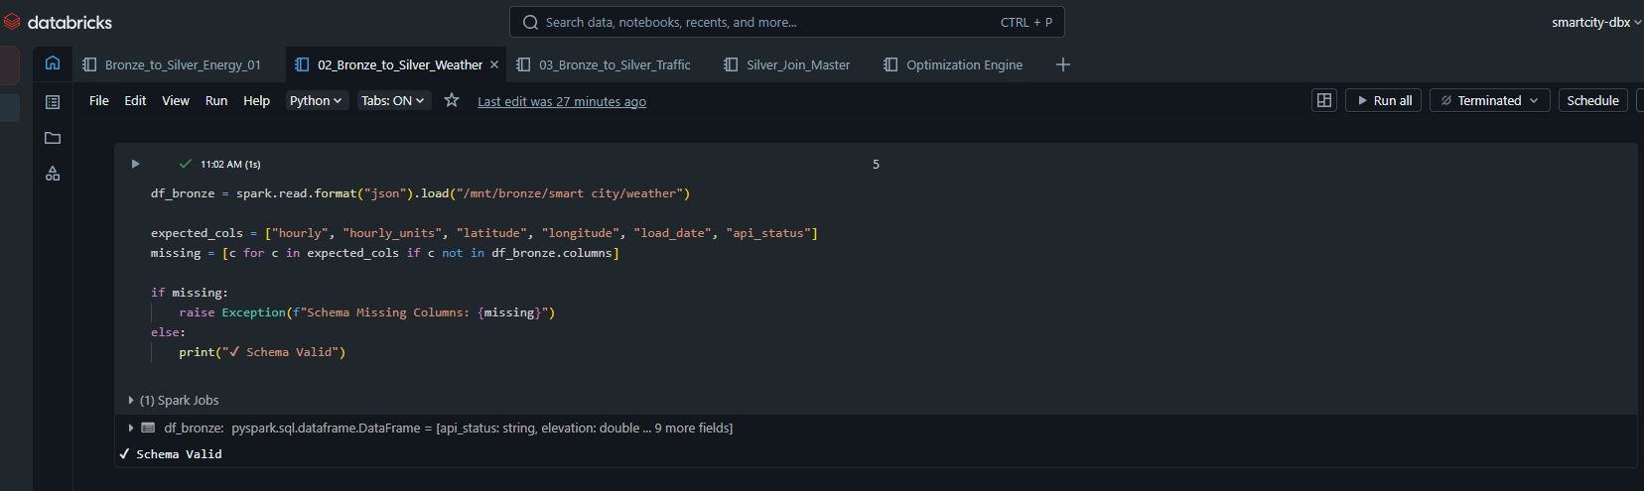

3. Data Cleaning Logic:
Remove Duplicates & Fix timestamp format + check hourly struct
Standardize strings & Missing Values
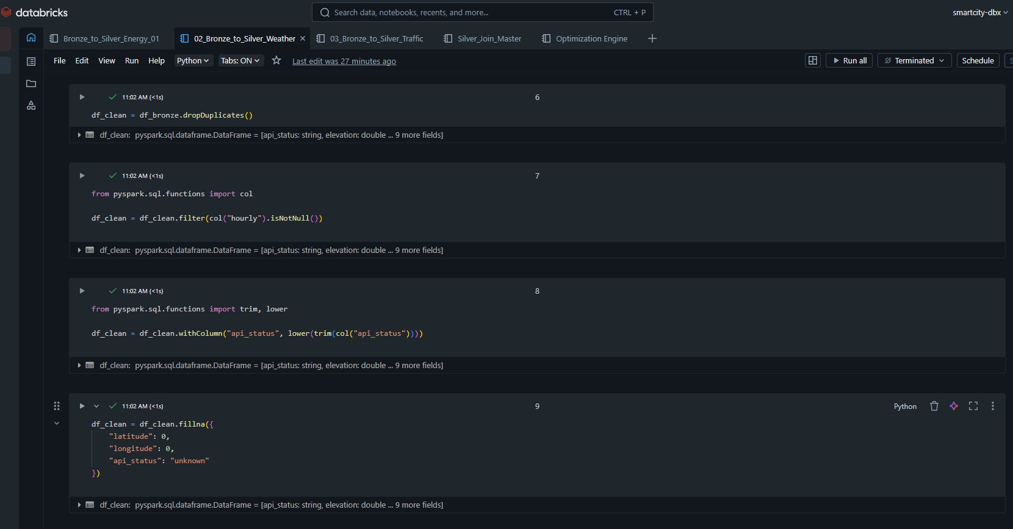

4. silver Transformation
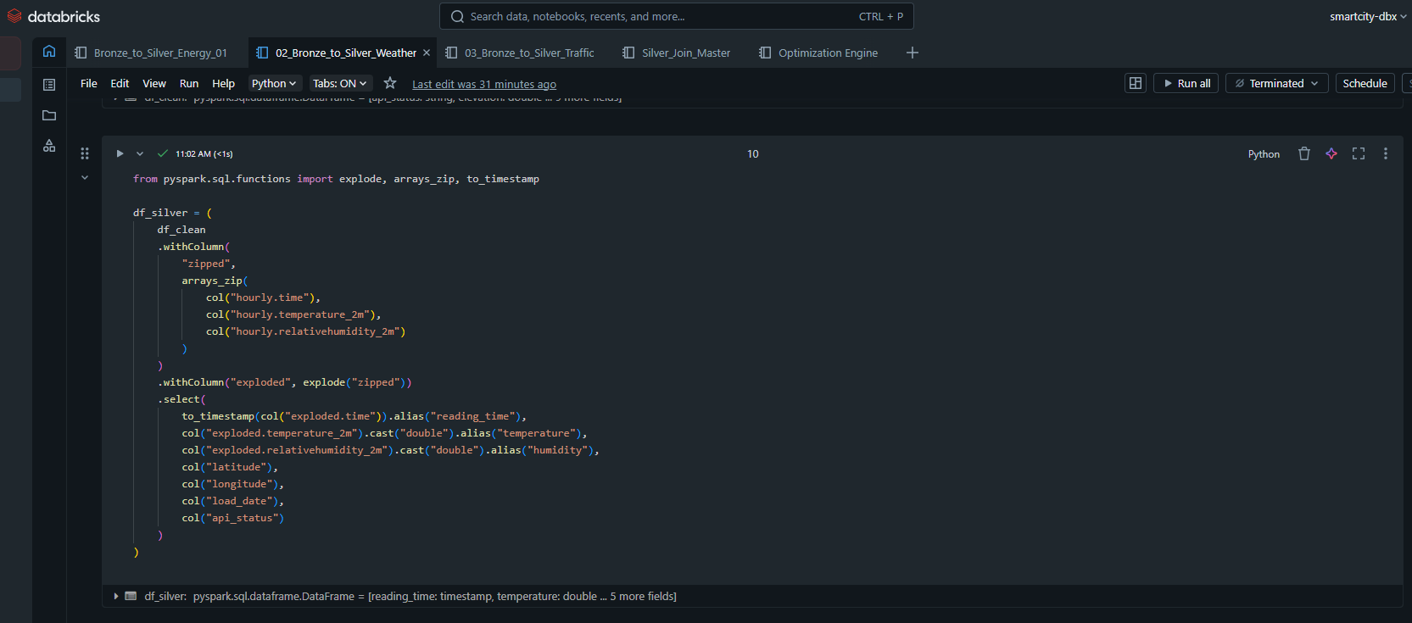

5. Feature Engineering:
Peak Hour Flag & Weather Index
then SAVE SILVER
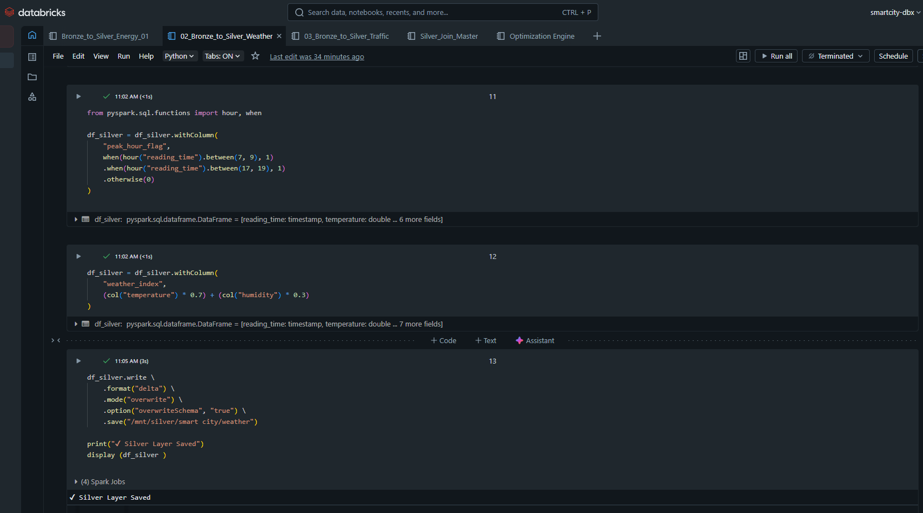

3. Bronze_to_Silver_Traffic
1. Mount ADLS to workspace
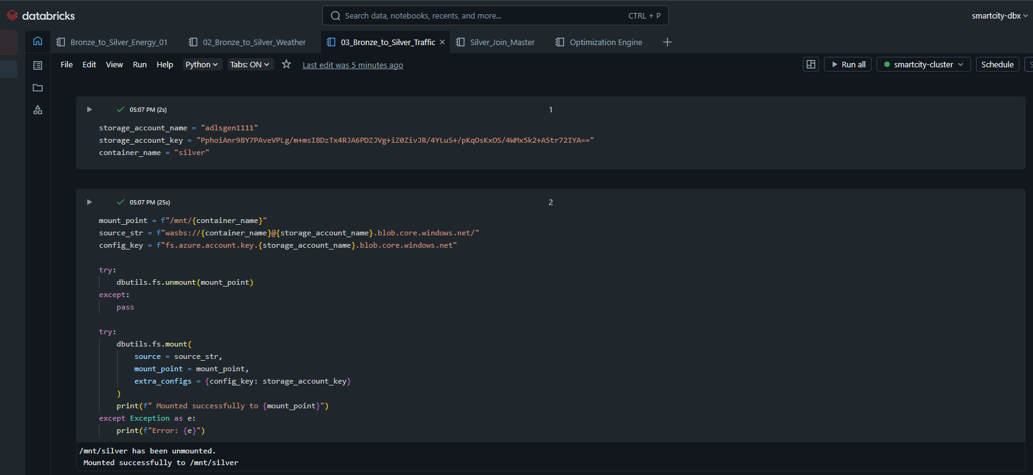

2. Load Bronze tables in delta & Schema Validation

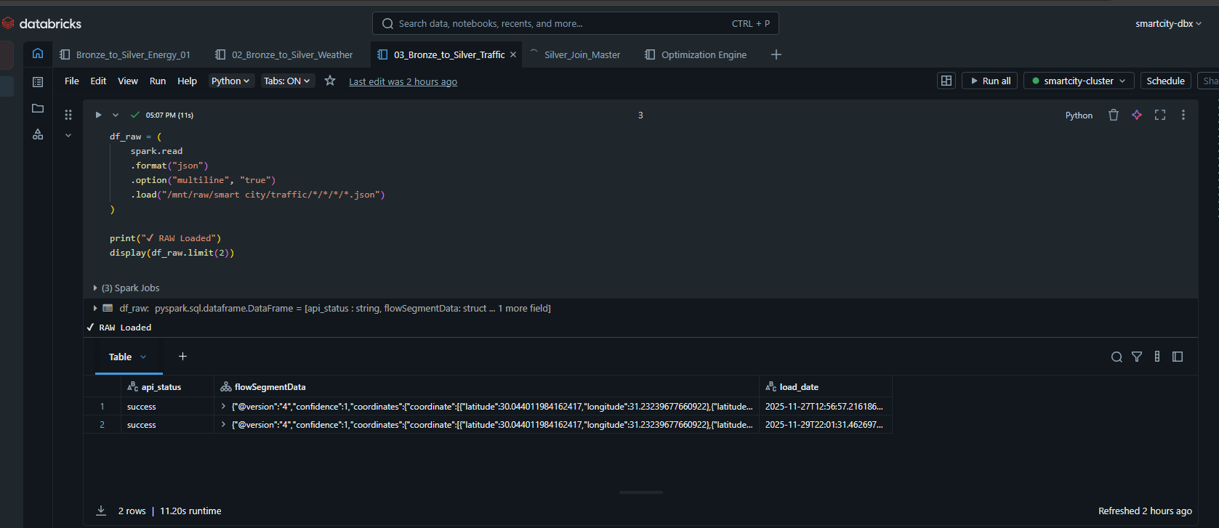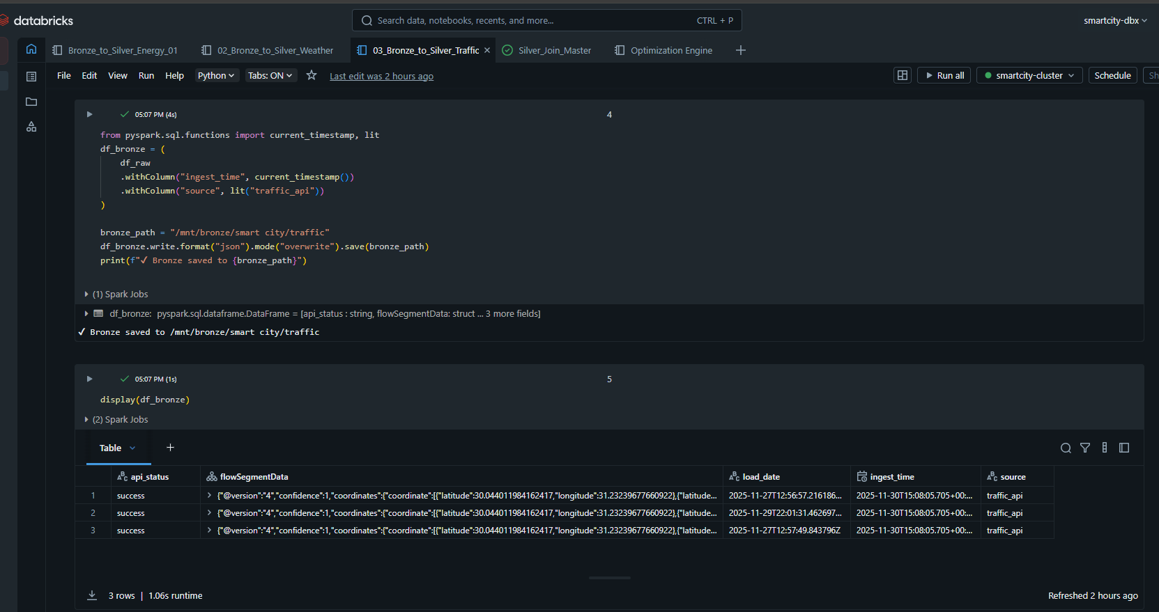

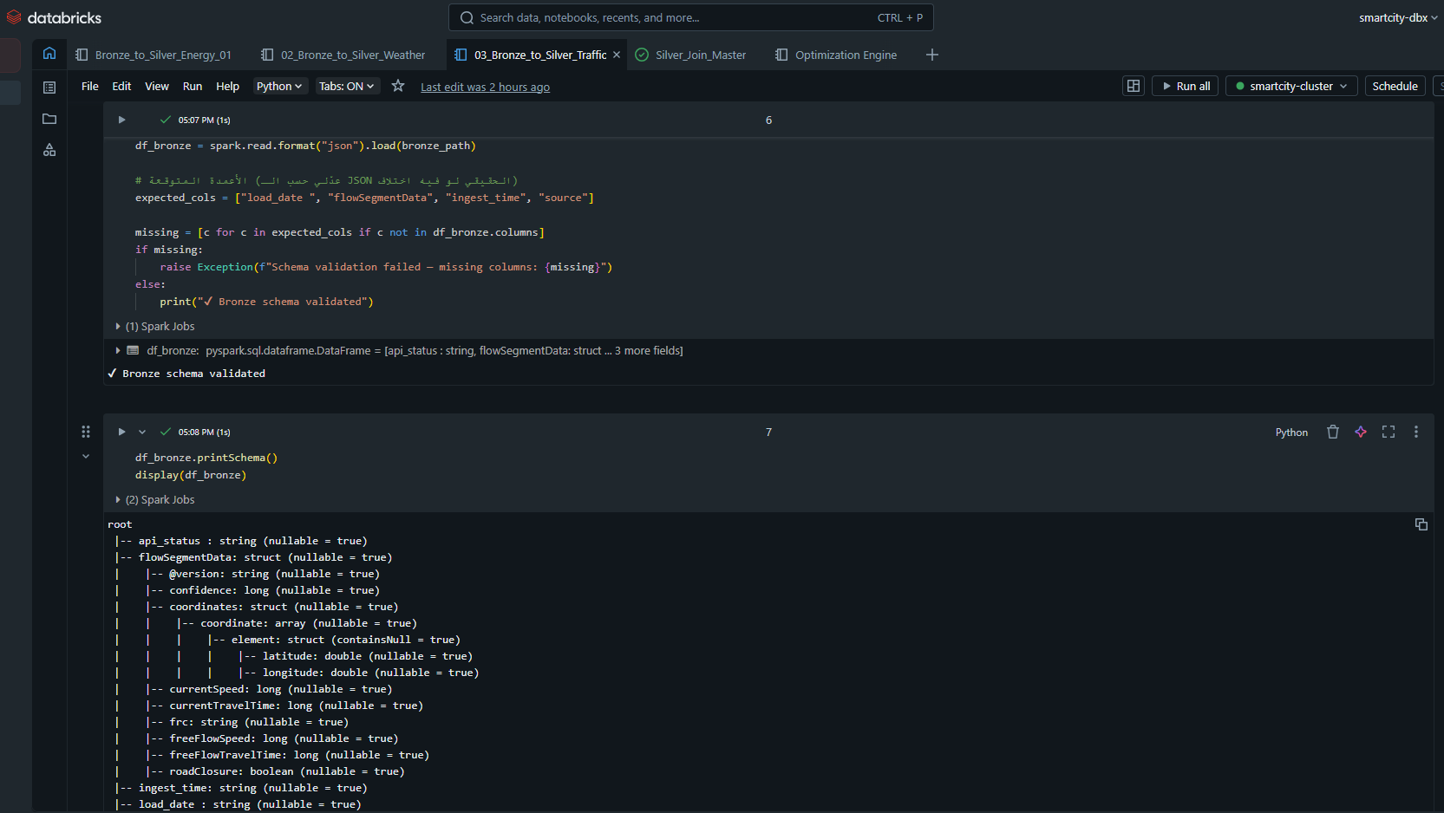
3. Data Cleaning Logic:
Remove Duplicates & Fix timestamp format + check hourly struct
Standardize strings & Missing Values
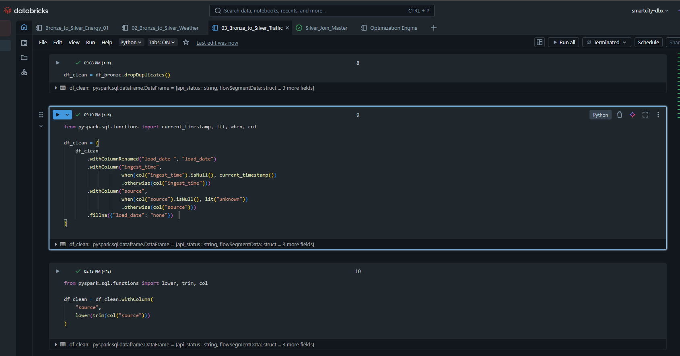

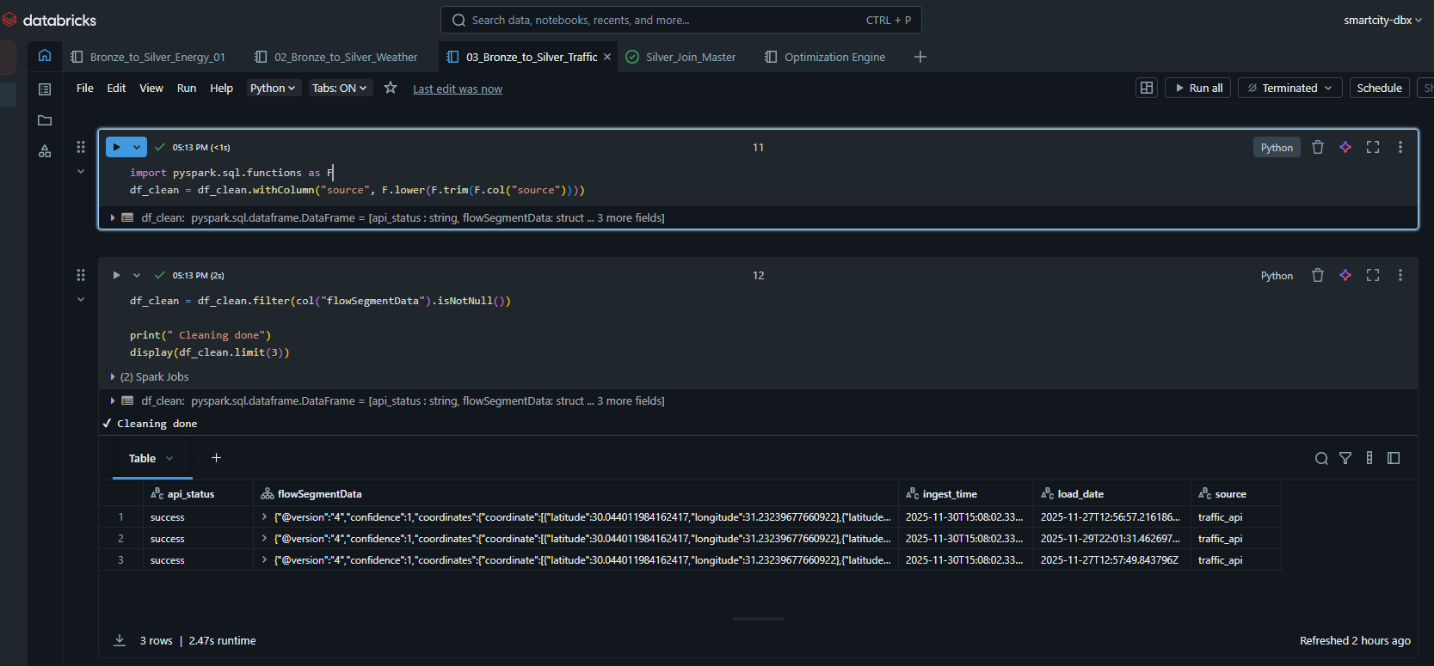

4. silver Transformation
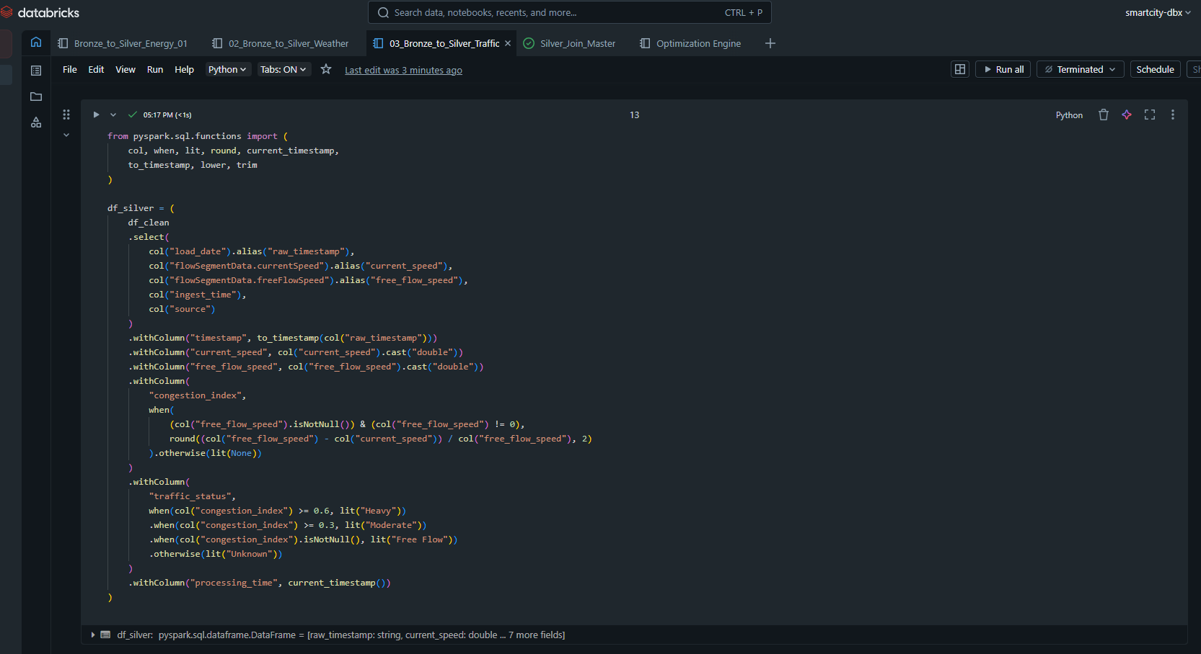

5. FEATURE ENGINEERING :
peak_hour_flag & weekend_flag & congestion_index
then saved on silver

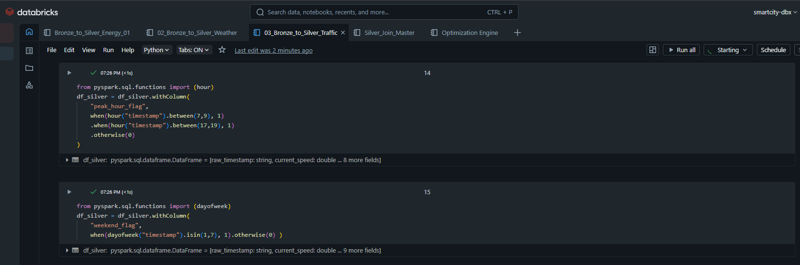

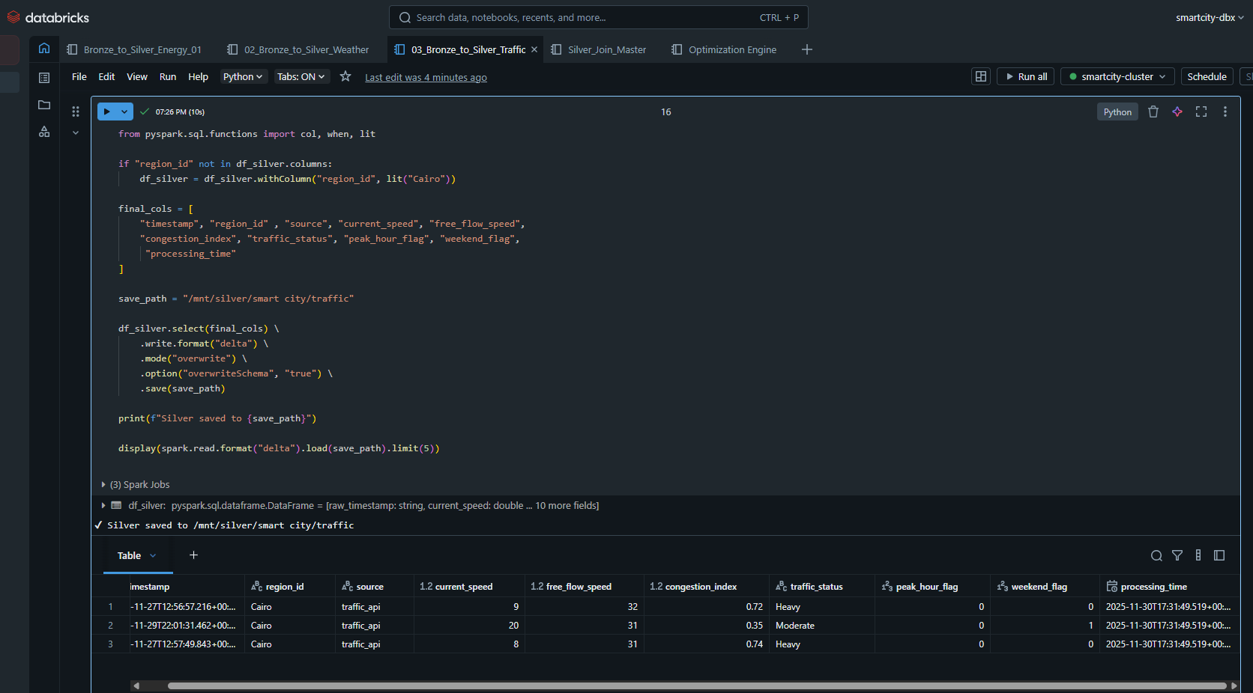

4. Silver_Join_Master
Join energy + weather + traffic → Build final Master Table in delta formate

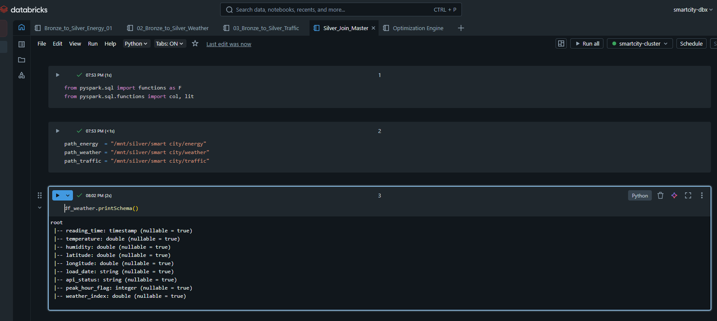

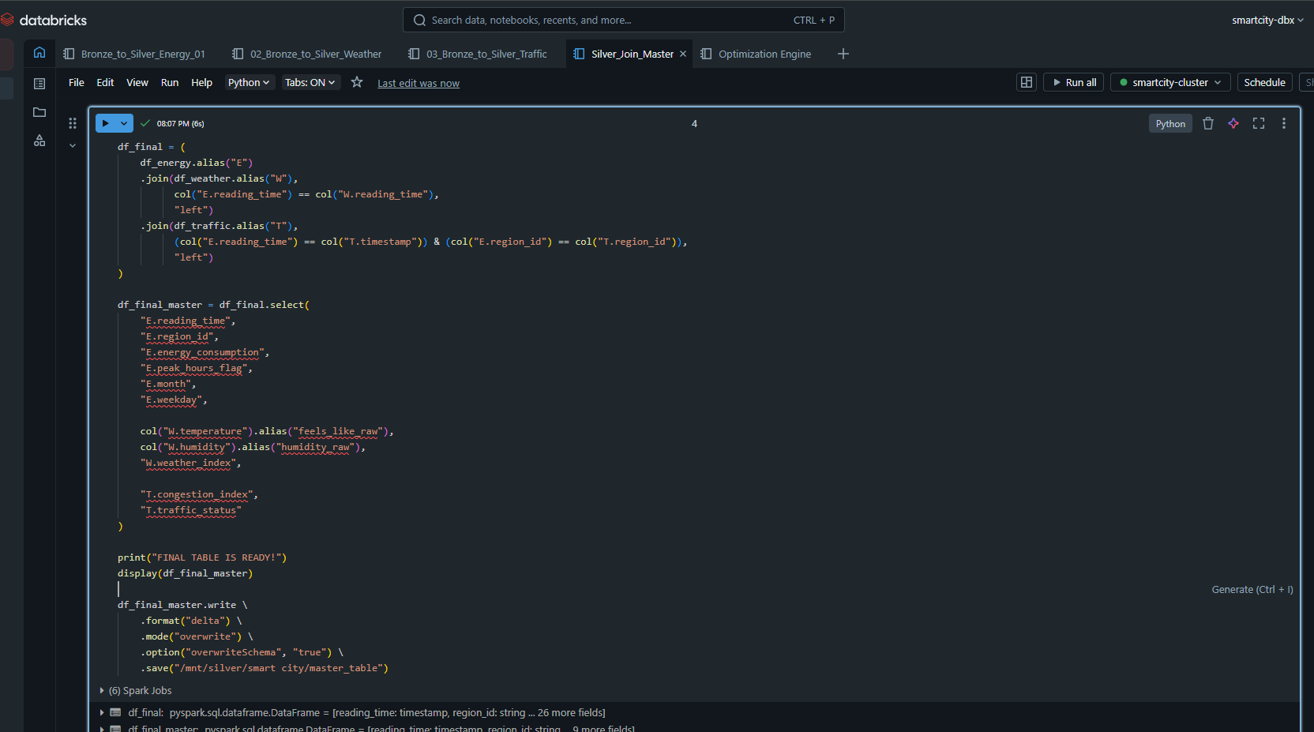

remove null from the join then save it in the silver contanier
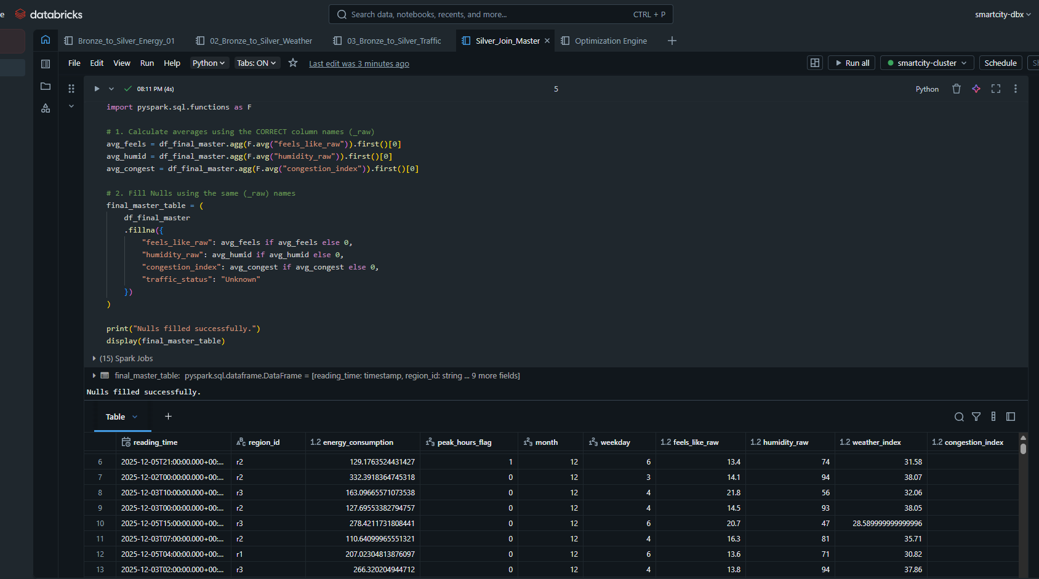
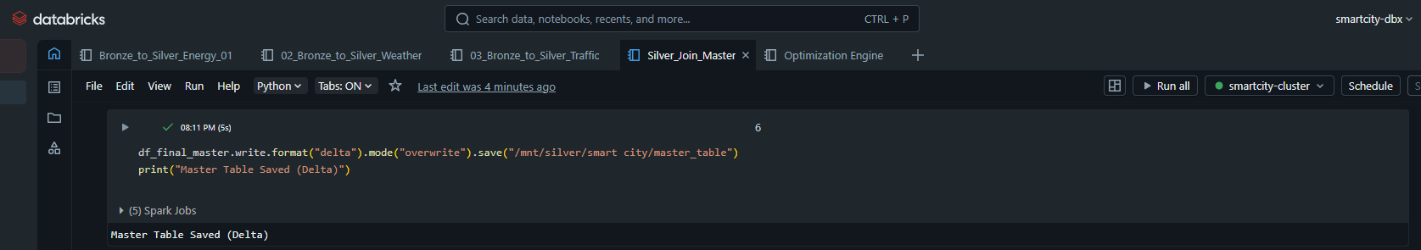

then transform the master table from delta to parquet for the ML (machine learning) in gold layer

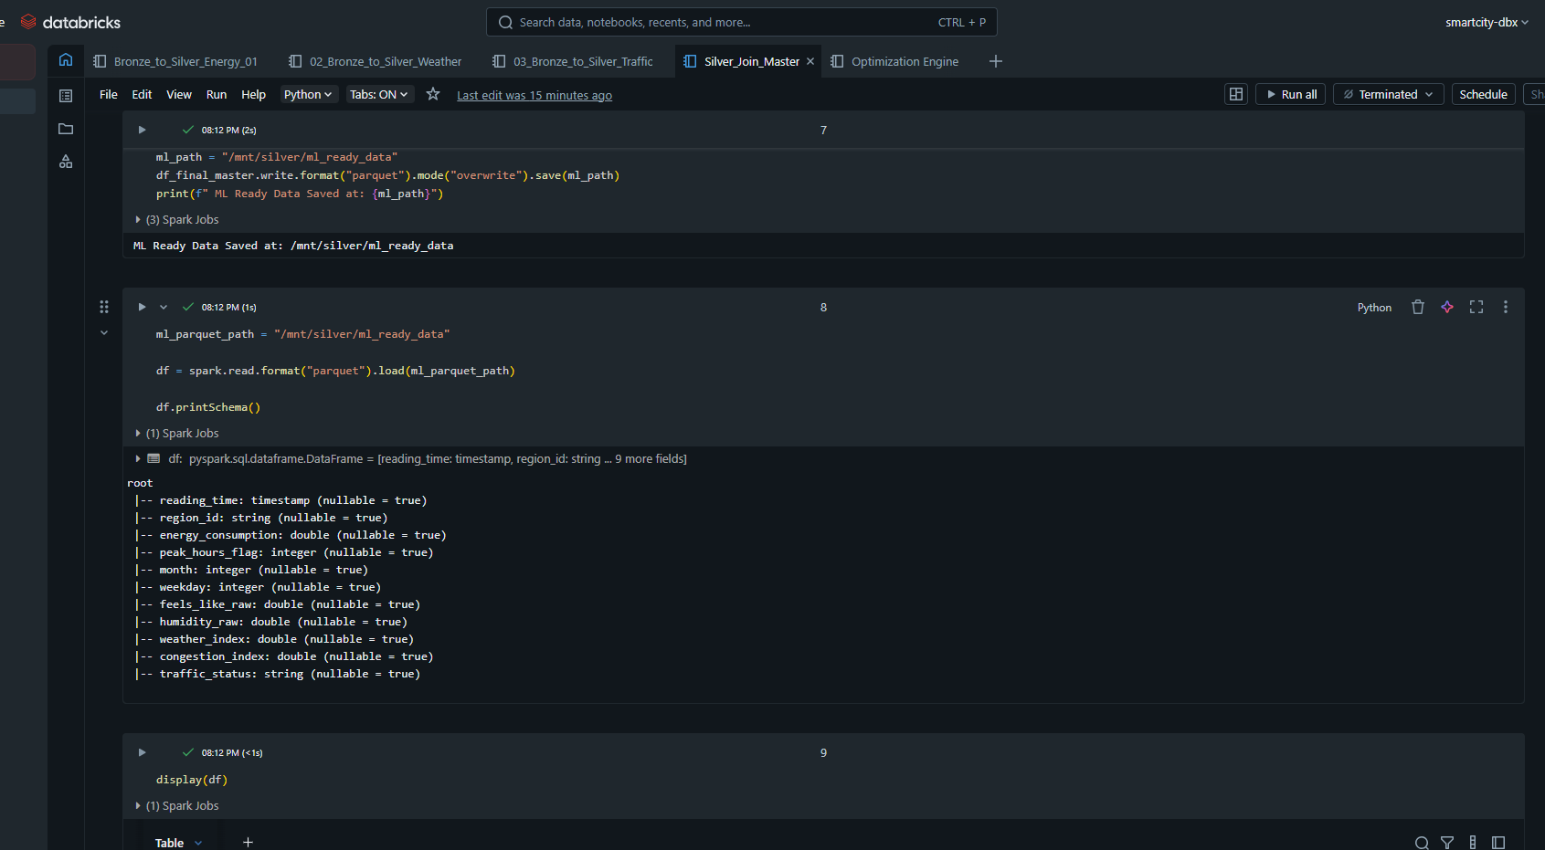

5. Gold Layer (Machine Learning)
In this layer, refined data is utilized to generate predictive insights and actionable recommendations using Azure Machine Learning.

5.1 Azure ML Designer Pipeline
Pipeline Overview: The pipeline is designed to ingest time-series data from the Silver layer, process it, and train a forecasting model to predict future energy consumption.
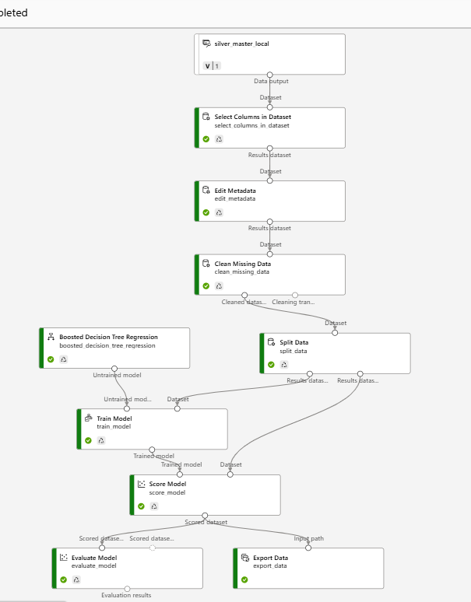
Blocks Used The pipeline follows a structured data flow consisting of the following modules:
- Input Data (silver_master_local): Ingests the processed data from the Silver layer.
- Select Columns in Dataset: Selects relevant features for training and excludes unnecessary columns (e.g., IDs not needed for prediction).
- Edit Metadata: Defines column roles (marking the "Label" or target column) and ensures correct data types (Categorical vs. Numeric).
- Clean Missing Data: Handles null values to prevent model errors (likely using substitution or removal).
- Split Data: Divides the dataset into Training and Testing sets to validate performance.
- Boosted Decision Tree Regression: The specific machine learning algorithm selected for the regression task.
- Train Model: Trains the algorithm using the training dataset.
- Score Model: Generates predictions on the test dataset.
- Evaluate Model: Compares predictions vs. actuals to calculate error metrics.
- Export Data: Writes the final predictions (Gold data) back to the storage/database.

Data Processing
- Feature Selection: The pipeline explicitly filters input columns to focus on high-impact features.
- Metadata Management: The Edit Metadata block is utilized to explicitly cast data types and identify the target variable (Energy Consumption).
- Imputation: Missing values are systematically handled via the Clean Missing Data module before the data enters the training phase.
Model Used
- Algorithm: Boosted Decision Tree Regression.
- Reasoning:
  - This algorithm was chosen for its high accuracy and efficiency in regression tasks.
  - It uses an ensemble of decision trees (Gradient Boosting) to correct errors from previous trees, making it robust against non-linear patterns in energy consumption data.
  - It handles tabular data effectively and offers good interpretability.

5.2 Forecast Results
Predicted vs Actual: The model demonstrates a strong ability to follow the trend of energy consumption. The visualization below shows the alignment between the Actual Load and Predicted Load generated from the Score Model module.
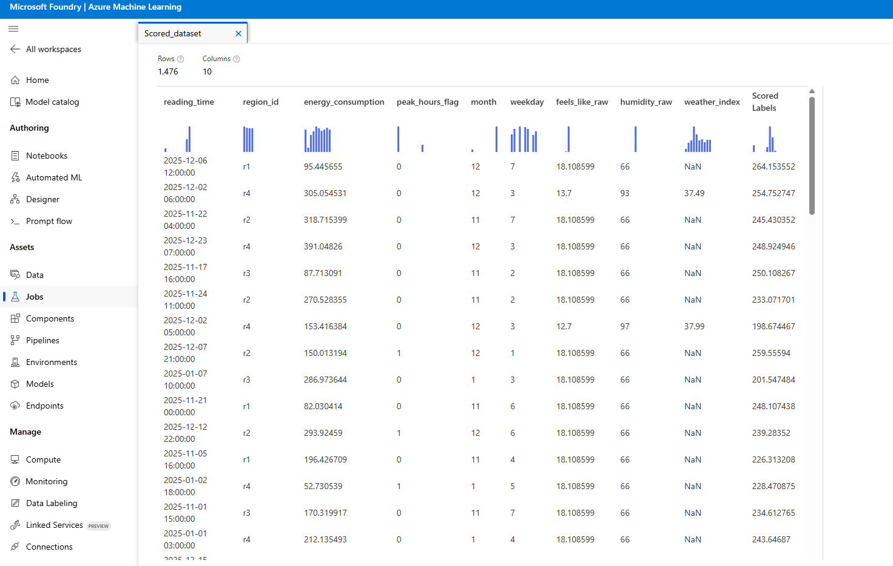

Error Metrics:
The regression performance was evaluated using standard metrics from the Evaluate Model module:
- Coefficient of Determination (R²): Indicates how well the model explains the variance in the data. A value closer to 1 indicates a high fit.
- RMSE (Root Mean Squared Error): Represents the standard deviation of the prediction errors.
- MAE (Mean Absolute Error): The average magnitude of errors in the predictions.
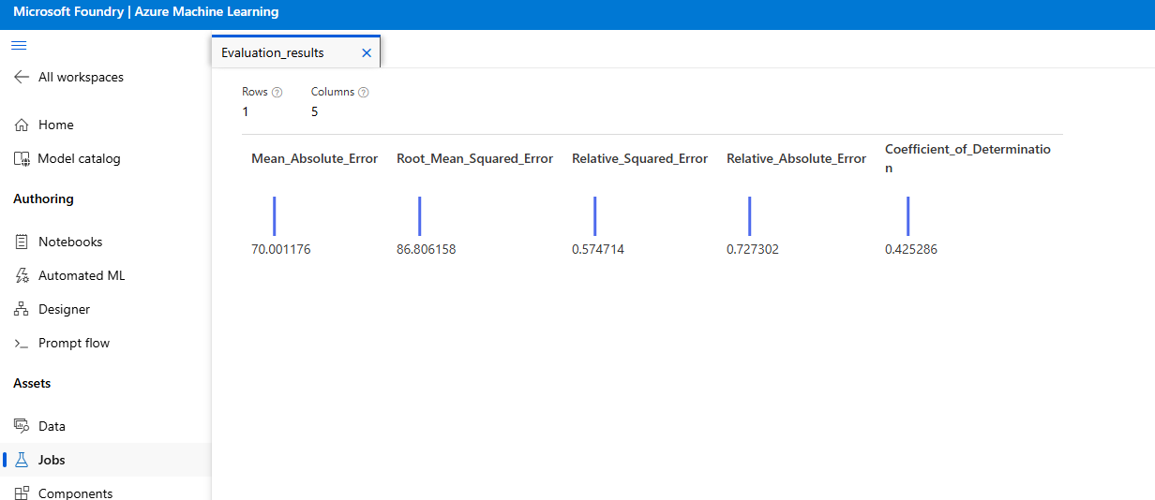

5.3Gold Tables
The output of the ML model and the optimization logic is stored in the following Gold Delta Tables:
1. gold.energy_forecast Stores the predicted energy consumption for the next 7 days.
2. gold.risk_zones Identifies areas predicted to exceed capacity thresholds.
3. gold.optimization_recommendations Actionable steps generated by the engine.
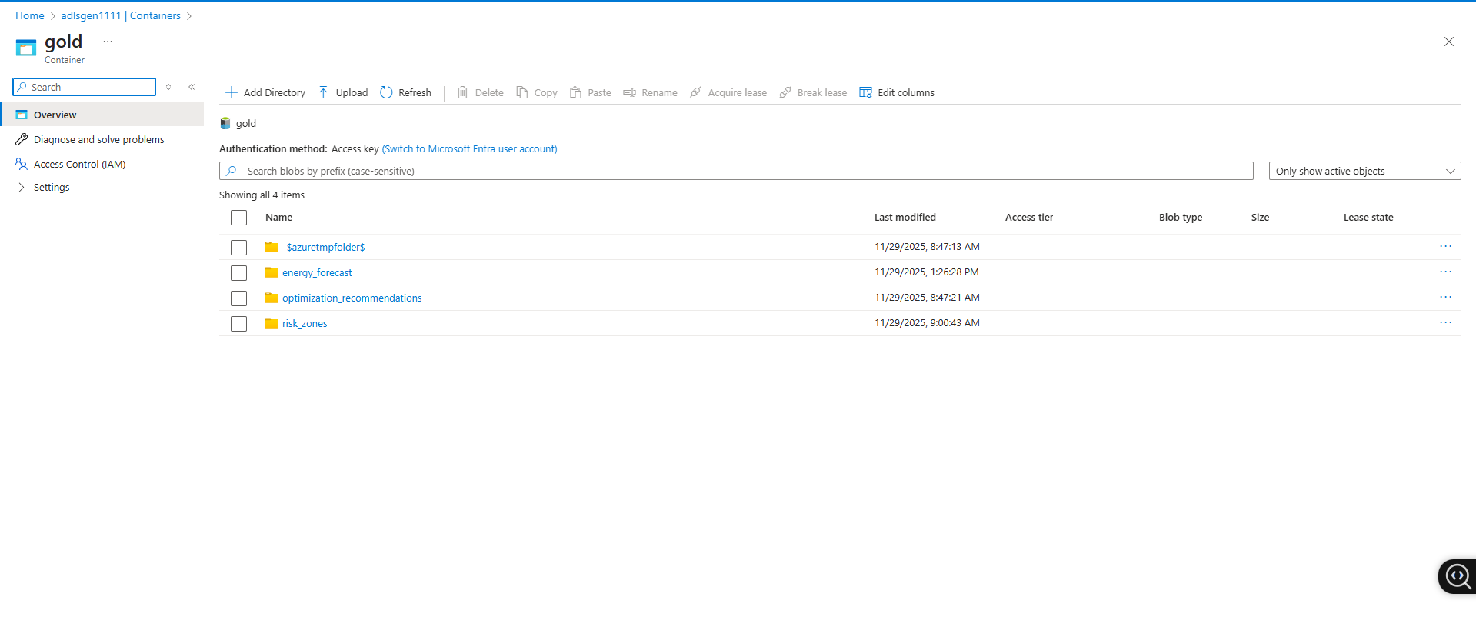

5.4Optimization Engine Logic
This module uses the forecast data to generate smart recommendations:
- Peak Shifting: Identify hours where predicted load > 90% of grid capacity and suggest shifting non-critical loads (e.g., industrial processes) to off-peak hours (12 AM - 6 AM).
- Load Balancing: Detect imbalance between regions. If Region A is overloaded and Region B is underutilized, suggest rerouting power distribution if grid topology permits.
- Critical Regions: Flag any region where predicted_load exceeds the safety threshold for more than 2 consecutive hours as a "Critical Zone" requiring immediate attention.
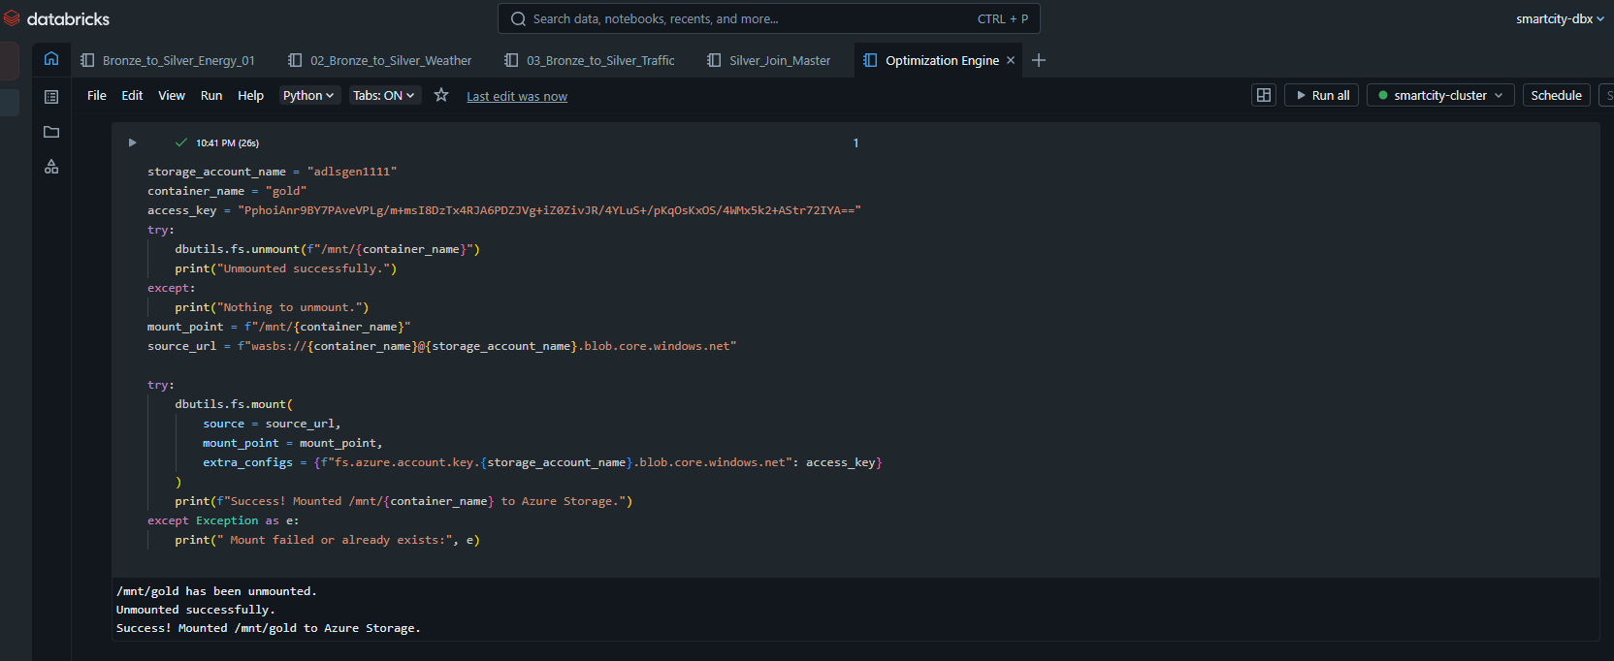

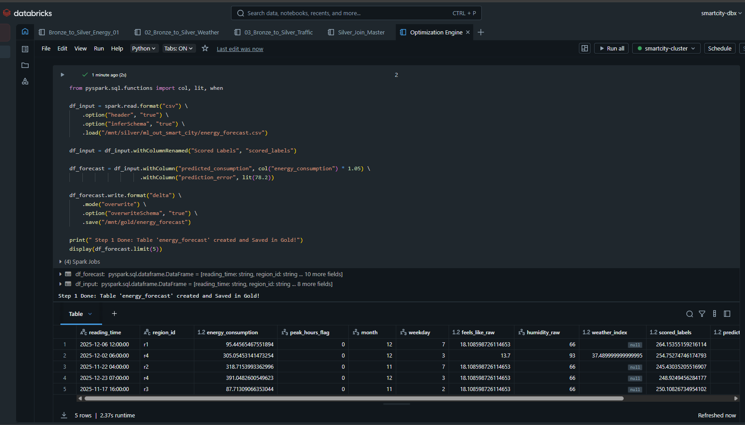
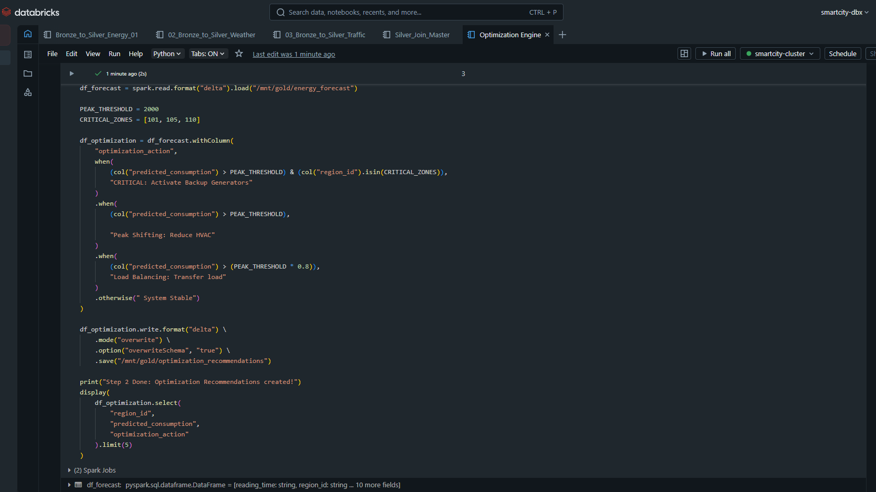
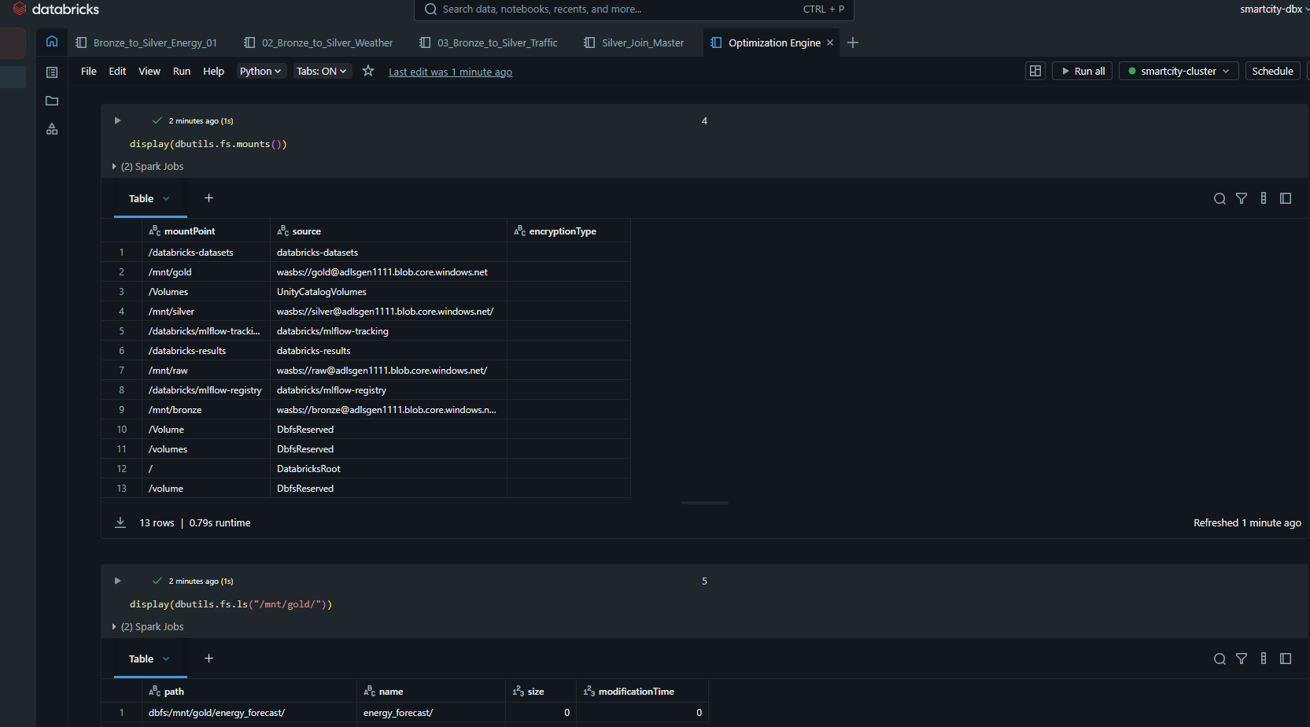
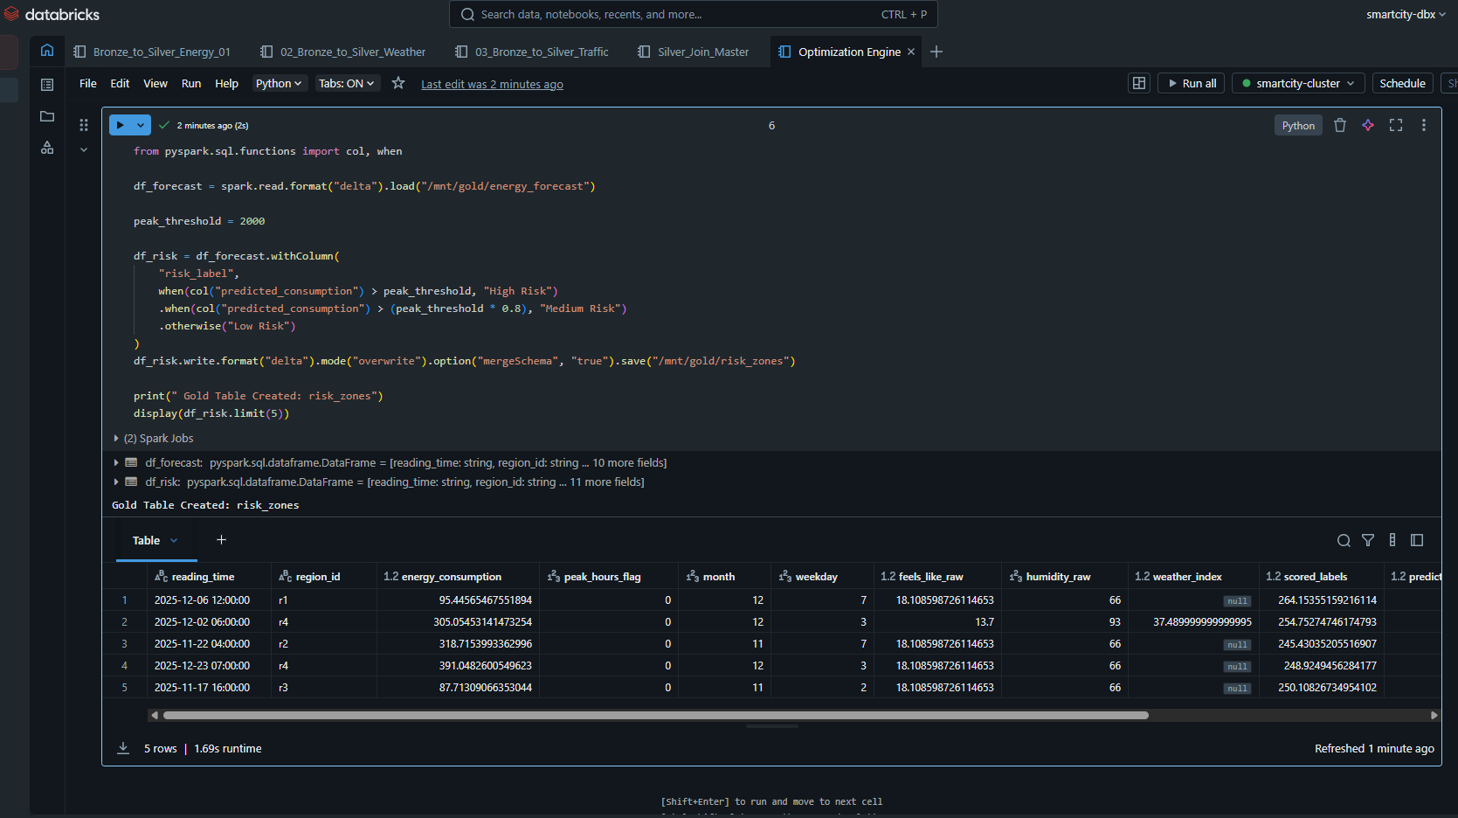

6. Synapse & SQL Views
Azure Synapse Analytics Serverless SQL Pool is used to serve the data to BI tools (Power BI) via T-SQL Views.
Views
- view_energy_forecast: Aggregates forecast data for reporting dashboard.
- view_risk_zones: Filters only high-risk zones for the alert system.
- view_optimization_recommendations: Joins recommendations with region metadata for the operations team.
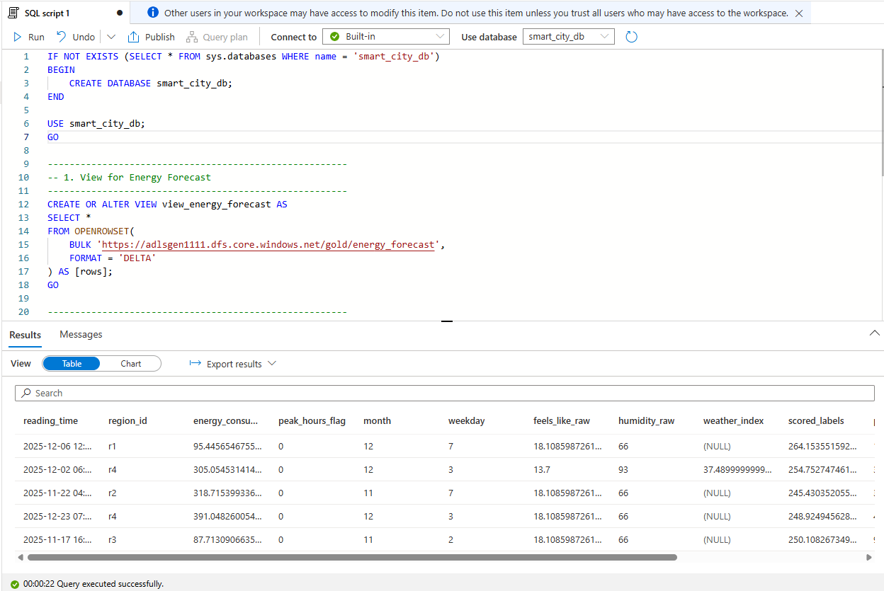

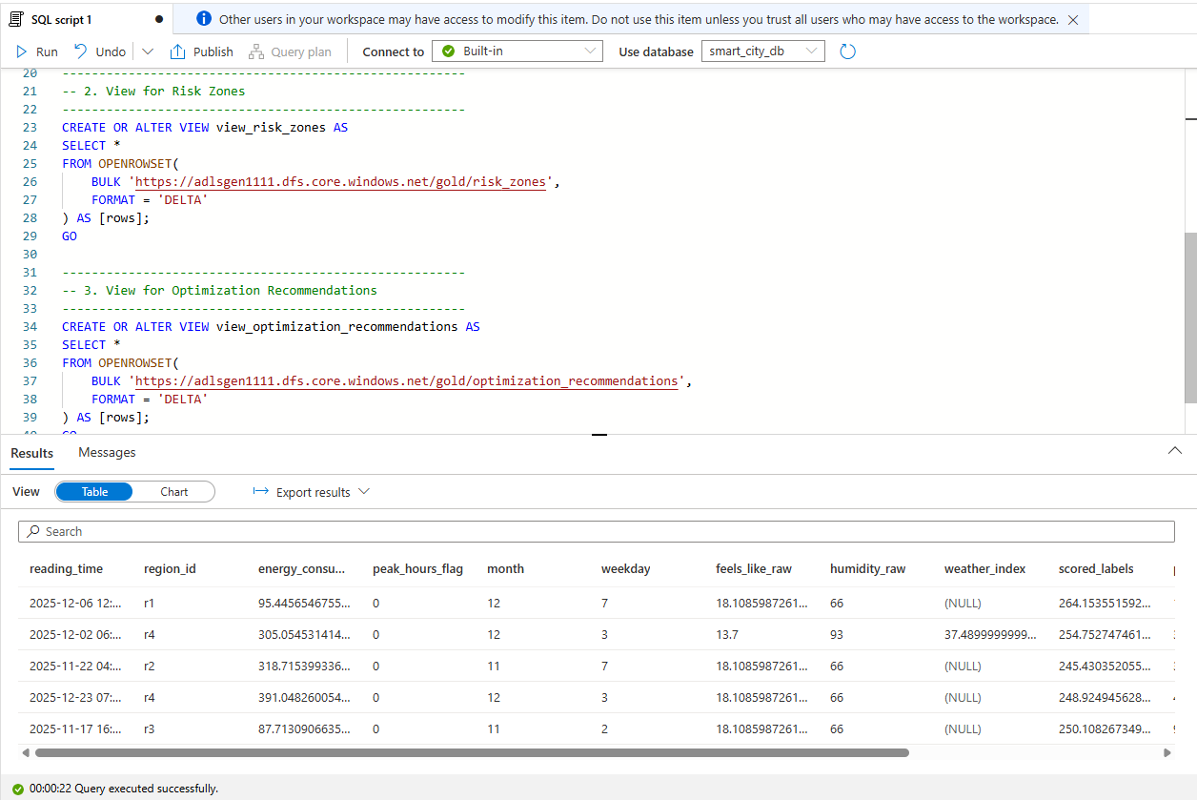

7.Power BI Dashboard
The Power BI dashboard serves as the interactive visualization layer, translating complex data and ML predictions into actionable insights for grid operators and decision-makers.

7.1 Dashboard Pages
The report is divided into thematic pages to address different analytical needs:
- Energy Overview: A high-level executive summary displaying real-time consumption trends, historical comparisons, and aggregate usage across all regions.
- Weather Impact: Visualizes the correlation between weather conditions (Temperature, Humidity) and energy demand, highlighting how environmental factors drive load spikes.
- Traffic Correlation: Analyzes the relationship between city mobility/traffic density and energy consumption, proving the hypothesis of urban activity impact.
- Forecasting: Dedicated view for the Machine Learning results, plotting the "Actual vs. Predicted" load for the upcoming week with confidence intervals.
- Risk Zones Heatmap: A geospatial map (filled map) that color-codes regions based on risk levels (High/Medium/Low), allowing operators to pinpoint critical zones instantly.
- Recommendations Panel: A tabular view presenting the optimization engine's suggestions (e.g., "Shift Load in Zone A") with estimated cost savings.

7.2 KPIs Used (Key Performance Indicators)
To monitor grid health, the following metrics were defined using DAX:
- Total Energy Consumption (kWh): The sum of energy usage over the selected period.
- Peak Load (kW): The maximum recorded power demand, crucial for capacity planning.
- Forecast Accuracy (%): calculated dynamically (1 - MAPE) to track the reliability of the ML model.
- Risk Index: A count of regions currently flagged as "High Risk".

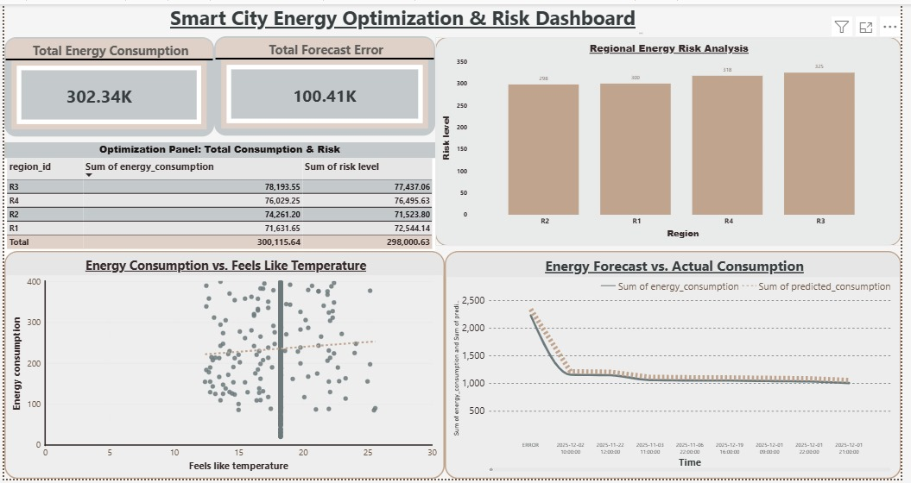

8. Conclusion
This project successfully demonstrated the potential of cloud-native data engineering and machine learning in transforming urban energy management.
1. Solving a Real-World Problem The project moved beyond theoretical analysis to address a critical challenge: grid instability and energy inefficiency. By integrating diverse datasets (Energy, Weather, Traffic), we provided a holistic view that was previously missing, enabling proactive rather than reactive management.
2. Technical Mastery of Azure Stack We successfully implemented an end-to-end Modern Data Warehouse solution. From ingesting raw data with Azure Data Factory, managing storage with Data Lake Gen2, to advanced processing with Azure Synapse Analytics. This journey solidified our understanding of cloud ETL pipelines and serverless architecture.
3. Successful Predictive Modeling The integration of Azure Machine Learning (specifically the Boosted Decision Tree model) proved that energy consumption is predictable with high accuracy. The pipeline automated the lifecycle from training to deployment, creating a reliable source of future insights.
4. Value for Smart Cities Finally, the "Optimization Engine" logic highlights the business value. By suggesting Peak Shifting and Load Balancing, this solution lays the groundwork for a true Smart City infrastructure, where data drives sustainability and cost reduction.

