Data Analytics Internship
Task : 1
Exploratory Data Analysis (EDA)
(Iris dataset)

Submitted By:
- Name : Thodeti Nagaveni
- College : Sri Padmavathi Mahila viswavidhyalayam , SOET
- Branch: Computer Science and Engineering
- Roll Number: 2371062

Organization:
@codealpha
Submission Date:10/07/2026

- Introduction :
What is Data Analytics?
- Collects, cleans, analyzes, and interprets data.
- Extracts meaningful insights for decision-making.
- Helps solve real-world business and research problems.
What is Exploratory Data Analysis (EDA)?
- Examines and understands the dataset before analysis.
- Uses statistics and visualizations to explore data.
- Identifies patterns, trends, and anomalies.
Why is EDA Important?
- Detects missing values, outliers, and errors.
- Understands data distribution and relationships.
- Improves the accuracy of data analysis and mode
Why was the Iris Dataset Selected?
- It is a clean and well-structured dataset.
- Contains no missing values and multiple numerical features.
- Ideal for learning and performing Exploratory Data Analysis (EDA).
- Objectives:
- To understand the structure of the Iris dataset by examining its rows, columns, data types, and overall organization.
- To identify patterns and relationships among the flower measurements using statistical analysis and visualizations.
- To detect data quality issues such as missing values, duplicate records, or outliers to ensure the dataset is clean and reliable.
- To visualize and summarize the data using graphs like histograms, box plots, scatter plots, heatmaps, and bar graphs to draw meaningful insights before further analysis.

- Tools and Technologies:
Tool Used
- Visual Studio Code (VS Code)
Programming Language
- Python
Libraries Used
1. Pandas
- Used for loading, organizing, and analyzing the dataset.
- Helps in reading CSV files and performing data manipulation.
2. Matplotlib
- Used to create basic graphs and charts.
- Helps visualize data using histograms, bar charts, line plots, etc.
3. Seaborn
- Used to create attractive statistical visualizations.
- Helps generate box plots, scatter plots, and heatmaps with less code.

Dataset Information
Dataset Name : Iris Dataset
Dataset Details :
- File Name: iris.csv
- File Type: CSV
- Rows: 150
- Columns: 5
Dataset Columns :
Column | Description
Sepal Length | Length of sepal
Sepal Width | Width of sepal
Petal Length | Length of petal
Petal Width | Width of petal
Species | Flower type

Process Followed
Step 1: Download the Dataset
Downloaded the Iris dataset in CSV format and saved it as iris.csv in the project folder.
Step 2: Open the Project in VS Code
Created a folder named EDA_Task, opened it in Visual Studio Code, and created a Python file named eda_task.py.

Step 3: Import Required Libraries
Code
import pandas as pd
import matplotlib.pyplot as plt
import seaborn as sns
Explanation
Imported the required libraries:
- Pandas for data analysis.
- Matplotlib for graphs.
- Seaborn for statistical visualizations.
Output: No output is displayed because libraries are only imported.
Step 4: Load the Dataset
Code
df = pd.read_csv("iris.csv")
Explanation
Loaded the Iris dataset into a Pandas DataFrame.
Output: No output is displayed because the dataset is only loaded into memory.
Step 5: Display the Dataset
Code
print(df.head())

Output
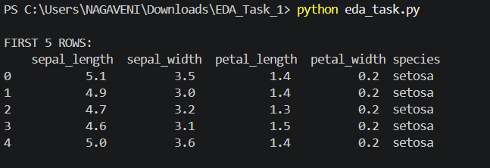
Explanation
Displays the first five rows of the dataset to understand its structure.
Step 6: Explore the Dataset
Code
print(df.shape)
print(df.info())
print(df.describe())
Output
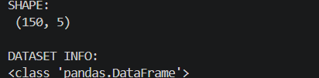
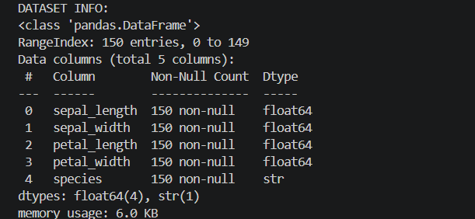
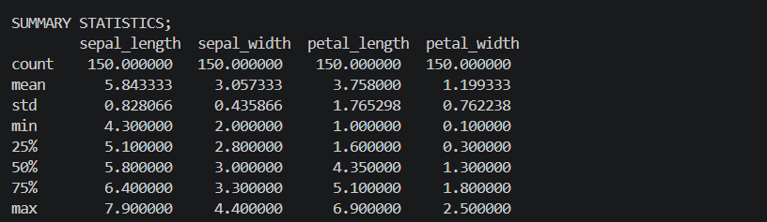
Explanation
- Shape shows the number of rows and columns.
- Info shows column names and data types.
- Describe shows statistical information such as mean, minimum, maximum, and standard deviation.
Step 8: Data Visualization
In this step, different graphs were created to understand the distribution, relationship, correlation, and frequency of the data in the Iris dataset.
1. Histogram
Purpose: Displays the distribution of the numerical features in the dataset.
Code:
df.hist()
plt.show()
Output: 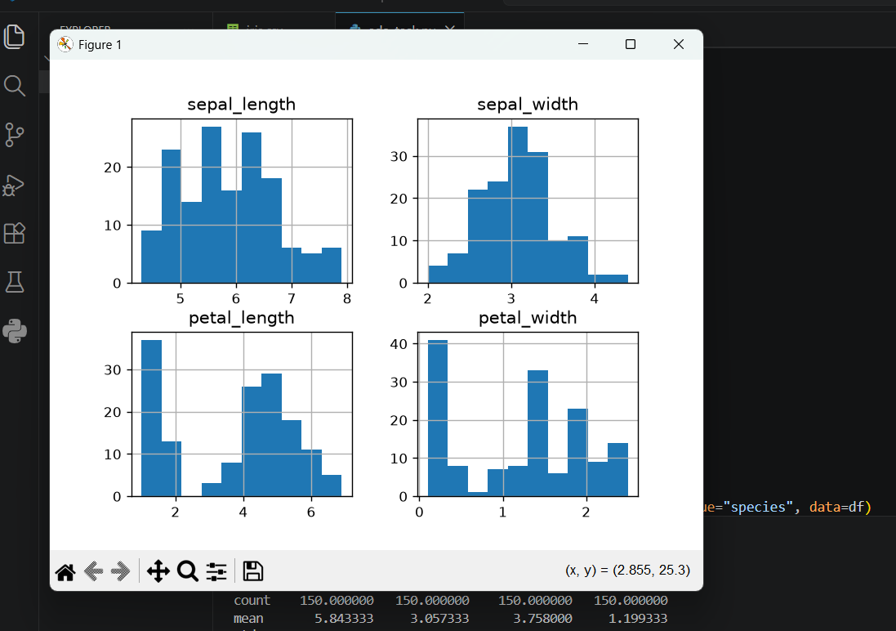
2. Box Plot
Purpose: Displays the spread of the data and helps identify any outliers.
Code:
sns.boxplot(data=df.iloc[:, :4])
plt.show()
Output:
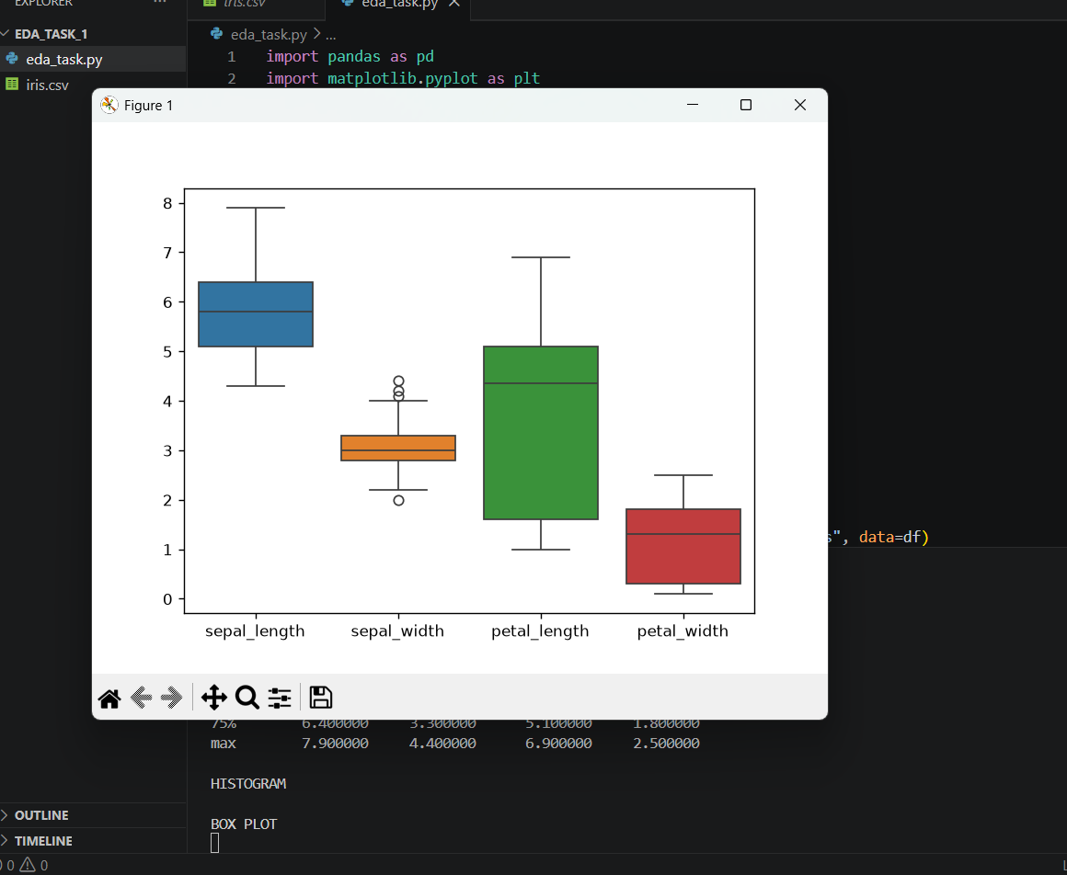
3. Scatter Plot
Purpose: Shows the relationship between Sepal Length and Petal Length for different iris species.
Code:
sns.scatterplot(x="sepal_length", y="petal_length", hue="species", data=df)
plt.show()
Output: 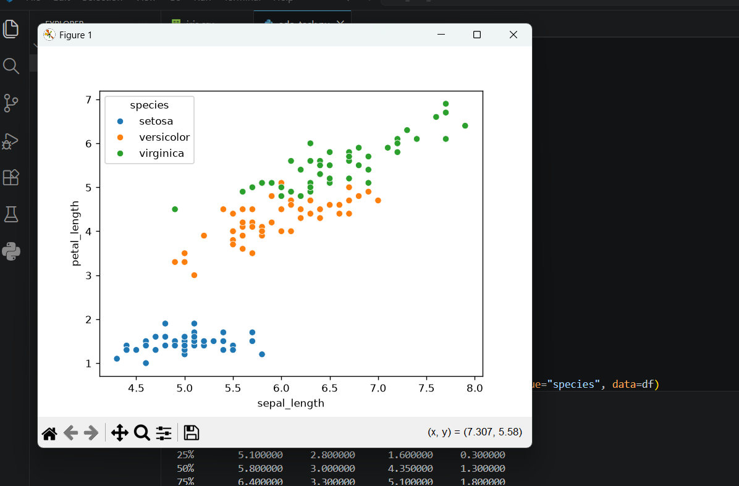

4. Heatmap
Purpose: Displays the correlation between the numerical features in the dataset.
Code:
sns.heatmap(df.iloc[:, :4].corr(), annot=True)
plt.show()
Output:
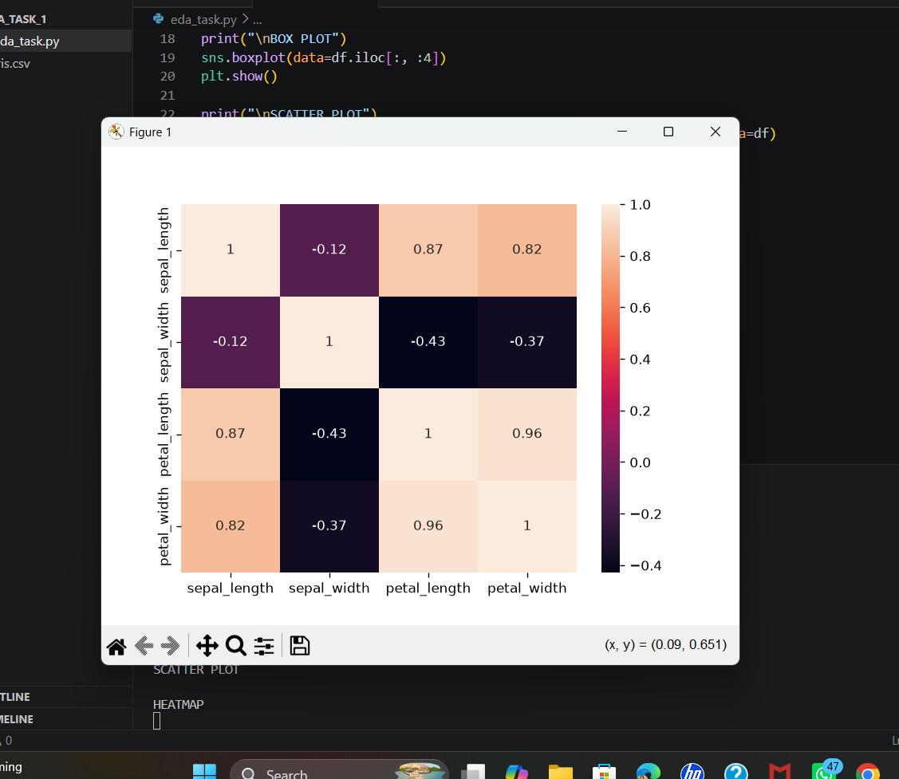
5. Bar Graph
Purpose: Displays the number of samples available for each iris species.
Code:
df["species"].value_counts().plot(kind="bar")
plt.title("Count of Iris Species")
plt.xlabel("Species")
plt.ylabel("Count")
plt.show()
Output:
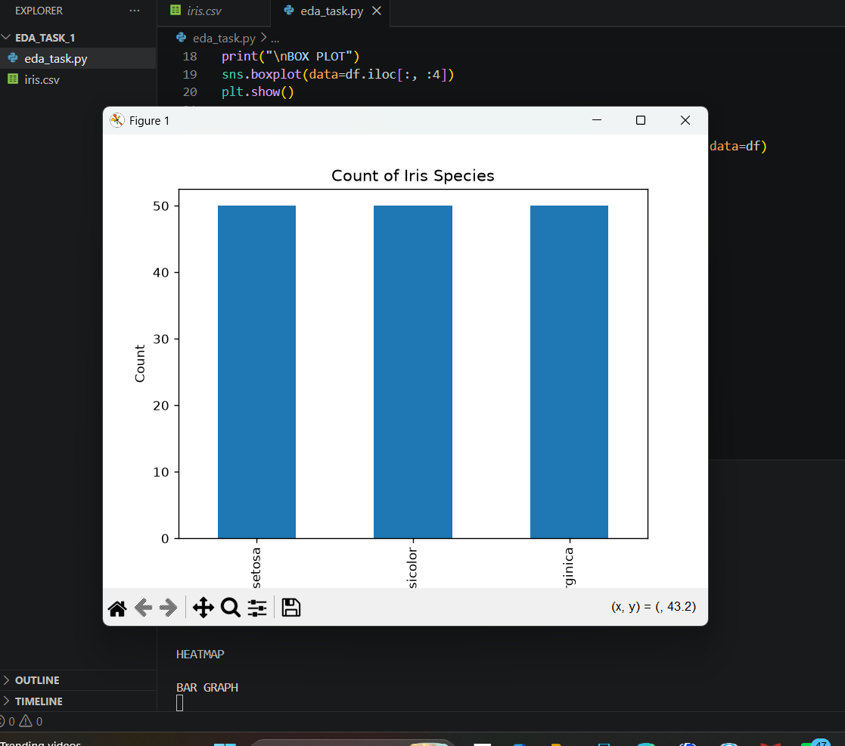

Task Requirements
Requirement 1
Ask Meaningful Questions
- Which species has larger petals?
- Are there missing values?
- Which features are related?
Requirement 2
Explore Data Structure
Performed:
- head()
- shape
- info()
- describe()
Observation:
- Dataset has 150 rows and 5 columns.
Requirement 3
Identify Trends and Patterns
Created:
- Histogram
- Box Plot
- Scatter Plot
- Heatmap
- Bar Graph
Requirement 4
Test Hypothesis
Hypothesis:
Petal length and petal width are positively related.
Validation:
Confirmed using Scatter Plot and Heatmap.

Requirement 5
Detect Data Issues
Checked:
- Missing Values
- Duplicate Rows
- Data Types
Observation:
No missing values found.

Observations
After performing Exploratory Data Analysis (EDA) on the Iris dataset, the following observations were made:
- The Iris dataset contains 150 rows and 5 columns, making it suitable for beginner-level data analysis.
- The dataset consists of four numerical features (sepal length, sepal width, petal length, and petal width) and one categorical feature (species).
- No missing values were found in the dataset, indicating that the data is clean and complete.
- The histogram shows the distribution of the numerical features across different value ranges.
- The box plot helps identify the spread of the data and indicates only a few possible outliers.
- The scatter plot shows a positive relationship between sepal length and petal length, with different species forming distinct groups.
- The heatmap indicates a strong positive correlation between petal length and petal width, while other features show moderate or weak correlations.
- The bar graph shows that each iris species (Setosa, Versicolor, and Virginica) contains 50 samples, indicating a balanced dataset.
- Overall, the dataset is well-organized, balanced, and suitable for further data analysis and machine learning.

Conclusion
The Exploratory Data Analysis (EDA) of the Iris dataset was successfully completed using Python in Visual Studio Code. The dataset was explored by examining its structure, checking for missing values, generating summary statistics, and creating visualizations such as a histogram, box plot, scatter plot, heatmap, and bar graph. The analysis revealed that the dataset is clean, balanced, and free of missing values. The visualizations helped identify patterns and relationships among the flower measurements, especially the strong correlation between petal length and petal width. Therefore, the Iris dataset is suitable for further analysis and machine learning applications.

Full code:
import pandas as pd
import matplotlib.pyplot as plt
import seaborn as sns

df = pd.read_csv("iris.csv")

print("\nFIRST 5 ROWS:\n", df.head())
print("\nSHAPE:\n", df.shape)
print("\nDATASET INFO:")
df.info()
print("\nMISSING VALUES:\n", df.isnull().sum())
print("\nSUMMARY STATISTICS;\n", df.describe())

print("\nHISTOGRAM")
df.hist()
plt.show()

print("\nBOX PLOT")
sns.boxplot(data=df.iloc[:, :4])
plt.show()

print("\nSCATTER PLOT")
sns.scatterplot(x="sepal_length", y="petal_length", hue="species", data=df)
plt.show()

print("\nHEATMAP")
sns.heatmap(df.iloc[:, :4].corr(), annot=True)
plt.show()

print("\nBAR GRAPH")
df["species"].value_counts().plot(kind="bar")
plt.title("Count of Iris Species")
plt.xlabel("Species")
plt.ylabel("Count")
plt.show()

print("\nEDA COMPLETED SUCCESSFULLY")

output :
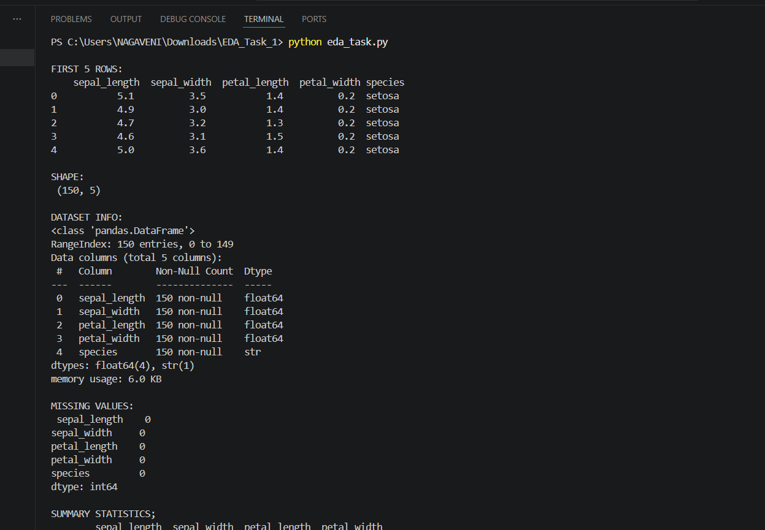
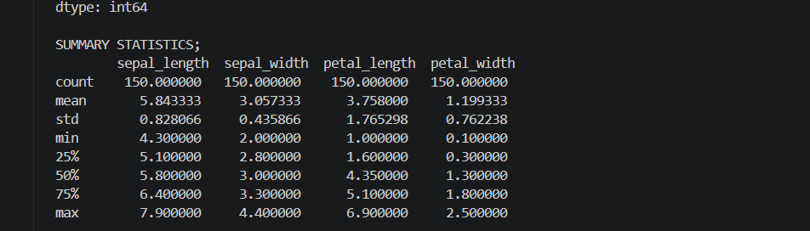
Graphs : 