TrustHire: A Secure Recruitment Platform with Intelligent Company Verification
Nagaveni
MCA Student
JSPM University, Pune (Wagholi Campus), India
Guide: Prof. Namrata Gadgil

Abstract
TrustHire is a secure recruitment platform designed to improve trust in online hiring systems. The platform verifies companies using document validation, intelligent verification mechanisms, and administrative approval before allowing job postings. The system is implemented using Spring Boot architecture with REST APIs and MySQL database integration. By integrating company verification, candidate profile validation, and administrative monitoring, TrustHire reduces fraudulent job postings and improves transparency in recruitment ecosystems.

Keywords
Recruitment System, Artificial Intelligence, Document Verification, Secure Job Portal, Spring Boot

1. Introduction
Online recruitment platforms have become essential for connecting employers and job seekers. However, many systems suffer from fake job postings and fraudulent companies. TrustHire aims to solve these issues by implementing intelligent company verification and secure user validation.

2. System Architecture
The system follows a layered architecture including presentation layer, Spring Boot application layer, verification layer, and database layer.
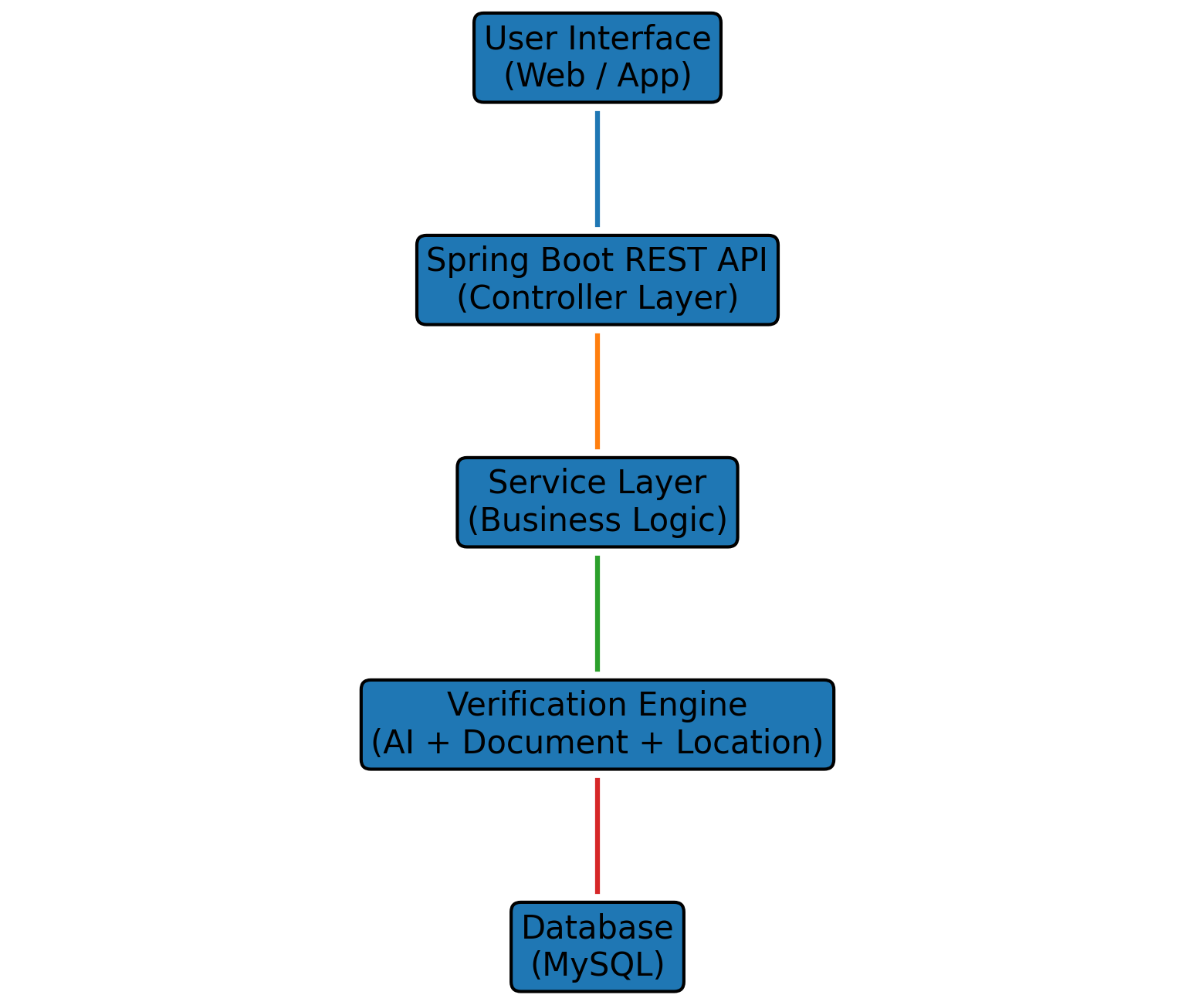

3. Database Design (ER Diagram)
The database includes entities such as Company, Admin, JobSeeker, Job, and Application. Relationships manage job postings and candidate applications.
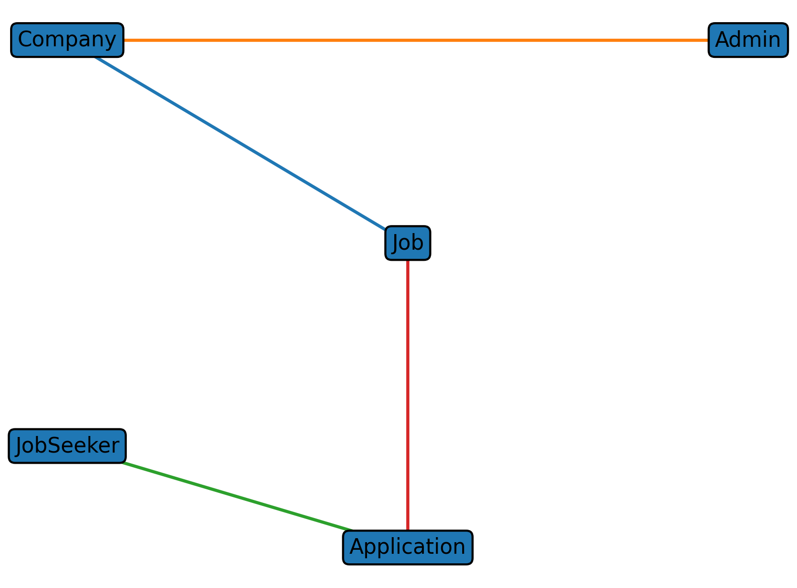

4. Workflow of the System
The workflow begins with user registration followed by document verification and admin approval before accessing job portal features.
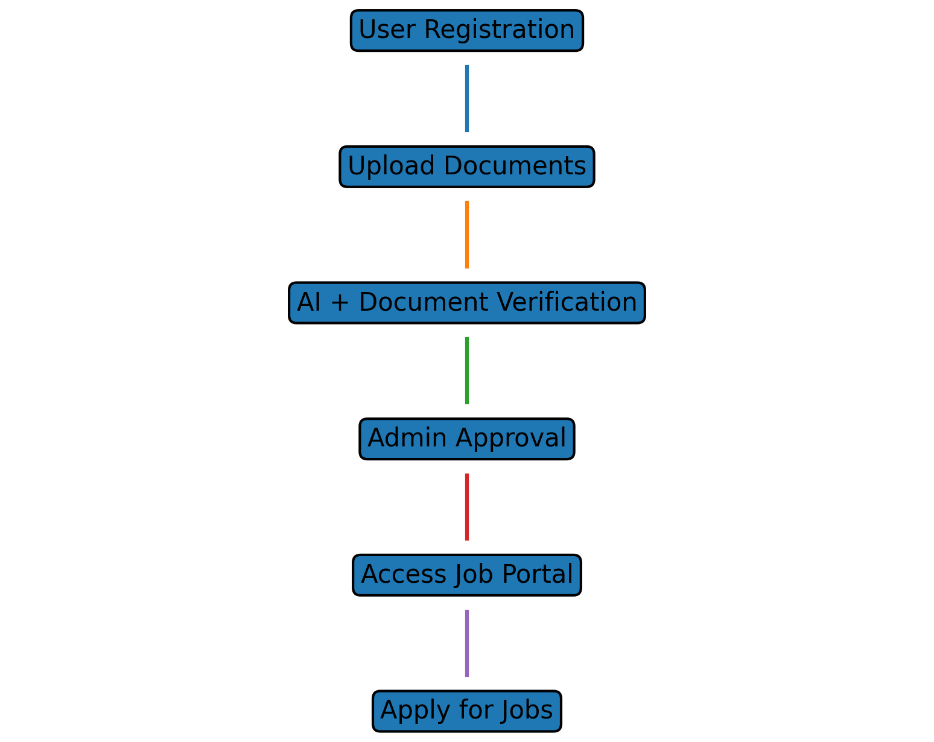

5. Implementation Using Spring Boot
The backend of TrustHire is implemented using Spring Boot. Controllers expose REST APIs, services handle business logic, and repositories interact with the MySQL database using Spring Data JPA.

6. Conclusion
TrustHire demonstrates how secure verification and modern web technologies can create a trustworthy recruitment environment by preventing fraudulent job postings and validating users.

References
[1] J. Smith, Online Recruitment Systems, 2021.
[2] A. Kumar, Machine Learning in Recruitment, 2020.
[3] L. Chen, Document Verification using OCR, 2022.

