Enterprise User Management Platform (EUMP)
Containers & Kubernetes Architecture & Operational Guide
Technical Architecture • High & Low-Level Diagrams • Physical JSON Persistence • Production Runbook

1. Executive Summary & Core Concepts
An overview of how containerization and cloud-native orchestration are implemented in the Enterprise User Management Platform.
The Enterprise User Management Platform (EUMP) is architected to showcase industry-grade enterprise software development using .NET 9 Web API (Clean Architecture), Angular 19 SPA (Standalone Components), Docker containerization, Kubernetes orchestration, and reliable physical JSON file persistence without external SQL dependencies.

1.1 Core Definitions: Containers vs. Orchestrator
- Container (Docker): A lightweight, standalone execution unit encapsulating the application code, runtime libraries, and operating system configuration. Containers eliminate the classic 'it works on my machine' challenge by guaranteeing identical behavior across development workstations, test pipelines, and cloud production.
- Docker Compose: A multi-container coordinator designed for single-host development. It defines networking, environment configurations, and persistent volume mounts across the frontend and backend with a single declaration (docker-compose.yml).
- Kubernetes (K8s): An enterprise-grade container orchestration system designed to automate deployment, auto-scaling, self-healing, and traffic routing across multi-node server clusters. Kubernetes manages pods, persistent volume claims, native health probes, and ingress routing.

1.2 Docker Compose vs. Kubernetes in EUMP
The following table contrasts the roles of Docker Compose and Kubernetes within this platform:
Architectural Dimension | Docker Compose (Local Runtime) | Kubernetes (Cluster Runtime)
Target Deployment | Developer workstation / single Docker host | Multi-node enterprise cloud (AKS, GKE, EKS, Docker Desktop K8s)
Definition Format | Single docker-compose.yml file | Declarative YAML manifests in kubernetes/ namespace
Data Persistence | Named volume: eump-data mounted to /app/data | PersistentVolumeClaim: eump-storage-pvc (ReadWriteOnce)
Frontend Scaling | 1 frontend container (Nginx + Angular) | 2 frontend pods (Stateless tier scaled across nodes)
Backend Scaling | 1 backend container (.NET 9 Web API) | 1 backend pod (Strict single-writer JSON locking)
Health Monitoring | Docker HEALTHCHECK command with curl | Native K8s Liveness (/health) & Readiness (/health/ready) Probes

2. High-Level Conceptual Architecture
Visual comparison between the single-host Docker Compose environment and the cluster-native Kubernetes orchestration.
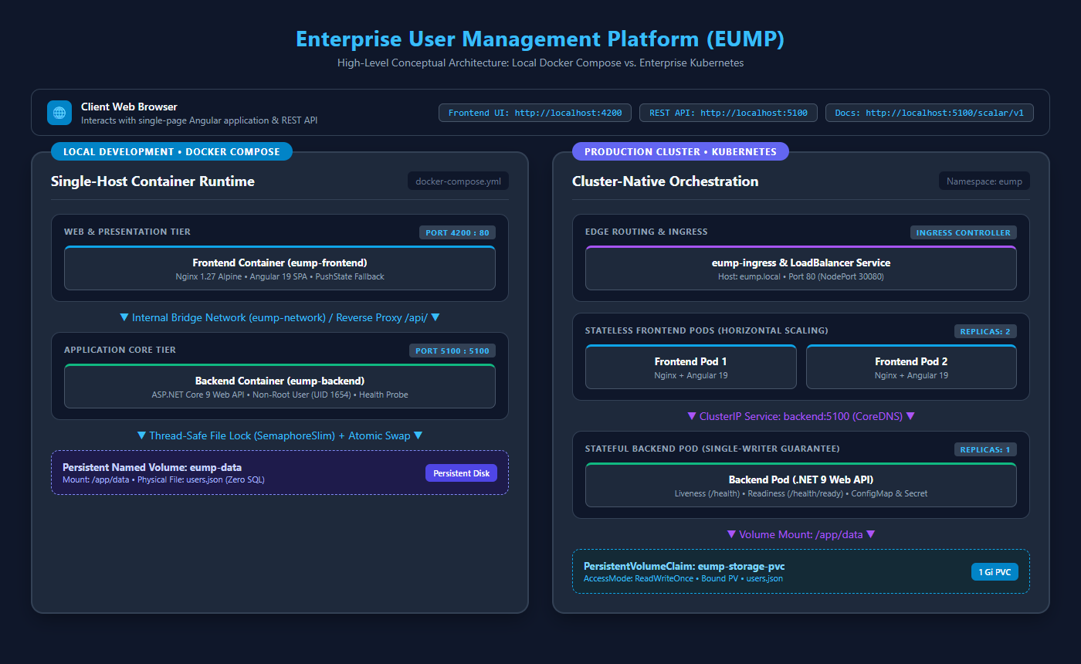
Figure 1: High-Level Conceptual Topology (Docker Compose vs. Kubernetes)

2.1 High-Level Architecture Walkthrough
Figure 1 illustrates how both container environments isolate and deliver the full-stack system:
- Client Layer: The end user's web browser interacts with the Angular 19 SPA running on port 4200 (or port 80 in production). The client communicates strictly through standard HTTP REST endpoints.
- Docker Compose Environment: Both the frontend and backend execute as coordinated containers on the host. They are linked through a private bridge network (eump-network). Nginx intercepts API requests at /api/ and proxies them internally to http://backend:5100. The persistent named volume (eump-data) stores users.json independently from container lifecycles.
- Kubernetes Environment: Workloads are isolated in the 'eump' namespace. An external Ingress or LoadBalancer Service directs incoming web traffic to 2 stateless frontend pods. The frontend communicates with the backend via internal CoreDNS (http://backend:5100). The backend pod mounts a PersistentVolumeClaim for physical file storage.

3. Low-Level Architectural Blueprint & Data Flow
Component-level breakdown showing how a user request traverses through Angular 19, Nginx, ASP.NET Core 9 Clean Architecture, and the thread-safe JSON engine.
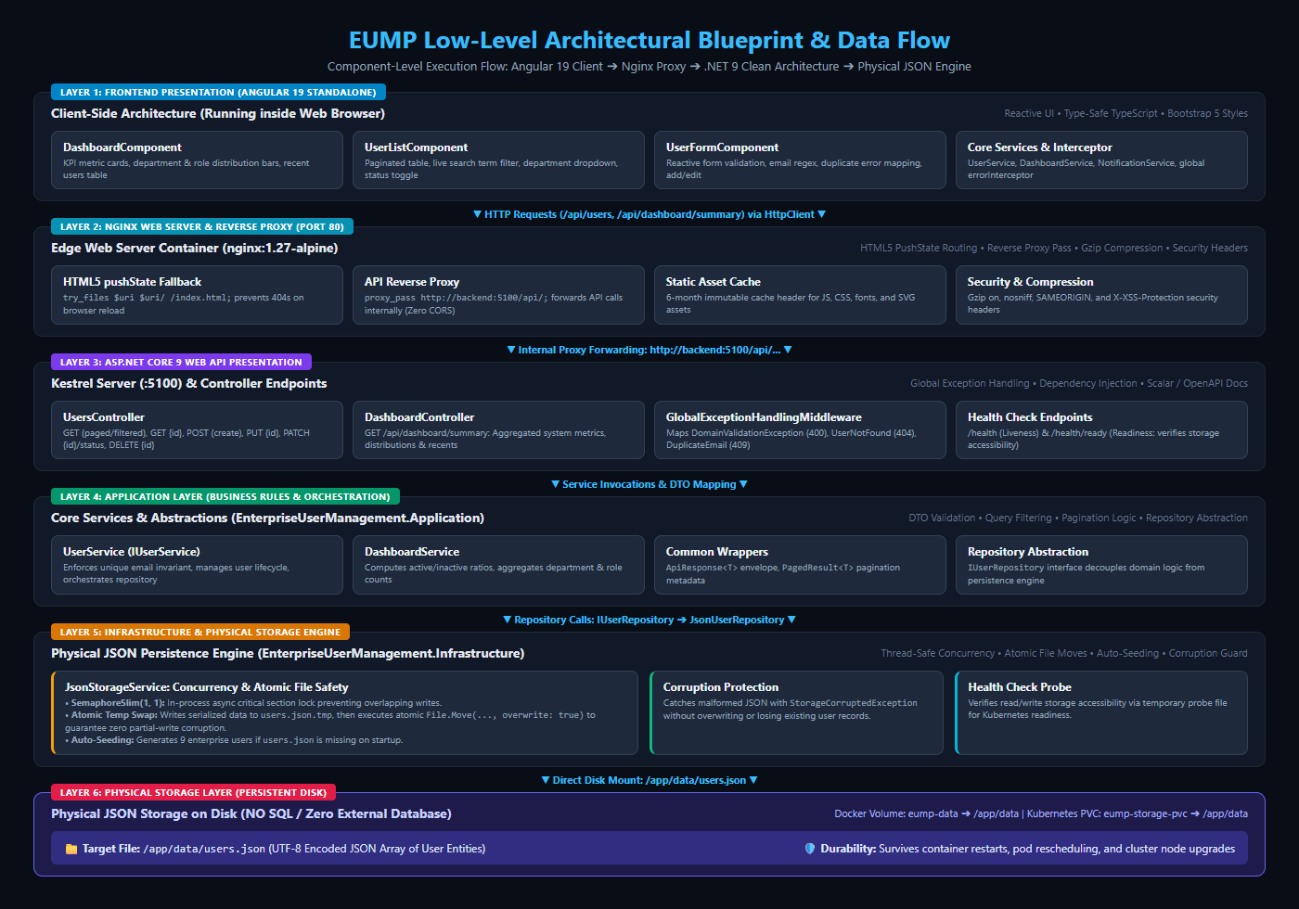
Figure 2: EUMP Low-Level Component Blueprint and End-to-End Execution Flow

3.1 Component Layer Deep-Dive
Figure 2 details the exact data path across all 6 architectural layers:

Layer 1: Frontend Client (Angular 19 SPA)
- DashboardComponent: Presents real-time KPI cards, active/inactive user ratios, department and role progress bars, and a table of the 5 most recently created users.
- UserListComponent: Provides full enterprise data grid capabilities: debounced search term filtering, department/role dropdown filtering, server-side pagination, sorting, status toggle switches, and deletion confirmation modals.
- UserFormComponent: Handles reactive creation and editing with real-time field validation, email pattern checking, and duplicate email error banners returned by the API.
- Core Services: Centralized Angular Injectable services (UserService, DashboardService, NotificationService) utilizing RxJS observables and a global errorInterceptor for unified toast alerts.

Layer 2: Edge Web Server & Reverse Proxy (Nginx 1.27 Alpine)
- HTML5 PushState Routing: Resolves Angular SPA client routes. A request to /dashboard or /users is rewritten to /index.html using 'try_files $uri $uri/ /index.html;' avoiding HTTP 404 errors on browser page reloads.
- Internal API Reverse Proxy: Catches all requests starting with /api/ and forwards them to http://backend:5100/api/. This eliminates cross-origin resource sharing (CORS) constraints and simplifies browser networking.
- Compression & Security Headers: Enables Gzip compression for JSON and JavaScript bundles and injects security headers (X-Frame-Options: SAMEORIGIN, X-Content-Type-Options: nosniff).

Layer 3: Presentation API (ASP.NET Core 9 Web API)
- Kestrel Server: Listens on port 5100. Optimized for high throughput using non-blocking asynchronous I/O.
- GlobalExceptionHandlingMiddleware: Global exception boundary mapping custom domain exceptions to RFC 7807 JSON error envelopes: DomainValidationException (400 Bad Request), UserNotFoundException (404 Not Found), DuplicateEmailException (409 Conflict), and StorageCorruptedException (500 Server Error).
- Controllers: Thin controllers (UsersController, DashboardController) delegating all business logic to application layer interfaces.
- Interactive Documentation: Modern Scalar / OpenAPI documentation accessible at /scalar/v1 and /swagger.

Layer 4: Application Layer (Clean Architecture)
- Business Services: UserService and DashboardService enforce domain constraints, coordinate query parameters, and handle business validations.
- Data Transfer Objects (DTOs): Decouples domain entity schema from client APIs (UserDto, CreateUserRequestDto, UpdateUserRequestDto, DashboardSummaryDto).
- Standard Response Envelopes: ApiResponse<T> guarantees consistent { success, message, data, errors, timestamp } JSON contracts for all endpoints.

Layer 5: Infrastructure & Physical Storage Engine
- JsonStorageService: Encapsulates physical JSON file I/O using System.Text.Json with string enum converters and indented formatting.
- SemaphoreSlim(1,1) Concurrency Control: An in-process asynchronous semaphore guarantees thread-safe serialization of simultaneous read/write operations.
- Atomic File Swapping: Writes serialized JSON to users.json.tmp first, followed by File.Move(..., overwrite: true). This ensures the production file is never left in a partially written or corrupted state if power or the container terminates.
- Auto-Seeding & Health Probes: Automatically seeds 9 diverse enterprise user records upon first launch and provides JsonStorageHealthCheck testing file accessibility.

Layer 6: Physical Storage Layer
- Zero SQL Dependency: All data is physically stored in /app/data/users.json on disk. No SQL Server, PostgreSQL, SQLite, or Mongo engine is required.
- Volume Mount: Backed by a named Docker volume (eump-data) or a Kubernetes PersistentVolumeClaim (eump-storage-pvc). Data persists permanently across container updates and pod restarts.

4. Physical JSON Persistence Engine & Concurrency Safety
How EUMP achieves enterprise-grade data integrity and corruption prevention using pure physical JSON storage.

4.1 Why No SQL?
A core architectural requirement of this project is demonstrating complete physical JSON file persistence without relying on SQL databases, SQLite, or in-memory static collections. Every write operation must persist safely to disk.

4.2 Thread-Safe Concurrency via SemaphoreSlim
In high-concurrency environments, multiple concurrent HTTP requests could attempt to read or write users.json simultaneously. Without synchronization, this would lead to IOException sharing violations or corrupted JSON fragments. To prevent this, JsonStorageService implements an asynchronous semaphore:
- SemaphoreSlim _fileLock = new(1, 1): Only one thread may enter the write critical section at any given moment. Other pending requests await the lock asynchronously without blocking operating system threads.
- Asynchronous Lock Release: The semaphore is guaranteed to be released inside a 'finally' block, preventing deadlocks even if serialization exceptions occur.

4.3 Atomic Temporary File Swap Pattern
If a write operation directly modified users.json and the host machine lost power or the container was killed mid-write, the file would become truncated or corrupt. EUMP employs the atomic swap pattern:
- Step 1 (Staging): Serialized JSON data is written to a temporary staging file: users.json.tmp.
- Step 2 (Flush): The stream is fully flushed and closed to ensure all bytes are committed to the filesystem.
- Step 3 (Atomic Move): File.Move(tempPath, finalPath, overwrite: true) executes an atomic filesystem metadata update that swaps the temporary file into place instantaneously.

4.4 Single-Writer Concurrency on Kubernetes (Replicas: 1)
Because thread-level locking via SemaphoreSlim operates within a single operating system process memory space, running multiple pod replicas on different Kubernetes cluster nodes accessing a shared network filesystem could introduce multi-node write conflicts. Consequently:
- Backend Replicas: 1: The backend deployment explicitly specifies replicas: 1, ensuring a single authoritative writer process.
- Deployment Strategy: Recreate: Guarantees that Kubernetes cleanly terminates and unmounts the storage volume from an old pod before attaching it to a replacement pod.
- ReadWriteOnce PVC: Binds the storage volume to one cluster node at a time with full POSIX filesystem semantics.

5. Kubernetes Manifests & Cluster Topology
Complete breakdown of the declarative Kubernetes manifests created in the kubernetes/ directory.
Manifest File | Kubernetes Kind | Description and Operational Role
00-namespace.yaml | Namespace | Creates the isolated 'eump' namespace to house all platform workloads.
01-storage.yaml | PersistentVolumeClaim | Requests a 1Gi volume with ReadWriteOnce access mode. Dynamically binds to host storage.
02-configmap.yaml | ConfigMap | Decouples ASPNETCORE_URLS, ASPNETCORE_ENVIRONMENT, and JsonStorage__StorageDirectory settings.
03-secret.yaml | Secret | Placeholder for enterprise secrets (API tokens, TLS certificates) stored outside source code.
04-backend-deployment.yaml | Deployment | Deploys .NET 9 API (1 replica) with PVC mounted to /app/data, Liveness probe (/health), Readiness probe (/health/ready), and CPU/memory limits.
05-backend-service.yaml | Service | Internal ClusterIP service exposing port 5100. Resolves to http://backend:5100 via cluster CoreDNS.
06-frontend-deployment.yaml | Deployment | Deploys Nginx + Angular 19 SPA with 2 replicas demonstrating horizontal scaling of the stateless tier.
07-frontend-service.yaml | Service | Exposes frontend externally via LoadBalancer on port 80 and NodePort 30080 for browser access.
08-ingress.yaml | Ingress | Path-based routing rules directing / to frontend and /api to backend under host eump.local.
k8s-deploy.ps1 | PowerShell Automation | One-click script supporting -Action Apply (deploy), -Action Status (check), and -Action Delete (teardown).

6. Operational Runbook & Verification Commands
Essential commands for operating, verifying, and testing containers and Kubernetes deployments.

6.1 Docker Compose Operations (Local Development)
Execute these commands from the project root (C:\Users\Nagarajan\source\repos\EnterpriseUserManagementPlatform):
- Build & Start Containers: docker compose up --build -d
- Check Status & Health: docker compose ps (verifies both containers are Up and healthy)
- Stream Backend Logs: docker compose logs -f backend (inspect real-time HTTP requests and JSON writes)
- Stream Frontend Logs: docker compose logs -f frontend (inspect Nginx access and reverse proxy traffic)
- Inspect Physical JSON File: docker exec -it eump-backend cat /app/data/users.json
- Stop Containers: docker compose down (safely preserves data volume eump-data)
- Reset Everything (Fresh State): docker compose down -v (deletes volume; re-seeds 9 sample users on next start)

6.2 Kubernetes Operations (Docker Desktop / Cloud Cluster)
When Kubernetes is enabled in Docker Desktop (Settings > Kubernetes > Enable Kubernetes):
- Deploy Platform: .\kubernetes\k8s-deploy.ps1 -Action Apply
- Check Pods & PVC: .\kubernetes\k8s-deploy.ps1 -Action Status or kubectl get all,pvc -n eump
- View Backend Pod Logs: kubectl logs -l app.kubernetes.io/component=backend -n eump
- View Frontend Pod Logs: kubectl logs -l app.kubernetes.io/component=frontend -n eump
- Teardown Platform: .\kubernetes\k8s-deploy.ps1 -Action Delete

6.3 Browser Verification URLs
- Angular Frontend UI: http://localhost:4200 (via Docker Compose) or http://localhost:80 (via Kubernetes)
- Interactive API Documentation: http://localhost:5100/scalar/v1 or http://localhost:5100/swagger
- Liveness Health Probe: http://localhost:5100/health (returns HTTP 200 'Healthy')
- Readiness Health Probe: http://localhost:5100/health/ready (returns HTTP 200 'Healthy' verifying JSON storage access)
Enterprise User Management Platform (EUMP) • Complete Architecture & Operations Documentation

