SmartHire - SSO & SCIM Provisioning: Complete Flow
  - How login (SSO) and database provisioning work between AuthBridge (parent) and SmartHire (child)

1. Components Involved
AuthBridge is the parent application and acts as the Identity Provider (IdP). SmartHire is the child application that relies on AuthBridge for login (SSO) and for provisioning user access via SCIM.
Component | Role
AuthBridge (parent app) | Identity Provider (IdP) - Duende IdentityServer + ASP.NET Identity. Master user store, application catalog, assignment decisions.
ScimProvisioning.Api (AuthBridge hub) | Fans out AuthBridge assign/revoke/update events to each downstream app as SCIM 2.0 calls.
SmartHire (child app - RP) | OIDC Relying Party. Redirects to AuthBridge for login, validates id_token, owns local Users / UserApplications tables for authorization.
ScimProvisioning.Api (SmartHire) | SmartHire's own inbound SCIM 2.0 endpoint. Receives provisioning calls from the hub, stores ProvisionedUser records, relays into the SmartHire app.

There are two independent, separately-triggered flows that both end up writing to SmartHire's database. They are explained separately below, then how they converge.

2. Flow Diagram
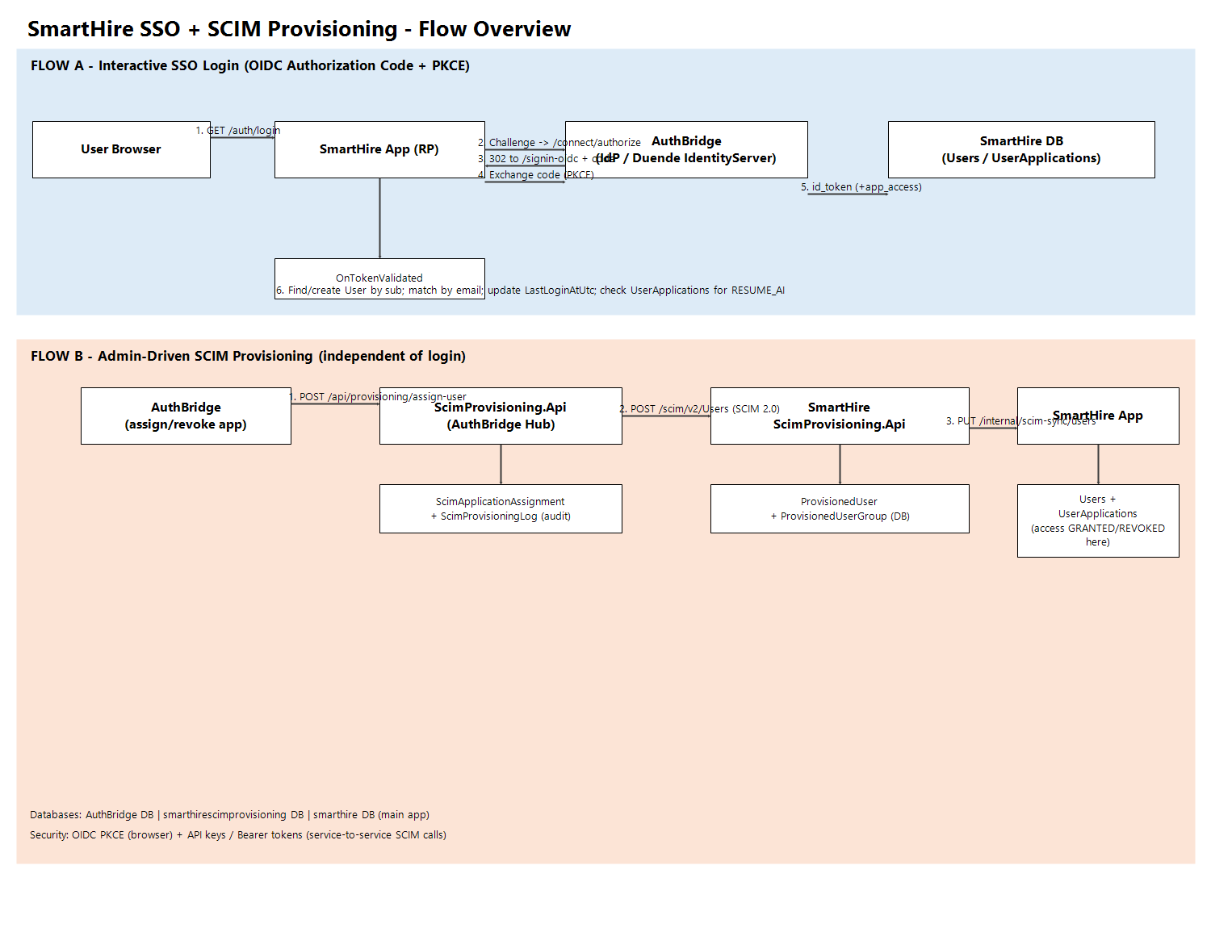

3. Flow A - Interactive SSO Login (OIDC Authorization Code + PKCE)
- User opens SmartHire while not authenticated. GET /auth/login issues an OIDC Challenge.
- Browser is redirected to AuthBridge's /connect/authorize (Duende IdentityServer) with client_id=RESUME_AI, PKCE challenge, and scopes: openid, profile, email, application_access.
- User authenticates at AuthBridge (password + optional MFA, or Entra ID).
- AuthBridge's ApplicationProfileService enriches the token: because 'application_access' scope was requested, it adds one app_access claim per ApplicationCode the user is actively assigned to (e.g. RESUME_AI) into the id_token.
- AuthBridge redirects back to SmartHire's /signin-oidc with an authorization code.
- SmartHire's OIDC handler exchanges the code for tokens using PKCE (no client secret needed for catalog apps).
- OnTokenValidated event fires in SmartHire (AuthServiceExtensions.cs) - THIS is where the SmartHire database is written:
- Reads 'sub' (subject id) from the validated principal.
- Looks up SmartHire.Entities.User by SubjectId == sub.
- If not found, tries to match an existing SCIM-provisioned user by Email (links a user provisioned earlier via SCIM instead of duplicating).
- If still not found, inserts a brand-new User row (SubjectId, Email, DisplayName).
- Updates LastLoginAtUtc on every login.
- Checks UserApplications (joined to Applications) for Code == RESUME_AI; if present, adds the local app_access claim used by [Authorize(Policy = RequireResumeAiAccess)].
- SmartHire sets its own cookie session; user lands in the Angular SPA.
Key point: SSO login only creates/matches a User row and updates LastLoginAtUtc. It does NOT grant application access by itself - access comes from SCIM provisioning (Flow B) or local registration.

4. Flow B - SCIM-Based Provisioning (Admin Assigns/Revokes Access)
Triggered independently in AuthBridge, e.g. an admin assigns the RESUME_AI application to a user, or changes their role. AuthBridge calls IScimNotificationService, which posts to the central ScimProvisioning.Api hub.
- AuthBridge to Hub: POST /api/provisioning/assign-user (also revoke-user, update-user, update-role), authenticated with X-Api-Key + Bearer token.
- Hub (ScimProvisioningService):
- Looks up the target ScimApplication row by ApplicationCode to get its BaseUrl / AccessToken.
- Builds a standard SCIM 2.0 payload (ScimUser) and calls the downstream app's SCIM endpoint - for SmartHire this is POST/PUT/PATCH {BaseUrl}/scim/v2/Users.
- Persists an audit row in ScimProvisioningLog and upserts ScimApplicationAssignment (ScimExternalId, IsActive, LastSyncUtc) in AuthBridge's own ScimProvisioning database.
- Hub to SmartHire's ScimProvisioning.Api (UsersController, secured by API key):
- Inserts/updates a ProvisionedUser (+ ProvisionedUserGroup rows for roles) in the smarthirescimprovisioning database (separate from the main SmartHire app database).
- Fires a non-blocking, fire-and-forget call via SmartHireSyncClient.SyncUserAsync.
- SmartHire ScimProvisioning.Api to SmartHire main app:
- PUT https://.../internal/scim-sync/users with externalId, userName, email, givenName, familyName, active, groups[] - authenticated via X-Api-Key.
- ScimSyncController.Upsert (SmartHire main app) writes to the smarthire database: finds User by ScimExternalId; if none, checks for a conflicting local/SSO account by Username/Email (returns 409 Conflict to avoid clobbering); otherwise creates a new User with ScimExternalId + Username set.
- Updates Email, DisplayName, IsActive.
- SyncGroupsAsync reconciles UserApplications rows against the Application row for RESUME_AI: removes grants no longer present in incoming groups[], adds new ones - this is what actually grants/revokes app access.

5. How the Two Flows Converge
Field | Written by SSO (Flow A) | Written by SCIM (Flow B)
User.SubjectId | Set on first SSO login | Never set
User.ScimExternalId | Never set | Set on first SCIM sync
User.Email / DisplayName | Set on create | Kept in sync on every SCIM event
UserApplications (access grants) | Only read/checked (not created, except local registration) | Created / updated / removed - the real authorization source

In practice: an admin assigning RESUME_AI to a user in AuthBridge is what actually provisions their UserApplications row in SmartHire (via SCIM). The user's first SSO login then either attaches their OIDC 'sub' to that already-provisioned record (matched by email) or creates a fresh local shell record if never provisioned - and it rechecks the UserApplications grant on every login to decide whether to add the app_access claim.

6. Databases Involved
- AuthBridge SQL DB - Identity tables (AspNetUsers, etc.), Applications, UserApplications (source of truth for who is assigned what), refresh tokens, MFA devices.
- SmartHire ScimProvisioning DB (smarthirescimprovisioning) - ProvisionedUser, ProvisionedUserGroup. Independent inbound SCIM store, decoupled from SmartHire's main schema.
- SmartHire main app DB (smarthire) - Users, UserApplications, Applications, plus all SmartHire domain data (candidates, resumes, screenings). This DB actually gates access to SmartHire features.
- AuthBridge ScimProvisioning hub DB - ScimApplication, ScimApplicationAssignment, ScimProvisioningLog (audit trail + retry queue for outbound SCIM calls).

7. Security Mechanisms
- SSO transport: Authorization Code + PKCE; no client secret for catalog apps (RequireClientSecret = false); AllowAccessTokensViaBrowser = true for SPA compatibility.
- SmartHire session: after OIDC validation, SmartHire issues its own HttpOnly, Secure, SameSite=Lax cookie - the OIDC round-trip only happens at login/refresh, not on every request.
- Service-to-service calls (AuthBridge to Hub to SmartHire SCIM to SmartHire app) are secured with static API keys (X-Api-Key header), not end-user tokens, since no user is present in that path.
- Fire-and-forget resilience: SmartHire's SCIM endpoint and the hub both swallow downstream failures (logged, not thrown) so an outage in one app never blocks provisioning in AuthBridge or breaks the SCIM response contract.

