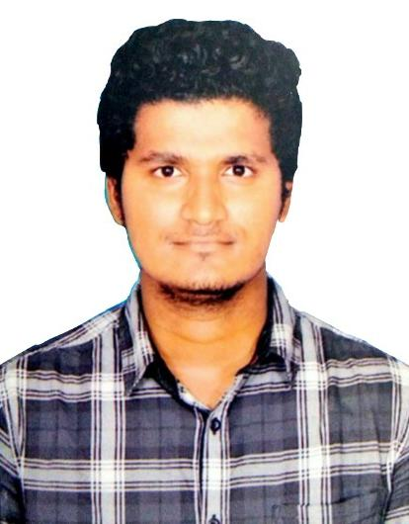 **NAGA YUGESH G B**

E-mail: gbnagayugesh@gmail.com

Contact number: 90875 51844

**CAREER OBJECTIVE**

To work in the most challenging position with an organization that provides ample opportunities to learn and to contribute and achieve organizational goal.

**EDUCATIONAL QUALIFICATION**

|  |  |  |  |  |
| --- | --- | --- | --- | --- |
| **Course** | **Name of the institution** | **Board/ University** | **Percentage** | **Year of passing** |
| B.E | S.A Engineering College | Anna University | 6.26 | 2019 |
| XII | Shree Niketan Matric Hr. Sec. School | State Board | 88.16 | 2015 |
| X | Shree Niketan Matric Hr. Sec. School | State Board | 92.2 | 2013 |

**TECHNICAL EXPERTISE**

**Programming / Scripting languages known:** Python, JavaScript

**Backend / Database Technologies:**

Node.js, Mongodb, SQL

**Area of Interest:**

Data Science, Full stack development

**Mini-project:**

Developed a Home automation system using sensors as an outcome of 5 days IoT workshop.

**Final year project:**

Developed an application for driver drowsiness detection using EAR method that would automatically detect the drowsiness of the driver and thereby prevent road accidents.

**Strength:**

* A team player with interpersonal skills.
* Quick learner.
* Adaptive to any type of environment.
* Good communication skills.
* Can handle stress well.
* Exceptional analytical and decision making skills.

**Extra – curricular activities:**

* Attended a seminar on Ethical Hacking.
* Attended a workshop on Cyber Security.
* Attended a 5 days IoT workshop.
* Participated in various technical events at national level technical symposiums.
* Completed GUVI online courses on C and Python.
* Attended FULL STACK DEVELOPER course at GUVI

**Web Presence:**

LinkedIn: <https://www.linkedin.com/in/naga-yugesh-gb-348b4015a>

**Personal Details:**

Date of birth: 17.07.1997

Father’s name: Babu G R

Marital status: Single

Languages known: Tamil (R/W/S), English (R/W/S), Telugu(S).

Hobbies: Solving puzzles (crosswords).

Residential address: Ramar Koil Street, Pudure Village, Kunnavalam Post,

Thiruvallur-631 210.

**DECLARATION**

I hereby declare that the above furnished details are true to the best of my knowledge and belief.

Date: Yours truly,

Place: Chennai Naga Yugesh G B