lab4:

Hospital management System:

Hospital management System Basically focus on the advantages like basic cost controlling system(having insurance tie up ), effective administration ,high level patient care and basic needs of profitability .

This project is greatly concentrated on many multispecialty hospitals ,to manage cost issues ,overall administration and controlling .This system basically carries the information across the hospitals so that it can assure the patient data ,financial issues and administration in an integrated way.

here we have basically have 3 actors:

1)doctor

2)medical assistant

3)patient.

and these are all individuals also.

human may be a doctor or patient or medical assistant .

***subjects:***

human

doctor

patient

medical assistant

services(central & non central )

specialty

pathologies

clinical tests

*properties:*

*is_a*

*has*

*part_of*

*a kind of*

*requests*

class &individual tree:

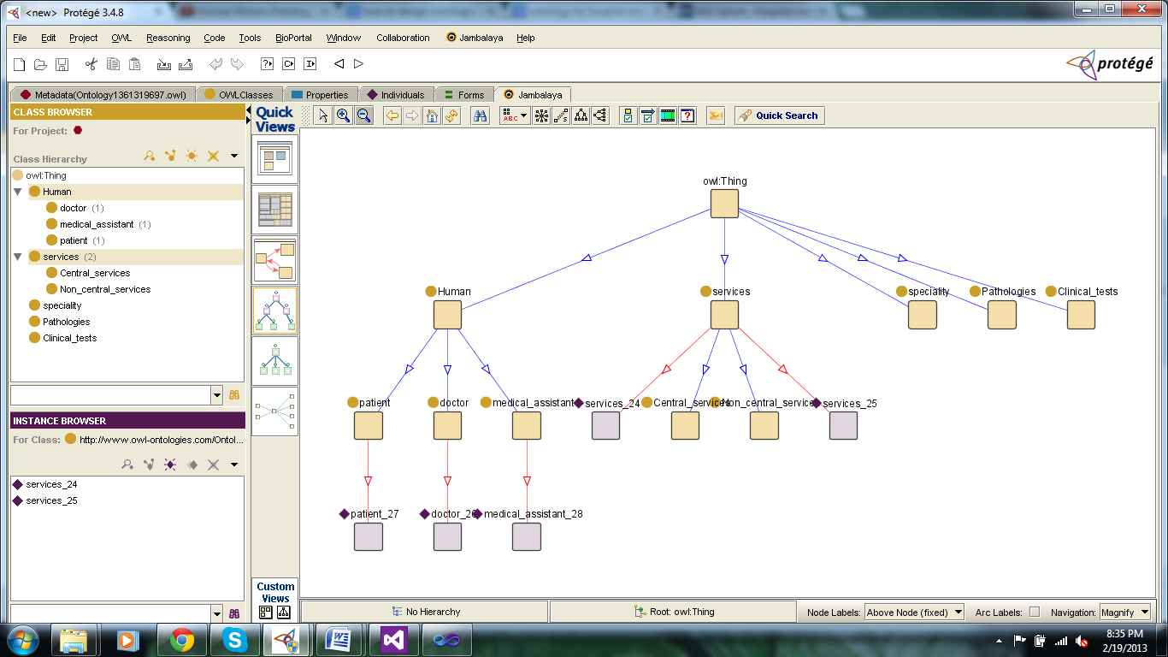

class tree formation:

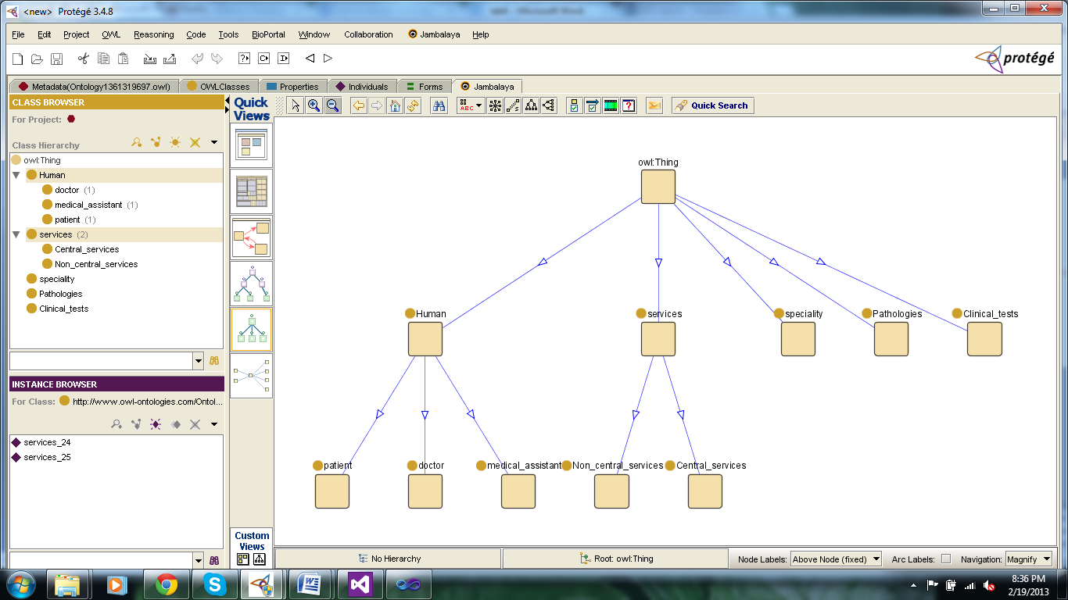

nested composite view:

