SOFTWARE REQUIREMENTS SPECIFICATION
Online Quiz System

Submitted By:
Nageena Hakam
Roll No: 4007
Submitted To:
Dr. Asad Ullah
Islamia University Bahawalpur
Date: 1 May 2026
CONFIDENTIAL — FOR INTERNAL USE ONLY

1. Introduction

1.1 Purpose
This Software Requirements Specification (SRS) document describes the complete functional and non-functional requirements for the Online Quiz System. The purpose of this document is to provide a comprehensive description of the system to be developed, serving as a guideline for developers, testers, project managers, and stakeholders involved in the project.
This document covers all features of the proposed system including user registration, quiz creation, quiz attempt, result management, analytics, leaderboard, and administrative functions.

1.2 Scope
The Online Quiz System is a web-based platform designed to allow administrators and educators to create, manage, and publish quizzes across multiple categories. Users (students or participants) can register, attempt quizzes, view real-time results, earn certificates, and compare scores on a leaderboard.
The system will support multiple user roles including Super Admin, Quiz Creator, and Student. It will provide a secure, scalable, and user-friendly environment for conducting online assessments.

1.3 Definitions, Acronyms, and Abbreviations
Term | Definition
SRS | Software Requirements Specification
UI | User Interface
API | Application Programming Interface
MCQ | Multiple Choice Question
OTP | One-Time Password
HTTPS | Hypertext Transfer Protocol Secure
Admin | System Administrator
DB | Database

1.4 References
- IEEE Std 830-1998 — IEEE Recommended Practice for Software Requirements Specifications
- ISO/IEC 25010:2011 — System and software quality models
- OWASP Security Guidelines for Web Applications
- Project Proposal Document — Online Quiz System v0.1

1.5 Overview
The remainder of this document is organized as follows: Section 2 provides an overall description of the system. Section 3 describes specific functional requirements. Section 4 covers external interface requirements. Section 5 outlines non-functional requirements. Section 6 discusses system constraints. Section 7 covers appendices and supporting information.

2. Overall System Description

2.1 Product Perspective
The Online Quiz System is an independent, self-contained web application. It is not a replacement for any existing system but rather a new platform built to streamline the process of quiz creation and online examination. The system will interact with an email server for notifications and a cloud storage service for certificate generation.

2.2 Product Functions
The primary functions of the Online Quiz System include:
- User Registration, Login, and Profile Management
- Quiz Creation with multiple question types (MCQ, True/False, Short Answer)
- Category and Tag Management for Quizzes
- Timed Quiz Attempts with Auto-Submit Feature
- Real-Time Score Calculation and Result Display
- Leaderboard with Global and Category-wise Rankings
- Certificate Generation upon Quiz Completion
- Admin Dashboard with Analytics and Reporting
- Email Notifications for Registration and Results
- Role-Based Access Control (Super Admin, Quiz Creator, Student)

2.3 User Classes and Characteristics
User Role | Characteristics | Permissions
Super Admin | Full system access, manages all users and content | All system permissions
Quiz Creator | Creates and manages quizzes, views analytics | Create, edit, delete quizzes; view reports
Student | Attempts quizzes, views results and leaderboard | Attempt quizzes, view own results

2.4 Operating Environment
- Operating System: Windows, macOS, Linux (Server); Any OS with modern browser (Client)
- Web Server: Node.js / Apache / Nginx
- Database: MySQL / PostgreSQL
- Browser Support: Google Chrome 90+, Firefox 88+, Safari 14+, Edge 90+
- Minimum Server RAM: 4 GB | Recommended: 8 GB
- Internet Connection: Required for all operations

2.5 Design and Implementation Constraints
- The system must use HTTPS for all data transmission
- Passwords must be encrypted using bcrypt hashing
- The system must comply with GDPR for user data privacy
- Maximum quiz duration is limited to 180 minutes
- File uploads (images for questions) must not exceed 2 MB

2.6 Assumptions and Dependencies
- Users are assumed to have a stable internet connection
- Email service (SMTP) will be configured and available
- Third-party payment gateway may be required for premium features
- Cloud storage (AWS S3 or similar) will be used for certificate storage

3. Functional Requirements

3.1 User Authentication Module

3.1.1 User Registration
- The system shall allow new users to register with name, email, and password
- The system shall send an email verification OTP upon registration
- The system shall validate email format and password strength (minimum 8 characters, 1 uppercase, 1 number)
- Duplicate email registration shall not be permitted

3.1.2 User Login
- Users shall be able to log in using email and password
- The system shall support Remember Me functionality using secure tokens
- After 5 consecutive failed login attempts, the account shall be temporarily locked for 30 minutes
- The system shall support Google OAuth 2.0 for social login

3.1.3 Password Management
- Users shall be able to reset password via email link
- The password reset link shall expire within 24 hours
- Users shall be able to change password from their profile

3.2 Quiz Management Module

3.2.1 Quiz Creation
- Quiz Creator shall be able to create a quiz with title, description, category, and tags
- The system shall support question types: MCQ, True/False, and Short Answer
- Each quiz shall support a configurable time limit (1 to 180 minutes)
- Quiz Creator shall be able to set pass/fail percentage threshold
- Quizzes shall support image attachments for questions
- Quiz Creator shall be able to randomize question and option order

3.2.2 Quiz Publishing and Scheduling
- Quiz Creator shall be able to set a quiz as draft, published, or archived
- The system shall allow scheduling of quiz availability with start and end date/time
- Quiz Creator shall be able to restrict quiz access by user group or enrollment key

3.2.3 Quiz Categories
- Admin shall be able to create, edit, and delete quiz categories
- Each quiz must belong to at least one category
- Users shall be able to browse quizzes by category

3.3 Quiz Attempt Module

3.3.1 Attempting a Quiz
- Registered users shall be able to browse and search available quizzes
- The system shall display quiz details (duration, number of questions, passing score) before starting
- The system shall start a countdown timer upon quiz start
- Users shall be able to navigate between questions and mark questions for review
- The system shall auto-submit the quiz when the timer expires
- Users shall not be able to attempt the same quiz more than the allowed number of attempts

3.3.2 Question Display
- Questions shall be displayed one at a time or all on one page (configurable by creator)
- MCQ options shall be displayed with radio buttons
- True/False questions shall display two option buttons
- Short Answer questions shall provide a text input field

3.4 Result and Analytics Module

3.4.1 Result Display
- Upon quiz completion, the system shall immediately display the score and pass/fail status
- The system shall show correct answers after the quiz (if enabled by creator)
- Users shall be able to view their complete attempt history
- The system shall send a result summary email to the user

3.4.2 Certificate Generation
- The system shall automatically generate a certificate for users who pass the quiz
- Certificates shall include user name, quiz title, score, date, and a unique certificate ID
- Certificates shall be downloadable as PDF
- Certificates shall have a unique URL for online verification

3.5 Leaderboard Module
- The system shall maintain a global leaderboard ranked by total score across all quizzes
- Category-wise leaderboards shall also be available
- Leaderboard shall display user name, score, rank, and number of quizzes attempted
- Users shall be able to view their own rank on the leaderboard
- Leaderboard shall be updated in real-time after each quiz attempt

3.6 Admin Dashboard Module

3.6.1 User Management
- Admin shall be able to view, search, and filter all registered users
- Admin shall be able to activate, deactivate, or permanently delete user accounts
- Admin shall be able to assign and change user roles
- Admin shall be able to view each user's quiz history

3.6.2 Analytics and Reporting
- Admin shall have access to a dashboard showing total users, total quizzes, and total attempts
- The system shall provide graphical reports for quiz performance over time
- Admin shall be able to export reports in CSV and PDF formats
- The system shall display top-performing and most-attempted quizzes

3.6.3 System Configuration
- Admin shall be able to configure email notification templates
- Admin shall be able to manage site settings (logo, name, contact info)
- Admin shall be able to set global quiz attempt limits and certificate templates

3.7 Notification Module
- The system shall send a welcome email upon successful registration
- The system shall send quiz result emails with score details
- The system shall send certificate attachment via email upon passing
- Admin shall be able to send broadcast announcements to all users
- Users shall be able to manage their notification preferences

4. External Interface Requirements

4.1 User Interfaces
- The system shall provide a responsive web interface compatible with desktop and mobile browsers
- The UI shall follow a clean, modern design with consistent color scheme and typography
- All forms shall include proper validation messages and error highlighting
- The system shall support both light and dark modes
- Loading indicators shall be displayed during all asynchronous operations
- The quiz interface shall be distraction-free with a prominent timer display

4.2 Hardware Interfaces
- The system shall be accessible from any device with a web browser and internet connection
- No specialized hardware is required for the client side
- The server shall require a minimum of 4 GB RAM and 50 GB storage

4.3 Software Interfaces
Interface | Type | Purpose
SMTP Server | Email Service | Send notifications and OTP
Google OAuth 2.0 | Authentication API | Social login
AWS S3 / Cloud Storage | File Storage | Store certificates and images
PDF Generator Library | Report Tool | Certificate and report generation
MySQL / PostgreSQL | Database | Store all application data

4.4 Communication Interfaces
- All client-server communication shall use HTTPS (TLS 1.2 or higher)
- REST API shall be used for front-end and back-end communication
- WebSocket or long polling shall be used for real-time timer synchronization
- JSON shall be the standard data format for all API responses

5. Non-Functional Requirements

5.1 Performance Requirements
- The system shall support at least 1,000 concurrent users without performance degradation
- Page load time shall not exceed 3 seconds under normal network conditions
- Quiz submission processing shall complete within 2 seconds
- The system shall process API responses within 500 milliseconds for 95% of requests
- Database queries shall complete within 1 second for standard operations

5.2 Security Requirements
- All user passwords shall be hashed using bcrypt with a minimum salt factor of 10
- The system shall implement CSRF protection on all forms
- SQL Injection prevention shall be enforced using parameterized queries
- XSS prevention shall be implemented through input sanitization and output encoding
- Session tokens shall expire after 30 minutes of inactivity
- All sensitive data shall be encrypted at rest using AES-256
- The system shall implement rate limiting on authentication endpoints

5.3 Reliability Requirements
- The system shall maintain 99.5% uptime, allowing a maximum of 44 hours downtime per year
- The system shall perform automated database backups every 24 hours
- In case of server failure, the system shall recover within 2 hours
- The system shall implement graceful error handling to prevent data loss during failures

5.4 Scalability Requirements
- The system architecture shall support horizontal scaling to handle increased user load
- The database shall be designed to support up to 1 million user records efficiently
- The system shall support up to 100,000 quiz records with full search functionality

5.5 Usability Requirements
- New users shall be able to register and attempt their first quiz within 5 minutes
- The system shall provide clear error messages in plain language
- The quiz interface shall be operable without any training or tutorial
- The system shall be accessible to users with disabilities (WCAG 2.1 Level AA compliance)
- The system shall support multiple languages (English as default, with provision for Urdu)

5.6 Maintainability Requirements
- The source code shall follow consistent coding standards and be well-documented
- The system shall use a modular architecture to allow easy addition of new features
- All major system events shall be logged with timestamps for debugging
- The system shall include automated unit and integration tests with at least 80% coverage

6. System Constraints and Limitations

6.1 Technical Constraints
- The system must be developed using open-source technologies to minimize licensing costs
- The system shall be deployed on a cloud platform (AWS, Azure, or DigitalOcean)
- Mobile native applications are outside the scope of this version; only web is supported
- Offline quiz attempts are not supported in this version

6.2 Business Constraints
- The system must be delivered within a 6-month development timeline
- The total development budget shall not exceed the approved project budget
- All data must be stored within the country's data privacy jurisdiction

6.3 Regulatory Constraints
- The system must comply with GDPR (General Data Protection Regulation) for European users
- The system must provide a clear Privacy Policy and Terms of Service
- Users must provide explicit consent for data collection and processing
- Users must have the right to request deletion of their personal data

7. Use Case Descriptions

7.1 Use Case: Student Attempts a Quiz
Use Case ID | UC-01
Use Case Name | Attempt Online Quiz
Actor | Student (Registered User)
Precondition | Student is logged in; Quiz is published and available
Main Flow | 1. Student browses quiz list 2. Student selects a quiz 3. Student reviews quiz details 4. Student clicks Start Quiz 5. Timer begins 6. Student answers questions 7. Student submits quiz 8. System calculates and displays result
Alternate Flow | Timer expires: System auto-submits the quiz with answered questions
Postcondition | Result is saved; Certificate generated if passed; Leaderboard updated

7.2 Use Case: Admin Creates a Quiz
Use Case ID | UC-02
Use Case Name | Create and Publish Quiz
Actor | Quiz Creator / Admin
Precondition | Creator is logged in with appropriate role
Main Flow | 1. Creator navigates to Create Quiz 2. Enters title, description, category 3. Adds questions with options and correct answers 4. Sets time limit and passing score 5. Configures quiz settings 6. Publishes quiz
Alternate Flow | Creator saves as draft for later publishing
Postcondition | Quiz is available for students to attempt

8. Data Requirements

8.1 Data Entities
The following are the primary data entities in the Online Quiz System:

8.1.1 User Entity
Field | Type | Description
user_id | INT (PK) | Unique identifier
name | VARCHAR(100) | Full name
email | VARCHAR(150) | Email address (unique)
password_hash | VARCHAR(255) | Bcrypt hashed password
role | ENUM | admin / creator / student
is_verified | BOOLEAN | Email verification status
created_at | DATETIME | Registration timestamp

8.1.2 Quiz Entity
Field | Type | Description
quiz_id | INT (PK) | Unique quiz identifier
title | VARCHAR(200) | Quiz title
category_id | INT (FK) | Reference to category
creator_id | INT (FK) | Reference to creator user
time_limit | INT | Duration in minutes
pass_percentage | FLOAT | Minimum passing score (%)
status | ENUM | draft / published / archived

9. System Diagrams

9.1 Use Case Diagram
The Use Case Diagram below illustrates the interactions between different actors (Student, Admin, Quiz Creator) and the system functionalities of the Online Quiz System.

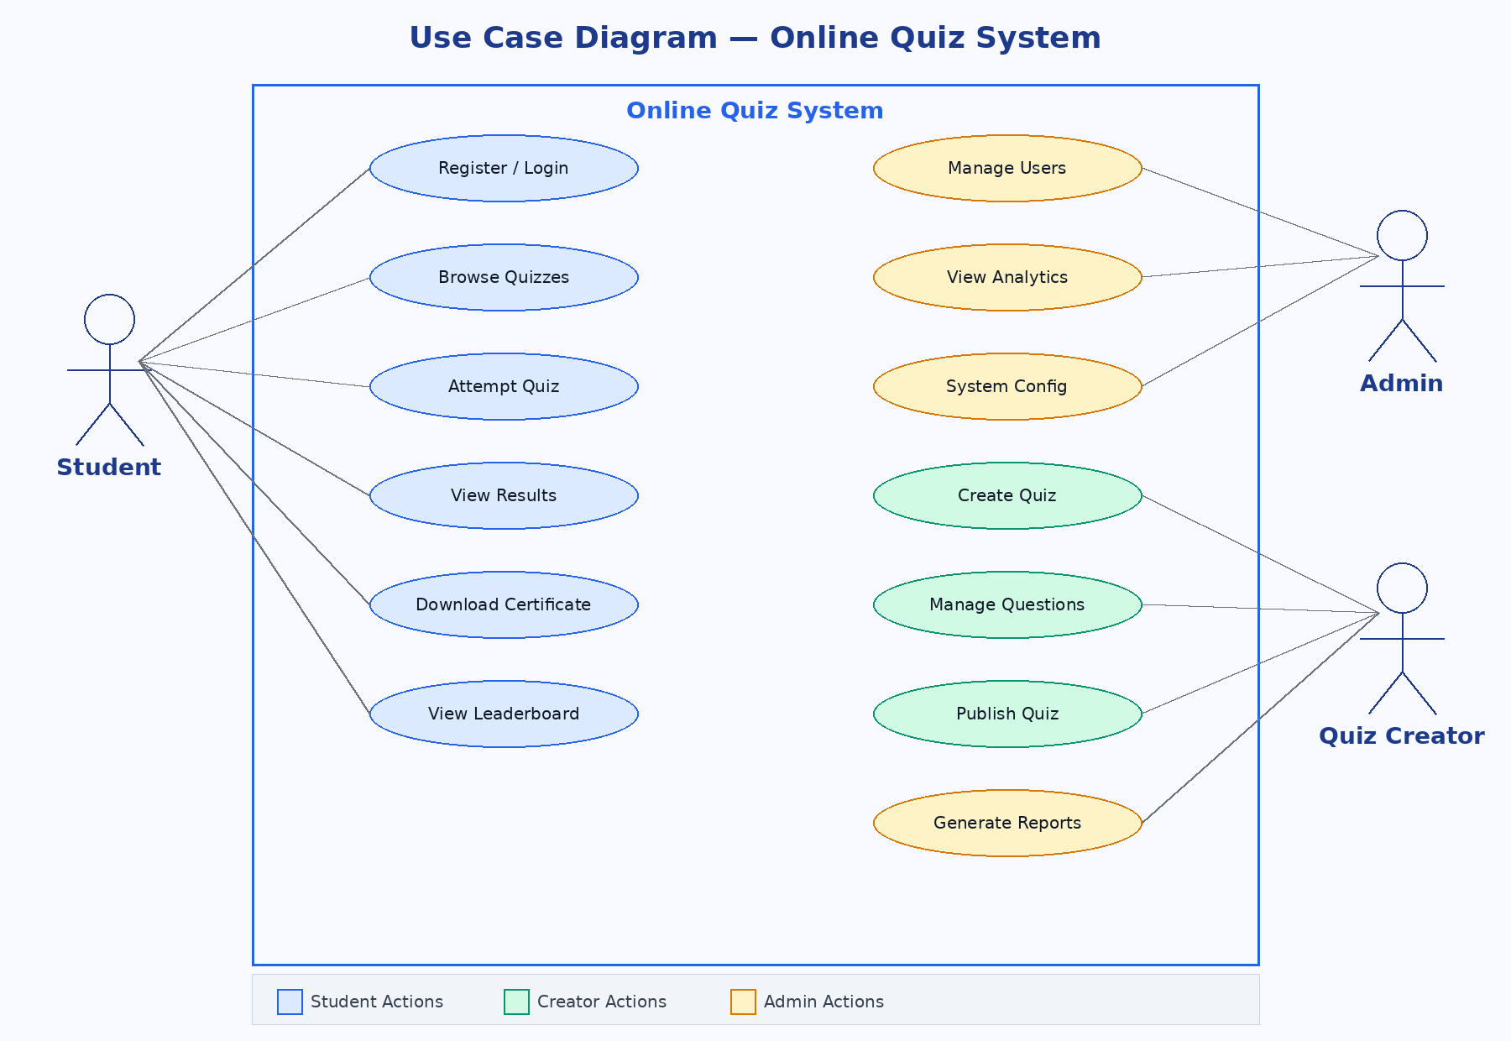
Figure 9.1: Use Case Diagram — Online Quiz System

9.2 Entity Relationship (ER) Diagram
The ER Diagram below shows the database schema of the Online Quiz System, illustrating all entities and their relationships including User, Quiz, Question, Attempt, Certificate, Category, and Leaderboard.

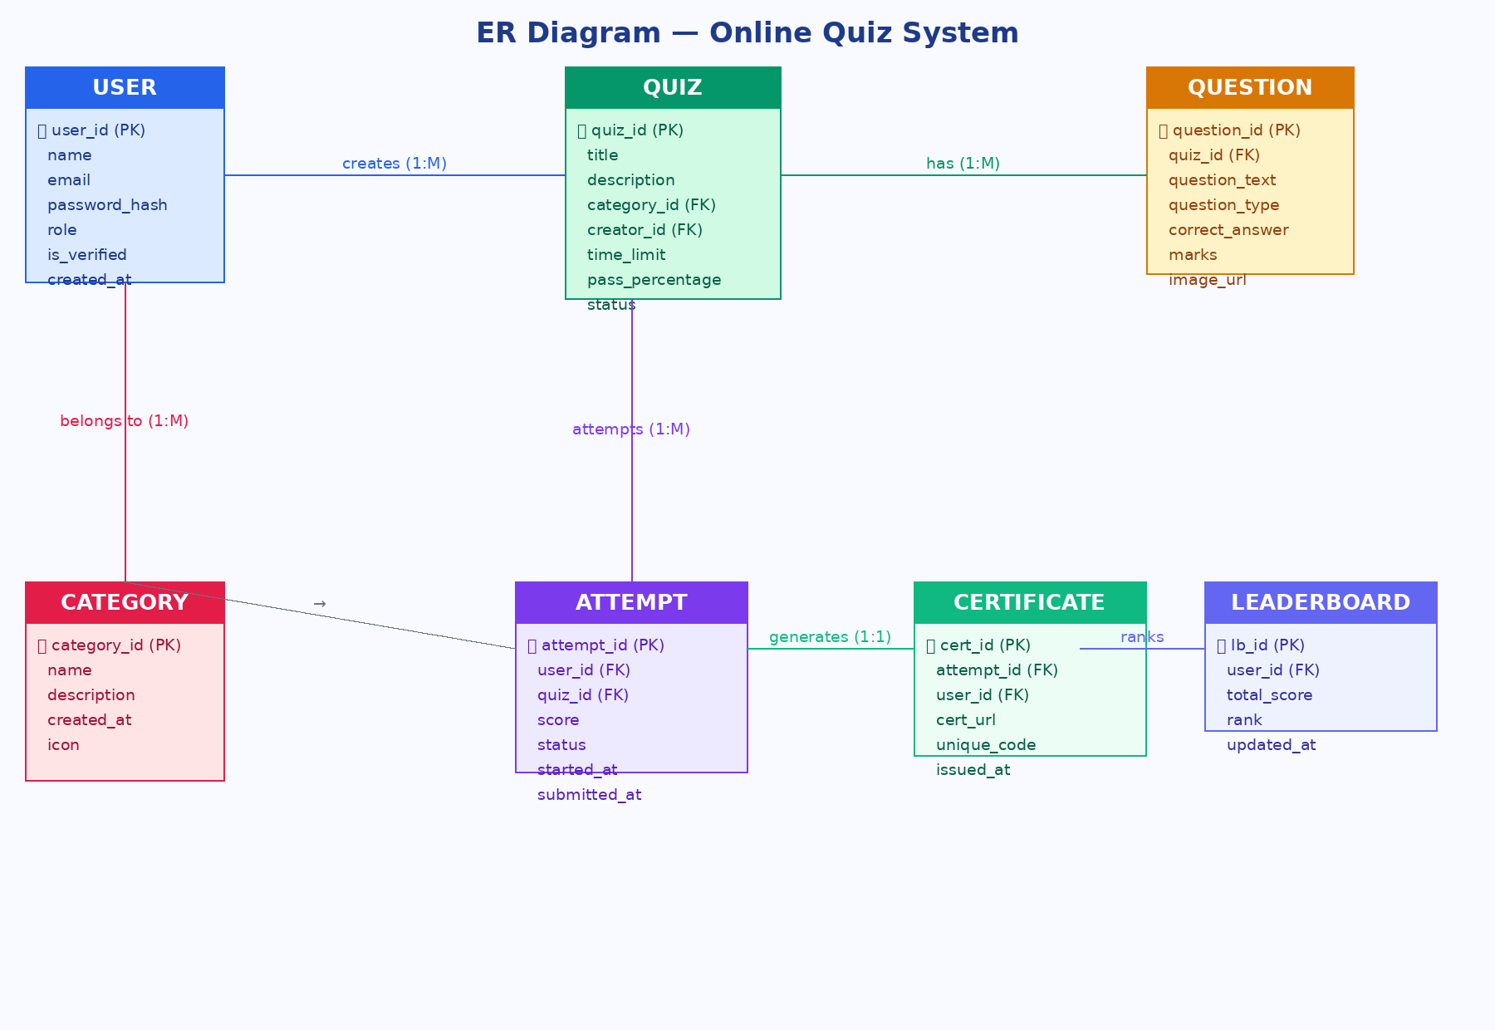
Figure 9.2: ER Diagram — Online Quiz System Database

9.3 Data Flow Diagram (DFD) — Level 1
The Data Flow Diagram (Level 1) below illustrates the flow of data between external entities, processes, and data stores within the Online Quiz System.

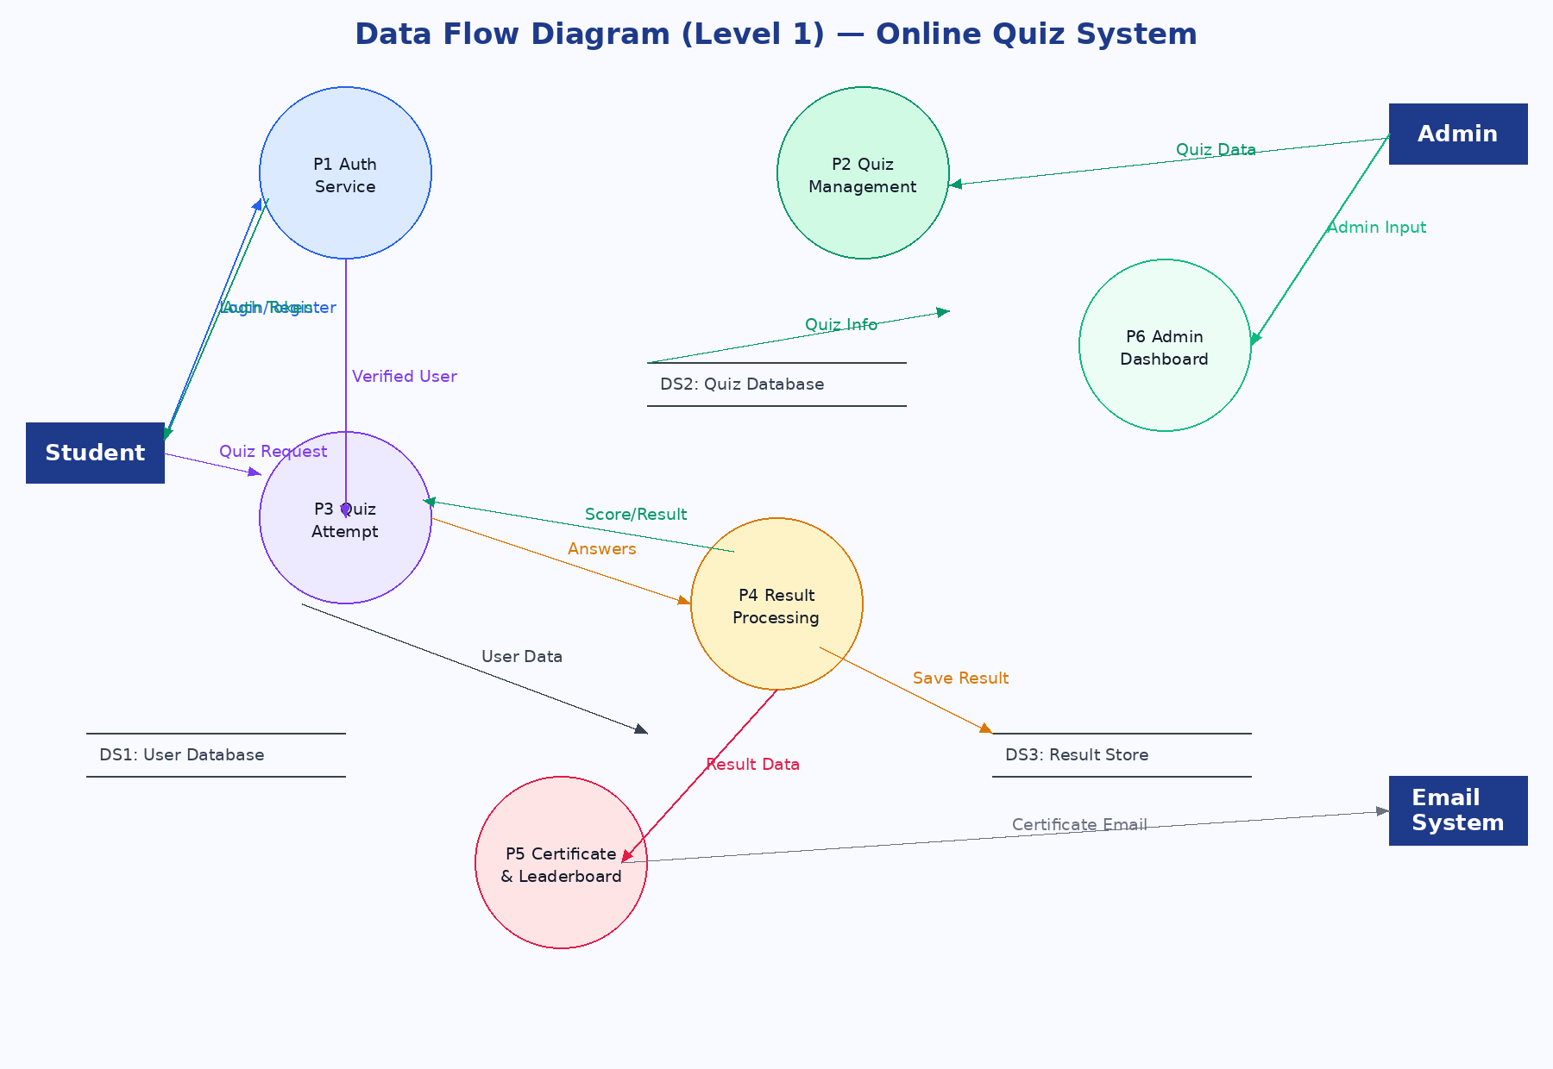
Figure 9.3: Data Flow Diagram (Level 1) — Online Quiz System

10. Appendices

10.1 Revision History
Version | Date | Author | Description
0.1 | April 2026 | Development Team | Initial Draft
0.5 | April 2026 | Development Team | Added functional requirements
1.0 | May 2026 | Development Team | Final version

10.2 Approval
Name | Role | Signature
___________________ | Project Manager | ___________________
___________________ | Lead Developer | ___________________
___________________ | Client / Stakeholder | ___________________

10.3 Glossary
- Authentication: The process of verifying the identity of a user
- Authorization: The process of determining whether a user has access to a resource
- Certificate: A digital document issued upon successful quiz completion
- Leaderboard: A ranked list of users based on their quiz scores
- Quiz Creator: A user role with permission to create and manage quizzes
- Session Token: A temporary key used to maintain a user's login state
- OTP: A one-time code sent to verify user identity

10.4 Future Enhancements
The following features are planned for future versions of the Online Quiz System:
- Mobile Native Application (iOS and Android)
- AI-powered question generation and difficulty assessment
- Video-based questions and proctoring with webcam integration
- Integration with Learning Management Systems (LMS)
- Subscription and monetization system for premium quiz access
- Multi-language interface support (Urdu, Arabic, French)
- Gamification features including badges, points, and achievements

— End of Software Requirements Specification Document —

