1. Sign Up the employee.

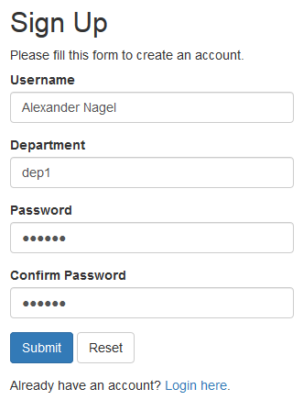

1. Login

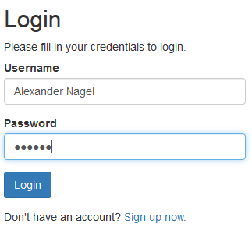

1. Landing to main dep view.

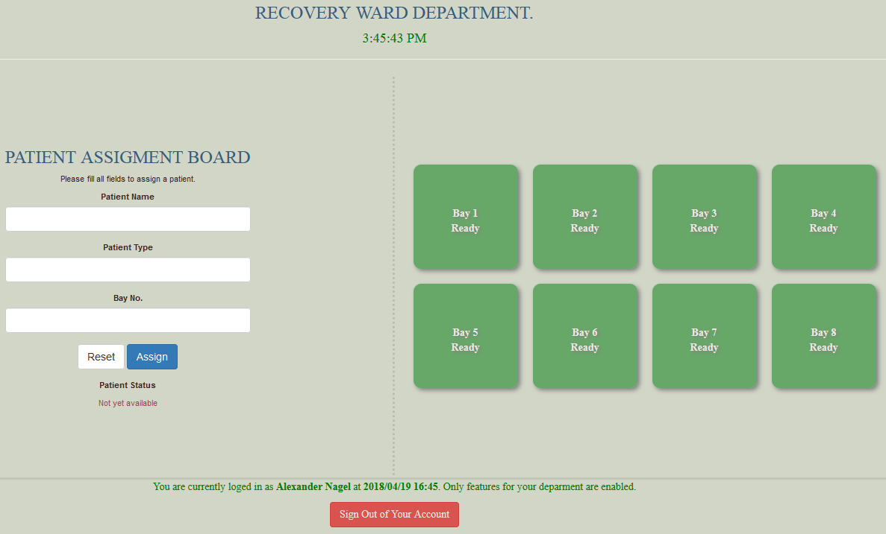

1. Assign patient to a bay

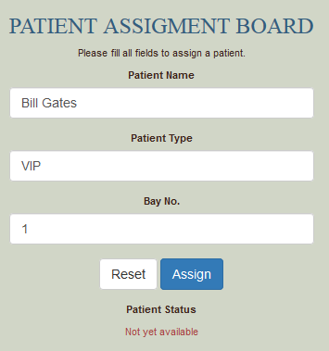

1. GUI response after successful assignment

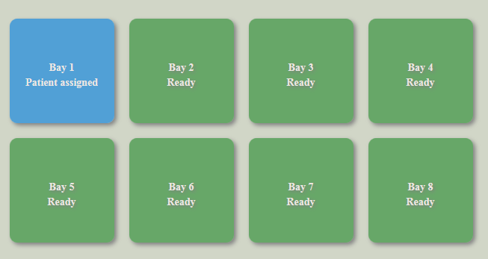

1. GUI response after request for transfer been sent to Day ward department

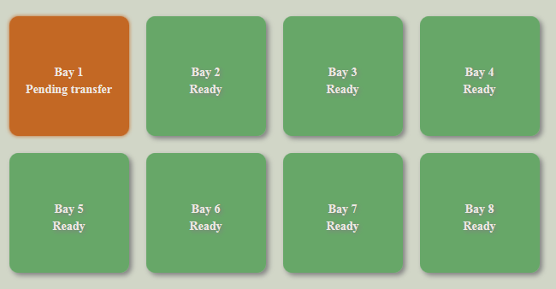

1. GUI response after request for transfer has been accepted by Day ward department

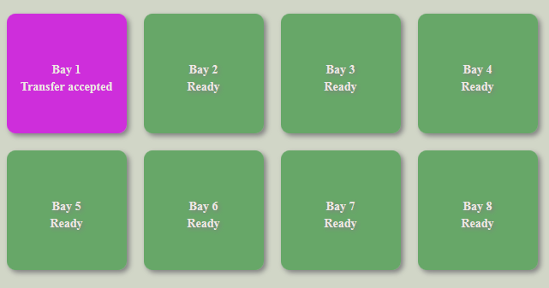

1. GUI response if timeout for pending transfer or patient collection by Day ward department.

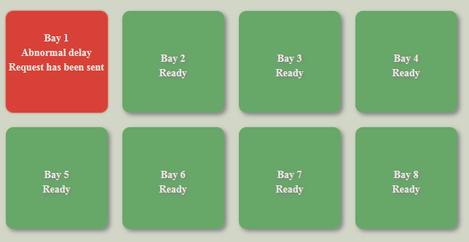

1. GUI response when patient transferred to Day ward department.

