Lead_Report

2024-10-01

lead <- read_csv("../DataRaw/lead-iq-01.csv", show_col_types = FALSE)

(  
 ggplot(data = lead, aes(x = Smelter, y = IQ))  
 + geom_boxplot()  
 + labs(title = "Figure 1")  
 + theme_classic()  
)

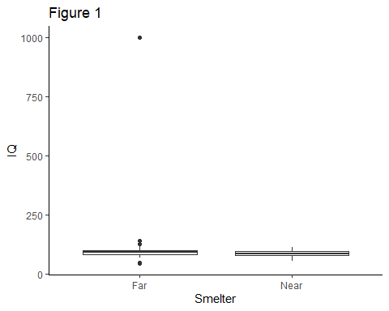

(  
 lead  
 %>% summarise(  
 .by = Smelter,  
 `Mean IQ` = mean(IQ) %>% round(2),  
 `SD IQ` = sd(IQ) %>% round(2)  
 )  
) -> summaries  
  
knitr::kable(summaries, format = "pipe", padding = 2, caption = "Table 1: Means and SDs")

Table 1: Means and SDs

| Smelter | Mean IQ | SD IQ |
| --- | --- | --- |
| Far | 106.12 | 111.88 |
| Near | 89.19 | 12.17 |

Looking at *Figure 1* and *Table 1* above, it appears that those in the Far group have, on average, a higher IQ $\left(mean±SD=106.12±111.88\right)$ than those in the Near group ($\left(mean±SD=89.19±12.17\right)$).