**Lab: Cassandra setup | Master-less architecture**

1. Create a security group : ‘cassandra-ports’

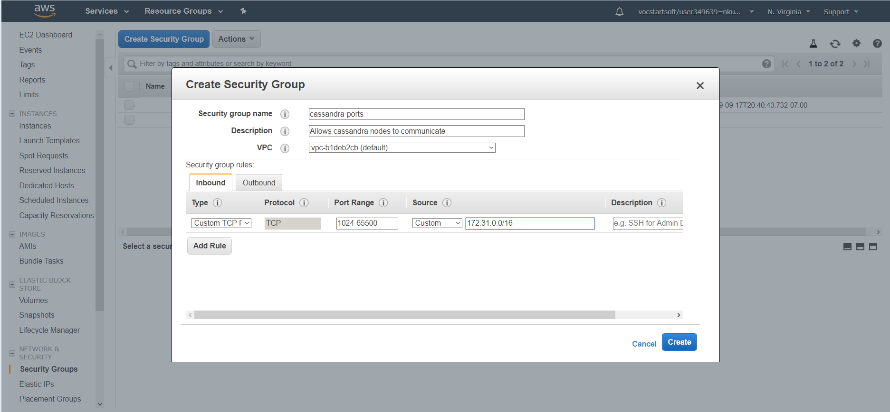

1. Launch 3 EC2 instance each one in different Availability zones using community AMI (SKL-Ubuntu-Cassandra)

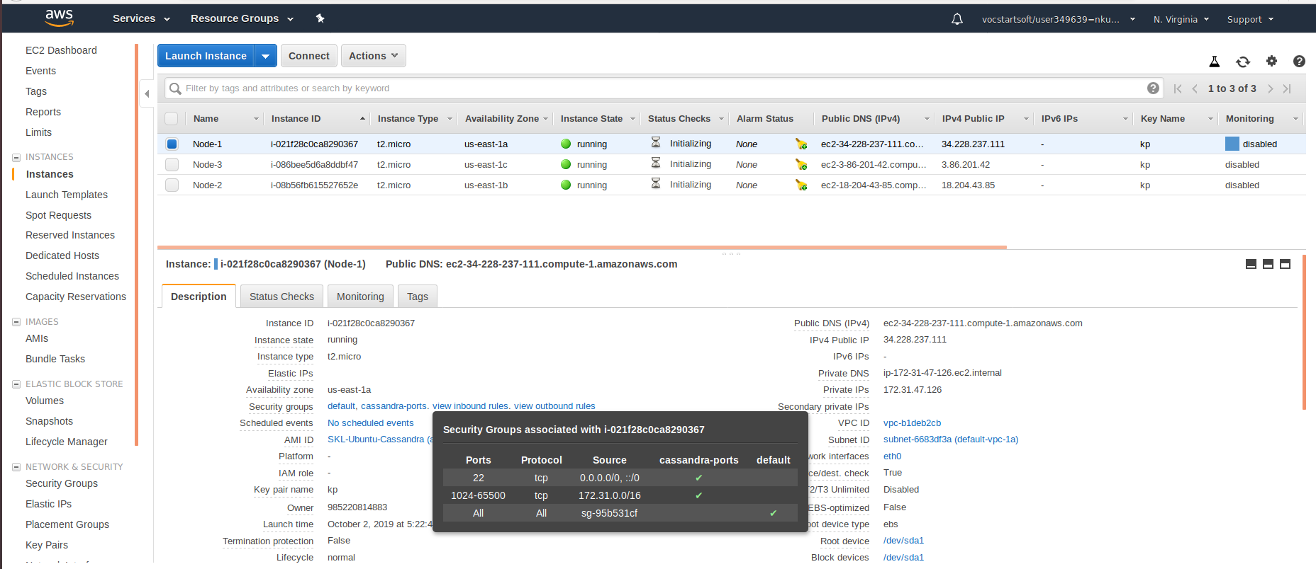

1. Node-1 cassandra config setup in AZ-1a

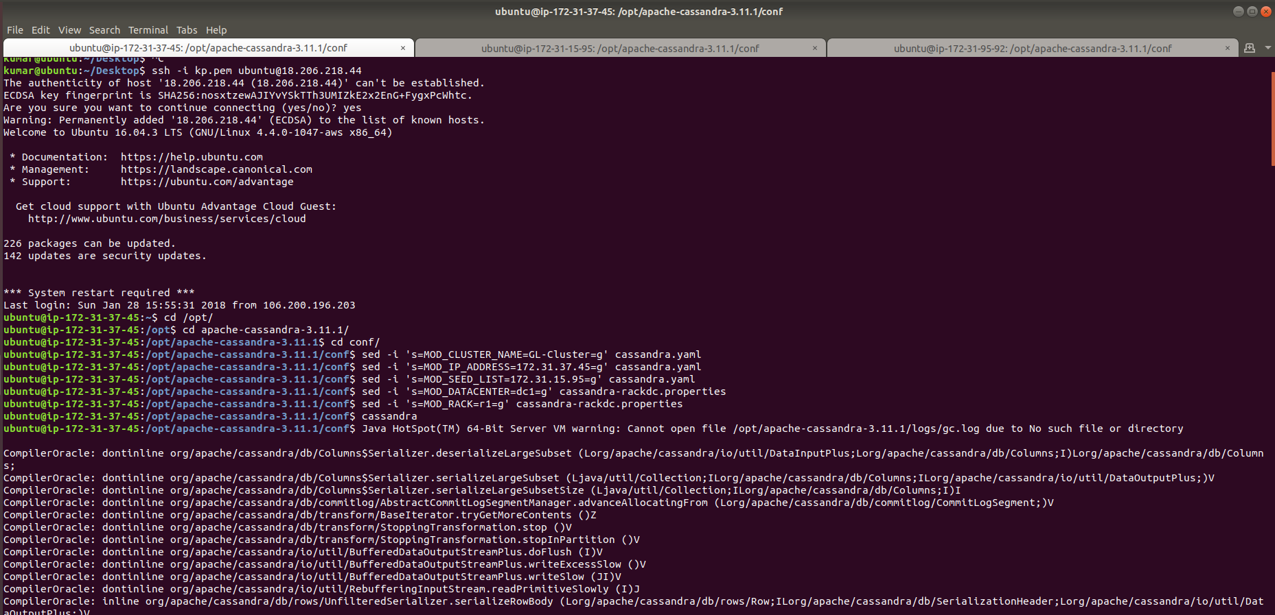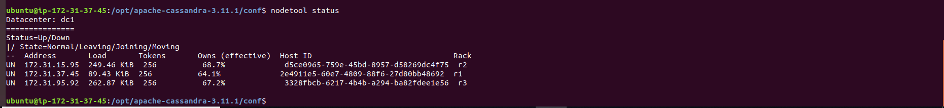

1. Node-2 cassandra config setup in AZ-1b

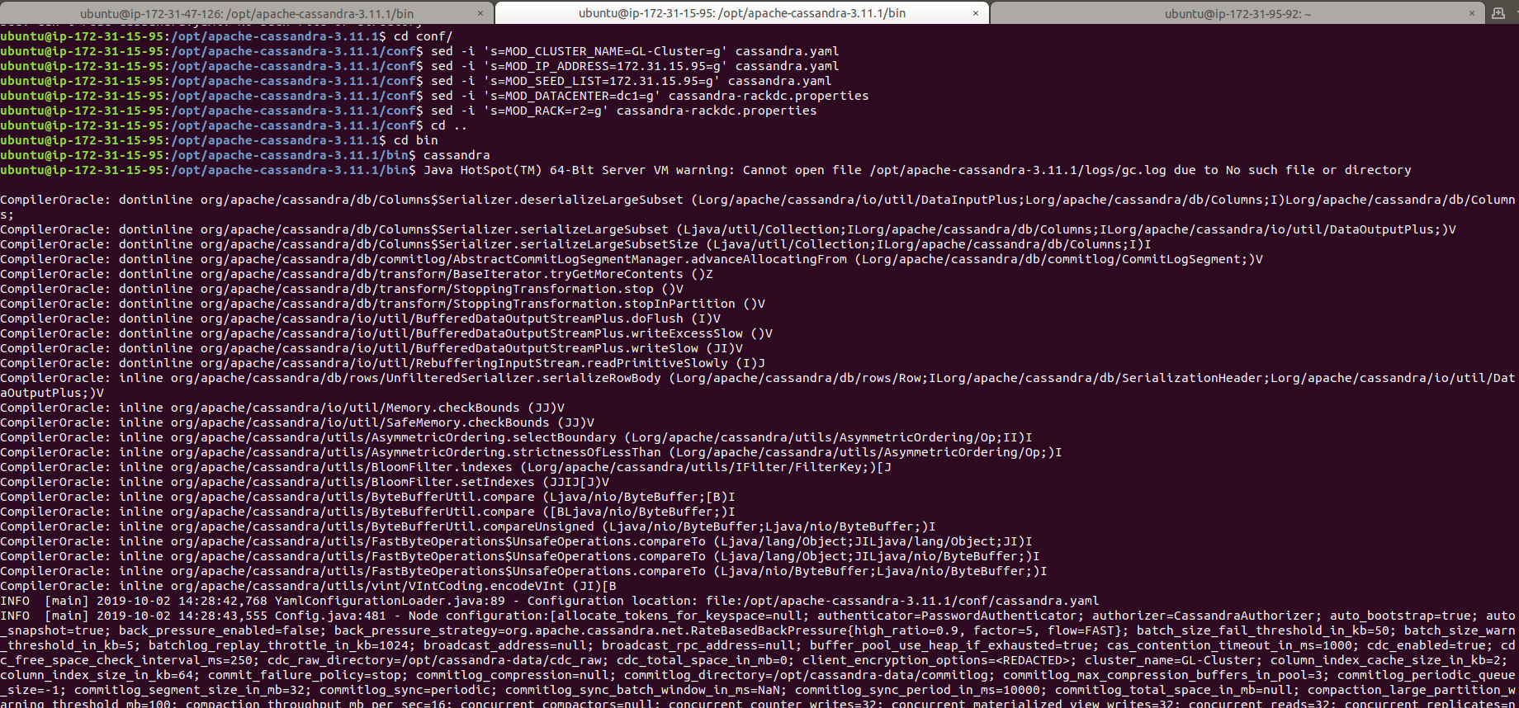 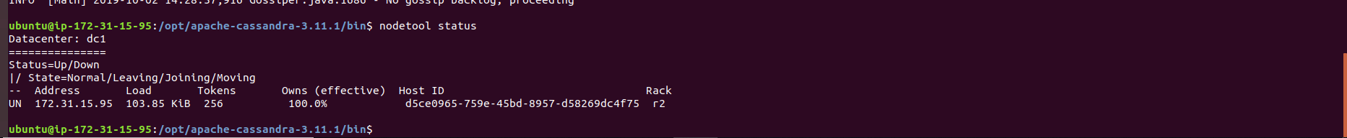

1. Node-3 cassandra config setup in AZ-1c

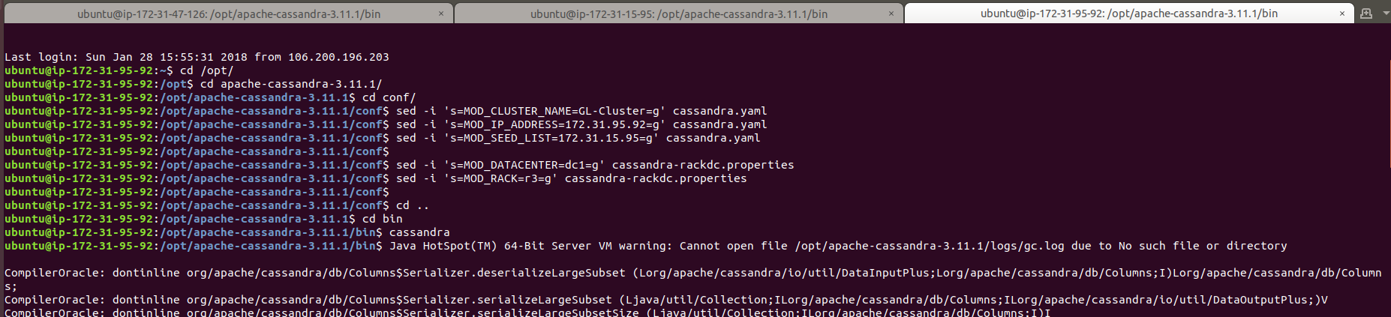

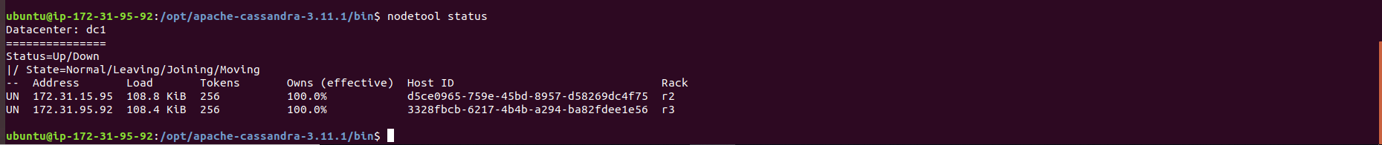

1. Login to cqlsh and create table with data

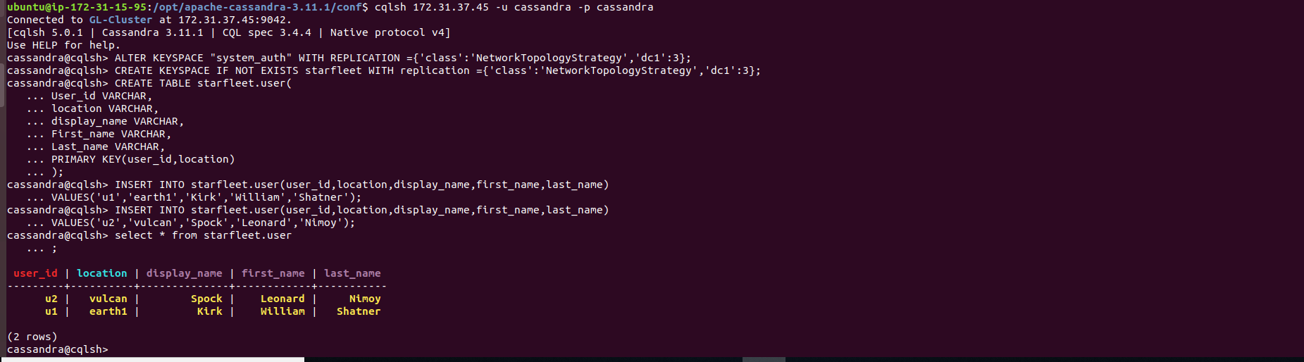

1. Changing CONSISTENCY level

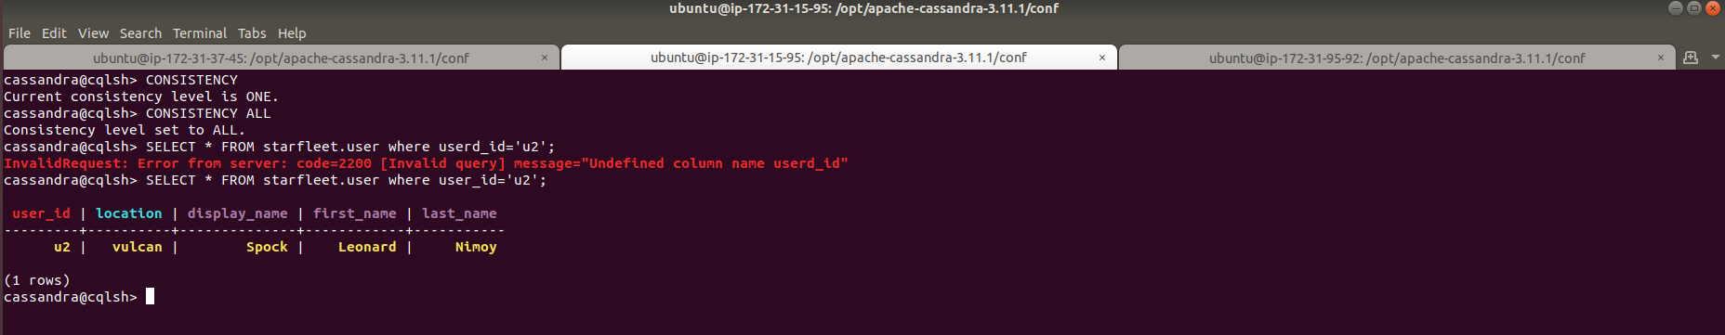

1. Shutting down the Node-3 in AZ-c

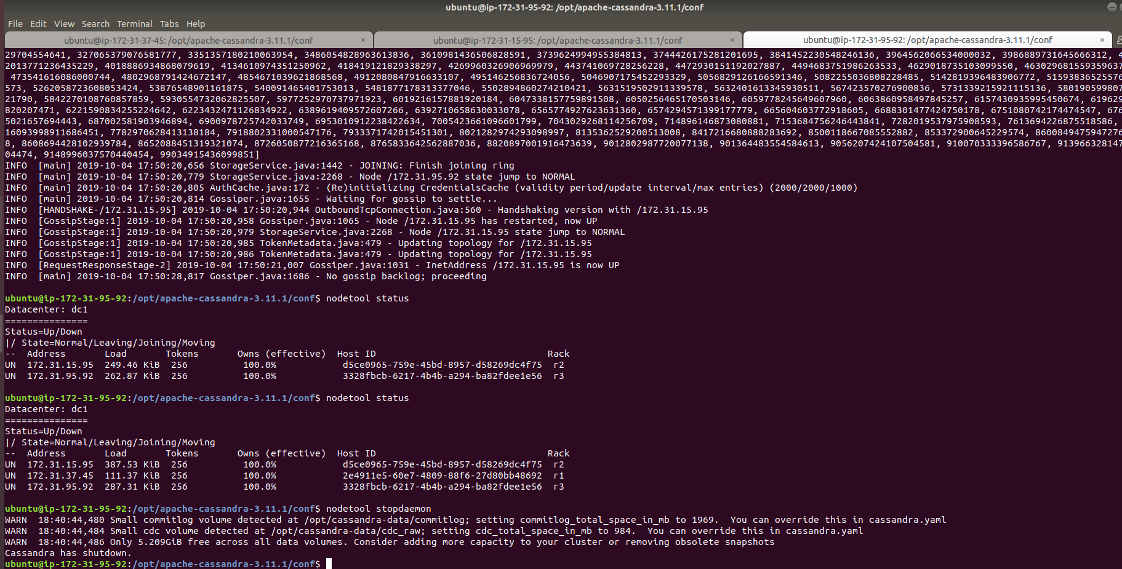

1. Observation after shutting down node-3, high consistency and lowest availability

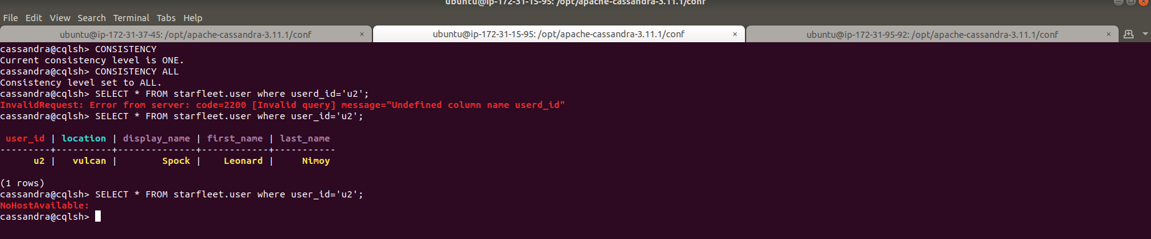

1. Changing CONSISTENCY level to Quorum and firing same query gives output even after failure of one node as Quorum of all nodes all data centers

