**Storage Lab**

1. Amazon Linux AMI- EC2 instance in N.Varginia

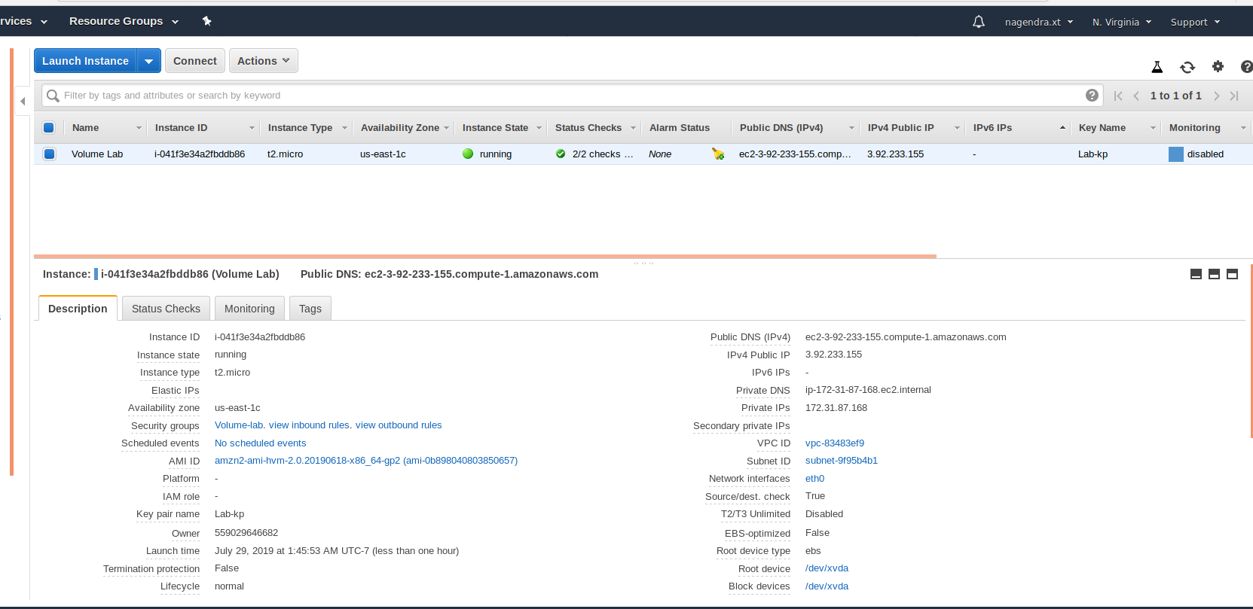

1. SSH EC2

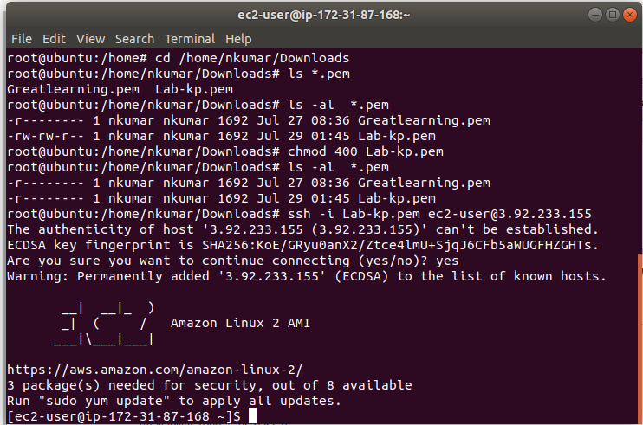

1. Volume associated to EC2

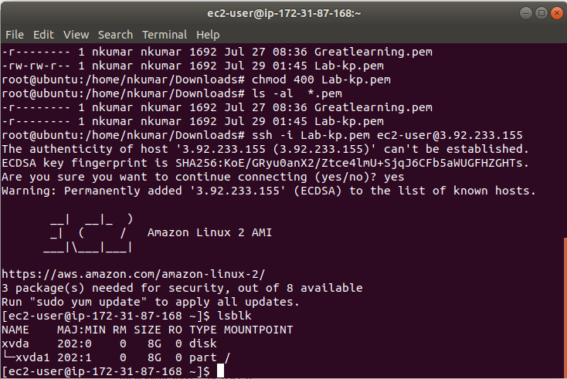

1. Additional Volume creation

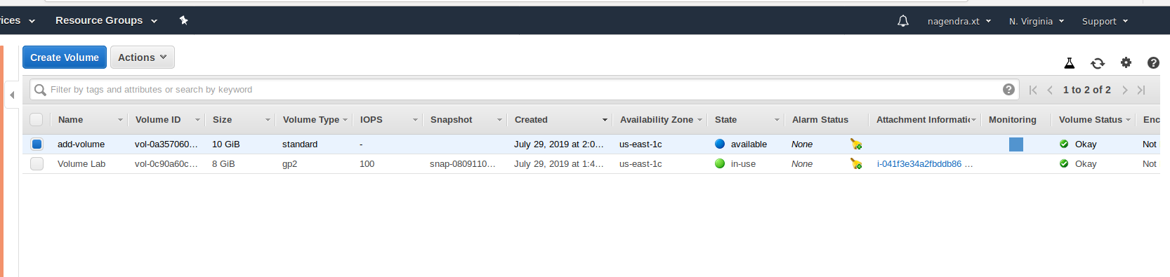

1. In use of additional volume

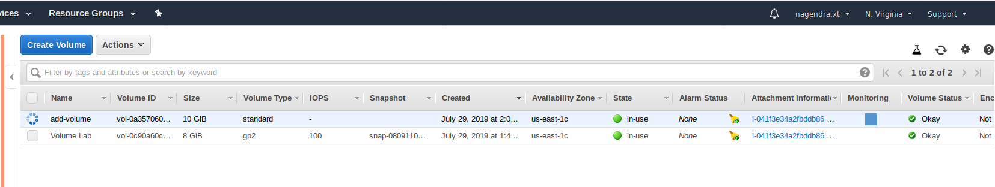

1. LSBLK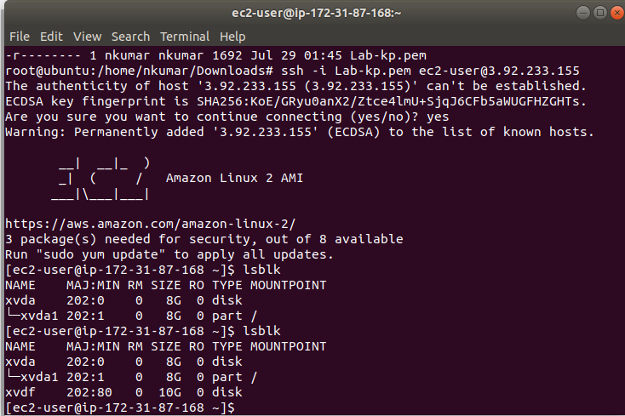
2. Disk fragmentation

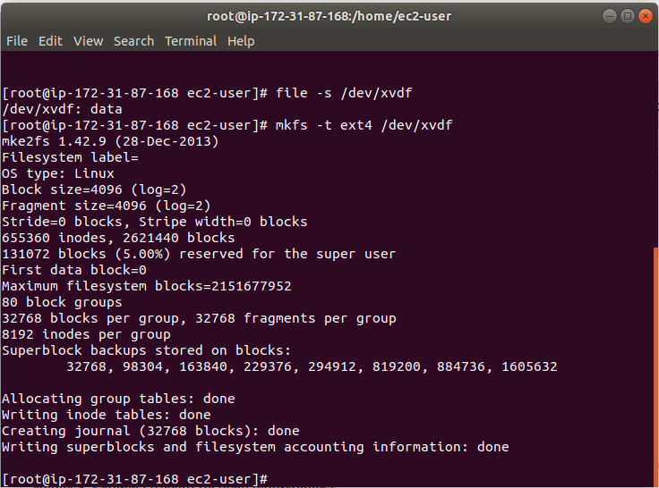

1. Create new directory and mount the disk

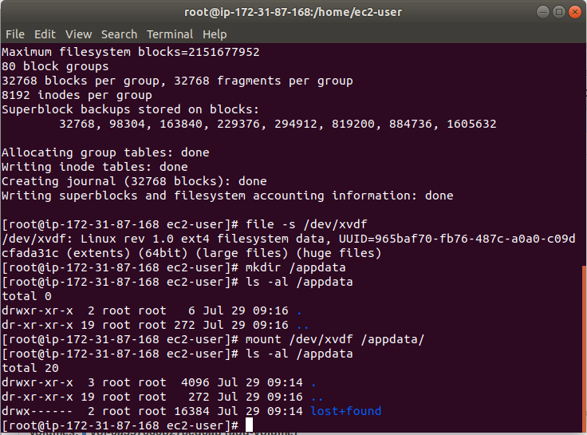

1. File creation and umount the disk

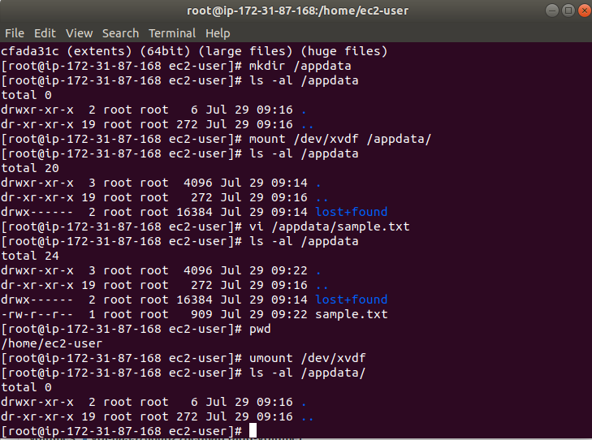

1. Snapshot creation

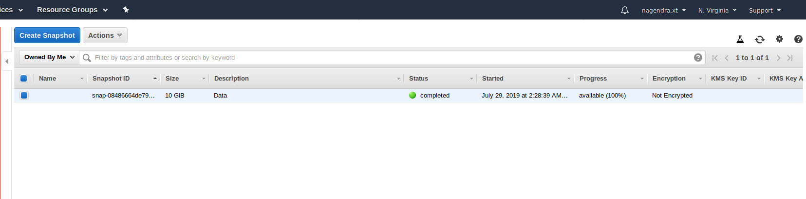

1. Additional 15 GIB volume

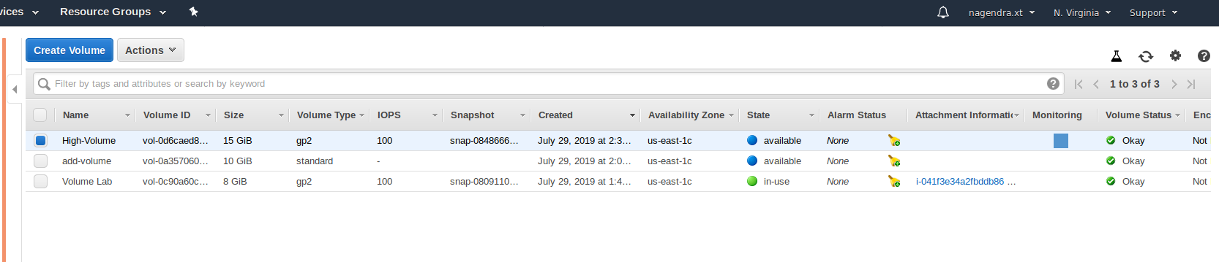

1. New volume mount

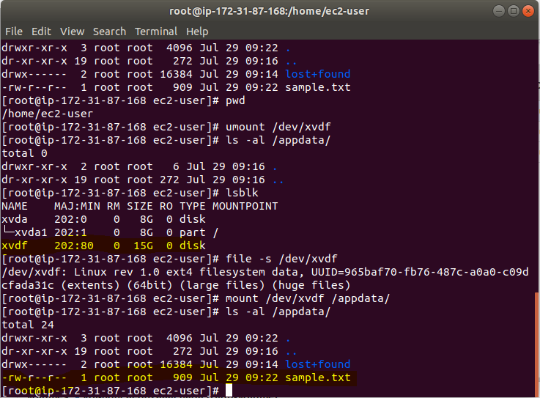

1. Disk partition

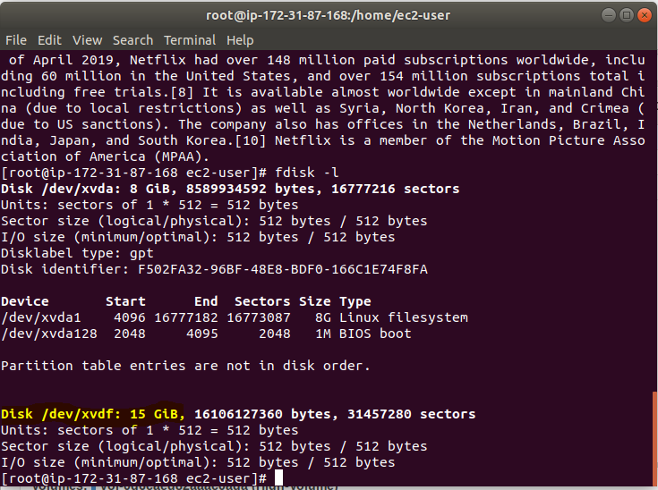

**S3 CLI Lab**

1. Create user from IAM with CLI access

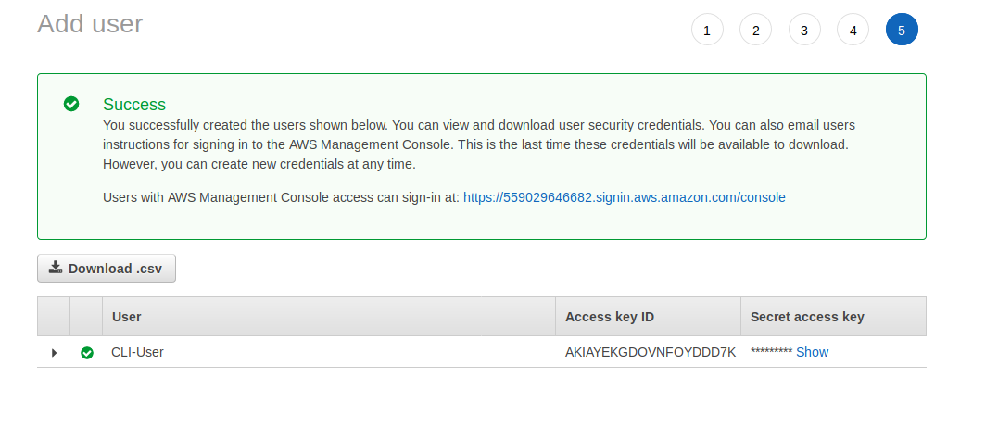

1. Create Bucket

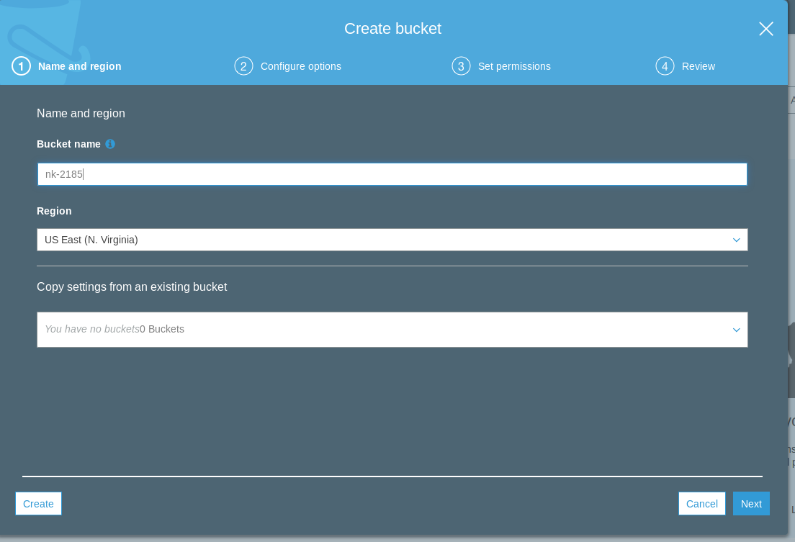

1. Upload file to S3

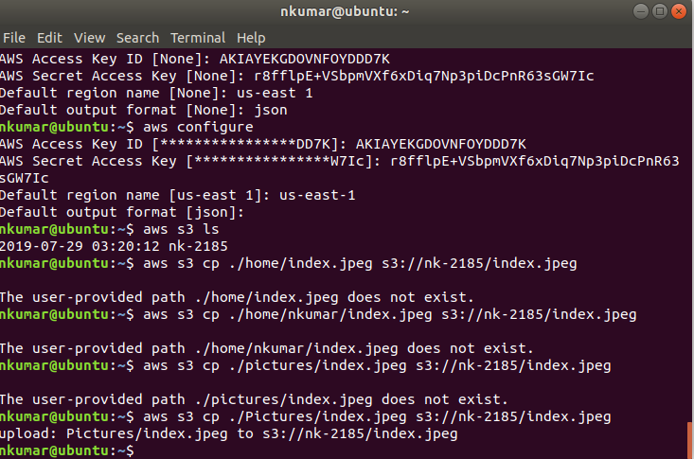

1. Index.jpeg under bucket

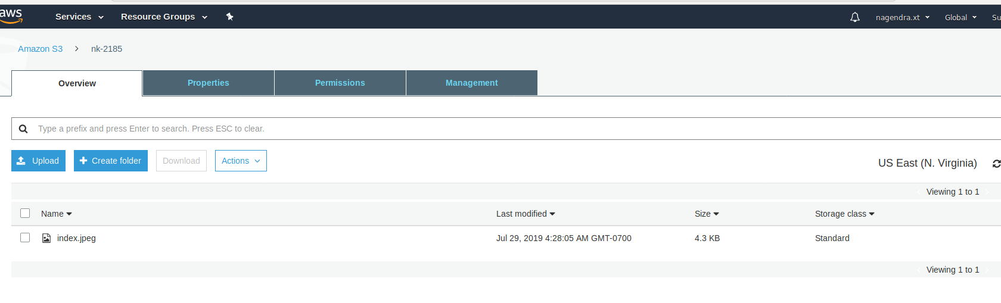

1. Delete file from s3 bucket

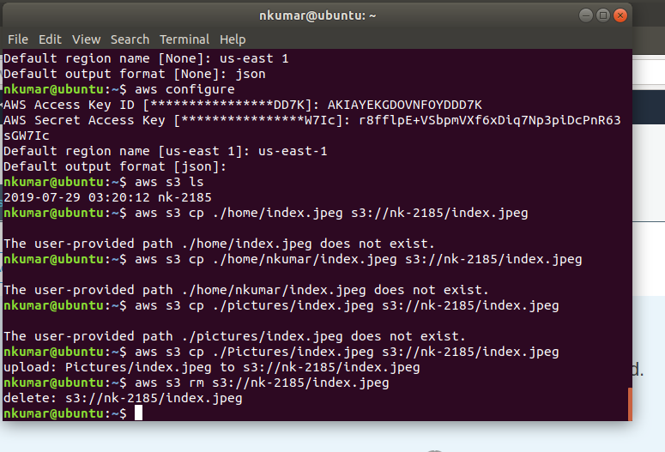

1. Replication- Enabling versioning

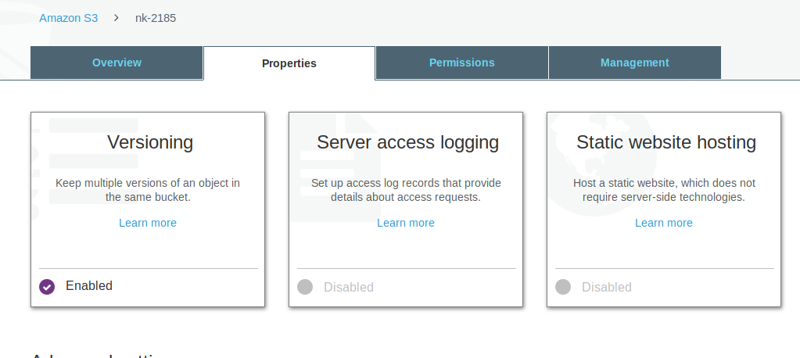

1. Replication rule

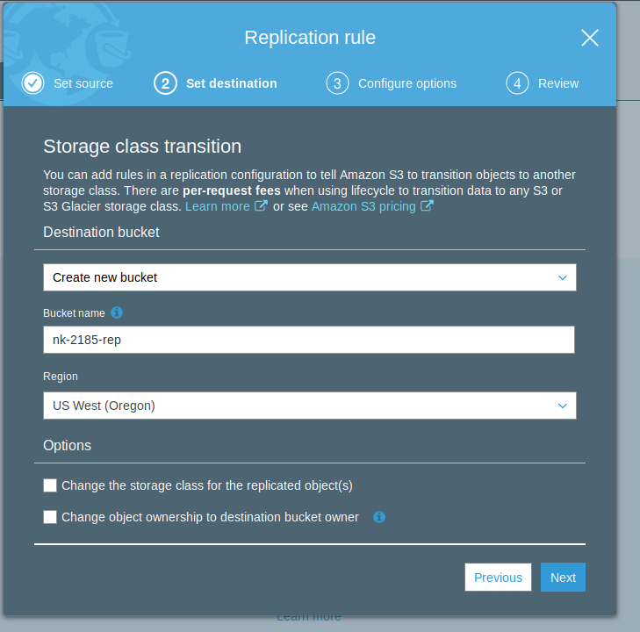

1. Rule summary

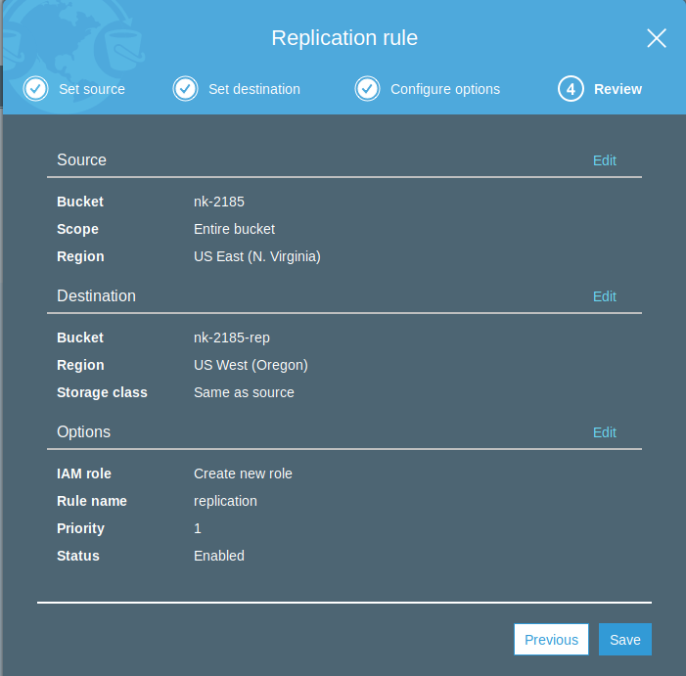

1. Bucket in replication bucket in Oregon

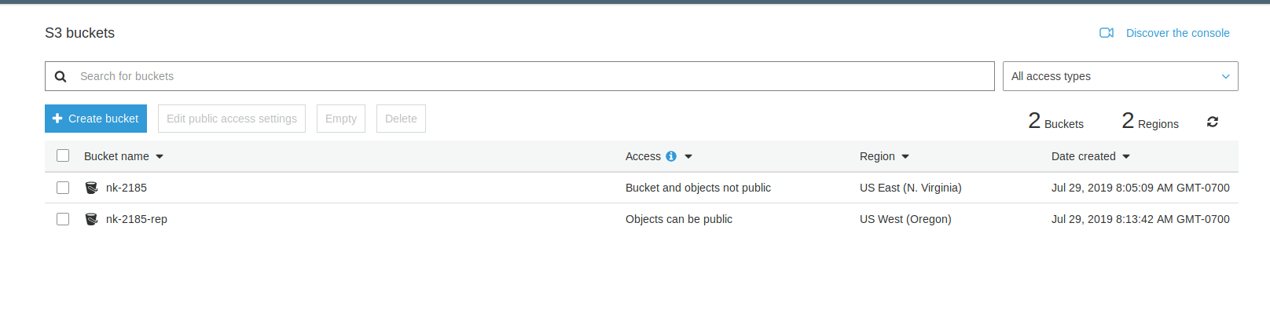

1. File upload for replication in Oregon

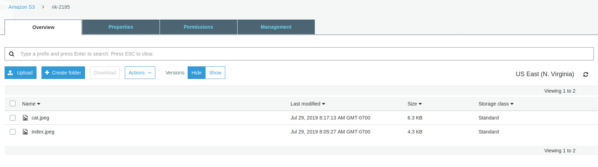

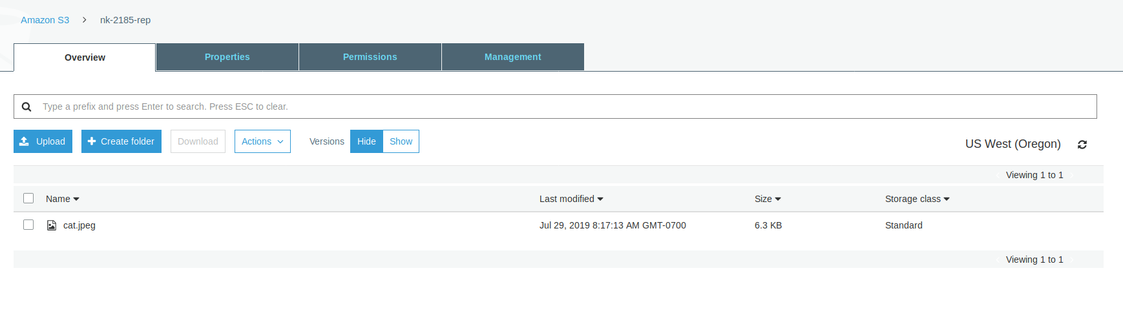

11.Versioning

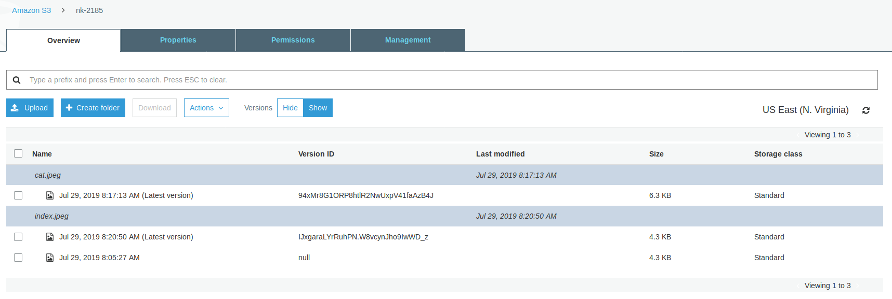

1. Deleting the original file from N.varginia, replica still exists in Oregon

