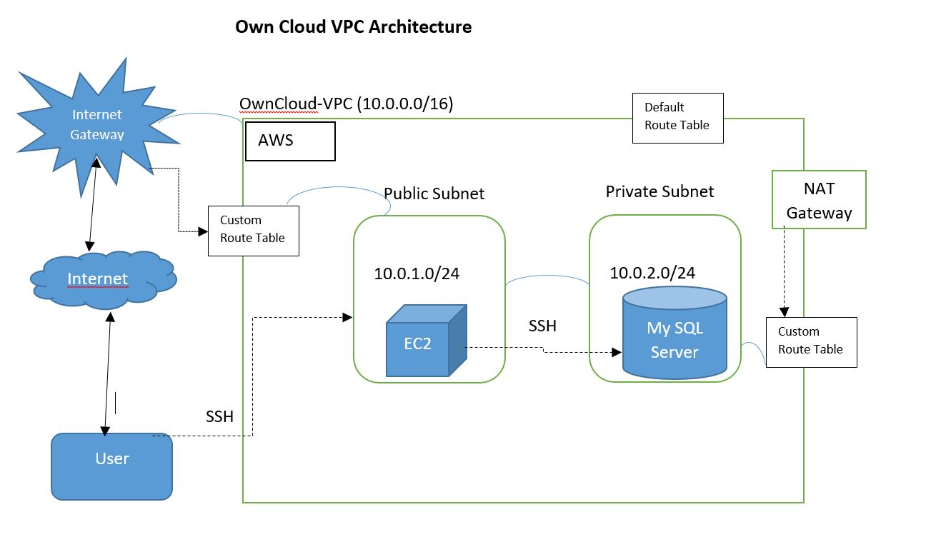

1. Creating a Custom VPC from Services with CIDR block 10.0.0.0/16

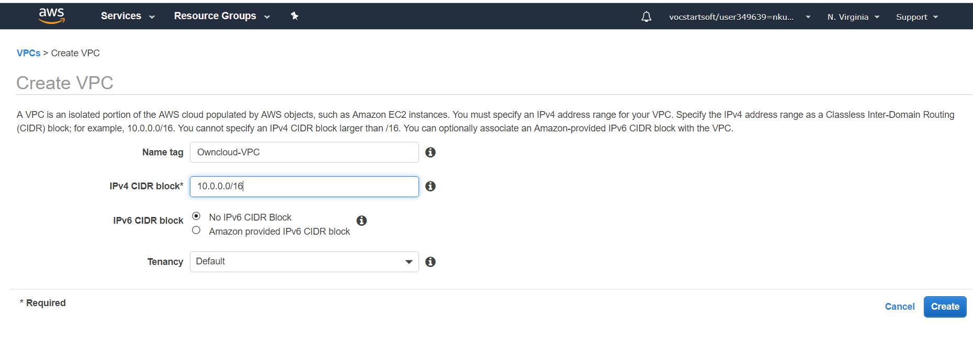

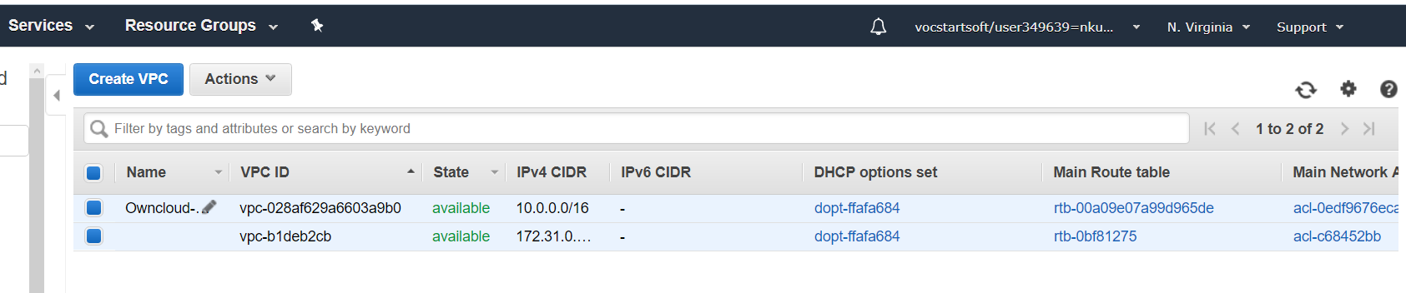

1. Create Public Subnet under Subnet tab with CIDR block 10.0.10./24

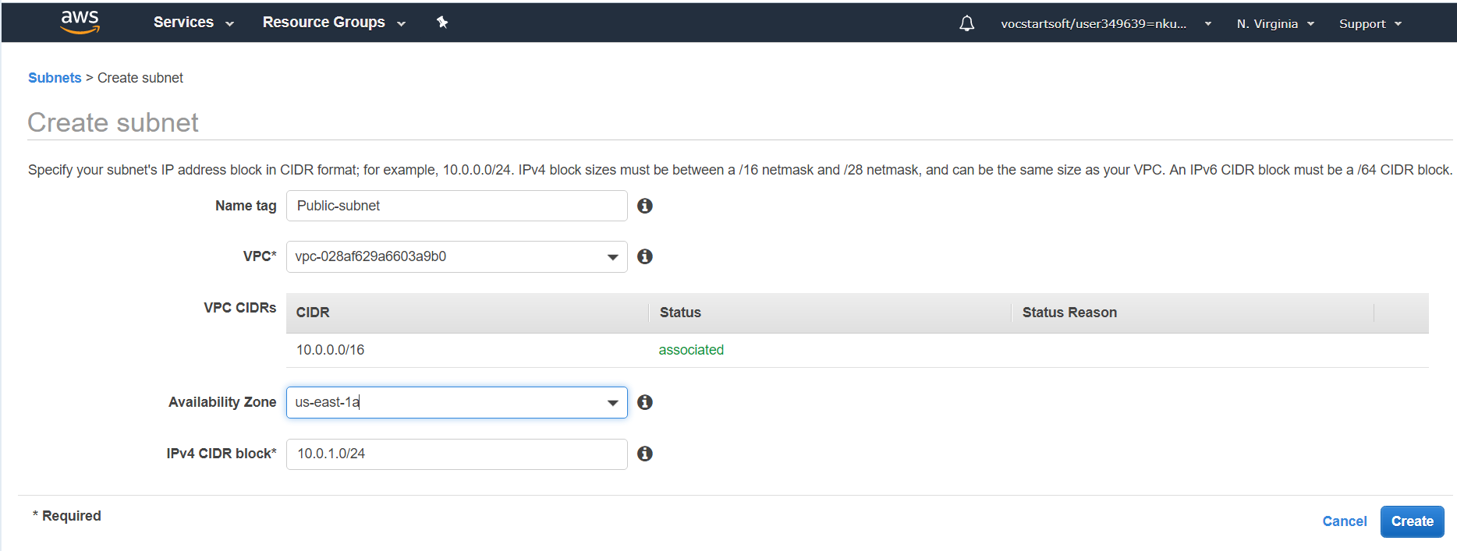

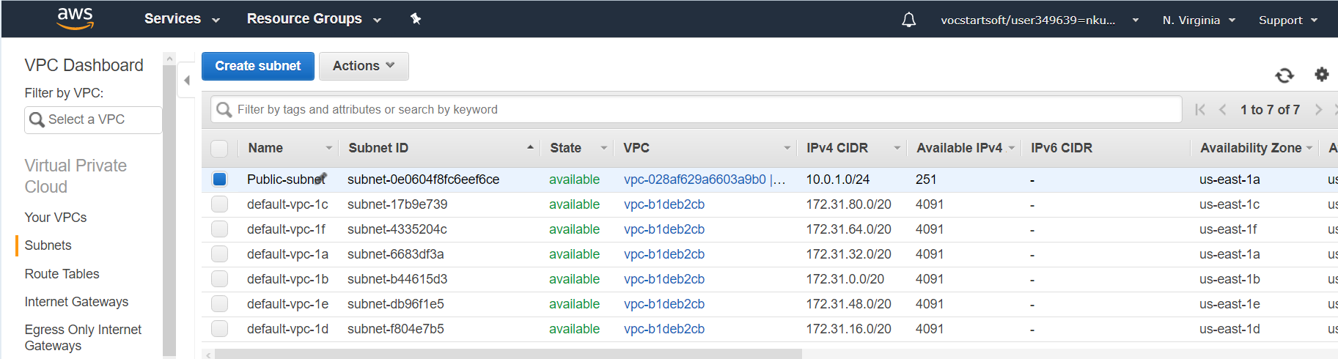

1. Create Private Subnet with CIDR block 10.0.2.0/24

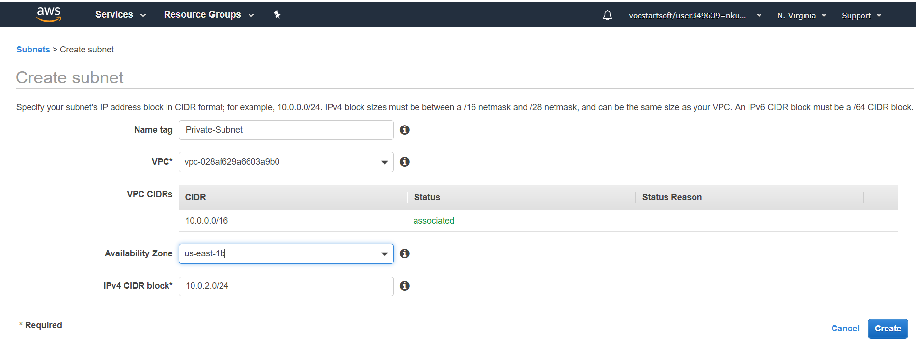

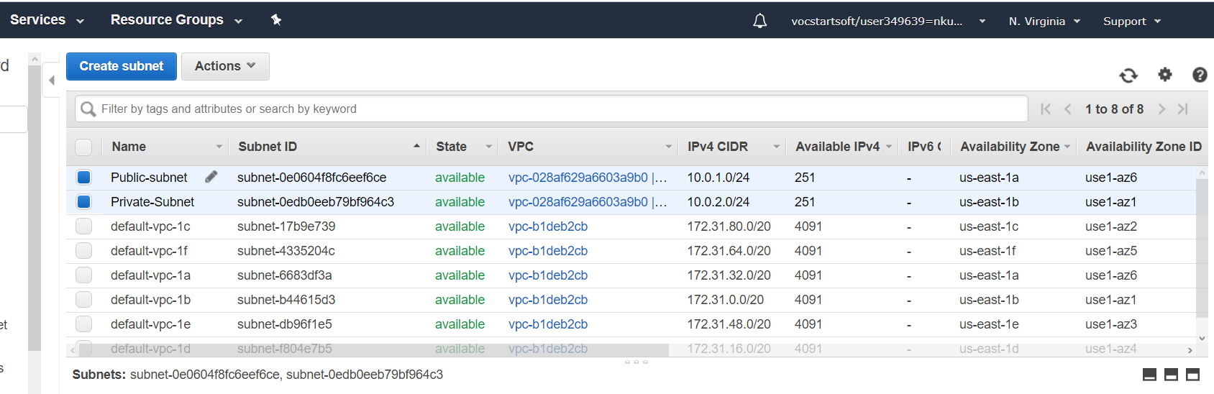

1. Making Public –subnet expose to public by creating an Internet gateway

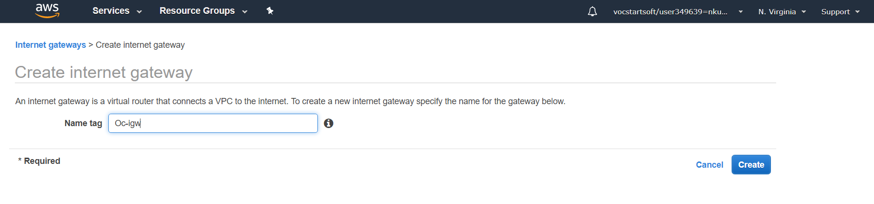

1. Attach Oc-igw internet gateway to Custom VPC(Owncloud-VPC)

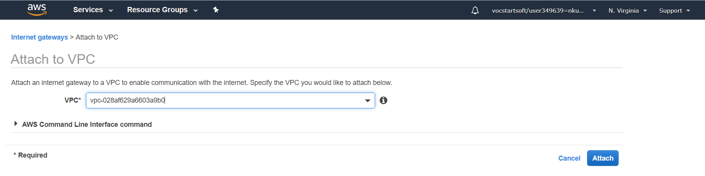

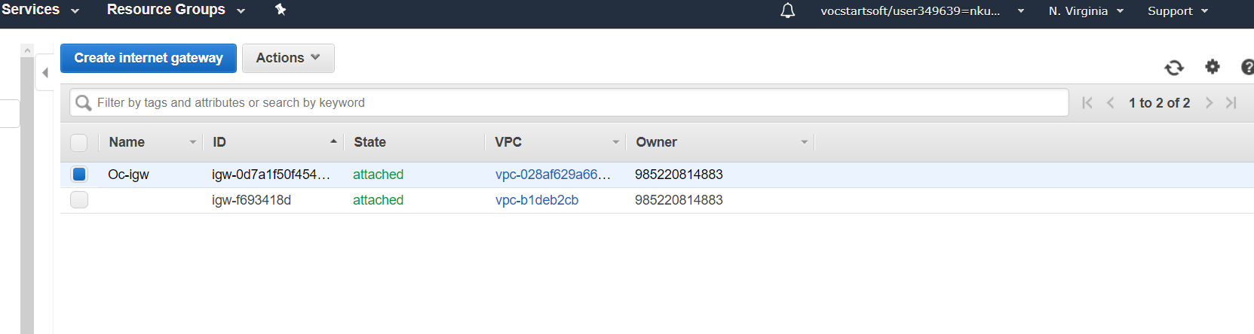

1. Create route table for custom VPC

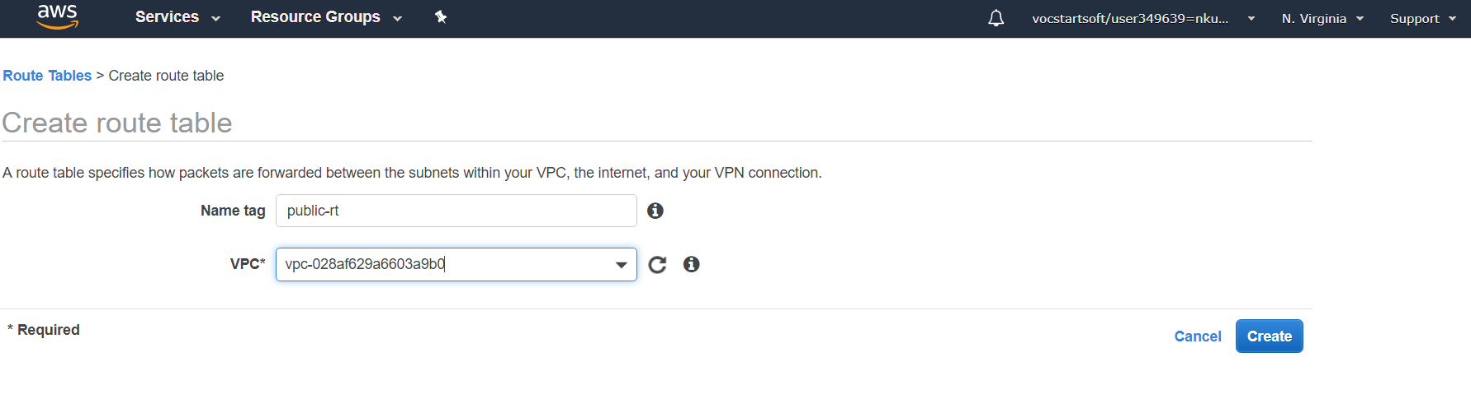

1. Edit the Routes under Route tab

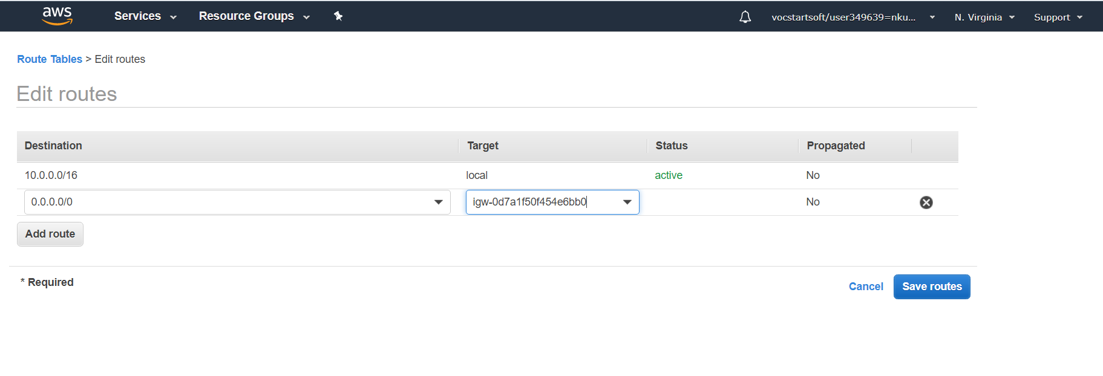

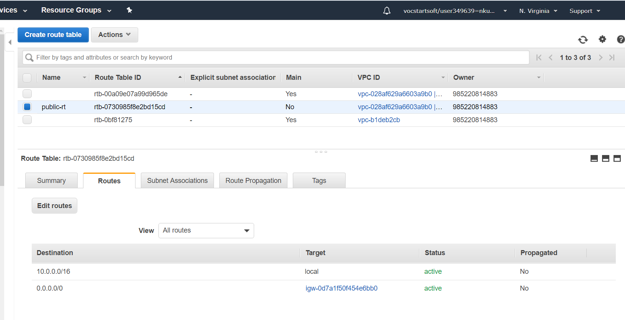

1. Subnet Associations under public-Route Table

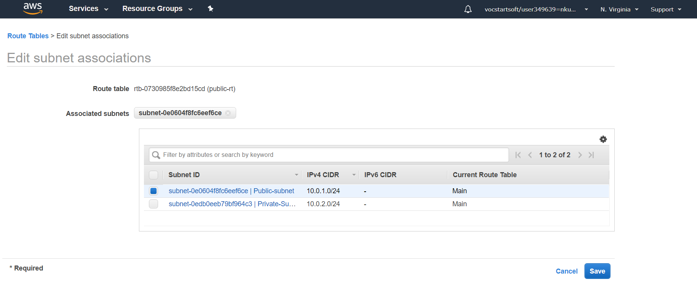

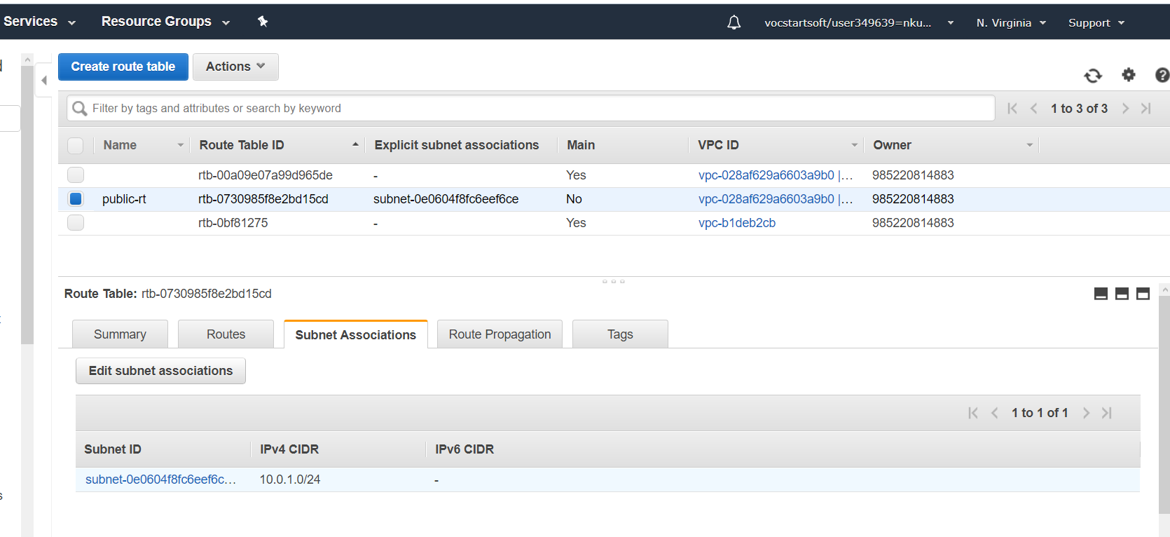

1. Public route table associated with public subnet

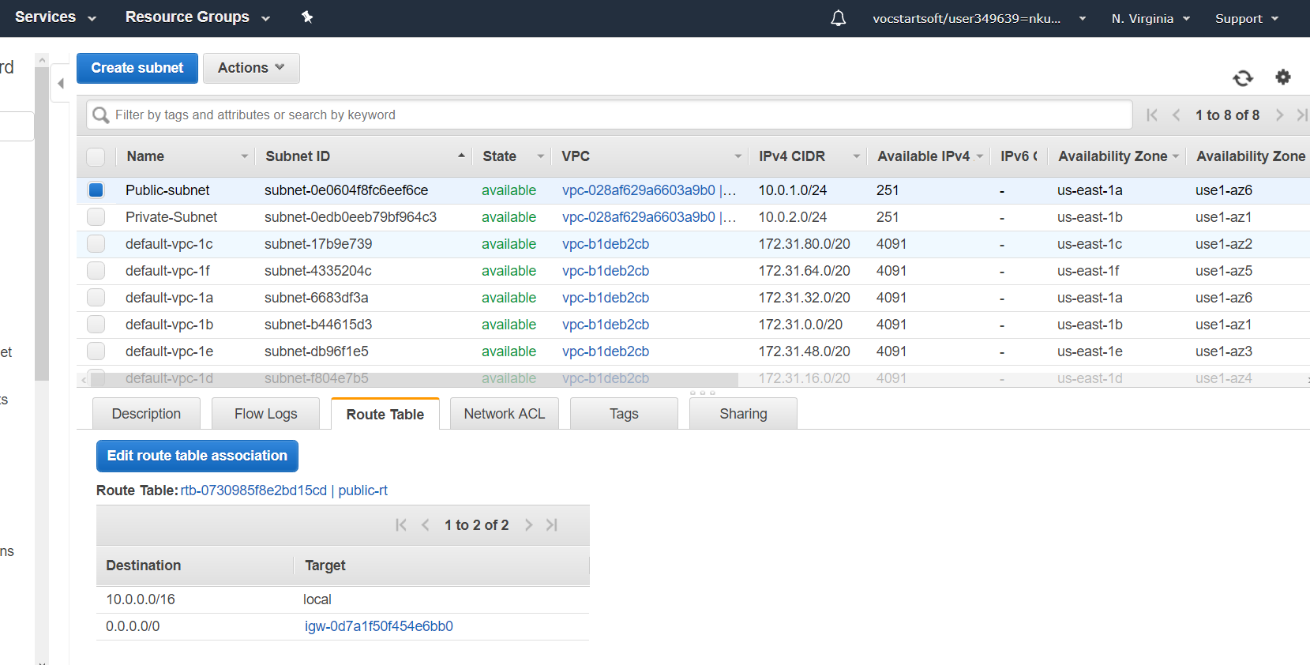

1. Auto Assigning the IP address for Public subnet

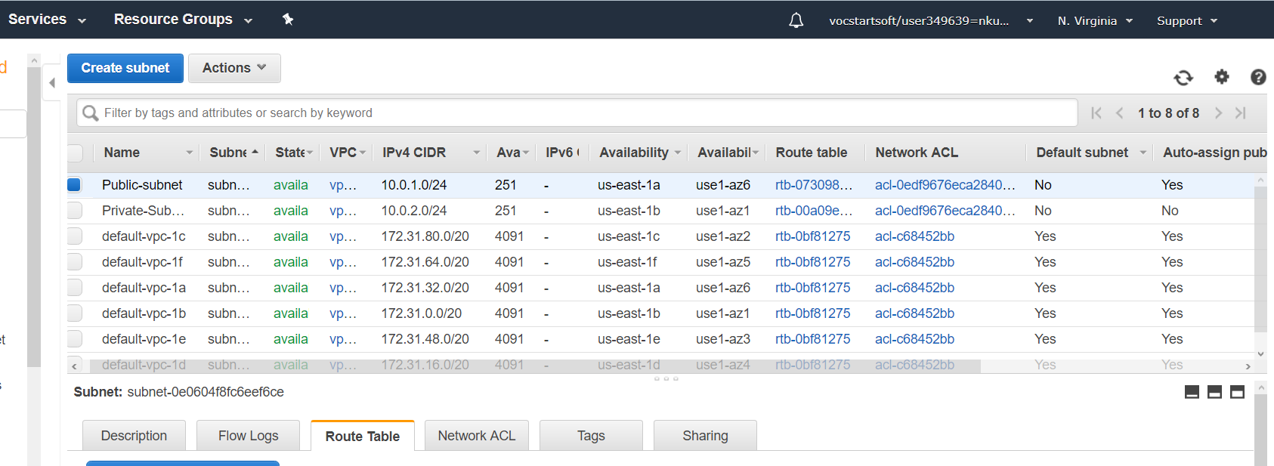

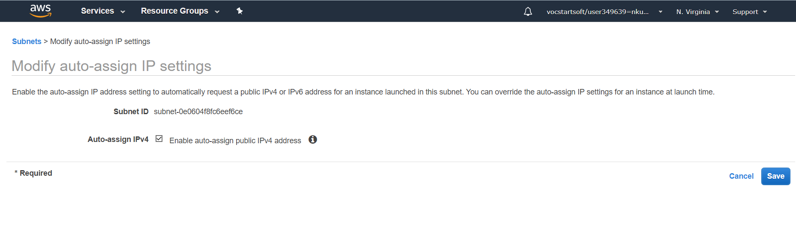

1. Create EC2 instance and choose custom VPC under Network drop down and select public subnet under subnet drop down

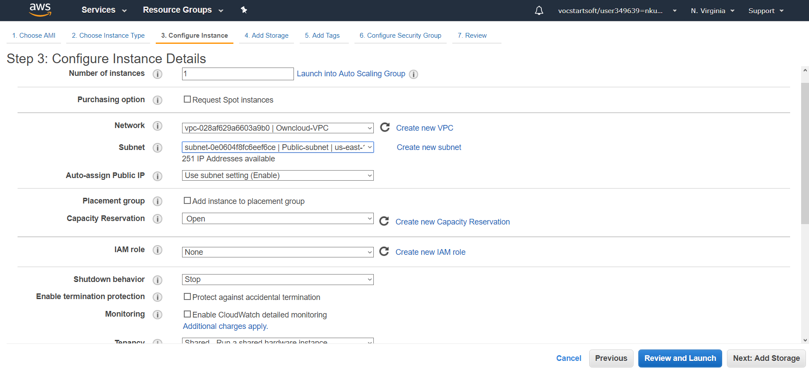

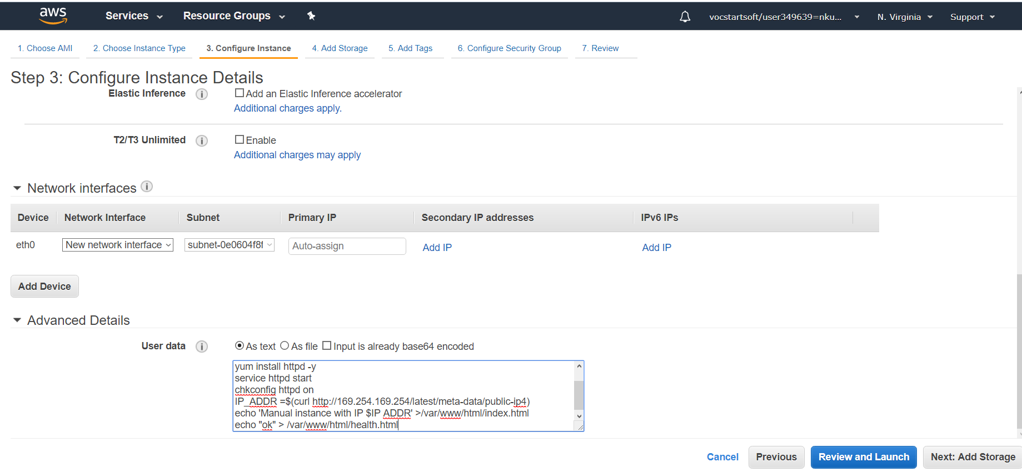

1. Create new security group

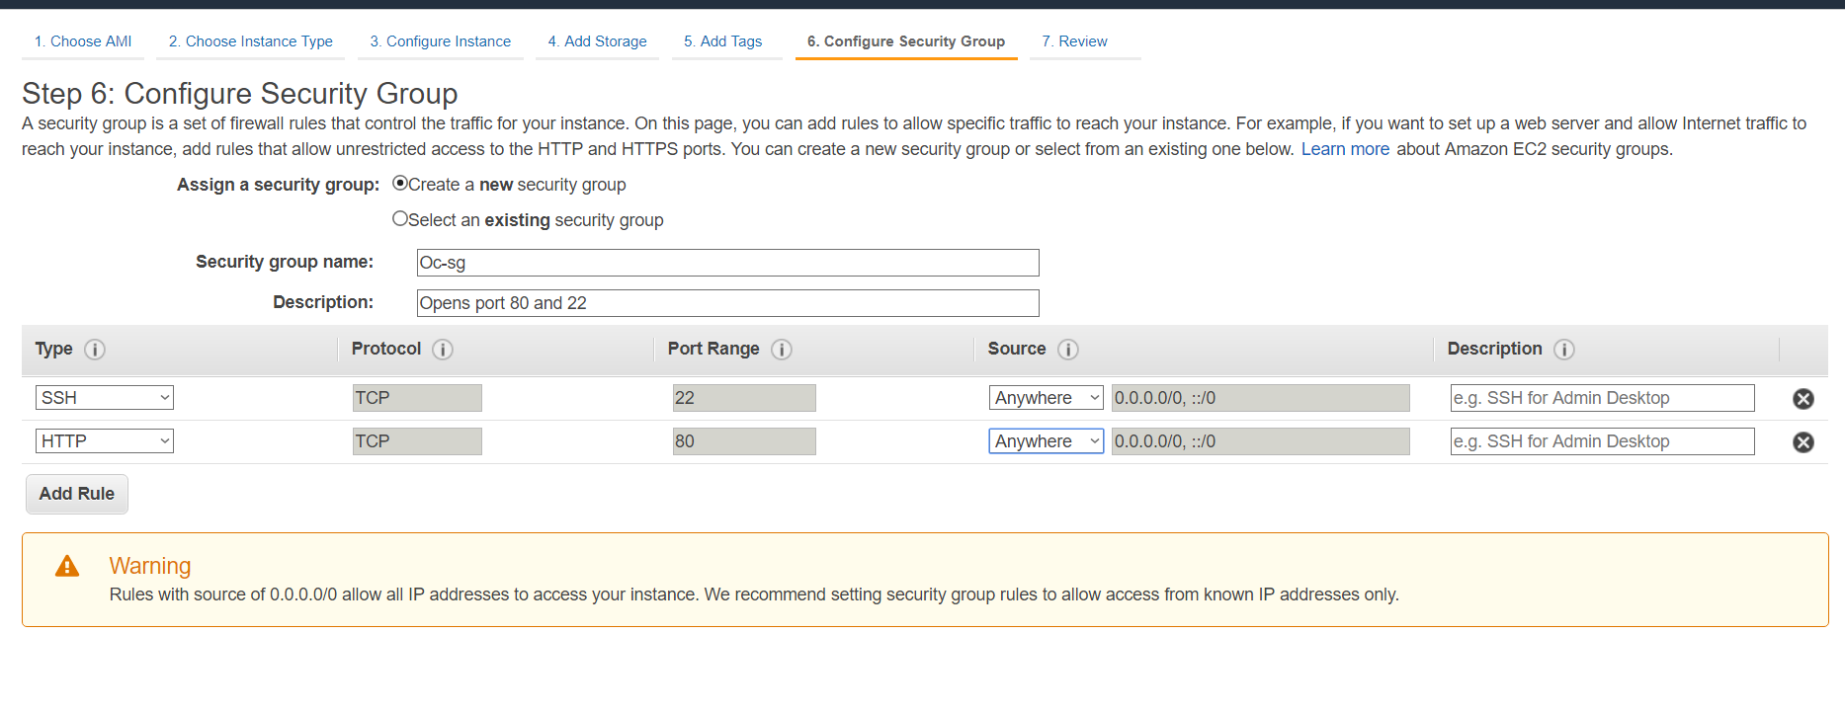

1. SSH the public IP of EC2 from Terminal and check the Httpd service status

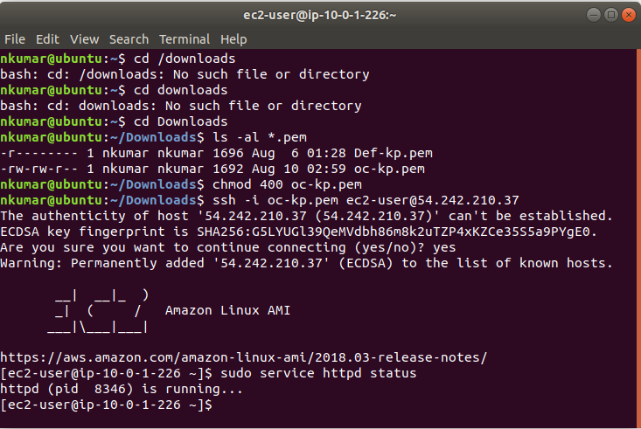

1. Create another EC2 instance in prove subnet and custom VPC

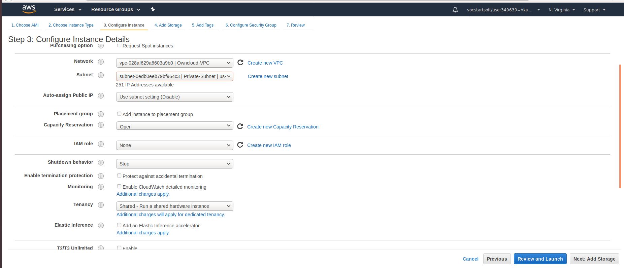

1. Create security group to allow traffic from public subnet as below

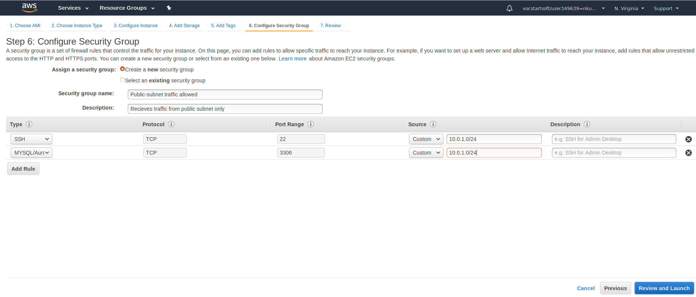

1. DB-server EC2 Summary

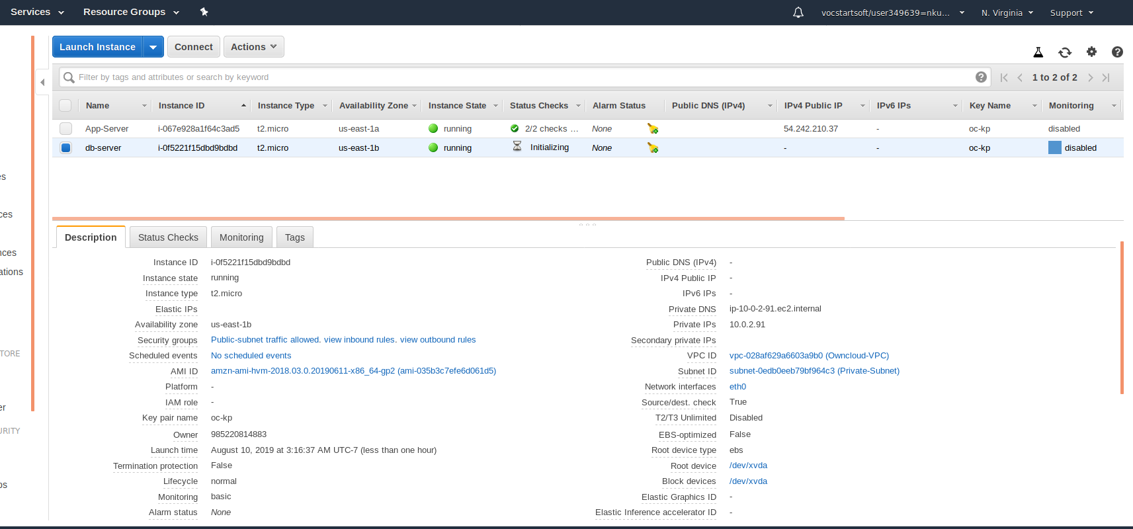

1. Copying the pem file to /opt folder

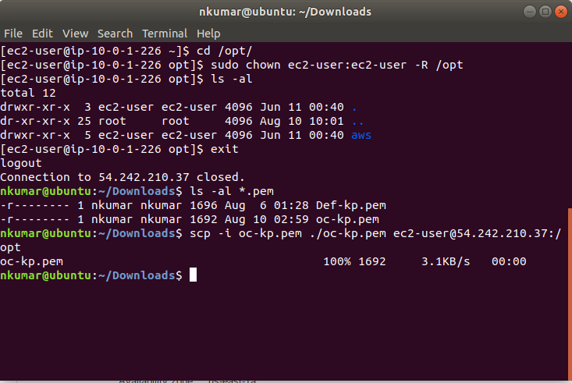

1. SSH using public ip

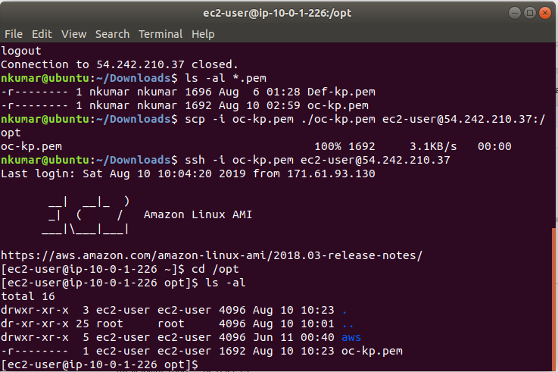

1. SSH using private ip

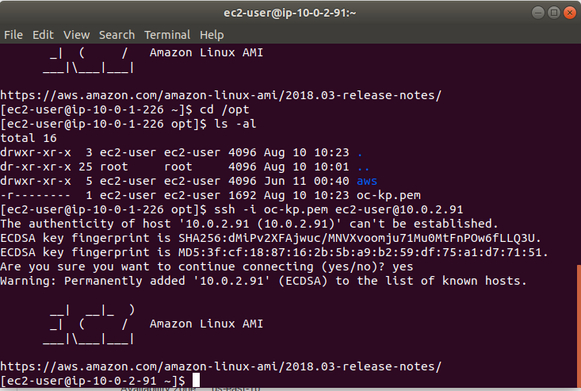

1. Create Route table and associate it to private subnet

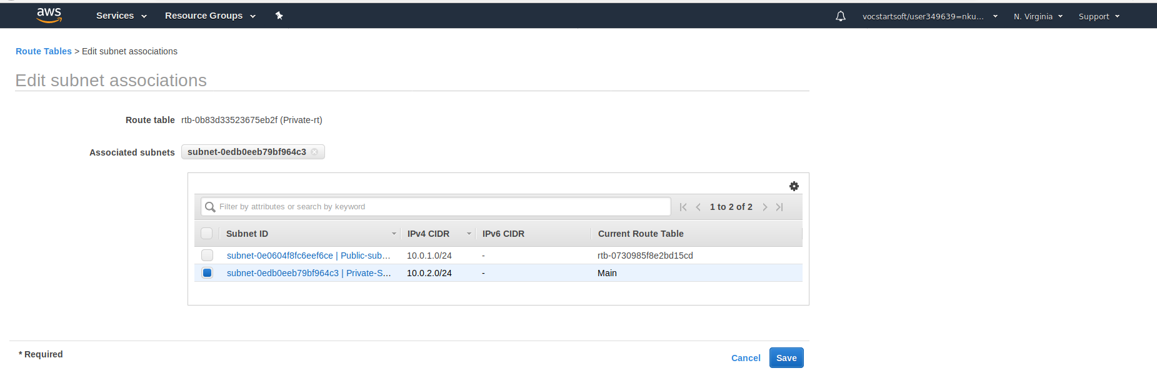

1. Search for NAT instance from community AMI’s

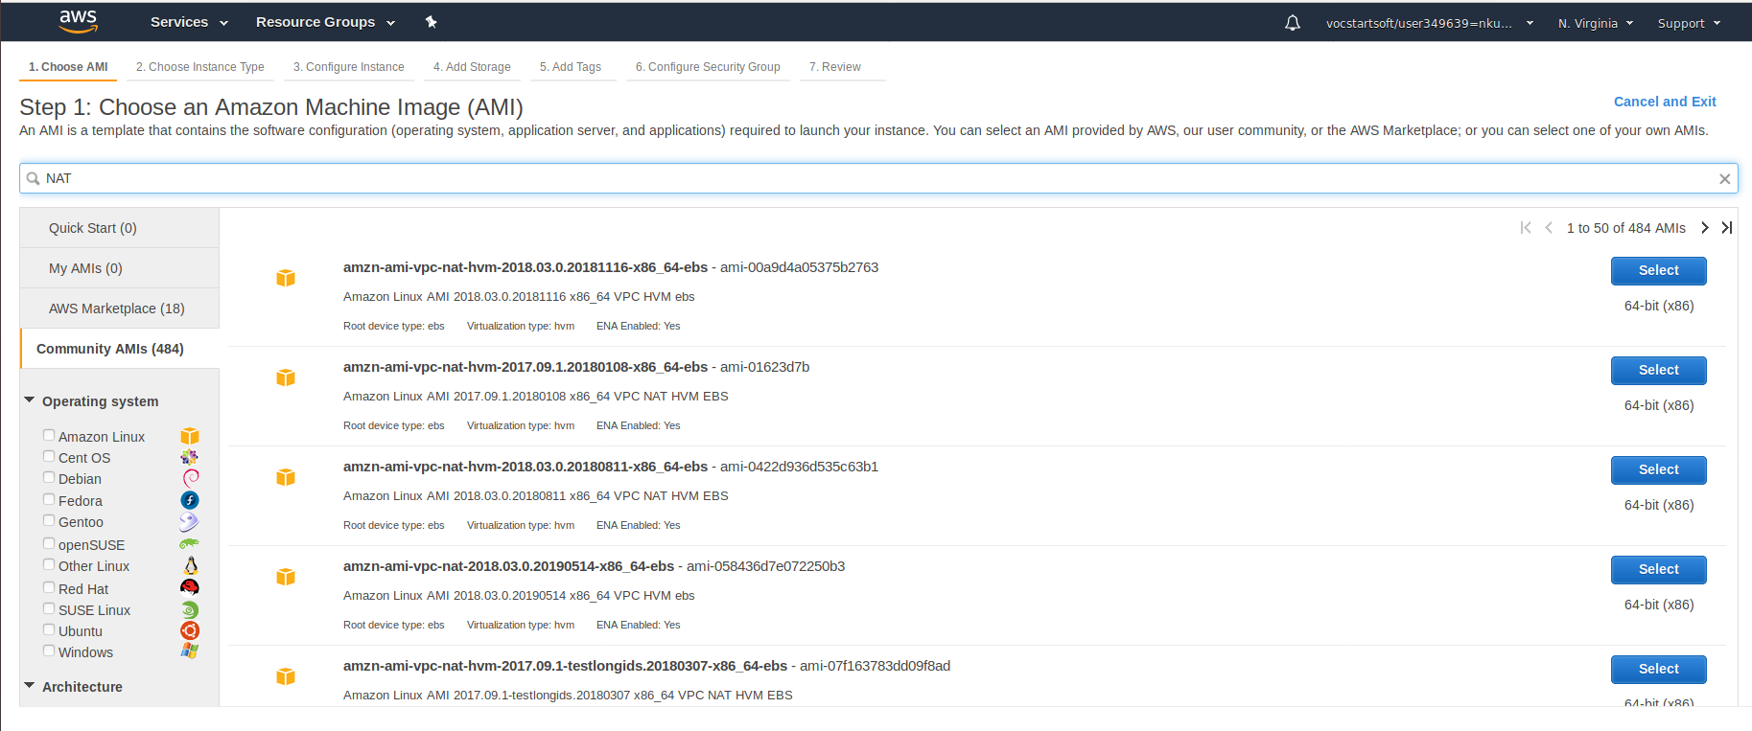

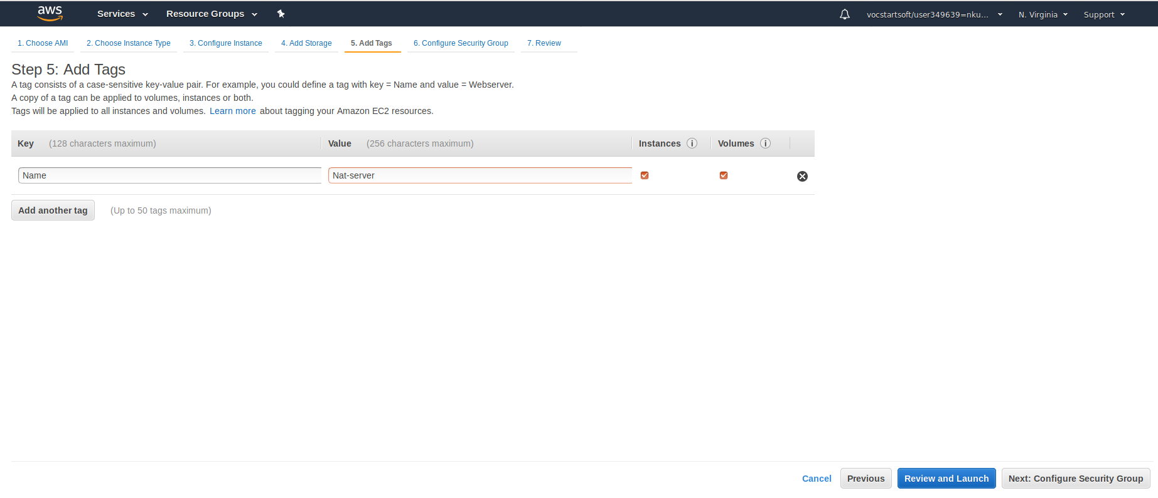

1. Change the Source/destination check for NAT instance to disable

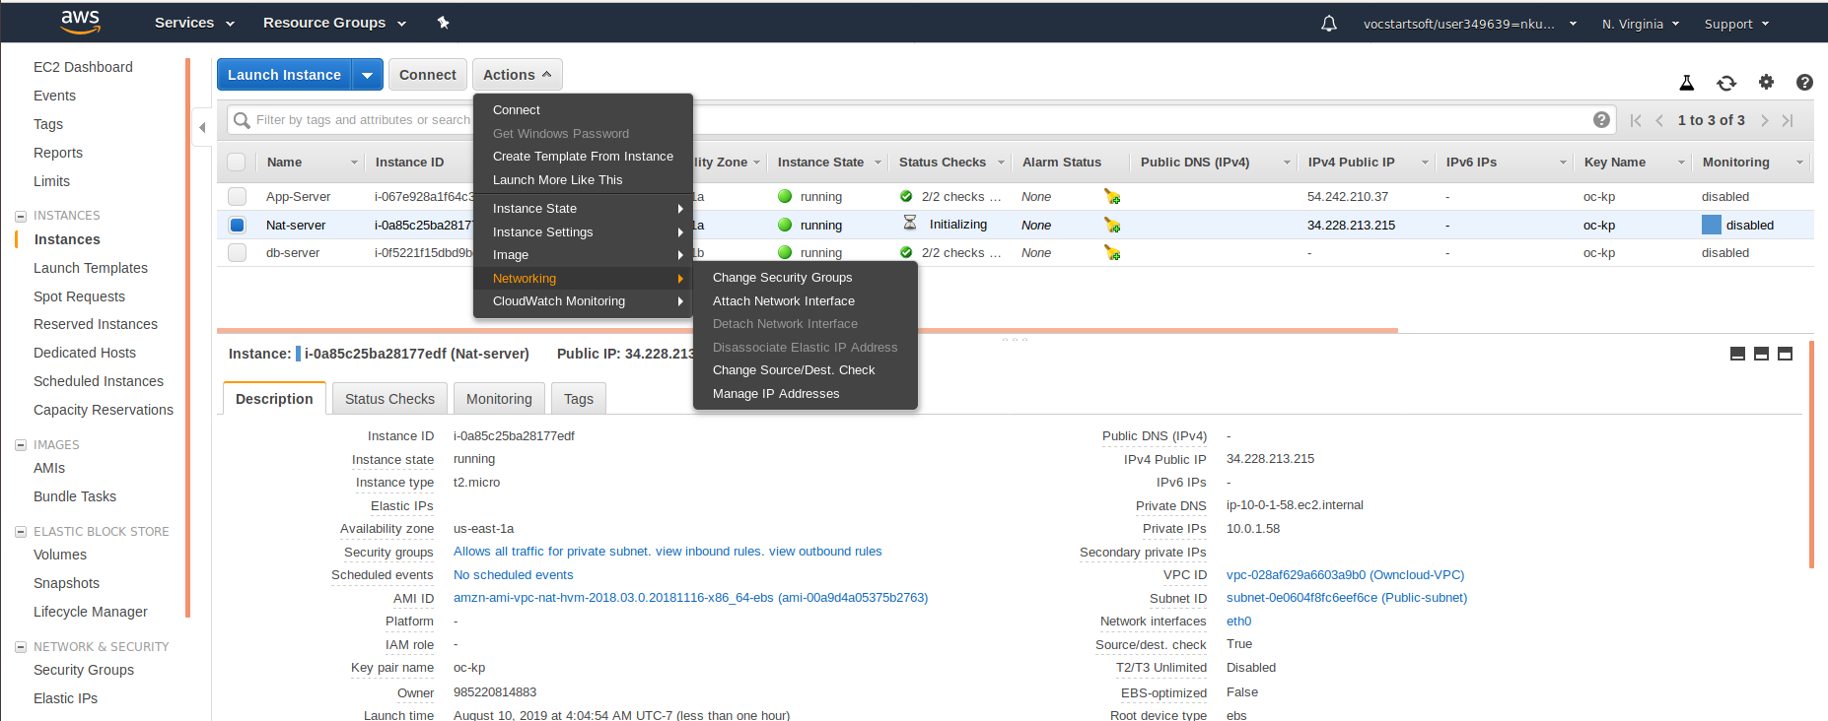

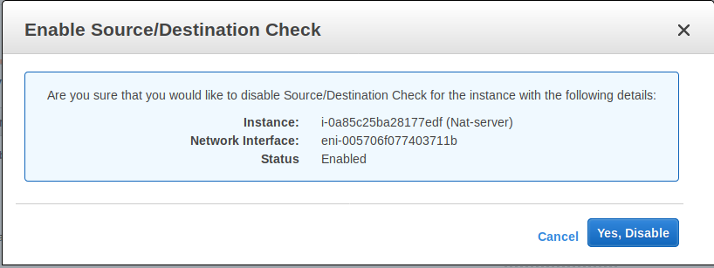

1. Add route in private subnet and associate NAT instance in Target as below

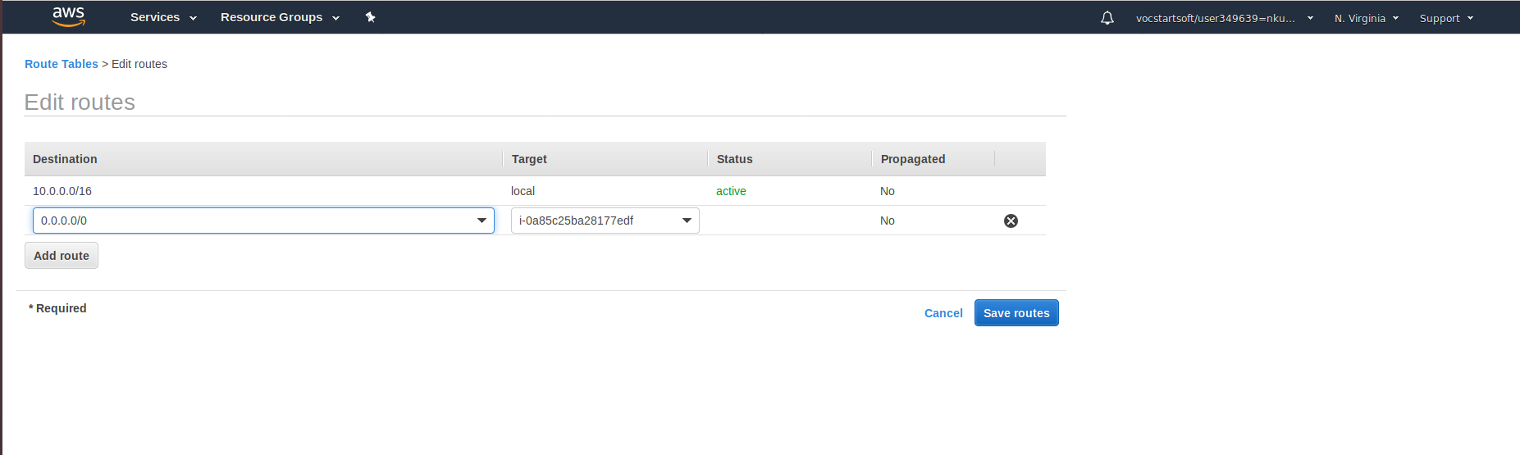

1. From private instance we are able to update by connecting to internet

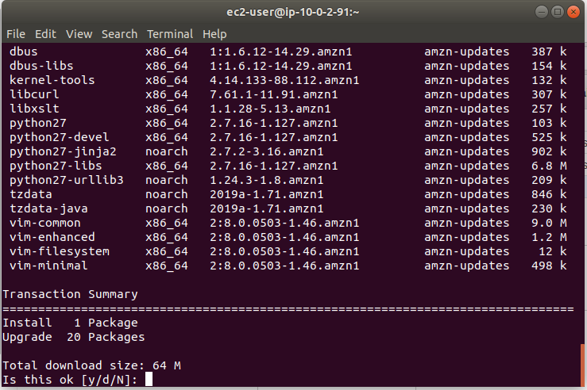

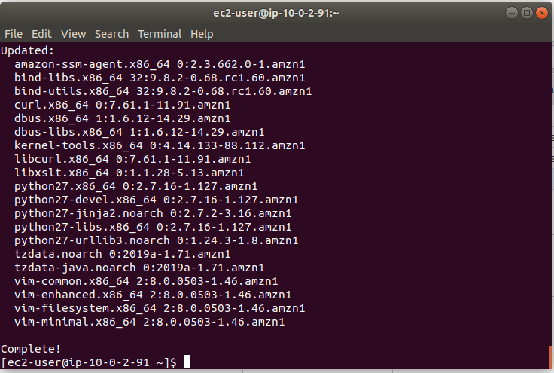

1. Install Mysql-server

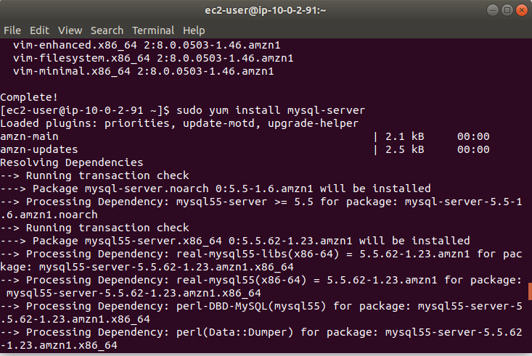

1. Install mysql-server

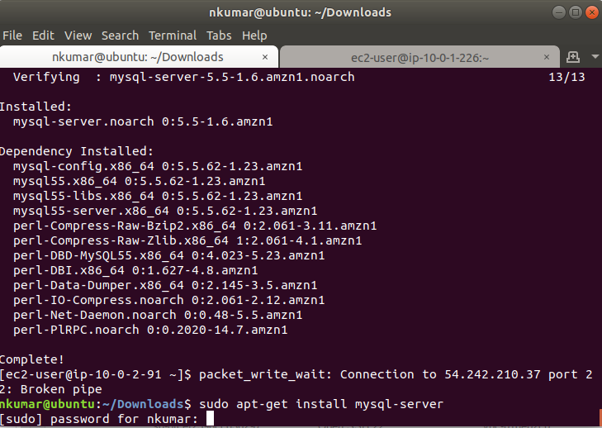

1. Open Mysql terminal

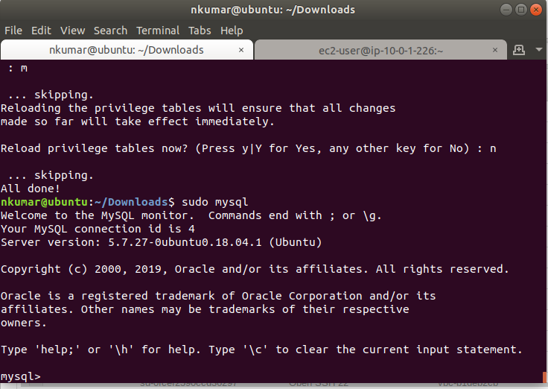

1. Create new DB and use Owncloud database

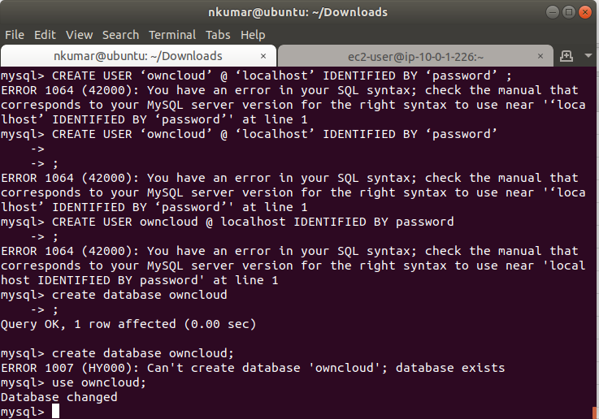

1. Grant all privileges to user owncloud

