Own Cloud with PHP Modules

1. Public subnet 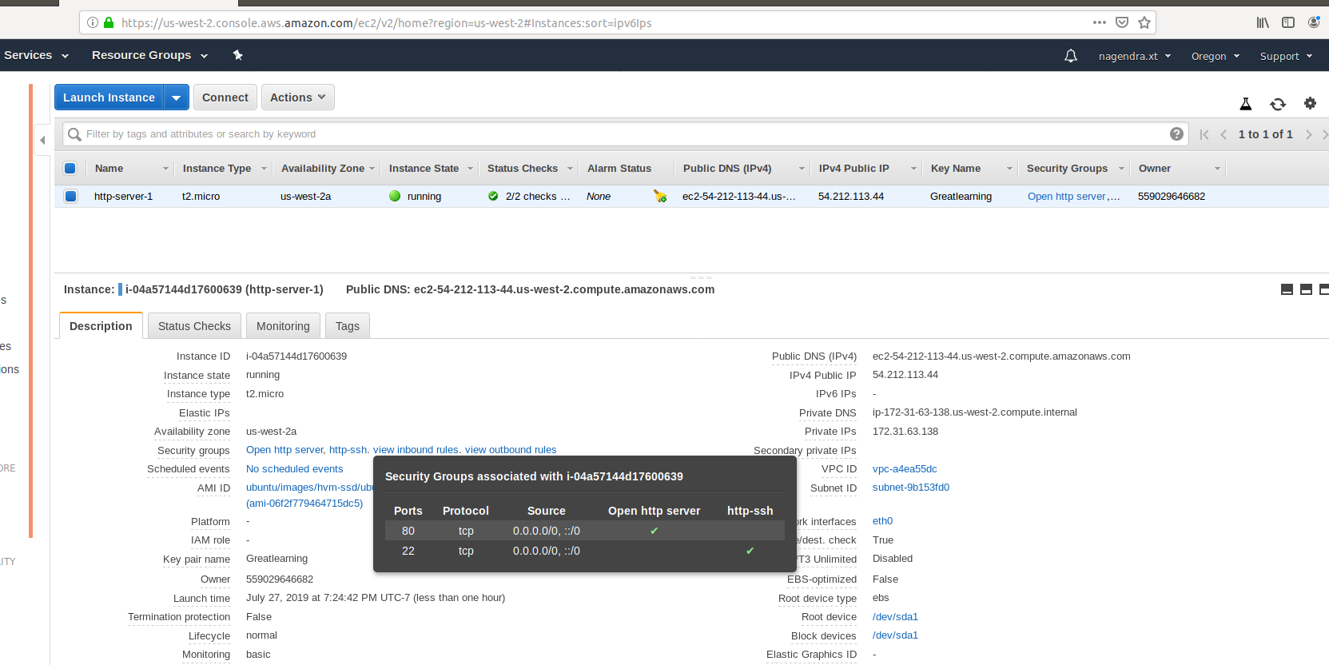
2. Accessing public ip of EC2 instance in browser

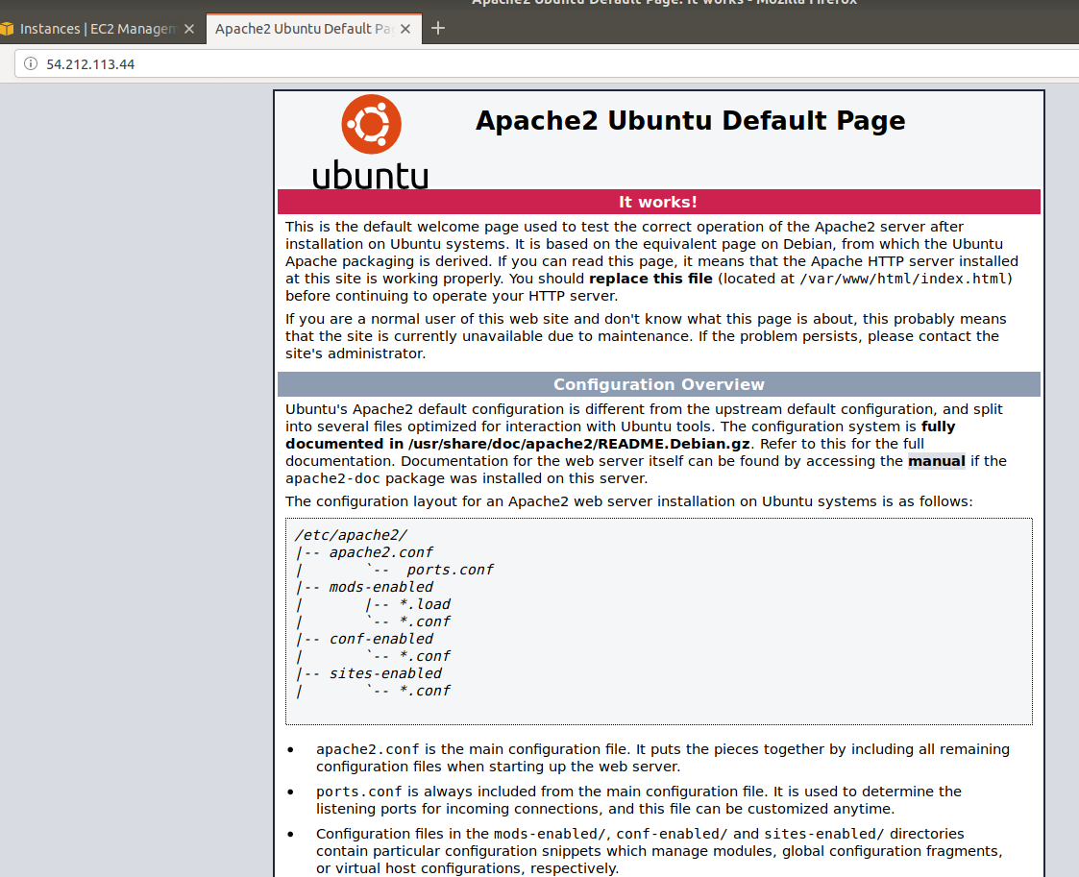

1. Installing PHP with PHP Modules

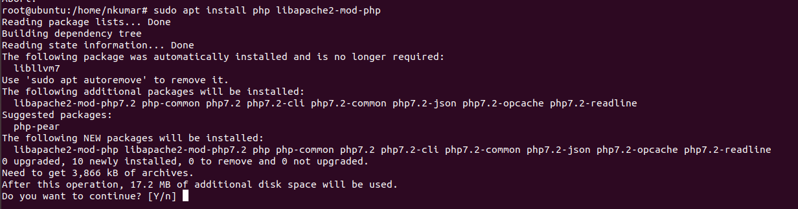

1. Making index.php as first page

