Creating an Open Stack Single Node Private Cloud Deployment on EC2 on AWS

1. Create EC2 instance t2.large with Centos 7

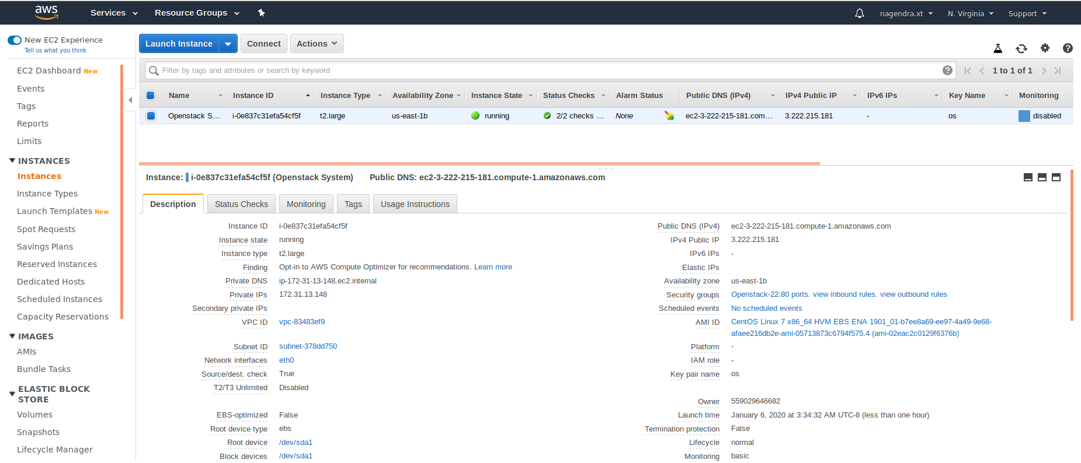

1. SSH to EC2 instance

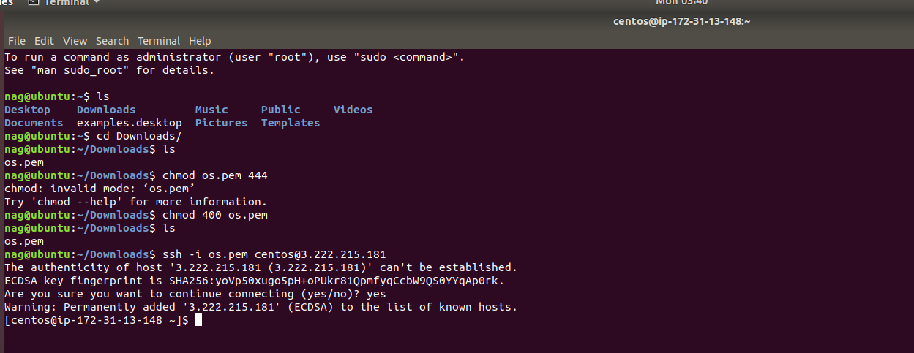

1. Phase-1 Commands

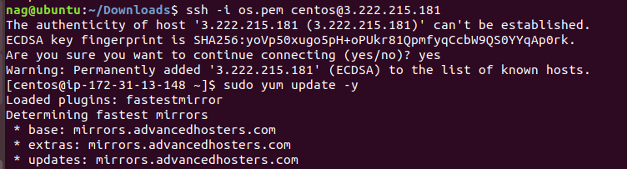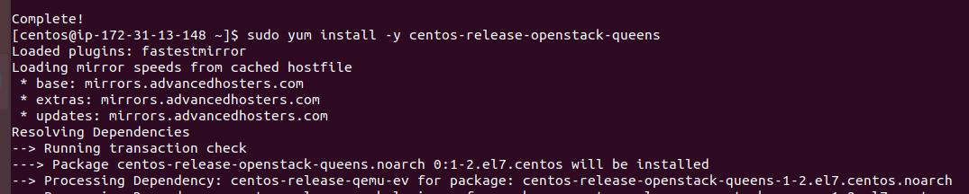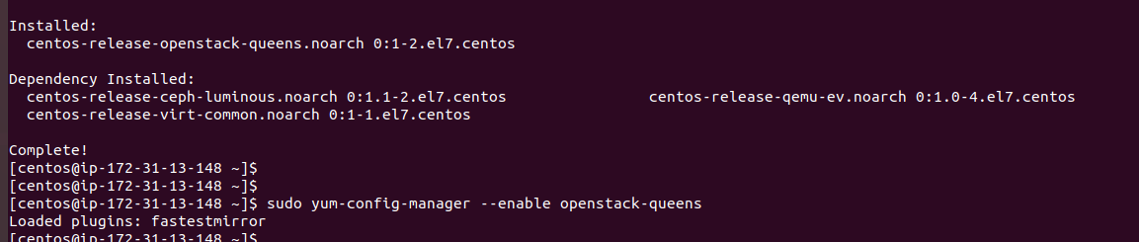

Restart the EC2 instance

1. Phase-2 commands

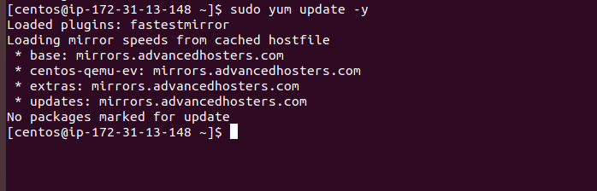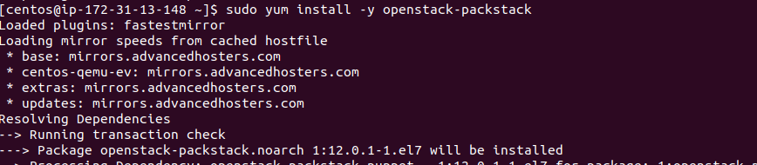

1. Phase 3 Commands

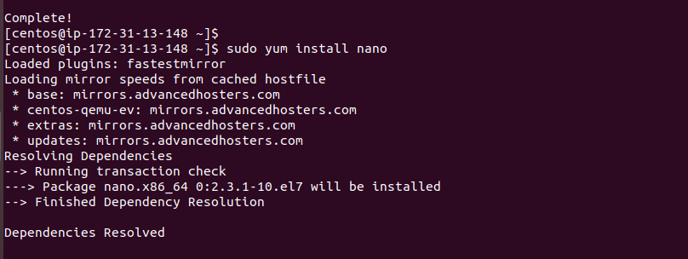

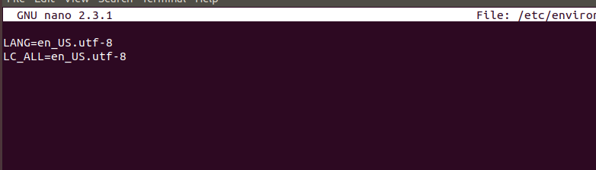

1. Phase 4 Commands

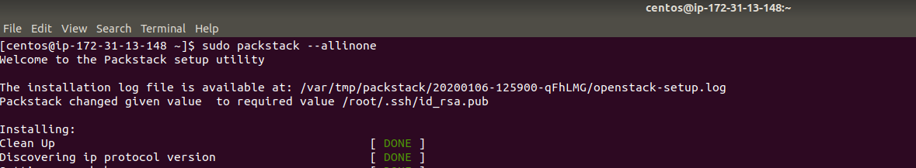

1. Backend Execution

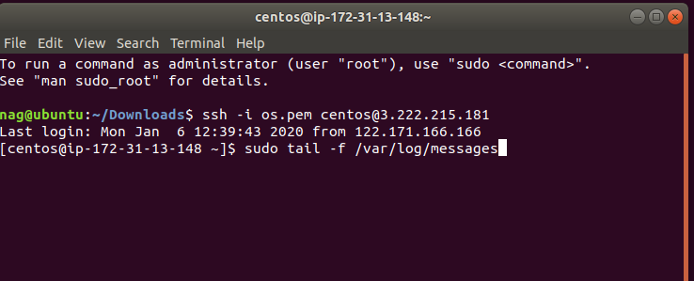

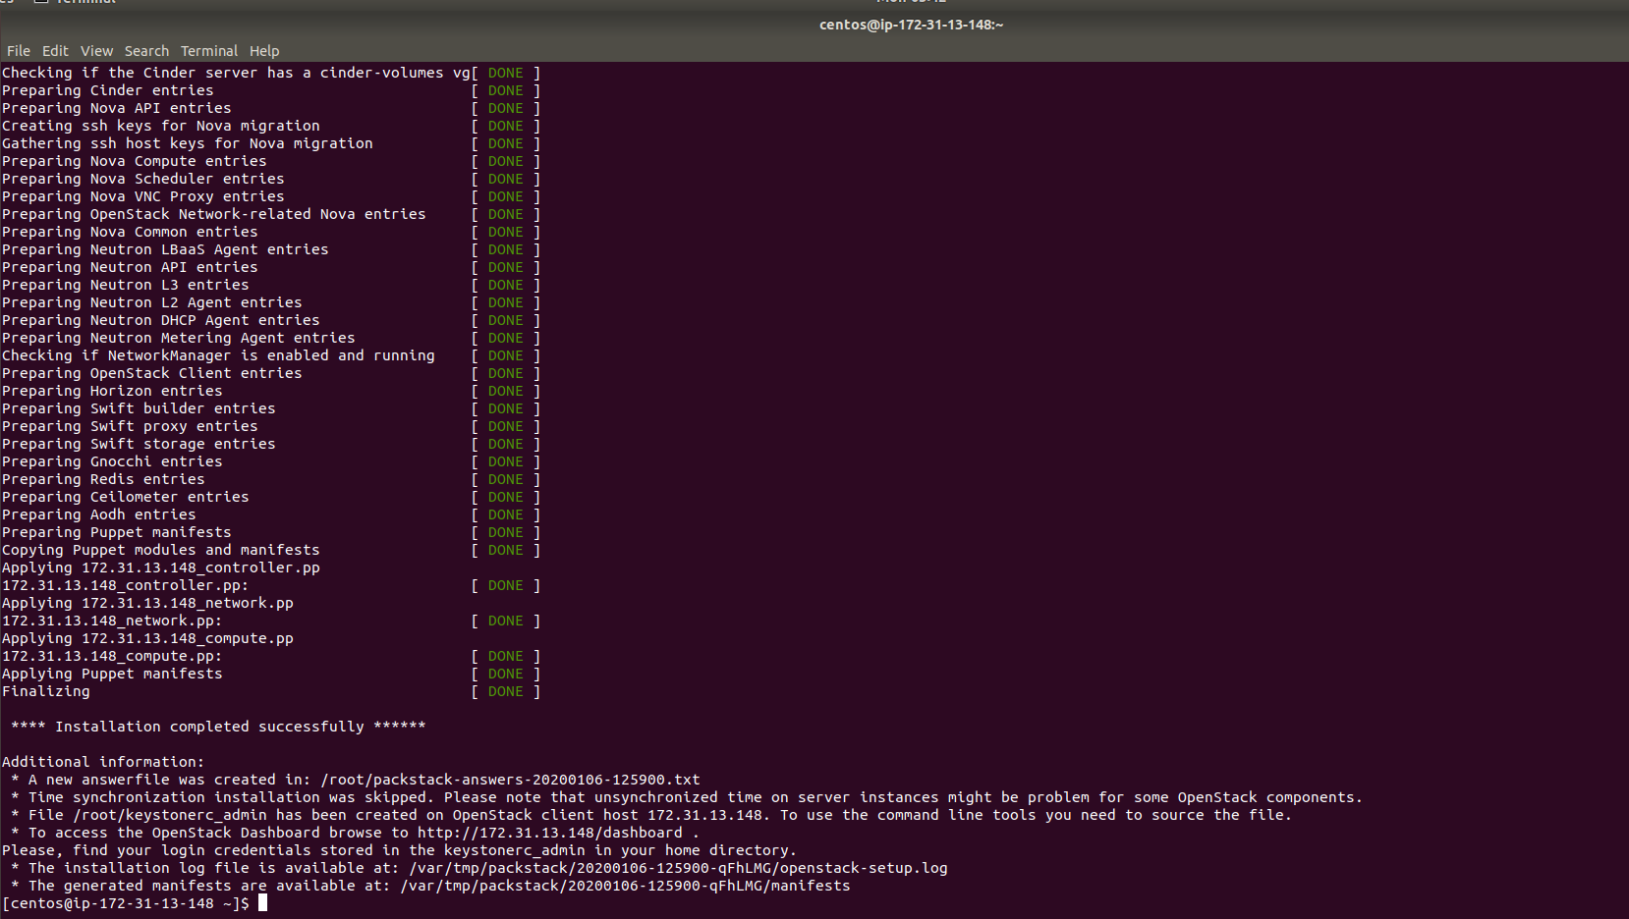

1. Phase 5 commands

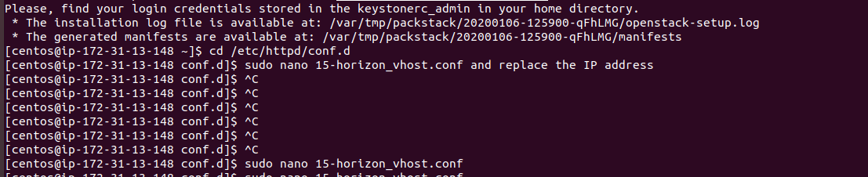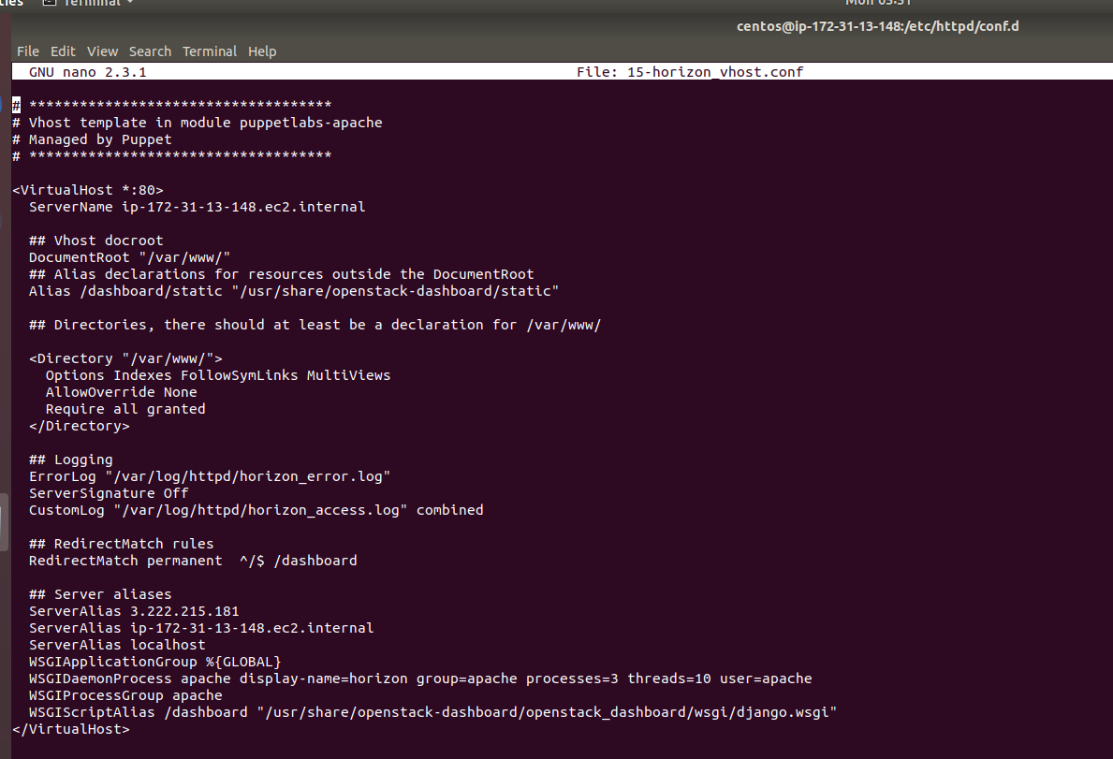

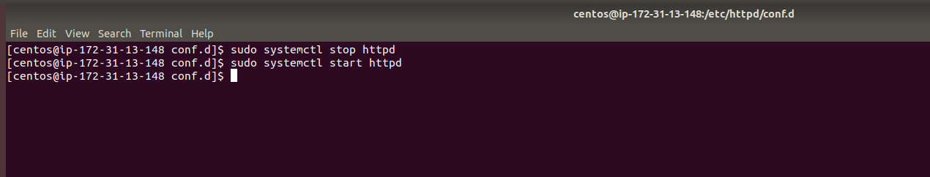

Open the public using browser

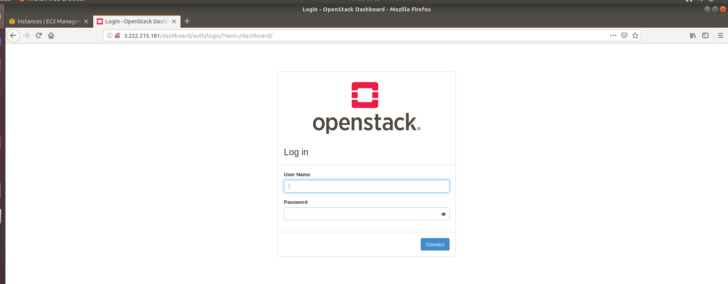

1. Phase 6

Login to console

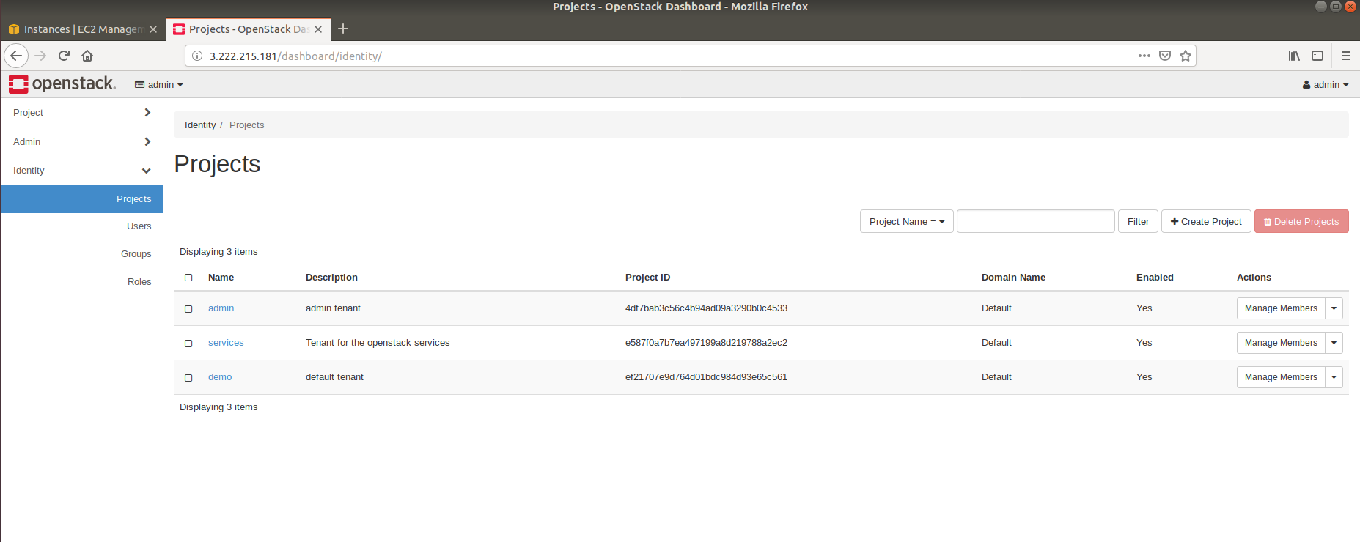

1. Observations

* OpenStack certainly lacks some of the pre-installed AWS applications and setups such as the excellent security module.
* Besides AWS services available globally which attracts start-ups
* Both the platforms offer similar services and it boils down to the usability and integration factor of the application with your organizational needs. OpenStack, on one hand, offers better resiliency and increased corporate profitability with its open frame network; AWS appeal to start-ups and small IT firms due to its many offerings and flexible customer support.

1. Creating cirros instance

Creating SSH port under security group

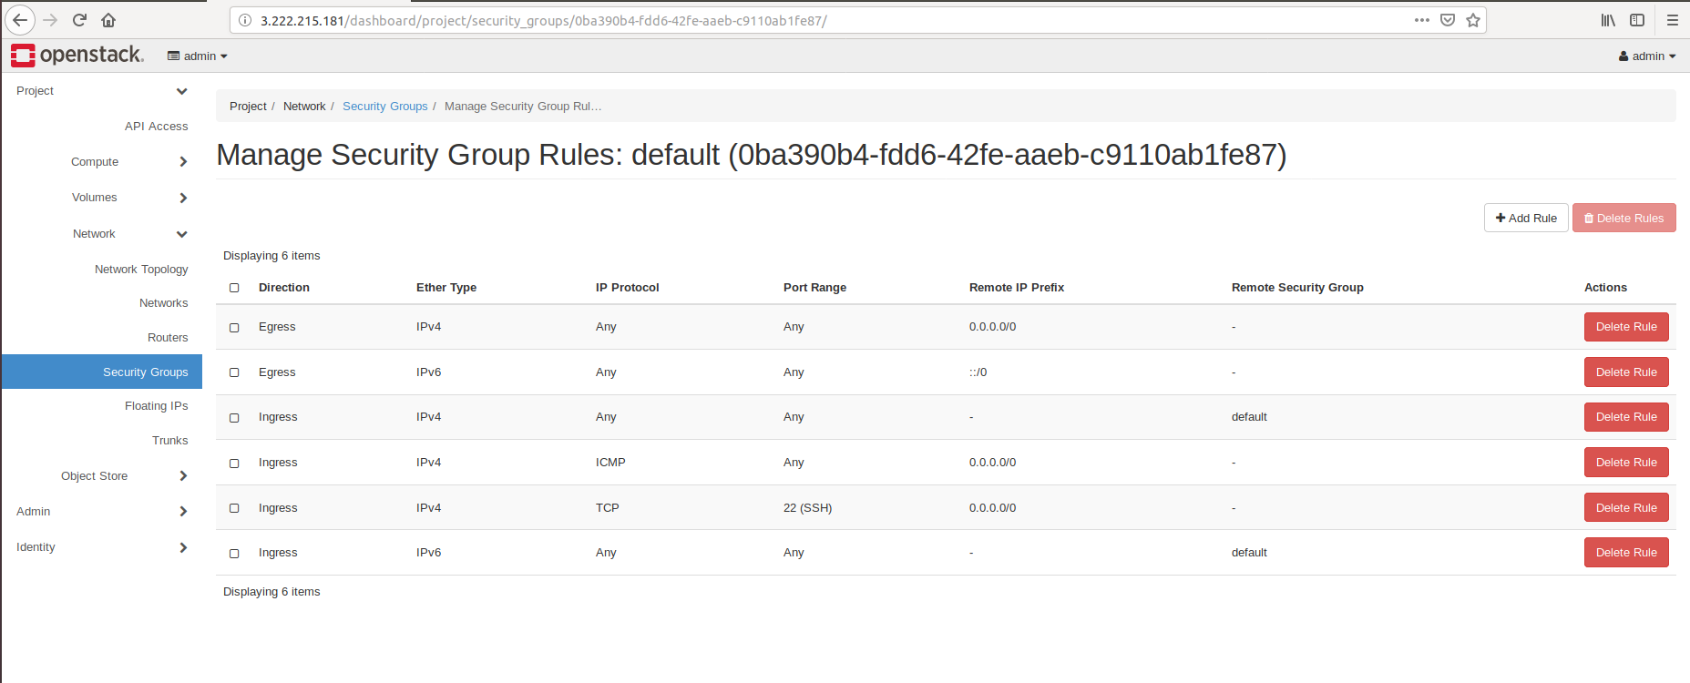

Creating Network

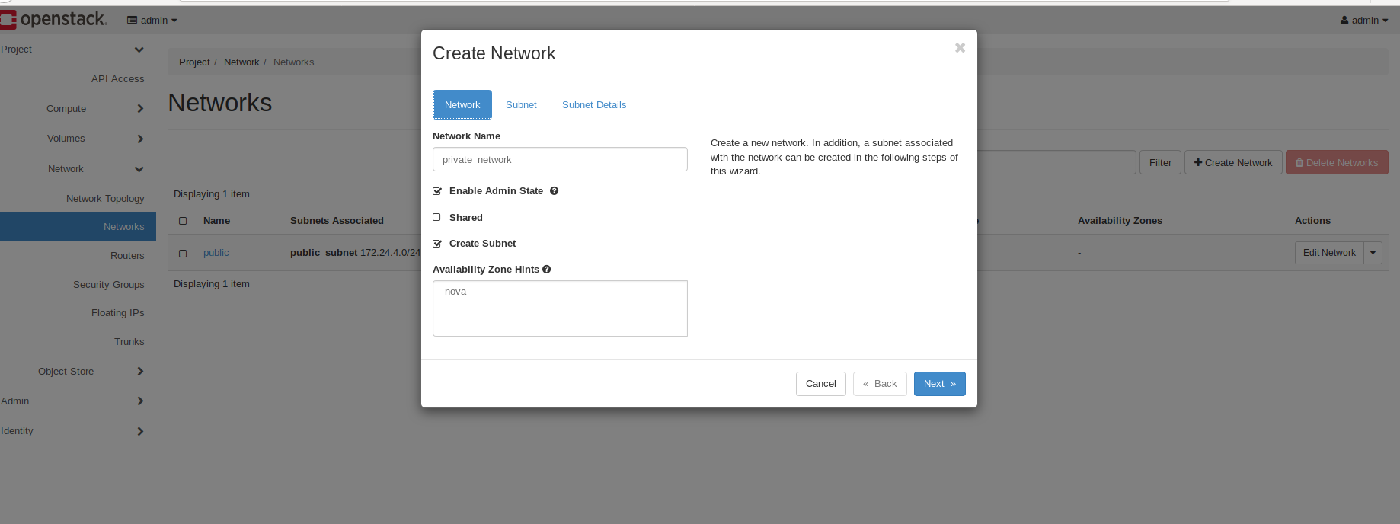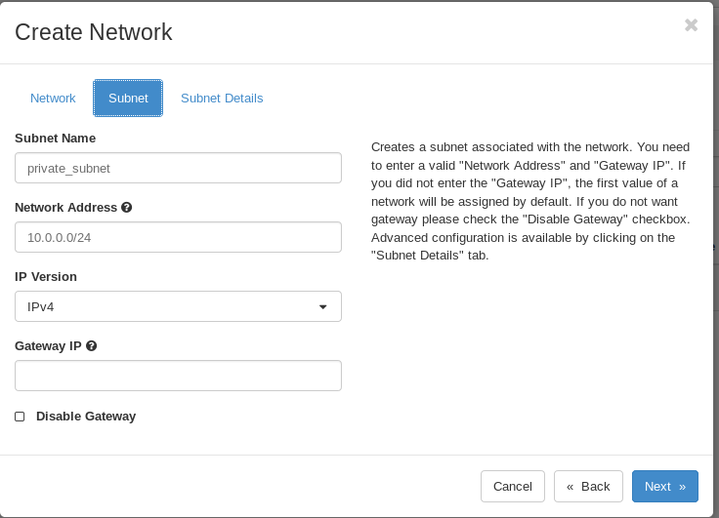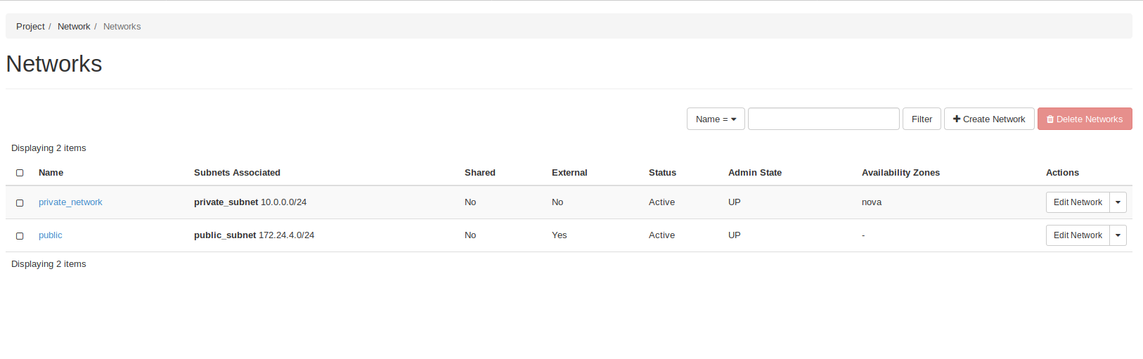

Creating Router

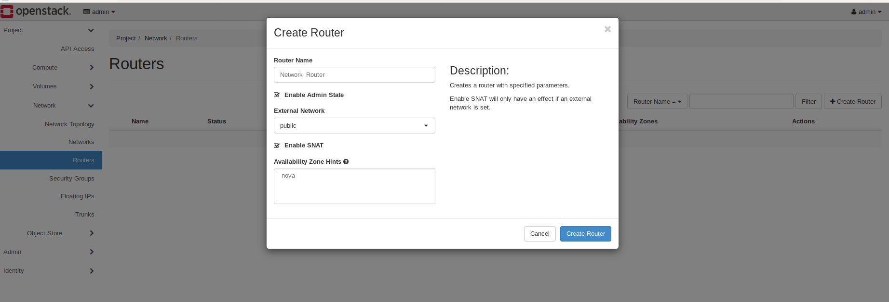

Add interface

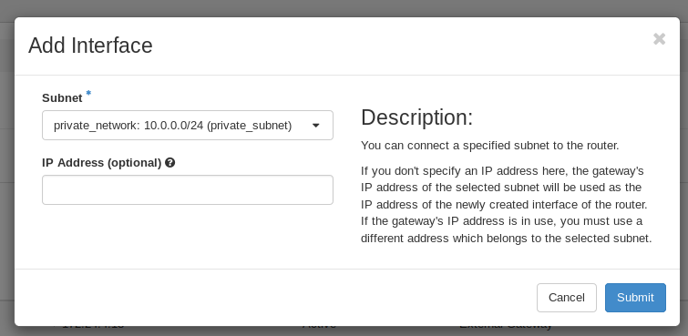

Creating Floating IP

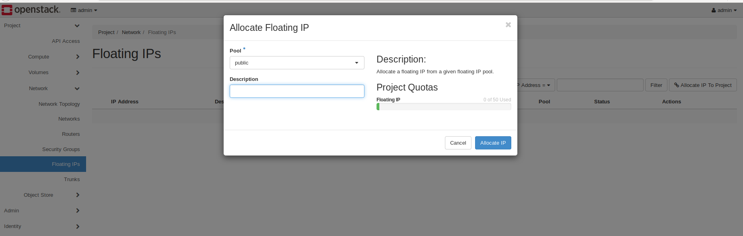

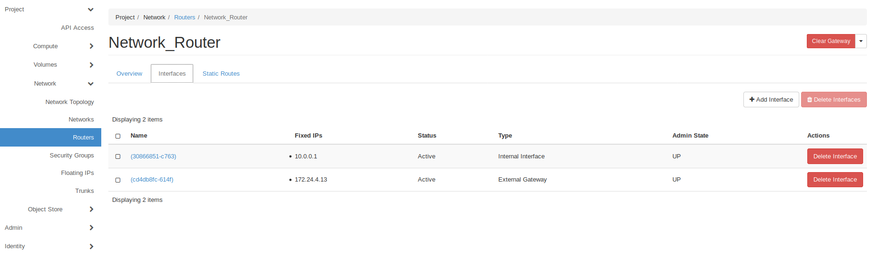

Create an Instance with below options

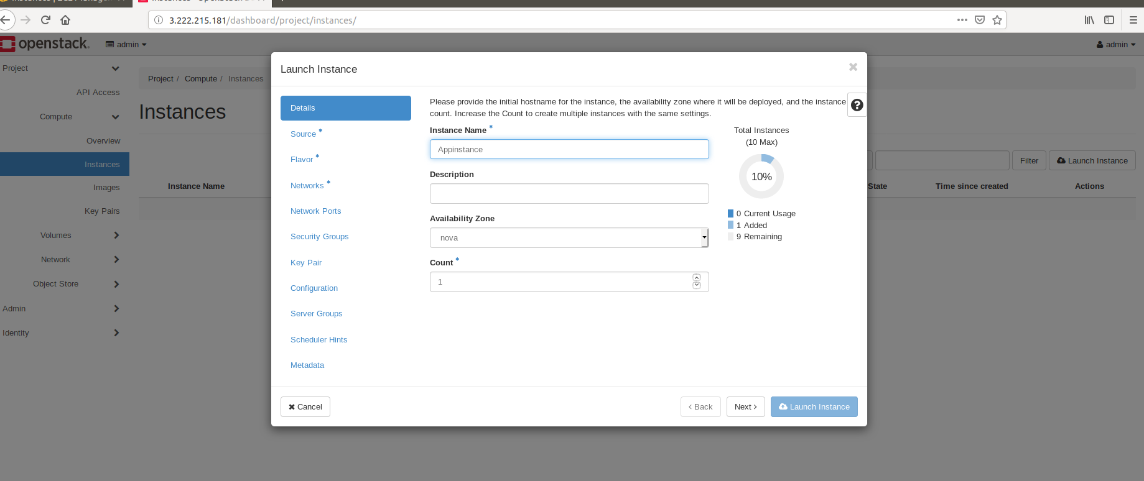

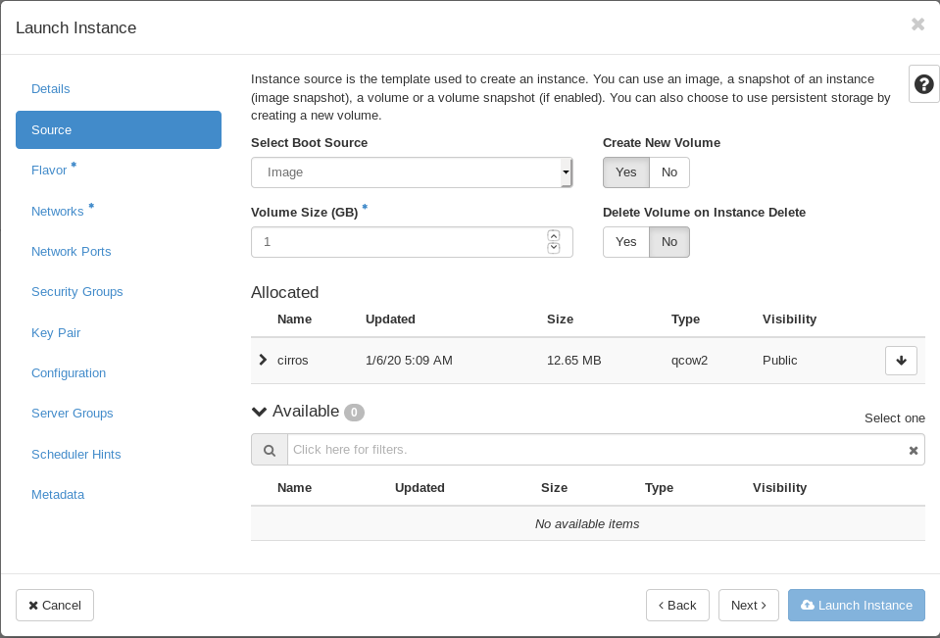

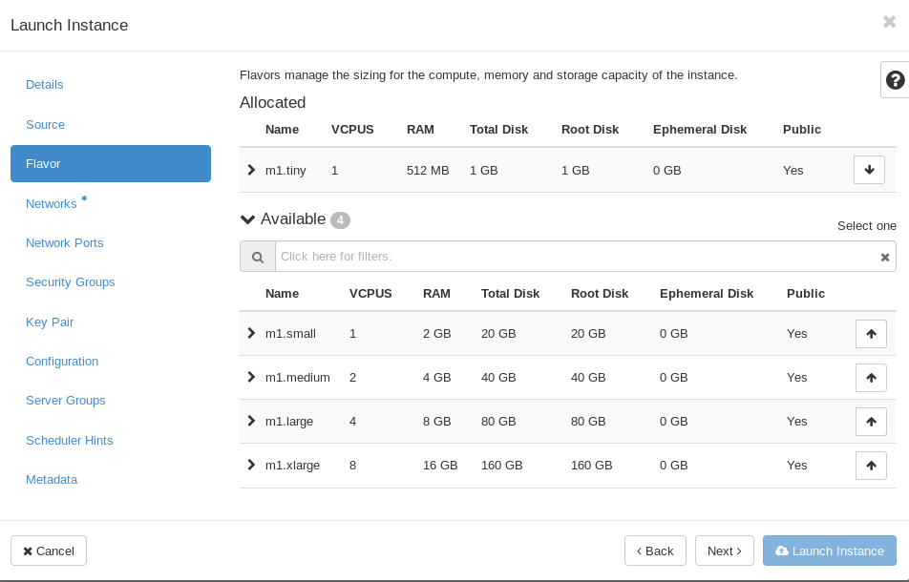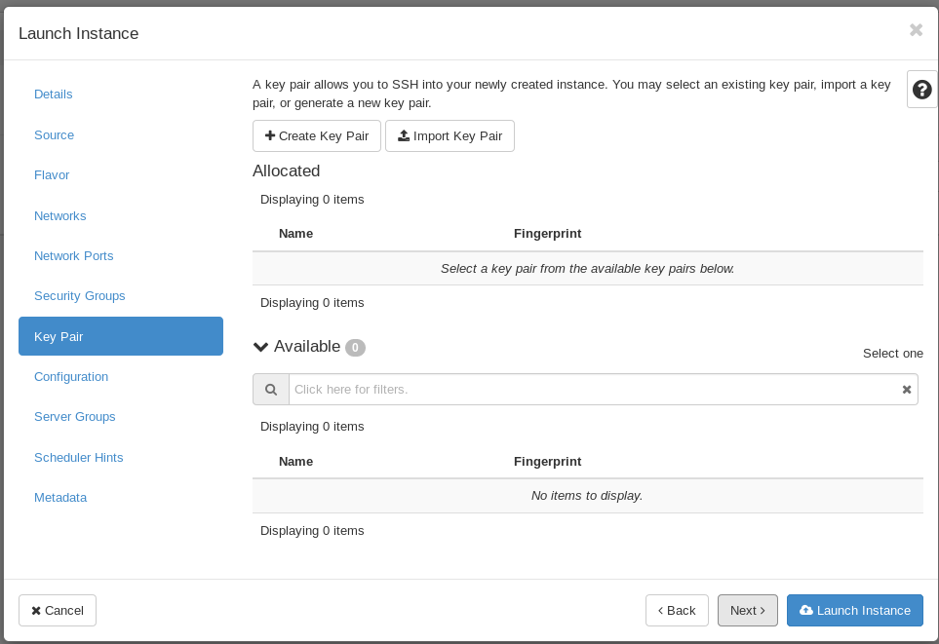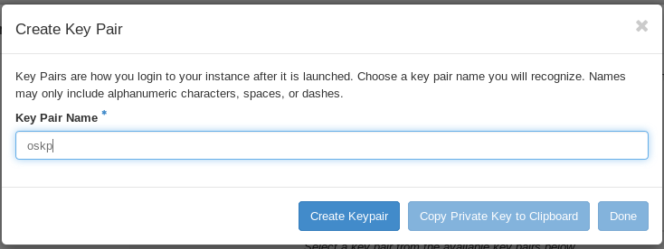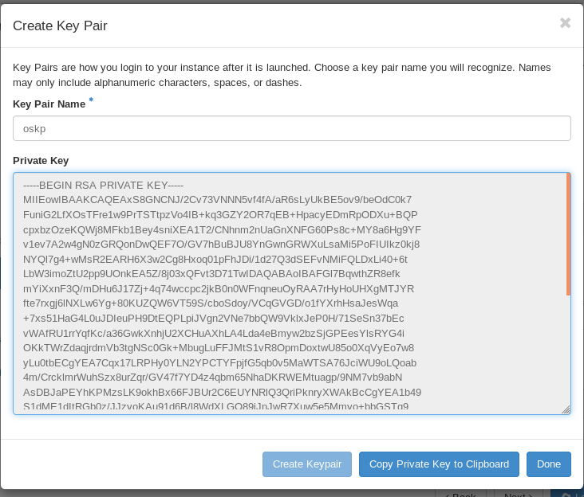

Instance Launched

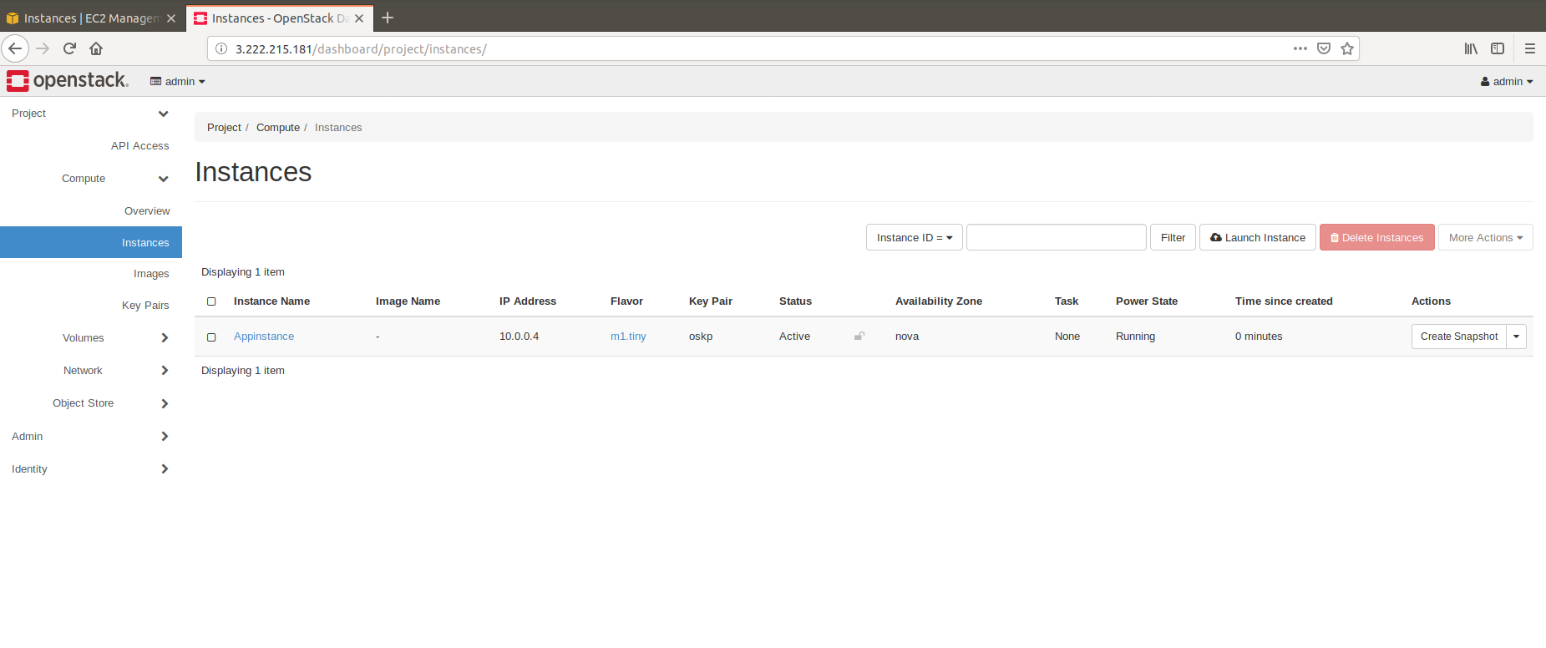

Allocate Floating IP

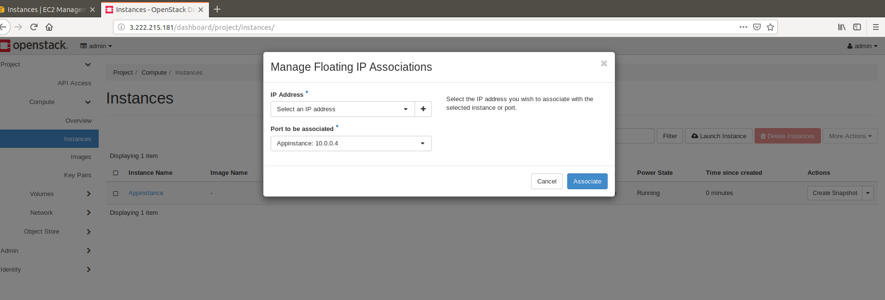

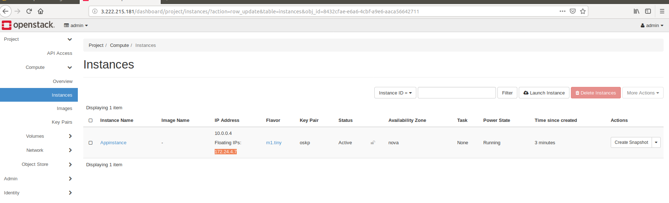

Ping the Floating IP from EC2 instance

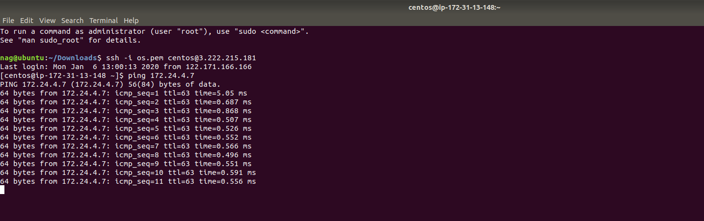

Creating pem file using Key pair downloaded

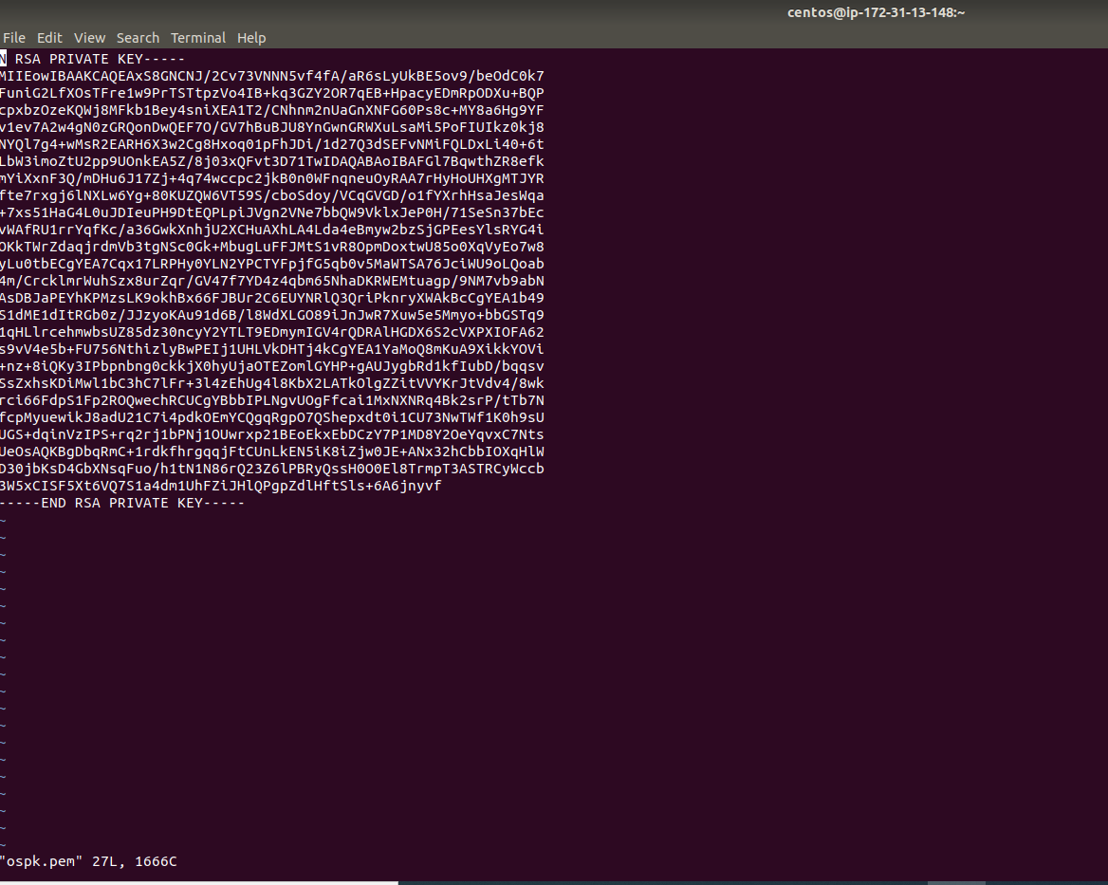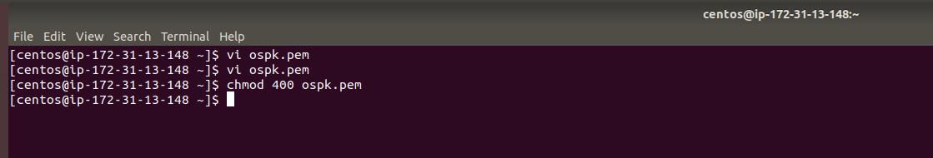

SSH to the Cirros instance

